Week-01-overview of c ,constants , variables , data and types

Week 1 – 0

Coding-C-language features-optional.

REG NO.:241801291

NAME : TARRUN.B

Q1)

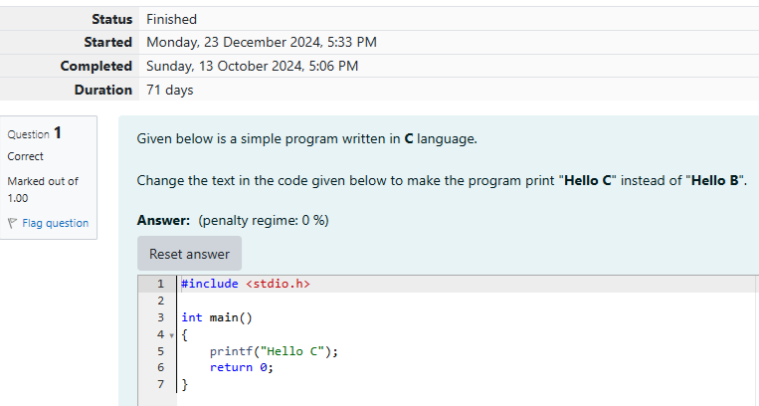

OUTPUT

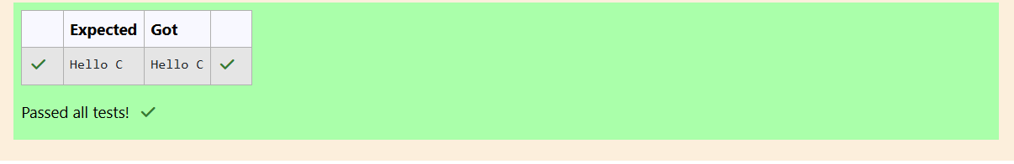

WEEK 1-0

CODING C LANGUAGE FEATURES OPTIONAL

REG NO.:241801291

NAME: TARRUN.B

Q2)

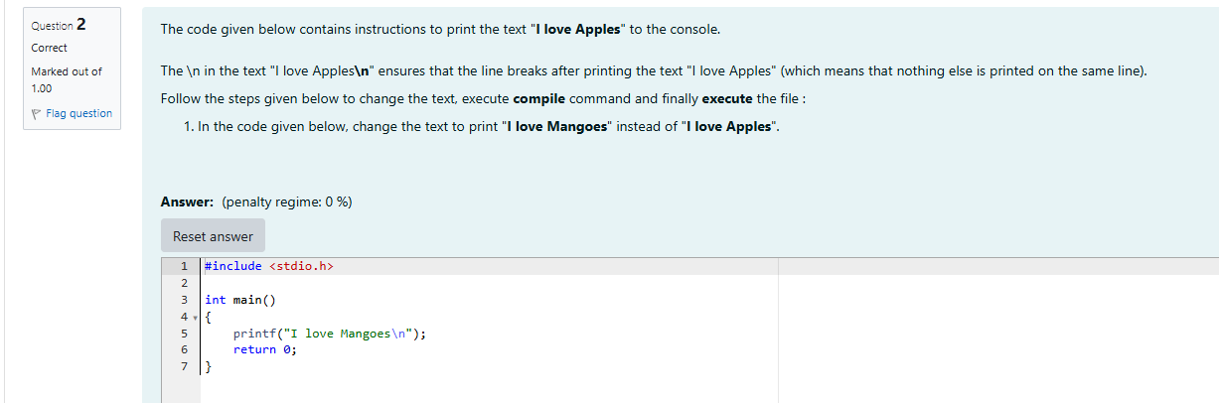

OUTPUT

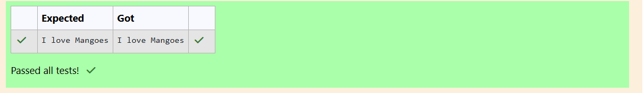

Week 01-01-practice session coding

Reg no : 241801291

Name : TARRUN.B

Q1)

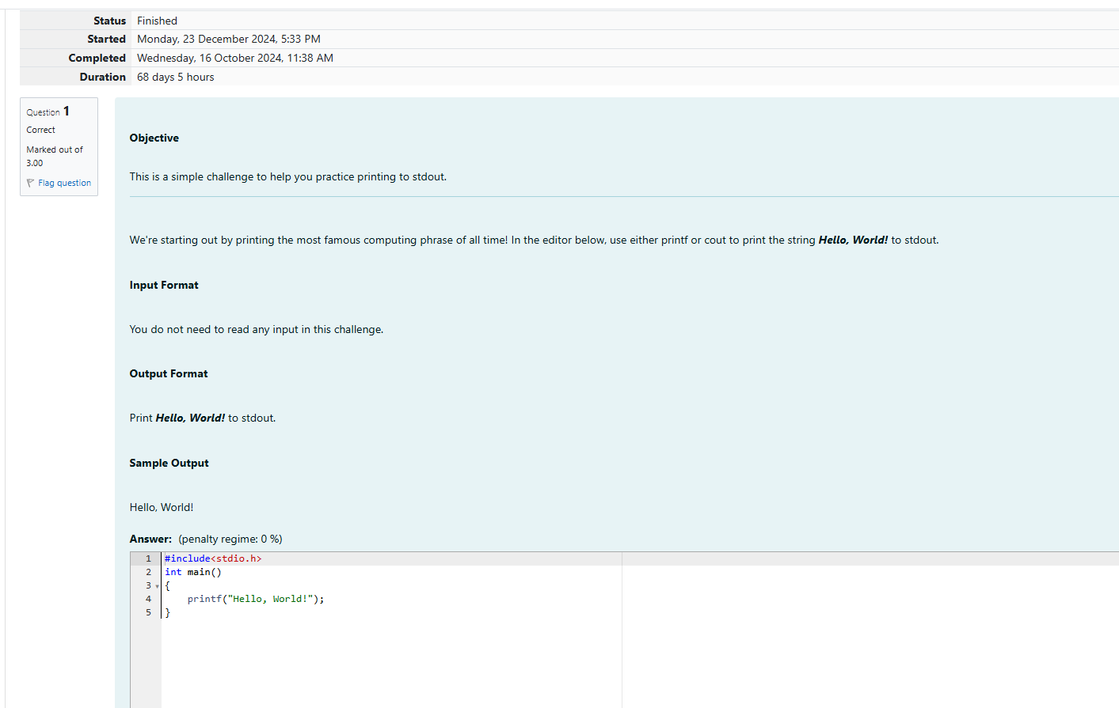

OUTPUT

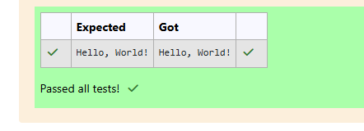

Week 01-01-practice session coding

Reg no : 241801291

Name : TARRUN.B

Q2)

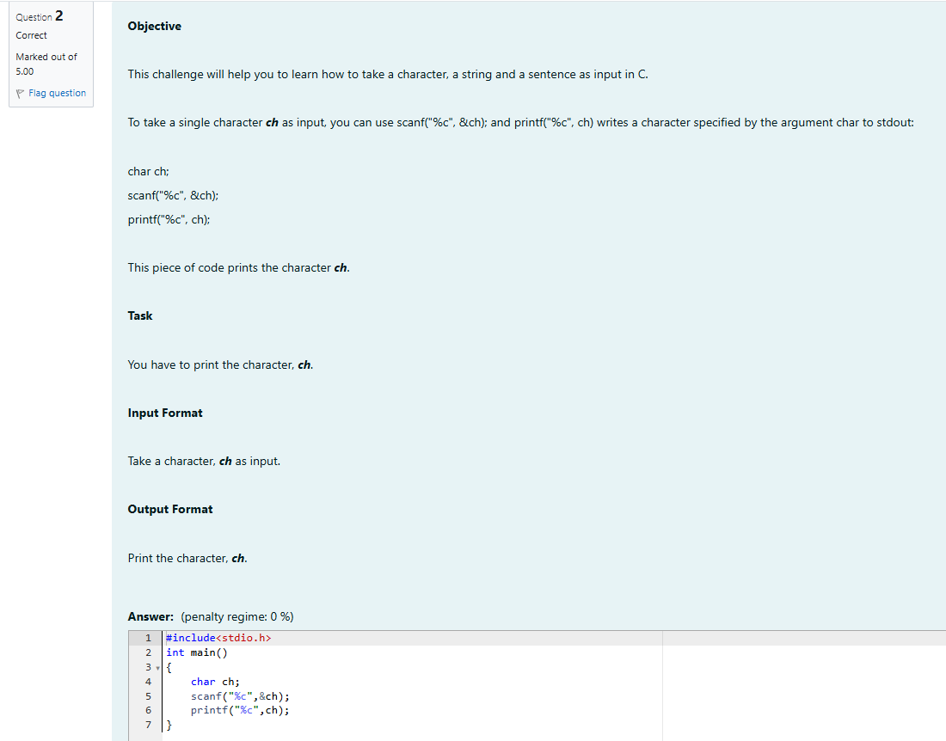

OUTPUT

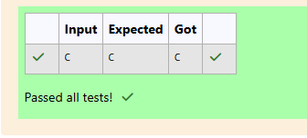

Week 01-01-practice session coding

Reg no : 241801291

Name : TARRUN.B

Q3) 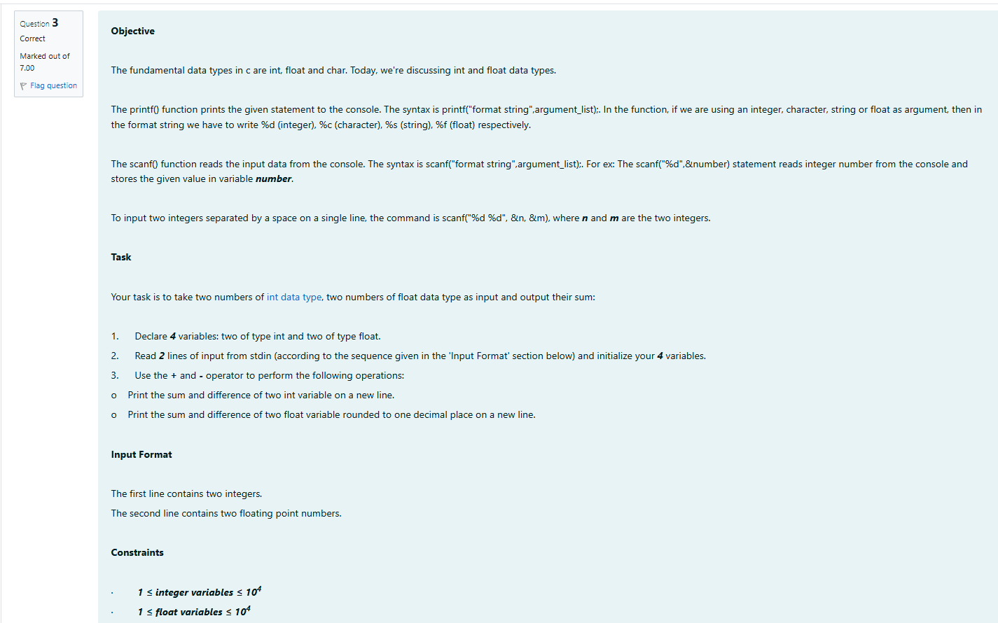

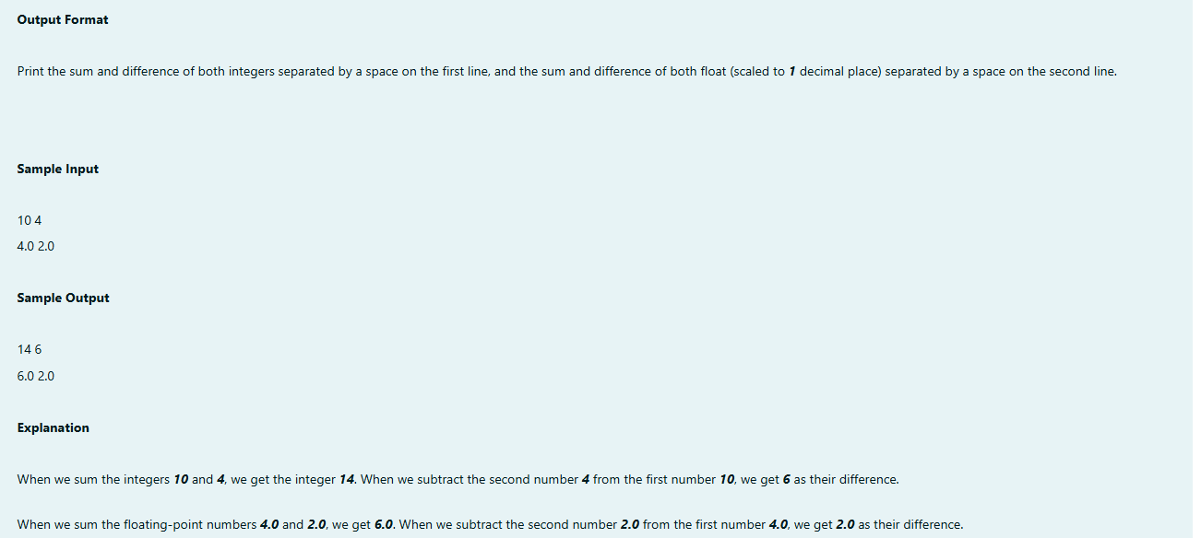

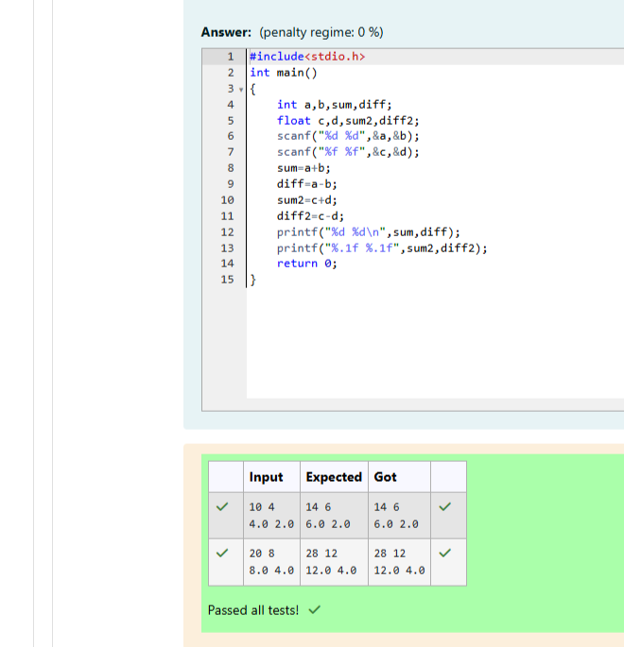

Week 01-02-practice session coding

Reg no : 241801291

Name : TARRUN.B

Q1)

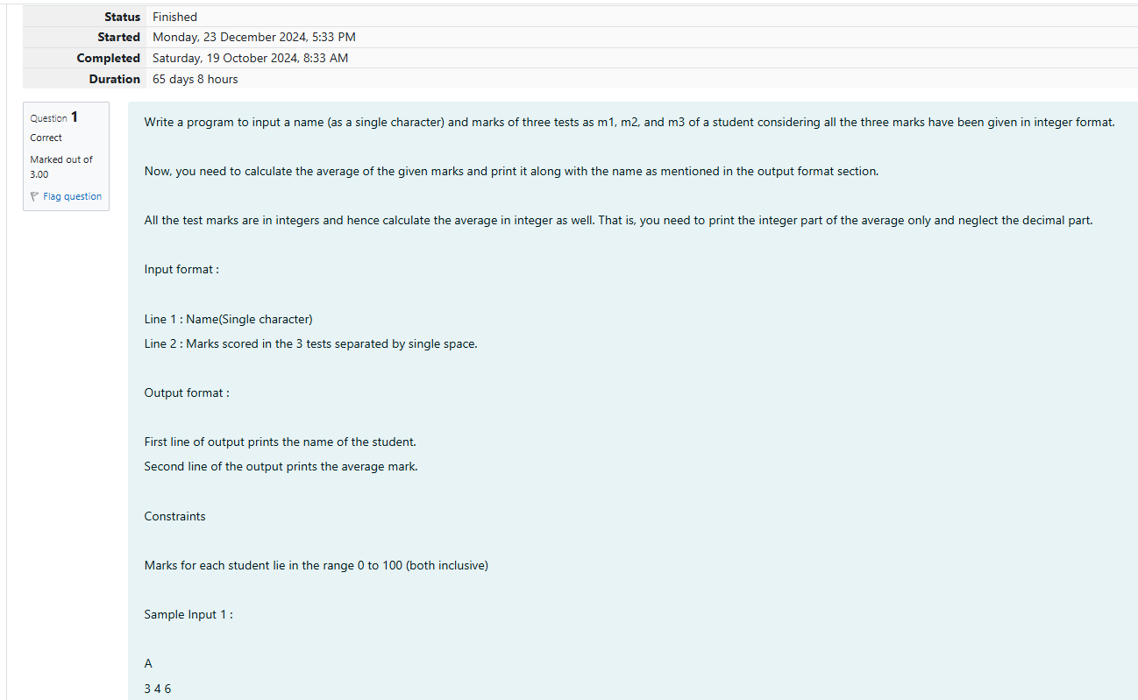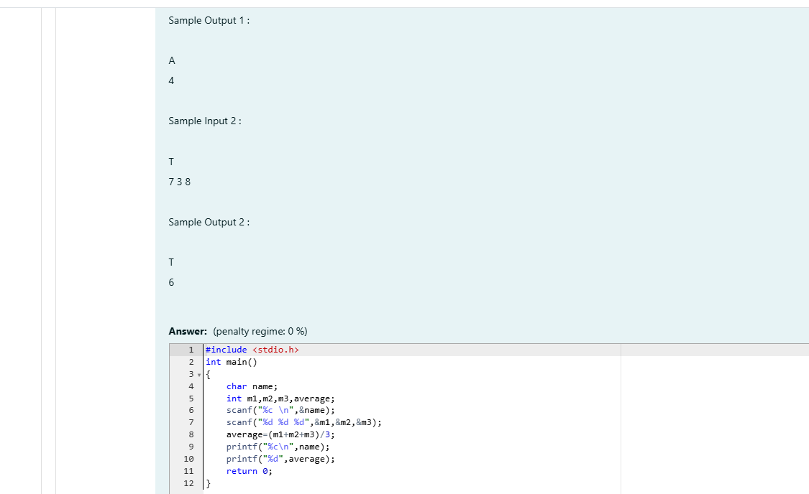

OUTPUT

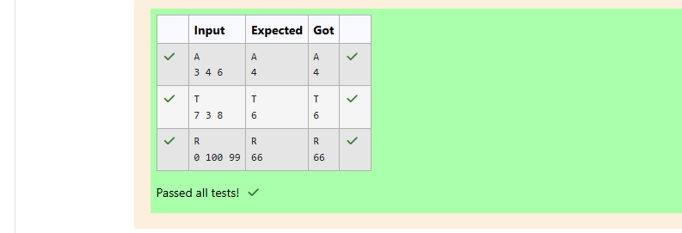

Week 01-02-practice session coding

Reg no : 241801291

Name : TARRUN.B

Q2)

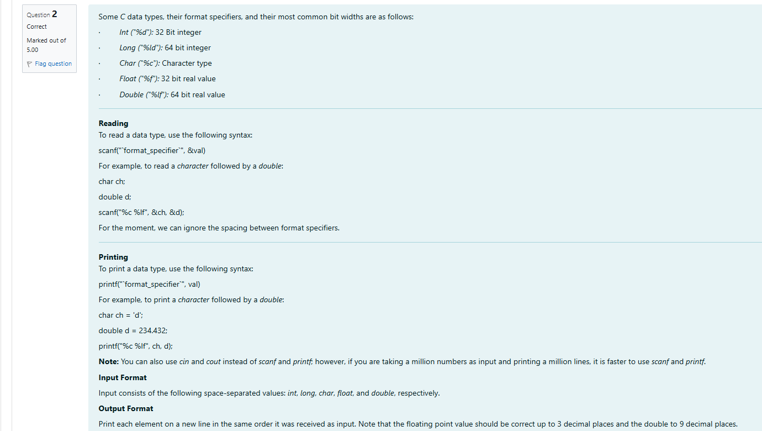

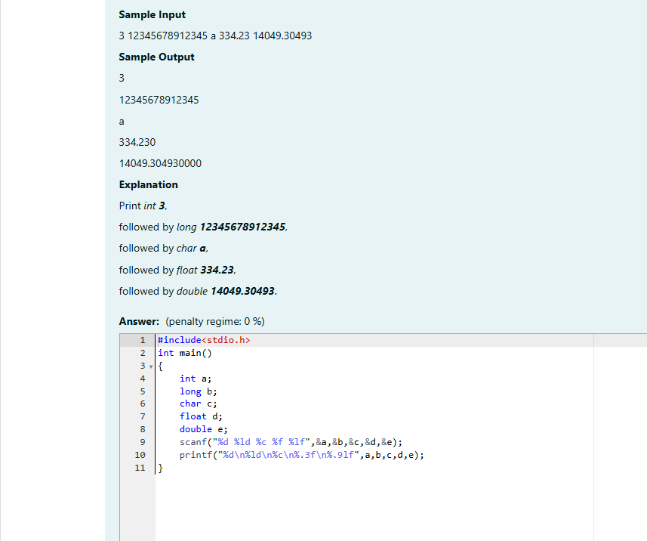

OUTPUT

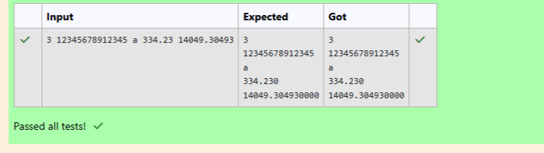

Week 01-02-practice session coding

Reg no : 241801291

Name : TARRUN.B

Q3)

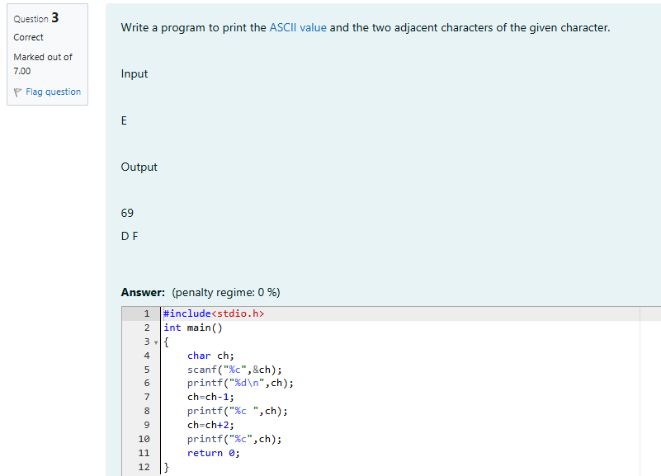

OUTPUT

