Retrieval-Augmented Generation (RAG) and Large Language Models (LLMs) for Enterprise Knowledge Management and Document Automation: A Systematic Literature Review
檢索增強生成（RAG）與大型語言模型（LLM）於企業知識管理與文件自動化之應用：一項系統性文獻回顧
Ehlullah Karakurt & Akhan Akbulut（伊斯坦堡文化大學 資訊工程系）
Applied Sciences, 2026, 16(1), 368.
DOI：10.3390/app16010368
公信力：SCIE收錄．Applied Sciences為Q2期刊（★★★★）．開放取用．系統性文獻回顧（SLR）
▶ 閱讀說明 本版採「逐段中英對照」：每一段英文原文後緊接一個藍框中文譯文。本研讀聚焦核心章節，收錄範圍：摘要、第1節引言、第2節背景與相關工作（2.1至2.4）、第3節研究方法、第4節結果之RQ1至RQ6與RQ9、第5節討論、第6節結論；第4節之RQ7（軟體程式碼指標）與RQ8（最佳技術配置之模型細節）因與本研究主題相關性較低，未納入本次研讀。數據表以中英對照重建呈現，獨特之流程圖、分類圖、熱圖等則裁切自原文嵌入。
羅靜娟 學號714630117

摘要 Abstract
The integration of Retrieval-Augmented Generation (RAG) with Large Language Models (LLMs) is rapidly transforming enterprise knowledge management, yet a comprehensive understanding of their deployment in real-world workflows remains limited. This study presents a systematic literature review (SLR) analyzing 63 high-quality primary studies selected after rigorous screening to evaluate how these technologies address practical enterprise challenges. We formulated nine research questions targeting platforms, datasets, algorithms, and validation metrics to map the current landscape. Our findings reveal that enterprise adoption is largely in the experimental phase: 63.6% of implementations utilize GPT based models, and 80.5% rely on standard retrieval frameworks such as FAISS or Elasticsearch. Critically, this review identifies a significant 'lab-to-market' gap; while retrieval and classification sub-tasks frequently employ academic validation methods like k-fold cross-validation (93.6%), generative evaluation predominantly relies on static hold-out sets due to computational constraints. Furthermore, fewer than 15% of studies address real-time integration challenges required for production scale deployment. By systematically mapping these disparities, this study offers a data-driven perspective and a strategic roadmap for bridging the gap between academic prototypes and robust enterprise applications.
▶ 中文譯文 檢索增強生成（RAG）與大型語言模型（LLM）的結合，正迅速改變企業知識管理的樣貌，然而學界對這些技術在真實工作流程中如何部署，仍缺乏全面的理解。本研究進行一項系統性文獻回顧（SLR），在嚴格篩選後分析63篇高品質原始研究，評估這些技術如何回應企業端的實務挑戰。研究者擬定九個研究問題，涵蓋平台、資料集、演算法與驗證指標，以勾勒當前研究全貌。研究發現指出，企業導入大多仍處於實驗階段：63.6%的實作採用GPT類模型，80.5%仰賴FAISS或Elasticsearch等標準檢索框架。關鍵的是，本回顧辨識出一道明顯的「從實驗室到市場」（lab-to-market）落差；檢索與分類等子任務常採用k折交叉驗證（93.6%）等學術驗證方法，但生成式評估卻因運算成本限制，主要仰賴靜態的保留集（hold-out）。此外，處理正式上線規模部署所需之即時整合挑戰的研究不到15%。本研究透過系統性地標定這些落差，提出一個以數據為本的觀點，以及一條銜接學術原型與穩健企業應用之間落差的策略路線圖。
第一章 引言 1. Introduction
In the era of digital transformation, organizations in all industries are inundated with vast amounts of unstructured information, from technical manuals, regulatory policies, and customer support transcripts to internal wikis and multimedia logs. Businesses, especially in finance and healthcare, must organize, retrieve, and integrate knowledge to comply with regulations, accelerate innovation, and improve customer satisfaction. However, traditional knowledge management systems, which rely on keyword searches or manual categorization, struggle to handle rapidly evolving data or complex queries, as observed in legacy corporate archives. Currently, document automation workflows, including contract generation, report writing, and policy alignment, are hampered by labor-intensive processes, error risks, and reliance on rigid templates.
▶ 中文譯文 在數位轉型的時代，各行各業的組織都被大量非結構化資訊淹沒，從技術手冊、法規政策、客服對話紀錄，到內部維基與多媒體日誌皆是。企業（尤其在金融與醫療領域）必須組織、檢索並整合知識，以符合法規、加速創新並提升顧客滿意度。然而，仰賴關鍵字搜尋或人工分類的傳統知識管理系統，難以處理快速演變的資料或複雜查詢，這在老舊的企業檔案庫中尤為明顯。目前的文件自動化流程，包含合約生成、報告撰寫與政策對齊，仍受制於高度耗費人力的程序、出錯風險，以及對僵化範本的依賴。
Recent advances in LLMs, such as GPT, PaLM, and LLaMA, and open-source counterparts, such as OPT, GPT-NeoX, and BLOOM, have improved natural language understanding and generation. These models excel in generating coherent text, answering queries, summarizing documents, and producing code, but their reliance on fixed training data limits the precision of niche or dynamic topics, often leading to hallucinations. The Retrieval-Augmented Generation (RAG) approach addresses this limitation by integrating real-time knowledge retrieval with LLM generation, anchoring outputs in current domain-specific data. This approach minimizes factual errors and improves accuracy, enabling LLM applications in enterprise tasks such as reviewing legal documents, monitoring regulatory compliance, financial analytics, and automation of technical support.
▶ 中文譯文 近期大型語言模型的進展（如GPT、PaLM、LLaMA，以及OPT、GPT-NeoX、BLOOM等開源模型）大幅提升了自然語言的理解與生成能力。這些模型擅長生成連貫的文字、回答查詢、摘要文件與產出程式碼，但它們對固定訓練資料的依賴，限制了在小眾或動態主題上的準確度，往往導致幻覺（hallucination）。檢索增強生成（RAG）方法透過將即時知識檢索與LLM生成結合，把輸出錨定在當前的領域特定資料上，藉此化解此一限制。此方法能最小化事實性錯誤、提升準確度，使LLM得以應用於審閱法律文件、監控法規遵循、財務分析與技術支援自動化等企業任務。
Despite the potential of RAG + LLM integration, the current literature lacks detailed frameworks for their application in enterprise knowledge management and document automation, particularly in terms of scalability. Critical research questions arise, such as which retrieval indexes, vector databases, or knowledge graph representations are most effective for diverse types of documents, such as contracts or policies. How are LLMs fine-tuned or prompted to integrate retrieved contexts without sacrificing fluency? What evaluation metrics and validation strategies reliably capture generative quality, latency, and factual correctness? This review assesses enterprise scenarios, including contract generation, policy compliance, and customer self-service, to evaluate successful RAG + LLM deployments and identify persistent challenges such as real-time integration and scalability.
▶ 中文譯文 儘管RAG與LLM的整合潛力可觀，現有文獻仍缺乏將其應用於企業知識管理與文件自動化的細緻框架，尤其在可擴展性方面。由此衍生出若干關鍵研究問題，例如：對於合約或政策等不同類型的文件，哪一種檢索索引、向量資料庫或知識圖譜表示法最為有效？如何對LLM進行微調或設計提示，使其整合檢索到的脈絡而又不犧牲流暢度？又有哪些評估指標與驗證策略，能可靠地捕捉生成品質、延遲與事實正確性？本回顧評估了包含合約生成、政策遵循與顧客自助服務在內的企業情境，以檢視成功的RAG與LLM部署，並辨識即時整合與可擴展性等持續存在的挑戰。
To address these gaps, a comprehensive systematic literature review (SLR) of RAG + LLM research was conducted in the context of enterprise knowledge management and document automation, covering publications from 2015 through mid-2025. For this review, six major academic databases were searched: IEEE Xplore, ACM Digital Library, ScienceDirect, SpringerLink, Wiley Online Library, and Google Scholar. The scope of the review was expanded to include both journal articles and conference proceedings. These RQs guided the analysis of 63 studies, structuring the inquiry into platforms, datasets, ML types, specific RAG + LLM algorithms, evaluation metrics, validation techniques, knowledge representation methods, best-performing configurations, and open challenges. After retrieving more than 500 candidate papers, exclusion criteria were applied; a rigorous quality assessment then reduced the pool to 63 high-quality papers.
▶ 中文譯文 為了填補這些缺口，本研究在企業知識管理與文件自動化的脈絡下，對RAG與LLM的相關研究進行了一項全面的系統性文獻回顧（SLR），涵蓋2015年至2025年中的出版品。本回顧檢索了六大學術資料庫：IEEE Xplore、ACM數位圖書館、ScienceDirect、SpringerLink、Wiley線上圖書館與Google Scholar，並將收錄範圍擴大至期刊論文與研討會論文兩者。這些研究問題引導了對63篇研究的分析，將探究結構化為平台、資料集、機器學習類型、特定的RAG與LLM演算法、評估指標、驗證技術、知識表示方法、最佳效能配置與待解挑戰。在檢索逾500篇候選論文後，研究者套用排除準則，再經嚴格的品質評估，將樣本縮減至63篇高品質論文。
The analysis reveals several notable trends. First, enterprise RAG + LLM research has grown dramatically since 2020, with a nearly equal split between journal articles and conference venues. Second, supervised learning remains the dominant paradigm, although emerging work in semi-supervised and unsupervised retrieval shows promise for scenarios with limited labeled data. Third, hybrid architectures combining dense vector retrieval, symbolic knowledge graphs, and prompt LLM tuning are increasingly adopted to balance accuracy, interpretability, and computational efficiency. Fourth, evaluation practices remain heterogeneous: while standard metrics include precision and recall for QA tasks, few studies incorporate end-to-end measures of business impact. Finally, a key challenge lies in maintaining data privacy when integrating LLMs with proprietary corpora, while optimizing latency for real-time applications and developing robust methods to detect and mitigate hallucinations.
▶ 中文譯文 分析揭示出幾項值得注意的趨勢。第一，企業RAG與LLM的研究自2020年起急遽成長，期刊論文與研討會論文的數量幾乎各半。第二，監督式學習仍是主導範式，不過半監督與非監督檢索的新興研究，對於標註資料有限的情境展現出潛力。第三，結合密集向量檢索、符號式知識圖譜與LLM提示微調的混合架構日益普及，以在準確度、可解釋性與運算效率之間取得平衡。第四，評估實務仍相當分歧：問答任務雖普遍採用正確率與召回率等標準指標，但鮮少研究納入端到端的商業影響衡量。最後，一項關鍵挑戰在於：當把LLM與專屬語料整合時如何維護資料隱私，同時又要為即時應用優化延遲，並發展穩健的方法來偵測與緩解幻覺。
第二章 背景與相關工作 2. Background and Related Work
This section outlines the technical scope of Retrieval-Augmented Generation (RAG) within enterprise settings and positions this review against existing surveys. We focus specifically on the transition from generic Large Language Models (LLMs) to grounded, domain-specific architectures suitable for corporate knowledge management (KM) and document automation.
▶ 中文譯文 本節勾勒檢索增強生成（RAG）在企業情境中的技術範疇，並將本回顧定位於既有綜述之間。研究者特別聚焦於從通用型大型語言模型（LLM），過渡到適合企業知識管理（KM）與文件自動化、且具事實依據的領域特定架構此一轉變。
2.1 企業情境中的檢索增強生成 2.1. Retrieval-Augmented Generation in Enterprise Contexts
While Large Language Models (LLMs) demonstrate impressive fluency, their application in enterprise environments is hindered by hallucinations, lack of domain-specific knowledge, and static training cutoffs. RAG addresses these limitations by decoupling the knowledge base from the model weights, allowing the generative component to access up-to-date, proprietary information via a retrieval mechanism.
▶ 中文譯文 大型語言模型雖展現出令人印象深刻的流暢度，但其在企業環境中的應用，仍受幻覺、缺乏領域特定知識，以及訓練資料時間截斷等問題所阻。RAG透過將知識庫與模型權重解耦，讓生成元件得以經由檢索機制取得最新的專屬資訊，藉此化解這些限制。
In a typical enterprise RAG architecture, a retriever identifies relevant document chunks (via dense vector similarity or sparse keyword matching) from a corporate corpus, which are then fed into the LLM context window for grounded generation. Unlike standard academic benchmarks, enterprise implementations often employ hybrid indexing strategies, combining dense embeddings with symbolic Knowledge Graphs (KGs), to ensure the high precision and auditability required for regulated industries.
▶ 中文譯文 在典型的企業RAG架構中，檢索器會從企業語料庫中（透過密集向量相似度或稀疏關鍵字比對）找出相關的文件片段，再將其送入LLM的脈絡視窗，以進行有事實依據的生成。與標準學術基準不同，企業端的實作常採用混合索引策略，把密集嵌入與符號式知識圖譜（KG）結合，以確保受監管產業所要求的高精準度與可稽核性。
2.2 企業應用：知識管理與文件自動化 2.2. Enterprise Applications: KM and Document Automation
Traditional enterprise KM systems rely on rigid taxonomies and keyword search, which struggle to scale with unstructured data volume. Similarly, legacy document automation depends on brittle, rule-based templates. RAG+LLM architectures bridge this gap by enabling semantic search and context-aware content generation. As detailed in Table 1, our review of 63 primary studies identifies six core application domains. The majority of research focuses on regulatory compliance (26.0%) and contract automation (23.4%), reflecting the high value of automating labor-intensive, text-heavy workflows.
▶ 中文譯文 傳統企業知識管理系統仰賴僵化的分類體系與關鍵字搜尋，難以隨非結構化資料量擴充。同樣地，舊式文件自動化也依賴脆弱的規則式範本。RAG與LLM架構藉由實現語意搜尋與情境感知的內容生成，銜接了這道落差。如表1所示，本研究對63篇原始研究的回顧辨識出六個核心應用領域。多數研究聚焦於法規遵循（26.0%）與合約自動化（23.4%），反映出將高度耗費人力、文字密集的工作流程自動化所具有的高價值。
表1 各知識管理領域之研究分布 Table 1. Distribution of studies by knowledge management domain.
應用領域 Domain | 論文數 # Papers | 百分比 %
法規遵循與治理 Regulatory compliance | 16 | 25.4%
合約與法律文件自動化 Contract automation | 15 | 23.8%
客服聊天機器人 Customer support chatbots | 12 | 19.0%
技術手冊生成 Technical manual generation | 10 | 15.9%
財務報告分析 Financial reporting | 7 | 11.1%
醫療文件 Healthcare documentation | 3 | 4.8%
合計 Total | 63 | 100%

2.3 RAG企業價值鏈框架 2.3. The RAG–Enterprise Value Chain Framework
To structure the analysis of these diverse applications, we propose the RAG–Enterprise Value Chain (Table 2). This conceptual framework maps the technical components of RAG systems to the specific Research Questions (RQs) of this study, providing a standardized perspective for evaluating solutions from raw data input to measurable business impact.
▶ 中文譯文 為了結構化地分析這些多元應用，研究者提出「RAG企業價值鏈」（表2）。此一概念框架將RAG系統的技術元件對應到本研究的特定研究問題（RQ），提供一個標準化的視角，用以評估從原始資料輸入到可衡量商業影響的整套解決方案。
表2 RAG企業價值鏈：將RAG與LLM階段對應至研究問題 Table 2. The RAG–Enterprise Value Chain.
階段 Stage | 對應研究問題 Key RQ | 說明 Description
1. 輸入 Input | RQ1平台、RQ2資料集 | 界定專屬資料來源與基礎設施限制
2. 檢索 Retrieval | RQ3範式、RQ4架構 | 索引策略（密集對稀疏）與擷取企業脈絡的檢索機制
3. 生成 Generation | RQ8最佳配置 | 以特定LLM骨幹與提示策略合成輸出
4. 驗證 Validation | RQ5指標、RQ6驗證 | 部署前的技術品質檢查（事實性、延遲、來源可追溯）
5. 商業影響 Business Impact | RQ9挑戰、RQ5商業指標 | 衡量超越學術指標的營運效益（投資報酬、節省工時）

2.4 與既有回顧的區隔 2.4. Differentiation from Existing Reviews
Although RAG is a rapidly evolving field, existing surveys predominantly focus on general architectural taxonomies or creative content generation. As summarized in Table 3, current reviews lack a dedicated focus on the specific constraints of Enterprise Knowledge Management and Document Automation. This study fills that gap by systematically analyzing the 'lab-to-market' transition, specifically addressing privacy, latency, and business value verification in corporate environments.
▶ 中文譯文 儘管RAG是一個快速演進的領域，現有的綜述大多聚焦於一般性的架構分類，或創意內容生成。如表3所摘要，當前的回顧缺乏對「企業知識管理與文件自動化」此一特定限制的專門關注。本研究透過系統性地分析「從實驗室到市場」的過渡，特別針對企業環境中的隱私、延遲與商業價值驗證，來填補這道缺口。
表3 既有RAG與LLM回顧文獻 Table 3. Prior reviews on RAG and LLMs.
作者 | 年份範圍 | 論文數 | 關注焦點
Gao et al. (2023) | 2020–2023 | 45 | RAG方法與演進綜述
Zhao et al. (2024) | 2021–2024 | 38 | RAG全面綜述
Susnjak et al. (2024) | 2021–2024 | 27 | RAG用於自動化系統性回顧
Chen et al. (2024) | 2022–2024 | 30 | RAG中的LLM基準測試
Mialon et al. (2023) | 2020–2023 | 52 | 增強型語言模型綜述
Ji et al. (2023) | 2019–2023 | 47 | 自然語言生成的幻覺綜述

第三章 研究方法 3. Research Methodology
In this section, the systematic review methodology (SLR) was used to provide a rigorous and reproducible investigation of Retrieval-Augmented Generation (RAG) and Large Language Models (LLMs) in the context of enterprise knowledge management and document automation. This method involves three main stages: planning, conducting and reporting the review. Each stage incorporates specific protocols designed to minimize bias and improve transparency throughout the research process. During the planning phase, nine specific research questions were formulated to guide this investigation and address issues such as data sources, algorithmic approaches, evaluation criteria, and practical challenges. The questions were then translated into precise Boolean search strings.
▶ 中文譯文 本節採用系統性回顧方法（SLR），對企業知識管理與文件自動化脈絡下的檢索增強生成（RAG）與大型語言模型（LLM）進行嚴謹且可重現的探究。此方法包含三個主要階段：規劃、執行與報告回顧。每個階段都納入特定的協定，以在整個研究過程中最小化偏誤並提升透明度。在規劃階段，研究者擬定九個具體的研究問題以引導探究，處理資料來源、演算法取向、評估準則與實務挑戰等議題，再將這些問題轉譯為精確的布林檢索字串。
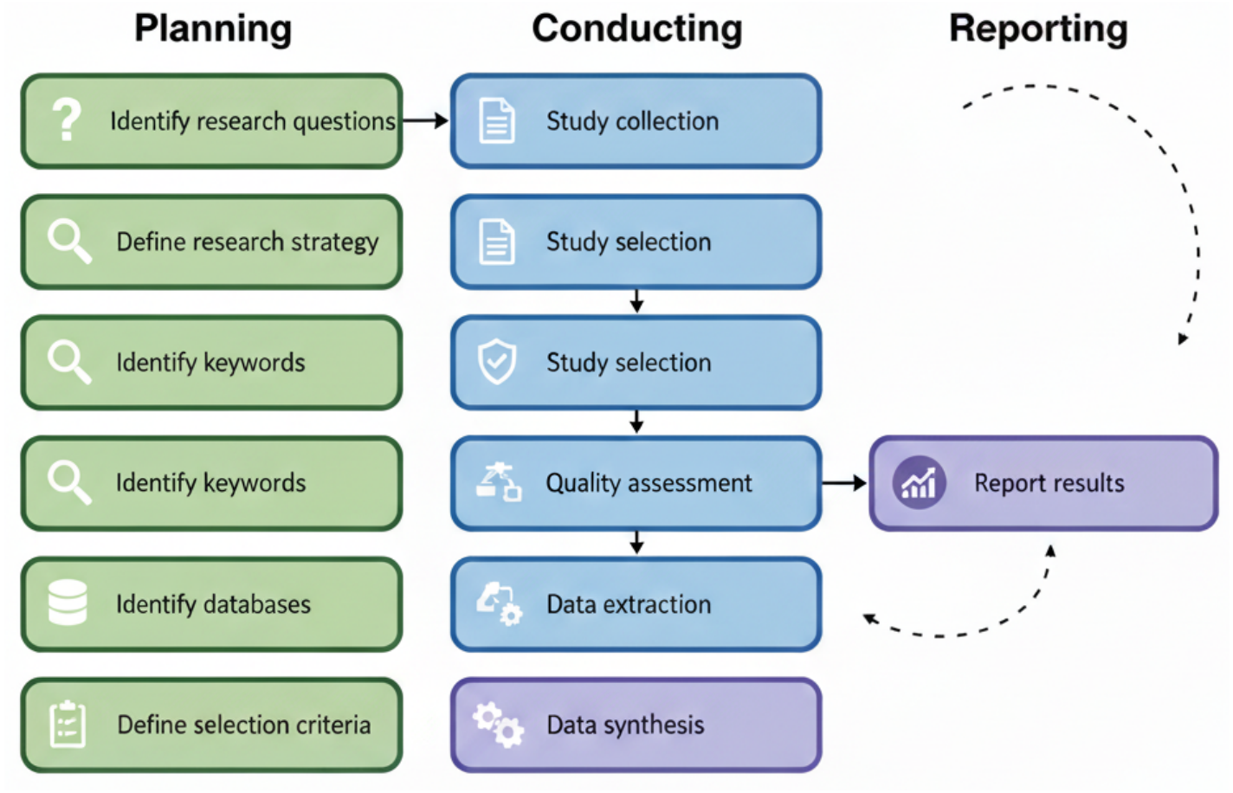
Figure 1. Systematic literature review process.
圖1 系統性文獻回顧流程（規劃→執行→報告三階段）
By exclusively selecting peer-reviewed English language studies with empirical results and detailed descriptions of the RAG + LLM method, a transparent and reproducible process was established that ensured the reliability of subsequent synthesis and analysis. The nine research questions (RQ1–RQ9) address: platforms used; datasets used; types of machine learning employed; specific RAG architectures and LLM algorithms applied; evaluation metrics used to assess performance; validation approaches adopted; knowledge and software metrics utilized; configurations achieving the best performance; and the main practical challenges, limitations, and research gaps.
▶ 中文譯文 研究者僅選取經同儕審查、以英文撰寫、具實證結果且對RAG與LLM方法有詳細描述的研究，藉此建立一套透明且可重現的流程，確保後續綜整與分析的可靠性。九個研究問題（RQ1至RQ9）分別處理：所採用的平台；所使用的資料集；採用的機器學習類型；應用的特定RAG架構與LLM演算法；用以評估效能的評估指標；採用的驗證方法；運用的知識與軟體指標；達到最佳效能的配置；以及主要的實務挑戰、限制與研究缺口。
A search was carried out on six academic databases (IEEE Xplore, ScienceDirect, ACM Digital Library, Wiley Online Library, SpringerLink, and Google Scholar) between 2015 and 2025. The searches were finalized on 15 June 2025. To eliminate irrelevant results, a set of exclusion criteria was applied: excluding non-English articles, abstract-only entries, non-empirical studies, and works that lacked a detailed explanation of RAG or LLM methodologies. The Boolean search string combined terms for Retrieval Augmented Generation, Large Language Model, and Knowledge Management or Document Automation or Enterprise.
▶ 中文譯文 研究者於2015年至2025年間，在六大學術資料庫（IEEE Xplore、ScienceDirect、ACM數位圖書館、Wiley線上圖書館、SpringerLink與Google Scholar）進行檢索，並於2025年6月15日截止。為剔除不相關的結果，研究者套用一組排除準則：排除非英文文章、僅有摘要者、非實證研究，以及未詳細說明RAG或LLM方法的作品。布林檢索字串結合了「檢索增強生成」、「大型語言模型」，以及「知識管理」或「文件自動化」或「企業」等詞彙。
表4 各資料庫的檢索字串與時間範圍 Table 4. Search strings and temporal scope across databases.
資料庫 Database | 檢索字串／策略 Search String | 範圍 Scope
IEEE Xplore | （RAG）AND（企業 OR 文件自動化） | 2015–2025
ACM Digital Library | 檢索增強生成 AND 知識管理 | 2015–2025
ScienceDirect | RAG AND 大型語言模型 AND 企業 | 2015–2025
SpringerLink | 檢索增強生成 AND 企業 | 2015–2025
Wiley Online | RAG AND 文件自動化 | 2015–2025
Google Scholar | 檢索增強生成 AND 企業知識管理（前100筆相關結果） | 2020–2025

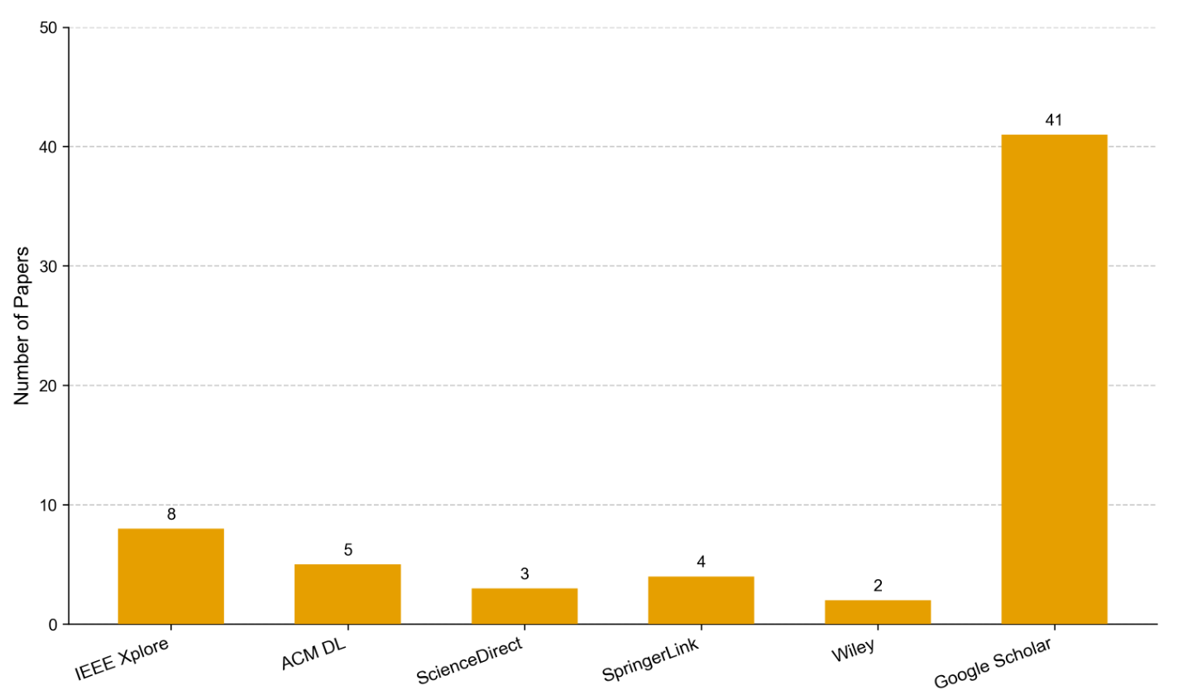
Figure 2. Distribution of selected papers after each screening stage.
圖2 各篩選階段後的論文分布（多數高影響力研究經Google Scholar取得）
Once the exclusion criteria were enforced, the remaining articles were subjected to an eight-question quality assessment. Any paper scoring less than 10 out of 16 was removed. Each 'yes' earned 2 points, 'partial' earned 1 point, and 'no' earned 0 points. The quality questions assessed whether the aims, scope, proposed solution, variables, research process, coverage of research questions, transparency of negative findings, and clarity of main findings were adequately declared and validated.
▶ 中文譯文 在套用排除準則後，剩餘文章須接受八題式的品質評估。任何在16分中得分低於10分的論文皆被剔除。每個「是」得2分、「部分」得1分、「否」得0分。品質題目評估的面向包括：研究目的、範疇、所提解決方案、變項、研究流程、是否涵蓋所有研究問題、是否透明報告負面發現，以及主要發現是否清楚陳述並經驗證。
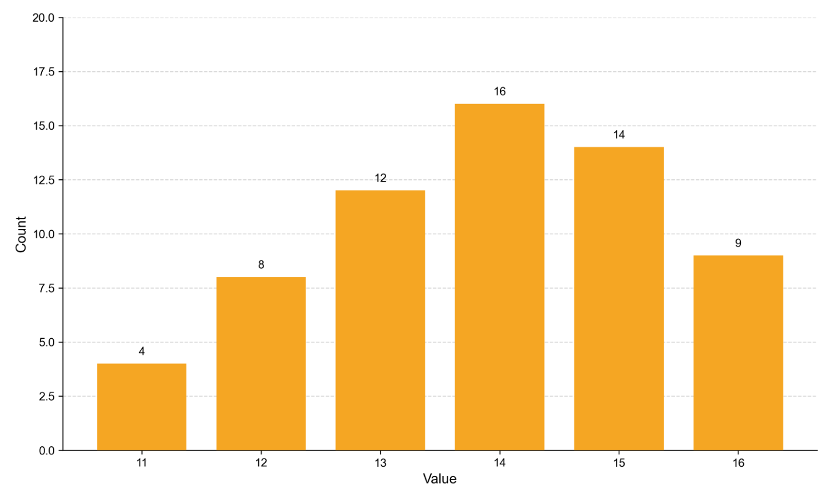
Figure 3. Quality score distribution of the selected papers (scores 11–16).
圖3 入選論文的品質分數分布（分數介於11至16之間）
Figure 4 illustrates the temporal distribution of the selected studies, showing a sharp increase in RAG + LLM research since 2020. The selected publications slightly favor conference proceedings (58.4%) over journal articles (41.6%), which is typical for a fast-moving field like RAG. To ensure the reliability of the quantitative analysis, a dual-coding procedure was employed: both authors independently screened titles and abstracts, and discrepancies in classification were resolved through consensus meetings. Foundational papers describing generic model architectures (e.g., BERT, Transformer) were treated as background literature and excluded from the statistical analysis of primary RAG applications.
▶ 中文譯文 圖4呈現入選研究的時間分布，顯示RAG與LLM研究自2020年起急遽增加。入選出版品略為偏向研討會論文（58.4%）多於期刊論文（41.6%），這對RAG這類快速演進的領域而言相當典型。為確保量化分析的可靠性，研究者採用雙重編碼程序：兩位作者各自獨立篩選標題與摘要，分類上的歧異則透過共識會議解決。描述通用型模型架構（如BERT、Transformer）的奠基性論文，被視為背景文獻，並排除於主要RAG應用的統計分析之外。
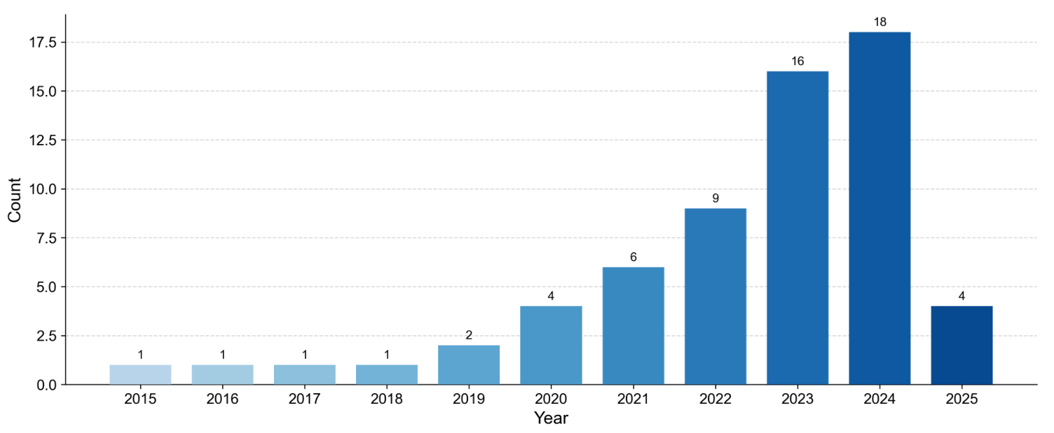
Figure 4. Selected publications per year (2015–2025).
圖4 各年度入選論文數（2015至2025）
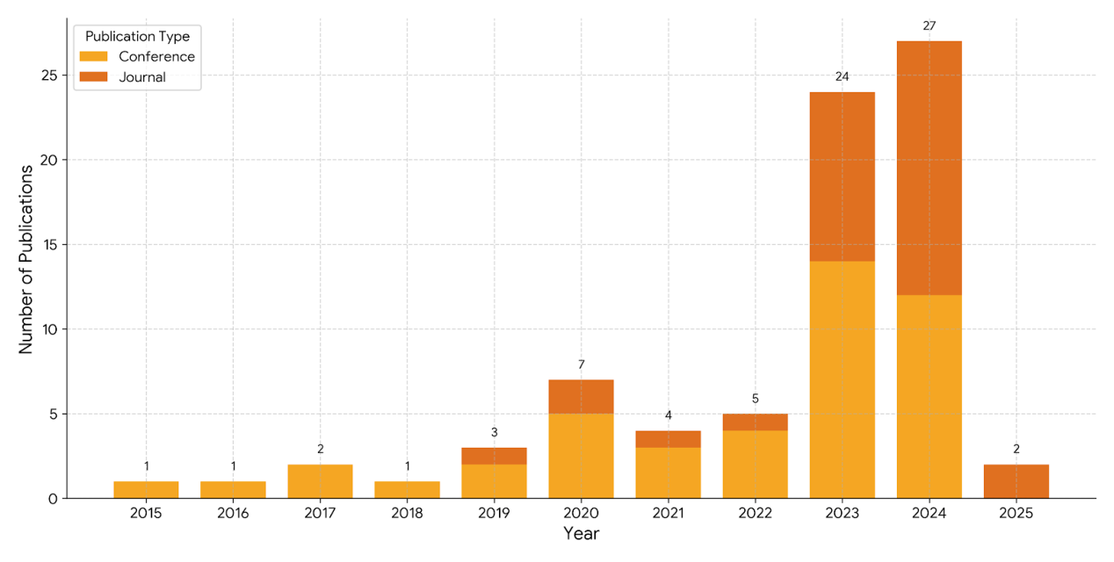
Figure 5. Distribution of publication types (journal vs. conference).
圖5 出版類型分布（期刊與研討會）
第四章 結果 4. Results
In this section, the responses to each research question are explained. Figure 6 shows the thematic taxonomy of the RAG + LLM components under review, visualizing the architectural and conceptual relationships resulting from classical machine learning methods to modern variants of RAG.
▶ 中文譯文 本節說明對各研究問題的回應。圖6呈現所回顧之RAG與LLM元件的主題分類，視覺化從古典機器學習方法到現代RAG變體之間的架構與概念關係。
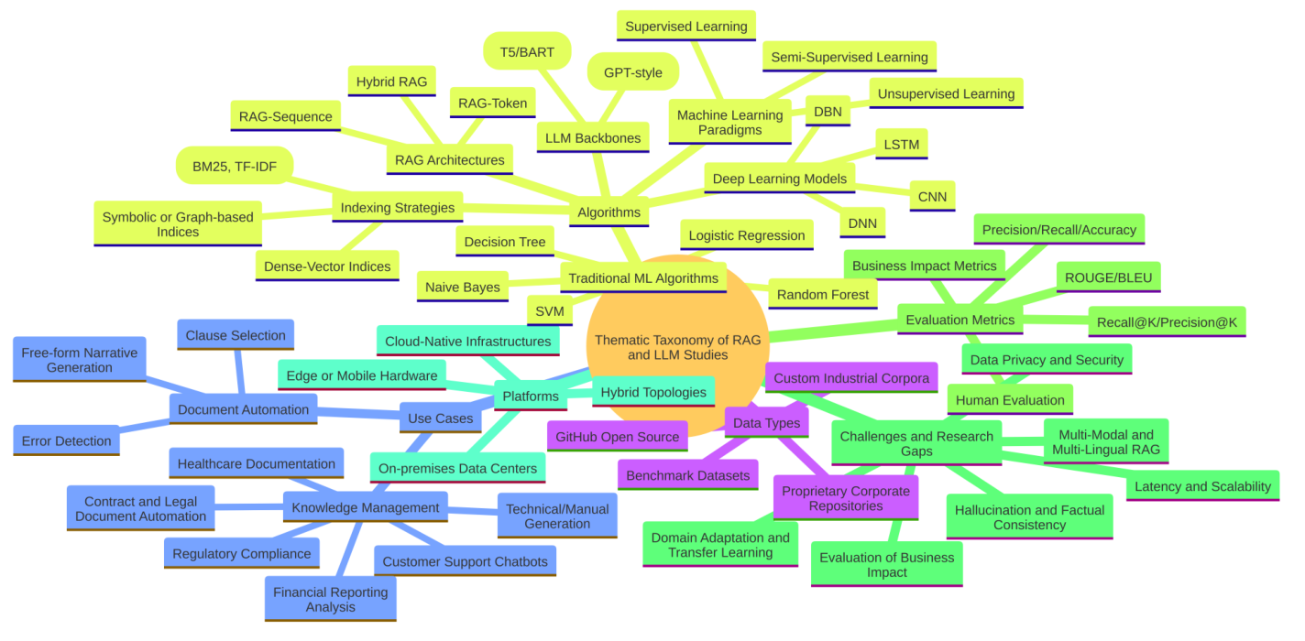
Figure 6. Thematic taxonomy of RAG and LLM components.
圖6 RAG與LLM元件的主題分類：學習範式、索引策略、模型骨幹與應用領域之間的關係
4.1 RQ1：所採用的平台 4.1. RQ1: Platforms Addressed
Research Question 1 examines the computational and deployment infrastructures used for enterprise-level RAG + LLM systems. Findings indicate that a significant majority (66.2%) of studies favor cloud-based infrastructures that leverage managed vector services and virtually unlimited GPU/TPU resources for flexible scaling. On-premises deployments (19.5%) locate model inference and retrieval indices within corporate data centers to ensure data sovereignty and regulatory compliance. A notable subset (10.4%) explores edge computing scenarios, enabling personalized LLMs running on-device for low latency and offline operation. Finally, hybrid schemes (3.9%) divide workloads between cloud and dedicated/edge infrastructures to balance privacy, responsiveness, and cost efficiency.
▶ 中文譯文 研究問題一檢視企業級RAG與LLM系統所使用的運算與部署基礎設施。研究發現指出，相當高比例（66.2%）的研究偏好雲端基礎設施，藉以運用受管理的向量服務，以及近乎無限的GPU／TPU資源來彈性擴充。地端（on-premises）部署（19.5%）則把模型推論與檢索索引置於企業資料中心內，以確保資料主權與法規遵循。另有值得注意的一小部分（10.4%）探索邊緣運算情境，讓個人化LLM在裝置端運行，以達成低延遲與離線運作。最後，混合方案（3.9%）將工作負載在雲端與專用／邊緣基礎設施之間分配，以在隱私、回應速度與成本效率之間取得平衡。
表6 平台拓樸分布 Table 6. Distribution of platform topologies.
平台類別 Platform | 研究數 # | 百分比 %
雲端原生基礎設施 Cloud-native | 42 | 66.7%
地端資料中心 On-premises | 12 | 19.0%
邊緣或行動硬體 Edge/mobile | 7 | 11.1%
混合拓樸 Hybrid | 2 | 3.2%

4.2 RQ2：資料集來源 4.2. RQ2: Dataset Sources
Findings indicate that open-source GitHub repositories were the primary data source in 54.5% of studies. This widespread use is enabled by diverse codebases, documentation, and issue trackers. However, reliance on public corpora introduces risks for enterprise transferability: models trained solely on general purpose resources are prone to domain shift and may fail to generalize to sensitive enterprise contexts. A further 13.0% uses established academic benchmarks (such as MS MARCO for retrieval, and SQuAD, Natural Questions, HotpotQA, and TriviaQA for question answering). In 16.9% of studies, custom industrial corpora were assembled, while 15.6% leveraged proprietary repositories via on-premises RAG pipelines to satisfy data sovereignty.
▶ 中文譯文 研究發現指出，開源的GitHub儲存庫是54.5%研究的主要資料來源。其廣泛使用，得益於多元的程式碼庫、文件與問題追蹤系統。然而，仰賴公開語料會對企業可移轉性帶來風險：僅以通用資源訓練的模型容易發生領域偏移（domain shift），可能無法泛化到敏感的企業情境。另有13.0%採用既有的學術基準（如用於檢索的MS MARCO，以及用於問答的SQuAD、Natural Questions、HotpotQA與TriviaQA）。16.9%的研究自建客製化的產業語料，另有15.6%則透過地端RAG管線運用專屬儲存庫，以滿足資料主權需求。
表7 資料集類別分布 Table 7. Distribution of dataset categories.
資料集類別 Category | 研究數 # | 百分比 %
GitHub開源 GitHub open-source | 34 | 54.0%
客製化產業語料 Custom industrial | 11 | 17.4%
專屬儲存庫 Proprietary repos | 10 | 15.9%
學術基準資料集 Benchmarks | 8 | 12.7%

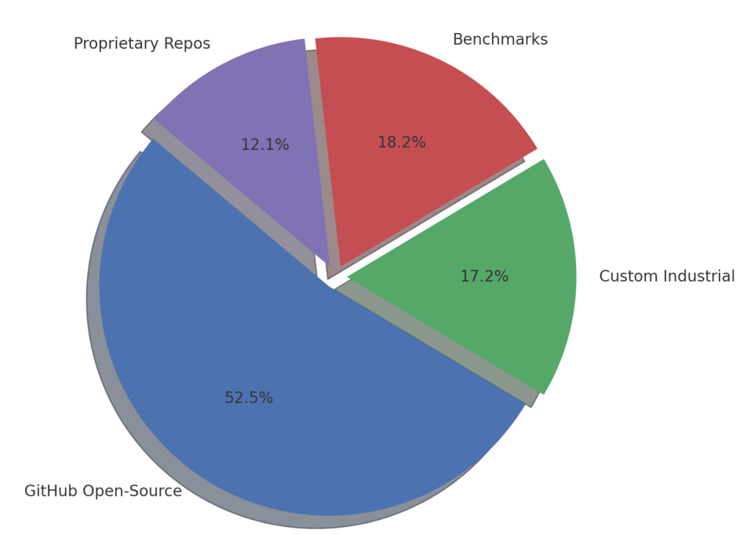
Figure 7. Proportional distribution of dataset sources.
圖7 資料集來源的比例分布
4.3 RQ3：所採用的機器學習範式 4.3. RQ3: Machine Learning Paradigms Employed
A review of 63 studies shows an overwhelming preference for supervised learning when combining RAG and LLM in enterprise contexts. Supervised approaches dominate (92.2%), with most experiments leveraging labeled query–response pairs, defect annotations, or classification labels to train retrieval rankers and fine tune LLMs. A very small portion of studies investigate unsupervised (3.9%) or semi-supervised (3.9%) paradigms. This points to research opportunities in low-label or zero-shot enterprise scenarios. This strong trend toward supervised learning reflects the availability of annotated enterprise data.
▶ 中文譯文 對63篇研究的回顧顯示，在企業情境中結合RAG與LLM時，研究者對監督式學習有壓倒性的偏好。監督式取向居主導地位（92.2%），多數實驗運用已標註的查詢與回應配對、缺陷標註或分類標籤，來訓練檢索排序器並微調LLM。僅有極小部分的研究探討非監督（3.9%）或半監督（3.9%）範式。這指向低標註或零樣本（zero-shot）企業情境中的研究機會。此一明顯偏向監督式學習的趨勢，反映了已標註企業資料的可得性。
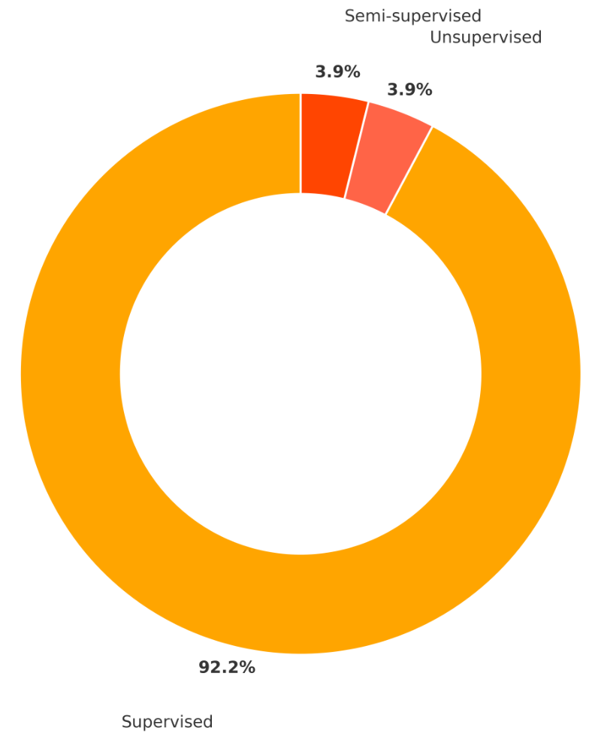
Figure 8. Distribution of machine learning paradigms.
圖8 機器學習範式分布（監督式92.2%、非監督3.9%、半監督3.9%）
4.4 RQ4：所應用的機器學習與RAG架構 4.4. RQ4: ML and RAG Architectures Applied
The synthesis reveals a technological landscape where traditional machine learning algorithms serve as robust baselines, while modern Transformer-based RAG architectures drive the core generative capabilities. Naïve Bayes, SVM, and Logistic Regression are frequently cited, but a qualitative analysis indicates they are primarily employed as baselines for performance comparison or for auxiliary tasks such as intent classification and retrieval re-ranking, rather than as the primary generative engine.
▶ 中文譯文 綜整結果揭示出一種技術圖景：傳統機器學習演算法扮演穩健的基準線，而現代以Transformer為基礎的RAG架構則驅動核心的生成能力。Naïve Bayes、SVM與邏輯斯迴歸雖被頻繁引用，但質性分析顯示它們主要被用作效能比較的基準線，或用於意圖分類、檢索重排序等輔助任務，而非作為主要的生成引擎。
Regarding RAG Architectures, RAG Sequence is the most common approach (46.8%), followed by RAG Token (36.4%). Emerging Hybrid RAG designs (23.4%) attempt to combine the strengths of both. In terms of Retrieval and Indexing, dense vector retrieval is the dominant standard (80.5%), utilizing libraries like FAISS or Annoy. However, purely dense retrieval is often augmented by sparse filtering (e.g., BM25) (55%) or Knowledge Graph lookups (24%) to handle domain-specific terminology.
▶ 中文譯文 在RAG架構方面，RAG Sequence是最常見的取向（46.8%），其次是RAG Token（36.4%）。新興的混合式RAG設計（23.4%）則嘗試結合兩者的優勢。在檢索與索引方面，密集向量檢索是主導的標準（80.5%），運用FAISS或Annoy等函式庫。然而，純粹的密集檢索往往會再以稀疏過濾（如BM25，佔55%）或知識圖譜查找（24%）加以強化，以處理領域特定的術語。
表9 演算法、RAG架構與索引策略的分類與出現次數 Table 9. Taxonomy and frequency of algorithms, architectures, indexing.
類別 Category | 具體演算法／架構 | 次數 #
傳統機器學習（基準） | Naïve Bayes(26), SVM(22), 邏輯斯迴歸(19), 決策樹(18), 隨機森林(15)… | 121
深度學習模型 | LSTM(3), DNN(2), CNN(2), DBN(1) | 8
RAG架構 | RAG Sequence(36), RAG Token(28), Hybrid RAG(18) | 82
檢索與索引 | 密集向量FAISS/Annoy(62), BM25/TF-IDF(45), 知識圖譜(20) | 127

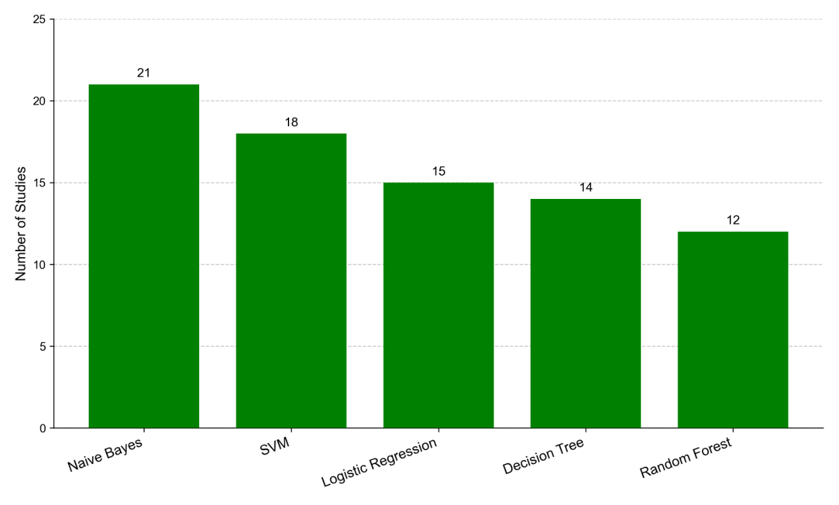
Figure 9. Frequency of the top five ML algorithms used as baselines.
圖9 最常作為基準線／分類器的前五大機器學習演算法出現頻率
4.5 RQ5：所採用的評估指標 4.5. RQ5: Evaluation Metrics Employed
The vast majority of studies rely on classical classification metrics (precision, recall, accuracy) to evaluate retrieval and error prediction components (80.5%). Specifically, Recall@K/Precision@K (72.7%), which measure relevance within the top K results for retrieval tasks, and ROUGE/BLEU (44.2%) for generation tasks are frequently reported. However, these automated scores may not fully capture the factual correctness that is critical in enterprise narratives. In contrast, more holistic approaches to evaluating real-world usability are rare: only 19.5% of studies included human judgments, and just 15.6% measured tangible business impact outcomes.
▶ 中文譯文 絕大多數研究仰賴古典的分類指標（正確率、召回率、準確率）來評估檢索與錯誤預測元件（80.5%）。具體而言，衡量檢索任務前K個結果相關性的Recall@K／Precision@K（72.7%），以及用於生成任務的ROUGE／BLEU（44.2%），是最常被報告的指標。然而，這些自動化分數未必能完整捕捉企業敘事中至關重要的事實正確性。相較之下，以更整體性的方式評估真實世界可用性的做法則相當罕見：僅19.5%的研究納入人工判斷，更只有15.6%衡量了具體的商業影響成果。
表10 評估指標類別分布 Table 10. Distribution of metric categories.
指標類別 Metric | 研究數 # | 百分比 %
正確率／召回率／準確率 Precision/Recall/Acc | 51 | 81.0%
Recall@K／Precision@K | 46 | 73.0%
ROUGE／BLEU | 28 | 44.4%
人工評估 Human Evaluation | 12 | 19.0%
商業影響指標 Business Impact | 10 | 15.9%

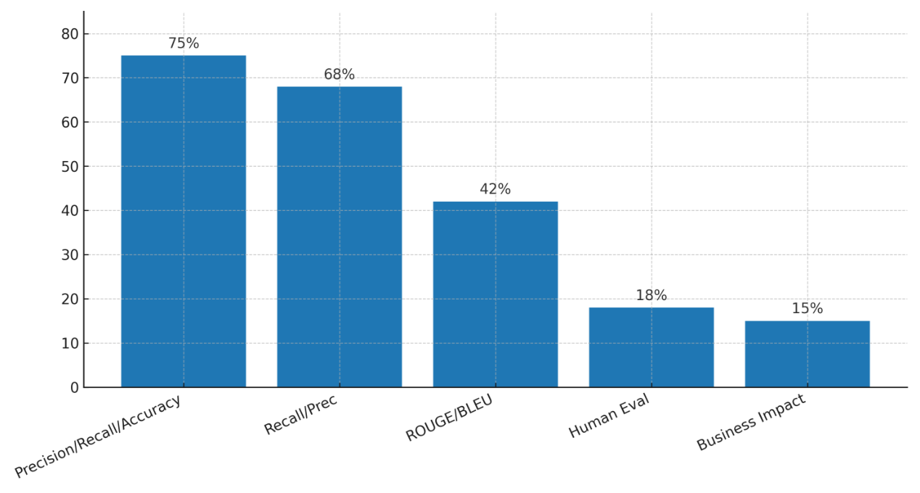
Figure 10. Proportions of studies using each evaluation metric category.
圖10 採用各評估指標類別的研究比例（n=63）
4.6 RQ6：所採用的驗證方法 4.6. RQ6: Validation Approaches Adopted
The findings show that a significant portion of studies (93.6%) employ k-fold cross-validation, predominantly for evaluating retrieval modules and auxiliary classification tasks where classical ML algorithms are used. In contrast, due to the high computational cost of fine-tuning and inference, the generative LLM components are almost exclusively evaluated using a Hold-out Split strategy. Only 13% of the articles reported real world case studies or field trials deploying RAG + LLM prototypes in live corporate environments to measure end-user impact. While k-fold provides statistical reliability, it can overestimate performance when data are not independently and identically distributed.
▶ 中文譯文 研究發現顯示，相當比例的研究（93.6%）採用k折交叉驗證，主要用於評估檢索模組，以及使用古典機器學習演算法的輔助分類任務。相較之下，由於微調與推論的運算成本高昂，生成式LLM元件幾乎一律以保留集分割（Hold-out Split）策略進行評估。僅有13%的文章報告了真實世界的案例研究或實地試驗，亦即在運作中的企業環境部署RAG與LLM原型，以衡量終端使用者的影響。k折交叉驗證雖提供統計上的可靠性，但當資料並非獨立且同分布時，可能會高估效能。
表11 驗證方法分布 Table 11. Distribution of validation methods.
驗證方法 Method | 研究數 # | 百分比 %
k折交叉驗證 k-fold CV | 59 | 93.6%
保留集分割 Hold-out Split | 16 | 25.4%
真實世界案例研究 Real-world Case Study | 8 | 12.7%

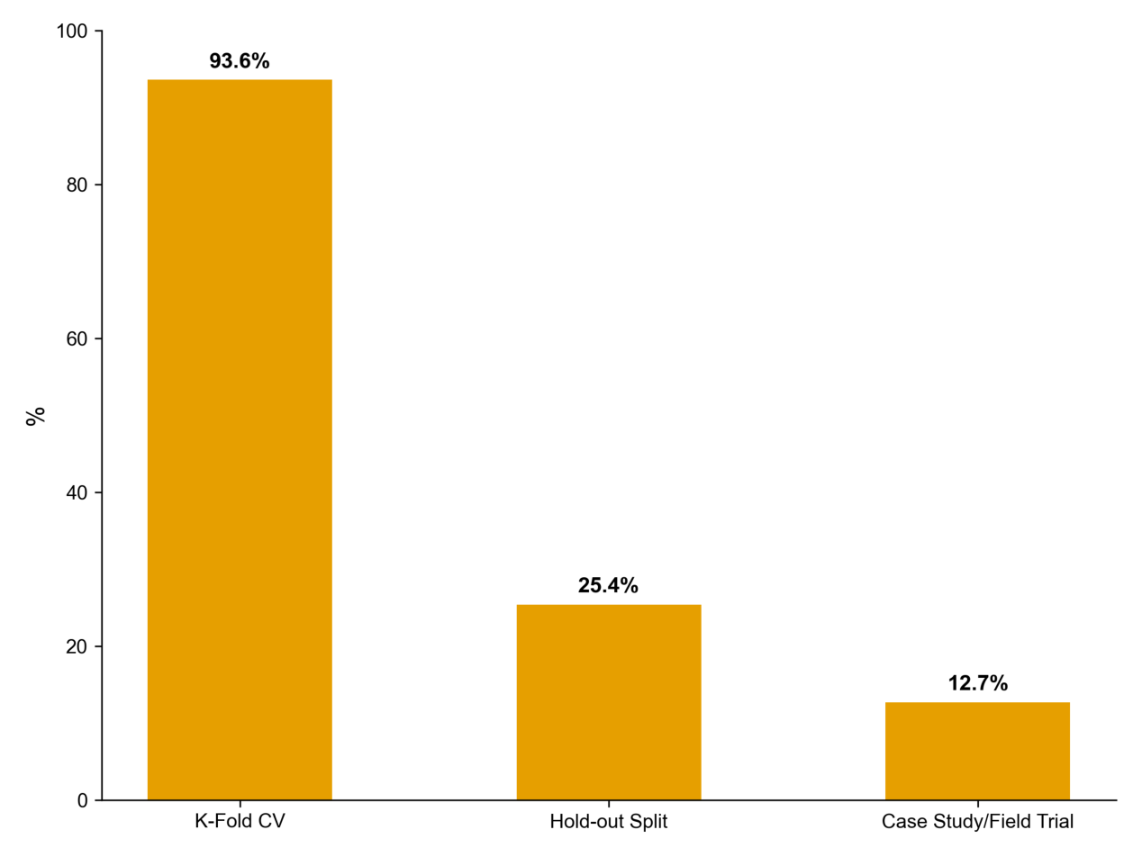
Figure 11. Distribution of validation approaches across 63 studies.
圖11 63篇企業RAG與LLM研究的驗證方法分布
（研讀範圍說明）原文第4.7節RQ7「軟體指標」與第4.8節RQ8「最佳效能配置」涉及物件導向程式碼指標與BART／T5等模型實作細節，與本研究「檢索成效比較」主題相關性較低，未納入本次逐段研讀。以下續接第4.9節RQ9「挑戰與研究缺口」，此節與本研究定位最為相關。
4.9 RQ9：挑戰與研究缺口 4.9. RQ9: Challenges and Research Gaps
Despite the rapid advances in RAG + LLM for enterprise knowledge management and document automation, the synthesis of 63 high-quality studies reveals five recurring challenges. Hallucination and factual consistency is the most cited (47.6%), followed by data privacy and security (38.1%), latency and scalability (31.7%), domain adaptation and transfer learning (23.8%), and difficulty in measuring business impact (15.9%). Holistic evaluation frameworks remain rare; there is a need for standardized benchmarks that incorporate user satisfaction, process efficiency, and compliance metrics alongside traditional precision/recall and ROUGE/BLEU.
▶ 中文譯文 儘管RAG與LLM在企業知識管理與文件自動化上進展迅速，對63篇高品質研究的綜整仍揭示出五項反覆出現的挑戰。被引用最多的是幻覺與事實一致性（47.6%），其次依序為資料隱私與安全（38.1%）、延遲與可擴展性（31.7%）、領域適應與遷移學習（23.8%），以及商業影響難以衡量（15.9%）。整體性的評估框架仍屬罕見；學界需要標準化的基準，能在傳統的正確率／召回率與ROUGE／BLEU之外，一併納入使用者滿意度、流程效率與法規遵循等指標。
表13 企業RAG與LLM研究中的挑戰分布 Table 13. Distribution of challenges in enterprise RAG + LLM studies.
挑戰 Challenge | 研究數 # | 百分比 %
幻覺與事實一致性 Hallucination | 30 | 47.6%
資料隱私與安全 Data Privacy | 24 | 38.1%
延遲與可擴展性 Latency/Scalability | 20 | 31.7%
領域適應與遷移學習 Domain Adaptation | 15 | 23.8%
商業影響難以衡量 Business Impact | 10 | 15.9%

Beyond raw frequency counts, relational analysis reveals a critical linkage: while real-world case studies/field trials (12.7% of studies) remain underutilized, 80% of these live deployments consistently incorporated Business Impact Metrics. This robust correlation underscores the principle that real world deployment is the necessary prerequisite for demonstrating tangible business value to enterprise stakeholders. The high overlap between RQ4 (Architectures) and RQ8 (Best Configurations) (Pearson r = 0.77) confirms that architectural design is the strongest determining factor for top performance in enterprise RAG systems.
▶ 中文譯文 在單純的次數統計之外，關聯性分析揭示出一條關鍵連結：儘管真實世界的案例研究／實地試驗（佔12.7%的研究）仍被低度運用，但這些實地部署中有80%一致地納入了商業影響指標。此一穩固的相關性凸顯出一項原則：唯有真實世界的部署，才是向企業利害關係人證明具體商業價值的必要前提。RQ4（架構）與RQ8（最佳配置）之間的高度重疊（皮爾森r=0.77），則確認了架構設計是企業RAG系統頂尖效能的最強決定因子。
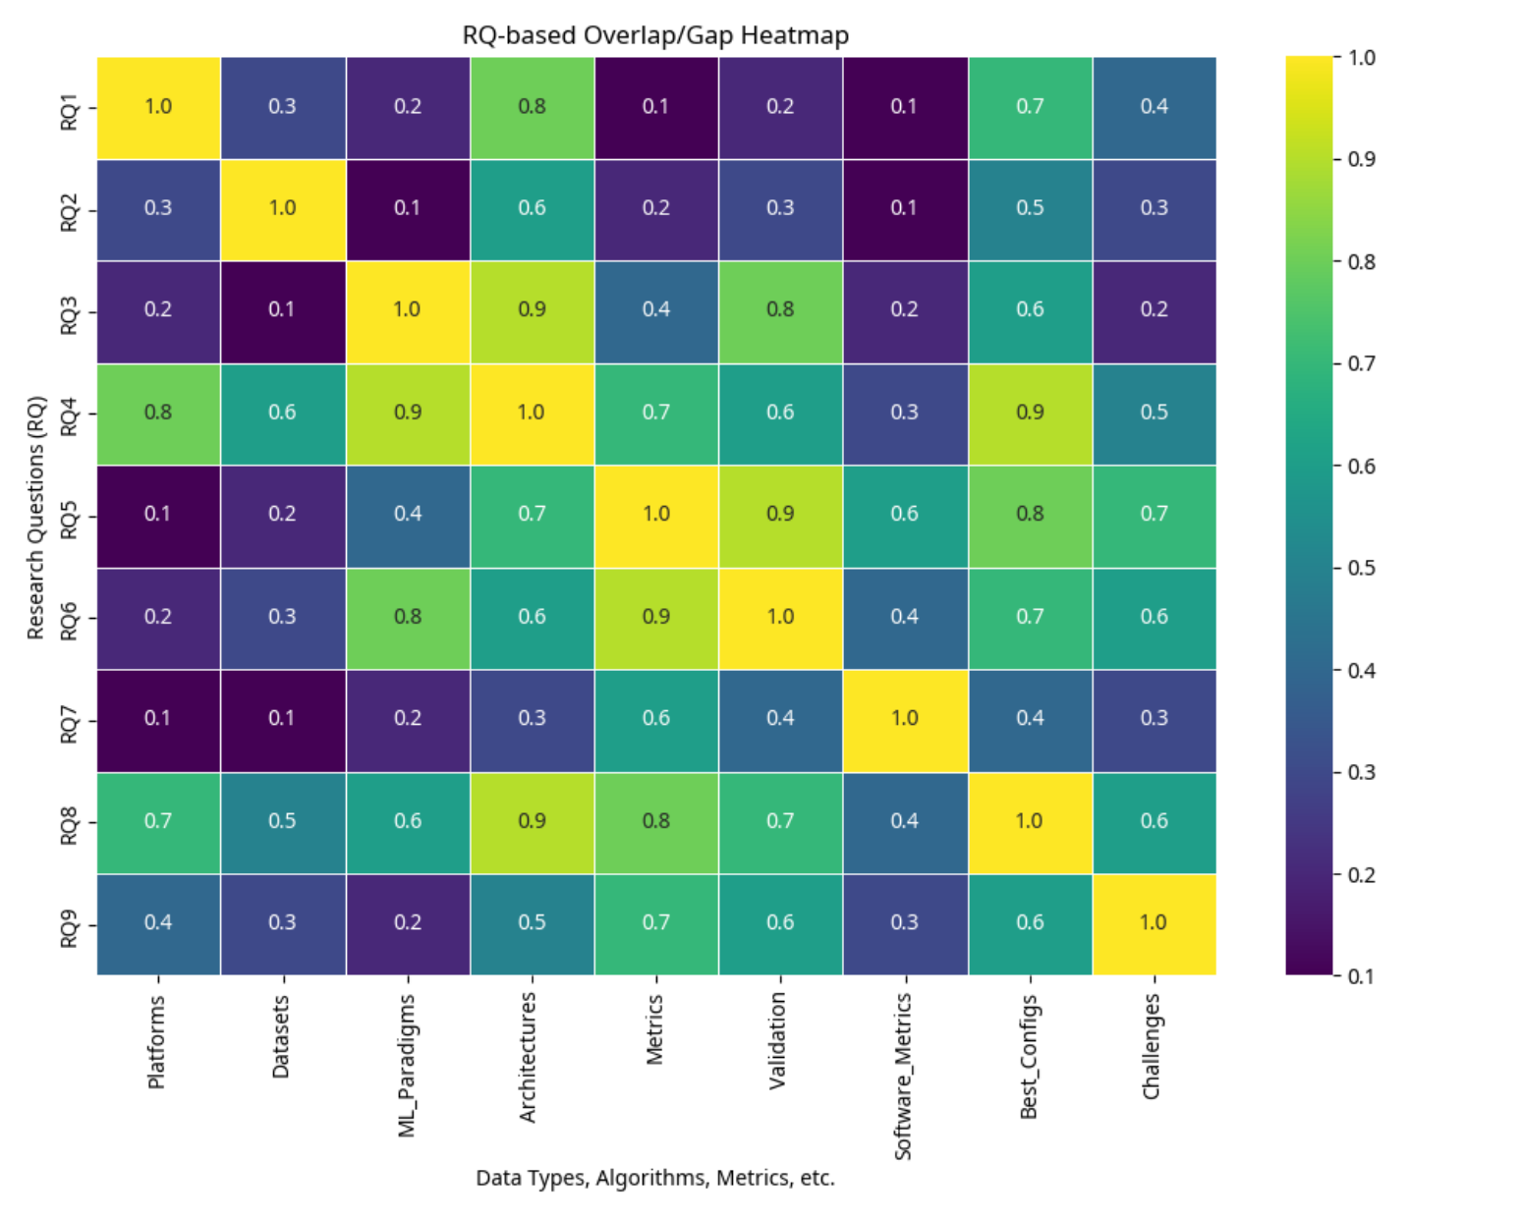
Figure 14. Heatmap of overlap and gaps between research questions (RQ1–RQ9).
圖14 各研究問題（RQ1至RQ9）之間重疊與缺口的熱圖；色彩越深代表兩問題越常被一併處理
第五章 討論 5. Discussion
In this section, answers to the nine research questions (RQ1–RQ9) are synthesized, the maturity and limitations of the current body of work are assessed, and a roadmap is outlined for moving RAG + LLM from academic prototypes to robust, production-ready enterprise systems. Across the reviewed studies, a practical guideline emerges: use sequence-level retrieval for generative reasoning in open ended tasks, and employ token-level methods for narrowly scoped extractive tasks (e.g., field lookup).
▶ 中文譯文 本節綜整對九個研究問題（RQ1至RQ9）的回應，評估當前研究體系的成熟度與限制，並勾勒一條將RAG與LLM從學術原型推進到穩健、可正式上線之企業系統的路線圖。綜觀所回顧的研究，浮現出一條實務準則：在開放式任務的生成推理上使用序列層級（sequence-level）檢索，而在範圍狹窄的擷取式任務（如欄位查找）上採用詞元層級（token-level）方法。
5.1 關鍵發現綜整 5.1. Synthesis of Key Findings
Most RAG + LLM research targets cloud-native infrastructures (66.2%), while 33.8% explore on-premises, edge, or hybrid deployments. Over half of the studies (54.5%) rely on public GitHub data, which aids reproducibility but risks domain shift. Supervised learning dominates (92.2%). Hybrid indexing that combines dense vectors and knowledge graphs appears in 23.1% of studies and often boosts explainability and precision. Technical metrics dominate, with human studies reported in 19.5% and business impact in only 15.6%. This gap underscores the need to pair automated scores with user studies and operational KPIs.
▶ 中文譯文 多數RAG與LLM研究以雲端原生基礎設施為目標（66.2%），另有33.8%探索地端、邊緣或混合部署。超過半數的研究（54.5%）仰賴公開的GitHub資料，這雖有助於可重現性，卻有領域偏移的風險。監督式學習居主導地位（92.2%）。結合密集向量與知識圖譜的混合索引出現在23.1%的研究中，往往能提升可解釋性與精準度。技術性指標佔多數，人工評估僅見於19.5%、商業影響更只有15.6%。此一落差凸顯出：必須將自動化分數與使用者研究、營運關鍵績效指標（KPI）相互搭配。
5.2 從實驗室到市場的落差 5.2. The Lab-to-Market Gap
Our analysis reveals a distinct divergence between academic RAG research and enterprise requirements. While academic studies often prioritize leaderboard metrics (e.g., Recall@K on MS MARCO), enterprise deployments face strictly operational constraints that are rarely simulated in benchmarks. First, the Latency vs. Accuracy Trade-off: academic models often employ computationally expensive re-ranking steps, but in enterprise real-time document automation, the latency budget is often under 200 ms, forcing a reliance on lighter, less accurate methods. Second, Auditability and Traceability: regulated industries require determinism, so black-box end-to-end RAG is often rejected in favor of modular pipelines where the retrieved context can be manually audited. Third, Catastrophic Hallucination Risk: a hallucination in a generated contract or medical report carries legal liability, necessitating 'Strict RAG' configurations where the model outputs 'I don't know' if the retrieval score is below a high confidence threshold.
▶ 中文譯文 本研究的分析揭示出學術RAG研究與企業需求之間的明顯分歧。學術研究往往優先追求排行榜指標（如MS MARCO上的Recall@K），但企業部署所面對的，是基準測試鮮少模擬的嚴格營運限制。第一，延遲與準確度的取捨：學術模型常採用運算成本高昂的重排序步驟，但在企業的即時文件自動化中，延遲預算往往低於200毫秒，迫使系統仰賴較輕量、準確度較低的方法。第二，可稽核性與可追溯性：受監管產業要求決定性（determinism），因此黑箱式的端到端RAG常被捨棄，改採可人工稽核所檢索脈絡的模組化管線。第三，災難性的幻覺風險：生成的合約或醫療報告若出現幻覺，將涉及法律責任，這使得「嚴格RAG」（Strict RAG）配置成為必要，亦即當檢索分數低於高信心門檻時，模型須輸出「我不知道」。
5.3 企業導入的實務意涵 5.3. Practical Implications for Enterprise Adoption
Organizations aiming to deploy RAG and LLM solutions will benefit from a hybrid infrastructure that uses cloud platforms for large-scale, low-sensitivity workloads; on-premises indexing to protect confidential data; and edge inference to deliver rapid, low-latency responses. To ensure regulatory compliance under frameworks like GDPR, CCPA, and HIPAA, privacy-preserving retrieval mechanisms such as encrypted embeddings, access-controlled vector stores, or federated retrieval should be adopted. A comprehensive evaluation setup integrates quantitative metrics such as Recall, ROUGE, and BLEU with human in the loop evaluations and business KPIs to assess both technical performance and strategic impact.
▶ 中文譯文 有意部署RAG與LLM解決方案的組織，將受益於一種混合式基礎設施：以雲端平台處理大規模、低敏感度的工作負載；以地端索引保護機密資料；並以邊緣推論提供快速、低延遲的回應。為確保在GDPR、CCPA與HIPAA等框架下的法規遵循，應採用保護隱私的檢索機制，例如加密嵌入、權限控管的向量儲存，或聯邦式檢索。一套全面的評估設計，會將召回率、ROUGE與BLEU等量化指標，與「人在迴路中」（human-in-the-loop）的評估及商業KPI整合，以同時評估技術效能與策略影響。
5.4 本回顧的限制 5.4. Limitations of This Review
Several intrinsic limitations must be acknowledged. Firstly, a scope bias is present due to the exclusion of gray literature: the review was strictly limited to peer-reviewed academic articles, yet significant operational data is often first released in industry white papers and non-peer-reviewed preprints. Secondly, publication bias is recognized: studies reporting positive outcomes are more likely to be published than those detailing failures. Thirdly, the rapid pace of the field means innovations appearing during the final stages of this review may be absent, and metric heterogeneity precluded a direct quantitative meta-analysis.
▶ 中文譯文 本回顧必須坦承幾項內在限制。第一，因排除灰色文獻而存在範疇偏誤：本回顧嚴格限定於經同儕審查的學術文章，但重要的營運數據往往最先出現在產業白皮書與未經同儕審查的預印本中。第二，承認存在發表偏誤：報告正面結果的研究，比詳述失敗的研究更容易被發表。第三，由於領域演進快速，在本回顧最後階段才出現的創新可能未被納入；而指標的異質性也使得直接的量化統合分析（meta-analysis）無法進行。
第六章 結論與未來工作 6. Conclusions and Future Work
This systematic literature review, based on 63 rigorously quality-assessed studies, synthesized the state of RAG and LLMs in enterprise knowledge management and document automation. The native cloud is dominant (66.2%), while the remainder explore on-premises, edge, or hybrid deployments to satisfy sovereignty, latency, and compliance constraints. Studies commonly rely on public GitHub data (54.5%). Supervised learning is the norm (92.1%). Architecturally, RAG Sequence is reported in 36 studies and RAG Token in 28 studies; hybrid dense + KG designs appear in 18 studies. Evaluation skews toward technical metrics, with relatively scarce human evaluation (19.0%) and measurement of business impact (15.9%). Field trials in the real world remain limited (12.7%), despite their importance to demonstrate production readiness and ROI.
▶ 中文譯文 本系統性文獻回顧奠基於63篇經嚴格品質評估的研究，綜整了RAG與LLM在企業知識管理與文件自動化中的現況。雲端原生佔主導地位（66.2%），其餘則探索地端、邊緣或混合部署，以滿足主權、延遲與法規遵循的限制。研究普遍仰賴公開的GitHub資料（54.5%）。監督式學習是常態（92.1%）。在架構上，RAG Sequence見於36篇研究、RAG Token見於28篇；混合式「密集向量加知識圖譜」設計則出現在18篇。評估偏向技術性指標，人工評估（19.0%）與商業影響衡量（15.9%）相對稀少。真實世界的實地試驗仍然有限（12.7%），儘管它對於證明可正式上線性與投資報酬率至關重要。
In general, RAG + LLM mitigates stale knowledge and reduces hallucinations through retrieval grounding, but substantial work remains to meet enterprise requirements around privacy, latency, compliance, and measurable value. To bridge the gap between promising prototypes and robust, production-ready systems, we outline six priority directions: security and privacy (end-to-end encrypted federated retrieval); latency optimization (sub-100 ms via faster ANN search and model compression); advanced learning strategies (contrastive and self-training for label-scarce domains); holistic evaluation (pairing automated scores with human studies and operational KPIs); multimodal and multilingual capabilities; and continual maintenance to handle concept drift. Realizing its full potential will require security-by-design retrieval, latency-aware systems, data-efficient adaptation, holistic measurement of business value, and disciplined continual learning, validated through rigorous field trials at scale.
▶ 中文譯文 整體而言，RAG與LLM透過檢索接地（retrieval grounding）緩解了知識過時的問題並減少幻覺，但要滿足企業在隱私、延遲、法規遵循與可衡量價值上的需求，仍有大量工作待完成。為了銜接前景可期的原型與穩健、可正式上線之系統間的落差，研究者勾勒出六個優先方向：安全與隱私（端到端加密的聯邦式檢索）、延遲優化（透過更快的近似最近鄰搜尋與模型壓縮達成低於100毫秒）、進階學習策略（針對標註稀缺領域的對比式與自我訓練）、整體性評估（將自動化分數與人工研究及營運KPI搭配）、多模態與多語言能力，以及處理概念漂移的持續性維護。要充分發揮其潛力，將需要以安全為設計核心的檢索、具延遲意識的系統、資料高效的適應、對商業價值的整體性衡量，以及有紀律的持續學習，並透過大規模的嚴謹實地試驗加以驗證。

