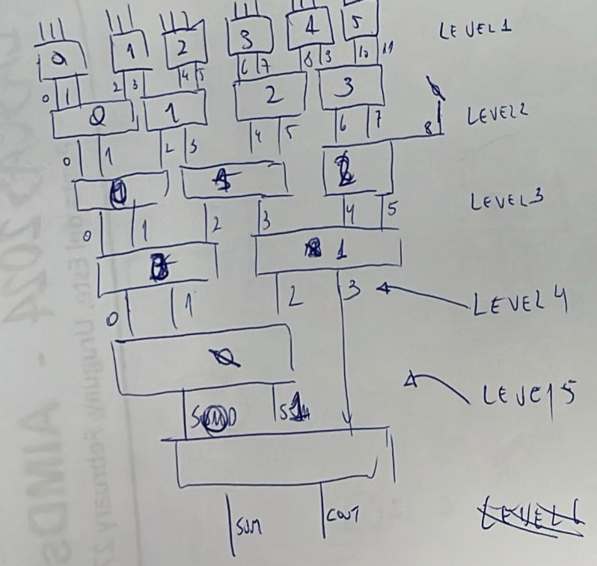




--- le a matriz cp.txt----
s0: entity work.CSA_8 port map ( 2P0, 1P3, P6, 1P7, 1P11, 2P12, 1P15, P18, SOMAxx);
s1: entity work.CSA_6 port map ( 1P3, 1P6, P7, 2P11, 1P12, P18, SOMAxx);
s2: entity work.CSA_8 port map ( 2P1, 1P3, P7, 1P7, 1P12, 2P12, 1P16, P18, SOMAxx);
s3: entity work.CSA_4 port map ( 1P3, P6, 1P11, P18, SOMAxx);
s4: entity work.CSA_8 port map ( 2P1, 1P4, P7, 1P8, 1P12, 2P13, 1P16, P19, SOMAxx);
s5: entity work.CSA_6 port map ( 1P6, 2P7, P11, 1P12, 1P15, P18, SOMAxx);
s6: entity work.CSA_5 port map ( 2P6, 1P7, 1P11, P12, P18, SOMAxx);
s7: entity work.CSA_6 port map ( 1P7, 2P7, P12, 1P12, 1P16, P18, SOMAxx);
s8: entity work.CSA_3 port map ( 1P6, P11, P18, SOMAxx);
s9: entity work.CSA_6 port map ( 1P7, 2P8, P12, 1P13, 1P16, P19, SOMAxx);
s10: entity work.CSA_8 port map ( 2P5, 1P8, P11, 1P11, 1P12, 2P12, 1P15, P18, SOMAxx);
s11: entity work.CSA_6 port map ( 1P8, 1P11, 2P11, P12, 1P12, P18, SOMAxx);
s12: entity work.CSA_6 port map ( 2P6, 1P8, P12, 3P12, 1P16, P18, SOMAxx);
s13: entity work.CSA_4 port map ( 1P8, P11, 1P11, P18, SOMAxx);
s14: entity work.CSA_8 port map ( 2P6, 1P9, P12, 1P12, 1P13, 2P13, 1P16, P19, SOMAxx);
s15: entity work.CSA_4 port map ( P6, 1P7, 1P15, P18, SOMAxx);
s16: entity work.CSA_3 port map ( 1P6, P7, P18, SOMAxx);
s17: entity work.CSA_4 port map ( P7, 1P7, 1P16, P18, SOMAxx);
s18: entity work.CSA_2 port map ( P6, P18, SOMAxx);
s19: entity work.CSA_4 port map ( P7, 1P8, 1P16, P19, SOMAxx);
s20: entity work.CSA_8 port map ( 2P5, 1P8, P11, 1P12, 1P16, 2P17, 1P20, P23, SOMAxx);
s21: entity work.CSA_6 port map ( 1P8, 1P11, P12, 2P16, 1P17, P23, SOMAxx);
s22: entity work.CSA_8 port map ( 2P6, 1P8, P12, 1P12, 1P17, 2P17, 1P21, P23, SOMAxx);
s23: entity work.CSA_4 port map ( 1P8, P11, 1P16, P23, SOMAxx);
s24: entity work.CSA_8 port map ( 2P6, 1P9, P12, 1P13, 1P17, 2P18, 1P21, P24, SOMAxx);

--- le a matriz cn.txt----
s0: entity work.CSA_8 port map ( 1P1, 2P2, 1P5, P8, 2P10, 1P13, P16, 1P17, SOMAxx);
s1: entity work.CSA_6 port map ( 2P1, 1P2, P8, 1P13, 1P16, P17, SOMAxx);
s2: entity work.CSA_8 port map ( 1P2, 2P2, 1P6, P8, 2P11, 1P13, P17, 1P17, SOMAxx);
s3: entity work.CSA_4 port map ( 1P1, P8, 1P13, P16, SOMAxx);
s4: entity work.CSA_8 port map ( 1P2, 2P3, 1P6, P9, 2P11, 1P14, P17, 1P18, SOMAxx);
s5: entity work.CSA_6 port map ( 2P5, 1P8, 1P10, P13, P16, 1P17, SOMAxx);
s6: entity work.CSA_4 port map ( 1P8, P13, 1P16, P17, SOMAxx);
s7: entity work.CSA_6 port map ( 2P6, 1P8, 1P11, P13, P17, 1P17, SOMAxx);
s8: entity work.CSA_3 port map ( 1P8, P13, P16, SOMAxx);
s9: entity work.CSA_6 port map ( 2P6, 1P9, 1P11, P14, P17, 1P18, SOMAxx);
s10: entity work.CSA_8 port map ( 1P6, 2P7, 1P10, 2P10, P13, 1P13, P16, 1P17, SOMAxx);
s11: entity work.CSA_6 port map ( 2P6, 1P7, P13, 1P13, 1P16, P17, SOMAxx);
s12: entity work.CSA_8 port map ( 1P7, 2P7, 1P11, 2P11, P13, 1P13, P17, 1P17, SOMAxx);
s13: entity work.CSA_4 port map ( 1P6, P13, 1P13, P16, SOMAxx);
s14: entity work.CSA_8 port map ( 1P7, 2P8, 1P11, 2P11, P14, 1P14, P17, 1P18, SOMAxx);
s15: entity work.CSA_4 port map ( 1P5, P8, P16, 1P17, SOMAxx);
s16: entity work.CSA_3 port map ( P8, 1P16, P17, SOMAxx);
s17: entity work.CSA_4 port map ( 1P6, P8, P17, 1P17, SOMAxx);
s18: entity work.CSA_2 port map ( P8, P16, SOMAxx);
s19: entity work.CSA_4 port map ( 1P6, P9, P17, 1P18, SOMAxx);
s20: entity work.CSA_8 port map ( 1P6, 2P7, 1P10, P13, 2P15, 1P18, P21, 1P22, SOMAxx);
s21: entity work.CSA_6 port map ( 2P6, 1P7, P13, 1P18, 1P21, P22, SOMAxx);
s22: entity work.CSA_8 port map ( 1P7, 2P7, 1P11, P13, 2P16, 1P18, P22, 1P22, SOMAxx);
s23: entity work.CSA_4 port map ( 1P6, P13, 1P18, P21, SOMAxx);
s24: entity work.CSA_8 port map ( 1P7, 2P8, 1P11, P14, 2P16, 1P19, P22, 1P23, SOMAxx);

aqui vão as 25 subtrações

\

