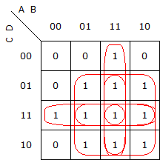 Práctica 1 – Ejercicio 2

AND/OR:

(C*D)+(B*D)+(B*C)+(A*D)+(A*C)+(A*B)

NAND/NAND:

~(~(C*D)*~(B*D)*~(B*C)*~(A*D)*~(A*C)*~(A*B))

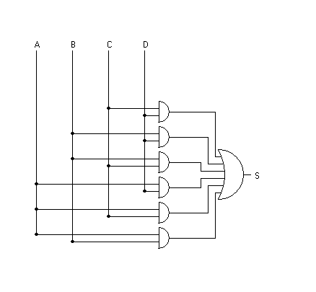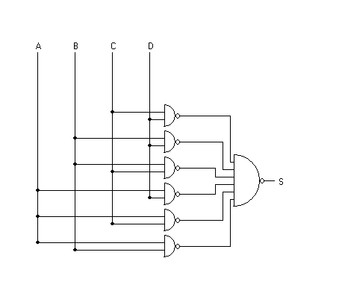Tabla de verdad

|  |  |  |  |  |  |
| --- | --- | --- | --- | --- | --- |
| N | A | B | C | D | S |
| 0 | 0 | 0 | 0 | 0 | 0 |
| 1 | 0 | 0 | 0 | 1 | 0 |
| 2 | 0 | 0 | 1 | 0 | 0 |
| 3 | 0 | 0 | 1 | 1 | 1 |
| 4 | 0 | 1 | 0 | 0 | 0 |
| 5 | 0 | 1 | 0 | 1 | 1 |
| 6 | 0 | 1 | 1 | 0 | 1 |
| 7 | 0 | 1 | 1 | 1 | 1 |
| 8 | 1 | 0 | 0 | 0 | 0 |
| 9 | 1 | 0 | 0 | 1 | 1 |
| 10 | 1 | 0 | 1 | 0 | 1 |
| 11 | 1 | 0 | 1 | 1 | 1 |
| 12 | 1 | 1 | 0 | 0 | 1 |
| 13 | 1 | 1 | 0 | 1 | 1 |
| 14 | 1 | 1 | 1 | 0 | 1 |
| 15 | 1 | 1 | 1 | 1 | 1 |