Informatică aplicată – Tema2

Student: Tarța Bianca

Grupa: 30133, semigrupa 2

**Baza de date:**

**WebService:**

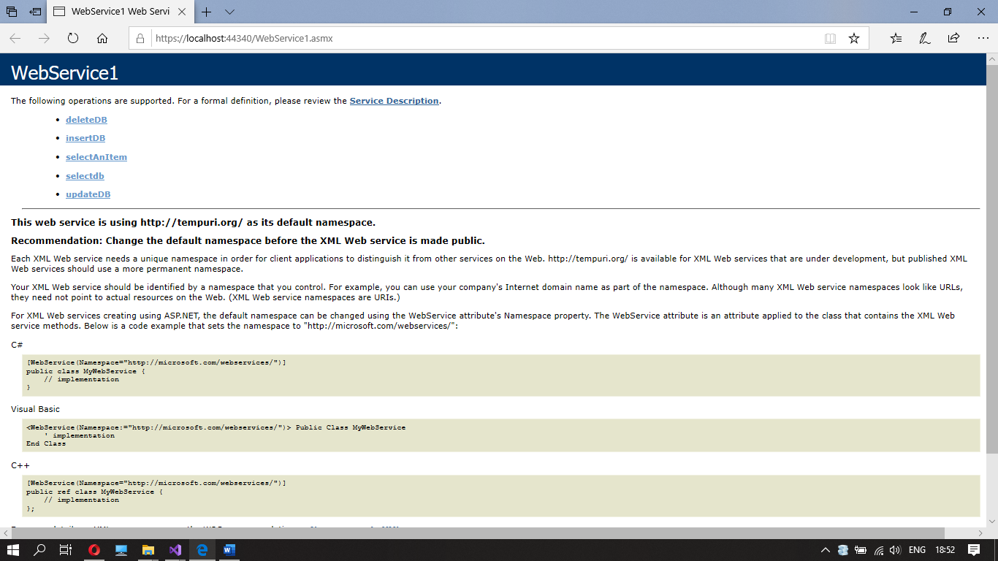

public class WebService1 : System.Web.Services.WebService

{

List<String> prods;

[WebMethod]

public bool insertDB(int id, String Name,int No,float Price, String Shop)

{

bool t = false;

SqlConnection con = new SqlConnection();

con.ConnectionString = "Data Source=(LocalDB)\\MSSQLLocalDB; AttachDbFilename=|DataDirectory|\\Database1.mdf;Integrated Security=True";

con.Open();

String q = "insert into [Products] values('" + id + "','" + Name + "','" + No + "','" + Price + "','" + Shop + "')";

SqlCommand cmd = new SqlCommand(q, con);

int i = cmd.ExecuteNonQuery();

con.Close();

if (i > 0)

t = true;

return t;

}

[WebMethod]

public List<String> selectdb(String Shop)

{

prods = new List<String>();

SqlConnection con = new SqlConnection();

con.ConnectionString = "Data Source=(LocalDB)\\MSSQLLocalDB; AttachDbFilename=|DataDirectory|\\Database1.mdf;Integrated Security=True";

con.Open();

DataSet dsProducts = new DataSet();

SqlDataAdapter daProducts = new SqlDataAdapter("select * from Products where Shop='"+Shop+"'", con); daProducts.Fill(dsProducts, "Products");

foreach (DataRow dr in dsProducts.Tables["Products"].Rows)

{

String name = dr.ItemArray.GetValue(1).ToString();

prods.Add(name);

}

con.Close();

return prods;

}

[WebMethod]

public bool deleteDB(String Product,String Shop)

{

bool t = false;

SqlConnection con = new SqlConnection();

con.ConnectionString = "Data Source=(LocalDB)\\MSSQLLocalDB; AttachDbFilename=|DataDirectory|\\Database1.mdf;Integrated Security=True";

con.Open();

String q = "delete from Products where Name='" + Product + "'and Shop='" + Shop + "'";

SqlCommand cmd = new SqlCommand(q, con);

int i = cmd.ExecuteNonQuery();

con.Close();

if (i > 0)

t = true;

return t;

}

[WebMethod]

public bool updateDB(String Product, String Shop, int nId, String nName, int nNo, float nPrice, String nShop)

{

bool t = false;

SqlConnection con = new SqlConnection();

con.ConnectionString = "Data Source=(LocalDB)\\MSSQLLocalDB; AttachDbFilename=|DataDirectory|\\Database1.mdf;Integrated Security=True";

con.Open();

String q = "UPDATE Products set Id='"+nId+ "',Name='" + nName + "',Number='" + nNo + "',Price='" + nPrice + "',Shop='" + nShop + "'" +

" where Name='" + Product + "'and Shop='" + Shop + "'";

SqlCommand cmd = new SqlCommand(q, con);

int i = cmd.ExecuteNonQuery();

con.Close();

if (i > 0)

t = true;

return t;

}

[WebMethod]

public List<String> selectAnItem(String Shop,String Name)

{

prods = new List<String>();

SqlConnection con = new SqlConnection();

con.ConnectionString = "Data Source=(LocalDB)\\MSSQLLocalDB; AttachDbFilename=|DataDirectory|\\Database1.mdf;Integrated Security=True";

con.Open();

DataSet dsProducts = new DataSet();

SqlDataAdapter daProducts = new SqlDataAdapter("select * from Products where Name='" + Name + "' and Shop='" + Shop + "'", con);

daProducts.Fill(dsProducts, "Products");

foreach (DataRow dr in dsProducts.Tables["Products"].Rows)

for(int i=0;i<5;i++)

{

String prodInf = dr.ItemArray.GetValue(i).ToString();

prods.Add(prodInf);

}

con.Close();

return prods;

}

}

**Client:**

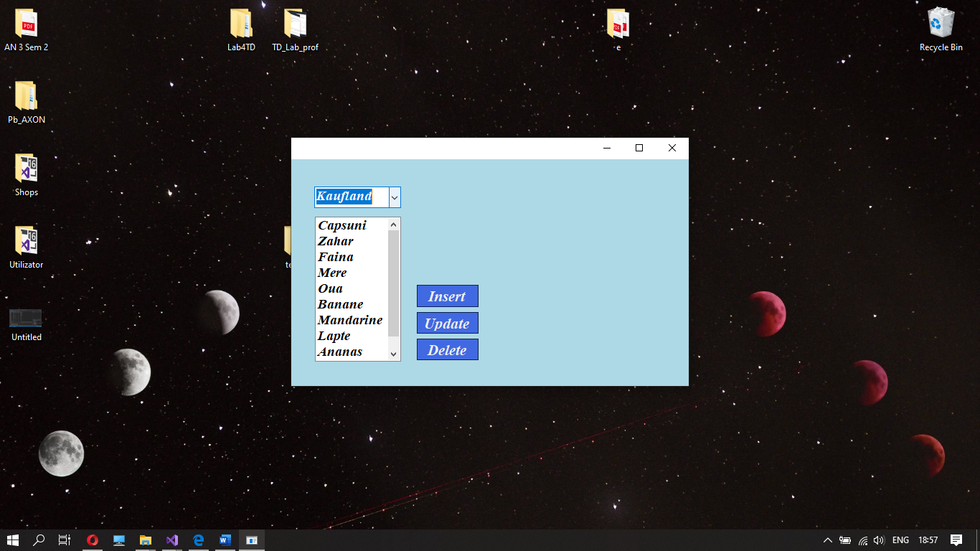

* **La apasarea butonului Insert va aparea un groupBox care contine cateva campuri care se vor complete cu detalii privind produsul care se doreste adaugat**

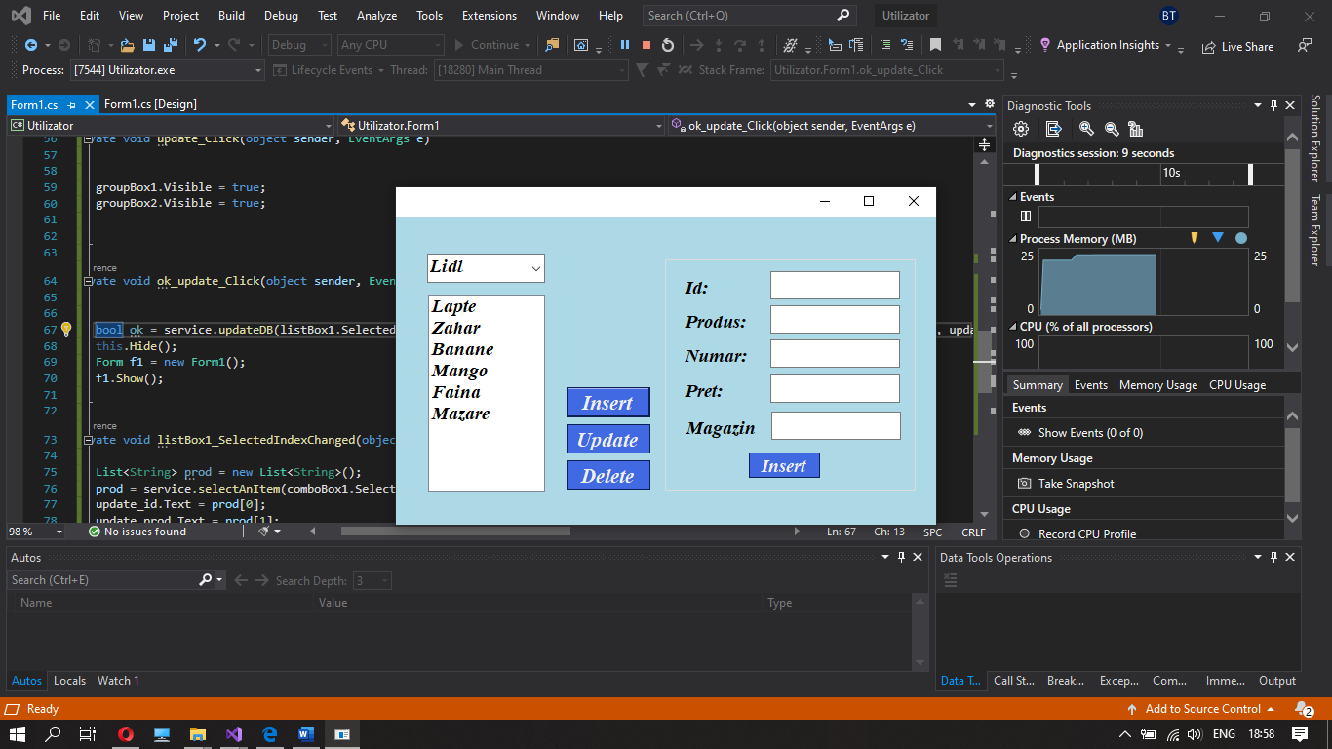

* **La apasarea butonului Update va aparea un groupBox care contine cateva campuri care contin informatii despre produsul selectat, care se vor putea modifica pentru a actualiza produsul**

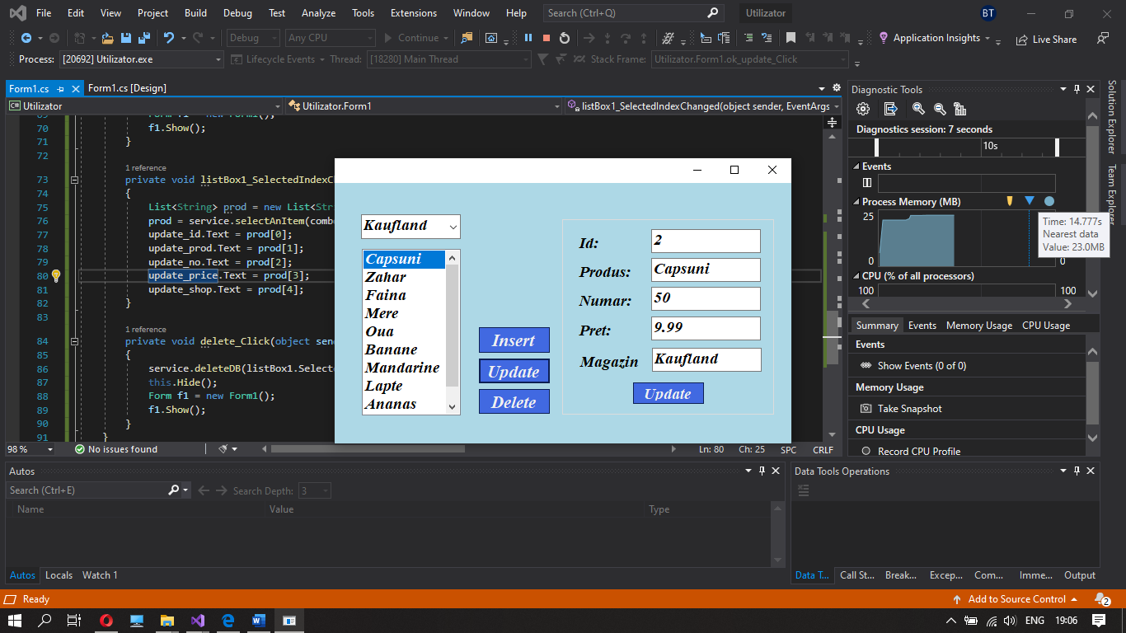

* **La apasarea butonului Delete, produsul selectat din lista va fi sters din baza de date**

**Cod:**

public partial class Form1 : Form

{

Utilizator.ServiceReference1.WebService1SoapClient service = new Utilizator.ServiceReference1.WebService1SoapClient();

public Form1()

{

InitializeComponent();

}

private void Form1_Load(object sender, EventArgs e)

{

}

private void comboBox1_SelectedIndexChanged(object sender, EventArgs e)

{

listBox1.Text = "";

List<String> prods=new List<String>();

prods = service.selectdb(comboBox1.SelectedItem.ToString());

int sizeOfList = prods.Count;

for (int i = 0; i < sizeOfList; i++)

listBox1.Items.Add(prods[i]);

}

private void insert_Click(object sender, EventArgs e)

{

groupBox1.Visible = true;

groupBox2.Visible = false;

}

private void ok_insert_Click(object sender, EventArgs e)

{

bool ok = service.insertDB(Int32.Parse(insert_id.Text), insert_prod.Text, Int32.Parse(insert_no.Text),float.Parse(insert_price.Text), insert_shop.Text);

this.Hide();

Form f1 = new Form1();

f1.Show();

}

private void update_Click(object sender, EventArgs e)

{

groupBox1.Visible = true;

groupBox2.Visible = true;

}

private void ok_update_Click(object sender, EventArgs e)

{

bool ok = service.updateDB(listBox1.SelectedItem.ToString(), comboBox1.SelectedItem.ToString(), Int32.Parse(update_id.Text), update_prod.Text, Int32.Parse(update_no.Text), float.Parse(update_price.Text), update_shop.Text);

this.Hide();

Form f1 = new Form1();

f1.Show();

}

private void listBox1_SelectedIndexChanged(object sender, EventArgs e)

{

List<String> prod = new List<String>();

prod = service.selectAnItem(comboBox1.SelectedItem.ToString(), listBox1.SelectedItem.ToString());

update_id.Text = prod[0];

update_prod.Text = prod[1];

update_price.Text = prod[2];

update_no.Text = prod[3];

update_shop.Text = prod[4];

}

private void delete_Click(object sender, EventArgs e)

{

service.deleteDB(listBox1.SelectedItem.ToString(), comboBox1.SelectedItem.ToString());

this.Hide();

Form f1 = new Form1();

f1.Show();

}

}