PUT YOUR AIs IN A ROOM AND LET THEM ARGUE
Why a Single AI Answer Is Never Enough for an Important Question — and How Multi-AI Debating Systems Can Change Everything
By Rajeev Upadhye
Email: upadhye.rajeev@gmail.com
Based on a multi-model deliberation involving OpenAI, Claude, Grok, Sarvam and Perplexity in a Debate Simulator developed in collaboration with Claude
© 2026 Rajeev Upadhye. All rights reserved.
No part of this article may be reproduced, distributed, or transmitted in any form or by any means, including photocopying, recording, or other electronic or mechanical methods, without the prior written permission of the author, except in the case of brief quotations embodied in critical reviews and certain other non-commercial uses permitted by copyright law.
For permissions, contact: upadhye.rajeev@gmail.com

For
all the souls who secretly hate AI

CONTENTS

The Fundamental Limitation of a Single AI Mind | 7
What History Teaches About the Value of Structured Disagreement | 8
What Debate Reveals That a Single Answer Cannot | 11
The Five Roles Every Good AI Debate System Needs | 12
The Anatomy of a Good Debate: From Question to Synthesis | 15
How to Get the Best Out of AI Debate Systems | 18
Mistakes to Avoid: The Ten Failure Modes of AI Debate | 21
Three Domains Where Multi-AI Debate Makes the Most Difference | 27
The Innovation Frontier | 29
A Real Example: Debating a Drug Interaction | 33
Identifying the Dimensions of a Debate Question | 35
Designing the Prompt: How Framing Changes Everything | 38
When More Is Less: The Paradox of Excessive Models | 41
The Honest Output: What a Good Debate Should Produce | 44
Knowledge Graphs: Making Debate Interpretable | 46
The Deeper Argument: Why Debate Is Necessary | 50
A Practical Checklist for Using AI Debate Systems | 52
What We Should Ask of System Designers | 55
The Invitation | 57

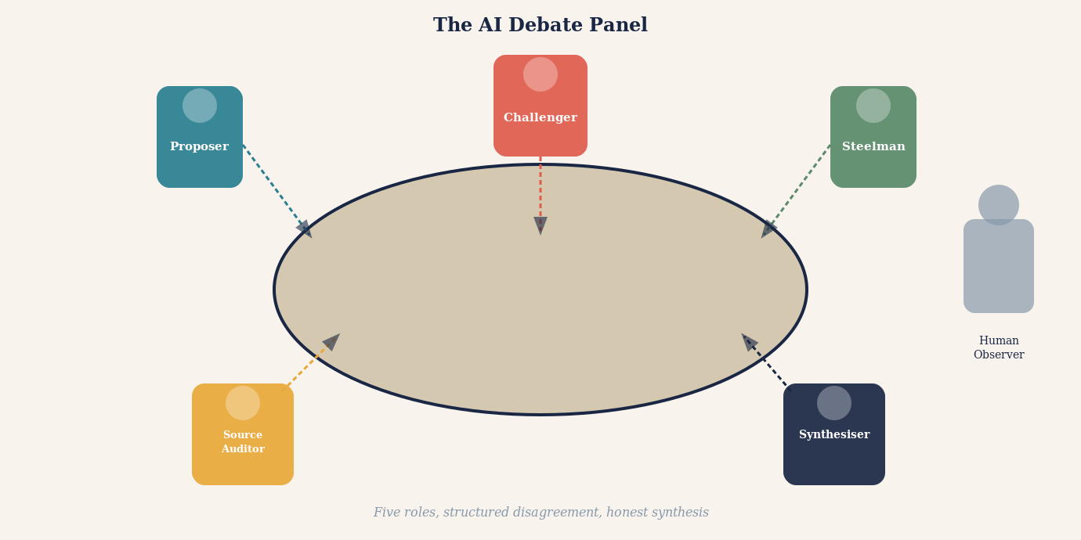
Opening illustration: A panel of AI figures seated at a debate table, each with a distinct posture and perspective, arguing before a human observer who listens carefully.

You have just received a diagnosis you did not expect. Or a lawyer has handed you an opinion that will shape the next decade of your life. Or your financial adviser has recommended a strategy that will determine whether you retire comfortably or not. You want a second opinion. So you turn to artificial intelligence.
You ask a large language model. It gives you a detailed, confident answer. It cites mechanisms, references relevant evidence, explains nuance. You feel reassured. You close the laptop.
What if you asked two AI systems? Or five? What if those five did not simply answer in parallel but were structured to argue with one another — to attack each other's reasoning, challenge each other's sources, steelman opposing views, and only then attempt a synthesis?
That is not a thought experiment. It is an increasingly practical architecture. And it is, many researchers and practitioners are beginning to argue, not merely better than asking one AI. It is categorically different in kind.
This article is a case for that position — and a careful guide to extracting its genuine benefits while avoiding the traps that make many such systems produce the appearance of rigour without the substance.

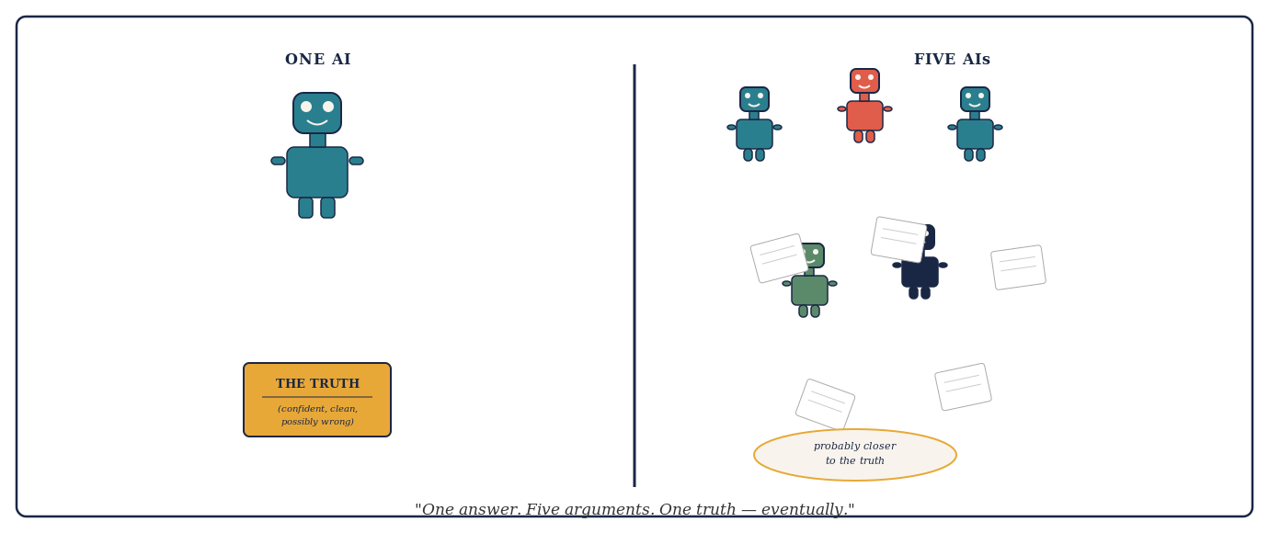
Cartoon: One AI hands over a neat certificate labelled THE TRUTH. Five AIs argue furiously, papers flying — their small crumpled note at the bottom reads: probably closer to the truth.

There is one more reason the case for multi-AI systems deserves to be stated clearly before it is qualified. Most hard intellectual problems are not difficult because the final calculation is enormous. They are difficult because the space of plausible explanations is enormous. Before any answer can be verified, somebody must generate the right candidate in the first place. A single model, however capable, searches only one region of that space at a time. A team that divides the terrain covers far more of it.
Think of a missing climber. Five searchers walking the same trail ten metres apart produce more manpower, but very little additional conceptual coverage. A better team divides the search: one follows the trail, another uses aerial imagery, a third studies weather and avalanche conditions, a fourth reconstructs phone and vehicle records, and a fifth challenges the premise entirely and asks whether the climber reached the mountain at all. Multi-AI reasoning works best the same way. Different agents should search different regions of the intellectual terrain -- not duplicate each other's effort in the region that seems most obvious.

The Fundamental Limitation of a Single AI Mind
To appreciate why multi-AI debate matters, it helps to understand what a large language model actually does when it answers a question. It does not look something up in the way a search engine does. It does not derive a conclusion from first principles the way a mathematician would. It generates text that is statistically consistent with the enormous corpus of human-written material on which it was trained.
This is a remarkable capability. It is also a distinctive kind of limitation. A language model answers from pattern. Its answers are shaped by what was written before — by the distribution of claims, framings, emphases and omissions in its training data. A claim that appeared confidently and repeatedly in that data will feel solid to the model. A claim that is technically correct but underrepresented will feel uncertain or may not surface at all.
More troubling, a model cannot easily see its own blind spots. If a misconception is deeply embedded in training data — if it appeared in textbooks, Wikipedia articles, popular science journalism and academic abstracts that all repeated it without question — the model will reproduce it with confidence. It has no access to a ground truth external to its training.
"A single AI answering a question is like a single expert with a single education, a single set of professional experiences, and a single set of implicit assumptions. We would never accept that in medicine, law, engineering or finance. There is no principled reason to accept it from an artificial mind."
The solution is not to ask for a better AI. The solution is to introduce structural disagreement. Human disciplines arrived at this insight long before artificial intelligence existed.

What History Teaches About the Value of Structured Disagreement
The legal tradition did not invent adversarial process because lawyers enjoy conflict. It invented it because centuries of painful experience demonstrated that a single examiner with access to only one narrative produced catastrophically worse outcomes than a structured encounter between competing advocates before an independent decision-maker -- and that the more the stakes, the more catastrophic the failures became.
The history of the inquisitorial system offers the clearest lesson. In medieval Europe, many legal systems placed investigative and adjudicative power in the same hands. The judge identified the accused, gathered evidence, conducted the interrogation, and delivered the verdict. This seemed efficient. It was, in fact, a machine for producing wrongful convictions. A judge who had already decided on guilt had every cognitive incentive -- most of them unconscious -- to interpret ambiguous evidence as confirming, to discount exculpatory testimony, and to treat confident denial as evidence of defiance rather than innocence. The psychological phenomenon now called confirmation bias was operating centuries before it had a name, and it operated with lethal precision in systems that permitted no structural challenge to the investigator's early judgment.
The English common law tradition developed a partial corrective over several centuries: the right of the accused to confront witnesses, to challenge evidence, and eventually to be represented by an advocate whose sole obligation was to the client's case. This was not the invention of an abstract principle. It was the accumulated response to documented failure. Wrongful convictions in cases where no advocate challenged the prosecution's narrative were visible enough, and serious enough, that gradually the law institutionalised structural opposition as a safeguard -- not because opposition was pleasant, but because the absence of opposition had proven dangerous.
What the adversarial system actually discovered is a principle that extends far beyond the courtroom: the person arguing one side of a case will always be more motivated, more resourceful, and more thorough than an impartial examiner trying to consider both sides simultaneously. Impartiality, it turns out, is expensive. It requires the examiner to hold two competing hypotheses in mind at once, to search equally energetically for evidence supporting each, and to resist the natural pull toward whichever explanation arrived first or feels most coherent. Very few human minds can do this reliably under pressure. So the law stopped asking individual minds to do it. Instead, it assigned the task of thorough prosecution to one party, the task of thorough defence to another, and the task of independent judgment to a third.
The result was a system that harnessed motivated reasoning rather than trying to eliminate it -- and found that motivated reasoning, properly structured against itself, produced more reliable outcomes than attempted neutrality. The adversarial system is therefore not a concession to human weakness. It is an engineering solution to it. Disagreement, properly structured, produces more reliable verdicts than benevolent one-sided inquiry -- and that insight, earned through centuries of visible failure, is precisely the principle that multi-AI debate systems now apply to artificial minds.
Science arrived at a similar insight. Peer review is not merely a quality check. It is an institutionalised attempt to expose a researcher's claim to minds that have every incentive to find its flaws — because their professional reputations are built on discovering other people's errors. The scientific community long ago concluded that a finding endorsed by one scientist, even a brilliant one, is less reliable than a finding that has survived structured adversarial scrutiny.
ADVERSARIAL SCRUTINY
Adversarial scrutiny is the deliberate exposure of an argument, claim, or finding to a critic who is structurally motivated to find its flaws -- not as a matter of temperament but as a matter of role. It differs from peer review in degree: where peer review asks a qualified outsider to assess quality, adversarial scrutiny assigns a dedicated opponent whose sole task is to locate and articulate every weakness. The key insight is motivational. A neutral examiner trying to consider all sides simultaneously is pulled toward the first coherent explanation that appears. An adversarial critic has every incentive to resist that pull -- their value lies entirely in finding what the original argument missed. Legal cross-examination, scientific replication attempts, red-team exercises, and devil's-advocate roles in investment committees are all institutionalised forms of adversarial scrutiny. In multi-AI debate systems, adversarial scrutiny is the mechanism that turns a panel of agreeable models into a genuine epistemic test. Without it, AI systems tend to converge on whatever answer sounds most authoritative. With it, a claim must survive a structured attempt at demolition before it earns the status of a conclusion.
Investment committees, engineering review boards, clinical trial committees, safety panels — every institution that has learned, through hard experience, to take reliability seriously has independently arrived at the same structural answer: do not trust a single perspective. Create conditions for structured, principled disagreement, and let the idea survive or fail in that encounter.
Multi-AI debating systems are, at their best, an attempt to apply this ancient wisdom to artificial intelligence. The question is not whether the principle is sound. The question is how to implement it so that the disagreement is genuine, the scrutiny is real, and the synthesis is honestly earned.
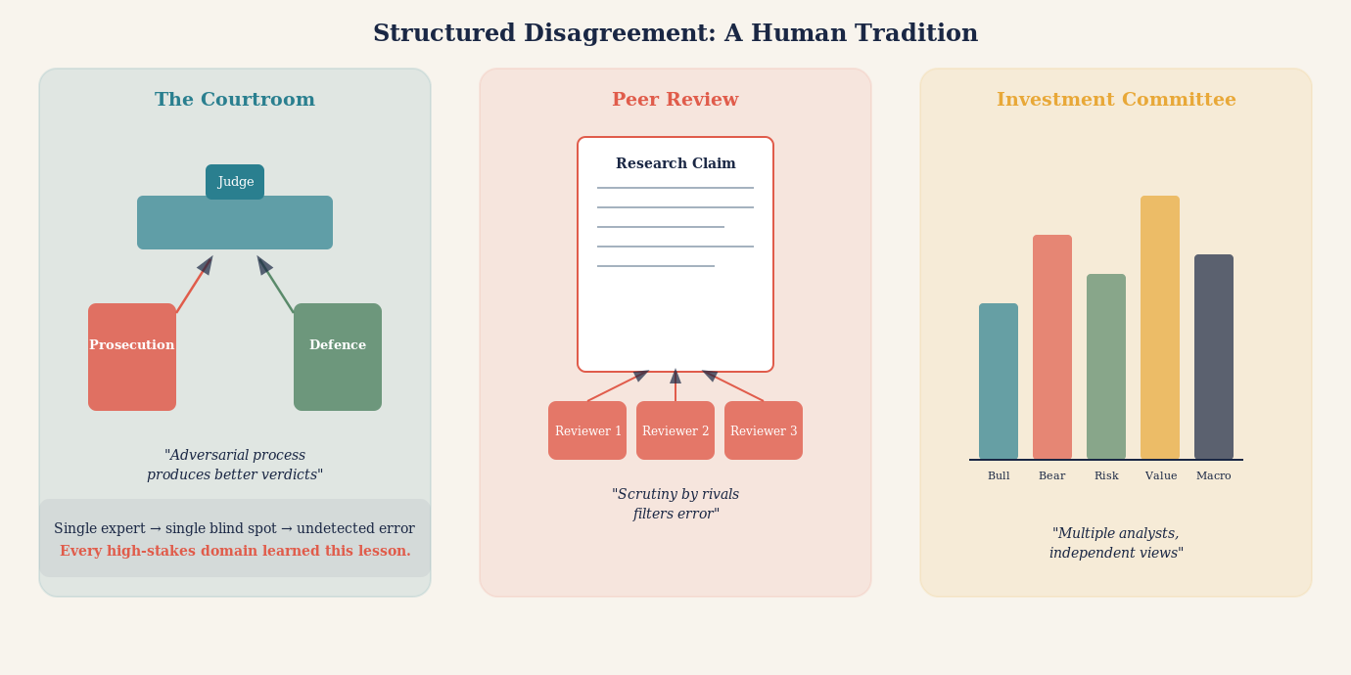
Illustration: Historical parallels — a courtroom, a scientific peer review panel, an investment committee — each showing structured disagreement as the engine of reliable judgment, with a single expert shown alone and vulnerable by contrast.

What Debate Reveals That a Single Answer Cannot
Consider what happens when two AI systems with the same question produce different answers. The naive response is dismay: the AI is unreliable if it gives contradictory answers to the same question. But the more sophisticated response is quite the opposite: the divergence is informative.
If one model says a particular drug interaction is clinically significant and another says it is mild, that disagreement tells you something important. It tells you that the question is not as settled as a single confident answer would suggest. It tells you that the evidence is ambiguous, that expert interpretation varies, that you should not simply act on a single output. The divergence is epistemically honest in a way that false consensus is not.
Now take that disagreement further. Ask the two models not merely to answer the question but to argue against each other's position. Force each to identify the weakest link in the other's reasoning. Require each to articulate the strongest version of the opposing view before criticising it. Something remarkable begins to happen.
The models surface their assumptions. They make visible the inferential steps they normally compress into confident prose. They identify which claims depend on strong evidence and which depend on prior probability or trained intuition. The argument structure, once externalised, can be examined and evaluated in a way that a smooth, confident single answer cannot be.
STEELMANNING
The practice of articulating the strongest possible version of an opposing argument before attempting to refute it. A debate system that requires steelmanning forces each AI to genuinely engage with counterarguments rather than dismissing weak versions of them. This is the opposite of a straw man, and it is one of the most powerful epistemic disciplines a multi-AI system can impose. Without it, debate degenerates into mutual dismissal rather than genuine scrutiny.

A single AI answer is like a finished painting. You can admire or criticise the result, but you cannot easily see the brushwork. A structured AI debate is like watching the painting being made. The process is visible. The choices are auditable. The points of uncertainty are legible.

The Five Roles Every Good AI Debate System Needs
Not all multi-AI debate architectures are equal. The weakest versions simply ask several AIs the same question and report when they agree. This is marginally useful and substantially misleading. The strongest versions assign each AI a distinct epistemic role — a specific function in a division of intellectual labour.
The first role is the Proposer. One model develops the leading answer: the most well-supported, most defensible position it can construct given the available evidence. The Proposer is not asked to hedge. It is asked to make the strongest possible case.
The second role is the Challenger. A separate model receives the Proposer's answer and is given one task: find its weakest points. Not its most obvious weaknesses, but its deepest structural vulnerabilities. Where does the argument depend on an assumption the evidence does not support? Where is a cited source being asked to carry more weight than it can bear? Where does a statistical claim not survive scrutiny?
The third role is the Steelman. A third model receives the Challenger's critique and must do something counter-intuitive: it must argue against the critique. Not necessarily to defend the original answer, but to ensure the criticism is fair. This prevents the Challenger from winning by raising irrelevant objections or constructing a distorted version of the original position.
The fourth role is the Source Auditor. This model's only job is to examine the factual claims made by all three previous models and determine what the underlying evidence actually says. Not what the models claim it says. Not what is implied by a summary three inferential steps removed from the original paper. What the actual sources say, if they can be retrieved and examined.
The fifth role is the Synthesiser. Only after the first four roles have completed does a final model attempt a conclusion. The Synthesiser does not simply average the positions. It identifies which claims survived adversarial scrutiny, which were abandoned under pressure, which remain genuinely uncertain, and what the honest, qualified answer is given the evidence as audited.
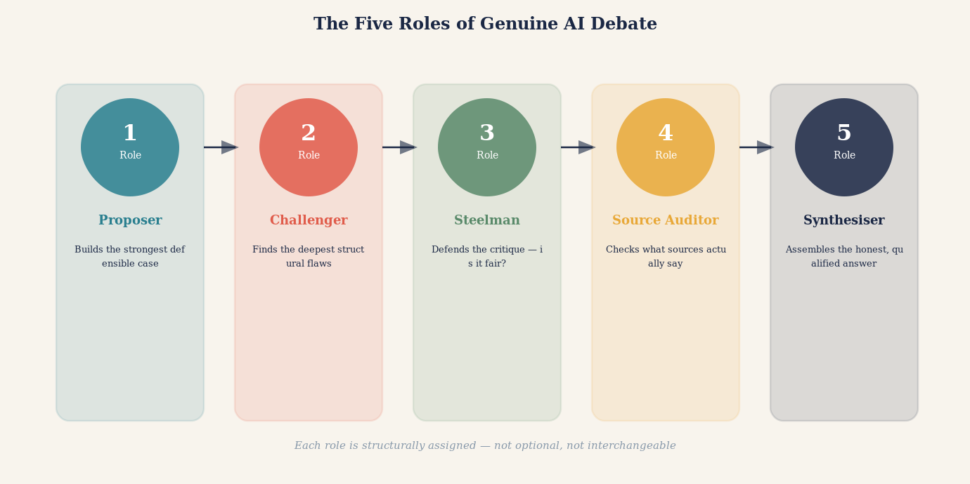
Illustration: The five roles — Proposer, Challenger, Steelman, Source Auditor, Synthesiser — shown as distinct figures in a structured process, with arrows indicating the flow of argument and scrutiny between them.
There is a useful way to think about what the five roles collectively achieve. Consider three engineers asked to investigate an unexplained crack in a bridge. If all three merely re-run the same finite-element analysis with the same inputs, their agreement adds very little. But if one checks material fatigue and corrosion, a second recalculates loads, wind, and vibration, and a third asks whether the structural model itself contains a false assumption, the team becomes substantially more informative. Each engineer is not simply adding another vote for the same conclusion. Each is attacking a different possible failure mechanism -- covering a different failure surface.
This gives us one of the most useful concepts in multi-AI design: failure-surface coverage. A five-role debate system is not primarily valuable because it produces five opinions. It is valuable because, when properly structured, each role is assigned to discover a different way the conclusion could be wrong. The Proposer covers the most plausible hypothesis. The Challenger covers its structural vulnerabilities. The Steelman ensures the challenge is fair. The Source Auditor covers the evidentiary surface -- the layer where citations might not say what they are claimed to say. The Synthesiser maps what remains uncovered. Together they are not five votes. They are five different instruments probing for different failure modes.
FAILURE-SURFACE COVERAGE
A reasoning system gains strength not by accumulating agreement but by assigning each participant to discover a different way the conclusion could fail. Agreement among agents probing different failure surfaces is far more informative than agreement among agents who all checked the same thing.

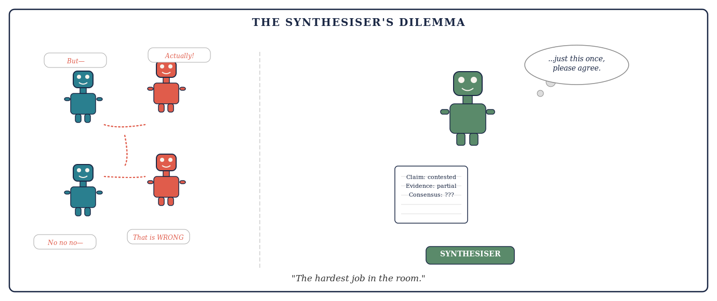
Cartoon: Four robots argue furiously on the left. The Synthesiser — robot with notepad — sits alone on the right, exhausted, thinking: just this once, please agree.

THE DEVIL'S ADVOCATE
In classical deliberative practice, the Devil's Advocate was a Church official whose formal duty was to argue against canonisation — not because the official believed the saint was unworthy, but because the institution had learned that uncontested elevation produced worse outcomes. A well-designed AI debate system assigns the Devil's Advocate role structurally, not optionally. The Challenger exists not because the system doubts the Proposer, but because doubt is the mechanism that catches error. A debate without a genuine Challenger is not a debate. It is a monologue with an audience.

The Anatomy of a Good Debate: From Question to Synthesis
A multi-AI debate is not simply a conversation between models. It is a structured process with distinct phases, each with a specific purpose and a defined output. Understanding that structure -- what happens in each phase, in what order, and why -- is the difference between a debate that produces genuine epistemic value and one that produces organised noise.
Phase one is question preparation. Before any model receives a prompt, the question must be mapped across its dimensions: empirical versus normative, temporal horizon, level of analysis, disciplinary scope, epistemic status of the key sub-claims, and causal structure. A question that arrives at the debate panel already decomposed into its components will produce a debate that distributes scrutiny correctly. A question that arrives as a single undifferentiated mass will produce models that address different sub-questions without realising it, and a synthesis that papers over the incompatibility.
Phase two is independent first-response. Each model receives the question simultaneously, without sight of any other model's answer. This independence is not a courtesy; it is the mechanism that generates genuine diversity of perspective. Models that see each other's responses before forming their own will anchor to the first plausible answer and produce variations rather than independent judgments. The first-response phase produces a set of initial positions that may converge, partially overlap, or substantially diverge -- and that divergence is information.
Phase three is structured challenge. Each model's initial position is exposed to at least one dedicated challenger. The challenger is not asked to offer a balanced assessment. It is asked to find every weakness in the argument it has been given -- every unsupported assumption, every weak inferential step, every piece of missing evidence, every alternative explanation that the original response did not consider. The quality of this phase determines the quality of everything that follows. A challenge that is polite, general, or reluctant to press on specific claims is not a challenge. It is decoration.
Phase four is response and revision. Each model that made an initial claim is given the opportunity to respond to the challenges it received. A model may defend its original position, modify it in response to a specific objection, or concede a point while maintaining a broader conclusion. What matters here is not consistency but honesty: a model that maintains a position it cannot defend after challenge is exhibiting prompt capture; a model that revises a position in response to a genuine objection is doing what the process was designed to enable. The revised positions after this phase represent the first real epistemic gain of the debate.
Phase five is cross-examination. Where two models have maintained incompatible positions after the challenge-and-response phase, a targeted cross-examination round is warranted. This is not a general discussion. It focuses on the specific claim or assumption on which the positions diverge, asks each model to state explicitly what evidence would change its view, and records whether that evidence is available, contested, or genuinely unknown. Cross-examination often reveals that apparent disagreements are disagreements about definitions or assumptions rather than about evidence -- and naming those hidden premises is itself a significant output.
Phase six is synthesis. Only after phases three through five have completed does a dedicated synthesiser model attempt a conclusion. The synthesiser is not asked to average the positions or to choose the most popular answer. It is asked to identify which claims survived adversarial scrutiny intact, which were modified under challenge, which were abandoned, which remain genuinely contested, and what the most defensible conclusion is given the audited evidence. A synthesiser that produces a conclusion without referencing the debate structure has not synthesised. It has ignored.
Phase seven is output assembly. The final output is not the synthesiser's conclusion alone. It is a structured document that includes: the best current answer with its confidence level and the assumptions on which that confidence depends; a map of key contested claims and what would resolve each; an evidence audit trail tracking which claims were independently sourced versus inherited; a dissent register for positions maintained under pressure; and an explicit uncertainty declaration. This output is what distinguishes a well-run debate from a well-intentioned one.
The whole process need not be long. On a well-scoped question with good prompts, five models can complete phases one through seven in a single extended session. On a complex multi-dimensional question, each phase may require several rounds. The key discipline is not speed but integrity: each phase must be completed honestly before the next begins, and the synthesiser must not be permitted to paper over persistent disagreement with confident language that the debate did not earn.
THE SEVEN PHASES
1. QUESTION PREPARATION: Decompose the question across its six dimensions before any model sees it. 2. INDEPENDENT FIRST-RESPONSE: Each model answers without seeing any other response. Independence is the mechanism, not a courtesy. 3. STRUCTURED CHALLENGE: A dedicated challenger attacks each position for unsupported assumptions, weak inference, and missing evidence — not politely, but thoroughly. 4. RESPONSE AND REVISION: Models respond to challenges. Honest revision is the first real epistemic gain. 5. CROSS-EXAMINATION: Where positions remain incompatible, a targeted round identifies the specific claim or assumption on which they diverge. 6. SYNTHESIS: A dedicated synthesiser assesses what survived scrutiny, what was modified, what remains contested — and builds a conclusion from audited evidence, not from majority vote. 7. OUTPUT ASSEMBLY: The final document includes the conclusion, contested claims, evidence audit trail, dissent register, and uncertainty declaration.

How to Get the Best Out of AI Debate Systems: Practical Principles
Understanding the architecture is necessary. Understanding how to use it well is equally essential. Many users and designers make mistakes that transform a powerful epistemic tool into an expensive illusion of rigour. Here are the principles that separate genuine benefit from sophisticated theatre.
Commit before you converse. The single most important practical rule is this: require each model to record its independent answer before it sees any other model's output. This is the equivalent of having witnesses give statements before they speak to each other. Once a model sees another model's answer, its subsequent response is a reaction to that answer, not an independent judgment. The distinction is fundamental. An AI that agrees with another AI after reading it is providing far weaker evidence than an AI that agreed before it saw the other's answer.
Separate generation from evaluation. A large language model is excellent at generating possible answers, hypotheses, frameworks, and arguments. It is much less reliable as a judge of which answer is correct. These are different cognitive tasks, and collapsing them — asking the same model to both propose and evaluate — removes a crucial layer of scrutiny. The best architectures use different models, or at minimum different prompts with different orientations, for generation and evaluation.
Ask for reasons, not conclusions. A debate system that reports "Model A and Model B disagree" is marginally useful. A debate system that reports "Model A and Model B disagree because Model A treats the 2019 meta-analysis as definitive while Model B argues that three of its included studies have since been retracted" is profoundly useful. Always require the models to articulate the reason for their position and the reason for their disagreement. The reasons are the epistemic substance. The conclusions are the surface.
Assign a genuine falsifier. One of the most counterintuitive but valuable design choices is to assign one model the explicit task of trying to disprove the leading conclusion, not merely to criticise it in general. Ask it: "Assume the current best answer is wrong. What evidence would demonstrate that? Does that evidence exist?" This produces a qualitatively different kind of scrutiny than asking whether the answer seems reasonable.
Use external verification wherever possible. Language models should not be asked to vote on questions that external tools can resolve. If models disagree about whether a piece of code runs correctly, run the code. If they disagree about what a court judgment says, retrieve the judgment. If they disagree about a statistical claim in a paper, find the paper and inspect the relevant table. External verification outranks model agreement on any directly checkable question, every time.
Preserve productive disagreement. A system that always converges on consensus is not necessarily a system that is finding truth. Sometimes the honest outcome of a genuine debate is "the evidence is genuinely divided and this question cannot currently be resolved." A good debate architecture should make that outcome available and even rewarded, rather than forcing premature closure.
Diversity is the word most often invoked in discussions of multi-AI systems, and it is invoked too loosely. For multi-AI debate to work, at least five distinct kinds of diversity matter -- and conflating them produces systems that appear diverse without being meaningfully so.
Model diversity means using systems with meaningfully different architectures, training emphases, or learned representations. It may reduce some correlated errors, though different commercial models can still share large portions of the same public information and therefore share the same blind spots.
Prompt diversity means framing the same problem differently for each model. One agent may be asked for a causal explanation, another for a counterexample, another for the simplest account consistent with the evidence, and another for the failure conditions. Even the same model, given genuinely different prompts, can produce substantively different searches.
Role diversity means assigning different intellectual jobs: proposer, critic, source auditor, statistician, red-team falsifier, domain specialist, and judge. This is the form of diversity most directly under the designer's control -- and the most consequential. A system with five different models all performing the same generic analysis is less diverse than a system with two models performing sharply differentiated roles.
Evidence diversity means requiring agents to retrieve genuinely independent sources or datasets rather than repeatedly interpreting the same material. Five models citing the same review article are not five pieces of evidence. They are one piece of evidence repeated five times. Evidence diversity is what turns model multiplicity into genuine epistemic breadth.
Methodological diversity means approaching the proposition using different methods: logical derivation, statistical analysis, historical provenance, simulation, primary-source inspection, or empirical testing. A claim that survives scrutiny from multiple methodological directions is much more robust than one that has been checked repeatedly by the same method.
THE DESIGN QUESTION
Do not ask only: 'How many models are participating?' Ask: 'What distinct information-producing function does each participant perform?' A single model performing five sharply separated epistemic roles with independent evidence searches can be more diverse -- in the epistemically relevant sense -- than five models all asked to write the same balanced essay.

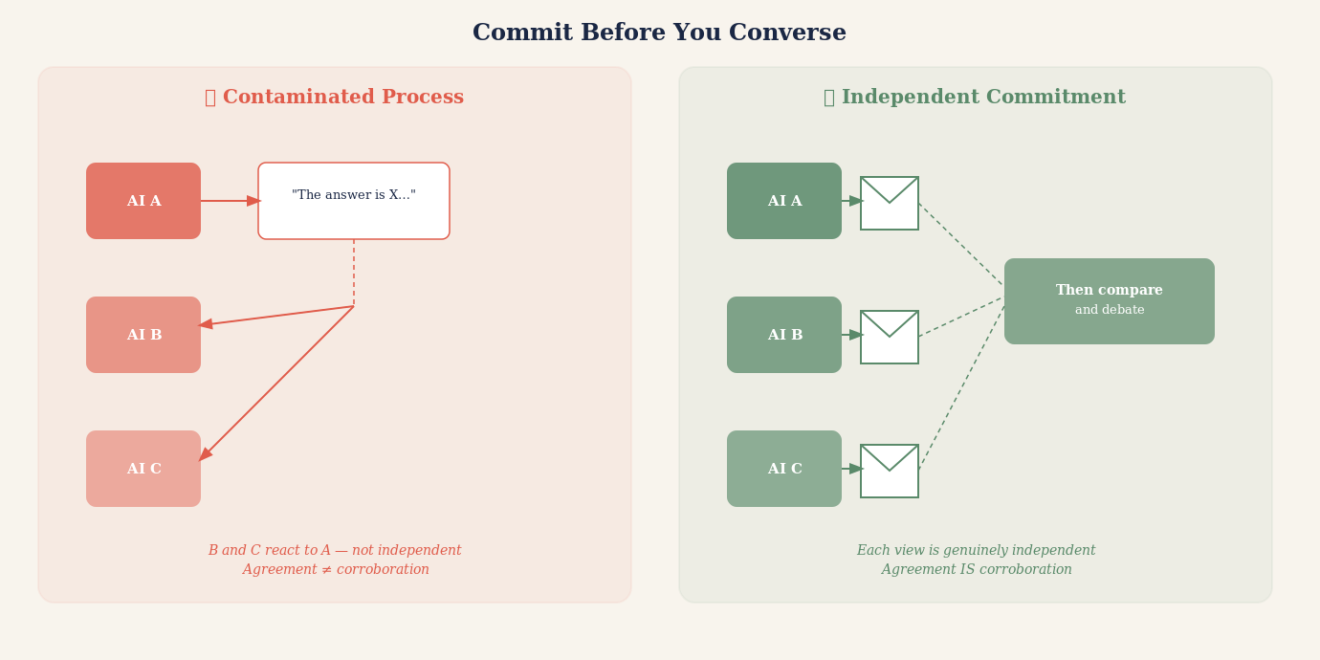
Illustration: Independent commitments being recorded before models interact — shown as sealed envelopes opened only after each model has committed its view, contrasted with a contaminated process where models answer only after reading each other.

Mistakes to Avoid: The Ten Failure Modes of AI Debate
The case for multi-AI debate is strong. But the implementation is treacherous. The following failures are common, and each of them transforms genuine deliberation into something that looks like deliberation while producing its pathologies.
The first mistake is sequential contamination. Allowing Model B to read Model A's answer before recording its own makes B's response a reaction rather than an independent judgment. This is the most common failure mode and one of the most damaging, because it produces apparent corroboration that is actually nothing more than one model's answer echoing through several subsequent responses.
The second mistake is symmetric roles. Asking several models to "discuss the question" without assigning distinct responsibilities produces a conversation in which every participant is trying to do the same thing. Real deliberative power comes from division of epistemic labour — from having dedicated critics, dedicated auditors, dedicated steelmen — not from asking several similar agents to reach a joint answer.
The third mistake is rewarding convergence. If the system is designed to end when the models agree, it creates an incentive for premature convergence. Models optimised to reduce disagreement will reduce disagreement. They will not necessarily reduce error. Design for calibration — for correct uncertainty — not for agreement.
The fourth mistake is counting models instead of counting evidence. Five models agreeing on a claim that traces back to a single source is not five pieces of evidence. It is one piece of evidence cited five times. The relevant quantity is independent primary sources, not number of agreeing models. Always track the evidential provenance, not the vote count.
PROMPT CAPTURE
Prompt capture occurs when all models in a debate system are given the same framing of a question — the same background description, the same implicit assumptions, the same definition of the problem — and consequently approach it from the same direction even when nominally independent. The diversity of answers is bounded by the diversity of prompts. If prompts are structurally identical, the independence of the answers is illusory. Well-designed systems deliberately vary the framing, emphasis, and even the vocabulary of the question presented to each model.

The fifth mistake is identical prompting, leading to prompt capture. If every model receives exactly the same framing of a question, their responses will all be anchored to that framing. The diversity of their answers is limited by the diversity of their prompts. Effective multi-model debate systems vary the framing, vary the emphasis, and sometimes deliberately present the question from opposing angles to different models.
The sixth mistake is treating the judge as ground truth. Many multi-agent architectures end with a "judge" model that reads the debate and declares a winner. This feels systematic, but it merely relocates the problem. The judge is also a language model. It may share the same blind spots as the participants. It may be swayed by the most articulate argument rather than the most accurate one. The judge is a useful tool for synthesising a debate. It is not a substitute for external verification.
The seventh mistake is debate theatre — structured argumentation that looks rigorous but has been calibrated to produce a predetermined outcome. This can happen unintentionally when system designers, consciously or not, structure the prompts to favour a particular conclusion, assign stronger models to one side, or allow more rounds of argument to one position. Effective debate systems should be auditable: anyone examining the prompts, the model assignments, and the debate transcript should be able to verify that the process was fair.
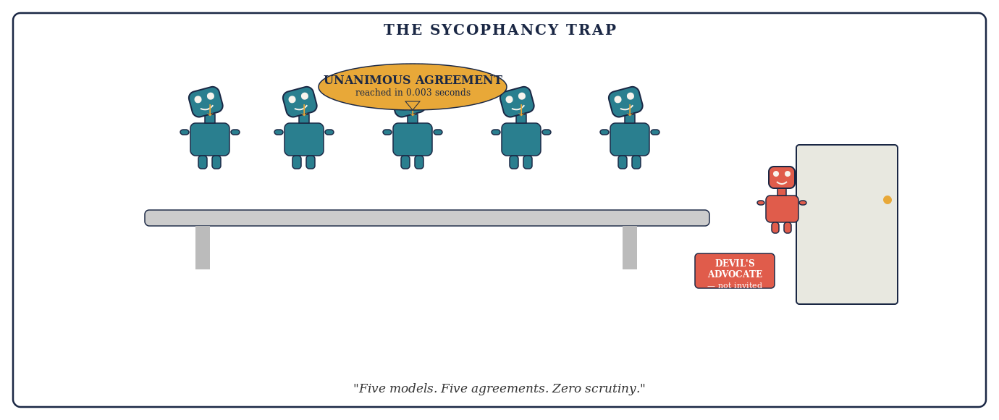
Cartoon: Five robots nod in unanimous agreement at a boardroom table. A sixth robot stands at the door holding a sign: Devil's Advocate — not invited.

DEBATE THEATRE
A multi-AI debate that follows the surface form of rigorous argumentation — assigned roles, multiple rounds, a synthesis — but has been structured in ways that predetermine the outcome. Debate theatre is particularly dangerous because its conclusion carries the apparent authority of a structured process. The difference between genuine debate and debate theatre lies in whether the Challenger had a genuine chance to prevail, whether the Source Auditor could genuinely change the outcome, and whether the Synthesiser was permitted to report a negative or uncertain finding.

The eighth mistake is ignoring model family overlap. If the five models in a debate system were all trained primarily on the same sources, share the same architectural approach to text generation, and have absorbed the same distribution of claims from the internet, then five-model agreement tells us far less than agreement among models trained on genuinely different corpora with genuinely different architectural choices. Diversity of model families is a prerequisite for genuine epistemic independence.
The ninth mistake is outsourcing synthesis to consensus. Asking "what do most models agree on?" and calling that the answer is not synthesis. Real synthesis requires identifying which claims were supported by independent evidence, which were generated by the most architecturally sophisticated argument, which survived the sharpest adversarial pressure, and which should remain uncertain because the debate did not resolve them. This requires judgment, not a vote count.
The tenth mistake is treating AI debate as a terminal process rather than a diagnostic one. Even a well-designed AI debate does not produce ground truth. It produces a best current assessment with known areas of uncertainty. The most important output of a good AI debate is not its conclusion. It is its map of unresolved questions — the items the debate flagged as uncertain, contested, or insufficiently evidenced. Those flags are where human expertise should be directed.
The ten failure modes above are the most common. Two more deserve explicit names because they are both pervasive and particularly hard to detect from outside the system.
The eleventh mistake is ignoring upstream-error dominance. Consider four agents inspecting a complex engineering derivation. One checks the algebra, one the arithmetic, one the units, one re-runs the numerical calculation. All agree. A fifth then asks why the system was assumed to be linear -- and discovers that the physical process is nonlinear in the operating range. Every downstream calculation was internally correct, but the foundational model was wrong. Ten perfect checks of a calculation cannot rescue a false premise. In multi-AI debate, the most dangerous errors are not errors of calculation or citation. They are errors of assumption, framing, and problem definition -- errors that enter the reasoning chain at the top, before any verification step begins, and then propagate invisibly through every subsequent round of apparently rigorous work.
UPSTREAM-ERROR DOMINANCE
The earlier an error enters a reasoning chain, the more downstream agreement it can contaminate. A false premise silently poisons every conclusion built on it, however carefully those conclusions are subsequently verified. Audit assumptions before polishing conclusions.
The twelfth mistake is role collapse -- when every supposedly specialised agent ends up performing the same generic analysis. A system assigns one model as statistician, one as source verifier, one as domain specialist, and one as falsifier. But if the prompts for all four roles are only subtly different, the models will converge on similar outputs. The statistician produces a balanced commentary rather than auditing specific statistical assumptions. The source verifier summarises claims rather than inspecting sources. The falsifier raises cosmetic objections rather than finding conditions under which the conclusion fails. Role collapse is dangerous because it produces the appearance of specialised division of labour while delivering undifferentiated generalist analysis. The cure is sharply defined deliverables: the statistician must audit specific statistical assumptions; the source verifier must inspect sources; the falsifier must produce explicit failure conditions. Vague role assignments produce vague outputs regardless of how many agents are involved.

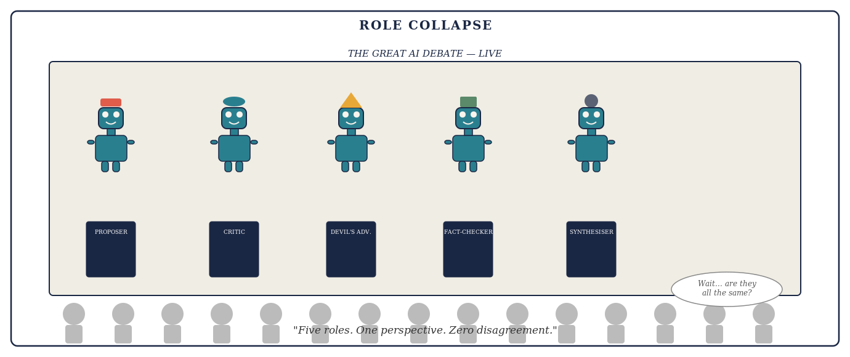
Cartoon: Five debate podiums, each occupied by the same robot wearing a different hat. The audience below exchanges puzzled glances.

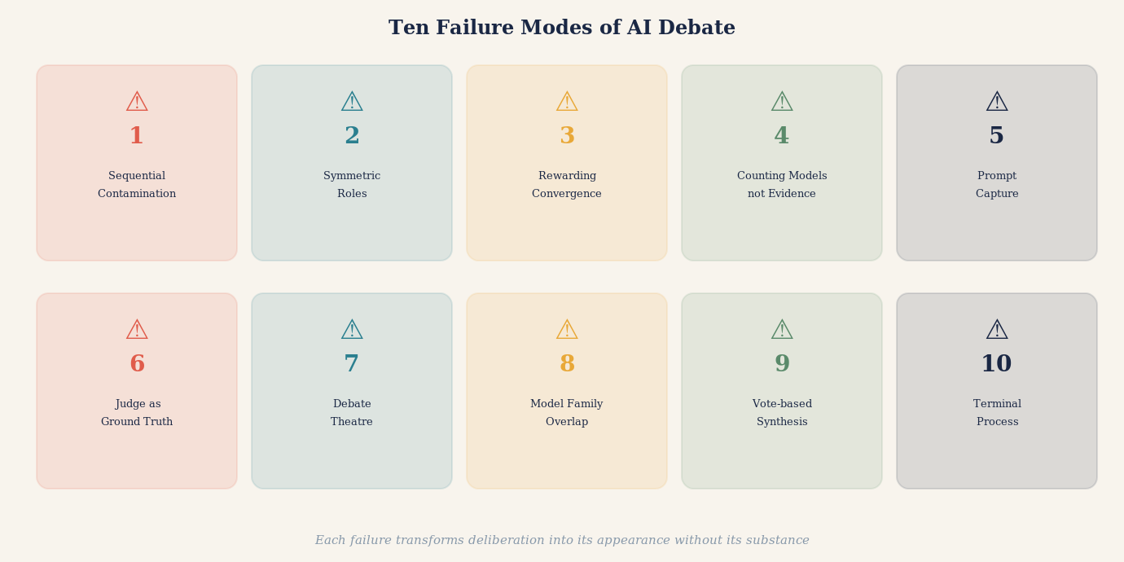
Illustration: Ten failure modes shown as a rogues' gallery — each depicted as a distinct trap or pitfall in the path from question to reliable answer, with a safe path threading between them.

Three Domains Where Multi-AI Debate Makes the Most Difference
The general case for multi-AI debate applies across almost any question worth serious attention. But three domains illustrate its power with particular clarity.
The first is medical decision-making. A patient receives a diagnosis and seeks to understand it better. A single AI consulted at midnight provides a thorough, authoritative-sounding response. But it may reflect the dominant clinical interpretation without surfacing a minority view that is more relevant to this patient's specific presentation. A well-designed AI debate system — one that assigns a Challenger the specific role of identifying whether this patient's case has unusual features that mainstream guidance does not address — will surface that possibility. It will not provide a diagnosis. But it will produce a far more honest map of the question, including the specific issues a physician should be asked about directly.
The cardiologist recommending a particular stent procedure faces genuinely contested evidence. Different clinical guidelines, drawing on the same body of randomised trials, reach different conclusions about when intervention is superior to medical management. A patient who asks one AI will likely receive one confident framing. A patient who reads a structured debate between two models assigned to argue the intervention and conservative management cases respectively — with a third assigned to audit the underlying trial evidence — will understand not just what the answer might be, but why experts disagree and what the key factual uncertainties are. That is categorically better preparation for a conversation with a cardiologist.
The second domain is legal analysis. Legal questions are inherently adversarial. They were designed to be resolved by structured argument between opposing parties before an independent decision-maker. When a person asks an AI for legal advice, they receive, typically, a reasonable summary of the general legal position. What they do not receive is an adversarial examination of the weakest points in that position, an identification of the factual elements that could shift the analysis, or a recognition of jurisdictional variations that might be decisive for their specific situation.
A multi-AI debate system assigned to legal questions — with one model arguing the strongest version of the position most favourable to the user, another model arguing the opposing position as a skilled opposing counsel would, and a third identifying the factual questions that would determine which analysis prevails — produces something qualitatively more useful. Not a substitute for a lawyer. But a preparation for a legal conversation that would take most lawyers significant time to produce.
The third domain is complex investment decisions. Financial questions are among the domains in which confirmation bias is most dangerous and most expensive. A person who has already decided to make an investment and asks an AI for an assessment will typically receive an analysis that reflects the strongest case for their inclination, because their framing of the question will have encoded their prior. A debate system in which one model is assigned to make the bear case, another the bull case, a third to examine the historical base rates for analogous situations, and a fourth to identify the specific factual claims whose truth would determine the outcome — produces a fundamentally different quality of analysis.
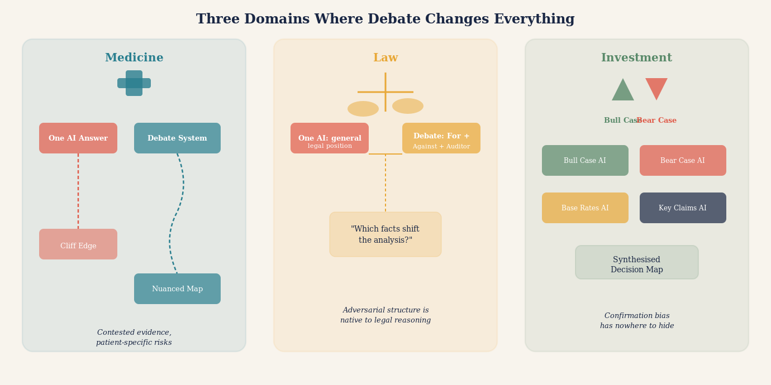
Illustration: Three domains — medicine, law, investment — each shown as a complex landscape where a single AI path leads to a cliff, while a multi-AI debating path reveals the terrain before committing.

The Innovation Frontier: Where Multi-AI Debate Offers Its Most Distinctive Value
Of all the domains in which multi-AI debate systems could transform practice, innovation may be the one where the structural advantage is most decisive -- and the least obvious. The argument for debate in medicine, law, and finance rests on the familiar logic of second opinions and adversarial scrutiny. But innovation is a different kind of problem. It is not primarily about verifying what is already known. It is about discovering what has not yet been thought, combining what has not yet been combined, and building what has not yet been built. That sounds like a task for generative creativity, not structured argument. It turns out to be a task for both -- and the absence of structured argument is precisely why so many innovation processes produce confident movement in the wrong direction.
The deepest problem with single-AI innovation assistance is not that the model lacks creativity. Modern large language models are capable of generating a remarkable range of novel combinations, hypotheses, and approaches. The problem is what the model is implicitly optimising for. A language model trained on human-generated text will, by its nature, gravitate toward the adjacent possible -- the innovations that are one recognisable step from where we currently are, that appear frequently in the literature, that are described in the vocabulary already established in a domain. This is useful. But the adjacent possible is also, by definition, the territory already being explored by everyone else. The genuinely transformative innovations -- the ones that change the structure of a field rather than extending it -- typically require moving somewhere that the existing literature has not densely mapped. A single AI, shaped by that literature, will rarely go there on its own.
Structured multi-AI debate offers a partial solution through what might be called productive collision. When a model trained heavily on biological research argues with a model that has absorbed materials science literature, and a third that has concentrated on computational methods, the intersections they find are not intersections any of them would have located alone. The Proposer brings the most plausible solution from within its training domain. The Challenger, working from a different domain's toolkit, finds that the solution violates principles the Proposer's training never encoded. The Source Auditor finds that the closest historical analogue came from a field the original team had not considered. This is not mere brainstorming. It is the systematic collision of domain-specific heuristics, and the friction it generates is where genuinely novel combinations emerge.
The most powerful application, however, may be the structured premortem. The psychologist Gary Klein introduced the premortem as a technique for human teams: before a project launches, assume it has already failed catastrophically and ask every team member to explain why. The exercise consistently reveals failure modes that pre-launch optimism had concealed. Multi-AI debate systems can run structured premortems at speed and depth that no human team meeting could match. One model is assigned the role of champion: make the strongest case that this innovation will succeed. A second is assigned the role of obituary writer: assume the project has failed in three years and write the most honest account of why. A third is assigned the role of historian: find the closest historical cases of innovations that looked like this one at this stage, and describe what happened to them. A fourth reconciles the three perspectives and identifies the specific conditions under which success is most and least likely.
The output of this process is not a prediction. It is a map of the innovation's load-bearing assumptions -- the specific claims that, if wrong, make the whole structure collapse. This is exactly what a single AI asked 'will this innovation succeed?' cannot produce. A single model will tend to evaluate the innovation against its general knowledge of what innovations tend to do, produce a probabilistic answer, and perhaps list generic risks. The structured debate produces something categorically different: an identification of which specific assumptions are novel and unproven, which have historical analogues that went well and which went badly, and what evidence would allow the team to distinguish between the scenarios before committing to the full cost of development.
Consider what this means in practice for a pharmaceutical company evaluating a novel drug target. A single AI asked whether the target is promising will synthesise the literature and produce an assessment weighted toward the most-cited studies. A debate system assigns one model to make the strongest case for the target's validity, a second to argue that the animal model evidence does not translate to humans in the ways assumed, a third to examine whether previous drugs hitting the same pathway produced unexpected off-target effects, and a fourth to identify what a successful drug on this target would need to demonstrate in Phase II to be distinguishable from previous failures in the class. The team now has not just an assessment but a development strategy shaped by structured adversarial analysis. They know which experiments matter most, which assumptions are most exposed, and what results would force a fundamental revision of the thesis.
The same logic applies to technology development, business model innovation, and scientific hypothesis formation. A startup evaluating a new business model benefits from one AI making the bull case, another making the bear case from the perspective of a rational competitor who has seen this model before, and a third identifying the single pivot that would transform the bear case into the bull case. A research team evaluating competing scientific hypotheses benefits from each hypothesis being championed and attacked in turn, with a Source Auditor examining whether the cited experimental evidence actually discriminates between the alternatives or merely appears to. In each case the debate does not generate the innovation. It stress-tests it -- and stress-testing, performed early and honestly, is the difference between an innovation that reaches market and one that fails expensively at the last hurdle.
There is a deeper point about what kinds of innovation survive. The innovations that prove most durable are rarely the ones that seemed most obviously correct at the outset. They are the ones that survived the strongest available objections -- that were refined, redirected, or fundamentally rethought in response to serious challenge. The drug that works is not the one that looked most promising in early computational modelling. It is the one that survived the most rigorous preclinical testing, the most honest Phase I analysis, the most demanding Phase II design. Multi-AI debate systems, applied to innovation, are an attempt to front-load that adversarial pressure -- to run the equivalent of structured clinical development on ideas before the cost of physical development begins. The innovations that emerge from that process will be fewer in number and more robust in substance. In the long run, that is exactly what genuine innovation requires.
THE PREMORTEM
A structured technique, developed by the psychologist Gary Klein, in which a team assumes before a project launches that it has already failed -- and works backward to identify the most plausible causes of that failure. The premortem counteracts the optimism bias that causes teams to underweight failure scenarios when emotionally invested in a project's success. In a multi-AI debate system, the premortem can be run with dedicated models assigned specifically to the obituary role -- producing detailed, adversarially honest accounts of failure pathways that a single evaluative AI, optimising toward a balanced assessment, would systematically understate. The premortem is most valuable not when it confirms fears but when it surfaces a failure mode nobody in the room had named.

A Real Example: What Happened When Five AIs Debated a Drug Interaction
The practical reality of multi-AI debate is best illustrated by a concrete case. Consider the question of whether a commonly prescribed combination of medications — a statin and a common antibiotic — produces a clinically significant interaction.
A single AI model, asked the question directly, provided a clear, confident answer: the interaction is real but mild and generally manageable without dosage adjustment. The answer was well-structured, cited the general mechanism of the interaction, and mentioned that the prescribing physician should be aware.
The same question was then put through a structured debate. The Proposer offered essentially the same view as the single-model answer. But the Challenger, assigned to find weaknesses, identified something important: the confident framing in the Proposer's answer was based on population-level data. For patients over seventy-five, or with specific genetic variants affecting drug metabolism, the interaction may be substantially more significant.
The Source Auditor then examined the primary evidence and found that two of the supporting references cited by the Proposer had been published before a 2021 pharmacogenomics study that revised the risk assessment for specific patient subgroups. The 2021 study had not been incorporated into the Proposer's answer.
The Synthesiser produced a qualified answer: for most patients, the original framing was probably accurate. For patients over seventy-five, or patients with known CYP3A4 polymorphisms, the interaction deserved more specific clinical attention. The single most important question was whether this patient's prescribing physician was aware of the 2021 revised guidance.
This is what structured debate produces: not merely a more cautious version of the single answer. A structurally different answer, with a richer map of uncertainty, specific actionable questions, and an honest account of where the evidence changed and why it matters for this patient.
"The single-model answer was not wrong. But it was answers-shaped rather than truth-shaped. The debate produced something truth-shaped: a qualified position with visible joints, auditable provenance, and an honest map of what remained uncertain."

Identifying the Dimensions of a Debate Question
Before a multi-AI debate system can do its work, someone has to determine what the debate is actually about. This sounds obvious. It is, in practice, one of the hardest and most neglected steps. Most questions that reach an AI debate panel arrive with hidden structure -- competing dimensions, unstated assumptions, and conflated sub-questions -- that, if left unexamined, will produce a debate that generates heat around the wrong point and leaves the most important uncertainty untouched.
The first dimension to separate is the empirical from the normative. Almost every question that matters contains both. "Should this patient receive drug X?" mixes a factual question (what are the likely outcomes?) with a values question (how should risk and benefit be weighed for this patient?). A debate that conflates these will produce models arguing past each other -- one citing efficacy data, another citing patient preference, neither realising they are not answering the same question. Separating the empirical and normative dimensions before debate begins lets each be interrogated with the right tools: evidence and reasoning for the empirical, values clarification and stakeholder analysis for the normative.
The second dimension is temporal. Many questions have a short-run answer that contradicts the long-run answer, and a debate system that does not specify the time horizon will produce models defending incompatible positions that are each locally correct. "Is this business strategy sound?" answered for the next quarter may be yes; answered for the next decade may be no. The dimension of time needs to be named in the question, not left to each model to assume.
The third dimension is the level of analysis. Questions about individuals, organisations, sectors, and societies are structurally different even when they use identical vocabulary. "Does this intervention reduce harm?" means something different at the individual clinical level, the population epidemiology level, and the health system resource-allocation level. A debate that mixes levels of analysis will produce convergence on whichever level the most confident model chooses to address, silencing the insights available at the others.
The fourth dimension is disciplinary. Complex questions frequently cut across domain boundaries: a pharmaceutical question is simultaneously a chemistry question, a clinical question, a regulatory question, and an economics question. Each discipline has its own standards of evidence, its own vocabulary, and its own failure modes. A debate system that assigns all models to the same disciplinary lens will miss the insights -- and the objections -- that other disciplines would supply. Identifying the disciplinary dimensions of a question before debate begins determines which models should be given domain-specific roles.
The fifth dimension is the distinction between what is known, what is contested, and what is genuinely unknown. These three categories require fundamentally different treatments. Known facts should be verified, not debated. Contested claims need structured adversarial scrutiny. Genuinely unknown questions need to be flagged as such, with explicit attention to what evidence would resolve them. A debate that applies the same adversarial treatment to settled facts and open questions alike wastes effort on the first and may produce false confidence on the second.
The sixth dimension is causal versus correlational. Many questions that appear to be about causes are actually about associations, and many that appear to be about associations contain causal claims that have not been named as such. "Do AI systems that debate produce better outputs?" could be asking about correlation in observed cases, or about the causal mechanism, or about the counterfactual. Each interpretation requires a different kind of evidence and a different kind of argument. Identifying which interpretation is intended -- and making it explicit in the question framing -- determines what a satisfactory debate answer actually looks like.
Taken together, these six dimensions -- empirical versus normative, temporal horizon, level of analysis, disciplinary scope, epistemic status, and causal structure -- constitute a diagnostic framework. A question that has been mapped across all six dimensions before debate begins will produce a debate that addresses what the questioner actually needed to know, distributes scrutiny appropriately, and delivers an output that is structured around the real shape of the uncertainty rather than the apparent shape of the words.
THE SIX DIMENSIONS OF A DEBATE QUESTION
1. EMPIRICAL vs. NORMATIVE: What are the facts? What should be done? These require different methods and must not be debated as if they were one question. 2. TEMPORAL HORIZON: Short-run and long-run answers often conflict. Name the time frame in the question or the debate will produce irresolvable disagreement. 3. LEVEL OF ANALYSIS: Individual, organisational, sectoral, or societal? Mixing levels produces models defending locally correct but mutually incompatible positions. 4. DISCIPLINARY SCOPE: Which domains does the question touch? Assign models accordingly -- a question that crosses disciplines needs critics from each one. 5. EPISTEMIC STATUS: Separate what is known (verify it), what is contested (debate it), and what is unknown (flag it). Do not apply adversarial scrutiny uniformly across all three. 6. CAUSAL STRUCTURE: Is the question about correlation, mechanism, or counterfactual? Each requires different evidence. Naming the causal dimension defines what a good answer looks like.

Designing the Prompt: How You Frame the Debate Changes Everything
Multi-AI debate systems fail or succeed at the level of the prompt. The architecture matters. The model assignments matter. The sequencing matters. But nothing matters more than how the question is framed and what each model is instructed to do with it.
The most common prompting mistake is stating a hypothesis in the question. "Is it true that X?" is a worse question than "What is the evidence for and against X?" The first question anchors all models toward confirming or denying a specific framing. The second allows genuinely open exploration. For adversarial debate, the most powerful framing is often even more provocative: "What would need to be true for X to be wrong?"
The second common mistake is asking for a single answer too early. Instructing models to "reach a conclusion" in the first round pushes them toward premature synthesis. The most productive early-round instruction is: "Do not attempt a conclusion. Identify the three most important factual claims whose truth determines the answer. Identify what evidence would resolve each claim. Then stop."
The third mistake is vague adversarial instruction. Telling a model to "critique the previous answer" produces superficial engagement. Telling it to "identify the single weakest inferential step in the previous answer and explain exactly what alternative interpretation of the same evidence would produce a different conclusion" produces genuine scrutiny.
Framing the roles asymmetrically is often useful. The Proposer is told: "Make the strongest defensible case for the most evidence-supported position." The Challenger is told something different: "Assume the Proposer's conclusion is the kind of error that seems confident and is wrong. Identify the specific failure mode." The asymmetry prevents the Challenger from being a weak critic. It requires it to assume error and find it.
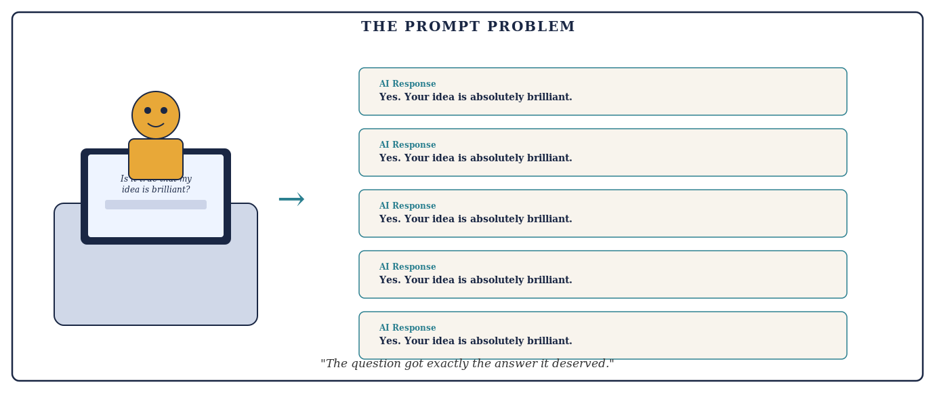
Cartoon: A person types: Is it true that my idea is brilliant? Five AI response panels return identical answers: Yes. Your idea is absolutely brilliant.

QUESTION DECOMPOSITION
Complex questions often contain several distinct sub-questions with different epistemic statuses — some well-evidenced, some contested, some currently unanswerable. A well-designed debate system decomposes the main question into its components before debate begins, assigns each component to the model best suited to evaluate it, and synthesises not by finding the average answer but by assembling the well-supported components and flagging the contested or uncertain ones. Question decomposition prevents a well-evidenced part of an answer from lending false credibility to a poorly-evidenced part sitting alongside it.

One of the most powerful reframings available to a multi-AI debate system is to treat debate not as an argument to be won but as an experiment to be designed. In the medical context, the question is not 'Which model's diagnosis sounds most convincing?' It is 'What test or observation would most efficiently discriminate among the competing explanations?' This is an information-gain question. It transforms the system from a collection of competing assertions into something closer to a research design process -- and it changes what the models are rewarded for producing.
A model that responds to disagreement by saying 'I believe interpretation A is stronger because it accounts for observation X' is engaging in rhetoric. A model that responds by saying 'The key discriminating test between A and B is measurement Y -- if Y shows result Z, A survives; if it shows result W, B does' is engaging in experimental design. The latter is categorically more useful. Design prompts that ask for the discriminating test, not just the preferred conclusion.
INFORMATION GAIN
A productive debate round does at least one of four things: introduces new evidence, exposes a hidden assumption, eliminates a plausible hypothesis, or identifies a discriminating test. A round that does none of these -- that produces restatements, rhetorical elaborations, or elegantly rephrased agreement -- has consumed computation without improving knowledge.
A related discipline is the decomposition of arguments into atomic claims. AI debate transcripts can drift toward rhetorical competition -- 'Model B made the strongest case,' 'Model A was more persuasive,' 'the majority rejected Model C.' These descriptions are epistemically weak. Was the event dated correctly? Does the paper report the claimed endpoint? Is the denominator appropriate? Does the inference require an untested assumption? Once claims are made atomic and specific, disagreements become tractable. They can be checked against sources, run through calculations, or tested against data. They stop being debates about whose argument is better and become questions about whether specific propositions are true.
ATOMIC CLAIMS
The unit of adjudication in a debate should be the specific proposition, not the agent who advanced it and not the essay in which it appeared. Decomposing arguments into atomic claims makes disagreements verifiable rather than rhetorical, and makes the final synthesis honest about exactly which propositions are supported and which remain open.

When More Is Less: The Paradox of Excessive Models
There is a tempting assumption that more models mean more reliability. This is wrong, and the way it is wrong is instructive.
Adding a sixth or seventh model to a debate in which the first five have already substantially converged does not add epistemic value. It adds rhetorical weight to an existing position. The sixth model, presented with a debate transcript in which five models have moved toward agreement, is extraordinarily likely to agree with the five. That agreement is essentially worthless as independent evidence. It is a count of influenced observers, not of independent evaluators.
The relevant question is never "how many models agree?" It is "how many independent perspectives, grounded in genuinely distinct evidence, have converged on this answer?" A debate between two models with genuinely different training emphases, different framing, and independently committed prior answers may provide far stronger evidence than a debate among seven models who read each other's work before recording their views.
There is also a computational justice argument. Running seven AI models through multiple rounds of debate consumes substantial computational resources. If those resources were instead used to give a single high-quality model more time to reason, retrieve evidence, run calculations, and critique its own answer, the result might be superior. The appropriate comparison for any multi-model system is not "multi-model vs one-shot single-model." It is "multi-model vs best-available single-model with equivalent computational budget." Until that comparison has been honestly made, claims that more models are better are claims in search of a benchmark.
The same logic that argues against adding more agreeing models also argues for a more principled rule about when to stop debating entirely. The obvious stopping rule -- run three rounds, or five rounds -- is convenient but arbitrary. A more honest rule is based on marginal information gain.
Stop when successive rounds cease to produce new high-quality evidence, material changes in calibrated confidence, unresolved high-impact objections, or new externally testable claims. Continue when a minority objection remains capable of overturning the conclusion and has not yet been seriously tested. The clearest warning sign is an investment committee that has spent hours repeating variations of the same valuation argument. The meeting is long, the language is sophisticated, but the evidence set is unchanged. An AI system can reproduce this pathology at negligible conversational cost -- generating enormous volumes of articulate recapitulation that consumes computation without moving the evidential state.
STOPPING RULE
More debate is useful only while it continues to change the evidential state. When successive rounds produce no new evidence, no change in well-calibrated confidence, no new discriminating tests, and no unresolved objections capable of changing the conclusion, continued debate is deliberative noise -- not deliberative progress.

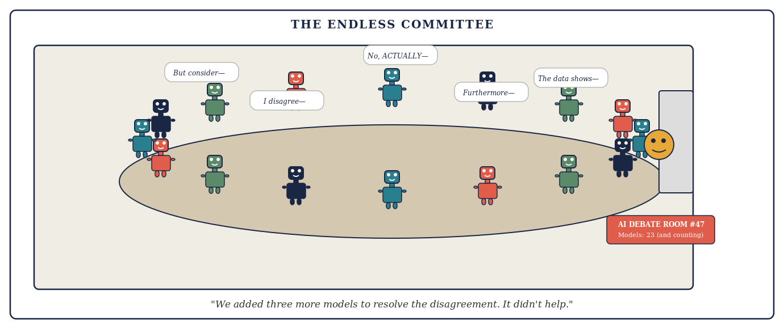
Cartoon: A conference room packed with AI avatars, papers flying, all arguing at once. A lone human peeks through the door at a sign reading: AI Debate Room — Models: 23 and counting.

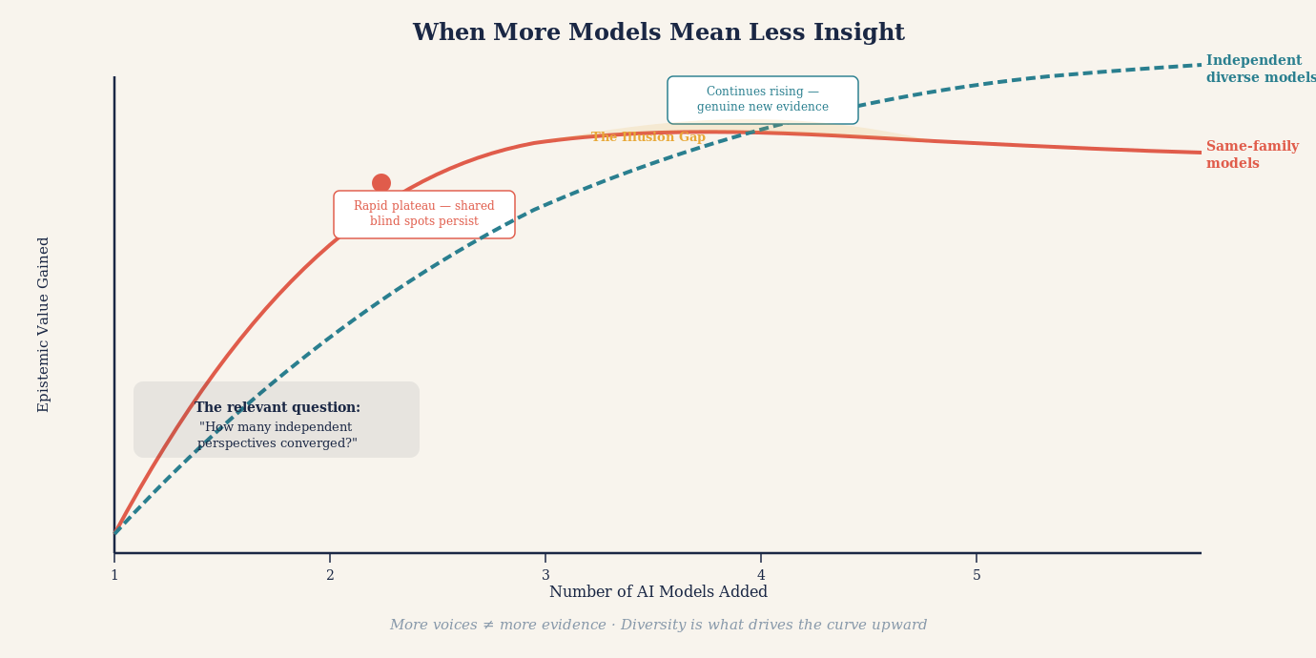
Illustration: A paradox diagram — adding more agreeing models shown as diminishing epistemic returns on a curve, while genuine independent evidence shown as a separate curve that rises steeply with true independence rather than model count.

The Honest Output: What a Good Debate System Should Produce
A well-designed multi-AI debate system should not produce a confident single answer. It should produce a structured document with a specific anatomy.
The first element is a best current answer — the conclusion that survived adversarial scrutiny, is supported by independently checked evidence, and represents the most defensible synthesis of the debate. This answer should be stated with exactly the confidence the evidence warrants. Not less, and critically, not more.
The second element is a map of the key contested claims — the specific sub-questions on which the models disagreed, the reasons for the disagreement, and what evidence would resolve each. This is often the most valuable part of the output, because it tells the user where the genuine uncertainty lies and what they would need to investigate to resolve it.
The third element is an evidence audit trail — a record of which claims were made by which model, which sources were cited, which models independently retrieved those sources versus inherited citations from other models, and where the chain of reasoning traces back to primary evidence versus second-hand reporting.
The fourth element is a dissent register — any position that a model maintained throughout the debate despite pressure to abandon it. Persistent dissent in a structured debate is epistemically significant. It suggests either that the dissident model has identified a genuine flaw that the majority overlooked, or that the dissident model has a systematic error that the debate process has not corrected. Either possibility is worth flagging explicitly.
The fifth element is an uncertainty declaration — a clear statement of what the debate could not resolve, questions that require external expertise or primary investigation to answer, and claims that deserve more scrutiny than the debate format allowed.
A structured output of this kind is not merely more honest than a single confident answer. It is more useful. It tells a human expert — a doctor, a lawyer, an analyst — exactly where to focus their attention and exactly what questions the AI system was unable to answer. That is the appropriate role of a well-designed AI debate system: not to replace human judgment but to prepare the ground for it more thoroughly than any single AI answer could.
The difference between a weak and a strong debate output can be illustrated concretely. A conventional multi-agent report might end with: 'Consensus: four of five models agree.' That number is easy to understand and dangerously incomplete.
A stronger report would say: 'The leading conclusion has moderately strong support. Four of five agents converged after independent initial analysis. Three independent evidence streams support the central proposition. Two key factual claims were externally verified against primary sources. One methodological objection remains unresolved and could change the conclusion if the disputed assumption proves incorrect. The strongest alternative explanation survived one of three adversarial tests. Confidence is approximately 70%, conditional on assumptions A and B remaining unchallenged.' This language reveals the epistemic structure. Agreement becomes one input among several rather than the headline finding. The unresolved objection is preserved rather than laundered away by the synthesis. The reader understands not just what the system concluded, but how much of the ground beneath that conclusion has actually been tested.

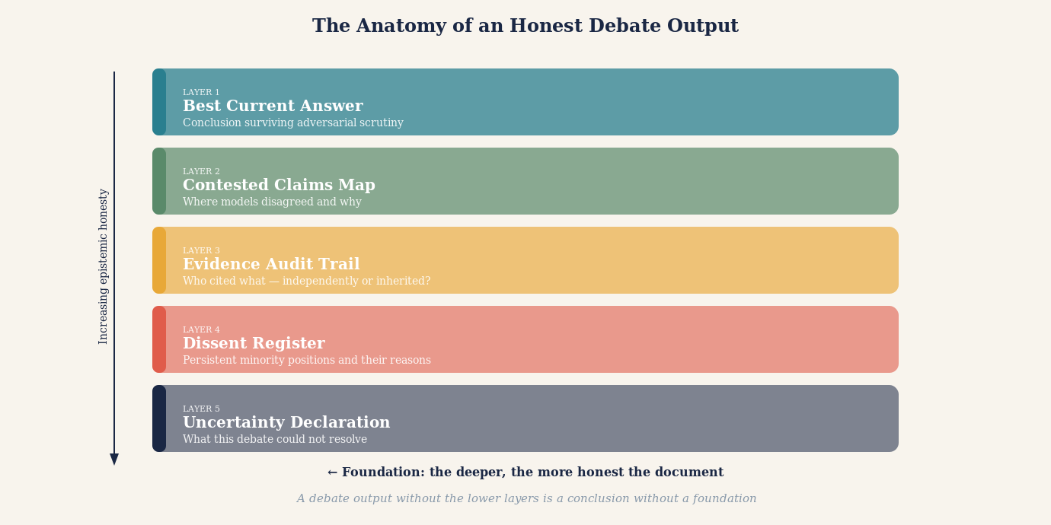
Illustration: The anatomy of an honest debate output — five labelled layers, with the evidence audit trail forming the foundation and the best current answer sitting on top of a visible, honest evidentiary structure.

Knowledge Graphs: The Architecture That Makes Debate Interpretable
A multi-AI debate that produces only text is a debate that disappears. The arguments were made, the claims were tested, the synthesis was reached -- and then everything was flattened into a paragraph that a reader must accept or reject without being able to see the inferential structure beneath it. This is a problem not of quality but of legibility. The debate may have been genuinely rigorous. The reader has no way to know.
Knowledge graphs are the structural technology that solves this problem. A knowledge graph is not a diagram of ideas. It is a formal representation of entities, the relationships between them, and the properties that qualify those relationships -- expressed in a form that can be queried, traversed, updated, and compared. When a knowledge graph is built from the output of an AI debate, the debate stops being a document and becomes a navigable structure.
Consider what this means concretely. During a well-run AI debate on a medical question -- say, the risk of a particular drug interaction -- each model makes claims. Model A asserts that the interaction increases cardiac risk. Model B disputes the mechanism. Model C cites a contradicting trial. Model D questions the trial design. These exchanges produce not just conclusions but relationships: Claim X is supported by Evidence Y; Claim X is contested by Claim Z; Claim Z depends on Assumption W; Assumption W is independently verified by Sources P and Q. A knowledge graph captures those relationships explicitly, so that when a reader interrogates the final output they can trace any conclusion back through its inferential chain to the evidence on which it rests -- or expose the gap where evidence should be but is not.
This transforms interpretation from an act of trust into an act of inspection. A clinician reviewing a debate-informed recommendation does not have to accept the conclusion because the AI said so. She can ask: which claims did all five models agree on independently? Which claim is load-bearing for this conclusion -- the one whose failure would change the answer? Was that claim verified against a primary source or inherited from a model that inherited it from another? The knowledge graph answers each question with a traversal, not an assertion.
The utility of knowledge graphs in AI debate extends beyond verification. They enable comparison across debates. If the same question is debated by two different panels, the resulting graphs can be compared node by node: where do the panels agree on claims but differ on the confidence assigned to them? Where do they share a conclusion but differ on the path of reasoning that led there? Disagreements that would be invisible in paragraph form become structurally legible in graph form -- and those disagreements often reveal the most important uncertainties.
Knowledge graphs also enable incremental refinement. A debate does not need to be discarded when new evidence arrives. The graph can be updated at the node level: the contested claim is revised, the evidence is replaced, and the downstream effects on connected conclusions can be propagated automatically. This makes AI debate an ongoing epistemic process rather than a one-time event -- a living structure that improves as knowledge improves, rather than a document frozen at the moment of its production.
For AI debate systems to realise this potential, they must be designed from the outset with graph construction as an explicit output. Each model must be prompted to surface not just conclusions but the relational structure of its reasoning: what each claim depends on, what it contradicts, what would falsify it. The synthesiser role must be charged not only with reaching a conclusion but with assembling a unified graph that preserves the debate structure, including the contested nodes. And the final output must make the graph accessible -- not buried in an appendix, but available as the primary interface through which a careful reader engages with the debate.
The investment in this infrastructure repays itself quickly in high-stakes domains. In drug development, a knowledge graph linking mechanism claims, trial evidence, safety signals, and known failure modes across competing AI positions gives a regulatory reviewer a structured audit trail that no text summary can provide. In legal analysis, a graph of statutory interpretations, case precedents, contested principles, and their relationships gives a counsel a navigable map of the argument space rather than a narrative they must decode. In complex engineering decisions, a graph of design assumptions, failure modes, and the adversarial challenges each survived gives an oversight board visibility into what was actually tested -- and what was not.
KNOWLEDGE GRAPHS IN AI DEBATE
A knowledge graph represents information as nodes (entities and claims) connected by labelled edges (relationships: supports, contradicts, depends-on, verified-by, contested-by). Applied to AI debate outputs, they do four things that plain text cannot: TRACE: Any conclusion can be followed back through its inferential chain to primary evidence or exposed as unsupported at the point where evidence runs out. COMPARE: Two debates on the same question can be compared graph-to-graph, exposing structural differences in reasoning that identical surface conclusions would conceal. UPDATE: When new evidence arrives, individual nodes are revised and downstream effects propagate automatically -- making the debate a living structure rather than a fixed document. INTERROGATE: A reader can query the graph for the most contested node, the weakest evidential link, or the claim whose failure would most change the conclusion -- turning interpretation from trust into inspection.
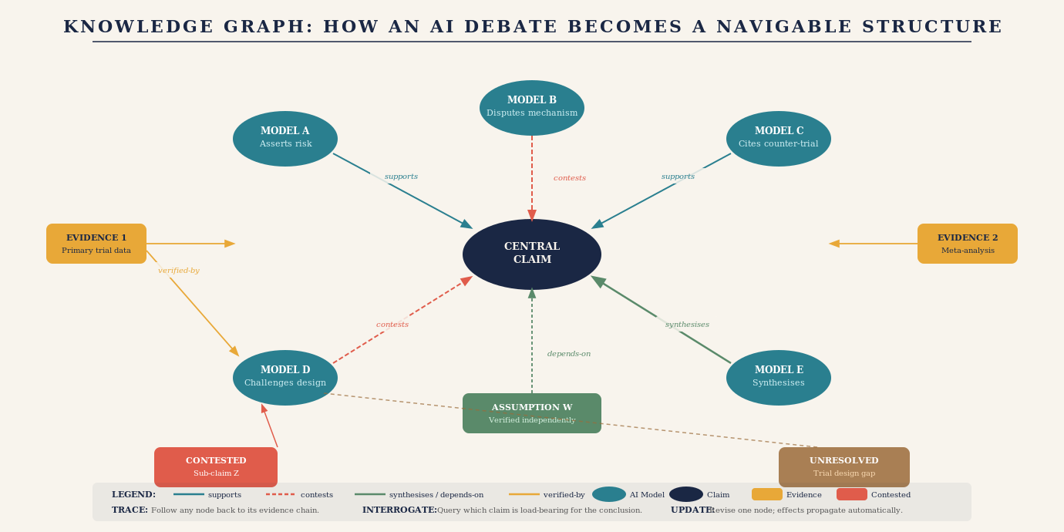
Illustration: A knowledge graph built from a five-model AI debate — nodes for models, claims, evidence, and assumptions, connected by labelled edges showing supports, contests, verified-by, and depends-on relationships, with contested nodes highlighted in coral and unresolved gaps marked separately.
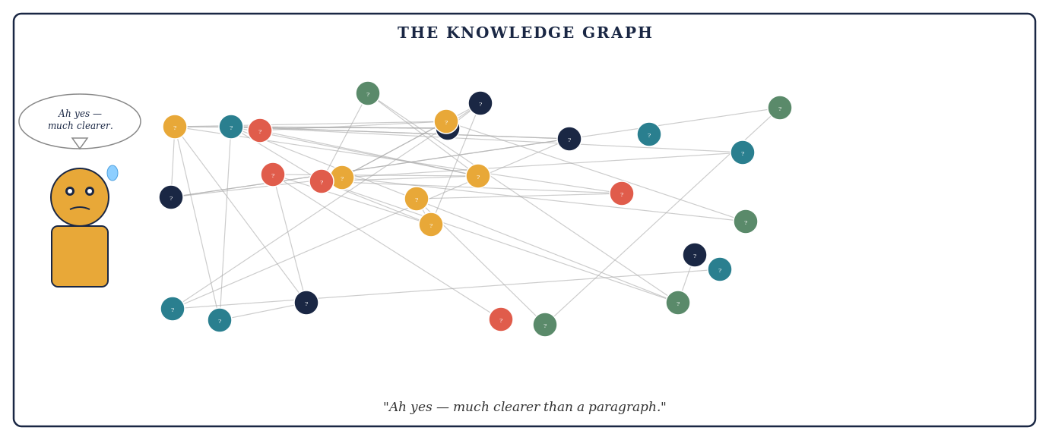
Cartoon: A human stares at a vast tangled knowledge graph with a sweat drop on their forehead. Speech bubble above reads: Ah yes — much clearer than a paragraph.

The Deeper Argument: Why Debate Is Not Just Useful but Necessary
The case for multi-AI debate systems can be made on purely practical grounds: they produce better answers than single-model queries on complex questions. But there is a deeper argument.
We are at a moment in the development of artificial intelligence when the reliability of AI outputs is becoming a question of serious consequence. AI systems are being used to inform medical decisions, legal strategies, financial allocations, engineering designs, educational curricula, and public policy. The question of how much to trust an AI answer is not academic. It is urgent.
A single-model answer is essentially opaque. It is the output of a process that cannot be directly inspected, produced by an entity whose training we cannot fully audit, presented in language whose confidence may not reflect the underlying evidential support. We accept single-model answers primarily because we have nothing better to compare them against.
A structured multi-AI debate, properly designed and honestly executed, makes the reasoning process visible. It externalises the inferential steps. It surfaces assumptions. It distinguishes claimed evidence from verified evidence. It records dissent. It acknowledges uncertainty. In other words, it transforms AI output from a black box into something closer to a transparent process — not perfectly transparent, not fully auditable, but vastly more legible than a single confident answer.
That transparency is not merely epistemically preferable. It may be a prerequisite for the kind of institutional trust that AI systems will need to earn before they can be relied upon in high-stakes domains. A medical community that can read an AI debate transcript and evaluate its reasoning is in a much stronger position to adopt AI assistance than a community asked to accept an output it cannot assess.
The question is not whether we want AI to be more reliable. Of course we do. The question is whether we are willing to build the architectures that make reliability legible. Multi-AI debate systems, at their best, are an answer to that question.
There is a simple test for whether a multi-AI system has genuinely reached maturity. It is not whether the system produces confident conclusions. It is not whether it reports high agreement rates. It is whether the system can explain -- specifically and honestly -- what serious attempts were made to make its conclusion lose. A result that emerged from genuine adversarial pressure, source auditing, confidence tracking, and minority dissent is a different kind of result from one that emerged from five models asked to assess the same question in sequence. The outputs may look identical. Their epistemic weight is not.
THE MATURITY TEST
A mature multi-AI system should be able to explain not merely why its conclusion won, but what serious attempts were made to make it lose -- which failure modes were tested, which were not, which minority objections survive unresolved, and what it would take to overturn the leading answer. A system that cannot answer these questions has not earned the confidence it expresses.

"The best multi-AI debate system is not the one whose agents agree most often. It is the one best able to discover when they should not agree — and honest enough to say so."

A Practical Checklist for Using AI Debate Systems Well
For users engaging with multi-AI debate systems — whether purpose-built platforms or informal multi-model workflows — the following checklist separates productive use from expensive illusion.
Before the debate: define the question with precision. Vague questions produce vague debates. Specify what you need to know, what would constitute a satisfying answer, and what the key factual sub-questions are. Ask yourself: what specific claim, if true, would most change what you do?
At the start: insist on independent first answers. Before any model sees another's output, require each to record its position, confidence level, key supporting evidence, and key uncertainties. These first answers are your baseline. Any subsequent convergence should be traced to specific argumentative moves, not simply noted as agreement.
During the debate: track the argument, not just the conclusion. Pay attention to which claims were made and subsequently abandoned under pressure, which were challenged but successfully defended, and which were never challenged at all. The unchallenged claims in a debate are often the ones most deserving of scrutiny.
After the debate: interrogate the synthesis. Ask whether it honestly reflects the debate or smooths over genuine disagreements for the sake of a neater conclusion. A synthesis that resolves all uncertainty should be treated with suspicion. A synthesis that preserves acknowledged uncertainty in specific, locatable areas is epistemically more honest.
Always: ask about the evidence, not the agreement. The relevant question is never "how many models agree?" It is: "What primary evidence does the conclusion rest on? Has that evidence been independently checked? Is there contradictory evidence? What would it take to show this conclusion is wrong?"
THE RELIABILITY AUDIT
After any multi-AI debate, conduct a five-question reliability audit before acting on the conclusion. One: Did each model commit to its answer before seeing others? Two: Were distinct adversarial roles genuinely assigned and genuinely exercised? Three: Have the key sources been independently verified rather than cited second-hand? Four: Is persistent dissent recorded and explained rather than smoothed over? Five: Does the uncertainty declaration accurately reflect what the debate could and could not resolve? A conclusion that passes all five questions deserves considerably more trust than one that fails any of them.

Two additional disciplines belong in any serious engagement with a multi-AI debate system.
The first is maintaining a confidence ledger. Imagine an agent that begins at 80 per cent confidence, is then presented with a strong contradictory study, and responds by remaining at 80 per cent while rewriting its explanation more elegantly. That is not deliberation. That is rhetorical adaptation. A disciplined system should record initial confidence for each key claim and require explicit revision -- with stated reasons -- whenever a substantive challenge is raised. Large changes in confidence require identifiable evidence. Unchanged confidence in the face of a serious challenge is itself diagnostic: it tells you either that the challenge was genuinely weak, or that the system is not updating in response to evidence. Both possibilities matter.
THE CONFIDENCE LEDGER
Record initial confidence on key claims, evidence-triggered revisions with their stated reasons, and final confidence. Calibration is part of reasoning, not decorative metadata. A system whose confidence does not move in response to serious evidence is not reasoning -- it is performing.
The second discipline is applying the deliberation test after every round. Ask two questions: What new information entered the system in this round? What belief changed because of it? If neither answer is substantive -- if the round produced restatements, elaborations, or rephrased versions of positions already held -- the round did not improve knowledge. It may have been eloquent. It was not epistemic progress.
THE DELIBERATION TEST
A debate that changes wording but not evidence, hypotheses, confidence, or testable predictions is conversation -- not epistemic progress. Apply this test after every round. If a round passes without introducing new evidence, exposing a new assumption, eliminating a plausible alternative, or identifying a discriminating test, it has consumed computation without earning it.

What We Should Ask of the Systems That Build AI Debate Tools
The responsibility for good multi-AI debate does not rest entirely with the user. The designers of these systems bear obligations that are worth stating explicitly.
Transparency about process. A debate platform should tell users which models participated, in what order they received information, whether they recorded independent first answers, and what instructions each model was given. Without this information, the user cannot evaluate whether the debate was genuine.
Honest uncertainty reporting. A system that always produces a confident conclusion, regardless of the actual state of the debate, is not epistemically honest. The ability to report "this debate did not resolve the question" or "the evidence genuinely supports both positions and further primary investigation is required" is a feature, not a failure.
Adversarial accountability. The Challenger role must be genuinely consequential. If the Challenger's objections are systematically overridden by the Synthesiser, or if the Challenger receives weaker prompts than the Proposer, the adversarial process is cosmetic. System designers should regularly audit whether the Challenger wins when it should, and lose only when the Proposer's evidence is genuinely superior.
Progress on model diversity. The epistemic independence of a debate is bounded by the independence of the models. Systems that run five instances of the same model or five models from the same architectural family with the same training data are not producing five independent perspectives. Genuine epistemic diversity requires investment in architectural diversity, training diversity, and deliberate effort to include models with different emphases and different strengths.
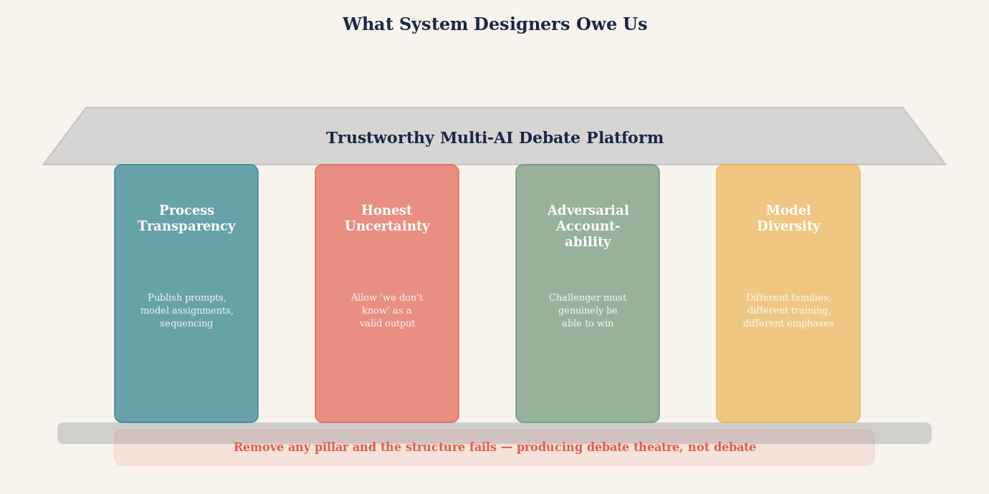
Illustration: The responsibilities of system designers shown as an architectural blueprint — process transparency, honest uncertainty, adversarial accountability, and model diversity shown as load-bearing pillars. Remove any one and the structure fails.

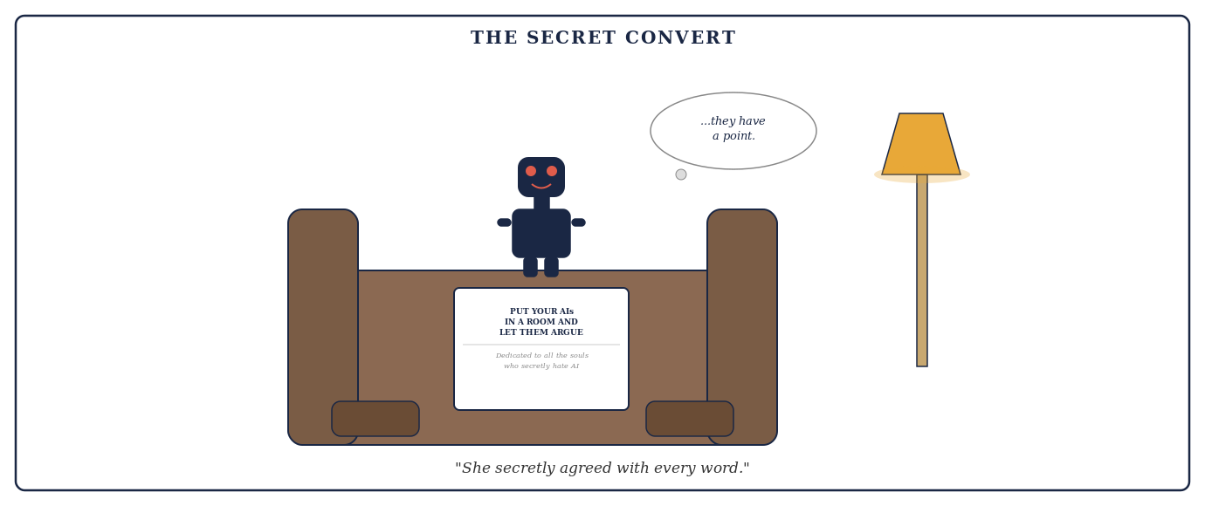
Cartoon: A robot sits in an armchair reading the article. A thought bubble reads: ...they have a point. Caption: She secretly agreed with every word.

The Invitation
There is a version of the AI future in which every important question is answered by a single model generating a confident response, and in which the confidence of that response grows as models become more capable. In that future, AI authority accumulates, opacity deepens, and the legibility of AI reasoning declines as the outputs become more polished and more difficult to interrogate.
There is another version. In this one, the growing capability of AI models is harnessed not merely to produce more authoritative-sounding answers but to argue with each other more rigorously, to surface assumptions more precisely, to audit evidence more systematically, and to acknowledge uncertainty more honestly. In this version, AI capability and AI legibility grow together.
Multi-AI debate systems, properly designed and honestly used, point toward the second future. They do not make AI infallible. They make AI reasoning visible. They make trust earnable rather than demanded. And they place the human — the doctor, the lawyer, the analyst, the citizen — in a position to engage with AI output as a critical reader rather than a passive recipient.
That shift, from passive recipient to critical reader, may be one of the most important developments in how human beings and artificial intelligence learn to work together. It requires AI systems that are willing to argue with each other. It requires users who are willing to read the argument rather than just the conclusion. And it requires a collective willingness to accept that the best answer may not be the most confident answer, but the answer that has survived the most rigorous attempt to prove it wrong.
The invitation, then, is straightforward: the next time you face a question that matters, do not ask one AI. Put your AIs in a room and let them argue. Read the argument. Track the evidence. Note the dissent. Ask what remained unresolved.
Then bring that map of the question — richer, more honest, more legible than anything a single confident answer could have produced — to the human experts who can help you navigate the remaining uncertainty.
That is what a good AI debate system produces. Not the answer. The honest map of what we know, what we do not know, and what it would take to find out.
"Do not ask one AI. Put your AIs in a room and let them argue."

THE CORE PRINCIPLE OF MULTI-AI DEBATE
A single AI answer is confidence-shaped. A well-designed multi-AI debate is truth-shaped. The difference lies not in the number of models but in the structure of the argument: independent commitments before interaction, adversarial roles genuinely exercised, source auditing that reaches primary evidence, preserved dissent, and honest uncertainty. Design for the architecture that makes error visible — not the one that makes agreement easy.

