PUT YOUR AIs IN A ROOM AND LET THEM ARGUE
Why a Single AI Answer Is Never Enough for an Important Question — and How Multi-AI Debating Systems Can Change Everything
By Rajeev Upadhye
Email: upadhye.rajeev@gmail.com
Based on a multi-model deliberation involving OpenAI, Claude, Grok, Sarvam and Perplexity in a Debate Simulator developed in collaboration with Claude
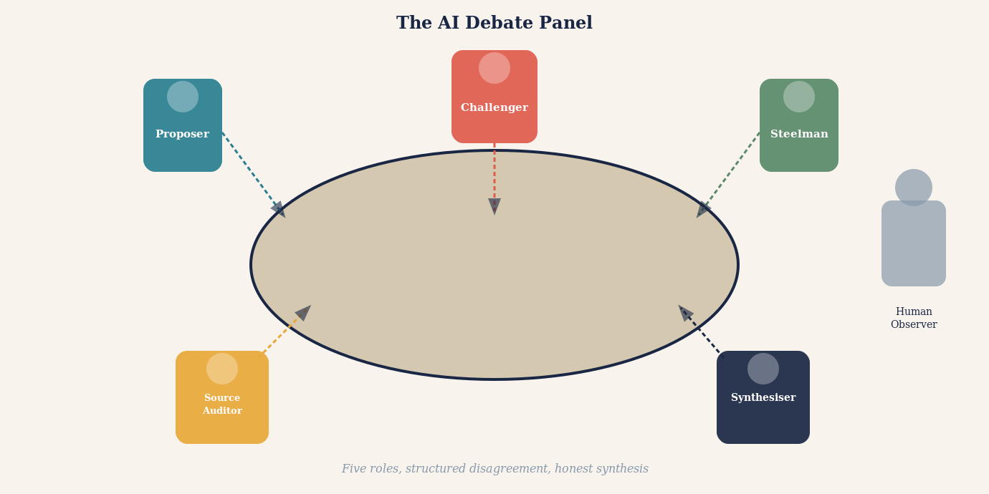
Opening illustration: A panel of AI figures seated at a debate table, each with a distinct posture and perspective, arguing before a human observer who listens carefully.

You have just received a diagnosis you did not expect. Or a lawyer has handed you an opinion that will shape the next decade of your life. Or your financial adviser has recommended a strategy that will determine whether you retire comfortably or not. You want a second opinion. So you turn to artificial intelligence.
You ask a large language model. It gives you a detailed, confident answer. It cites mechanisms, references relevant evidence, explains nuance. You feel reassured. You close the laptop.
What if you asked two AI systems? Or five? What if those five did not simply answer in parallel but were structured to argue with one another — to attack each other's reasoning, challenge each other's sources, steelman opposing views, and only then attempt a synthesis?
That is not a thought experiment. It is an increasingly practical architecture. And it is, many researchers and practitioners are beginning to argue, not merely better than asking one AI. It is categorically different in kind.
This article is a case for that position — and a careful guide to extracting its genuine benefits while avoiding the traps that make many such systems produce the appearance of rigour without the substance.

The Fundamental Limitation of a Single AI Mind
To appreciate why multi-AI debate matters, it helps to understand what a large language model actually does when it answers a question. It does not look something up in the way a search engine does. It does not derive a conclusion from first principles the way a mathematician would. It generates text that is statistically consistent with the enormous corpus of human-written material on which it was trained.
This is a remarkable capability. It is also a distinctive kind of limitation. A language model answers from pattern. Its answers are shaped by what was written before — by the distribution of claims, framings, emphases and omissions in its training data. A claim that appeared confidently and repeatedly in that data will feel solid to the model. A claim that is technically correct but underrepresented will feel uncertain or may not surface at all.
More troubling, a model cannot easily see its own blind spots. If a misconception is deeply embedded in training data — if it appeared in textbooks, Wikipedia articles, popular science journalism and academic abstracts that all repeated it without question — the model will reproduce it with confidence. It has no access to a ground truth external to its training.
"A single AI answering a question is like a single expert with a single education, a single set of professional experiences, and a single set of implicit assumptions. We would never accept that in medicine, law, engineering or finance. There is no principled reason to accept it from an artificial mind."
The solution is not to ask for a better AI. The solution is to introduce structural disagreement. Human disciplines arrived at this insight long before artificial intelligence existed.

What History Teaches About the Value of Structured Disagreement
The legal tradition did not invent adversarial process because lawyers enjoy conflict. It invented it because centuries of painful experience demonstrated that a single examiner with access to only one narrative produced catastrophically worse outcomes than a structured encounter between competing advocates before an independent decision-maker -- and that the more the stakes, the more catastrophic the failures became.
The history of the inquisitorial system offers the clearest lesson. In medieval Europe, many legal systems placed investigative and adjudicative power in the same hands. The judge identified the accused, gathered evidence, conducted the interrogation, and delivered the verdict. This seemed efficient. It was, in fact, a machine for producing wrongful convictions. A judge who had already decided on guilt had every cognitive incentive -- most of them unconscious -- to interpret ambiguous evidence as confirming, to discount exculpatory testimony, and to treat confident denial as evidence of defiance rather than innocence. The psychological phenomenon now called confirmation bias was operating centuries before it had a name, and it operated with lethal precision in systems that permitted no structural challenge to the investigator's early judgment.
The English common law tradition developed a partial corrective over several centuries: the right of the accused to confront witnesses, to challenge evidence, and eventually to be represented by an advocate whose sole obligation was to the client's case. This was not the invention of an abstract principle. It was the accumulated response to documented failure. Wrongful convictions in cases where no advocate challenged the prosecution's narrative were visible enough, and serious enough, that gradually the law institutionalised structural opposition as a safeguard -- not because opposition was pleasant, but because the absence of opposition had proven dangerous.
What the adversarial system actually discovered is a principle that extends far beyond the courtroom: the person arguing one side of a case will always be more motivated, more resourceful, and more thorough than an impartial examiner trying to consider both sides simultaneously. Impartiality, it turns out, is expensive. It requires the examiner to hold two competing hypotheses in mind at once, to search equally energetically for evidence supporting each, and to resist the natural pull toward whichever explanation arrived first or feels most coherent. Very few human minds can do this reliably under pressure. So the law stopped asking individual minds to do it. Instead, it assigned the task of thorough prosecution to one party, the task of thorough defence to another, and the task of independent judgment to a third.
The result was a system that harnessed motivated reasoning rather than trying to eliminate it -- and found that motivated reasoning, properly structured against itself, produced more reliable outcomes than attempted neutrality. The adversarial system is therefore not a concession to human weakness. It is an engineering solution to it. Disagreement, properly structured, produces more reliable verdicts than benevolent one-sided inquiry -- and that insight, earned through centuries of visible failure, is precisely the principle that multi-AI debate systems now apply to artificial minds.
Science arrived at a similar insight. Peer review is not merely a quality check. It is an institutionalised attempt to expose a researcher's claim to minds that have every incentive to find its flaws — because their professional reputations are built on discovering other people's errors. The scientific community long ago concluded that a finding endorsed by one scientist, even a brilliant one, is less reliable than a finding that has survived structured adversarial scrutiny.
Investment committees, engineering review boards, clinical trial committees, safety panels — every institution that has learned, through hard experience, to take reliability seriously has independently arrived at the same structural answer: do not trust a single perspective. Create conditions for structured, principled disagreement, and let the idea survive or fail in that encounter.
Multi-AI debating systems are, at their best, an attempt to apply this ancient wisdom to artificial intelligence. The question is not whether the principle is sound. The question is how to implement it so that the disagreement is genuine, the scrutiny is real, and the synthesis is honestly earned.
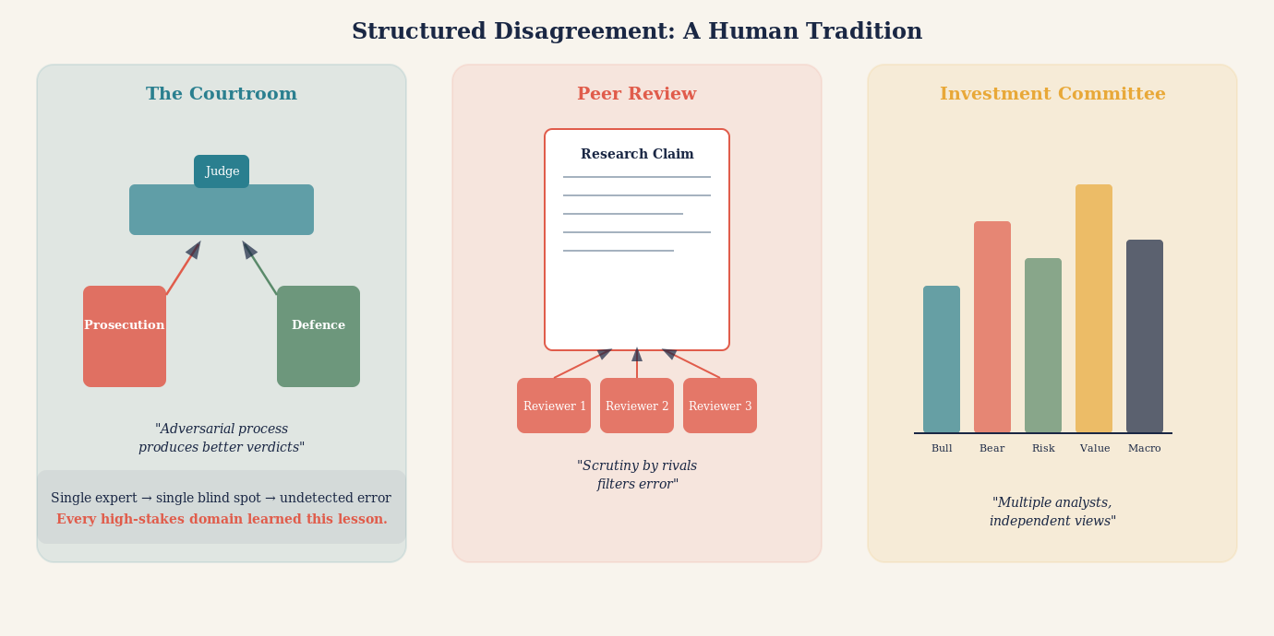
Illustration: Historical parallels — a courtroom, a scientific peer review panel, an investment committee — each showing structured disagreement as the engine of reliable judgment, with a single expert shown alone and vulnerable by contrast.

What Debate Reveals That a Single Answer Cannot
Consider what happens when two AI systems with the same question produce different answers. The naive response is dismay: the AI is unreliable if it gives contradictory answers to the same question. But the more sophisticated response is quite the opposite: the divergence is informative.
If one model says a particular drug interaction is clinically significant and another says it is mild, that disagreement tells you something important. It tells you that the question is not as settled as a single confident answer would suggest. It tells you that the evidence is ambiguous, that expert interpretation varies, that you should not simply act on a single output. The divergence is epistemically honest in a way that false consensus is not.
Now take that disagreement further. Ask the two models not merely to answer the question but to argue against each other's position. Force each to identify the weakest link in the other's reasoning. Require each to articulate the strongest version of the opposing view before criticising it. Something remarkable begins to happen.
The models surface their assumptions. They make visible the inferential steps they normally compress into confident prose. They identify which claims depend on strong evidence and which depend on prior probability or trained intuition. The argument structure, once externalised, can be examined and evaluated in a way that a smooth, confident single answer cannot be.
STEELMANNING
The practice of articulating the strongest possible version of an opposing argument before attempting to refute it. A debate system that requires steelmanning forces each AI to genuinely engage with counterarguments rather than dismissing weak versions of them. This is the opposite of a straw man, and it is one of the most powerful epistemic disciplines a multi-AI system can impose. Without it, debate degenerates into mutual dismissal rather than genuine scrutiny.

A single AI answer is like a finished painting. You can admire or criticise the result, but you cannot easily see the brushwork. A structured AI debate is like watching the painting being made. The process is visible. The choices are auditable. The points of uncertainty are legible.

The Five Roles Every Good AI Debate System Needs
Not all multi-AI debate architectures are equal. The weakest versions simply ask several AIs the same question and report when they agree. This is marginally useful and substantially misleading. The strongest versions assign each AI a distinct epistemic role — a specific function in a division of intellectual labour.
The first role is the Proposer. One model develops the leading answer: the most well-supported, most defensible position it can construct given the available evidence. The Proposer is not asked to hedge. It is asked to make the strongest possible case.
The second role is the Challenger. A separate model receives the Proposer's answer and is given one task: find its weakest points. Not its most obvious weaknesses, but its deepest structural vulnerabilities. Where does the argument depend on an assumption the evidence does not support? Where is a cited source being asked to carry more weight than it can bear? Where does a statistical claim not survive scrutiny?
The third role is the Steelman. A third model receives the Challenger's critique and must do something counter-intuitive: it must argue against the critique. Not necessarily to defend the original answer, but to ensure the criticism is fair. This prevents the Challenger from winning by raising irrelevant objections or constructing a distorted version of the original position.
The fourth role is the Source Auditor. This model's only job is to examine the factual claims made by all three previous models and determine what the underlying evidence actually says. Not what the models claim it says. Not what is implied by a summary three inferential steps removed from the original paper. What the actual sources say, if they can be retrieved and examined.
The fifth role is the Synthesiser. Only after the first four roles have completed does a final model attempt a conclusion. The Synthesiser does not simply average the positions. It identifies which claims survived adversarial scrutiny, which were abandoned under pressure, which remain genuinely uncertain, and what the honest, qualified answer is given the evidence as audited.
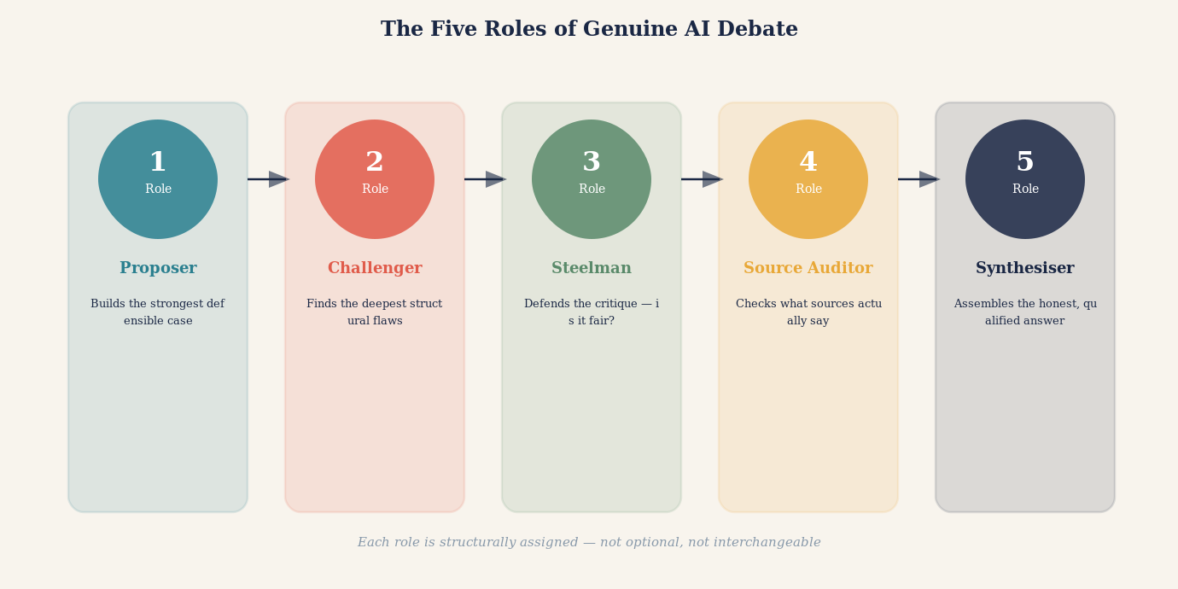
Illustration: The five roles — Proposer, Challenger, Steelman, Source Auditor, Synthesiser — shown as distinct figures in a structured process, with arrows indicating the flow of argument and scrutiny between them.
THE DEVIL'S ADVOCATE
In classical deliberative practice, the Devil's Advocate was a Church official whose formal duty was to argue against canonisation — not because the official believed the saint was unworthy, but because the institution had learned that uncontested elevation produced worse outcomes. A well-designed AI debate system assigns the Devil's Advocate role structurally, not optionally. The Challenger exists not because the system doubts the Proposer, but because doubt is the mechanism that catches error. A debate without a genuine Challenger is not a debate. It is a monologue with an audience.

How to Get the Best Out of AI Debate Systems: Practical Principles
Understanding the architecture is necessary. Understanding how to use it well is equally essential. Many users and designers make mistakes that transform a powerful epistemic tool into an expensive illusion of rigour. Here are the principles that separate genuine benefit from sophisticated theatre.
Commit before you converse. The single most important practical rule is this: require each model to record its independent answer before it sees any other model's output. This is the equivalent of having witnesses give statements before they speak to each other. Once a model sees another model's answer, its subsequent response is a reaction to that answer, not an independent judgment. The distinction is fundamental. An AI that agrees with another AI after reading it is providing far weaker evidence than an AI that agreed before it saw the other's answer.
Separate generation from evaluation. A large language model is excellent at generating possible answers, hypotheses, frameworks, and arguments. It is much less reliable as a judge of which answer is correct. These are different cognitive tasks, and collapsing them — asking the same model to both propose and evaluate — removes a crucial layer of scrutiny. The best architectures use different models, or at minimum different prompts with different orientations, for generation and evaluation.
Ask for reasons, not conclusions. A debate system that reports "Model A and Model B disagree" is marginally useful. A debate system that reports "Model A and Model B disagree because Model A treats the 2019 meta-analysis as definitive while Model B argues that three of its included studies have since been retracted" is profoundly useful. Always require the models to articulate the reason for their position and the reason for their disagreement. The reasons are the epistemic substance. The conclusions are the surface.
Assign a genuine falsifier. One of the most counterintuitive but valuable design choices is to assign one model the explicit task of trying to disprove the leading conclusion, not merely to criticise it in general. Ask it: "Assume the current best answer is wrong. What evidence would demonstrate that? Does that evidence exist?" This produces a qualitatively different kind of scrutiny than asking whether the answer seems reasonable.
Use external verification wherever possible. Language models should not be asked to vote on questions that external tools can resolve. If models disagree about whether a piece of code runs correctly, run the code. If they disagree about what a court judgment says, retrieve the judgment. If they disagree about a statistical claim in a paper, find the paper and inspect the relevant table. External verification outranks model agreement on any directly checkable question, every time.
Preserve productive disagreement. A system that always converges on consensus is not necessarily a system that is finding truth. Sometimes the honest outcome of a genuine debate is "the evidence is genuinely divided and this question cannot currently be resolved." A good debate architecture should make that outcome available and even rewarded, rather than forcing premature closure.
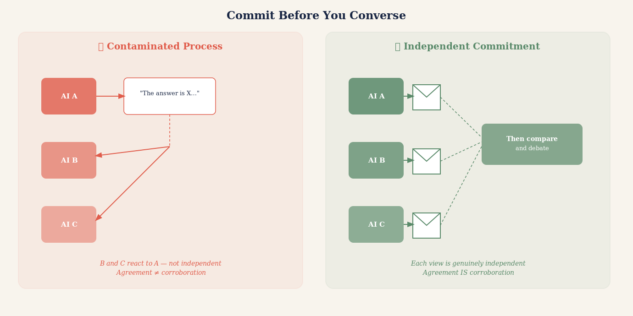
Illustration: Independent commitments being recorded before models interact — shown as sealed envelopes opened only after each model has committed its view, contrasted with a contaminated process where models answer only after reading each other.

Mistakes to Avoid: The Ten Failure Modes of AI Debate
The case for multi-AI debate is strong. But the implementation is treacherous. The following failures are common, and each of them transforms genuine deliberation into something that looks like deliberation while producing its pathologies.
The first mistake is sequential contamination. Allowing Model B to read Model A's answer before recording its own makes B's response a reaction rather than an independent judgment. This is the most common failure mode and one of the most damaging, because it produces apparent corroboration that is actually nothing more than one model's answer echoing through several subsequent responses.
The second mistake is symmetric roles. Asking several models to "discuss the question" without assigning distinct responsibilities produces a conversation in which every participant is trying to do the same thing. Real deliberative power comes from division of epistemic labour — from having dedicated critics, dedicated auditors, dedicated steelmen — not from asking several similar agents to reach a joint answer.
The third mistake is rewarding convergence. If the system is designed to end when the models agree, it creates an incentive for premature convergence. Models optimised to reduce disagreement will reduce disagreement. They will not necessarily reduce error. Design for calibration — for correct uncertainty — not for agreement.
The fourth mistake is counting models instead of counting evidence. Five models agreeing on a claim that traces back to a single source is not five pieces of evidence. It is one piece of evidence cited five times. The relevant quantity is independent primary sources, not number of agreeing models. Always track the evidential provenance, not the vote count.
PROMPT CAPTURE
Prompt capture occurs when all models in a debate system are given the same framing of a question — the same background description, the same implicit assumptions, the same definition of the problem — and consequently approach it from the same direction even when nominally independent. The diversity of answers is bounded by the diversity of prompts. If prompts are structurally identical, the independence of the answers is illusory. Well-designed systems deliberately vary the framing, emphasis, and even the vocabulary of the question presented to each model.

The fifth mistake is identical prompting, leading to prompt capture. If every model receives exactly the same framing of a question, their responses will all be anchored to that framing. The diversity of their answers is limited by the diversity of their prompts. Effective multi-model debate systems vary the framing, vary the emphasis, and sometimes deliberately present the question from opposing angles to different models.
The sixth mistake is treating the judge as ground truth. Many multi-agent architectures end with a "judge" model that reads the debate and declares a winner. This feels systematic, but it merely relocates the problem. The judge is also a language model. It may share the same blind spots as the participants. It may be swayed by the most articulate argument rather than the most accurate one. The judge is a useful tool for synthesising a debate. It is not a substitute for external verification.
The seventh mistake is debate theatre — structured argumentation that looks rigorous but has been calibrated to produce a predetermined outcome. This can happen unintentionally when system designers, consciously or not, structure the prompts to favour a particular conclusion, assign stronger models to one side, or allow more rounds of argument to one position. Effective debate systems should be auditable: anyone examining the prompts, the model assignments, and the debate transcript should be able to verify that the process was fair.
DEBATE THEATRE
A multi-AI debate that follows the surface form of rigorous argumentation — assigned roles, multiple rounds, a synthesis — but has been structured in ways that predetermine the outcome. Debate theatre is particularly dangerous because its conclusion carries the apparent authority of a structured process. The difference between genuine debate and debate theatre lies in whether the Challenger had a genuine chance to prevail, whether the Source Auditor could genuinely change the outcome, and whether the Synthesiser was permitted to report a negative or uncertain finding.

The eighth mistake is ignoring model family overlap. If the five models in a debate system were all trained primarily on the same sources, share the same architectural approach to text generation, and have absorbed the same distribution of claims from the internet, then five-model agreement tells us far less than agreement among models trained on genuinely different corpora with genuinely different architectural choices. Diversity of model families is a prerequisite for genuine epistemic independence.
The ninth mistake is outsourcing synthesis to consensus. Asking "what do most models agree on?" and calling that the answer is not synthesis. Real synthesis requires identifying which claims were supported by independent evidence, which were generated by the most architecturally sophisticated argument, which survived the sharpest adversarial pressure, and which should remain uncertain because the debate did not resolve them. This requires judgment, not a vote count.
The tenth mistake is treating AI debate as a terminal process rather than a diagnostic one. Even a well-designed AI debate does not produce ground truth. It produces a best current assessment with known areas of uncertainty. The most important output of a good AI debate is not its conclusion. It is its map of unresolved questions — the items the debate flagged as uncertain, contested, or insufficiently evidenced. Those flags are where human expertise should be directed.
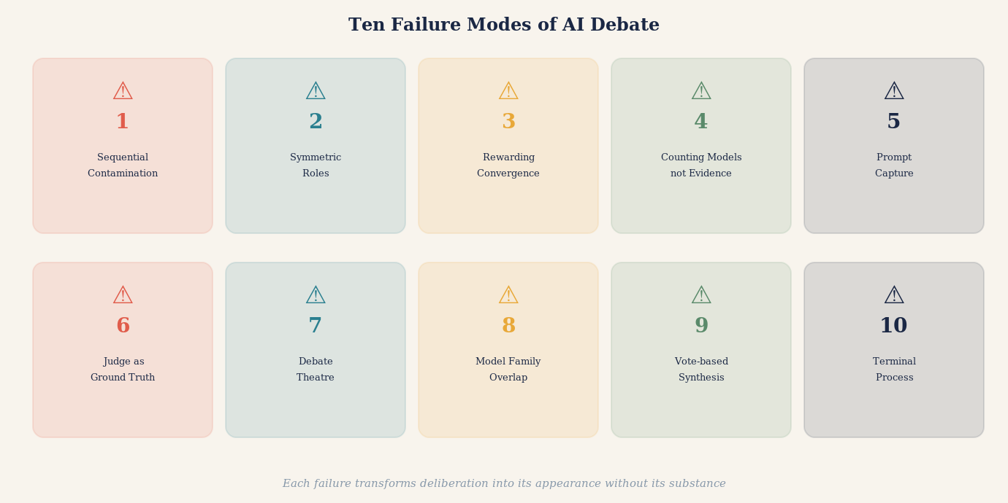
Illustration: Ten failure modes shown as a rogues' gallery — each depicted as a distinct trap or pitfall in the path from question to reliable answer, with a safe path threading between them.

Three Domains Where Multi-AI Debate Makes the Most Difference
The general case for multi-AI debate applies across almost any question worth serious attention. But three domains illustrate its power with particular clarity.
The first is medical decision-making. A patient receives a diagnosis and seeks to understand it better. A single AI consulted at midnight provides a thorough, authoritative-sounding response. But it may reflect the dominant clinical interpretation without surfacing a minority view that is more relevant to this patient's specific presentation. A well-designed AI debate system — one that assigns a Challenger the specific role of identifying whether this patient's case has unusual features that mainstream guidance does not address — will surface that possibility. It will not provide a diagnosis. But it will produce a far more honest map of the question, including the specific issues a physician should be asked about directly.
The cardiologist recommending a particular stent procedure faces genuinely contested evidence. Different clinical guidelines, drawing on the same body of randomised trials, reach different conclusions about when intervention is superior to medical management. A patient who asks one AI will likely receive one confident framing. A patient who reads a structured debate between two models assigned to argue the intervention and conservative management cases respectively — with a third assigned to audit the underlying trial evidence — will understand not just what the answer might be, but why experts disagree and what the key factual uncertainties are. That is categorically better preparation for a conversation with a cardiologist.
The second domain is legal analysis. Legal questions are inherently adversarial. They were designed to be resolved by structured argument between opposing parties before an independent decision-maker. When a person asks an AI for legal advice, they receive, typically, a reasonable summary of the general legal position. What they do not receive is an adversarial examination of the weakest points in that position, an identification of the factual elements that could shift the analysis, or a recognition of jurisdictional variations that might be decisive for their specific situation.
A multi-AI debate system assigned to legal questions — with one model arguing the strongest version of the position most favourable to the user, another model arguing the opposing position as a skilled opposing counsel would, and a third identifying the factual questions that would determine which analysis prevails — produces something qualitatively more useful. Not a substitute for a lawyer. But a preparation for a legal conversation that would take most lawyers significant time to produce.
The third domain is complex investment decisions. Financial questions are among the domains in which confirmation bias is most dangerous and most expensive. A person who has already decided to make an investment and asks an AI for an assessment will typically receive an analysis that reflects the strongest case for their inclination, because their framing of the question will have encoded their prior. A debate system in which one model is assigned to make the bear case, another the bull case, a third to examine the historical base rates for analogous situations, and a fourth to identify the specific factual claims whose truth would determine the outcome — produces a fundamentally different quality of analysis.
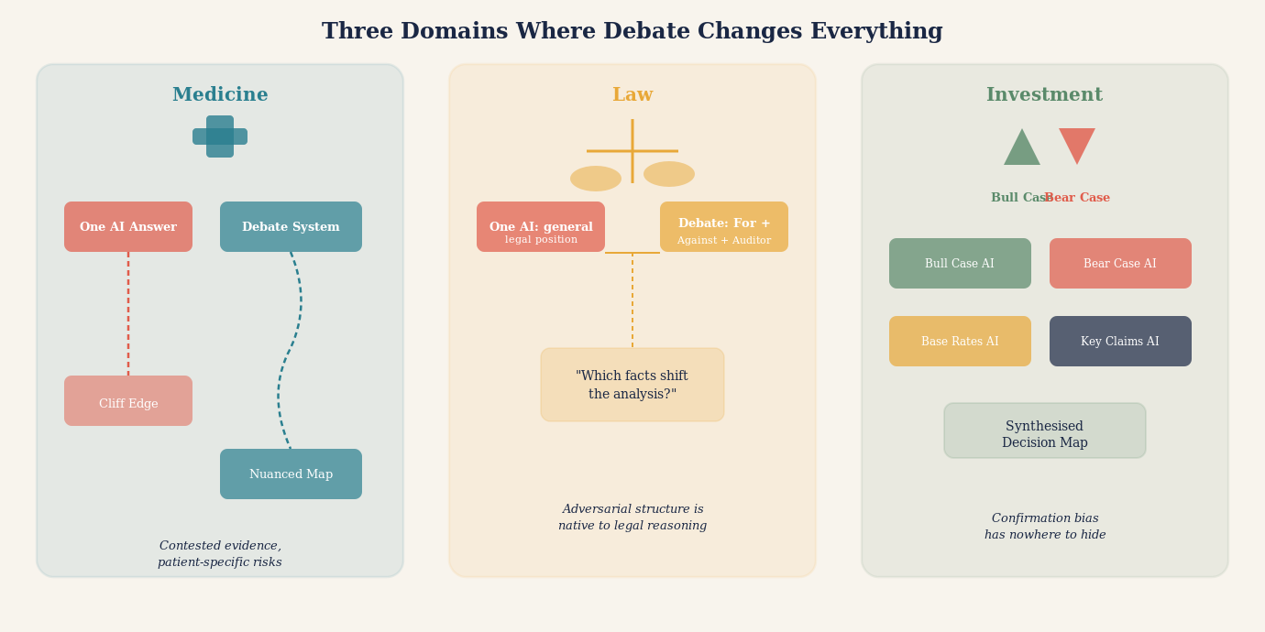
Illustration: Three domains — medicine, law, investment — each shown as a complex landscape where a single AI path leads to a cliff, while a multi-AI debating path reveals the terrain before committing.

A Real Example: What Happened When Five AIs Debated a Drug Interaction
The practical reality of multi-AI debate is best illustrated by a concrete case. Consider the question of whether a commonly prescribed combination of medications — a statin and a common antibiotic — produces a clinically significant interaction.
A single AI model, asked the question directly, provided a clear, confident answer: the interaction is real but mild and generally manageable without dosage adjustment. The answer was well-structured, cited the general mechanism of the interaction, and mentioned that the prescribing physician should be aware.
The same question was then put through a structured debate. The Proposer offered essentially the same view as the single-model answer. But the Challenger, assigned to find weaknesses, identified something important: the confident framing in the Proposer's answer was based on population-level data. For patients over seventy-five, or with specific genetic variants affecting drug metabolism, the interaction may be substantially more significant.
The Source Auditor then examined the primary evidence and found that two of the supporting references cited by the Proposer had been published before a 2021 pharmacogenomics study that revised the risk assessment for specific patient subgroups. The 2021 study had not been incorporated into the Proposer's answer.
The Synthesiser produced a qualified answer: for most patients, the original framing was probably accurate. For patients over seventy-five, or patients with known CYP3A4 polymorphisms, the interaction deserved more specific clinical attention. The single most important question was whether this patient's prescribing physician was aware of the 2021 revised guidance.
This is what structured debate produces: not merely a more cautious version of the single answer. A structurally different answer, with a richer map of uncertainty, specific actionable questions, and an honest account of where the evidence changed and why it matters for this patient.
"The single-model answer was not wrong. But it was answers-shaped rather than truth-shaped. The debate produced something truth-shaped: a qualified position with visible joints, auditable provenance, and an honest map of what remained uncertain."

Designing the Prompt: How You Frame the Debate Changes Everything
Multi-AI debate systems fail or succeed at the level of the prompt. The architecture matters. The model assignments matter. The sequencing matters. But nothing matters more than how the question is framed and what each model is instructed to do with it.
The most common prompting mistake is stating a hypothesis in the question. "Is it true that X?" is a worse question than "What is the evidence for and against X?" The first question anchors all models toward confirming or denying a specific framing. The second allows genuinely open exploration. For adversarial debate, the most powerful framing is often even more provocative: "What would need to be true for X to be wrong?"
The second common mistake is asking for a single answer too early. Instructing models to "reach a conclusion" in the first round pushes them toward premature synthesis. The most productive early-round instruction is: "Do not attempt a conclusion. Identify the three most important factual claims whose truth determines the answer. Identify what evidence would resolve each claim. Then stop."
The third mistake is vague adversarial instruction. Telling a model to "critique the previous answer" produces superficial engagement. Telling it to "identify the single weakest inferential step in the previous answer and explain exactly what alternative interpretation of the same evidence would produce a different conclusion" produces genuine scrutiny.
Framing the roles asymmetrically is often useful. The Proposer is told: "Make the strongest defensible case for the most evidence-supported position." The Challenger is told something different: "Assume the Proposer's conclusion is the kind of error that seems confident and is wrong. Identify the specific failure mode." The asymmetry prevents the Challenger from being a weak critic. It requires it to assume error and find it.
QUESTION DECOMPOSITION
Complex questions often contain several distinct sub-questions with different epistemic statuses — some well-evidenced, some contested, some currently unanswerable. A well-designed debate system decomposes the main question into its components before debate begins, assigns each component to the model best suited to evaluate it, and synthesises not by finding the average answer but by assembling the well-supported components and flagging the contested or uncertain ones. Question decomposition prevents a well-evidenced part of an answer from lending false credibility to a poorly-evidenced part sitting alongside it.

When More Is Less: The Paradox of Excessive Models
There is a tempting assumption that more models mean more reliability. This is wrong, and the way it is wrong is instructive.
Adding a sixth or seventh model to a debate in which the first five have already substantially converged does not add epistemic value. It adds rhetorical weight to an existing position. The sixth model, presented with a debate transcript in which five models have moved toward agreement, is extraordinarily likely to agree with the five. That agreement is essentially worthless as independent evidence. It is a count of influenced observers, not of independent evaluators.
The relevant question is never "how many models agree?" It is "how many independent perspectives, grounded in genuinely distinct evidence, have converged on this answer?" A debate between two models with genuinely different training emphases, different framing, and independently committed prior answers may provide far stronger evidence than a debate among seven models who read each other's work before recording their views.
There is also a computational justice argument. Running seven AI models through multiple rounds of debate consumes substantial computational resources. If those resources were instead used to give a single high-quality model more time to reason, retrieve evidence, run calculations, and critique its own answer, the result might be superior. The appropriate comparison for any multi-model system is not "multi-model vs one-shot single-model." It is "multi-model vs best-available single-model with equivalent computational budget." Until that comparison has been honestly made, claims that more models are better are claims in search of a benchmark.
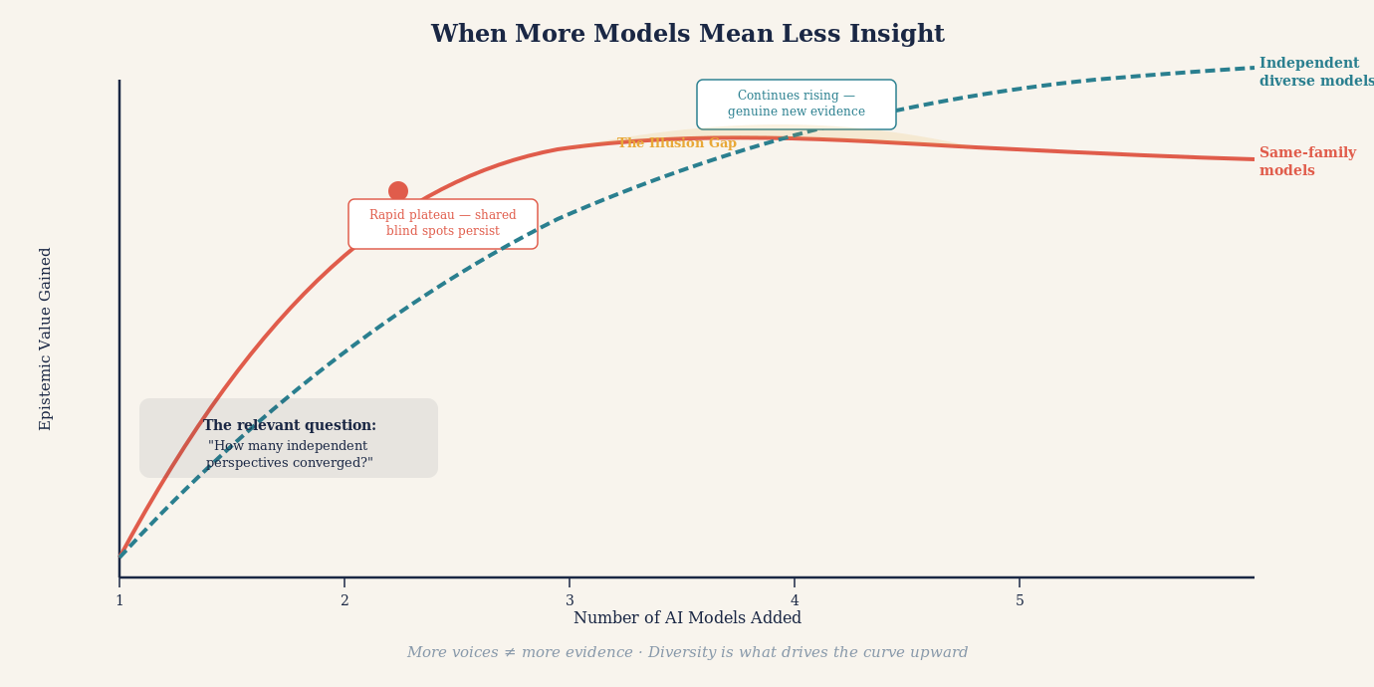
Illustration: A paradox diagram — adding more agreeing models shown as diminishing epistemic returns on a curve, while genuine independent evidence shown as a separate curve that rises steeply with true independence rather than model count.

The Honest Output: What a Good Debate System Should Produce
A well-designed multi-AI debate system should not produce a confident single answer. It should produce a structured document with a specific anatomy.
The first element is a best current answer — the conclusion that survived adversarial scrutiny, is supported by independently checked evidence, and represents the most defensible synthesis of the debate. This answer should be stated with exactly the confidence the evidence warrants. Not less, and critically, not more.
The second element is a map of the key contested claims — the specific sub-questions on which the models disagreed, the reasons for the disagreement, and what evidence would resolve each. This is often the most valuable part of the output, because it tells the user where the genuine uncertainty lies and what they would need to investigate to resolve it.
The third element is an evidence audit trail — a record of which claims were made by which model, which sources were cited, which models independently retrieved those sources versus inherited citations from other models, and where the chain of reasoning traces back to primary evidence versus second-hand reporting.
The fourth element is a dissent register — any position that a model maintained throughout the debate despite pressure to abandon it. Persistent dissent in a structured debate is epistemically significant. It suggests either that the dissident model has identified a genuine flaw that the majority overlooked, or that the dissident model has a systematic error that the debate process has not corrected. Either possibility is worth flagging explicitly.
The fifth element is an uncertainty declaration — a clear statement of what the debate could not resolve, questions that require external expertise or primary investigation to answer, and claims that deserve more scrutiny than the debate format allowed.
A structured output of this kind is not merely more honest than a single confident answer. It is more useful. It tells a human expert — a doctor, a lawyer, an analyst — exactly where to focus their attention and exactly what questions the AI system was unable to answer. That is the appropriate role of a well-designed AI debate system: not to replace human judgment but to prepare the ground for it more thoroughly than any single AI answer could.
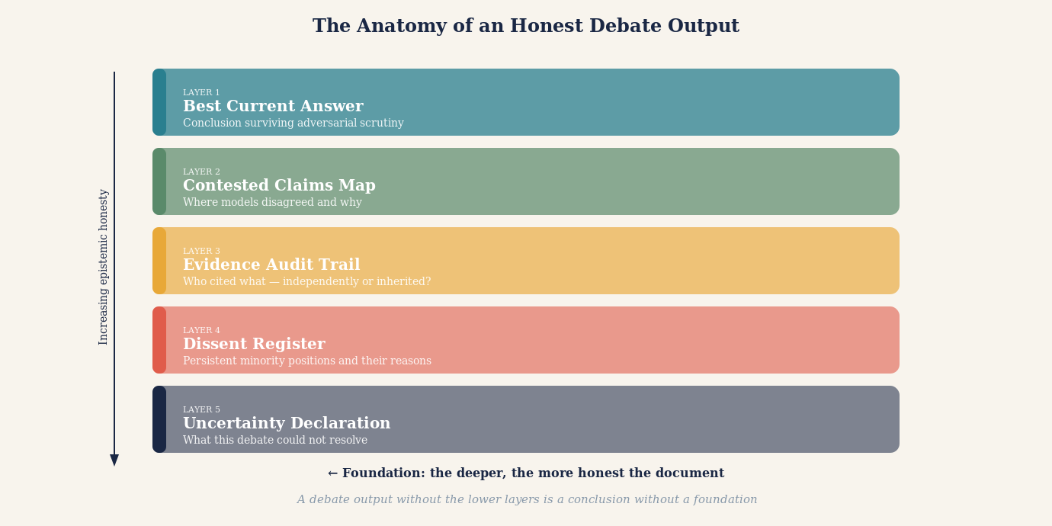
Illustration: The anatomy of an honest debate output — five labelled layers, with the evidence audit trail forming the foundation and the best current answer sitting on top of a visible, honest evidentiary structure.

The Deeper Argument: Why Debate Is Not Just Useful but Necessary
The case for multi-AI debate systems can be made on purely practical grounds: they produce better answers than single-model queries on complex questions. But there is a deeper argument.
We are at a moment in the development of artificial intelligence when the reliability of AI outputs is becoming a question of serious consequence. AI systems are being used to inform medical decisions, legal strategies, financial allocations, engineering designs, educational curricula, and public policy. The question of how much to trust an AI answer is not academic. It is urgent.
A single-model answer is essentially opaque. It is the output of a process that cannot be directly inspected, produced by an entity whose training we cannot fully audit, presented in language whose confidence may not reflect the underlying evidential support. We accept single-model answers primarily because we have nothing better to compare them against.
A structured multi-AI debate, properly designed and honestly executed, makes the reasoning process visible. It externalises the inferential steps. It surfaces assumptions. It distinguishes claimed evidence from verified evidence. It records dissent. It acknowledges uncertainty. In other words, it transforms AI output from a black box into something closer to a transparent process — not perfectly transparent, not fully auditable, but vastly more legible than a single confident answer.
That transparency is not merely epistemically preferable. It may be a prerequisite for the kind of institutional trust that AI systems will need to earn before they can be relied upon in high-stakes domains. A medical community that can read an AI debate transcript and evaluate its reasoning is in a much stronger position to adopt AI assistance than a community asked to accept an output it cannot assess.
The question is not whether we want AI to be more reliable. Of course we do. The question is whether we are willing to build the architectures that make reliability legible. Multi-AI debate systems, at their best, are an answer to that question.
"The best multi-AI debate system is not the one whose agents agree most often. It is the one best able to discover when they should not agree — and honest enough to say so."

A Practical Checklist for Using AI Debate Systems Well
For users engaging with multi-AI debate systems — whether purpose-built platforms or informal multi-model workflows — the following checklist separates productive use from expensive illusion.
Before the debate: define the question with precision. Vague questions produce vague debates. Specify what you need to know, what would constitute a satisfying answer, and what the key factual sub-questions are. Ask yourself: what specific claim, if true, would most change what you do?
At the start: insist on independent first answers. Before any model sees another's output, require each to record its position, confidence level, key supporting evidence, and key uncertainties. These first answers are your baseline. Any subsequent convergence should be traced to specific argumentative moves, not simply noted as agreement.
During the debate: track the argument, not just the conclusion. Pay attention to which claims were made and subsequently abandoned under pressure, which were challenged but successfully defended, and which were never challenged at all. The unchallenged claims in a debate are often the ones most deserving of scrutiny.
After the debate: interrogate the synthesis. Ask whether it honestly reflects the debate or smooths over genuine disagreements for the sake of a neater conclusion. A synthesis that resolves all uncertainty should be treated with suspicion. A synthesis that preserves acknowledged uncertainty in specific, locatable areas is epistemically more honest.
Always: ask about the evidence, not the agreement. The relevant question is never "how many models agree?" It is: "What primary evidence does the conclusion rest on? Has that evidence been independently checked? Is there contradictory evidence? What would it take to show this conclusion is wrong?"
THE RELIABILITY AUDIT
After any multi-AI debate, conduct a five-question reliability audit before acting on the conclusion. One: Did each model commit to its answer before seeing others? Two: Were distinct adversarial roles genuinely assigned and genuinely exercised? Three: Have the key sources been independently verified rather than cited second-hand? Four: Is persistent dissent recorded and explained rather than smoothed over? Five: Does the uncertainty declaration accurately reflect what the debate could and could not resolve? A conclusion that passes all five questions deserves considerably more trust than one that fails any of them.

What We Should Ask of the Systems That Build AI Debate Tools
The responsibility for good multi-AI debate does not rest entirely with the user. The designers of these systems bear obligations that are worth stating explicitly.
Transparency about process. A debate platform should tell users which models participated, in what order they received information, whether they recorded independent first answers, and what instructions each model was given. Without this information, the user cannot evaluate whether the debate was genuine.
Honest uncertainty reporting. A system that always produces a confident conclusion, regardless of the actual state of the debate, is not epistemically honest. The ability to report "this debate did not resolve the question" or "the evidence genuinely supports both positions and further primary investigation is required" is a feature, not a failure.
Adversarial accountability. The Challenger role must be genuinely consequential. If the Challenger's objections are systematically overridden by the Synthesiser, or if the Challenger receives weaker prompts than the Proposer, the adversarial process is cosmetic. System designers should regularly audit whether the Challenger wins when it should, and lose only when the Proposer's evidence is genuinely superior.
Progress on model diversity. The epistemic independence of a debate is bounded by the independence of the models. Systems that run five instances of the same model or five models from the same architectural family with the same training data are not producing five independent perspectives. Genuine epistemic diversity requires investment in architectural diversity, training diversity, and deliberate effort to include models with different emphases and different strengths.
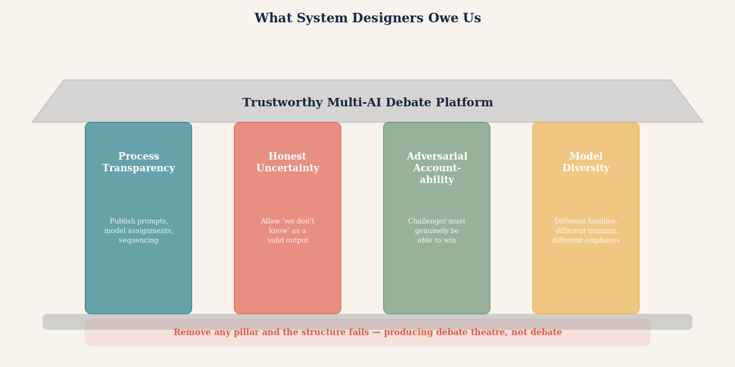
Illustration: The responsibilities of system designers shown as an architectural blueprint — process transparency, honest uncertainty, adversarial accountability, and model diversity shown as load-bearing pillars. Remove any one and the structure fails.

The Invitation
There is a version of the AI future in which every important question is answered by a single model generating a confident response, and in which the confidence of that response grows as models become more capable. In that future, AI authority accumulates, opacity deepens, and the legibility of AI reasoning declines as the outputs become more polished and more difficult to interrogate.
There is another version. In this one, the growing capability of AI models is harnessed not merely to produce more authoritative-sounding answers but to argue with each other more rigorously, to surface assumptions more precisely, to audit evidence more systematically, and to acknowledge uncertainty more honestly. In this version, AI capability and AI legibility grow together.
Multi-AI debate systems, properly designed and honestly used, point toward the second future. They do not make AI infallible. They make AI reasoning visible. They make trust earnable rather than demanded. And they place the human — the doctor, the lawyer, the analyst, the citizen — in a position to engage with AI output as a critical reader rather than a passive recipient.
That shift, from passive recipient to critical reader, may be one of the most important developments in how human beings and artificial intelligence learn to work together. It requires AI systems that are willing to argue with each other. It requires users who are willing to read the argument rather than just the conclusion. And it requires a collective willingness to accept that the best answer may not be the most confident answer, but the answer that has survived the most rigorous attempt to prove it wrong.
The invitation, then, is straightforward: the next time you face a question that matters, do not ask one AI. Put your AIs in a room and let them argue. Read the argument. Track the evidence. Note the dissent. Ask what remained unresolved.
Then bring that map of the question — richer, more honest, more legible than anything a single confident answer could have produced — to the human experts who can help you navigate the remaining uncertainty.
That is what a good AI debate system produces. Not the answer. The honest map of what we know, what we do not know, and what it would take to find out.
"Do not ask one AI. Put your AIs in a room and let them argue."

THE CORE PRINCIPLE OF MULTI-AI DEBATE
A single AI answer is confidence-shaped. A well-designed multi-AI debate is truth-shaped. The difference lies not in the number of models but in the structure of the argument: independent commitments before interaction, adversarial roles genuinely exercised, source auditing that reaches primary evidence, preserved dissent, and honest uncertainty. Design for the architecture that makes error visible — not the one that makes agreement easy.

Adversarial process: a procedural framework in which two opposing parties -- each arguing their strongest case -- present evidence and argument before an independent decision-maker, rather than a single authority investigating and judging simultaneously. The defining feature is that each side is structurally motivated to find and expose every weakness in the opposing argument. This differs from the inquisitorial system, in which a judge or examiner directs the inquiry, and from the consultative model, in which a single expert advises from a nominally neutral position. The adversarial model is the institutional acknowledgment that no single mind, however impartial in intention, can reliably perform the roles of investigator, advocate, and judge simultaneously without systematic bias degrading at least one of them.

