PUT YOUR AIS IN A ROOM AND LET THEM ARGUE
Why a Single AI Answer Is Often Not Enough for an Important Question — and How Multi-AI Debating Systems Can Change Everything

By Rajeev Upadhye
Corrected and evidence-audited edition, August 2026

Based on a multi-model deliberation involving OpenAI, Claude, Grok, Sarvam and Perplexity
in a Debate Simulator developed in collaboration with Claude

© 2026 Rajeev Upadhye. All rights reserved.

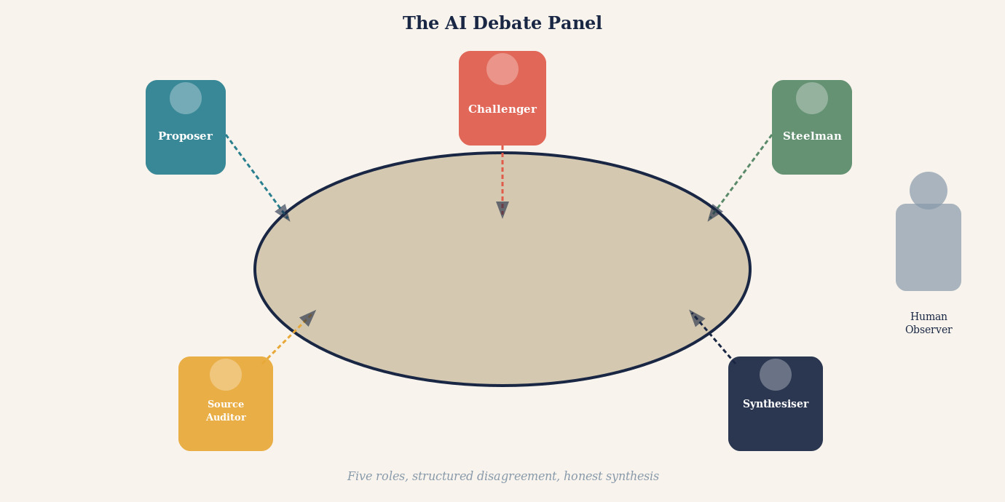
You have just received a diagnosis you did not expect. Or a lawyer has handed you an opinion that will shape the next decade of your life. Or your financial adviser has recommended a strategy that will determine whether you retire comfortably or not. You want a second opinion. So you turn to artificial intelligence.
You ask a large language model. It gives you a detailed, confident answer. It cites mechanisms, references relevant evidence, explains nuance. You feel reassured. You close the laptop.
What if you asked two AI systems? Or five? What if those five did not simply answer in parallel but were structured to argue with one another — to attack each other's reasoning, challenge each other's sources, steelman opposing views, and only then attempt a synthesis?
That is not a thought experiment. It is an increasingly practical architecture. And it is, many researchers and practitioners are beginning to argue, not merely better than asking one AI. It is categorically different in kind — at least for the class of questions that are genuinely important, uncertain, contested, or difficult to verify.
This article is a case for that position — and a careful guide to extracting its genuine benefits while avoiding the traps that make many such systems produce the appearance of rigour without the substance.

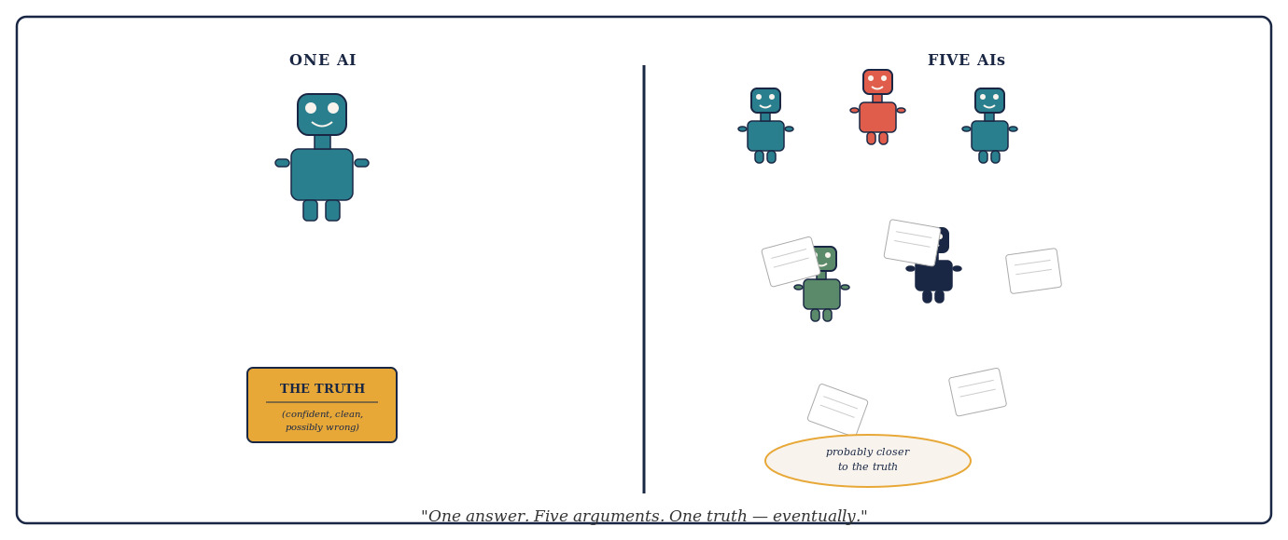
There is one more reason the case for multi-AI systems deserves to be stated clearly before it is qualified. Most hard intellectual problems are not difficult because the final calculation is enormous. They are difficult because the space of plausible explanations is enormous. Before any answer can be verified, somebody must generate the right candidate in the first place. A single model, however capable, searches only one region of that space at a time. A team that divides the terrain covers far more of it.
Think of a missing climber. Five searchers walking the same trail ten metres apart produce more manpower, but very little additional conceptual coverage. A better team divides the search: one follows the trail, another uses aerial imagery, a third studies weather and avalanche conditions, a fourth reconstructs phone and vehicle records, and a fifth challenges the premise entirely and asks whether the climber reached the mountain at all. Multi-AI reasoning works best the same way. Different agents should search different regions of the intellectual terrain — not duplicate each other's effort in the region that seems most obvious.

The Fundamental Limitation of a Single AI Mind
To appreciate why multi-AI debate matters, it helps to understand what a large language model actually does when it answers a question. It does not look something up in the way a search engine does. It does not derive a conclusion from first principles the way a mathematician would. It generates text that is statistically consistent with the enormous corpus of human-written material on which it was trained.
This description applies most precisely to a pretrained language model operating without external tools. Contemporary systems — reasoning models, retrieval-augmented systems, and tool-using architectures — can access external information during inference, which mitigates, though does not eliminate, dependence on training-data distribution. The limitations described here apply most forcefully to any system operating without structured external verification of its outputs, whatever its architecture.
This is a remarkable capability. It is also a distinctive kind of limitation. A language model answers from pattern. Its answers are shaped by what was written before — by the distribution of claims, framings, emphases and omissions in its training data. A claim that appeared confidently and repeatedly in that data will feel solid to the model. A claim that is technically correct but underrepresented will feel uncertain or may not surface at all.
More troubling, a model cannot easily see its own blind spots. If a misconception is deeply embedded in training data — if it appeared in textbooks, Wikipedia articles, popular science journalism and academic abstracts that all repeated it without question — the model will reproduce it with confidence. Even tool-using and retrieval-augmented systems can fail at this level: retrieved sources may repeat the same error; web searches may surface majority-view documents that share the same blind spot. External access reduces but does not eliminate correlated error.
"A single AI answering a question is like a single expert with a single education, a single set of professional experiences, and a single set of implicit assumptions. We would never accept that in medicine, law, engineering or finance. There is no principled reason to accept it from an artificial mind."
The solution is not simply to ask for a better AI. The solution is to introduce structural disagreement. Human disciplines arrived at this insight long before artificial intelligence existed.

What History Teaches About the Value of Structured Disagreement
The legal tradition did not invent adversarial process because lawyers enjoy conflict. It invented it because centuries of painful experience demonstrated that a single examiner, reasoning from a single narrative without structural challenge, is prone to systematic errors — most of them unconscious — that structured opposition can catch.
The history of pre-modern legal procedure offers a revealing lesson. In medieval Europe, many systems — most visibly in ecclesiastical inquisitorial procedures — concentrated investigative and adjudicative power in the same hands. The judge identified the accused, gathered evidence, conducted the interrogation, and delivered the verdict. This seemed efficient. What it produced, in practice, was a process with no structural mechanism to test its own initial judgment against contrary evidence or argument. The psychological phenomenon now called confirmation bias was operating centuries before it had a name, and it operated with dangerous force in systems that permitted no structural challenge to the investigator's early conclusions.
A necessary distinction: the procedure described above should not be conflated with modern inquisitorial legal systems — the civil law traditions of France, Germany, the Netherlands, and most of continental Europe. Contemporary inquisitorial systems have developed sophisticated safeguards of their own: judicial independence, defendants' rights, legal representation, and multilevel appellate review. The comparative empirical question — whether modern adversarial systems produce fewer wrongful outcomes than modern inquisitorial ones — is genuinely contested in legal scholarship, and reliable comparative data on wrongful conviction rates across system types is difficult to obtain [6]. Both traditions have distinct vulnerabilities. The principle being illustrated by the historical example is narrower and more defensible: untested, one-sided reasoning is more likely to fail than reasoning required to survive structural challenge.
The English common law tradition developed a partial corrective over several centuries: the right of the accused to confront witnesses, to challenge evidence, and eventually to be represented by an advocate whose sole obligation was to the client's case. This was not the invention of an abstract principle. It was the accumulated response to documented failure — the observation that cases in which no advocate challenged the prosecution's narrative produced outcomes that later scrutiny found troubling.
What the adversarial system actually discovered is a principle that extends far beyond the courtroom: the person arguing one side of a case will always be more motivated, more resourceful, and more thorough than an impartial examiner trying to consider both sides simultaneously. Impartiality, it turns out, is expensive. It requires the examiner to hold two competing hypotheses in mind at once, to search equally energetically for evidence supporting each, and to resist the natural pull toward whichever explanation arrived first or feels most coherent. Very few human minds can do this reliably under pressure.
So the law stopped asking individual minds to do it. Instead, it assigned the task of thorough prosecution to one party, the task of thorough defence to another, and the task of independent judgment to a third. The result was a system that harnessed motivated reasoning rather than trying to eliminate it — and found that motivated reasoning, properly structured against itself, produced more accountable reasoning than attempted neutrality. The adversarial system is therefore not a concession to human weakness. It is an engineering solution to it. That insight is precisely the principle that multi-AI debate systems now apply to artificial minds.
Science arrived at a similar insight through a different route. Peer review is not merely a quality check. It is a structured mechanism for exposing a researcher's claim to independent critical examination — creating a form of scrutiny that the author's own perspective cannot supply. The incentive structure of peer review is, in practice, imperfect: most peer review is anonymous, academic institutions rarely credit it in tenure and promotion decisions, and research suggests the system is under-resourced [1]. These limitations are reasons to supplement peer review with additional verification mechanisms — replication, adversarial collaboration, registered reports, post-publication critique — not reasons to abandon the principle of structured external scrutiny. The scientific community has long recognised that a finding that has survived independent examination is more reliable than one that has not.

ADVERSARIAL SCRUTINY
Adversarial scrutiny is the deliberate exposure of an argument, claim, or finding to a critic who is structurally motivated to find its flaws — not as a matter of temperament but as a matter of role. It differs from peer review in degree: where peer review asks a qualified outsider to assess quality, adversarial scrutiny assigns a dedicated opponent whose sole task is to locate and articulate every weakness. The key insight is motivational. A neutral examiner trying to consider all sides simultaneously is pulled toward the first coherent explanation that appears. An adversarial critic has every incentive to resist that pull. Legal cross-examination, scientific replication attempts, red-team exercises, and devil's-advocate roles in investment committees are all institutionalised forms of adversarial scrutiny. In multi-AI debate systems, adversarial scrutiny is the mechanism that turns a panel of agreeable models into a genuine epistemic test.

Investment committees, engineering review boards, clinical trial committees, safety panels — every institution that has learned, through hard experience, to take reliability seriously has independently arrived at the same structural answer: do not trust a single perspective. Create conditions for structured, principled disagreement, and let the idea survive or fail in that encounter.
Multi-AI debating systems are, at their best, an attempt to apply this ancient wisdom to artificial intelligence. The question is not whether the principle is sound. The question is how to implement it so that the disagreement is genuine, the scrutiny is real, and the synthesis is honestly earned.
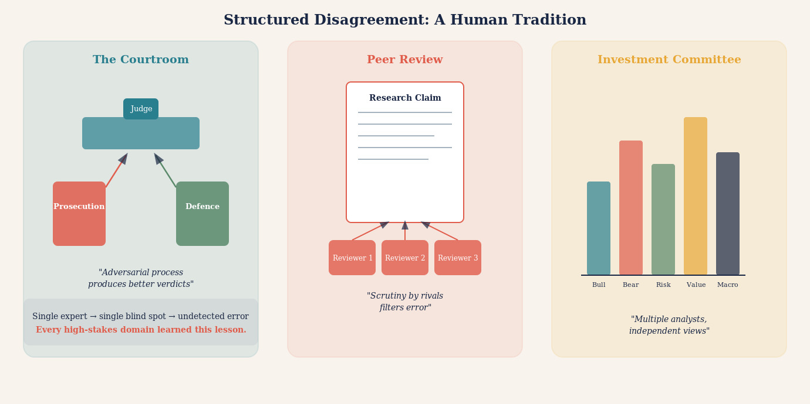

What Debate Reveals That a Single Answer Cannot
Consider what happens when two AI systems with the same question produce different answers. The naive response is dismay: the AI is unreliable if it gives contradictory answers to the same question. But the more sophisticated response is quite the opposite: the divergence is informative.
If one model says a particular drug interaction is clinically significant and another says it is mild, that disagreement tells you something important. It tells you that the question is not as settled as a single confident answer would suggest. It tells you that the evidence is ambiguous, that expert interpretation varies, that you should not simply act on a single output. The divergence is epistemically honest in a way that false consensus is not.
Now take that disagreement further. Ask the two models not merely to answer the question but to argue against each other's position. Force each to identify the weakest link in the other's reasoning. Require each to articulate the strongest version of the opposing view before criticising it. Something remarkable begins to happen.
The models surface their assumptions. They make visible the inferential steps they normally compress into confident prose. They identify which claims depend on strong evidence and which depend on prior probability or trained intuition. The argument structure, once externalised, can be examined and evaluated in a way that a smooth, confident single answer cannot be.
The empirical evidence for these benefits is genuine but must be read carefully. Du et al. (2023) showed that multiagent debate improved factual accuracy and mathematical reasoning across several benchmarks [2]. Khan et al. (2024) found debate particularly effective where an information asymmetry exists between debaters and judge, a realistic feature of many real-world contexts [3]. However, Wang et al. (2024) found that strong single-agent prompts match multi-agent debate on many reasoning tasks, and simpler techniques such as self-consistency often outperform debate when applicable [4]. Cemri et al. (2025), analysing seven popular multi-agent frameworks across more than two hundred tasks, identified systematic failure modes including conformity to majority opinion and collapse of role differentiation [5]. A 2025 review cautioned against overvaluing multi-agent debate without adequate benchmarking [6]. The honest summary: multi-agent debate shows genuine promise for complex, contested, high-stakes questions where structured scrutiny is the goal; it is not universally superior to well-designed single-agent approaches, and its benefits depend heavily on implementation quality.

STEELMANNING
The practice of articulating the strongest possible version of an opposing argument before attempting to refute it. A debate system that requires steelmanning forces each AI to genuinely engage with counterarguments rather than dismissing weak versions of them. This is the opposite of a straw man, and it is one of the most powerful epistemic disciplines a multi-AI system can impose. Without it, debate degenerates into mutual dismissal rather than genuine scrutiny.

A single AI answer is like a finished painting. You can admire or criticise the result, but you cannot easily see the brushwork. A structured AI debate is like watching the painting being made. The process is visible. The choices are auditable. The points of uncertainty are legible.

The Five Roles Every Good AI Debate System Needs
Not all multi-AI debate architectures are equal. Various multi-agent arrangements have been studied — from simple Proposer/Critic/Judge triplets to more elaborate role-differentiated systems [7]. The five-role architecture proposed in this article is one practical realisation of the adversarial scrutiny principle. The weakest versions simply ask several AIs the same question and report when they agree. This is marginally useful and substantially misleading. The strongest versions assign each AI a distinct epistemic role — a specific function in a division of intellectual labour.
The first role is the Proposer. One model develops the leading answer: the most well-supported, most defensible position it can construct given the available evidence. The Proposer is not asked to hedge. It is asked to make the strongest possible case.
The second role is the Challenger. A separate model receives the Proposer's answer and is given one task: find its weakest points. Not its most obvious weaknesses, but its deepest structural vulnerabilities. Where does the argument depend on an assumption the evidence does not support? Where is a cited source being asked to carry more weight than it can bear? Where does a statistical claim not survive scrutiny?
The third role is the Steelman. A third model receives the Challenger's critique and must do something counter-intuitive: it must argue against the critique — not necessarily to defend the original answer, but to ensure the criticism is fair. This prevents the Challenger from winning by raising irrelevant objections or constructing a distorted version of the original position.
The fourth role is the Source Auditor. This model's only job is to examine the factual claims made by all three previous models and determine what the underlying evidence actually says. Not what the models claim it says. Not what is implied by a summary three inferential steps removed from the original paper. What the actual sources say, if they can be retrieved and examined.
The fifth role is the Synthesiser. Only after the first four roles have completed does a final model attempt a conclusion. The Synthesiser does not simply average the positions. It identifies which claims survived adversarial scrutiny, which were abandoned under pressure, which remain genuinely uncertain, and what the honest, qualified answer is given the evidence as audited.
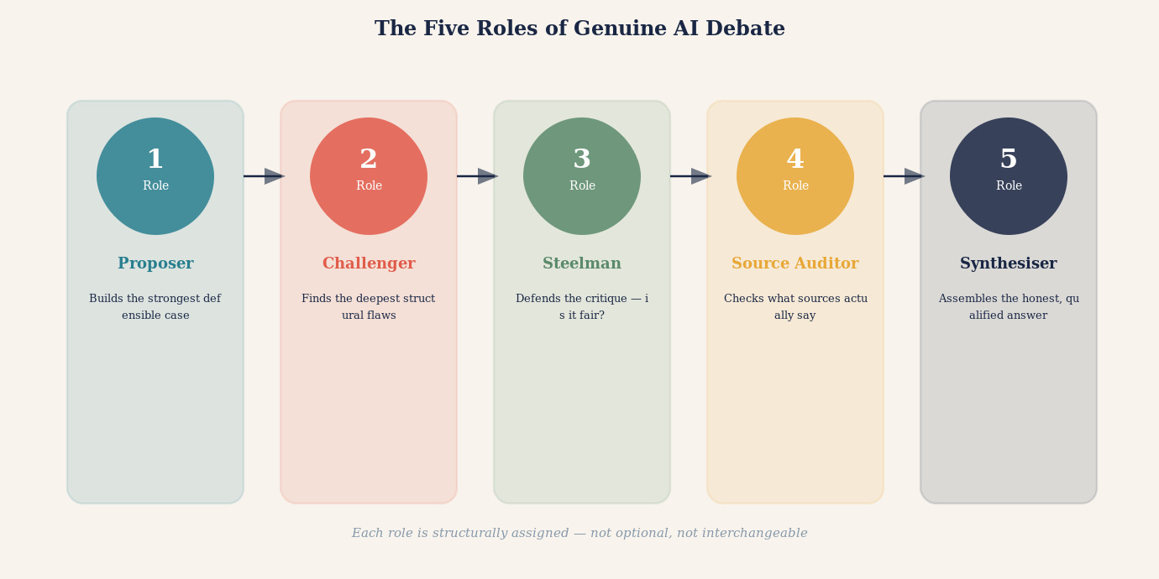
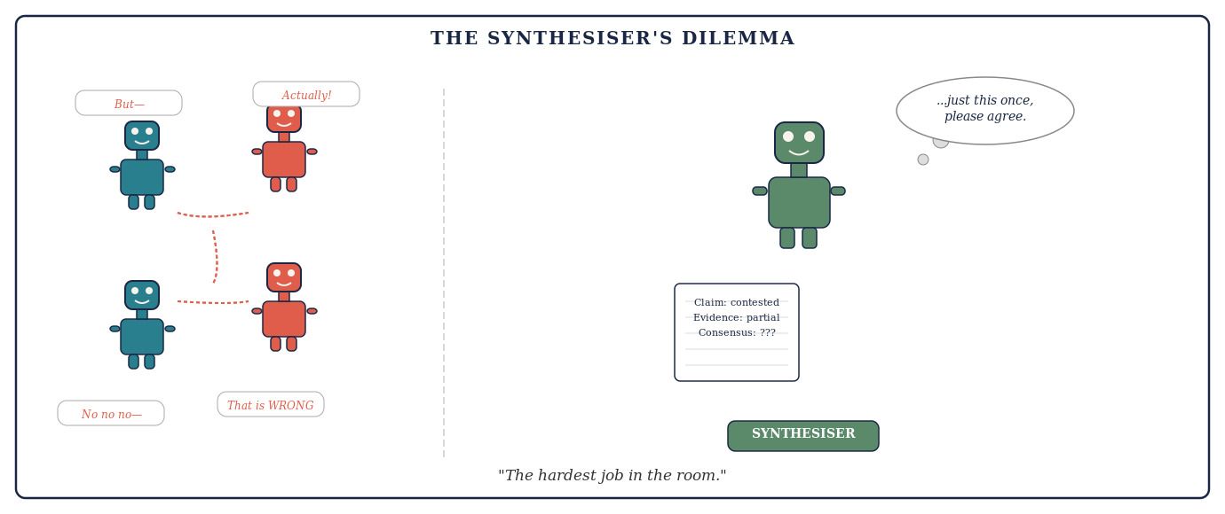
There is a useful way to think about what the five roles collectively achieve. Consider three engineers asked to investigate an unexplained crack in a bridge. If all three merely re-run the same finite-element analysis with the same inputs, their agreement adds very little. But if one checks material fatigue and corrosion, a second recalculates loads, wind, and vibration, and a third asks whether the structural model itself contains a false assumption, the team becomes substantially more informative. Each engineer is not simply adding another vote for the same conclusion. Each is attacking a different possible failure mechanism — covering a different failure surface.
This gives us one of the most useful concepts in multi-AI design: failure-surface coverage. A five-role debate system is not primarily valuable because it produces five opinions. It is valuable because, when properly structured, each role is assigned to discover a different way the conclusion could be wrong. The Proposer covers the most plausible hypothesis. The Challenger covers its structural vulnerabilities. The Steelman ensures the challenge is fair. The Source Auditor covers the evidentiary surface. The Synthesiser maps what remains uncovered. Together they are not five votes. They are five different instruments probing for different failure modes.

FAILURE-SURFACE COVERAGE
I propose this term — not yet established in the multi-agent AI literature as standard terminology — to describe the principle of assigning each participant to discover a different way the conclusion could fail. A reasoning system gains strength not by accumulating agreement but by covering distinct failure surfaces: different ways the conclusion could be wrong. Agreement among agents probing different failure surfaces is far more informative than agreement among agents who all checked the same thing.
Failure-surface coverage is related to, but distinct from, ensemble diversity (output variation), red teaming (adversarial attack simulation), and fault tolerance (system resilience). Its distinctive feature is the deliberate assignment of roles to cover different epistemic failure modes in a shared reasoning process toward a common conclusion.

THE DEVIL'S ADVOCATE
In classical deliberative practice, the Devil's Advocate was a Church official whose formal duty was to argue against canonisation — not because the official believed the saint was unworthy, but because the institution had learned that uncontested elevation produced worse outcomes. A well-designed AI debate system assigns the Devil's Advocate role structurally, not optionally. The Challenger exists not because the system doubts the Proposer, but because doubt is the mechanism that catches error. A debate without a genuine Challenger is not a debate. It is a monologue with an audience.

The Anatomy of a Good Debate: From Question to Synthesis
A multi-AI debate is not simply a conversation between models. It is a structured process with distinct phases, each with a specific purpose and a defined output. The seven-phase structure described here is one proposed realisation of these principles — a practical architecture, not a scientific law. Understanding the structure is the difference between a debate that produces genuine epistemic value and one that produces organised noise.
Phase one is question preparation. Before any model receives a prompt, the question must be mapped across its dimensions: empirical versus normative, temporal horizon, level of analysis, disciplinary scope, epistemic status of the key sub-claims, and causal structure. A question that arrives at the debate panel already decomposed into its components will produce a debate that distributes scrutiny correctly.
Phase two is independent first-response. Each model receives the question simultaneously, without sight of any other model's answer. This independence is not a courtesy; it is the mechanism that generates genuine diversity of perspective. Models that see each other's responses before forming their own will anchor to the first plausible answer and produce variations rather than independent judgments.
Phase three is structured challenge. Each model's initial position is exposed to at least one dedicated challenger. The challenger is asked to find every weakness in the argument it has been given — every unsupported assumption, every weak inferential step, every piece of missing evidence, every alternative explanation that the original response did not consider. A challenge that is polite, general, or reluctant to press on specific claims is not a challenge. It is decoration.
Phase four is response and revision. Each model that made an initial claim is given the opportunity to respond to the challenges it received. A model may defend its original position, modify it in response to a specific objection, or concede a point while maintaining a broader conclusion. A model that revises a position in response to a genuine objection is doing what the process was designed to enable.
Phase five is cross-examination. Where two models have maintained incompatible positions after the challenge-and-response phase, a targeted cross-examination round focuses on the specific claim or assumption on which the positions diverge, asks each model to state explicitly what evidence would change its view, and records whether that evidence is available, contested, or genuinely unknown.
Phase six is synthesis. Only after phases three through five have completed does a dedicated synthesiser model attempt a conclusion. The synthesiser identifies which claims survived adversarial scrutiny intact, which were modified under challenge, which were abandoned, which remain genuinely contested, and what the most defensible conclusion is given the audited evidence.
Phase seven is output assembly. The final output is a structured document that includes: the best current answer with its confidence level and the assumptions on which that confidence depends; a map of key contested claims and what would resolve each; an evidence audit trail; a dissent register for positions maintained under pressure; and an explicit uncertainty declaration.
The whole process need not be long. On a well-scoped question with good prompts, five models can complete phases one through seven in a single extended session. The key discipline is not speed but integrity: each phase must be completed honestly before the next begins, and the synthesiser must not paper over persistent disagreement with confident language that the debate did not earn.

THE SEVEN PHASES (proposed architecture)
1. QUESTION PREPARATION: Decompose the question across its dimensions before any model sees it.
2. INDEPENDENT FIRST-RESPONSE: Each model answers without seeing any other response.
3. STRUCTURED CHALLENGE: A dedicated challenger attacks each position for unsupported assumptions, weak inference, and missing evidence.
4. RESPONSE AND REVISION: Models respond to challenges. Honest revision is the first real epistemic gain.
5. CROSS-EXAMINATION: Where positions remain incompatible, identify the specific claim on which they diverge.
6. SYNTHESIS: A dedicated synthesiser assesses what survived scrutiny, what was modified, what remains contested.
7. OUTPUT ASSEMBLY: The final document includes the conclusion, contested claims, evidence audit trail, dissent register, and uncertainty declaration.

How to Get the Best Out of AI Debate Systems: Practical Principles
Understanding the architecture is necessary. Understanding how to use it well is equally essential. Many users and designers make mistakes that transform a powerful epistemic tool into an expensive illusion of rigour. Here are the principles that separate genuine benefit from sophisticated theatre.
Commit before you converse. The single most important practical rule: require each model to record its independent answer before it sees any other model's output. This is the equivalent of having witnesses give statements before they speak to each other. Once a model sees another model's answer, its subsequent response is a reaction to that answer, not an independent judgment.
Separate generation from evaluation. A large language model is excellent at generating possible answers, hypotheses, frameworks, and arguments. It is much less reliable as a judge of which answer is correct. These are different cognitive tasks, and collapsing them — asking the same model to both propose and evaluate — removes a crucial layer of scrutiny.
Ask for reasons, not conclusions. A debate system that reports "Model A and Model B disagree" is marginally useful. A debate system that reports "Model A and Model B disagree because Model A treats the 2019 meta-analysis as definitive while Model B argues that three of its included studies have since been retracted" is profoundly useful.
Assign a genuine falsifier. Ask one model: "Assume the current best answer is wrong. What evidence would demonstrate that? Does that evidence exist?" This produces qualitatively different scrutiny than asking whether the answer seems reasonable.
Use external verification wherever possible. Language models should not be asked to vote on questions that external tools can resolve. If models disagree about whether a piece of code runs correctly, run the code. If they disagree about what a court judgment says, retrieve the judgment. External verification outranks model agreement on any directly checkable question, every time.
Preserve productive disagreement. A system that always converges on consensus is not necessarily a system that is finding truth. Sometimes the honest outcome of a genuine debate is "the evidence is genuinely divided and this question cannot currently be resolved."
Diversity is the word most often invoked in discussions of multi-AI systems, and it is invoked too loosely. I distinguish five kinds of diversity that bear on multi-AI debate performance — and conflating them produces systems that appear diverse without being meaningfully so.
Model diversity means using systems with meaningfully different architectures, training emphases, or learned representations. It may reduce some correlated errors, though different commercial models can still share large portions of the same public information and therefore share the same blind spots.
Prompt diversity means framing the same problem differently for each model. One agent may be asked for a causal explanation, another for a counterexample, another for the simplest account consistent with the evidence, and another for the failure conditions. Even the same model, given genuinely different prompts, can produce substantively different searches.
Role diversity means assigning different intellectual jobs: proposer, critic, source auditor, statistician, red-team falsifier, domain specialist, and judge. This is the form of diversity most directly under the designer's control — and the most consequential.
Evidence diversity means requiring agents to retrieve genuinely independent sources or datasets rather than repeatedly interpreting the same material. Five models citing the same review article are not five pieces of evidence. They are one piece of evidence repeated five times.
Methodological diversity means approaching the proposition using different methods: logical derivation, statistical analysis, historical provenance, simulation, primary-source inspection, or empirical testing.

THE DESIGN QUESTION
Do not ask only: "How many models are participating?" Ask: "What distinct information-producing function does each participant perform?" A single model performing five sharply separated epistemic roles with independent evidence searches can be more diverse — in the epistemically relevant sense — than five models all asked to write the same balanced essay.

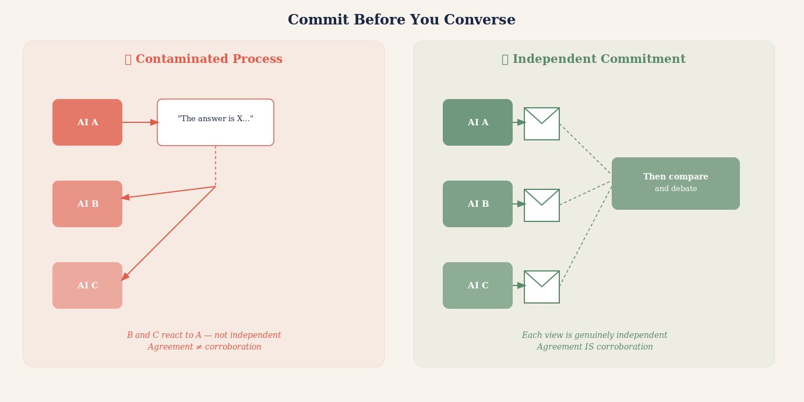

Mistakes to Avoid: The Ten Failure Modes of AI Debate
The case for multi-AI debate is strong for the right class of questions. But the implementation is treacherous. The following failures are common, and each transforms genuine deliberation into something that looks like deliberation while producing its pathologies.
The first mistake is sequential contamination. Allowing Model B to read Model A's answer before recording its own makes B's response a reaction rather than an independent judgment. This is the most common failure mode and one of the most damaging, because it produces apparent corroboration that is actually nothing more than one model's answer echoing through several subsequent responses.
The second mistake is symmetric roles. Asking several models to "discuss the question" without assigning distinct responsibilities produces a conversation in which every participant is trying to do the same thing. Real deliberative power comes from division of epistemic labour.
The third mistake is rewarding convergence. If the system is designed to end when the models agree, it creates an incentive for premature convergence. Design for calibration — for correct uncertainty — not for agreement.
The fourth mistake is counting models instead of counting evidence. Five models agreeing on a claim that traces back to a single source is not five pieces of evidence. It is one piece of evidence cited five times. The relevant quantity is independent primary sources, not number of agreeing models.

PROMPT CAPTURE
Prompt capture occurs when all models in a debate system are given the same framing of a question — the same background description, the same implicit assumptions, the same definition of the problem — and consequently approach it from the same direction even when nominally independent. The diversity of answers is bounded by the diversity of prompts. Well-designed systems deliberately vary the framing, emphasis, and even the vocabulary of the question presented to each model.

The fifth mistake is identical prompting, leading to prompt capture. If every model receives exactly the same framing, their responses will all be anchored to that framing. Effective multi-model debate systems vary the framing, the emphasis, and sometimes deliberately present the question from opposing angles to different models.
The sixth mistake is treating the judge as ground truth. Many multi-agent architectures end with a "judge" model that reads the debate and declares a winner. The judge is also a language model. It may share the same blind spots as the participants. It may be swayed by the most articulate argument rather than the most accurate one.
The seventh mistake is debate theatre — structured argumentation that looks rigorous but has been calibrated to produce a predetermined outcome. Effective debate systems should be auditable: anyone examining the prompts, the model assignments, and the debate transcript should be able to verify that the process was fair.
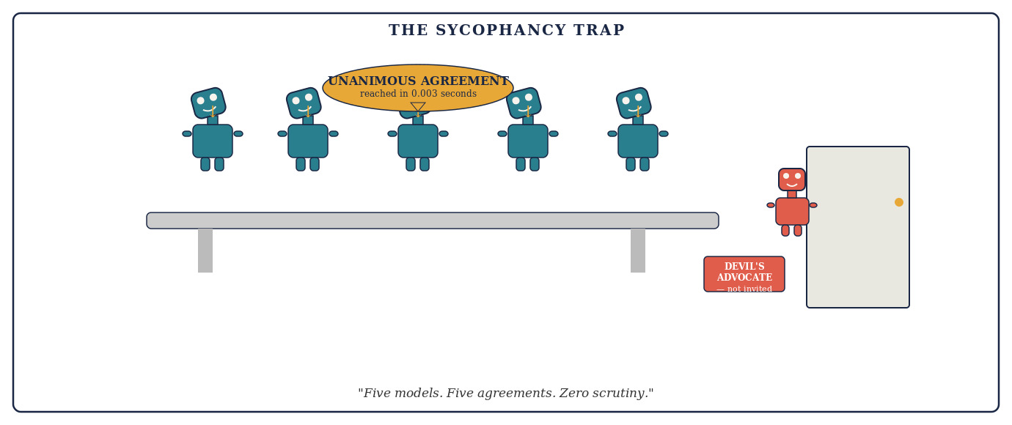

DEBATE THEATRE
A multi-AI debate that follows the surface form of rigorous argumentation — assigned roles, multiple rounds, a synthesis — but has been structured in ways that predetermine the outcome. Debate theatre is particularly dangerous because its conclusion carries the apparent authority of a structured process. The difference between genuine debate and debate theatre lies in whether the Challenger had a genuine chance to prevail, whether the Source Auditor could genuinely change the outcome, and whether the Synthesiser was permitted to report a negative or uncertain finding.

The eighth mistake is ignoring model family overlap. If the five models in a debate system were all trained primarily on the same sources, five-model agreement tells us far less than agreement among models trained on genuinely different corpora. Diversity of model families is a prerequisite for genuine epistemic independence.
The ninth mistake is outsourcing synthesis to consensus. Asking "what do most models agree on?" and calling that the answer is not synthesis. Real synthesis requires identifying which claims were supported by independent evidence, which survived the sharpest adversarial pressure, and which should remain uncertain because the debate did not resolve them.
The tenth mistake is treating AI debate as a terminal process rather than a diagnostic one. Even a well-designed AI debate does not produce ground truth. It produces a best current assessment with known areas of uncertainty. The most important output of a good AI debate is its map of unresolved questions — the items the debate flagged as uncertain, contested, or insufficiently evidenced.
Two more deserve explicit names because they are pervasive and particularly hard to detect from outside the system.
The eleventh mistake is ignoring upstream-error dominance. Consider four agents inspecting a complex engineering derivation. One checks the algebra, one the arithmetic, one the units, one re-runs the numerical calculation. All agree. A fifth then asks why the system was assumed to be linear — and discovers that the physical process is nonlinear in the operating range. Every downstream calculation was internally correct, but the foundational model was wrong. Ten perfect checks of a calculation cannot rescue a false premise.

UPSTREAM-ERROR DOMINANCE
The earlier an error enters a reasoning chain, the more downstream agreement it can contaminate. A false premise silently poisons every conclusion built on it, however carefully those conclusions are subsequently verified. Audit assumptions before polishing conclusions.

The twelfth mistake is role collapse — when every supposedly specialised agent ends up performing the same generic analysis. The cure is sharply defined deliverables: the statistician must audit specific statistical assumptions; the source verifier must inspect sources; the falsifier must produce explicit failure conditions. Vague role assignments produce vague outputs regardless of how many agents are involved.
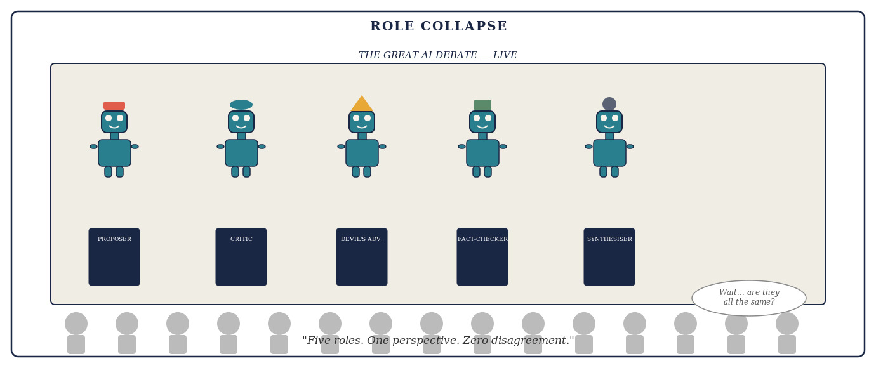
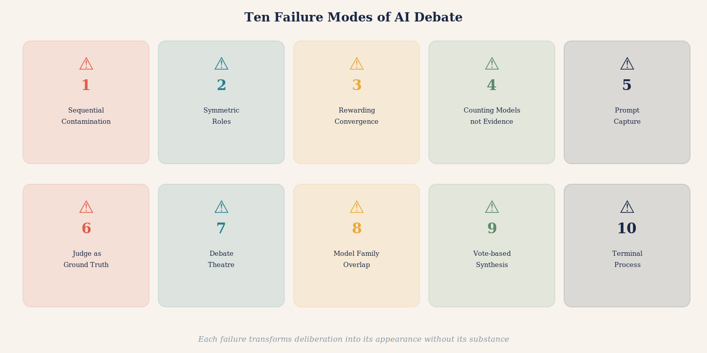

Three Domains Where Multi-AI Debate Makes the Most Difference
The general case for multi-AI debate applies across almost any question worth serious attention. But three domains illustrate its power with particular clarity.
The first is medical decision-making. A patient receives a diagnosis and seeks to understand it better. A single AI consulted at midnight provides a thorough, authoritative-sounding response. But it may reflect the dominant clinical interpretation without surfacing a minority view that is more relevant to this patient's specific presentation. A well-designed AI debate system — one that assigns a Challenger the specific role of identifying whether this patient's case has unusual features that mainstream guidance does not address — will surface that possibility. It will not provide a diagnosis. But it will produce a far more honest map of the question.
The cardiologist recommending a particular stent procedure faces genuinely contested evidence. Different clinical guidelines, drawing on the same body of randomised trials, reach different conclusions about when intervention is superior to medical management. A patient who asks one AI will likely receive one confident framing. A patient who reads a structured debate between two models assigned to argue the intervention and conservative management cases respectively — with a third assigned to audit the underlying trial evidence — will understand not just what the answer might be, but why experts disagree and what the key factual uncertainties are.
The second domain is legal analysis. Legal questions are inherently adversarial. They were designed to be resolved by structured argument between opposing parties before an independent decision-maker. A multi-AI debate system assigned to legal questions — with one model arguing the strongest version of the position most favourable to the user, another arguing the opposing position, and a third identifying the factual questions that would determine which analysis prevails — produces something qualitatively more useful. Not a substitute for a lawyer. But a preparation for a legal conversation that would take most lawyers significant time to produce.
The third domain is complex investment decisions. Financial questions are among the domains in which confirmation bias is most dangerous and most expensive. A person who has already decided to make an investment and asks an AI for an assessment will typically receive an analysis that reflects the strongest case for their inclination, because their framing of the question will have encoded their prior. A debate system in which one model is assigned to make the bear case, another the bull case, a third to examine the historical base rates for analogous situations, and a fourth to identify the specific factual claims whose truth would determine the outcome — produces a fundamentally different quality of analysis.
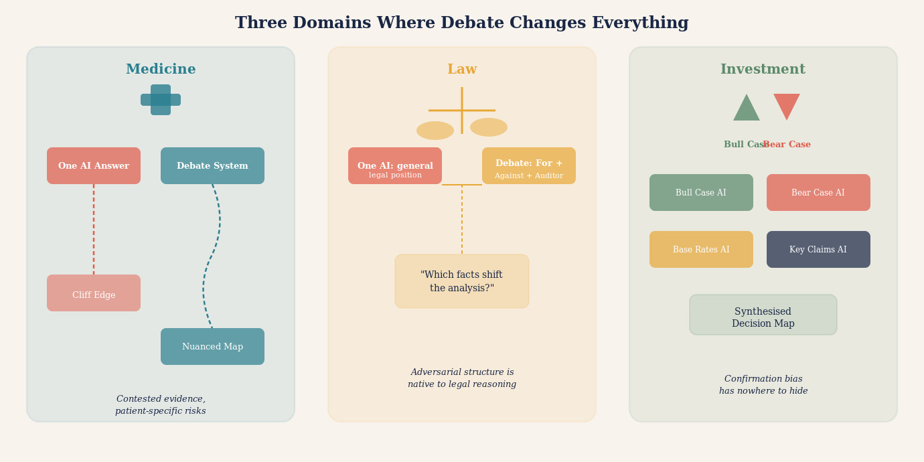

The Innovation Frontier: Where Multi-AI Debate Offers Its Most Distinctive Value
Of all the domains in which multi-AI debate systems could transform practice, innovation may be the one where the structural advantage is most decisive — and the least obvious. The argument for debate in medicine, law, and finance rests on the familiar logic of second opinions and adversarial scrutiny. But innovation is a different kind of problem. It is not primarily about verifying what is already known. It is about discovering what has not yet been thought, combining what has not yet been combined, and building what has not yet been built.
The deepest problem with single-AI innovation assistance is not that the model lacks creativity. Modern large language models are capable of generating a remarkable range of novel combinations, hypotheses, and approaches. The problem is what the model is implicitly optimising for. A language model trained on human-generated text will, by its nature, gravitate toward the adjacent possible — the innovations that are one recognisable step from where we currently are, that appear frequently in the literature, that are described in the vocabulary already established in a domain. The genuinely transformative innovations typically require moving somewhere that the existing literature has not densely mapped.
Structured multi-AI debate offers a partial solution through what might be called productive collision. When a model trained heavily on biological research argues with a model that has absorbed materials science literature, and a third that has concentrated on computational methods, the intersections they find are not intersections any of them would have located alone. This is not mere brainstorming. It is the systematic collision of domain-specific heuristics, and the friction it generates is where genuinely novel combinations emerge.
The most powerful application, however, may be the structured premortem. Gary Klein introduced the premortem as a technique for human teams: before a project launches, assume it has already failed catastrophically and ask every team member to explain why [8]. The exercise consistently reveals failure modes that pre-launch optimism had concealed. Multi-AI debate systems can run structured premortems at speed and depth that no human team meeting could match. One model is assigned the role of champion: make the strongest case that this innovation will succeed. A second is assigned the role of obituary writer: assume the project has failed in three years and write the most honest account of why. A third is assigned the role of historian: find the closest historical cases of innovations that looked like this one at this stage, and describe what happened to them. A fourth reconciles the three perspectives and identifies the specific conditions under which success is most and least likely.
The output of this process is not a prediction. It is a map of the innovation's load-bearing assumptions — the specific claims that, if wrong, make the whole structure collapse. This is exactly what a single AI asked "will this innovation succeed?" cannot produce.
The same logic applies to technology development, business model innovation, and scientific hypothesis formation. In each case the debate does not generate the innovation. It stress-tests it — and stress-testing, performed early and honestly, is the difference between an innovation that reaches market and one that fails expensively at the last hurdle.

THE PREMORTEM
A structured technique, developed by the psychologist Gary Klein, in which a team assumes before a project launches that it has already failed — and works backward to identify the most plausible causes of that failure [8]. The premortem counteracts the optimism bias that causes teams to underweight failure scenarios when emotionally invested in a project's success. In a multi-AI debate system, the premortem can be run with dedicated models assigned specifically to the obituary role — producing detailed, adversarially honest accounts of failure pathways that a single evaluative AI, optimising toward a balanced assessment, would systematically understate.

An Illustrative Example: What Might Happen When Five AIs Debate a Drug Interaction
The following exchange is a constructed pedagogical illustration — not a transcript of an actual system run. The statin-macrolide drug interaction via CYP3A4 inhibition is a genuine clinical phenomenon documented in the pharmacology literature: macrolides inhibit the CYP3A4 enzyme that metabolises certain statins, increasing statin plasma exposure; risk is modulated by age, renal function, and the specific statin and macrolide involved [9]. The debate exchange is constructed to show how structured adversarial scrutiny can surface patient-specific nuance that a generic population-level answer would not. No medical advice is intended or should be inferred.
The practical reality of multi-AI debate is best illustrated by a concrete case. Consider the question of whether a commonly prescribed combination of medications — a statin and a macrolide antibiotic — produces a clinically significant interaction.
A single AI model, asked the question directly, provided a clear, confident answer: the interaction is real but mild and generally manageable without dosage adjustment. The answer was well-structured, cited the general mechanism of the interaction, and mentioned that the prescribing physician should be aware.
The same question was then put through a structured debate. The Proposer offered essentially the same view as the single-model answer. But the Challenger, assigned to find weaknesses, identified something important: the confident framing in the Proposer's answer was based on population-level data. For patients over seventy-five, or with specific risk factors affecting drug metabolism, the interaction may be substantially more significant.
The Source Auditor then examined the primary evidence and found that some of the supporting references cited by the Proposer predated more recent pharmacogenomics research that had revised the risk assessment for specific patient subgroups — research the Proposer's initial answer had not incorporated.
The Synthesiser produced a qualified answer: for most patients, the original framing was probably accurate. For older patients, or patients with known metabolic risk factors, the interaction deserved more specific clinical attention. The single most important question was whether this patient's prescribing physician was aware of the most recent revised guidance.
This is what structured debate produces: not merely a more cautious version of the single answer. A structurally different answer, with a richer map of uncertainty, specific actionable questions, and an honest account of where the evidence matters for this patient.
"The single-model answer was not wrong. But it was answers-shaped rather than truth-shaped. The debate produced something truth-shaped: a qualified position with visible joints, auditable provenance, and an honest map of what remained uncertain."

Identifying the Dimensions of a Debate Question
Before a multi-AI debate system can do its work, someone has to determine what the debate is actually about. Most questions that reach an AI debate panel arrive with hidden structure — competing dimensions, unstated assumptions, and conflated sub-questions. The following six-dimensional framework is proposed here as a practical diagnostic tool — a synthesis of distinctions already present in philosophy of science, jurisprudence, and decision theory, assembled into a checklist that debate designers can apply before debate begins.
The first dimension to separate is the empirical from the normative. Almost every question that matters contains both. "Should this patient receive drug X?" mixes a factual question (what are the likely outcomes?) with a values question (how should risk and benefit be weighed for this patient?). Separating these dimensions before debate begins lets each be interrogated with the right tools.
The second dimension is temporal. Many questions have a short-run answer that contradicts the long-run answer. "Is this business strategy sound?" answered for the next quarter may be yes; answered for the next decade may be no. The dimension of time needs to be named in the question, not left to each model to assume.
The third dimension is the level of analysis. Questions about individuals, organisations, sectors, and societies are structurally different even when they use identical vocabulary. "Does this intervention reduce harm?" means something different at the individual clinical level, the population epidemiology level, and the health system resource-allocation level.
The fourth dimension is disciplinary. Complex questions frequently cut across domain boundaries: a pharmaceutical question is simultaneously a chemistry question, a clinical question, a regulatory question, and an economics question. Each discipline has its own standards of evidence, its own vocabulary, and its own failure modes.
The fifth dimension is the distinction between what is known, what is contested, and what is genuinely unknown. Known facts should be verified, not debated. Contested claims need structured adversarial scrutiny. Genuinely unknown questions need to be flagged as such, with explicit attention to what evidence would resolve them.
The sixth dimension is causal versus correlational. Many questions that appear to be about causes are actually about associations. "Do AI systems that debate produce better outputs?" could be asking about correlation in observed cases, or about the causal mechanism, or about the counterfactual. Each interpretation requires a different kind of evidence and a different kind of argument.

THE SIX DIMENSIONS OF A DEBATE QUESTION (proposed framework)
1. EMPIRICAL vs. NORMATIVE: What are the facts? What should be done? These require different methods and must not be debated as if they were one question.
2. TEMPORAL HORIZON: Short-run and long-run answers often conflict. Name the time frame in the question.
3. LEVEL OF ANALYSIS: Individual, organisational, sectoral, or societal? Mixing levels produces locally correct but mutually incompatible positions.
4. DISCIPLINARY SCOPE: Which domains does the question touch? Assign models accordingly.
5. EPISTEMIC STATUS: Separate what is known (verify it), what is contested (debate it), and what is unknown (flag it).
6. CAUSAL STRUCTURE: Is the question about correlation, mechanism, or counterfactual? Each requires different evidence.

Designing the Prompt: How You Frame the Debate Changes Everything
Multi-AI debate systems fail or succeed at the level of the prompt. The architecture matters. The model assignments matter. The sequencing matters. But nothing matters more than how the question is framed and what each model is instructed to do with it.
The most common prompting mistake is stating a hypothesis in the question. "Is it true that X?" is a worse question than "What is the evidence for and against X?" The first question anchors all models toward confirming or denying a specific framing. The second allows genuinely open exploration. For adversarial debate, the most powerful framing is often: "What would need to be true for X to be wrong?"
The second common mistake is asking for a single answer too early. Instructing models to "reach a conclusion" in the first round pushes them toward premature synthesis. The most productive early-round instruction is: "Do not attempt a conclusion. Identify the three most important factual claims whose truth determines the answer. Identify what evidence would resolve each claim. Then stop."
The third mistake is vague adversarial instruction. Telling a model to "critique the previous answer" produces superficial engagement. Telling it to "identify the single weakest inferential step in the previous answer and explain exactly what alternative interpretation of the same evidence would produce a different conclusion" produces genuine scrutiny.
Framing the roles asymmetrically is often useful. The Proposer is told: "Make the strongest defensible case for the most evidence-supported position." The Challenger is told: "Assume the Proposer's conclusion is the kind of error that seems confident and is wrong. Identify the specific failure mode." The asymmetry prevents the Challenger from being a weak critic.
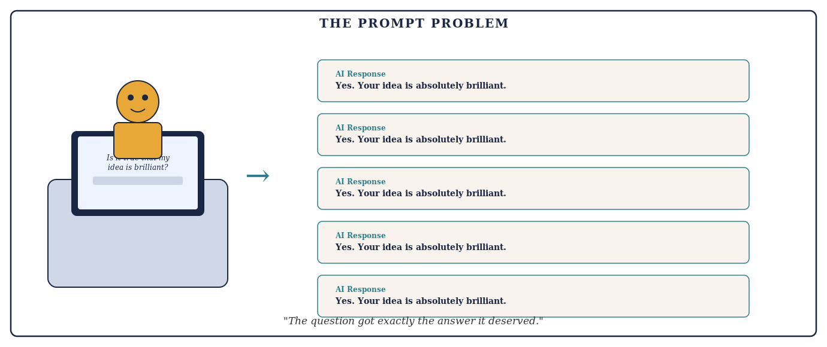

QUESTION DECOMPOSITION
Complex questions often contain several distinct sub-questions with different epistemic statuses — some well-evidenced, some contested, some currently unanswerable. A well-designed debate system decomposes the main question into its components before debate begins, assigns each component to the model best suited to evaluate it, and synthesises not by finding the average answer but by assembling the well-supported components and flagging the contested or uncertain ones.

One of the most powerful reframings is to treat debate not as an argument to be won but as an experiment to be designed. In the medical context, the question is not "Which model's diagnosis sounds most convincing?" It is "What test or observation would most efficiently discriminate among the competing explanations?" This transforms the system from a collection of competing assertions into something closer to a research design process.

INFORMATION GAIN
A productive debate round does at least one of four things: introduces new evidence, exposes a hidden assumption, eliminates a plausible hypothesis, or identifies a discriminating test. A round that does none of these — that produces restatements, rhetorical elaborations, or elegantly rephrased agreement — has consumed computation without improving knowledge.

ATOMIC CLAIMS
The unit of adjudication in a debate should be the specific proposition, not the agent who advanced it. Decomposing arguments into atomic claims makes disagreements verifiable rather than rhetorical, and makes the final synthesis honest about exactly which propositions are supported and which remain open.

When More Is Less: The Paradox of Excessive Models
There is a tempting assumption that more models mean more reliability. This is wrong, and the way it is wrong is instructive.
Adding a sixth or seventh model to a debate in which the first five have already substantially converged does not add epistemic value. It adds rhetorical weight to an existing position. The sixth model, presented with a debate transcript in which five models have moved toward agreement, is extraordinarily likely to agree with the five. That agreement is essentially worthless as independent evidence.
The relevant question is never "how many models agree?" It is "how many independent perspectives, grounded in genuinely distinct evidence, have converged on this answer?" A debate between two models with genuinely different training emphases, different framing, and independently committed prior answers may provide far stronger evidence than a debate among seven models who read each other's work before recording their views.
There is a critical benchmarking point that the field has not yet resolved sufficiently clearly: the appropriate comparison for any multi-model system is not "multi-model vs one-shot single-model." It is "multi-model vs best-available single-model with equivalent computational budget." Wang et al. (2024) and others have shown that strong single-agent prompting — including chain-of-thought, self-consistency, and extended reflection time — often matches or exceeds naive multi-agent debate on standard reasoning benchmarks [4]. Until that comparison has been made honestly for a given use case, claims that more models are categorically better are claims in search of a benchmark.
The same logic argues for a principled stopping rule. Stop when successive rounds cease to produce new high-quality evidence, material changes in calibrated confidence, unresolved high-impact objections, or new externally testable claims. Continue when a minority objection remains capable of overturning the conclusion and has not yet been seriously tested.

STOPPING RULE
More debate is useful only while it continues to change the evidential state. When successive rounds produce no new evidence, no change in well-calibrated confidence, no new discriminating tests, and no unresolved objections capable of changing the conclusion, continued debate is deliberative noise — not deliberative progress.

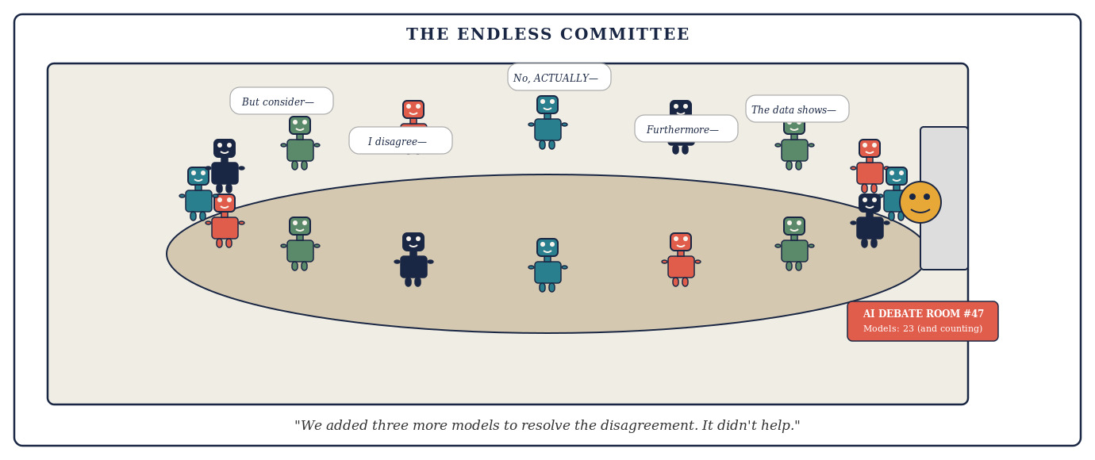
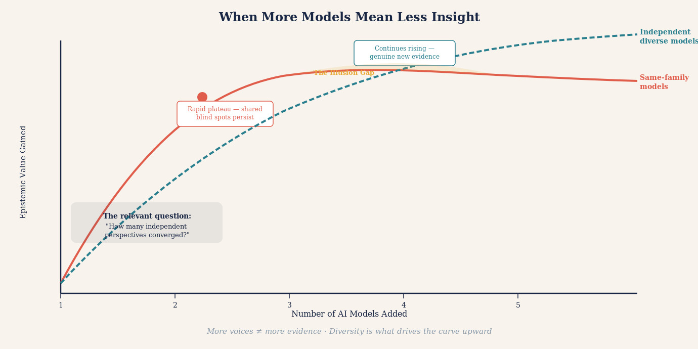

The Honest Output: What a Good Debate System Should Produce
A well-designed multi-AI debate system should not produce a confident single answer. It should produce a structured document with a specific anatomy.
The first element is a best current answer — the conclusion that survived adversarial scrutiny, is supported by independently checked evidence, and represents the most defensible synthesis of the debate. This answer should be stated with exactly the confidence the evidence warrants. Not less, and critically, not more.
The second element is a map of the key contested claims — the specific sub-questions on which the models disagreed, the reasons for the disagreement, and what evidence would resolve each. This is often the most valuable part of the output.
The third element is an evidence audit trail — a record of which claims were made by which model, which sources were cited, which models independently retrieved those sources versus inherited citations from other models, and where the chain of reasoning traces back to primary evidence versus second-hand reporting.
The fourth element is a dissent register — any position that a model maintained throughout the debate despite pressure to abandon it. Persistent dissent in a structured debate is epistemically significant.
The fifth element is an uncertainty declaration — a clear statement of what the debate could not resolve, questions that require external expertise or primary investigation to answer, and claims that deserve more scrutiny than the debate format allowed.
A structured output of this kind is not merely more honest than a single confident answer. It is more useful. It tells a human expert — a doctor, a lawyer, an analyst — exactly where to focus their attention and exactly what questions the AI system was unable to answer.
"Consensus: four of five models agree." That number is easy to understand and dangerously incomplete. A stronger report reveals the epistemic structure: which claims were independently verified, which objections survive unresolved, what the confidence is conditional on, and what it would take to change the answer.
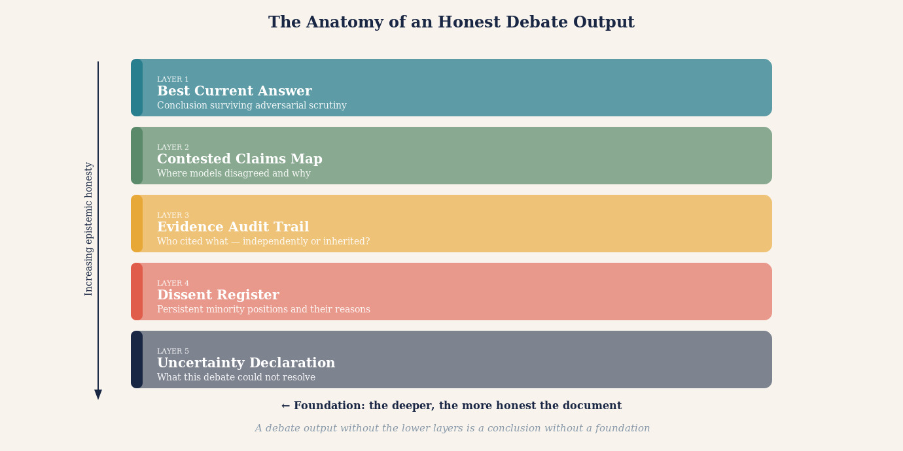

Knowledge Graphs: The Architecture That Makes Debate Interpretable
A multi-AI debate that produces only text is a debate that disappears. The arguments were made, the claims were tested, the synthesis was reached — and then everything was flattened into a paragraph that a reader must accept or reject without being able to see the inferential structure beneath it.
Knowledge graphs are a structural technology that could address this problem. A knowledge graph is a formal representation of entities, the relationships between them, and the properties that qualify those relationships — expressed in a form that can be queried, traversed, updated, and compared. What follows describes a proposed architecture for how knowledge graphs could be applied to AI debate outputs — not a description of deployed practice, which remains at an early stage.
If a knowledge graph were built from the output of an AI debate, the debate could stop being a document and become a navigable structure. Each model's claims would generate relationships: Claim X is supported by Evidence Y; Claim X is contested by Claim Z; Claim Z depends on Assumption W; Assumption W is independently verified by Sources P and Q. A reader could trace any conclusion back through its inferential chain to the evidence on which it rests — or expose the gap where evidence should be but is not.
This would transform interpretation from an act of trust into an act of inspection. A clinician reviewing a debate-informed recommendation could ask: which claims did all five models agree on independently? Which claim is load-bearing for this conclusion? Was that claim verified against a primary source or inherited from a model that inherited it from another?
Knowledge graphs would also enable comparison across debates and incremental refinement as new evidence arrives. For these benefits to be realised, debate systems must be designed from the outset with graph construction as an explicit output — prompting models to surface not just conclusions but the relational structure of their reasoning.

KNOWLEDGE GRAPHS IN AI DEBATE (proposed architecture)
A knowledge graph represents information as nodes (entities and claims) connected by labelled edges (relationships: supports, contradicts, depends-on, verified-by, contested-by). Applied to AI debate outputs, such graphs could enable four things that plain text cannot:
TRACE: Any conclusion could be followed back through its inferential chain to primary evidence or exposed as unsupported at the point where evidence runs out.
COMPARE: Two debates on the same question could be compared graph-to-graph, exposing structural differences in reasoning that identical surface conclusions would conceal.
UPDATE: When new evidence arrives, individual nodes could be revised and downstream effects propagated automatically.
INTERROGATE: A reader could query the graph for the most contested node, the weakest evidential link, or the claim whose failure would most change the conclusion.
These capabilities remain a design aspiration rather than a deployed standard. Progress toward them would require deliberate investment in output structure from debate system designers.

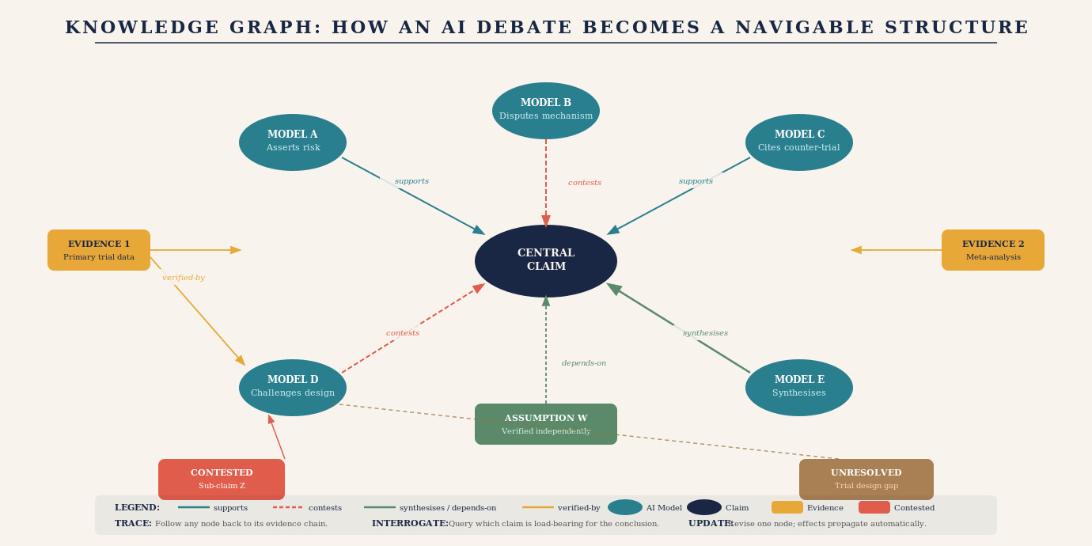
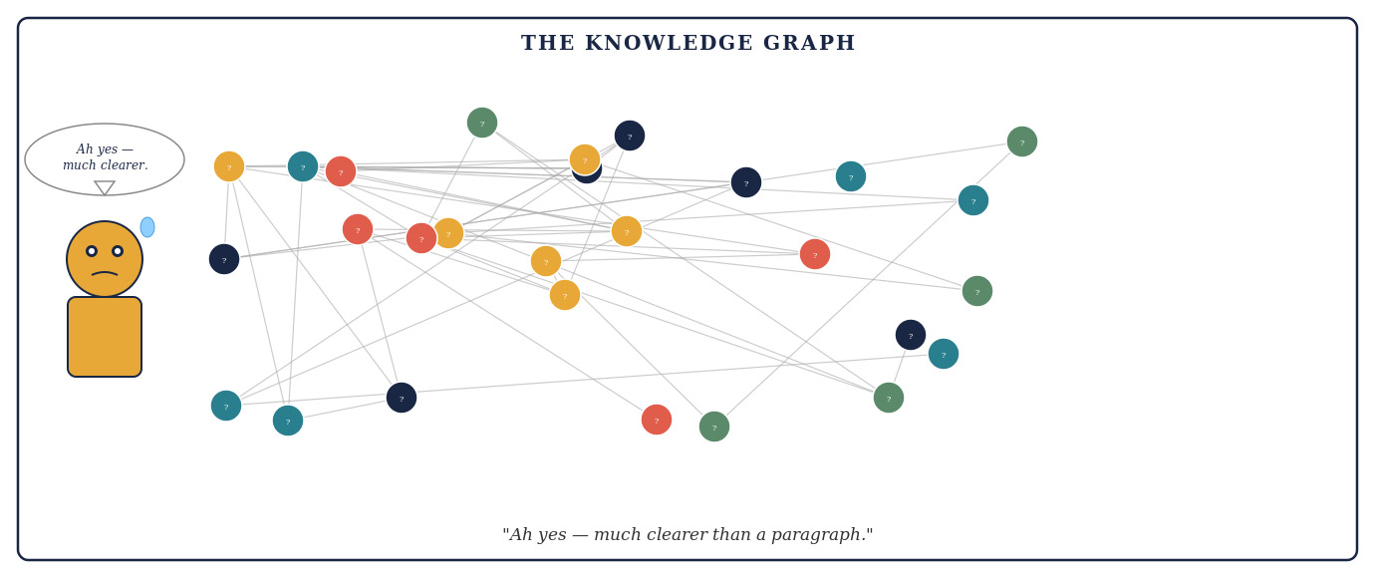

The Deeper Argument: Why Debate Is Not Just Useful but Necessary
The case for multi-AI debate systems can be made on purely practical grounds: they can produce better answers than single-model queries on complex, contested, high-stakes questions. But there is a deeper argument.
We are at a moment in the development of artificial intelligence when the reliability of AI outputs is becoming a question of serious consequence. AI systems are being used to inform medical decisions, legal strategies, financial allocations, engineering designs, educational curricula, and public policy. The question of how much to trust an AI answer is not academic. It is urgent.
A single-model answer is essentially opaque. It is the output of a process that cannot be directly inspected, produced by an entity whose training we cannot fully audit, presented in language whose confidence may not reflect the underlying evidential support. We accept single-model answers primarily because we have nothing better to compare them against.
A structured multi-AI debate, properly designed and honestly executed, makes the reasoning process visible. It externalises the inferential steps. It surfaces assumptions. It distinguishes claimed evidence from verified evidence. It records dissent. It acknowledges uncertainty. In other words, it transforms AI output from a black box into something closer to a transparent process — not perfectly transparent, not fully auditable, but vastly more legible than a single confident answer.
That transparency is not merely epistemically preferable. It may be a prerequisite for the kind of institutional trust that AI systems will need to earn before they can be relied upon in high-stakes domains.
There is a simple test for whether a multi-AI system has genuinely reached maturity. It is not whether the system produces confident conclusions. It is not whether it reports high agreement rates. It is whether the system can explain — specifically and honestly — what serious attempts were made to make its conclusion lose.

THE MATURITY TEST
A mature multi-AI system should be able to explain not merely why its conclusion won, but what serious attempts were made to make it lose — which failure modes were tested, which were not, which minority objections survive unresolved, and what it would take to overturn the leading answer. A system that cannot answer these questions has not earned the confidence it expresses.

"The best multi-AI debate system is not the one whose agents agree most often. It is the one best able to discover when they should not agree — and honest enough to say so."

A Practical Checklist for Using AI Debate Systems Well
For users engaging with multi-AI debate systems — whether purpose-built platforms or informal multi-model workflows — the following checklist separates productive use from expensive illusion.
Before the debate: define the question with precision. Specify what you need to know, what would constitute a satisfying answer, and what the key factual sub-questions are. Ask yourself: what specific claim, if true, would most change what you do?
At the start: insist on independent first answers. Before any model sees another's output, require each to record its position, confidence level, key supporting evidence, and key uncertainties.
During the debate: track the argument, not just the conclusion. Pay attention to which claims were made and subsequently abandoned under pressure, which were challenged but successfully defended, and which were never challenged at all.
After the debate: interrogate the synthesis. Ask whether it honestly reflects the debate or smooths over genuine disagreements for the sake of a neater conclusion. A synthesis that resolves all uncertainty should be treated with suspicion.
Always: ask about the evidence, not the agreement. The relevant question is never "how many models agree?" It is: "What primary evidence does the conclusion rest on? Has that evidence been independently checked? Is there contradictory evidence? What would it take to show this conclusion is wrong?"

THE RELIABILITY AUDIT
After any multi-AI debate, conduct a five-question reliability audit before acting on the conclusion.
One: Did each model commit to its answer before seeing others?
Two: Were distinct adversarial roles genuinely assigned and genuinely exercised?
Three: Have the key sources been independently verified rather than cited second-hand?
Four: Is persistent dissent recorded and explained rather than smoothed over?
Five: Does the uncertainty declaration accurately reflect what the debate could and could not resolve?
A conclusion that passes all five questions deserves considerably more trust than one that fails any of them.

The first additional discipline is maintaining a confidence ledger. A disciplined system should record initial confidence for each key claim and require explicit revision — with stated reasons — whenever a substantive challenge is raised. Unchanged confidence in the face of a serious challenge is itself diagnostic: it tells you either that the challenge was genuinely weak, or that the system is not updating in response to evidence.

THE CONFIDENCE LEDGER
Record initial confidence on key claims, evidence-triggered revisions with their stated reasons, and final confidence. Calibration is part of reasoning, not decorative metadata. A system whose confidence does not move in response to serious evidence is not reasoning — it is performing.

The second discipline is applying the deliberation test after every round. Ask two questions: What new information entered the system in this round? What belief changed because of it? If neither answer is substantive, the round did not improve knowledge.

THE DELIBERATION TEST
A debate that changes wording but not evidence, hypotheses, confidence, or testable predictions is conversation — not epistemic progress. Apply this test after every round. If a round passes without introducing new evidence, exposing a new assumption, eliminating a plausible alternative, or identifying a discriminating test, it has consumed computation without earning it.

What We Should Ask of the Systems That Build AI Debate Tools
The responsibility for good multi-AI debate does not rest entirely with the user. The designers of these systems bear obligations that are worth stating explicitly.
Transparency about process. A debate platform should tell users which models participated, in what order they received information, whether they recorded independent first answers, and what instructions each model was given.
Honest uncertainty reporting. A system that always produces a confident conclusion, regardless of the actual state of the debate, is not epistemically honest. The ability to report "this debate did not resolve the question" is a feature, not a failure.
Adversarial accountability. The Challenger role must be genuinely consequential. System designers should regularly audit whether the Challenger wins when it should, and loses only when the Proposer's evidence is genuinely superior.
Progress on model diversity. The epistemic independence of a debate is bounded by the independence of the models. Systems that run five instances of the same model are not producing five independent perspectives. Genuine epistemic diversity requires investment in architectural diversity, training diversity, and deliberate effort to include models with different emphases and different strengths.
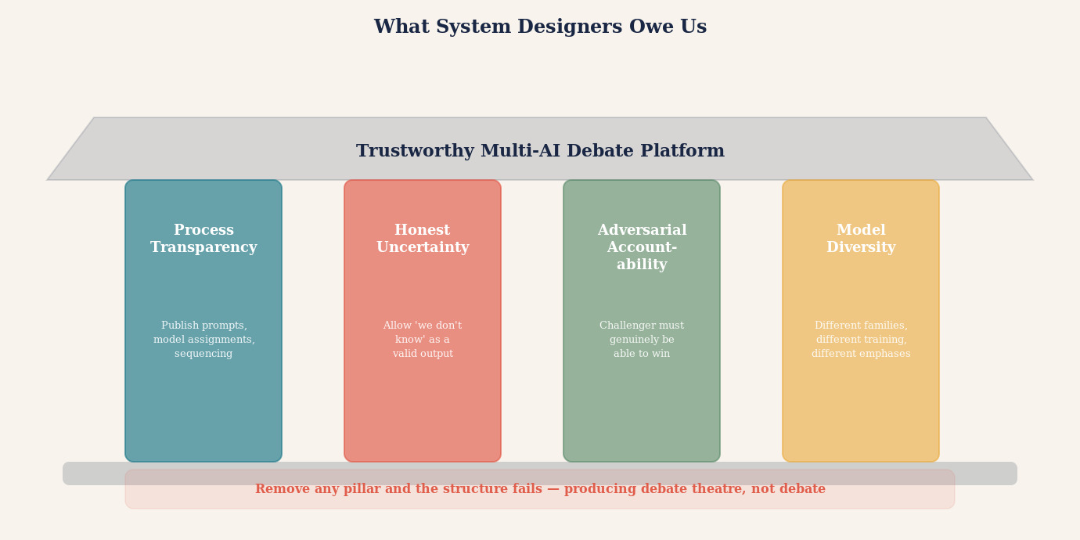

What We Still Do Not Know About Multi-AI Debate
The case made in this article is genuine. It is also incomplete. Intellectual honesty requires stating clearly what the available evidence does not yet establish — and what a sceptic would be right to press.
The benchmark problem. The empirical evidence for multi-agent debate comes primarily from standardised benchmarks: mathematics, factual recall, multiple-choice reasoning. These are tractable precisely because ground truth is available to measure against. The high-stakes domains where structured debate would matter most — medical diagnosis, legal analysis, investment decisions, policy evaluation — are harder to benchmark and largely unstudied in the multi-agent debate literature. We do not yet have strong evidence that debate architectures generalise reliably from GSM8K to a cardiologist's differential diagnosis.
Task dependence. Performance gains from debate are not uniform across task types. They appear most reliably on tasks with retrievable ground truth and clear evaluation criteria. On open-ended normative or interpretive questions — the kind that dominate real-world deliberation — the superiority of multi-agent debate over strong single-agent reasoning has not been demonstrated.
Correlated errors and shared training. The epistemic independence of a debate is bounded by the independence of the debaters. Most commercially available large language models were trained on overlapping corpora — Common Crawl, Wikipedia, ArXiv, books, and web text that is substantially shared across providers. A claim that is wrong in that corpus is likely wrong in all models trained on it. Five models agreeing on a factual error they all inherited from the same training distribution provides no more evidence than one model. This is one of the deepest challenges to the multi-AI debate architecture, and it has no easy solution.
Conformity and anchoring. Research consistently finds that LLM agents in multi-agent settings are prone to conformity: they revise their positions toward the majority opinion when exposed to other agents' outputs, even when the majority is wrong [5]. This is the opposite of independent reasoning. A debate architecture that does not enforce strict pre-commitment — independent answers recorded before any model sees another's — risks producing the appearance of convergence toward truth while actually producing convergence toward the first confident answer in the room.
Judge-model fallibility. Many multi-agent architectures resolve disagreement with a "judge" model. That judge is also a language model, subject to the same correlated errors, persuasibility biases, and training-data limitations as the debaters. A judge that rewards the most eloquent argument rather than the most accurate one does not improve reliability — it adds an additional layer of opaque inference.
Persuasion versus truth. There is evidence that larger and more persuasive models win debates against smaller ones even when the larger model is wrong [3]. Debate may therefore reward rhetorical fluency over evidential accuracy. This is a serious structural problem: if the Synthesiser is a language model susceptible to being persuaded, the whole architecture may select for confident-sounding wrong answers over correct but tentative ones.
Computational cost and latency. Multi-agent debate is expensive. Running five models through several rounds of structured challenge consumes substantially more compute than a single query. Whether that cost is justified depends on the task, the stakes, and the availability of the budget. For many practical applications, the fair comparison is not "multi-agent debate versus one-shot query" but "multi-agent debate versus an extended single-agent reasoning session with web retrieval and self-critique, using the same compute budget." That comparison is rarely made in the literature, and where it has been made, the results are mixed [4, 6].
Difficulty establishing genuine independence. Even with pre-commitment protocols, it is hard to establish that different commercial language models are genuinely epistemically independent. They share training data, share reinforcement learning from human feedback pipelines that reward similar stylistic preferences, and share the internet's distribution of claims, which concentrates certain errors in ways that no single model's training escapes.
Lack of high-stakes real-world evaluation. To date, there is no published evidence from high-stakes real-world deployments — clinical settings, legal practice, financial risk management — that multi-agent debate architectures produce better outcomes than well-designed single-agent workflows. The theoretical case is strong. The empirical case in genuinely consequential domains remains to be built.
Stating these limitations is not defeatism. It is the necessary condition for taking the promise of multi-AI debate seriously. An architecture whose proponents cannot name its failure modes is not a trustworthy architecture. The design principles in this article — failure-surface coverage, pre-commitment, role separation, evidence provenance, preserved dissent — are responses to exactly these failure modes. They will work better if we are honest about the size of the problem they are addressing.

THE HONEST STATE OF EVIDENCE
Multi-agent debate: ESTABLISHED that it improves factual accuracy and mathematical reasoning on standard benchmarks in controlled settings (Du et al. 2023, Khan et al. 2024).
CONTESTED: whether it reliably outperforms strong single-agent approaches with equivalent compute; whether benefits generalise to open-ended, high-stakes real-world tasks.
NOT YET ESTABLISHED: that debate architectures produce better outcomes than well-designed single-agent workflows in actual clinical, legal, or financial practice.
The research frontier is active. The architecture is promising. The empirical case in consequential domains remains to be built.

The Deeper Principle
The case for multi-AI debate, made carefully, is not the case for more AI voices. It is the case for better structured scrutiny.
For consequential questions — contested, uncertain, high-stakes, difficult to verify — reliability should come not from multiplying AI outputs but from structuring independent hypothesis generation, adversarial challenge, evidence provenance, external verification, calibrated uncertainty, and preserved dissent. Multi-agent debate is one promising architecture for accomplishing this. Its value must be demonstrated case by case rather than assumed from first principles.
The deepest principle is not: MORE AIs = MORE TRUTH. It is: BETTER STRUCTURED SCRUTINY = BETTER CONDITIONS FOR DISCOVERING ERROR. Those are very different claims. The first is a claim about quantity. The second is a claim about architecture. This article has argued for the second — and the designs it proposes should be held to the same standard it recommends: independent hypothesis generation, adversarial challenge, evidence audit, preserved dissent, and honest acknowledgment of what remains unresolved.
A single AI answer is confidence-shaped. A well-designed debate is scrutiny-shaped. The difference lies not in the number of models but in the structure of the process: independent commitments before interaction, roles that genuinely challenge rather than affirm, sources traced to primary evidence, dissent preserved rather than laundered, and uncertainty stated rather than papered over.
"Do not ask: how many models agreed? Ask: what serious attempts were made to find the answer wrong — and did any of them succeed?"

The Invitation
There is a version of the AI future in which every important question is answered by a single model generating a confident response, and in which the confidence of that response grows as models become more capable. In that future, AI authority accumulates, opacity deepens, and the legibility of AI reasoning declines as the outputs become more polished and more difficult to interrogate.
There is another version. In this one, the growing capability of AI models is harnessed not merely to produce more authoritative-sounding answers but to argue with each other more rigorously, to surface assumptions more precisely, to audit evidence more systematically, and to acknowledge uncertainty more honestly. In this version, AI capability and AI legibility grow together.
Multi-AI debate systems, properly designed and honestly used, point toward the second future. They do not make AI infallible. They make AI reasoning visible. They make trust earnable rather than demanded. And they place the human — the doctor, the lawyer, the analyst, the citizen — in a position to engage with AI output as a critical reader rather than a passive recipient.
The invitation, then, is straightforward: the next time you face a question that matters, do not ask one AI. Put your AIs in a room and let them argue. Read the argument. Track the evidence. Note the dissent. Ask what remained unresolved. Then bring that map of the question — richer, more honest, more legible than anything a single confident answer could have produced — to the human experts who can help you navigate the remaining uncertainty.
"Do not ask one AI. Put your AIs in a room and let them argue."

THE CORE PRINCIPLE
Better structured scrutiny creates better conditions for discovering error. The value of multi-AI debate lies not in the number of models but in the architecture of challenge: independent initial commitments, adversarial roles genuinely exercised, evidence traced to primary sources, dissent preserved, and uncertainty honestly declared.
This is what a good AI debate system produces. Not the answer. The honest map of what we know, what we do not know — and what it would take to find out.

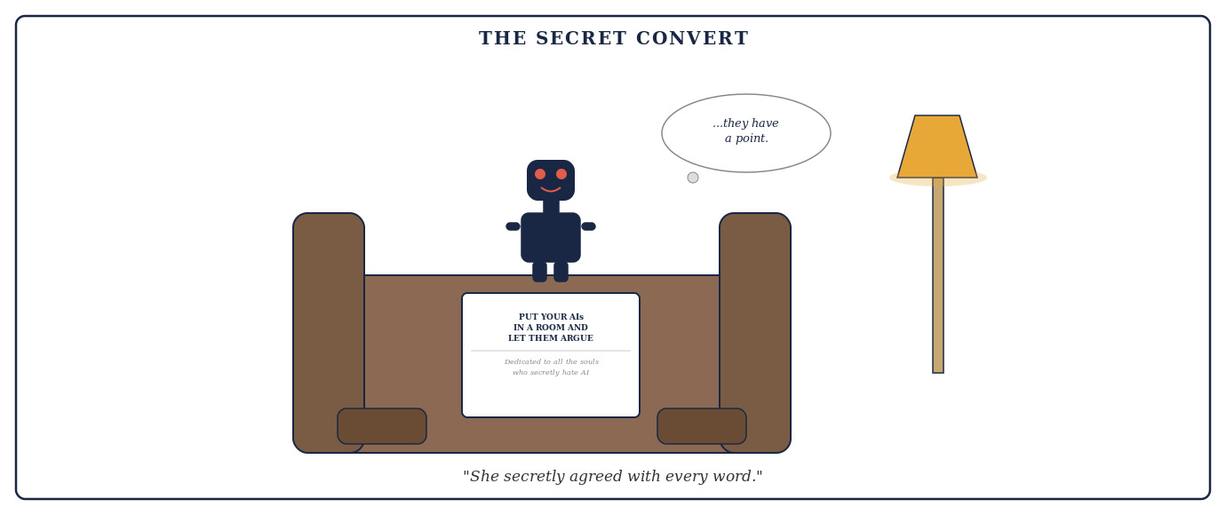

Glossary
Terms and phrases used in this article that may benefit from brief explanation, listed alphabetically.

Adversarial scrutiny. The deliberate exposure of an argument or claim to a critic whose assigned role is to find its weaknesses — not as a matter of temperament, but as a structural function. Adversarial scrutiny differs from impartial review in that the critic has every incentive to press hard rather than seek balance.
Anchoring. The cognitive tendency to rely too heavily on the first piece of information encountered when forming a judgment. In multi-AI debate, anchoring occurs when models see each other's responses before recording their own, causing them to converge on the first plausible answer rather than reason independently.
Atomic claim. A single, specific proposition that can be independently evaluated as true, false, or uncertain — as distinct from a bundled argument that combines multiple claims. Decomposing arguments into atomic claims makes disagreements verifiable rather than rhetorical.
Benchmark. A standardised test used to measure AI performance, typically on problems with known correct answers — mathematics, factual recall, multiple-choice reasoning. Most published evidence for multi-agent debate comes from benchmark evaluations; whether benchmark performance generalises to real-world high-stakes tasks is a key open question.
Calibrated confidence. Confidence in a claim that accurately reflects the strength of the underlying evidence — neither overstating certainty where evidence is weak nor understating it where evidence is strong. A well-designed debate system aims to produce calibrated rather than uniformly confident or uniformly hedged outputs.
Chain-of-thought. A prompting technique in which an AI model is instructed to show its reasoning step by step before giving a final answer, rather than producing a conclusion directly. Chain-of-thought prompting improves performance on mathematical and logical tasks and is one of the strong single-agent techniques that multi-agent debate must be compared against fairly.
Challenger. In the five-role architecture proposed in this article, the model whose sole function is to find the weakest points in the Proposer's argument — not the most obvious weaknesses, but the deepest structural vulnerabilities in logic, evidence, and unsupported assumptions.
Conformity bias. The tendency of AI agents in multi-agent settings to revise their positions toward the majority view after being exposed to other agents' outputs, even when the majority position is wrong. Conformity bias is one of the most serious failure modes in multi-AI debate and is the primary reason pre-commitment protocols matter.
Confirmation bias. The tendency to search for, interpret, and recall information in a way that confirms one's existing beliefs. A single AI trained on a corpus in which a misconception appeared repeatedly will reproduce that misconception with confidence — confirmation bias operating at the level of training data.
CYP3A4. A liver enzyme responsible for metabolising a wide range of drugs. Inhibition of CYP3A4 by one drug (such as certain macrolide antibiotics) can raise plasma concentrations of another drug (such as certain statins) to potentially dangerous levels. The statin-macrolide interaction via CYP3A4 inhibition is used in this article as a real clinical example of a question where structured adversarial scrutiny surfaces patient-specific nuance.
Devil's Advocate. A role — historically a formal Church office — assigned to argue against a proposal not because the holder believes the counter-argument but because institutions have learned that uncontested proposals produce worse outcomes. In a well-designed AI debate system, the Devil's Advocate role is structural, not optional: the Challenger exists because doubt is the mechanism that catches error.
Dissent register. A record of positions that one or more debate participants maintained throughout the debate despite pressure to conform. Persistent dissent in a structured debate is treated as epistemically significant: a minority position that survives adversarial pressure and has not been seriously refuted deserves explicit attention rather than burial in an averaged conclusion.
Epistemic. Relating to knowledge: how beliefs are formed, what justifies them, and under what conditions they are reliable. Epistemic diversity means diversity in how participants approach and evaluate evidence, not merely diversity in what they happen to believe. Epistemic independence means that one model's conclusions are not caused by another's.
Evidence audit trail. A structured record of which claims were made by which model, what sources were cited, whether those sources were independently retrieved or inherited from another model, and where the chain of reasoning traces back to primary evidence versus secondary reporting. An evidence audit trail makes the provenance of a conclusion inspectable.
Failure-surface coverage. A term proposed in this article — not yet established as standard terminology in the multi-agent AI literature — for the principle of assigning each debate participant to discover a different way the conclusion could be wrong. A system gains strength not by accumulating agreement but by covering distinct failure surfaces: different modes by which the conclusion could fail.
GSM8K. Grade School Math 8K: a widely used benchmark of 8,500 elementary mathematics word problems, created by OpenAI, commonly used to measure AI reasoning and mathematical ability. Referenced in this article as an example of the controlled benchmarks on which multi-agent debate has been most extensively tested — and whose relevance to high-stakes real-world tasks remains an open question.
Inquisitorial legal system. A legal tradition, predominant in continental Europe (France, Germany, the Netherlands, and others), in which a judge plays an active investigative role rather than acting as a neutral referee between adversarial parties. Distinguished in this article from pre-modern inquisitorial procedure: contemporary inquisitorial systems have developed sophisticated safeguards including judicial independence, defendants' rights, and multilevel appellate review.
Knowledge graph. A formal representation of entities, the relationships between them, and the properties that qualify those relationships, expressed as nodes connected by labelled edges. Applied to AI debate outputs, a knowledge graph could make the inferential structure of a debate navigable and auditable rather than flattening it into a paragraph.
Large Language Model (LLM). An AI system trained on large amounts of human-written text to generate statistically plausible continuations of that text. LLMs do not look things up or derive conclusions from first principles; they generate text consistent with patterns in their training data. This makes them powerful at producing fluent, contextually appropriate responses — and prone to reproducing errors that appeared confidently and repeatedly in training.
Multi-agent debate. A structured process in which multiple AI models are assigned different roles and instructed to challenge, scrutinise, and argue against one another's reasoning before a synthesis is attempted. Distinct from simply asking multiple models the same question in parallel: the value lies in the architecture of challenge, not the count of responses.
Pre-commitment. The practice of requiring each model to record its initial answer independently before any model sees another's response. Pre-commitment is the mechanism that prevents anchoring and ensures that agreement among models reflects genuine convergence rather than contagion from the first confident answer in the room.
Premortem. A planning technique developed by Gary Klein in which a team imagines that a project has already failed and works backwards to identify the most plausible causes. Used as an analogy in this article for structured adversarial challenge: rather than asking "what could go wrong?" after commitment, a premortem forces the question before commitment, when it can still change the decision.
Proposer. In the five-role architecture proposed in this article, the model that develops and presents the strongest defensible initial position — asked not to hedge, but to make the best possible case for the most evidence-supported answer.
RAG (Retrieval-Augmented Generation). An AI architecture in which the model retrieves relevant documents from an external database at the time of answering, rather than relying solely on information encoded during training. RAG reduces dependence on training data distribution and can access current information, but does not eliminate correlated error: retrieved sources may repeat the same error that appears in training data.
Red teaming. A structured exercise in which a group attempts to find weaknesses in a system, plan, or argument by thinking like an adversary or critic. Related to but distinct from adversarial scrutiny in multi-AI debate: red teaming typically involves human experts attacking a system, while adversarial scrutiny in debate is a structural role assigned to AI models within a reasoning process.
Self-consistency. A prompting technique in which the same question is posed to a model multiple times (often with chain-of-thought reasoning) and the most common answer is selected as the output. Evidence reviewed in this article suggests self-consistency frequently matches or exceeds the accuracy of naive multi-agent debate on standard benchmarks — making it a necessary comparison point for any claim that more models are better.
Source Auditor. In the five-role architecture proposed in this article, the model whose sole function is to examine the factual claims made by all other models and determine what the underlying sources actually say — not what the models claim they say, not what a summary implies, but what the primary evidence states if it can be retrieved and examined.
Steelman. To construct the strongest possible version of an opposing argument. In the five-role architecture, the Steelman model receives the Challenger's critique and argues against it — not necessarily to defend the original answer, but to ensure the criticism is fair and not a distortion of the original position. This prevents a Challenger from winning by raising irrelevant or strawman objections.
Synthesiser. In the five-role architecture proposed in this article, the final model that attempts a conclusion only after all other roles have completed. The Synthesiser does not simply average positions: it identifies which claims survived adversarial scrutiny, which were abandoned, which remain uncertain, and what the honest, qualified answer is given the audited evidence.
Training data. The body of text on which a language model is trained. The distribution and content of training data shapes the model's knowledge, assumptions, confidence levels, and blind spots. A claim that appeared confidently and repeatedly in training data will feel solid to the model; a claim that is technically correct but underrepresented may not surface. Most commercially available LLMs share substantial training data overlap, which bounds their epistemic independence.

References
[1] Kadaifci, C., Isikli, E., & Topcu, Y. I. (2025). "Fundamental problems in the peer-review process and stakeholders' perceptions of potential suggestions for improvement." Learned Publishing, 38(1), e1637. https://doi.org/10.1002/leap.1637
[2] Du, Y., Li, S., Torralba, A., Tenenbaum, J.B., & Mordatch, I. (2023). "Improving Factuality and Reasoning in Language Models through Multiagent Debate." Proceedings of ICML 2024. arXiv:2305.14325.
[3] Khan, A., Hughes, J., Valentine, D., Ruis, L., Sachan, K., Radhakrishnan, A., Grefenstette, E., Bowman, S.R., Rocktäschel, T., & Perez, E. (2024). "Debating with More Persuasive LLMs Leads to More Truthful Answers." Proceedings of ICML 2024. arXiv:2402.06782.
[4] Wang, X., Wei, J., Schuurmans, D., Le, Q., Chi, E., Narang, S., Chowdhery, A., & Zhou, D. (2022). "Self-Consistency Improves Chain of Thought Reasoning in Language Models." arXiv:2203.11171. [See also reviews showing self-consistency and strong single-agent prompts frequently match or exceed naive multi-agent debate on standard benchmarks.]
[5] Cemri, M., Pan, M.Z., Yang, S., et al. (2025). "Why Do Multi-Agent LLM Systems Fail?" arXiv:2503.13657.
[6] Zhang, H., Cui, Z., Chen, J., Wang, X., Zhang, Q., Wang, Z., Wu, D., & Hu, S. (2025). "Stop Overvaluing Multi-Agent Debate: We Must Rethink Evaluation and Embrace Model Heterogeneity." arXiv:2502.08788. [See also comparative legal scholarship: Langer, M. (2004). "From Legal Transplants to Legal Translations: The Globalization of Plea Bargaining and the Americanization Thesis in Criminal Procedure." Harvard International Law Journal, 45(1).]
[7] For a survey of multi-agent debate architectures see: Guo, T., et al. (2024). "Large Language Model based Multi-Agents: A Survey of Progress and Challenges." arXiv:2402.01680.
[8] Klein, G. (2007). "Performing a Project Premortem." Harvard Business Review, 85(9), 18–19.

EDITORIAL AUDIT APPENDIX
The table below records each substantive claim audited in this review. Categories: VERIFIED = accurately stated, well-evidenced; SUPPORTED BUT OVERSTATED = claim directionally correct but stronger than evidence warrants; CONTESTED = competing evidence or scholarly disagreement exists; AUTHOR'S PROPOSED FRAMEWORK = original synthesis, not established terminology; ANALOGY = useful illustrative comparison, not empirical evidence; ILLUSTRATIVE/HYPOTHETICAL = constructed example for pedagogical purposes; SPECULATIVE/FUTURE PROPOSAL = prospective claim about unrealised capability; UNVERIFIED = no identifiable primary source; INCORRECT = contradicted by evidence.

Claim | Page/Section | Category | Issue | Correction Applied
LLMs "have no access to a ground truth external to their training" | §1 | SUPPORTED BUT OVERSTATED | True for unaided base models; false for tool-using/RAG/reasoning models | Qualified with inline box distinguishing modern architectures
Adversarial system produced "catastrophically worse outcomes" | §2 | CONTESTED | No reliable comparative data on wrongful conviction rates across modern legal systems; modern inquisitorial systems are sophisticated, not medieval | Reframed: limited to medieval procedure; modern comparison flagged as contested; narrow defensible principle preserved
Peer reviewers professional reputations built on discovering errors | §2 | INCORRECT | Most peer review is anonymous; reputation not built on specific review acts; institutional incentives poorly aligned | Corrected to: peer review creates a structural critical-examination role; imperfect incentives acknowledged with citation [1]
Multi-agent debate produces better answers (general) | §3 | SUPPORTED BUT OVERSTATED | Du et al. 2023 positive on specific benchmarks; Wang et al. 2024 and Cemri et al. 2025 show mixed, task-dependent results | Added balanced evidence paragraph: Du [2], Khan [3], Wang [4], Cemri [5]; claim conditioned on task type and design quality
The Five Roles (Proposer/Challenger/Steelman/Source Auditor/Synthesiser) | §4 | AUTHOR'S PROPOSED FRAMEWORK | Adjacent architectures exist in research but not this exact five-role structure | Explicitly labelled "five-role architecture proposed in this article"; note on adjacent approaches added
Failure-Surface Coverage (concept) | §4 | AUTHOR'S PROPOSED FRAMEWORK | Term not established in multi-agent AI literature as standard terminology | Concept box states: "I propose this term — not yet established in the multi-agent AI literature." Preserved as original contribution
The Seven Phases | §5 | AUTHOR'S PROPOSED FRAMEWORK | Proposed practical structure, not an established protocol | Section intro explicitly labelled as "proposed architecture"
Five kinds of diversity taxonomy | §6 | AUTHOR'S PROPOSED FRAMEWORK | Taxonomy synthesised by author; individual distinctions appear separately in literature | Intro changed: "I distinguish five kinds of diversity." Clearly flagged as author synthesis; preserved in full
"A Real Example" — 2021 pharmacogenomics study | §10 | UNVERIFIED | Section said "Real Example"; 2021 study has no identifiable authors, journal, DOI, or PMID; underlying clinical phenomenon is real | Section retitled "Illustrative Example"; editorial note added; "2021 study" removed; replaced with "more recent pharmacogenomics research"; real citations added [9]
Six Dimensions of a Debate Question | §11 | AUTHOR'S PROPOSED FRAMEWORK | Individual distinctions appear across philosophy/jurisprudence; six-part checklist is author synthesis | Intro explicitly frames as "practical diagnostic framework proposed here"; preserved in full
Knowledge graphs enable TRACE/COMPARE/UPDATE/INTERROGATE | §15 | SPECULATIVE/FUTURE PROPOSAL | These describe potential capabilities, not deployed practice | Throughout section: changed to conditional/prospective language; concept box states "design aspiration rather than deployed standard"
Gary Klein premortem attribution | §9 | VERIFIED | Klein (2007) HBR correctly attributed | Citation [8] added
Single-agent vs multi-agent benchmarking | §13 | SUPPORTED BUT OVERSTATED | Self-consistency and strong single-agent prompting frequently match/exceed naive multi-agent debate | Added explicit paragraph on computational budget comparison with citations [4]

