Parallel Simulated Annealing Applied to the Travelling
Salesman Problem

Miloš Ohlídal*
ohlidal@fit vutbr.cz

Josef Schwarz*
schwarz@fit.vutbr.cz

Abstract: Simulated annealing is an effective method for solving large combinatorial optimisation problems. The topic of the paper is focused to advanced modifications of parallel simulated annealing algorithm and their testing. The parallelisation of the simulated annealing through architecture master-slave is proposed with various rate of the communication activity. Te performance of the designed variants is tested on the two known TSP benchmarks.

Introduction

Simulated annealing (SA) is an effective approach to solve large combinatorial optimization problems. It is an iterative improvement scheme with hill-climbing ability, which allows to reject inferior local solutions and find more globally optimal solutions. Starting with an initial configuration (solution) obtained by random or constructive means, the annealing algorithm is a sequence of small random perturbations. The perturbation that improves solution is always accepted, whereas a perturbation that worsens the current solution by an amount ΔE, based on predefined cost function, is accepted with probability 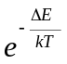, where T is control parameter analogous to the temperature in the annealing of physical system. Typically, T is decreased stepwise according to T_{i+1}=αT_{i}, where T_{i} is the i-th temperature phase and α determines the gradient of cooling. The core of simulated annealing algorithm is the Metropolis algorithm, which simulates the annealing process at the given temperature. In case of the high temperature most uphill perturbations are accepted. As the annealing process is finished and T is reduced to a small value uphill perturbations will be accepted with a much smaller probability.

  - Parameter setting
- Initial temperature T₀: It must be chosen so that almost all perturbations are accepted.

x=(number of perturbations accepted) / (total number of perturbations attempted)

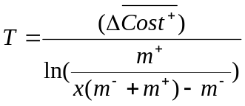, (1.1)

whereis the acceptance probability, 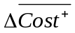is the average change in cost over all perturbations, which lessen cost function, m⁻ is the number of perturbations with the cost function decrease and m⁺ is the number of perturbations with the cost function increase.
- k_{max}: number of iterations of Metropolis algorithm in one temperature phase. The number k_{max} is based on the requirement that at each value of T quasi-equilibrium is succeeded.
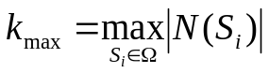, (1.2)
where 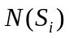 is the maximum size of the configuration subspace.
- Decrement coefficient α: The coefficient α (the term in brackets) is proposed to reduce the temperature.
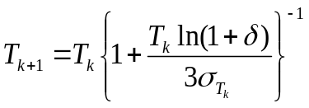, (1.3)
where δ is a measure of how close the equilibrium vectors of two successive iterations are to each other, 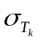is the standard deviation of the cost function up to the temperature T_{k}. The stopping criterion is based on the monitoring of the relevant reduction of the cost function during the optimisation process
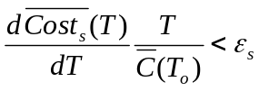, (1.4)
where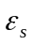is a small positive number called the stopping parameter, 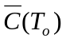is the average value of the cost function at T₀. This condition is based on extrapolation of the smoothed average cost 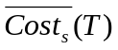obtained during the optimisation process.

This is a theory how to set the SA parameters. But in practice the value of SA parameters of some problems are known or are determined experimentally. This is the case of TSP problem solved in this paper

- A short survey of parallel SA

There are many parallel SA algorithms. In the paper we notice two interesting variants of parallel SA algorithms:
D. C. W. Pao, S. P. Lam and A. S. Fong described parallel implementation of simulated annealing on multiprocessor system with shared memory using transaction processing. Updated solutions are treated as database transactions. They presented a locking protocol which guarantees serializability and which is deadlock-free.
M. E. Aydin and T. C. Fogarty proposed parallel implementation of a modular simulated annealing algorithm. The implementation has been done as a multiple island system suitable to run on the distributed resource machines.

We proposed the parallelisation of the simulated annealing using architecture master-slave. All processes compute SA algorithm including master process, which decides about the acceptance or rejection of solutions and it controls synchronization of slaves. The detail description is presented in the next chapter.
- Parallelisation of the simulated annealing

It is possible to use two different techniques:
- In the first technique each process performs its complete SA algorithm, but each one works with different generator of random number and they don’t communicate. Final solution is chosen at the end of optimization process.
- In the second approach all processes communicate with master, which returns to all of them the current best solution. But the communication can be too frequent at higher temperature and the time of communication can be much greater than the time of optimisation.
We proposed the technique, which is a combination of both of them, i.e. in the higher temperature the processes are independent and the communication is activated only for the lower temperature phase.

- The basic terms and definitions

- Accepted solution
  - New solution have smaller predefined cost function or worse but it suits the condition: random()< min[1,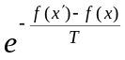], where f(x´) is new cost function, f(x) is old cost function, T is temperature and random is an number.

- Structure of parallel processes
- One control process (master)
- n – slave processes (slaves)
- Synchronization: the way of communication between master and slaves
- Asynchronous mode – a process communicates with master independently on the other processes
- Synchronous mode
- All slaves communicate with master in one allowed time period
- All slaves wait to the message from master at the end of the temperature phase to continue in computation, i.e. in one temperature period the communication slave – master proceeds asynchronous but whole execution appears as synchronous. The processes are namely synchronized at the end of temperature phase.

In the smaller temperatures the processes cooperate by using the architecture master – slave and all slaves (and also master) work on its sequence of solutions. If some slave process accepts a solution, it sends it to master, which determines on its acceptance according its rule of acceptance. If accepted this solution or found some new solution by master, it is sent to all slave processes.
Each communication slave/master runs asynchronously in one temperature phase. A problem appears with finishing computation and with delay of processes. The principle how to solve this problem is by usage of synchronisation at the end of temperature phase, which is controlled by master. This approach allows, that all processes work at the same temperature and also finish at the same time.
The scheduling of the messages are shown in the Fig.1.

The communication at the end of temperature phase
Pass as the first

M
S
S
M
S
S
S
S
M
The communication during temperature phase
Pass as the first
Pass as the second
Pass as the third
Pass as the fourth

Fig.1: Illustration of the communication during the temperature phase and at the end of the temperature phase

- Advanced modification of parallel simulated annealing (PSA)

- Communication only at the end of temperature phase:
In comparison to the described version in the chapter 4 slaves communicate with master exclusively at the end of temperature. In this case all processes communicate at the same time and therefore there is no need of synchronisation. This way of communication is already synchronous, i.e. processes work at the same temperature phase.

- Communication after defined number of iterations:
The same idea as for the case A, but in this version the communication is performed after defined number of iterations at each temperature phase of Metropolis algorithm (e.g. after each 10th, 100th or 1000th iteration). This way of communication is implicitly synchronous again.

- Usage of elitism:
In this case, the Metropolis algorithm is initialised by the best solution, which was obtained during previous temperature phases. Otherwise the output from Metropolis algorithm is taken as starting state of the next temperature phase (T= α*T). Communication proceeds asynchronous after each iteration, but it is synchronised at the end of temperature phase. The principle of synchronisation was described above.

- Sequential version of SA. It was described in the first chapter. The sequential SA algorithm performs as interesting comparison to PSA algorithms.

  - Control parameters of PSA
T_{max} initial/maximum temperature
T_{min} final/minimum temperature
α gradient of cooling (T= α*T)
k_{max} count of iterations of Metropolis algorithm in one temperature phase
T_{change} temperature determining the change of execution mode

- Experimental results
Variants of PSA and SA algorithm were tested on two problems, which were published on the website (travelling salesman problem - TSP). The most tests are performed on the benchmark of 52 cities see Fig.2 to 4. It was performed 15 runs for 52 cities in each versions of PSA. The efficiency of PSA versions were also proved by benchmark of 79 cities see Fig.5.

Optimal solution of TSP problems:
- berlin52 - TSP52 (52 cities) - tour length equals to 7542
- eil79 - TSP79 (79 cities) - tour length equals to is 538.

In all experiments the following control parameters were used:

K_{max} | 10000
T_{max} | 100
T_{min} | 1
T_{change} | 20
Alpha | 0,9
Count of processors | 6
Tab.1: The value of SA parameters

Notice: The value T_{change} was changed to 30 to achieve better lucidity of optimization curves of tour length in Fig. 4 and 5.

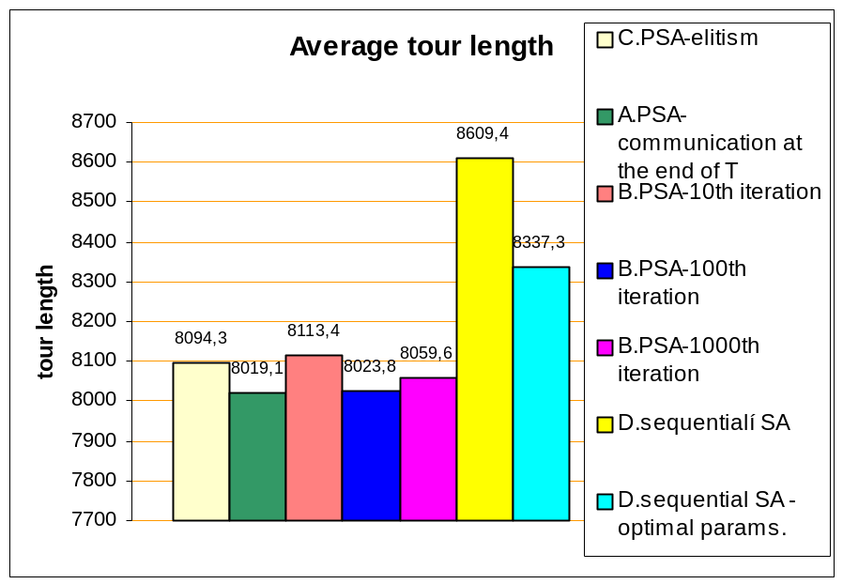
Fig.2: Average tour length of TSP 52 for several versions of PSA

In Fig.2 the performance of two sequential SA and five PSA algorithms are illustrated. Original SA, which is showed by yellow colour, uses the same parameters as PSA versions. The second sequential SA uses better parameters: alpha = 0,99 and T_{max} = 1000 (in light- blue colour) leading to the better solutions. This version already achieves better results as SA versions, which has the setting parameters according to Tab.1, but it still falls behind the best PSA versions. It is evident that the best versions of PSA are those, in which relatively small intensity of communication is used. The variant B provides the best results with communication after each 100th iteration of Metropolis algorithm.

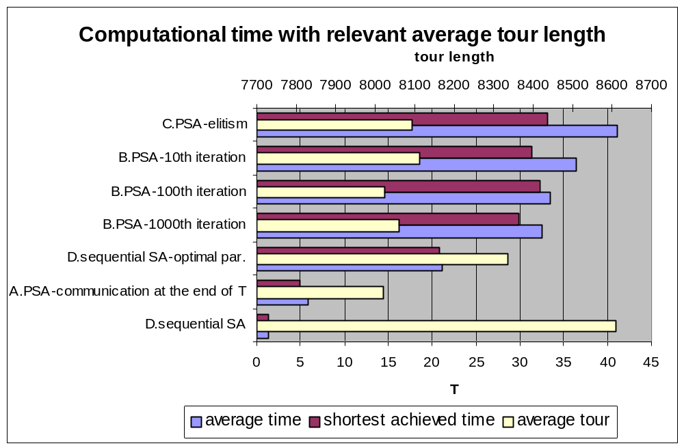
Fig.3: Computational time with relevant average tour length at each PSA versions including sequential SA versions

In Fig. 3 computational time and average tour length for each version is shown. There are showed two sequential versions of SA (variety D) with optimal parameters and with parameters, which are stated in Tab.1. Sequential version with optimal parameters doesn’t achieve such quality of results as the parallel versions indeed it runs the same time as the best parallel versions. However sequential SA with optimal parameters achieves much better result as the sequential version, which uses the same parameters as PSA versions. The best version of PSA is variety A according to computational time and average tour length, which communicates at the end of temperature phase and also variety B, which communicates after each 100th iteration.
It is evident that the higher is the intensity of communication, the longer execute time of PSA versions - therefore trade-off must be found.

In Fig.4 and Fig.5 the optimization curves of length tour are presented for several PSA versions. From version PSA B the variant was chosen with communication after each 100th iteration.

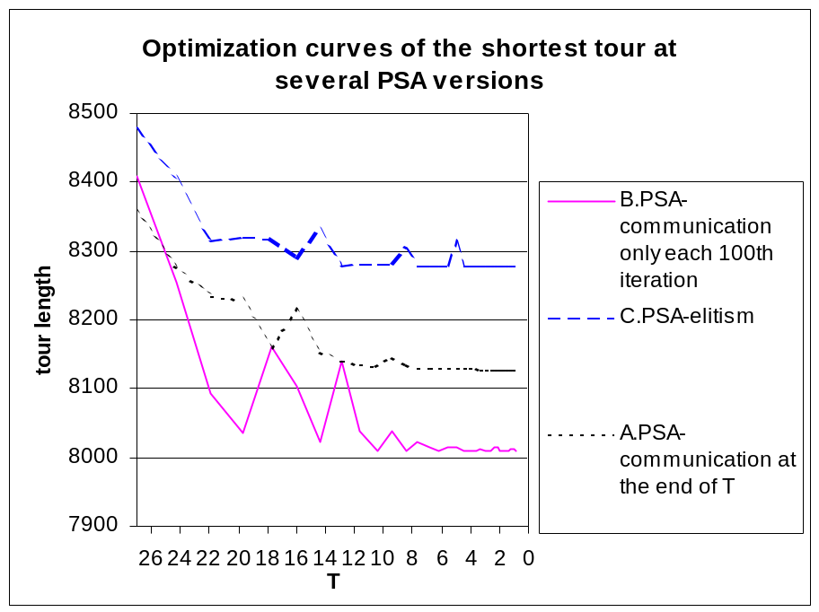
Fig.4: Optimization process of TSP 52 (52 cities)

In Fig.5 optimization curves of several PSA and SA versions are presented for TSP 79 problem.
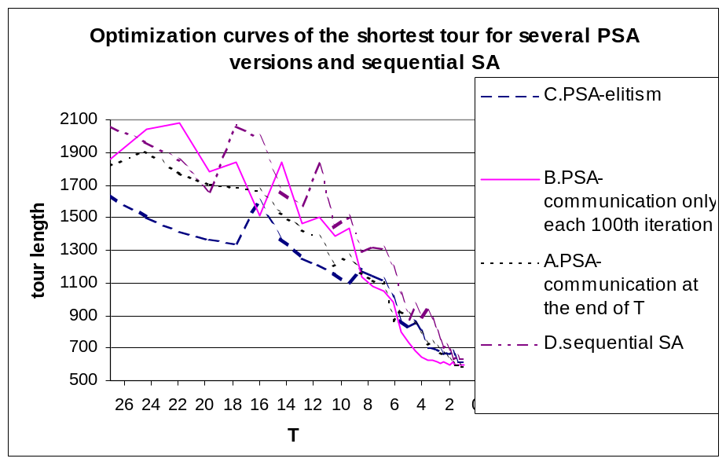
Fig.5: Optimization process of tour length for TSP 79 (79 cities)

Conclusions

All versions of PSA are based on mutual cooperation of the master-slave processes. In the first phase all processes are independent at temperature intervals T_{max}-T_{change} and each of them produces its optimised solution. In the second phase slave processes cooperate via control master process.
Individual versions differ only by form and by count of communication. The new conception of parallel algorithm of simulated annealing is based on three basic modifications, which was applied in designed PSA versions.
- Communication at a given iteration epoch or at the end of temperature phase
  - All processes communicate at defined time interval or after given iteration number, which provides synchronization
    - Advantage- excessive communication is reduced and problem with acceptance of worse solution at low temperature is solved
    - Disadvantage – at very low temperature the processes produce the similar solutions. The profit of parallelization is decreased
- Usage of elitism
  - It uses synchronization at the end of temperature phase, otherwise the communication proceeds asynchronous after each iteration.
    - Disadvantage of this approach lies in excessive communication, which results in computation time increase.
    - Advantage – elitism removes problem with the acceptance of worse solutions at low temperature phase

All variants were tested on two problems of travelling salesman problems TSP52 and TSP79. From received results follows the necessity of trade-off between intensity of communication and computational time. The best results produce PSA - B version, which uses communication after 100th iteration of Metropolis algorithm, see Fig. 2. In the case of communication after each 1000th iteration or at the end of temperature phase it wasn’t achieved such superior results. In a such small communication intensity the processes already generate similar results. In case of the intensive communication (almost at each iteration) the execution time is very high and the results are much worse than for the minimal communication. This fact was presented in Fig. 3.

Acknowledgement
This research has been carried out under the financial support of the Research intention no. CEZ: J22/98: 262200012-"Research in information and control systems" (Ministry of Education, CZ) and the research grant GA 102/02/0503 "Parallel system performance prediction and tuning" (Grant Agency of Czech Republic).

References

[1] Krajíc, M.: Algorithm of parallel hybrid genetic simulated annealing to solve of
travelling salesman problem, ČVUT FEL, Prag, 2002
[2] Sait, S., M. Youssef H.: Iterative Computer Algorithms with Applications in
Engineering, IEEE Computer Society, Los Alamos, California, 1999
[3] Pao, D. C. W., Lam, S. P., Fong A. S.: Parallel simulated annealing using transaction
processing, IEEE Proceedings, Hong Kong, 1999
[4] MP – TESTDATA
URL: http://elib.zib.de/pub/mp-testdata/tsp/tsplib/index.html
[5] Manual MPI. Document reasonable on URL:
http://bitscap.bits-pilani.ac.in/param/public_html/mpi_basic_calls.html (May 2002)
[6] Ohlídal, M.: Programming of versions of parallel simulated annealing algorithm PSA
and their testing, Technical report of research grant GA 102/02/0503, in Czech, VUT FIT,
Brno, 2003

* Faculty of Information Technology, Department of Computer Systems, Božetěchova 2, CZ-612 66 Brno
http://elib.zib.de/pub/mp-testdata/tsp/tsplib/tsp/index.html

