Printout
Friday, December 4, 2020
10:17 PM

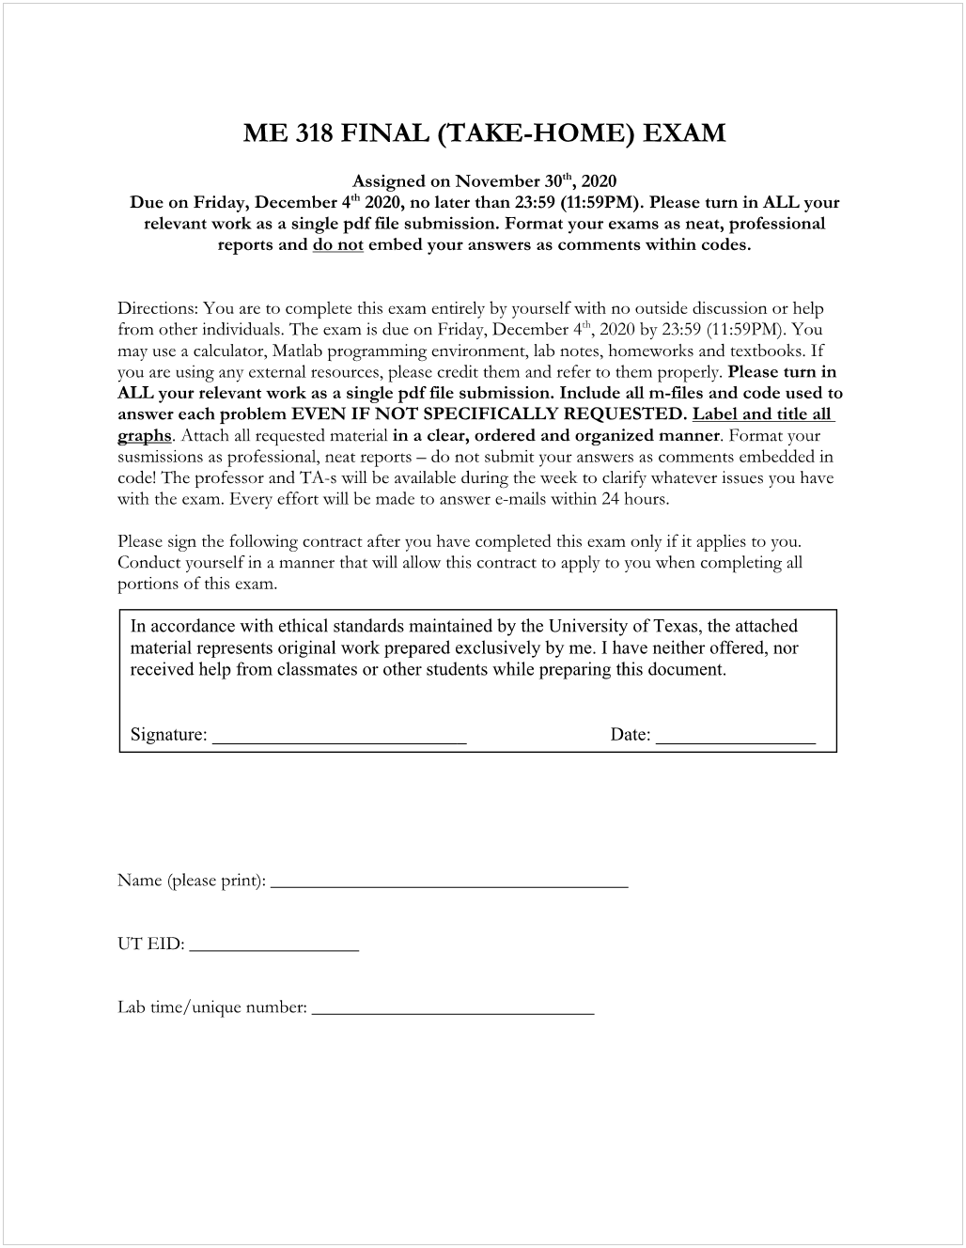
Jingo: Yum

Lings Zhou
522 4729

Mon 6:30 -8 PM; 17460
12/04/2020

