Comparison of Hypersonic and Laser Distance Sensor Accuracies

# Abstract

Several types of distance measuring sensors are available in for hardware developers to use in their projects. Each use different types of physical phenomena to calculate distance and thus have varying usable ranges and levels of accuracy. The purpose of this project was to compare the accuracies of some commonly used distance sensors, a hypersonic sensor (HC-SR04) and laser time-of-flight sensor (VL53L0X). Data were collected at 4 distances, 25, 50, 75 and 100 cm and repeated for the laser sensor’s 4 timing and ranging profiles. To find each sensor’s accuracy, the mean measurement of each sensor was then calculated for each control distance which was then used to compute a percent error and compared to the manufacturer’s stated error. From the results, it can be seen that both sensors are accurate within 1 or 2 cm of the true distance. On a percent-error for percent-error basis, the hypersonic sensor performed better than the laser sensor at all profiles except for the long-distance profile. However, when compared to the manufacturer’s stated accuracies, the laser sensor was within this limit in 69% of the trials, whereas the hypersonic sensor had a 100% failure rate.

# Summary

Two types of electronic distance sensors were compared for their accuracies in measuring distance, a laser time-of-flight sensor and a hypersonic sensor. The two sensors were connected to a breadboard and their measurements simultaneously read by an Arduino microcontroller. Measurements were taken at 25cm, 50cm, 75cm and 100cm for each of the laser sensor’s 4 configuration modes. Data were read using custom MATLAB scripts and exported to Microsoft Excel. Once the data were in Excel, the readings were used to calculate the average deviation which was then compared to the manufacturer’s stated accuracy for each device.

# Introduction

Measuring distance is very commonly used in many electronics projects from autonomous vehicles to industrial applications and each requires different levels of accuracy. IR and hypersonic have until recently been the most affordable sensors for these types of projects. In the past few years, however, laser time-of-flight sensor IC’s have become more inexpensive. Laser sensors also offer improvements in size as compared to hypersonic sensors and are also not influenced by environmental factors such as pressure and temperature which can affect hypersonic sensor readings. By comparing these types of devices, we hope to gain an understanding of when to use each type of sensor and under what conditions they perform optimally.

### Sensor Specifications

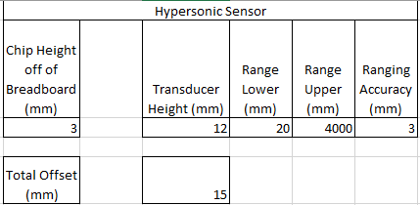

Figure - Table showing sensor height and manufacturer's stated accuracy for the hypersonic sensor

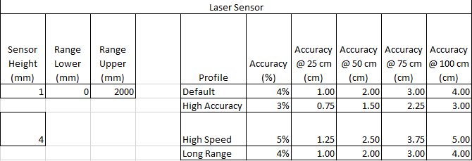

Figure - Table showing sensor height and manufacturer's stated accuracy for the laser sensor

# Apparatus and Test Procedure

## Board Layout

To test the accuracies of the two sensors, the experiment was designed to collect data simultaneously from both sensors and have them positioned on the breadboard so that their points of measurement were as close to each other as possible. The two sensors and their points of measurement are noticeably different and were measured in order to later adjust the readings in the results.

|  |  |
| --- | --- |
| Figure - Board Layout | Figure - Sensor Offsets |

First Testing Setup  
The first round of testing was performed on a coffee table with a box wrapped in printer paper as the target object. The purpose of the paper was to control for the luminance which is a factor that affects the readings of the laser sensor. Distances were marked at 0cm from the base of the box to 100cm in 25cm increments.

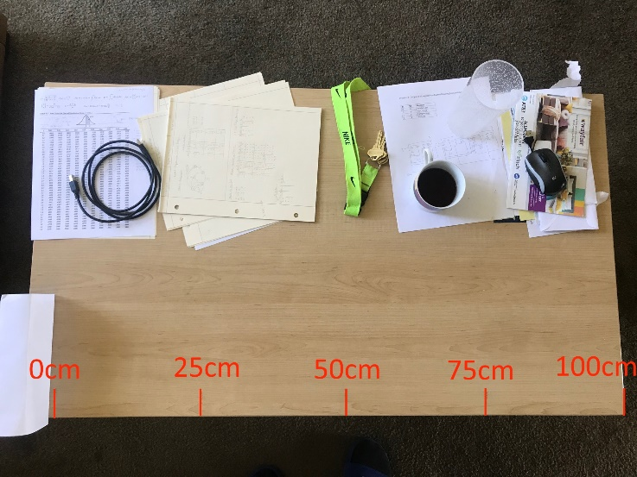This setup produced laser sensor readings which were increasingly noisy as the distance increased. Further reading of the VL53L0X datasheet revealed that the laser sensor needs at least a 25° field of view.

Another issue with this setup is that the 100cm mark is right on the edge of the table. Taking measurements at this point required partly balancing the apparatus on the table and manually keeping it straight. Because these two problems would introduce systematic error, the testing setup needed to be redesigned.

## Second Testing Setup

A simple calculation shows that the width required for a 25° field of view at 100cm is 93.2cm. This meant that the box covered with printer paper combination (with a width of 8.5”/21.6cm) is not wide enough to get accurate readings from the laser sensor.

Figure - Width and FOV calculations

## 

Figure - Second Testing Setup with plenty of testing space

To fix the systematic errors found in the first setup, a second testing setup was designed. The target against which distances were measured was changed to a section of wall which was 100cm in width, well over the maximum distance required of 93.2cm. Additionally, the marker for 100cm left enough room for the sensor apparatus to be completely supported on the table.

## Procedure

Data were collected and recorded from the Arduino microcontroller into MATLAB using several custom scripts. A custom object named *DataStore* was created to hold the readings along with the name of the current laser sensor profile, the control distance being tested as well as a timestamp for each reading.

After the serial connection between MATLAB and the Arduino was initiated, data collection was started. With the data recording, the sensor apparatus was situated so that the edge of the breadboard was on the distance marker on the table and held there for approximately 20 seconds. When the testing distance was ready to be changed, the new distance was set in the DataStore so that subsequent entries in the store had a corresponding control value for comparison. This was repeated for distances of 25cm, 50cm, 75cm and 100cm. After each of the 4 laser sensor profiles, data collection was stopped, and a separate script exported the data from the DataStore to an Excel spreadsheet using the profile name as the sheet/tab name in the spreadsheet.

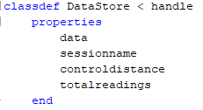

Figure - MATLAB DataStore object properties



Figure - Function for adding new entries to the DataStore with sensor values, the control distance, and a timestamp

# Data

Below are the data gathered from each sensor for each of the laser sensor’s 4 profiles. Because both sensors were on at the same time, data were collected simultaneously despite changing only the profile configuration of the laser sensor. In all 4 charts, the laser sensor readings become noisier with increasing distance.

# Results

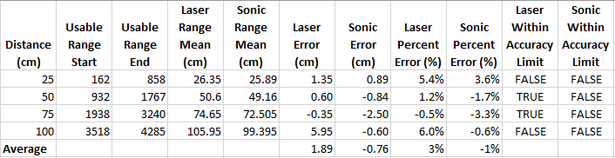

Table - Default Profile Results

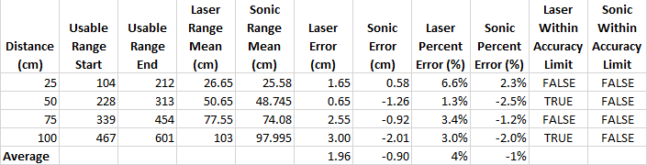

Table - High Accuracy Profile Results

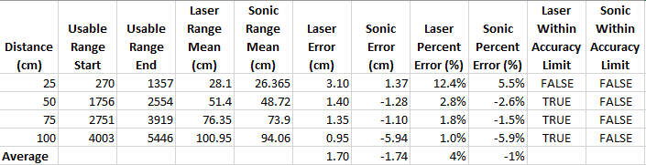

Table - High Speed Profile Results

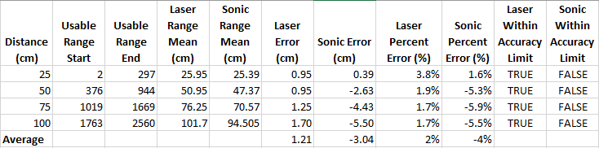

Table - Long Range Profile Results

# Discussion

# Conclusions

# References

<https://www.st.com/resource/en/datasheet/vl53l0x.pdf>

<https://cdn.sparkfun.com/datasheets/Sensors/Proximity/HCSR04.pdf>

# Appendices

## Ranging Accuracy

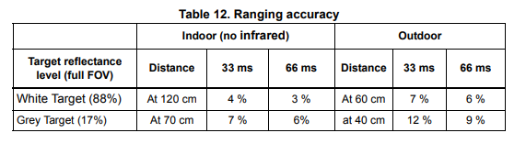

## Ranging Profiles

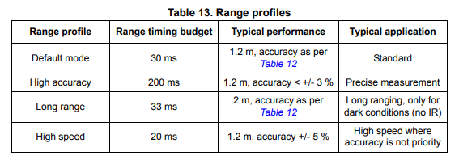

## Measurement Conditions

