Problem statement 1: Game
Game playing: -
In Game playing, we have more then one agent carrying out search algorithm.
Games of strategy have following characteristics: -
- Sequence of moves to play.
- Rules that specify possible moves.
- Rules that specify a payment for each move.
- Objective is to maximize our payment.
In Catchup game, the moves made by two players are sequential. Here, player 1 makes the move based on which player 2 makes the move. Now based on move made by player 2, player 1 decides.
Two player games like Catch-up have below workflow: -
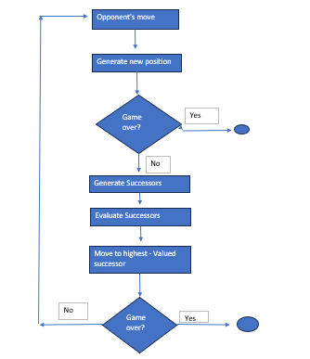
Here, we make an action and then the control is lost. We get control after the adversary (opponent player) has completed making the action.
States: Configuration of the game
Initial states: The game configuration and which player will move.
Successor function: Returns list of options, each indicating a legal move and the resulting state.
Terminal test: Determines when the game is over.
Utility function: Gives a numeric value in terminal states. For example: -1 for loss, 0 for tie and 1 for win.
When we try to maximize our utility function, our adversary (opponent) tries to minimize our utility function.
Minimax algorithm: -
- Minimize the opponent’s maximum payoff.
- Minimize our own maximum loss.
- It is a tree based algorithm perform Depth First Search.
- In our scenario, it is a zero sum game: -
Positive result: We won
Negative result: We lost
Zero: Draw
- Goal is to get largest positive value.
- Each min node copies least value.
- Each max node copies highest value.
- The process happens Bottom – Up.

Complexity of Minimax: -
- b: Branching factor: Each state has b possible moves.
- m: Maximum depth: Game goes up to m turns.
- Time complexity: O(b^m)
- Space complexity: O(m)

Properties of Minimax: -
- Complete: Yes (If tree is finite)
- Optimal: Yes (Against an optimal opponent)
- Optimal: No (Does not exploit opponent weakness against suboptimal opponent)

Alpha Beta Pruning: -
Case 1: -
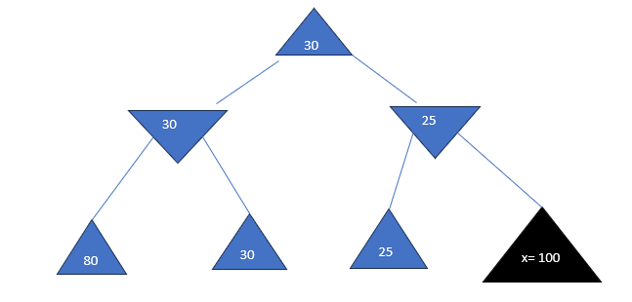
- The node x has a parent node which is min node.
- Thus, it will select left subtree and value=25.
- The parent of 25 is max node.
- Thus, it will select left subtree with value=30.
- As the result for x>30, the value of max node is never reached to it

Case 2: -
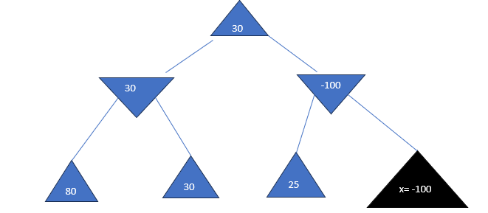
- The node x has parent node which is a min node.
- Thus, the parent of x that is min node will have value=100.
- But, the parent of min node is max node.
- As the result, the max node will not get the value from right sub tree and it will still choose from left sub tree as the optimal utility value.

Thus, in above two examples we can infer that we can prune away x from evaluation.
- The Alpha Beta procedure can speed up a depth first minimax search.
- Alpha: - A lower bound on the value that a max node may ultimately be assigned.
- Beta: - An upper bound on the value that a minimizing node may ultimately be assigned.
- If Alpha > Beta -> We prune the sub-tree.
- Thus:
Alpha: The highest value for MAX along the path
Beta: The lowest value for MIN along the path
Properties of Alpha Beta Pruning: -
- Pruning does not effect the final result.
- This means that it gets the exact same result as does full minimax.
- Good moves ordering improves effectiveness of pruning.
- With perfect ordering, Time complexity is O(b^(m/2))
- Pruning prunes sub-optimal nodes. It does not make any approximations.

Implementation of game play: -
- We have implemented Alpha Beta Pruning for optimal selection of options.
- Player 1 will be human choice.
- Player 2 will be computer choice with Alpha Beta Pruning.
- Best solution for Player 1: Draw
- Worst solution for Player 2: Loss

Design of the program: -
- The CatchUpGame class encapsulates the state of the game and the rules for playing it. It maintains the list of remaining numbers, the scores of the two players, and the current player. The class provides methods for making and undoing moves, checking if the game is over, and generating the possible moves for the current player.
- The make_move method updates the game state by removing the chosen numbers from the remaining list and adding them to the current player’s score.
- The undo_move method reverses these changes, which is useful for backtracking in the minimax function.
- The game_over method checks if there are any possible moves left for the current player. If there aren’t, the game is considered over.
- The possible_moves_for_agent method generates all subsets of the remaining numbers that sum to the target, which is the difference between the other player’s score and the current player’s score. This ensures that the current player can only choose numbers that would not make their total score less than the other player’s score.
- The static evaluation function, evaluateScore, estimates the value of a game state from the perspective of the maximizing player. It calculates the total remaining sum of the numbers and the maximum possible score each player can achieve if they make the best move each time. It then returns the difference between the maximum possible scores.
This function assumes that both players will play optimally and choose the largest available number at each turn. Therefore, it provides a simple but effective heuristic for evaluating game states.

PEAS: -
Performance Measure: The score of the game, with the goal being to end the game with a higher score than the opponent.
Environment: The set of numbers from 1 to n that haven’t been chosen yet.
Actuators: The function or method that allows the agent to choose a number.
Sensors: The function or method that allows the agent to observe the current state of the game, i.e., the numbers that have been chosen and the current scores.

- The minimax method of the CatchUpGame class uses the Min-Max algorithm with Alpha-Beta pruning to choose the best move.
- The CatchUpGame class represents the environment, and the possible_moves_for_agent method represents the fringe.
- The make_move method represents the actuators.
- The performance measure is the score of the game, with the goal being to end the game with a higher score than the opponent.
- The game is played in a loop until all numbers have been chosen, and the winner is determined by comparing the scores of the two players.
- The agent always makes the best move according to the Min-Max algorithm with Alpha-Beta pruning.
- This code takes input from user first and then agent uses min max algorithm to choose the next set of numbers.
Outputs: -
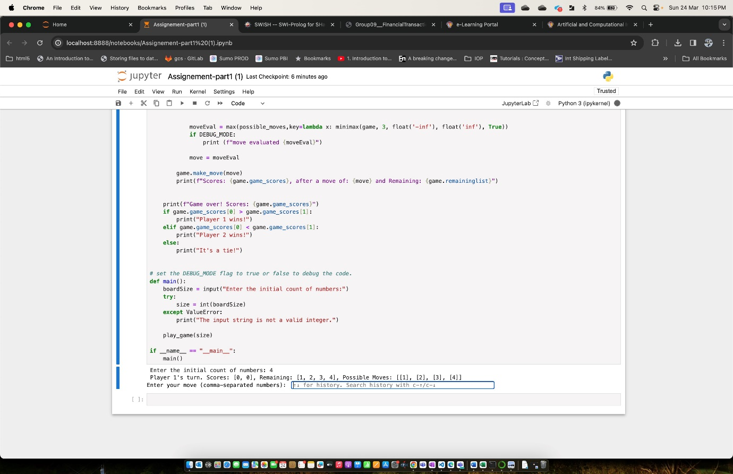
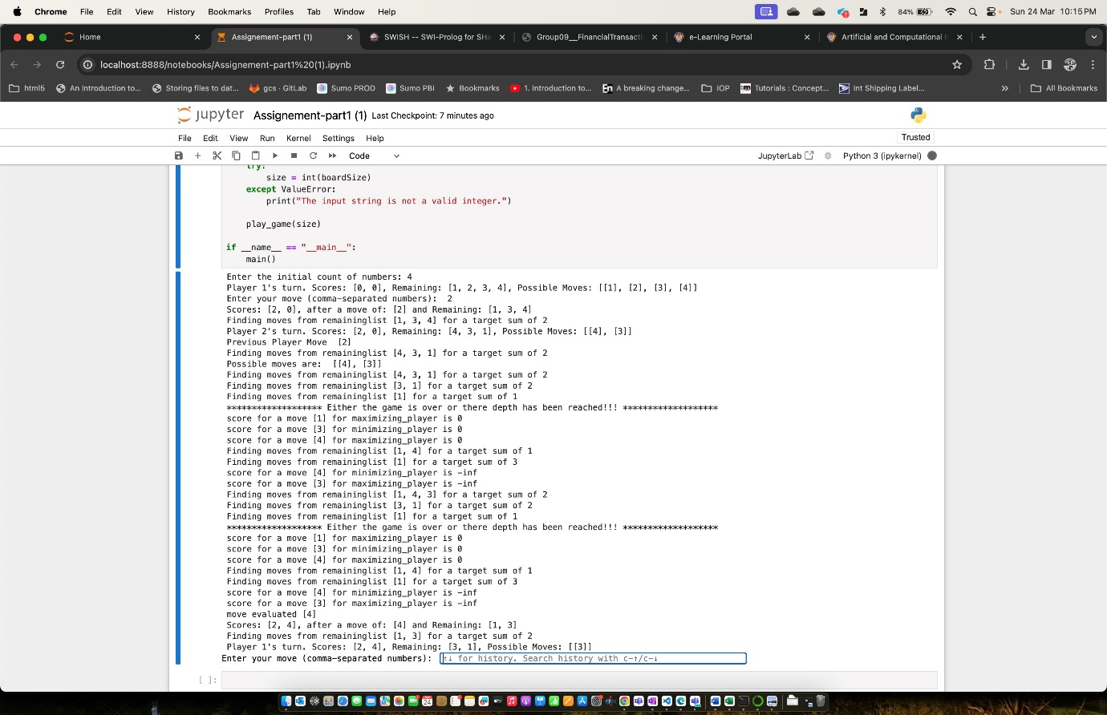
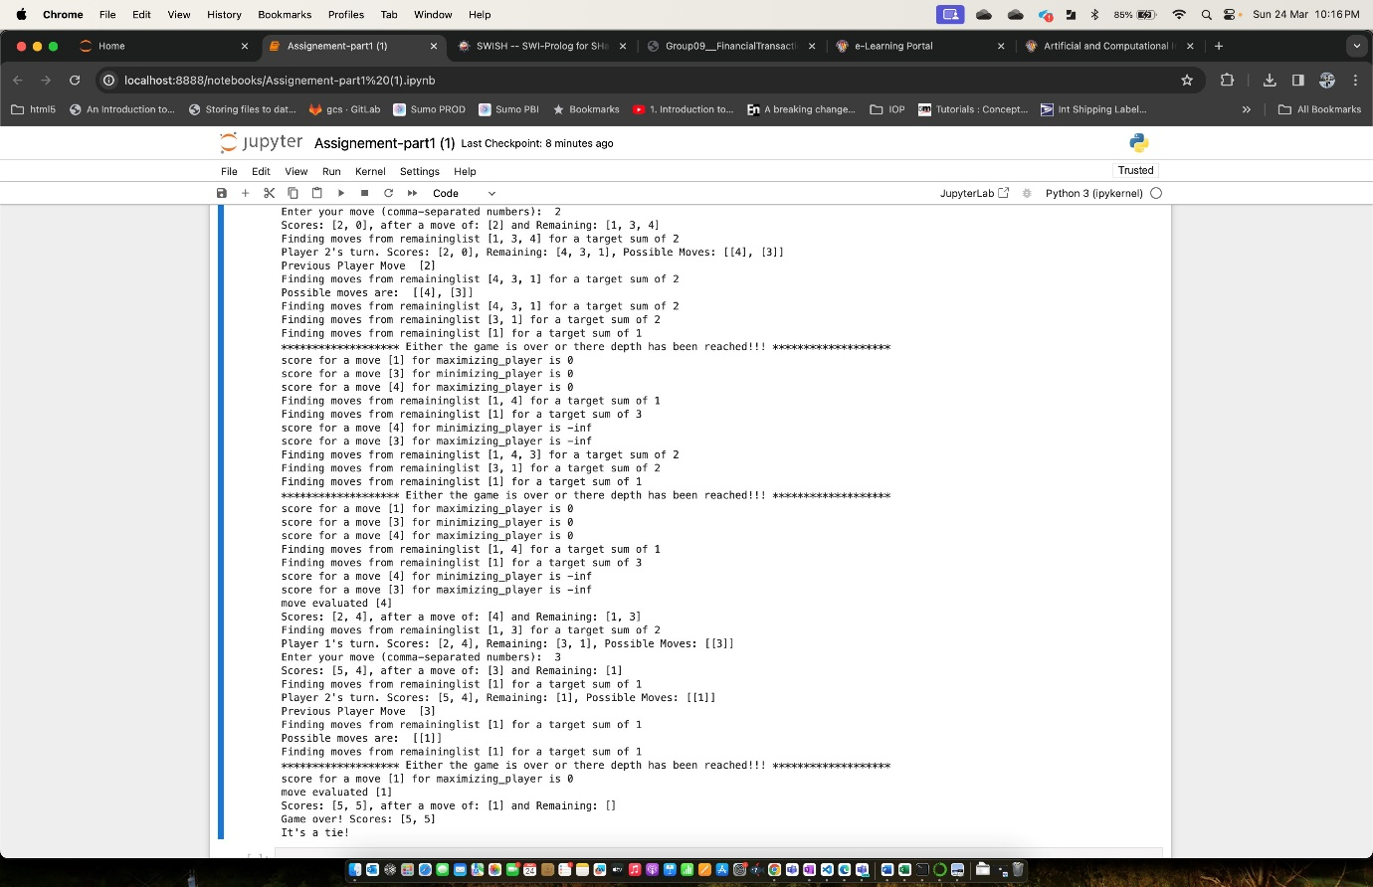
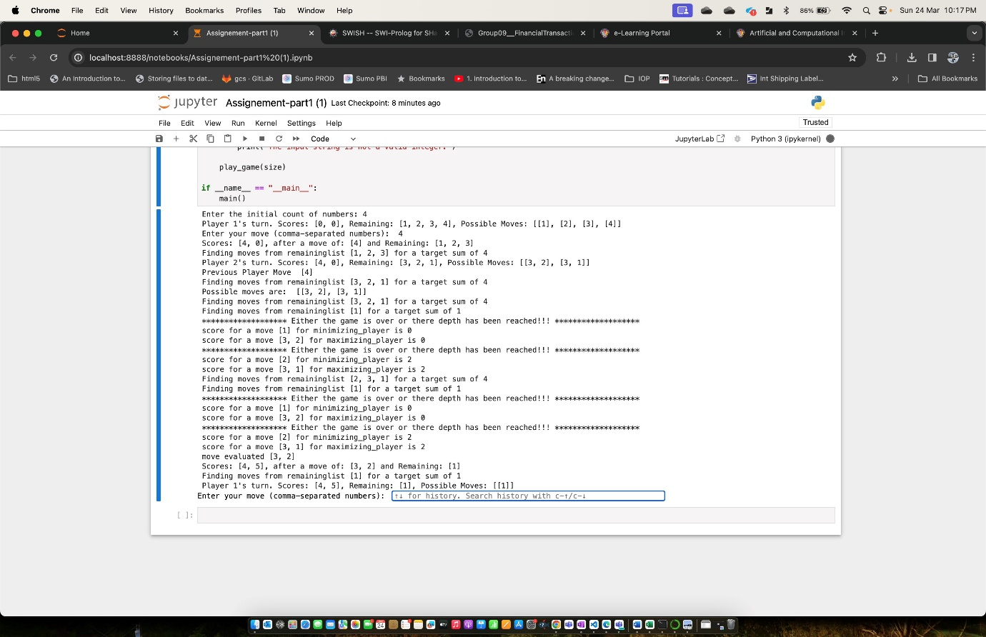
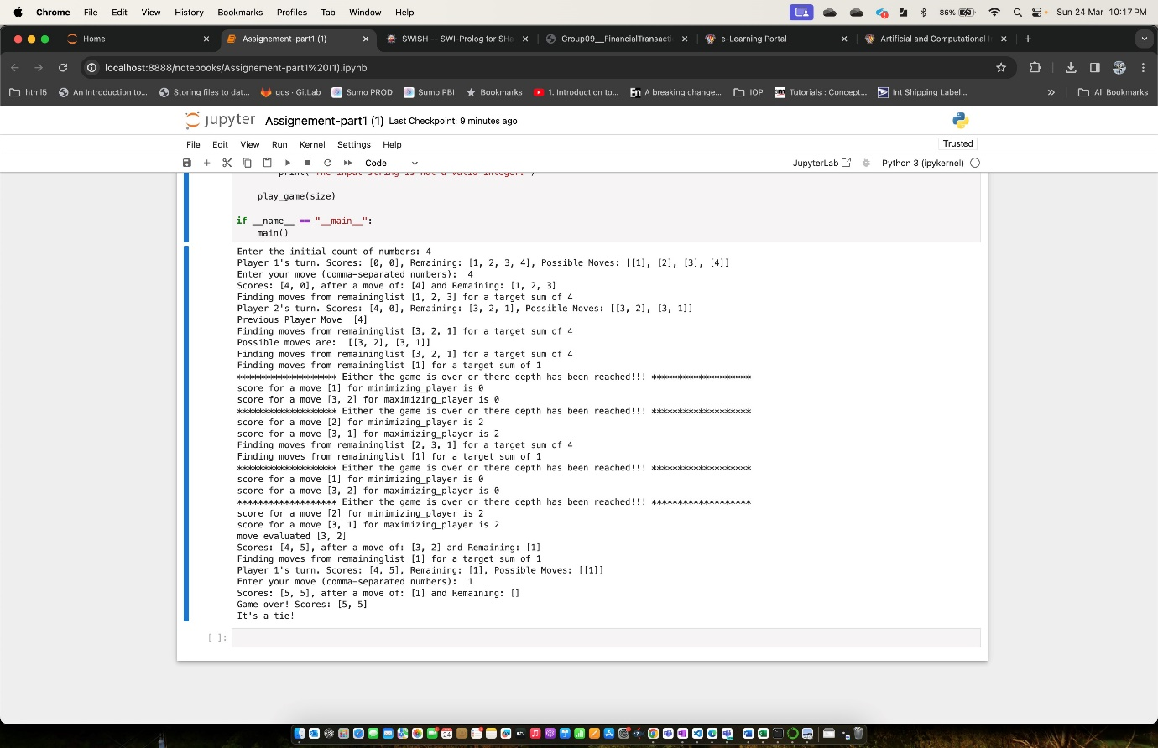
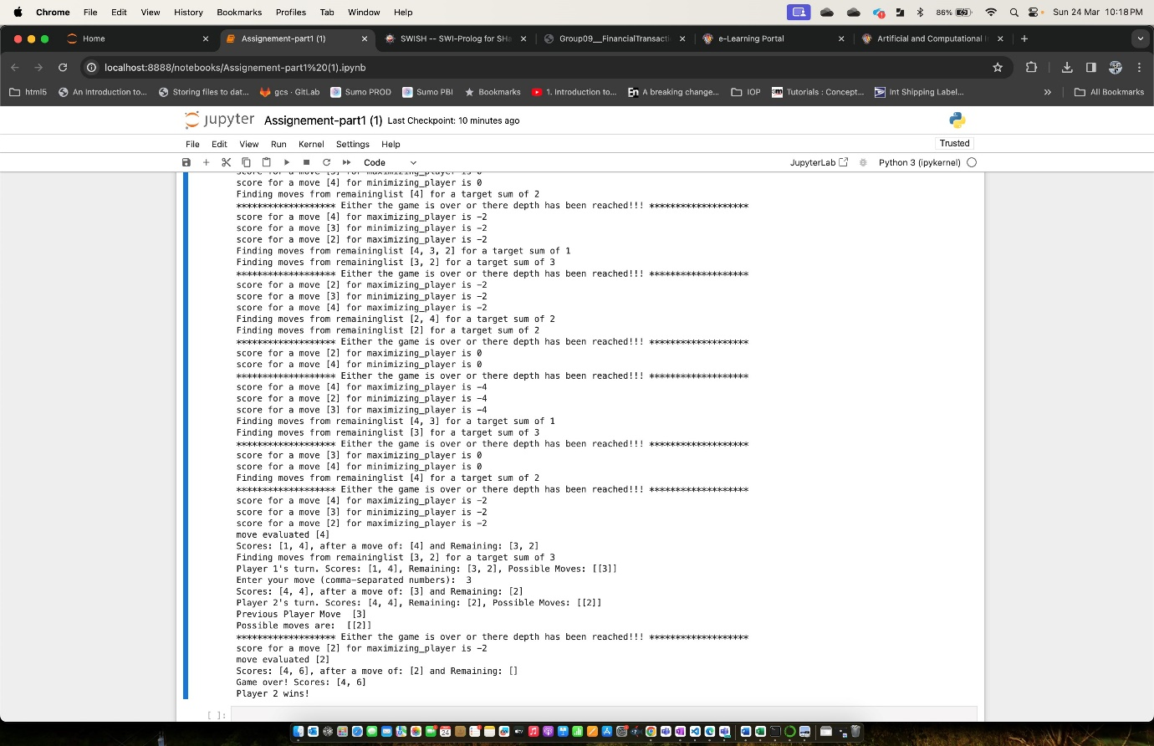
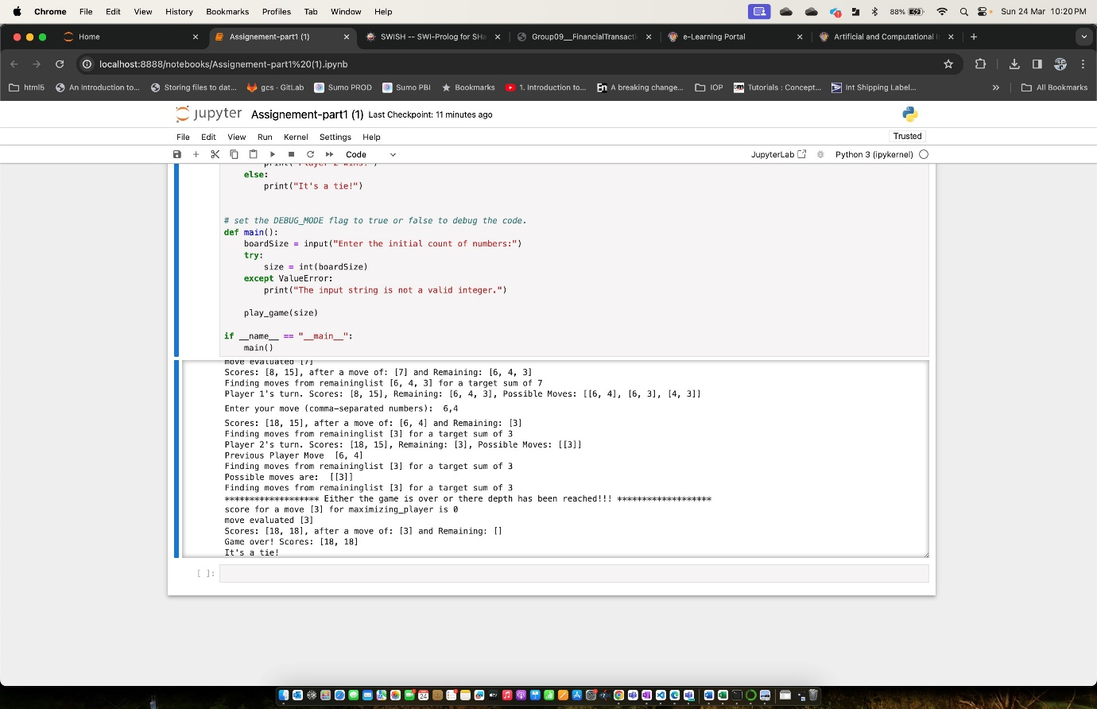

Problem statement 2: Logic
The figure below is a Decision Tree created to predict which water resource a location is most suitable to utilize. For example, if there is a case where a location has features: 120
mm/month rainfall, sandy aquifer, 10 km away from the perennial river, 20 km away from the lake, and 2 km away from the beach, could you decide which water resource suitable for the community to take from, rainfall, river water, lake, or groundwater? Use the below decision tree and create Prolog rules to predict which water source is best for the community under the given conditions. Take the attribute values from user by giving suitable user prompts and predict the water source.

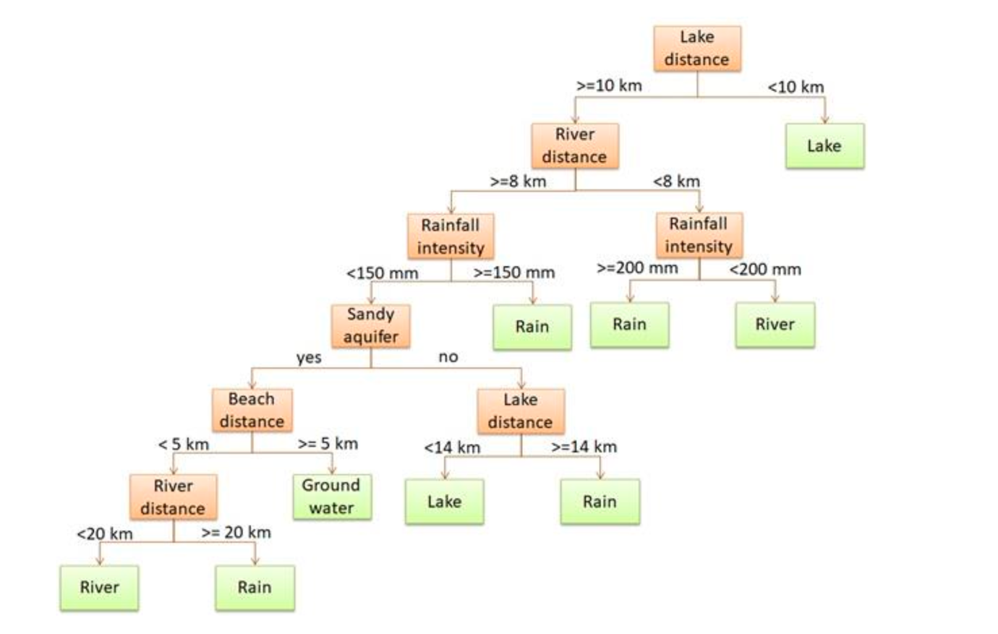

Execution process: -
- The program starts with the prologWaterSource predicate which welcomes the user and calls other predicates to get the necessary inputs.
- getRainfall, getAquifer, getRiverDistance, getLakeDistance, and getBeachDistance are predicates that ask the user for specific inputs and read the user’s response.
- determineWaterSource is the main logic of the program. It uses the collected data to determine the most suitable water source. The logic is implemented using a series of conditional statements.
- Each get predicate checks if the input is of the correct type and throws an error if it’s not. The catch/3 predicate in prolongWaterSource catches these errors and prints an error message. If an error occurs, the fail predicate is called to indicate that the prolongWaterSource predicate has failed.

Online Prolog IDE used to run the program:
https://swish.swi-prolog.org/p/waterSource_Assignement.pl

Positive Test Case – with no error
Welcome to the Water Source Expert System
Enter rainfall intensity in (mm/month):
200
Enter type of aquifer in (sandy/other):
other
Enter distance from river in (km):
5
Enter distance from lake in (km):
15
Enter distance from beach in (km):
6
The suitable water source is: rain
true
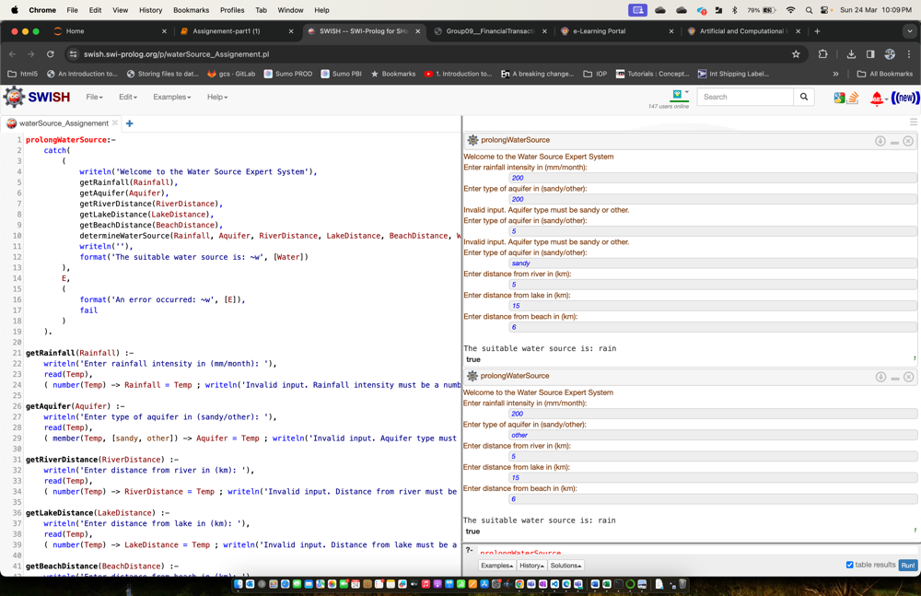

Negative Test Case – with no error
The red highlights the error handling. Also how the code re-prompts the user.
Welcome to the Water Source Expert System
Enter rainfall intensity in (mm/month):
200
Enter type of aquifer in (sandy/other):
200
Invalid input. Aquifer type must be sandy or other.
Enter type of aquifer in (sandy/other):
5
Invalid input. Aquifer type must be sandy or other.
Enter type of aquifer in (sandy/other):
sandy
Enter distance from river in (km):
5
Enter distance from lake in (km):
15
Enter distance from beach in (km):
6
The suitable water source is: rain
true

Time and Space Complexity
- In terms of complexity, the determineWaterSource predicate has a constant time complexity, O(1), because it makes a decision based on a fixed number of conditions and does not involve any loops or recursive calls.
- The overall time complexity of the program is also O(1) as it involves a fixed number of user inputs and computations.
- The space complexity is also O(1) as it uses a fixed amount of space to store the user inputs and the result.
- However, the actual time taken by the program will depend on the time taken by the user to provide the inputs.

