

CSCI 5409: Advance Topics in Cloud Computing

Mid Term Project Report

Banner ID: B00979961

Name: Sanif Ali Momin

Date: 28th February 2026

Gitlab Repo:

Contents
Project Introduction: 2
AWS Services Used: 2
1. AWS S3 2
2. AWS API Gateway (HTTP API) 3
3. AWS Lambda 3
4. AWS DynamoDB. 4
5. AWS SES. 5
6. AWS CloudWatch 5
Architecture: 6
1. Architecture Diagram 6
2. Component Delivery 6
3. Everything about Data 7
4. Programming Languages and Code Components 7
5. Application Deployment 8
6. Components Integration 8
Security 9
Data Security 9
Application Security: 9
Security Recommendation: 10
Conclusion: 11

Project Introduction:

The project is named ATS Resume Tailor which is a GenAI application that tailor/transform your master resume based on the job description provided. It also makes sure that the relevant keywords from the job description is present in the created resume and structure the resume that it follows the format accepted by ATS.

The application is addressing the critical pain point of job applicant in their job searching. Manual tailoring resume for each job applicant is a time-consuming job and is often inconsistent.

ATS Resume Tailor is doing following task currently.
- Extracting text from uploaded PDF resumes
- Analyzing job descriptions to identify key requirements
- Intelligently filtering and rewriting resume content to match job requirements
- Generating professionally formatted PDF outputs
- Providing email delivery of tailored resumes
- Tracking usage analytics for administrators

Target Users:
- Job Applicant.
- System Admin for tracking performance.

Performance Metrics:
- Response Time: < 30 seconds for resume tailoring (AI processing is the bottleneck and include Lambda cold start)
- Availability: 99.5% uptime (acceptable for non-critical application)
- Scalability: Currently support 100-500 concurrent users.
- Data Processing: Handle resume PDFs up to 5MB

AWS Services Used:
The whole solution is being build considering and prioritizing cost. So, most of the services we are using are cost effective in comparison to their alternatives.

AWS S3
We are currently using S3 for two things
  - Hosting our frontend web application.
  - Storing master resume.

Alternative for hosting:
- AWS Amplify.
- AWS EC2
Alternative for Storage
  - AWS EBS
  - AWS EFS

Reason:
We have chosen S3 because it is durable and has up time of 99.999999999 (11 nines) and is also cost effective as cheaper solution than other solutions in terms of both storage and web hosting. Also, the advantages of using S3 is that it provides native integration with AWS Lambda.

For web hosting in s3 we only have to pay for the static files that we are storing on s3 but for Amplify or hosting on EC2 (via web server) we have to pay for hosting charges. So, for static web applications s3 is the best available solution.

For storage purposes comparing it with other alternatives like EBS and EFS it costs 0.023/GB/month for s3 and for EBS its 0.10/GB/month and EFS is 0.30/GB/month so s3 is cheaper. Also, the biggest advantage is that lambda have native integration with s3. EBS and EFS are designed to mainly work with EC2 instances, so it does not fit our serverless architecture.

AWS API Gateway (HTTP API)
We are using API Gateway as an entry point for all our backend services. It will route the request to respective lambda.

Alternative Services:
  - AWS API Gateway (Rest API)
  - Application load balancer.
  - AWS Lambda (invoking it directly)

Reason:
AWS API Gateway is a cost-effective solution with easier lambda integration and auto scaling support. In terms of security, it’s also a good solution as we can filter out request at Gateway level without invoking lambda.

I also provide easier integration with different AWS security solutions like Cognito for authentication and WAF for DDoS protection.

HTTP API is lot cheaper than its direct alternative that is REST API. The comparison is it takes 1.00 per million requests for HTTP API and 3.50 per million requests for Rest API.

We are not invoking lambda directly which is a cheaper solution, but it lacks features like custom domains, throttling, and centralized API management. Not production-ready for public-facing applications.

ALB is not compatible with the serverless lambda architecture and lacks API management capabilities.

AWS Lambda
For compute service we are using AWS Lambda. Currently there are four lambda functions.
- Tailor Resume – Main resume processing
- Send Email – Email the tailor resume to the recipient.
- Track Analytics – Tracking analytics i.e. usage and other things.
- Get Analytics – Get the current analytics for admin.

Alternatives Services:
- AWS EC2
- AWS ECS and Fargate
- AWS EKS

Reason:
Considering the initial usage which will be very minimal and to save the cost we are using lambda. We only need to pay for the usage only. Application auto scaling is easier. Zero server management and easy integration with other services.

EC2 was not chosen as we will have to pay for idle period too which will be greater than total used time for a day.

ECS/Fargate was not chosen as it would be an overkill as the application only had 4 services and only 1 service will be used for most of the time. If our application features increase, we can opt for this option.
The code is written in a way that moving to different Compute solution would be easier with only infrastructure changes and minimal code changes.

AWS DynamoDB.
We are using DynamoDB as our database in our application. It is being used to store analytics tracking data.

Alternative:
  - Amazon RDS
  - Amazon Aurora
  - Amazon ElastiCache

Reason:
Our application has minimal database usage, and we are storing analytics as a key value pair as NoSQL so for that DynamoDB is the ideal choice.

It provides single digit latency in terms of read and write operations. No instance provisioning and management is required. It follows pay as you go model which is ideal considering our minimal usage.

We are not using RDS as that would be an overkill considering our database usage and NoSQL structure that we are following. Aurora provide serverless (pay as you go) model but is still expensive than DynamoDB.

Amazon ElastiCache is for caching and data in this is lost on restarting as we need data to persist, so we are not using this.

AWS SES.
We are using SES service for sending resume to the desired email address.

Alternatives:
  - Third party email services (mailgun)
  - Setting up SMTP server using EC2.

Reason:
It is services purposely build for sending emails with detailed support for all type of mail provided (like PDF attachment that we are doing). Its is AWS maintained and managed provides high deliverability. It is also cost effective with free tier for initial usage and 0.10 per 1000 emails after that.

As third-party services are outside AWS so it will add latency and will require external dependencies too. They are also expensive than SES.

SMTP server will be costly and will be a management overhead. As emailing is not the core functionality of application so we can avoid the management overhead by using SES.

AWS CloudWatch
We are using AWS CloudWatch for logging all the logs for all the lambdas.

Alternative and Reason:
No alternative for this in AWS ecosystem. We can use third party services but integration with lambda will be an overhead. AWS CloudWatch is attached by default with the lambda, and we don’t need to provision and configure anything. We can also setup alarms based on the logs.

Architecture:

Architecture Diagram

Figure 1 shows our current architecture.
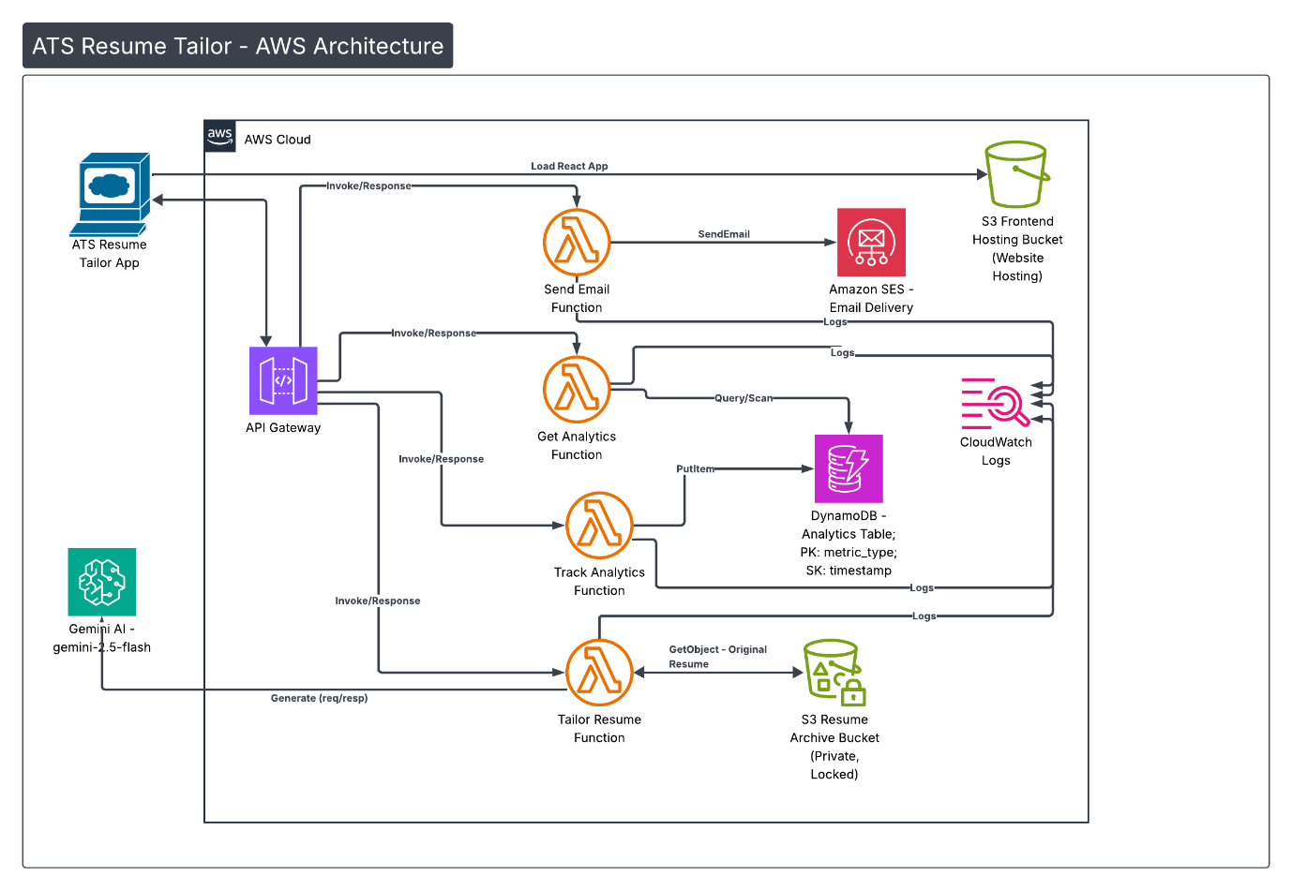
Figure 1 ATS Resume Tailor Architecture Diagram

Component Delivery
Our application is divided in 4 layers.
- Web Application Layer: S3 is being used to serve the web application to the user. We are using S3 static webhosting for it.
- Gateway Layer: We have API Gateway which is being accessed by our web application. Web application sends all the request to API Gateway which perform validation and then invoke the respective lambda based on route.
- Compute Layer: Here we have 4 lambda functions performing different responsibilities. They are triggered by API Gateway and after processing they send response back to API Gateway. In between they used some of the services to perform certain tasks. During this whole process logs are also being written to CloudWatch.
- Additional Services Layer: Here we have 4 services S3, DynamoDB, SES, Gemini AI (External). These services are attached to particular lambdas to perform certain functions

Everything about Data

Data Format:
- For the input and output data we are using structured JSON. We are sending as master resume as a binary file in the request along with job description as string.
- For response we are using s3 URL for downloaded in Json format with a short expiry.
- For all other services its JSON is used for communication between frontend and backend.
- Gemini Request is pure text and response is in JSON.

Data Source:
- Uploaded Resume – We are retaining one resume per user in our system for a week.
- Job description – Only using it for processing only not stored anywhere.
- Generated Resume – Using S3 bucket policy we are only retaining 10 generated resumes per user with expiration of 60 mins.
- Gemini Request and Response: Not stored any where only used for generating resume.
- Analytics Data – Automatically generated by system and stored in database.

Data Size:
- Input Resume – Maximum 5MB permitted. Controlled via frontend.
- Job Description – Average of 2KB based on characters allowed in input field.
- Generated PDF – Average of 300-500 KB as we are consolidating everything to 1 page only
- Data per user stored – 1 Input resume (Maximum 5MB) and 10 generated resume (Maximum 500 KB each)

Data Storage Solution:
- Input Resume – S3
- Generated Resume – S3
- Analytics Data – DynamoDB
- logs – CloudWatch with retention of 1 month.

Programming Languages and Code Components

Frontend: React
We have created out frontend using React which is a modern web development framework and contain rich ecosystem of libraries required. The developed application using this is compatible with all the browsers. It also provides us the files requires for hosting static application on S3.
Our whole frontend UI is code based.

Backend: Java 17
We are using java because it is widely used in enterprise environment. It is one of the languages allowed for lambda functions. It is type safe which reduces chance for error in production environment. AWS SDK support is also one of the reasons to choose Java.
We have code for all the processing on backend. No code required for request and response validation as it is being handled by API Gateway. No code sending email or setting up SMTP server we are just using SES to serve that purpose. No machine learning code we are using libraries for NLP to extract text from pdf and Gen AI model for tailoring resume.

IaC: Terraform
We have chosen to terraform as it tracks the current state of our infrastructure, and we have AWS provider support that covers all the AWS services. It’s a tool that supports multiple providers means single codebase will be good enough for multi cloud applications.

Application Deployment
We are using IaC for infrastructure deployments. The IaC that we are using is terraform and the state file of terraform is being stored in S3 and lock state is being stored in DynamoDB.
For frontend deployment are application is being hosted using S3 as a static website.
For complete deployment i.e. frontend, backend and infrastructure we have two ways.
- Manual – Use deploy.sh script for deploying whole application using your own machine. It includes following
  - Frontend and Backend Deployment.
  - Checking terraforms state file on S3 if bucket does not exists then it will create one.
  - Deploy the infrastructure (Changes or new based in state file)
  - Upload the front-end assets to S3 bucket.
  - Display the s3 and API Gateway endpoints.
- CI/CD – AWS Code Pipeline. Using buildspec.yaml file which is part of our current code. The process is.
  - It is triggered by git push on GitHub. We are using GitHub keys for connection.
  - Execute the build for both frontend and build using the image provided.
  - Checking terraforms state file on S3 if bucket does not exist then it will create one.
  - Deploy the infrastructure (Changes or new based in state file)
  - Upload the front-end assets to S3 bucket.
  - Display the s3 and API Gateway endpoints.
It is fetching environment variables from CodeBuild which will be fetching it from AWS Parameter Store.

Components Integration

Frontend to Backend integration.
Our frontend web app calls the respective API Gateway endpoint from the application. API gateway validates the request i.e. request type (GET, POST etc.), request body and authentication (we are using API keys for that, so our API gateway is only accessible from our frontend). After validating the request API Gateway invokes the respective lambda that is being attached for that request type.

Lambda Integration:
It is divided into three parts:

- AWS Services – For AWS Service integration from Lambda like S3, SES and DynamoDB we are using AWS SDK in our code. As all of the services are in same region and account, we are using IAM permissions to access all of these services.
- LLM Integration (Gemini AI) – For this we are using Google Gemini AI API Keys for access.
- AWS CloudFormation – No integration need as it is attached by default by lambda, we only have given the following IAM permissions logs:CreateLogGroup, logs:CreateLogStream, logs:PutLogEvents

Security
Data Security
- API Gateway provides https endpoint which we are using for communication with frontend, so all the data transmitted is encrypted as it moves between browser and API Gateway.
- The data stored (resumes) in S3 are in private buckets only accessible to Resume Tailor Lambda using IAM Role.
- The Data Stored in DynamoDB is by default encrypted by AWS. There is an IAM Policy set for only two functions to access the DynamoDB Table that we are using to save the data.

Vulnerability:
- S3 URL where application is hosted is http. On production environment we can use CloudFront and ACM which will secure the endpoint.

Application Security:
- Resume S3 buckets are private.
- API Gateway enforces most security measures on API like rate limiting, request validations etc.
- API Key is used to make sure only Web app can access the API Gateway endpoint and API Gateway will deny other traffic.
- IAM Policies are in place to only allow necessary services to access other services.
  - Tailor Resume Lambda can only access the bucket containing resumes and have read and write access.
  - Track Analytics Lambda can only put items dynamodb:PutItem to our analytics table
  - Get Analytics Lambda can only get items dynamodb:GetItem from our analytics table

Security Recommendation:
- Make S3 web hosting bucket private and accessible using CloudFront only.
- Implement VPC so outside access can be blocked.
- Add WAF on API Gateway to prevent DDoS (only in production)

Cost Analysis

Cost Analysis is being done considering the following usage assumptions per month.
- Number of Users: 1000
- Resume tailoring request: 2 per user, total 2000 request.
- Email Send (SES): 1 per user, total 1000 emails.
- Average resume size: 1 MB so total 1 GB storage
- Average request duration (Lambda running time): 4 sec so total 8000 sec.
- Analytics event: 5 per request so 10000 total

Upfront Costs:
There is no upfront cost associated with our application as we are using serverless services that follow pay as you go model.

Running Costs:
This cost is calculated using AWS Cost Calculator using estimated usage

AWS Services | Usage | Estimated Cost ($)
AWS Lambda | Requests: 12,700 total  Tailor Resume: 2,000 × 20 sec × 2GB = 80,000 GB-sec  Send Email: 600 × 3 sec × 0.5GB = 900 GB-sec  Track Analytics: 10,000 × 0.5 sec × 0.5GB = 2,500 GB-sec  Get Analytics: 100 × 2 sec × 0.5GB = 100 GB-sec  Total GB-sec: 43,050 | 0.76
AWS API Gateway | Requests: 12,700 requests  Data transfer: 2GB | 0.19
Amazon S3 | Storage: 2.5 GB (archive + website) | 0.21
Amazon DynamoDB | Writes: 14,000 WRUs = 0.0175  Reads: 25,000 RRUs = 0.00625  Storage: 0.01 GB = 0.0025 | 0.006
Amazon SES | Emails: 2,000 | 0.2
AWS CloudWatch | Log Storage: 0.435 GB = 0.013  Ingestion: 0.0145 GB = 0.007 | 0.02
Data Transfer | Outbound (PDFs + website): 8 GB | 0.72
Total Monthly Cost |  | 2.11

For GenAI tool there will be no cost are we are using free tier now and it can vary based on agent that we will use.

Additional Cost for Real World Application

Category | Details | Estimated Cost ($)
AWS Route 53 | DNS | 12 upfront  0.50 monthly
AWS WAF | For enhancing API Gateway Security | 7-10
AWS CloudFront | For edge caching. It will also reduce S3 and Data transfer cost. | 0.37
Total |  | 12 – upfront  8.87 - monthly

Cost Optimization
We are optimizing cost of our application by doing the following things.
- Allocation of lower memory to lambdas that don’t have less processing.
- S3 bucket lifecycle policy for deleting objects after specific time (1 week for Master resume and 1hr for generated resume).
- Use of Serverless services to go for pay as you go model.

Justification
- We have used 2GB memory for Tailor Resume Lambda to reduce the response time as this functions require some heavy lifting.

Cost Optimization Recommended:
- Add CloudFront to save S3 access and data transfer cost

Future Work
To make application more effective following features can be added.
- User based authentication – Currently its session based and Application is accessible by anyone. We can implement user authentication and for that we can use AWS Cognito for that.
- Paid AI Agents – To get better results we can integrate it to available AWS AI agents like Bedrock
- Integration with LinkedIn to apply for job application that suits our current master resume. This will require us to move to RDBMS and for them we have to switch it from DynamoDB to RDS.

Conclusion:
Resume Tailor demonstrates a modern, cost-effective cloud architecture leveraging AWS serverless services. The application successfully addresses the resume tailoring problem with minimal operational overhead and excellent scalability characteristics.
The architecture provides a solid foundation for growth, with clear paths to add features, improve security, and scale globally while maintaining cost efficiency.

References

[1] Amazon Web Services, "AWS Lambda Developer Guide," 2024. [Online]. Available: https://docs.aws.amazon.com/lambda/latest/dg/welcome.html.

[2] Amazon Web Services, "Amazon S3 User Guide," 2024. [Online]. Available: https://docs.aws.amazon.com/AmazonS3/latest/userguide/Welcome.html.

[3] Amazon Web Services, "Amazon DynamoDB Developer Guide," 2024. [Online]. Available: https://docs.aws.amazon.com/amazondynamodb/latest/developerguide/Introduction.html.

[4] Amazon Web Services, "Amazon API Gateway Developer Guide," 2024. [Online]. Available: https://docs.aws.amazon.com/apigateway/latest/developerguide/welcome.html.

[5] Amazon Web Services, "Amazon Simple Email Service (SES) Developer Guide," 2024. [Online]. Available: https://docs.aws.amazon.com/ses/latest/dg/Welcome.html.

[6] Amazon Web Services, "AWS Well-Architected Framework - Security Pillar," 2024. [Online]. Available: https://docs.aws.amazon.com/wellarchitected/latest/security-pillar/welcome.html.

[7] Amazon Web Services, "AWS Identity and Access Management (IAM) Best Practices," 2024. [Online]. Available: https://docs.aws.amazon.com/IAM/latest/UserGuide/best-practices.html.

[8] Amazon Web Services, "AWS Security Best Practices," 2024. [Online]. Available: https://aws.amazon.com/architecture/security-identity-compliance/.

[9] Amazon Web Services, "AWS Pricing Calculator," 2024. [Online]. Available: https://calculator.aws/.

[10] Amazon Web Services, "AWS Cost Optimization Pillar," 2024. [Online]. Available: https://docs.aws.amazon.com/wellarchitected/latest/cost-optimization-pillar/welcome.html.

[11] HashiCorp, "Terraform AWS Provider Documentation," 2024. [Online]. Available: https://registry.terraform.io/providers/hashicorp/aws/latest/docs.

[12] Google AI, "Google Gemini API Documentation," 2024. [Online]. Available: https://ai.google.dev/docs.

[13] Apache Software Foundation, "Apache PDFBox Documentation," 2024. [Online]. Available: https://pdfbox.apache.org/.

[14] Meta, "React Documentation," 2024. [Online]. Available: https://react.dev/.

[15] Amazon Web Services, "Serverless Architectures with AWS Lambda (Whitepaper)," 2024. [Online]. Available: https://d1.awsstatic.com/whitepapers/serverless-architectures-with-aws-lambda.pdf.

[16] OWASP Foundation, "OWASP Top Ten Web Application Security Risks," 2021. [Online]. Available: https://owasp.org/www-project-top-ten/.

