ERP Lab
Project Report and Technical Documentation
Course: CS5109 Brain–Computer Interfaces
Assignment: Option A (web-app teaching module), Topic 4: Epoching and ERP
Repository: https://github.com/tarun-227/erp-lab
Version documented: commit 2c02386, branch main

Member | Roll number | Role
[fill in] | [fill in] | [fill in]
[fill in] | [fill in] | [fill in]
[fill in] | [fill in] | [fill in]
[fill in] | [fill in] | [fill in]

Contents
1. Summary 3
2. Requirements and how they are met 3
3. Background 3
4. System overview 4
Technology and versions installed 4
Source layout 5
5. Data 5
5.1 Bundled samples 5
5.2 Uploaded recordings 6
6. Signal-processing methods 7
7. Backend API 8
8. Frontend and learning design 10
8.1 The six steps 10
8.2 Controls 10
8.3 Linked views 11
8.4 Teaching feedback 11
8.5 Design and accessibility 11
9. AI tutor (optional) 12
10. Export and reproducibility 12
11. Testing 12
11.1 Automated tests (all passing) 12
11.2 Robustness testing 13
12. Measured results 14
13. Performance and limits 17
14. Running and integrating 18
15. Security and privacy 18
16. Limitations and what has not been verified 19
17. Future work 19
18. Use of AI 20
19. References 20

1. Summary
ERP Lab is an interactive web application that teaches how event-related potentials (ERPs) are extracted from continuous EEG. A student loads real EEG, chooses which events to study, cuts the signal into epochs, averages them, and sees the brain response appear. Every setting can be changed with a slider, and the linked plots update in response, so the effect of each analysis decision is visible immediately.
The app has six guided steps, three bundled real recordings from different kinds of experiment, upload of the student's own files, a plain-language guide with questions on every step, a quiz, an optional AI tutor that knows the student's current results, and export of a standalone Python script that reproduces the analysis.
The backend does the signal processing with MNE-Python. The frontend is React and TypeScript with Plotly. The project has 121 automated tests, and all of them pass.

2. Requirements and how they are met
Course requirement | How it is met | Where
Sample data plus own file upload | Three bundled recordings; upload of .fif, .fif.gz, .edf, .bdf, .set, .vhdr, .gdf, .cnt | frontend/src/steps/LoadStep.tsx, backend/erp_module/api.py
5+ adjustable parameters | Epoch window, baseline on/off and window, high-pass, low-pass, reference, rejection threshold, channel, peak window, polarity, trials averaged, conditions | Section 8.2
2 linked, live-updating plots | Raw signal linked to ERP image; ERP waveform linked to scalp map; r² map linked to both channel and time | Section 8.3
"Explain" panel with questions | Guide tab on every step with an explanation, "Try this" tasks and "Think about it" questions | frontend/src/content/explain.ts
Export of code and parameters | Python script, parameters as JSON, share link, ERP as CSV, recording as FIF | frontend/src/steps/ExportStep.tsx
One-line run command | python run.py (after pip install -r requirements.txt) | run.py
README with user and developer guides | README.md, docs/USER_GUIDE.md, docs/DEVELOPER_GUIDE.md | docs/
At least 3 automated tests | 94 backend, 21 frontend, 6 browser tests | Section 11
10-minute demo | Script with one part per speaker | docs/DEMO.md
One-page contribution statement | Template ready; names, roll numbers and sign-off still to be filled in | CONTRIBUTION.md
Module merged in the shared repository | Not done yet. Mount and embed examples are ready; the shared repository's address and format are needed | integration/

3. Background
An ERP is a small voltage change, usually a few microvolts, that is time-locked to an event such as a stimulus or a response. It is buried in background EEG roughly ten times larger, so it cannot normally be seen in a single trial. The standard method repeats the event many times, cuts out the EEG around each one, and averages: activity locked to the event remains, and activity that is not locked averages towards zero. Random noise in the average falls by about 1/√N, where N is the number of trials.
Each analysis choice changes the result, and showing that is the purpose of this module:
Step | What it does | What can go wrong
Band-pass filter | Removes slow drift and fast noise | A high-pass above about 1 Hz shrinks and distorts slow components such as the P300
Re-reference | Sets what each voltage is measured against | Changes the amplitude at every electrode
Epoching | Cuts a window around each event | A window running past the recording's edge cannot be cut
Baseline correction | Subtracts the pre-event mean | A baseline that includes the response subtracts part of the response
Artefact rejection | Drops epochs with a large peak-to-peak swing | Too strict a threshold discards good data and raises the noise
Averaging | Reveals the time-locked response | Rare conditions have fewer trials and noisier averages

4. System overview
Browser (React + TypeScript) Server (FastAPI + MNE-Python)
┌────────────────────────────────┐ JSON ┌───────────────────────────────────┐
│ Six step screens │ ───────────► │ api.py routes │
│ Plotly plots, linked by a │ │ sessions.py sessions, filter cache│
│ shared store (Zustand) │ ◄─────────── │ core/ loading, processing, │
│ TanStack Query for requests │ arrays │ ERP maths, scalp map, │
│ Cheap updates in the browser │ │ script generator │
│ (trial averaging, scalp map) │ SSE │ tutor/ context, routing, │
│ Guide, Tutor, Quiz │ ◄──────────► │ tools, streaming │
└────────────────────────────────┘ └──────────────┬────────────────────┘
│ summaries, plot image
Gemini, with Groq as backup, optional

The work is split so that the interface stays responsive. The server does filtering and epoching, which are expensive, and returns compact arrays. The browser then handles frequent, cheap interactions itself: it recomputes the average for the "Trials averaged" slider from the single trials it already holds, and it draws the scalp map at any moment by multiplying a precomputed interpolation matrix by the channel values.

Technology and versions installed
Layer | Technology | Version
Language (backend) | Python | 3.12.4
EEG processing | MNE-Python | 1.13.2
Numerics | NumPy / SciPy | 2.5.4 / 1.18.1
Web API | FastAPI / Uvicorn / Pydantic | 0.162.0 / 0.54.0 / 2.14.2
LLM client | OpenAI Python SDK, pointed at Groq and Gemini | 3.42.0
Runtime (frontend) | Node.js | 24.15.0 (project requires 22+)
UI | React / TypeScript / Vite | 19.3.1 / 7.0.2 / 8.3.5
Styling and components | Tailwind CSS, shadcn/ui on Base UI | 4.3.3, Base UI 1.9.0
State and data | Zustand / TanStack Query | ^5.0.16 declared / 5.105.0
Plots | Plotly.js (plotly.js-dist-min), loaded lazily | 4.2.0
Tests | pytest, Vitest, Playwright, axe | Vitest 5.0.5, Playwright 1.64.1

Developed and tested on Windows 11 Home (build 26200) with Microsoft Edge. Continuous integration runs on Ubuntu with Python 3.12, Node 22 and Chromium.

Source layout
Path | Contents
backend/erp_module/api.py | HTTP routes; create_app() so the module can be mounted under a prefix
backend/erp_module/schemas.py | Request and response models with validation
backend/erp_module/sessions.py | Session store, shared filter cache, newest-request-only logic
backend/erp_module/core/io.py | Reading files, finding events, repairing missing data, preparing recordings
backend/erp_module/core/processing.py | Filter, reference, epoching, rejection, drop counts
backend/erp_module/core/erp.py | Averages, confidence intervals, peaks, SME, area latency, signed r²
backend/erp_module/core/pipeline.py | Combines the above into one response
backend/erp_module/core/topo.py | Thin-plate-spline scalp-map interpolation
backend/erp_module/core/codegen.py | Generates the exported Python script
backend/erp_module/tutor/ | LLM client and routing, context, prompts, tools, streaming routes
frontend/src/steps/ | The six step screens
frontend/src/plots/ | Raw, ERP image, ERP, scalp map, r² map, noise curve, drop log
frontend/src/components/ | Side panel with Controls, Guide and Tutor tabs, step bar, tour, shared controls
frontend/src/store/useAppStore.ts | Shared state: parameters, undo history, time cursor, selected trial
frontend/src/content/ | Guide text, concept cards, experiments, quiz
scripts/ | Sample builders and the robustness sweep
integration/ | FastAPI mount and Streamlit embed examples

5. Data

5.1 Bundled samples
The three samples were chosen to be different kinds of experiment. All are stored at 250 Hz in single precision and are built by scripts/make_sample_data.py.
 | Flanker task | Auditory oddball | Flickering light (SSVEP)
Source | ERP CORE, participant 1 (Kappenman et al., 2021) | OpenNeuro ds003061, participant 1, run 1 (Delorme, 2020) | MNE SSVEP example data, participant 2 (Welke & Tavano)
Licence | Distributed through MNE-Python | CC0 | CC-BY 4.0
Task | Press a button for a central arrow flanked by matching or opposing arrows | Frequent 500 Hz tones, rare 1000 Hz target tones (keypress), rare noise bursts; eyes closed | A stimulus flickers at 12 or 15 Hz for 20 s at a time
Sense and type | Vision, error monitoring | Hearing, rare events | Vision, steady-state rhythm
Channels | 30 | 32 (of 64) | 32
Duration | 914 s | 758 s | 467.6 s
Events | compatible 200, incompatible 200, correct 346, error 54 | standard 522, target 113, noise 112, keypress 113 | 12 Hz 180, 15 Hz 180
File size | 27.5 MB | 24.3 MB | 15.0 MB
Expected effect | ERN at FCz after errors; P3 at Pz | N1 at Cz; P300 at CPz/Pz | Oscillation at the flicker rate over occipital sites

Preparation of each sample:
- Flanker: keeps EEG channels and relabels events into stimulus and response types. A response is scored correct or an error against the preceding target, and only the first response after each stimulus is scored.
- Oddball: keeps a 32-channel subset to reduce file size, applies the BioSemi 64 electrode layout, and merges the original labels into tone/standard, tone/oddball, sound/noise and response/keypress. Events marked "ignore" are dropped.
- SSVEP: the app's epochs stop at 2 s, and with only 20 trial onsets the onset response hides the flicker in a short window. Each 20 s trial is therefore split into 18 one-second segments, starting one second in to skip the onset response. One second holds a whole number of cycles at both 12 and 15 Hz, so the segments stay in phase when averaged. An event in this sample is a segment start, not a new stimulus, and the app says so on screen. Which marker means which frequency was measured from whole trials rather than assumed: the coherent average at Oz had a signal-to-noise ratio of 15.6–17.6 at the correct frequency and 0.4–0.7 at the other.

5.2 Uploaded recordings
Uploads are limited to 300 MB. On upload, io.prepare does the following and tells the student about each change on the Load screen:
- Keeps EEG and stimulus channels; rejects files with no EEG.
- Keeps only the first 20 minutes of longer recordings.
- Fills NaN/Inf samples by interpolation and marks those stretches BAD_missing_data. Without this, a single NaN spreads through the filter to the whole channel and through the average reference to every channel.
- Applies a standard 10-20 electrode layout if the file has none, first correcting spellings such as PhysioNet's Fcz. to FCz.
- Finds events from a stimulus channel or from annotations. Annotations marking BAD or EDGE segments are not events.
- Resamples recordings above 300 Hz to 250 Hz.

Two further public recordings for practising upload are built by scripts/make_upload_examples.py: a visual P300 from the Brain Invaders dataset (Cattan et al., 2019) and a PhysioNet motor recording (Schalk et al., 2004). They are not stored in git.

6. Signal-processing methods
The order is the same in the app and in the exported script.
- Filter the EEG channels with MNE's default FIR filter, using the chosen high-pass and low-pass.
- Re-reference to the average of all channels, to one channel, or leave the recording's reference.
- Epoch around the selected events, with baseline correction. Epochs overlapping a BAD segment are not cut.
- Reject any epoch whose peak-to-peak amplitude exceeds the threshold on any EEG channel. Rejected epochs are kept in the response so the app can show them greyed out; this gives the same result as mne.Epochs(reject=dict(eeg=...)).
- Average per condition, with a 95% confidence interval, and compute the difference wave.
- Measure the components below inside the student's chosen window.

The rejection rule in step 4 is short enough to show in full. An epoch is kept only if no EEG channel exceeds the threshold.
Listing 1. Peak-to-peak rejection (backend/erp_module/core/processing.py).
data = epochs.get_data(copy=False)
ptp_uv = (data.max(axis=-1) - data.min(axis=-1)) * 1e6
kept = ~(ptp_uv > reject_uv).any(axis=1) if reject_uv else np.ones(len(epochs), bool)

Measure | Definition | Reference
Peak amplitude and latency | Most positive or negative point in the window | Standard
Mean amplitude | Mean voltage in the window; generally more robust than the peak | Standard
SME (standardized measurement error) | SD of the per-trial window means (ddof = 1) divided by √N; combined in quadrature for the difference wave | Luck et al., 2021
50% area latency | Time at which half of the area in the window has accumulated | ERP CORE (Kappenman et al., 2021)
Signed r² | r = √(n₁n₂)/(n₁+n₂) × (mean₂ − mean₁)/SD(all trials); reported as sign(r)·r², per channel and time | Blankertz et al., 2011
Noise against N | Measured baseline noise compared with a 1/√N curve | Standard

The r² map was checked against scipy.stats.pointbiserialr in backend/tests/test_erp.py.
Listing 2. Signed r² between two conditions (backend/erp_module/core/erp.py).
def signed_r2(a: np.ndarray, b: np.ndarray) -> np.ndarray:
n1, n2 = len(a), len(b)
both = np.concatenate([a, b])
sd = both.std(axis=0)
with np.errstate(divide="ignore", invalid="ignore"):
r = np.sqrt(n1 * n2) / (n1 + n2) * (b.mean(axis=0) - a.mean(axis=0)) / sd
r = np.nan_to_num(r)
return np.sign(r) * r**2

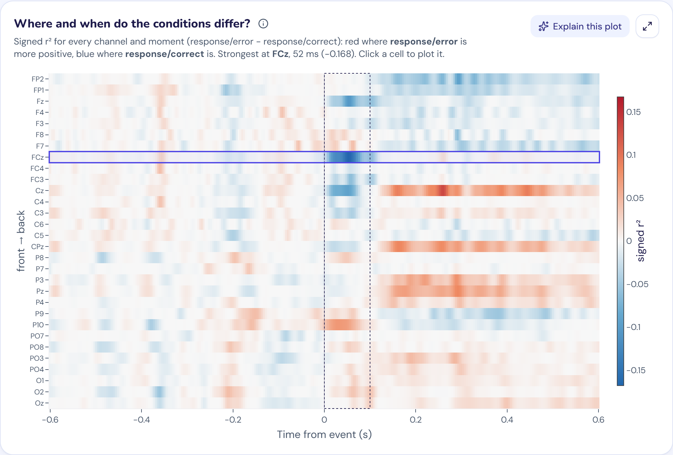
Figure 1. Signed r² map, flanker sample (error vs correct). It tests every channel and moment at once and finds the ERN at FCz, 52 ms (−0.168), with a later positive effect at central-parietal sites.
Scalp maps use thin-plate-spline interpolation. The server sends one matrix (grid points × channels) and the browser multiplies it by the channel values at the chosen time, which keeps scrubbing through time smooth.
Drop accounting. Every event ends in exactly one category: kept, rejected by threshold, off the recording's edge, inside a BAD segment, or a duplicate. These add up to the total and are shown separately. Each rejected epoch is attributed to the channel with the largest swing.

7. Backend API
Method and path | Purpose
GET /api/health | Status and which samples are available
POST /api/data/sample | Load a sample: {"sample": "flanker" | "oddball" | "ssvep"} (default flanker)
POST /api/data/upload | Upload one recording and its companion files
GET /api/sessions/{sid}/events | Event times and codes
POST /api/sessions/{sid}/process | Epochs, averages, measures, drop summary, r² map
POST /api/sessions/{sid}/raw | A window of the filtered recording
GET /api/sessions/{sid}/topo | Scalp-map interpolation matrix
POST /api/sessions/{sid}/export | Generated script and parameters
GET /api/sessions/{sid}/recording.fif | The prepared recording
GET /api/tutor/status | Whether the tutor has a key
POST /api/tutor/chat | Streamed tutor reply (SSE)
POST /api/tutor/quiz | Generated quiz questions
POST /api/tutor/grade | Grade a free-text answer

Processing parameters (ProcessParams in backend/erp_module/schemas.py):
Parameter | Range | Default | Notes
conditions | 1 to 6 | required | Event code and a unique name
l_freq | 0–5 Hz | 0.1 | 0 means off
h_freq | 0–100 Hz | 30 | 0 means off; must be below half the sampling rate
reference | average, none, or a channel | average
tmin / tmax | −1–0 s / 0.1–2 s | −0.2 / 0.8
baseline | true/false | true
baseline_start / baseline_end | −1–0.5 s | −0.2 / 0 | Must lie inside the epoch
reject_uv | 0–1000 µV | 100 | 0 means off; the slider goes to 300
channel | any EEG channel | Pz | Falls back to Pz or the first channel if unknown
peak_start / peak_end | −1–2 s | 0.25 / 0.5
polarity | positive / negative | positive

Errors. Invalid settings return 422 with a message a student can act on. An unreadable upload gets a message naming the file, without server paths. A BrainVision or EEGLAB upload that lacks a companion file names what is missing. Uploads over the limit return 413.
Staying responsive. A browser abandons its old request whenever a slider moves, but the server cannot see that. Left alone, abandoned work piled up: in a measured test the plots were still catching up about 35 s after the last slider move. Session.latest_only now runs one request at a time per session and skips any that a newer request has replaced (HTTP 409), which brought that delay down to about 2 s.
Listing 3. Newest-request-only processing (backend/erp_module/sessions.py).
def latest_only(self, kind: str) -> Iterator[None]:
"""Run requests of one kind one at a time, skipping any that a newer request has replaced.

A browser abandons its old request whenever a slider moves, but the server cannot see that.
Without this, abandoned work piles up and the plots lag far behind the sliders.
"""
with self._ticket_lock:
ticket = self._tickets[kind] = self._tickets.get(kind, 0) + 1
turn = self._turns.setdefault(kind, threading.Lock())
with turn:
if ticket != self._tickets[kind]:
raise Superseded
yield

Memory. Sessions are kept in memory, at most 8, least recently used first. One shared cache holds up to 4 filtered copies of recordings. Sessions on the same sample share their data.

8. Frontend and learning design

8.1 The six steps
Step | What the student does | Plots and output
1. Load | Picks one of three experiments or uploads a file | Summary of channels, rate, duration, events
2. Events | Chooses and names conditions; can apply a preset | Event counts and presets
3. Epoching | Sets window, baseline, filters, reference, threshold | Raw signal with epoch boxes, ERP image, drop log, kept/rejected counts
4. ERP | Sets the component window and trials averaged | ERP with confidence bands, difference wave, scalp map, r² map, measurements table, noise curve
5. Learn & Quiz | Reads 6 concept cards, runs 5 guided experiments, takes an 8-question quiz | Progress is saved in the browser
6. Export | Takes the analysis away | Script, recording, JSON, share link, CSV

The plots take the left of the screen. One panel on the right holds three tabs, Controls, Guide and Tutor, and shows one at a time, so the plots keep most of the width while a student moves the sliders. The panel can be resized or collapsed to a slim rail.
Each sample opens with suitable settings through presets in frontend/src/lib/presets.ts. A first-visit tour has three stops. Keyboard shortcuts: 1–6 change step, ←/→ move the time cursor by 10 ms, and [ collapses the side panel.
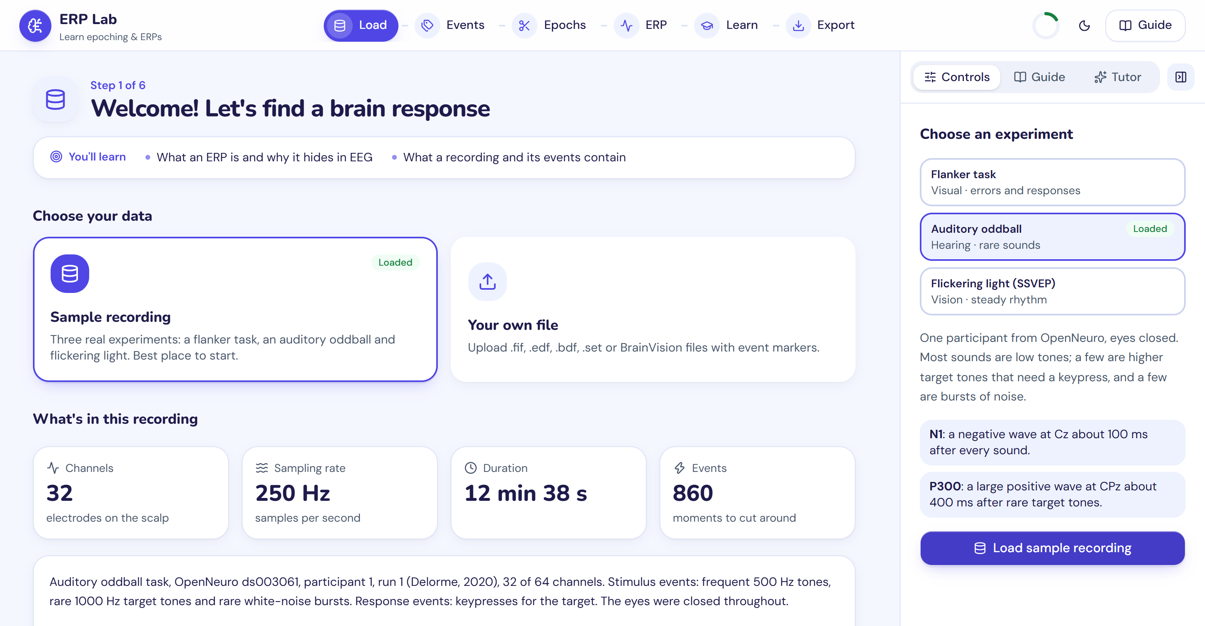
Figure 2. The Load step: three experiments to choose from, what to look for in each, and a summary of the recording.

8.2 Controls
Control | Range offered
Epoch window | −1 to 2 s, 0.05 s steps, at least 0.3 s wide
Baseline | On/off; window in 0.01 s steps, up to 0.5 s
High-pass | Off, 0.1, 0.3, 0.5, 1, 2, 5 Hz
Low-pass | 5, 10, 15, 20, 30, 40, 60, 100 Hz or off; only values below half the sampling rate are offered
Reference | Average, recording's own, or any channel
Rejection threshold | 0 (off) to 300 µV, 5 µV steps
Channel | Any EEG channel
Component window | Free range, with N1, P300, ERN and Pe shortcuts
Polarity | Positive or negative peak
Trials averaged | 1 to all kept trials

8.3 Linked views
- Selecting a trial in the ERP image highlights that trial's window in the raw signal.
- Clicking the ERP waveform moves a shared time cursor, and the scalp map follows it.
- Clicking an electrode on the scalp map changes the channel shown.
- Clicking a cell in the r² map sets both channel and time.
- "Pin to compare" keeps the current ERP as a ghost trace while a setting changes.

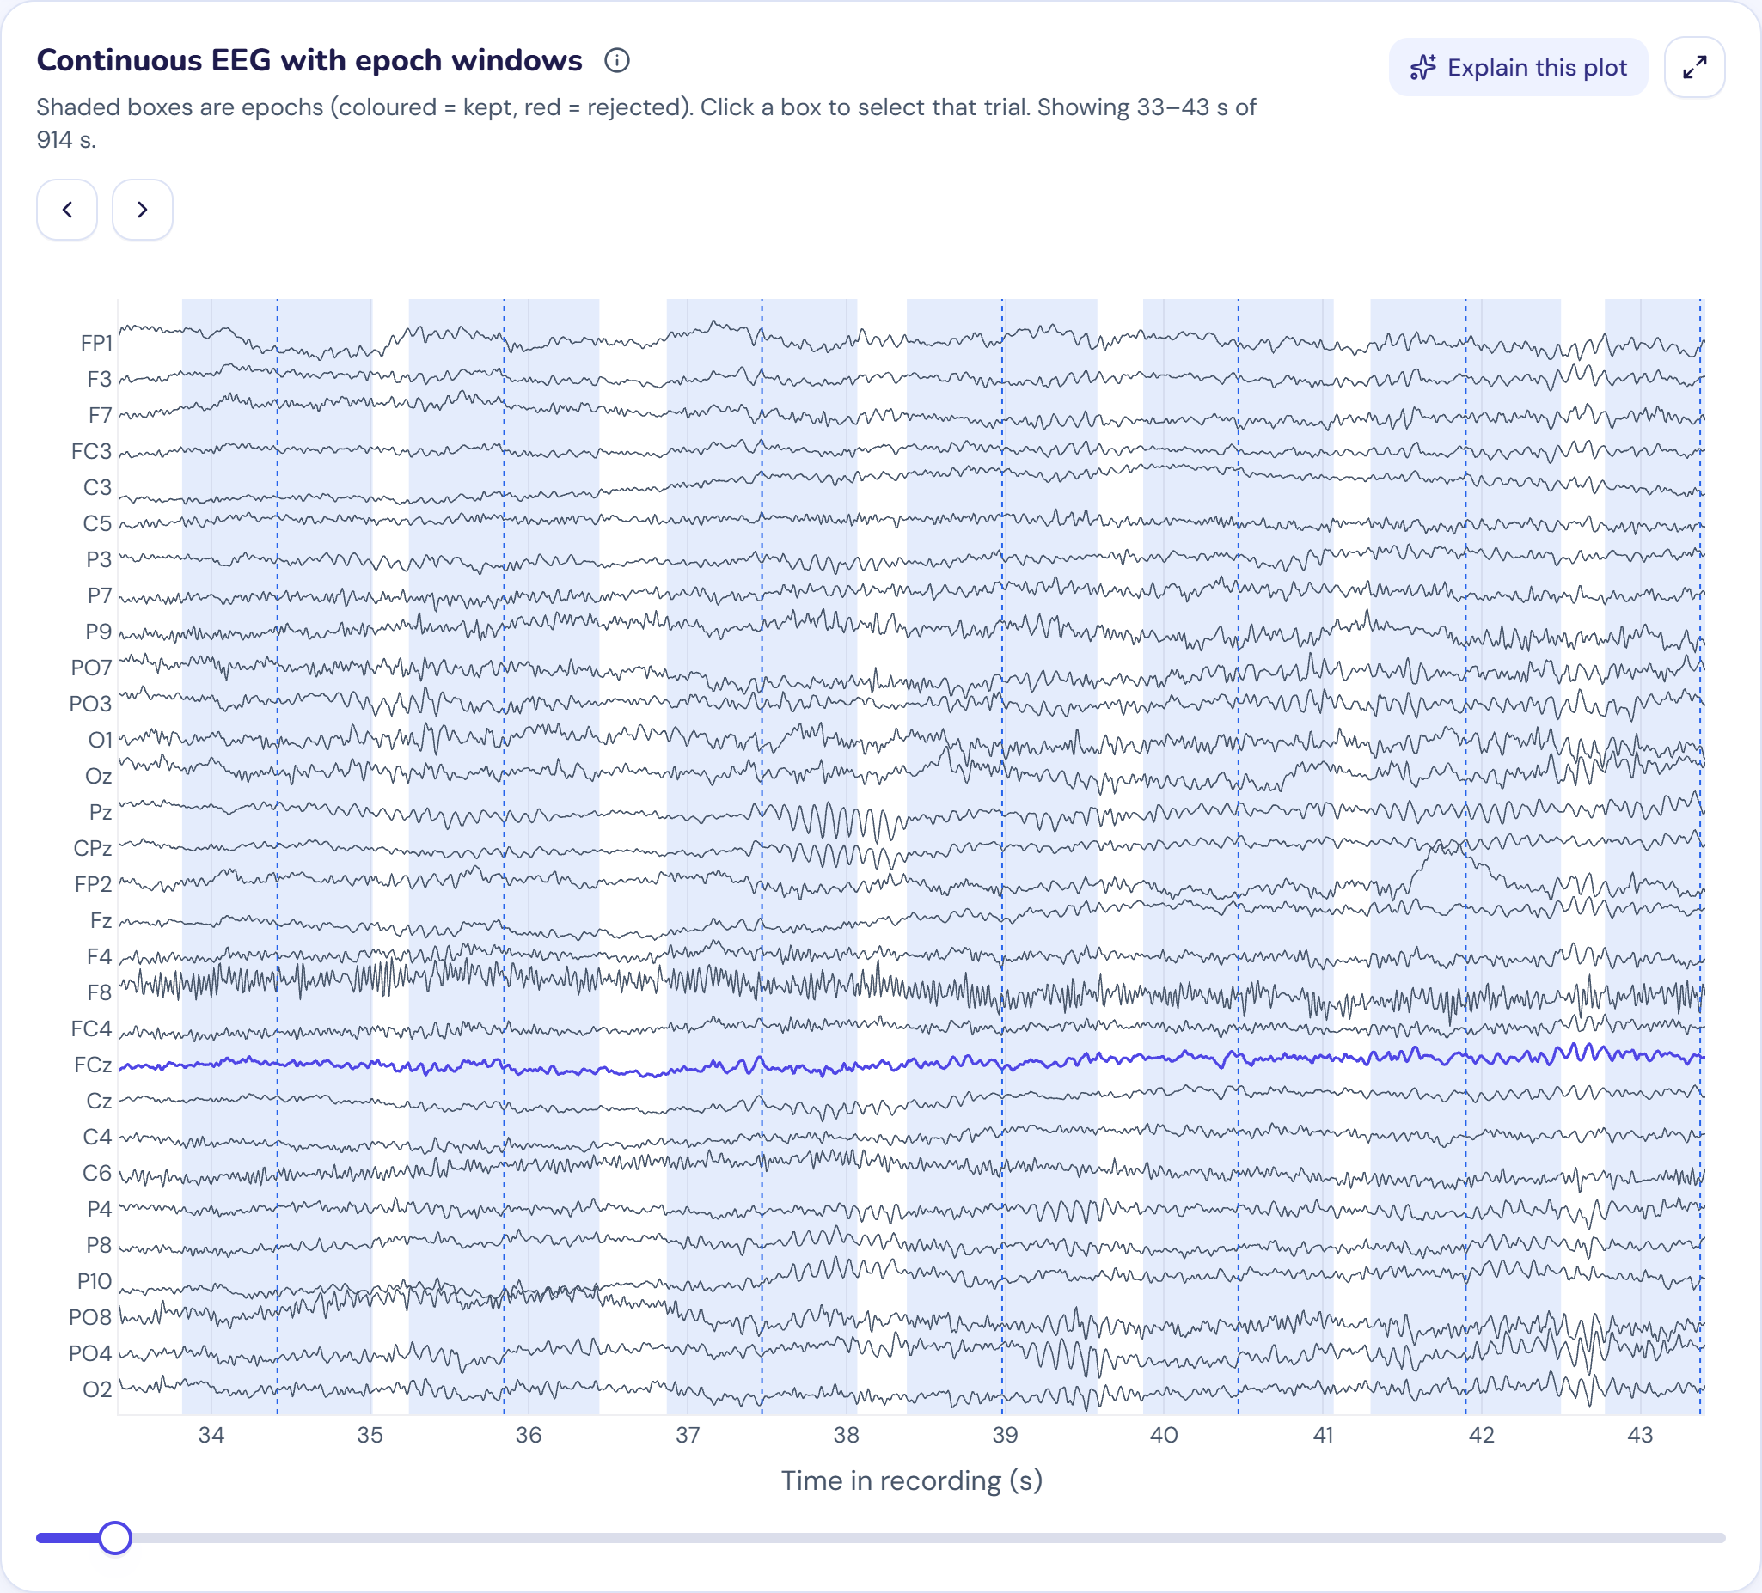 | 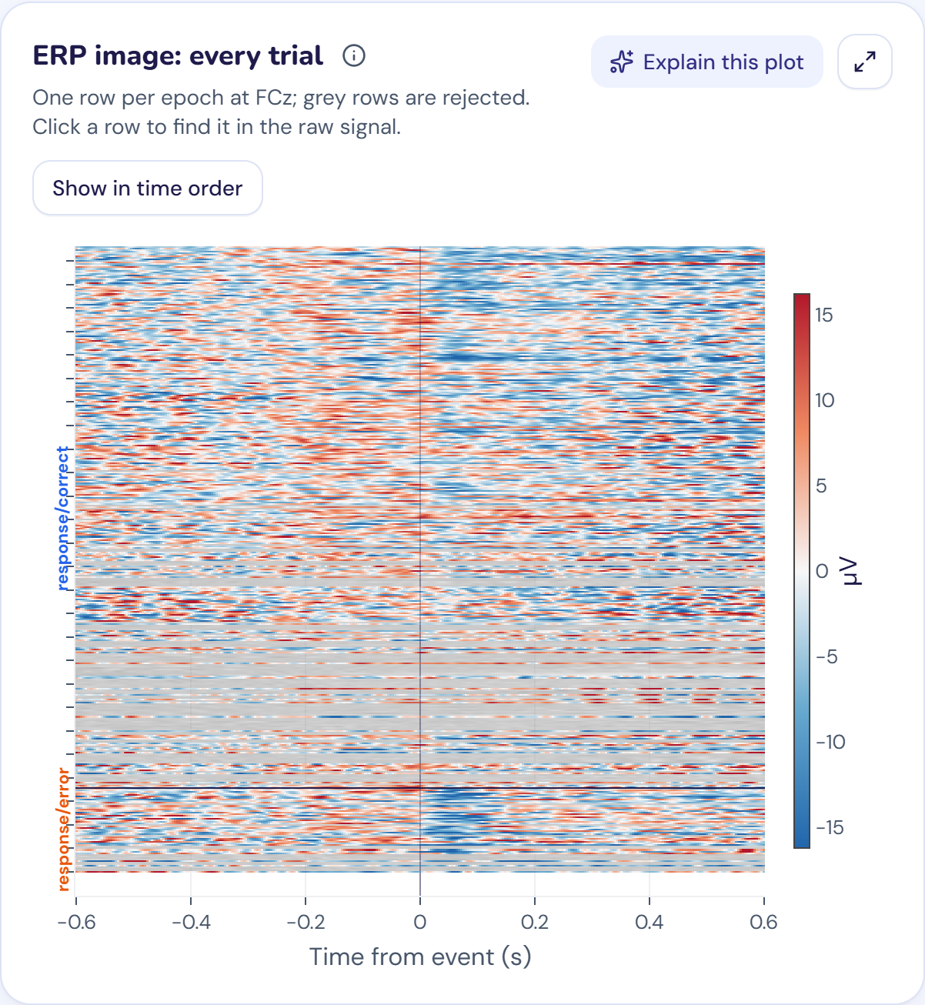

Figure 3. Epoching view, flanker sample. Left: the continuous recording with one shaded box per epoch. Right: the ERP image, with one row per epoch and rejected rows greyed out. Selecting a row finds that trial in the raw signal.

8.4 Teaching feedback
The app explains situations instead of just showing an empty plot. It warns when more than half of the epochs are rejected, when a high-pass may distort slow components, when a baseline includes the response, and when a condition has fewer than 20 trials. If no epochs remain, the ERP step says why and links back to Epoching.

8.5 Design and accessibility
The interface follows a friendly learning-app style (design-system/erp-lab/MASTER.md) with light and dark themes and self-hosted fonts. Automated axe checks of every step pass at WCAG 2.2 AA in both themes. Controls have accessible labels and work from the keyboard, and reduced-motion settings are respected.

9. AI tutor (optional)
The tutor knows the student's current step, settings and results, and answers about their own numbers. Without API keys it shows as offline and the rest of the app is unaffected.
Aspect | Implementation
Providers | Gemini (gemini-2.5-flash) answers first and sees plot images; Groq (openai/gpt-oss-120b) takes over when Gemini is rate-limited or unavailable; either key alone works
Modes | Socratic (hints first, on by default) or direct
Context sent | Experiment description, step, settings, drop counts, measurements. No raw EEG or per-trial data
Plot image | Sent to Gemini only when the student presses "Explain this plot"
Tools | propose_params (a card with Apply and Undo), highlight, go_to_step; arguments are validated, and nothing changes without a click
Other features | Generated quiz questions and grading of free-text answers
Limits | 12 requests per minute per session; last 8 messages of history; 700 tokens per reply, 1500 per quiz; 3 retries; 60 s timeout

10. Export and reproducibility
The Export step produces a standalone MNE-Python script from the current settings. It runs the same calls in the same order as the app. Three tests run the generated script in a separate process and confirm that it reproduces the app's ERP within 0.01 µV, across the flanker, oddball and SSVEP samples. Parameters can be saved and restored as JSON or shared as a link; the link carries parameters only, never data.

11. Testing

11.1 Automated tests (all passing)
Suite | Tests | Covers
backend/tests/test_robustness.py | 38 | Damaged and noisy files, parameter extremes
backend/tests/test_samples.py | 15 | Each sample shows its expected effect; exported script reproduces it
backend/tests/test_erp.py | 9 | √N noise, peaks, CI, signed r², SME, area latency
backend/tests/test_api.py | 8 | API end to end, upload, validation
backend/tests/test_tutor.py | 8 | Routing, offline mode, tool validation, rate limits, quiz schema (LLM mocked)
backend/tests/test_processing.py | 6 | Baseline, drop counts, rejection rule, filters, reference
backend/tests/test_sessions.py | 5 | Eviction, shared cache, newest-request-only
backend/tests/test_topo.py | 3 | Scalp-map interpolation
backend/tests/test_codegen.py | 1 | Exported script reproduces the app's ERP
backend/tests/test_mount.py | 1 | Mounting under a sub-path
Backend total | 94
Vitest, 6 files in frontend/src | 21 | Browser-side ERP maths, filter choices, presets, share links, navigation, SSE parsing
Playwright smoke.spec.ts | 1 | All six steps through to export
Playwright samples.spec.ts | 3 | Each sample loads and reaches the ERP step
Playwright a11y.spec.ts | 2 | axe WCAG 2.2 AA on every step, light and dark
Total | 121

GitHub Actions (.github/workflows/ci.yml) runs three jobs, backend, frontend and e2e, on each push. All three passed on commit 2c02386.

11.2 Robustness testing
scripts/robustness/ generates difficult inputs and sweeps parameters through the real API. A call fails if it crashes, returns non-finite numbers or returns inconsistent results. Clean 4xx answers to invalid settings are expected.
- 53 generated cases: every upload format; empty, random, truncated and bit-flipped files; an HTML page named .fif; missing companion files; no events; NaN and Inf; heavy noise, 50 Hz noise, large drift, spikes, clipping, flat or all-zero channels, wrong units; 2048 Hz and 64 Hz recordings; a 28-minute recording; a 310 MB file; one or two channels; no electrode positions.
- 8 real recordings on 7 tasks: flanker, visual P300, auditory oddball, SSVEP, motor execution, motor imagery and eyes-open rest, in FIF, EDF, EEGLAB and BrainVision formats, with about 245 parameter combinations each.
- In the browser: every control was moved to both ends on 10 recordings, and 5 bad files were confirmed to be rejected with a clear message.

After the fixes below, the final runs had no crashes and no inconsistent results.
Problem found | Fix
Raw view returned HTTP 500 for an unknown reference or a low-pass above Nyquist | Clear 422 message
Low-pass slider offered impossible values | Only values below half the sampling rate; default adapts
NaN samples spread silently and emptied the ERP | Filled, marked BAD, student told
Epochs in BAD segments were reported as "too close to edge" | Counted separately, with duplicates
Error messages exposed Python internals and server paths | Readable messages naming the file
Files with only BAD annotations returned an MNE error | Normal "no events found" message
Blank ERP with no explanation when all epochs were rejected | Notice with the reason and a link back
Trimming, resampling and renaming happened silently | Listed on the Load screen
Slider requests piled up, with plots about 35 s behind | Newest-request-only, about 2 s
Docker image had no sample data | data/ is now copied (not run; see Section 16)

12. Measured results
Measured through the app's own API with each sample's preset. Each sample is one participant, so these results show that the app works correctly; they are not group findings.
Preset | Condition | Kept / total | Mean (µV) | SME (µV) | Peak (µV) | Peak latency (ms) | 50% area latency (ms)
ERN (FCz, 0–100 ms, −) | Correct | 258 / 346 | −1.04 | 0.28 | −2.62 | 52 | 64
 | Error | 40 / 54 | −6.88 | 0.83 | −10.35 | 56 | 56
 | Error − correct |  | −5.84 | 0.88 | −7.76 | 56 | 52
P3 (Pz, 300–600 ms, +) | Compatible | 160 / 200 | 3.92 | 0.46 | 7.08 | 396 | 408
 | Incompatible | 161 / 200 | 4.52 | 0.41 | 7.38 | 440 | 452
 | Difference |  | 0.60 | 0.62 | 5.27 | 528 | 520
P300 (CPz, 250–600 ms, +) | Standard | 497 / 521 | −0.06 | 0.29 | 1.25 | 272 | 284
 | Target | 108 / 113 | 7.12 | 0.64 | 11.22 | 412 | 420
 | Target − standard |  | 7.17 | 0.71 | 11.61 | 424 | 428
Noise (Cz, 200–450 ms, +) | Standard | 497 / 521 | 0.27 | 0.26 | 2.46 | 200 | 236
 | Noise | 108 / 112 | 2.94 | 0.59 | 4.18 | 392 | 332
 | Noise − standard |  | 2.67 | 0.65 | 4.53 | 356 | 356

Preset | Strongest signed r² cell
ERN | FCz, 52 ms, −0.168
P3 | Cz, 536 ms, +0.070
P300 | CPz, 420 ms, +0.218
Noise | FC1, 360 ms, +0.059

SSVEP, 1–40 Hz filter | 12 Hz flicker | 15 Hz flicker
Epochs kept | 180 / 180 | 180 / 180
Dominant frequency of the average at O2 | 11.8 Hz | 14.9 Hz
Peak-to-peak of the average at O2 | 7.7 µV | 6.0 µV
Peak-to-peak of the average at Cz | 1.1 µV | 1.1 µV

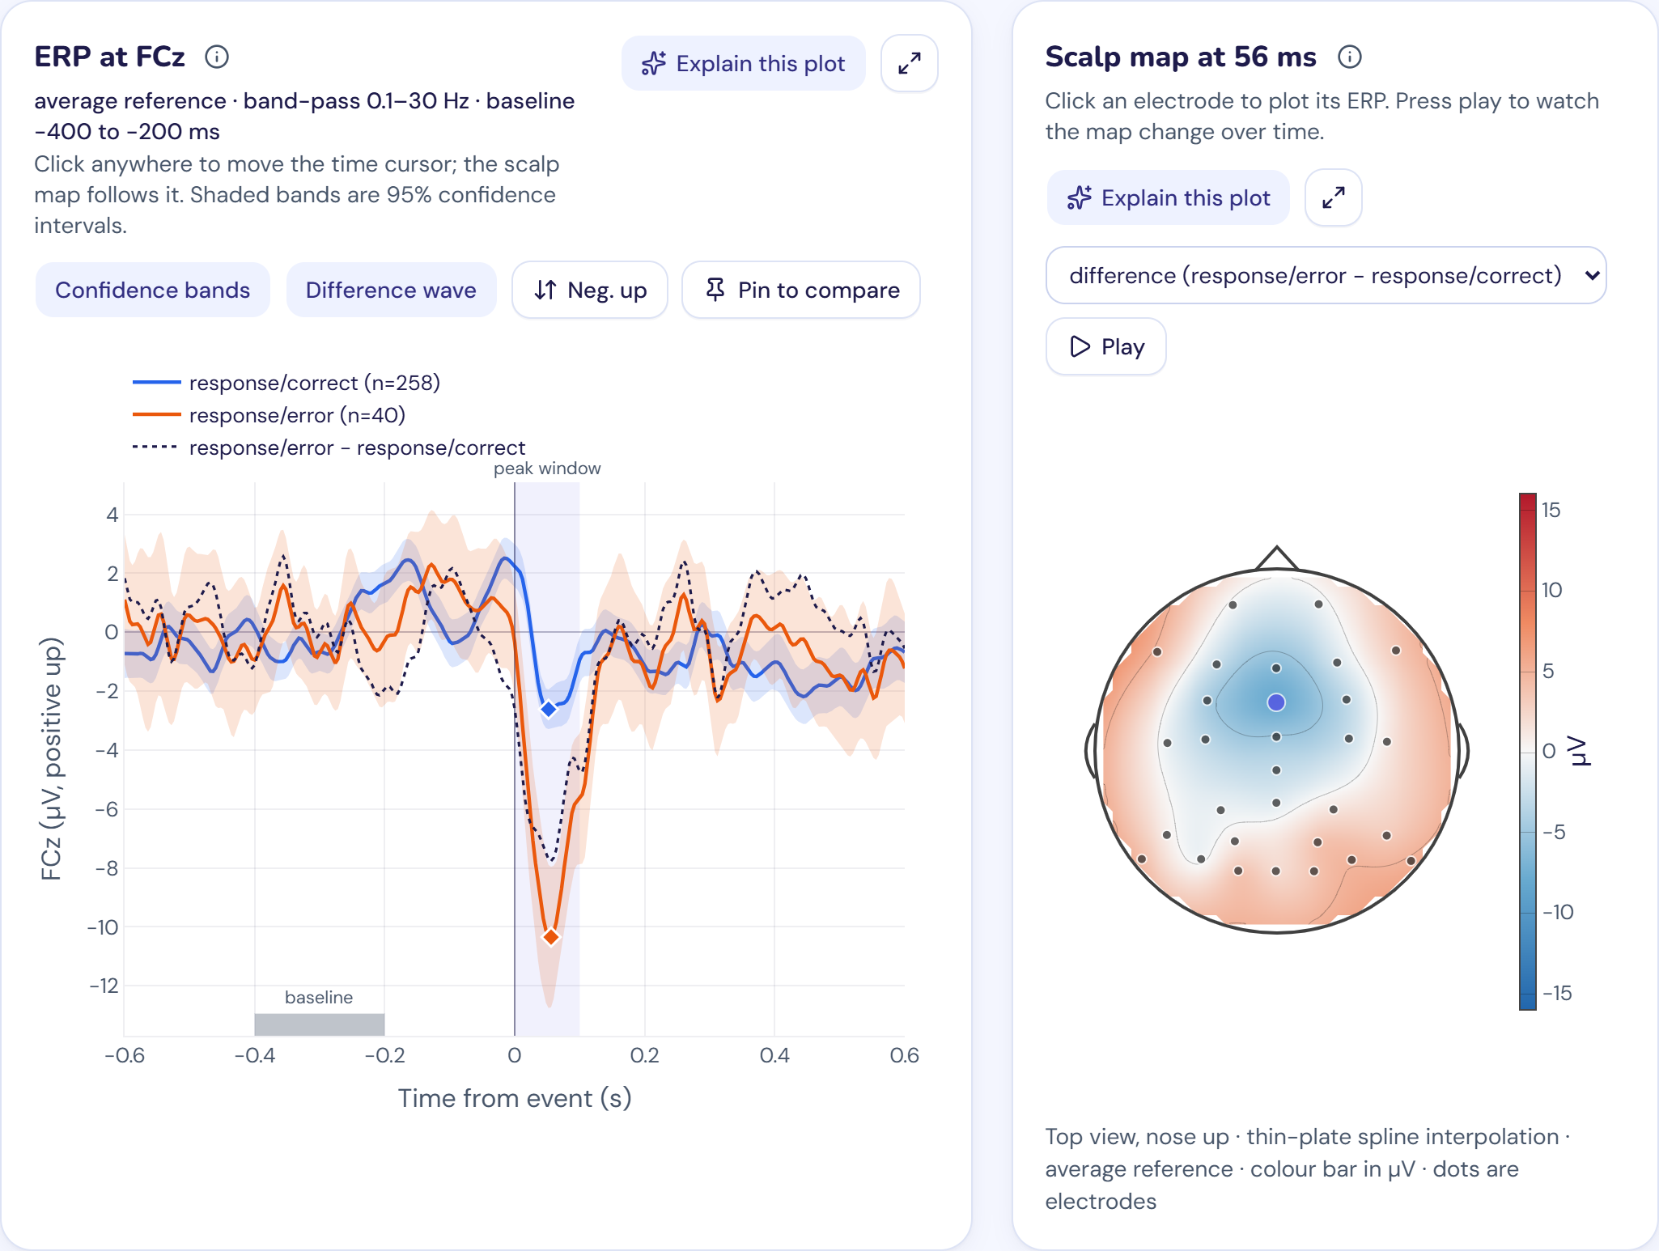
Figure 4. ERN, flanker sample. The error response dips to −10.35 µV at 56 ms, and the difference wave maps to a fronto-central focus.
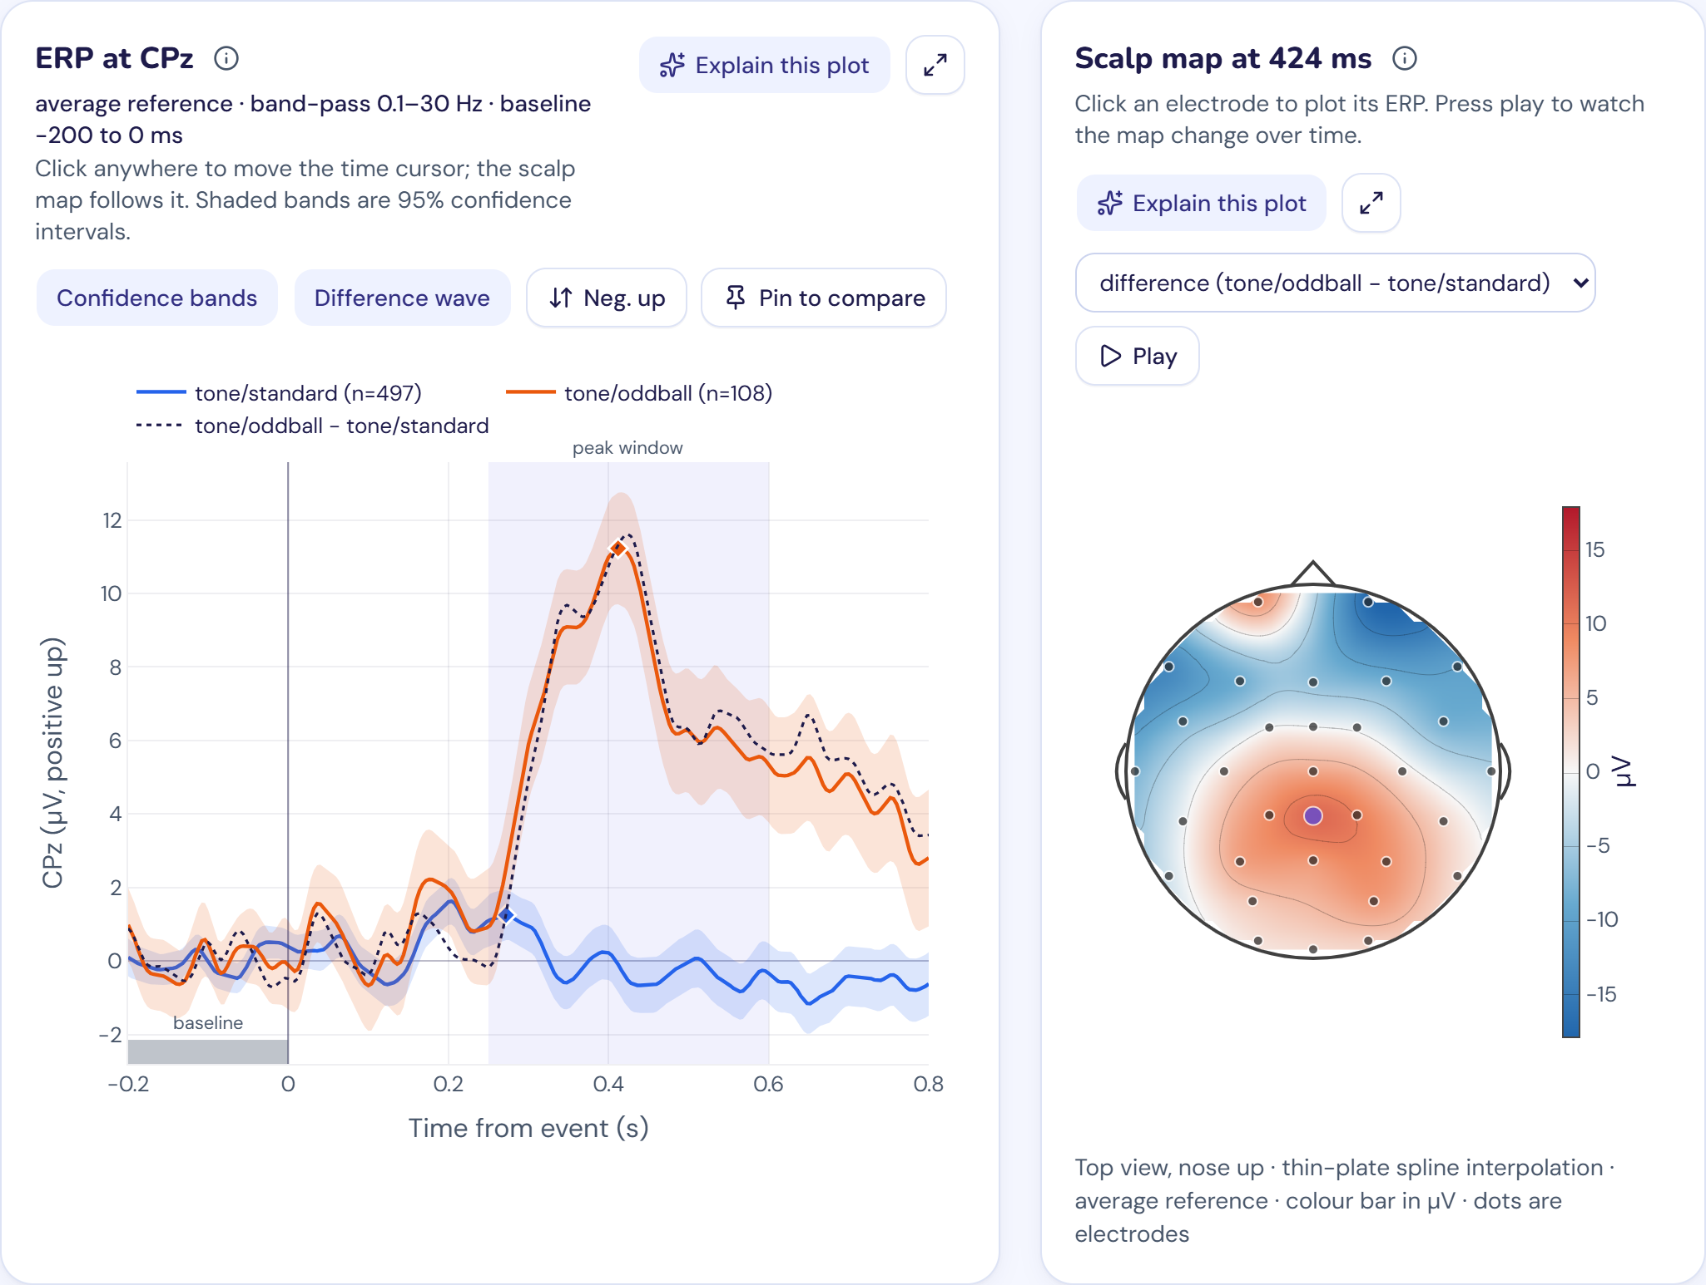
Figure 5. P300, auditory oddball sample. Only the rare target tone produces the large positive wave, peaking at 424 ms in the difference wave.
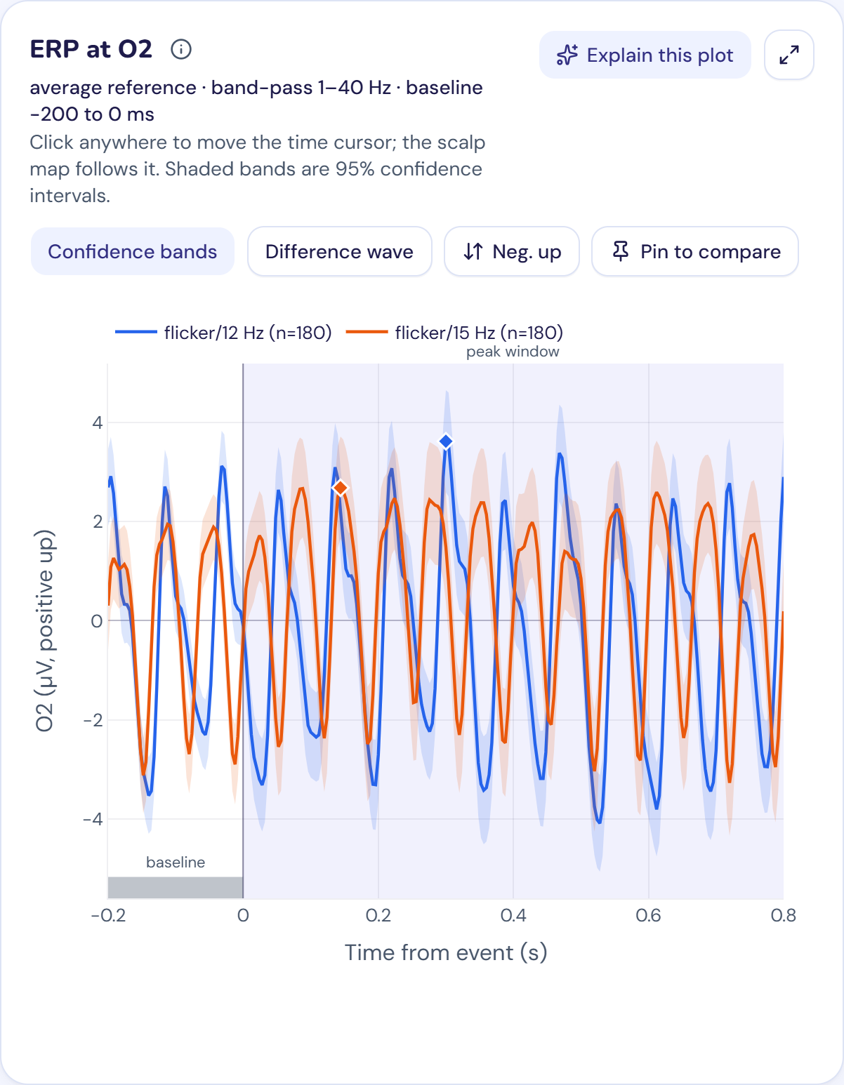
Figure 6. SSVEP sample at O2. The averages keep oscillating at the flicker rate instead of showing one peak.
Interpretation
- ERN: a negative deflection within 100 ms of errors at a fronto-central site, as described in the literature. The r² map independently finds the same channel and time.
- P300: large only for rare target tones and strongest over central-parietal sites near 420 ms; the r² map again agrees. An N1 of −2.54 µV appears at Cz at 120 ms for standard tones.
- Noise bursts: the response peaks earlier and more centrally (Cz, 356 ms) than the target P300 (CPz, 424 ms), the pattern reported for the P3a.
- SSVEP: the average follows the flicker rate, and is several times larger over the back of the head. Peak and mean amplitude are not meaningful for a sustained rhythm, so students are told to count cycles.
- Flanker P3: each condition shows a clear P3, but in this one participant the difference between compatible and incompatible (0.60 ± 0.62 µV) is within measurement error. The incompatible peak is 44 ms later (440 vs 396 ms).

13. Performance and limits
Measured on the development laptop (16 GB RAM).
Measure | Result
/process, new filter settings, flanker sample | 1.61 s
/process, same filter, new threshold (cached) | 0.71 s
Plots catch up after continuous slider movement | About 2 s
Server memory after sweeps on all three samples | About 690 MB
Frontend build | 5.5 MB in total; Plotly 4.5 MB (loaded lazily), app 593 KB, CSS 79 KB

Limit | Value | Where
Upload size | 300 MB | backend/erp_module/api.py
Recording length used | First 20 minutes | backend/erp_module/core/io.py
Resampled if above | 300 Hz, to 250 Hz | backend/erp_module/core/io.py
Sessions in memory | 8 | backend/erp_module/sessions.py
Filtered copies cached | 4 | backend/erp_module/sessions.py
Conditions per analysis | 6 | backend/erp_module/schemas.py
Epoch length | Up to −1 to 2 s | backend/erp_module/schemas.py

14. Running and integrating
pip install -r requirements.txt
python run.py

Then open http://localhost:8000. This needs Python 3.10+ and Node.js 22+. The first run installs the frontend packages and builds the app. Flags: --dev (hot reload, at http://localhost:5173), --rebuild, --host, --port.
Alternative with Docker: docker compose up --build.
For the optional tutor, copy .env.example to .env and add a free GROQ_API_KEY and/or GEMINI_API_KEY.
To run the tests:
pytest

cd frontend && npm test

cd frontend && npx playwright test

Merging into the shared course app. create_app() lets a FastAPI hub mount the module under a path after npm run build:mounted (integration/mount_in_fastapi.py; covered by test_mount.py). A Streamlit hub can embed it (integration/streamlit_embed.py).

15. Security and privacy
- API keys stay in .env on the server, are ignored by git and are never sent to the browser.
- Uploads are written to a temporary folder that is removed after reading; recordings then exist only in memory.
- The tutor receives summaries only, plus a plot image if the student asks for one to be explained. No raw EEG or per-trial data is sent to the LLM providers.
- No login or per-user isolation exists: anyone with a session ID can use that session. This suits a local or classroom tool, but public hosting would need authentication and stricter resource limits.
- No CORS middleware is configured, so browsers block cross-origin calls to the API by default.

16. Limitations and what has not been verified
Item | Status
Tutor with real keys | Tested on 10 November 2026 with six questions in both modes, plot explanation, quiz and grading. Gemini gave correct written answers every time; Groq's gpt-oss-120b sometimes replied with only a suggestion card and twice got the threshold direction wrong, so it is the backup
Docker image | Not run, because Docker is not available on the development machine
Streamlit embed | Not run
Merge into the shared course repository | Not done
Each sample is a single participant | The app demonstrates methods, not group-level findings
Epochs limited to 3 s in total | SSVEP data had to be split into segments
No artefact correction such as ICA | Only rejection is available, so blink-heavy recordings lose many epochs (102 of 400 in the ERN preset)
Filters use MNE defaults | Filter type and transition width cannot be changed
Sessions are in memory | They are lost on restart and limited to 8, which suits a classroom rather than a public service
Peak-based measures on a rhythm | Not meaningful for SSVEP; no frequency-domain plot exists yet

One backend test and one 310 MB upload failed once while two heavy jobs were competing for memory. Neither failure recurred when the job was run alone, in repeated runs.

17. Future work
- Add a frequency view for steady-state data (frontend/src/plots/, backend/erp_module/core/erp.py), so SSVEP can be read from its spectrum instead of by counting cycles.
- Add ICA-based blink correction beside rejection (backend/erp_module/core/processing.py), so students can compare removing epochs with removing artefacts.
- Add group-level samples and grand averages (scripts/make_sample_data.py).
- Let students compare filter types (backend/erp_module/core/processing.py).
- Add accounts and persistent sessions for hosted classroom use (backend/erp_module/sessions.py).

18. Use of AI
Claude Code was used during development for code generation, review, testing and documentation, and all git commits carry a co-author credit for it. The team has reviewed and tested the code and is responsible for explaining it. The AI tutor inside the app is a separate, student-facing feature that calls Groq and Gemini.

19. References
Datasets and methods used in the project
- Blankertz, B., Lemm, S., Treder, M., Haufe, S., & Müller, K.-R. (2011). Single-trial analysis and classification of ERP components: A tutorial. NeuroImage, 56(2), 814–825.
- Cattan, G., Andreev, A., Rodrigues, P. L. C., & Congedo, M. (2019). Dataset of an EEG-based BCI experiment in Virtual Reality and on a Personal Computer. Zenodo. doi:10.5281/zenodo.2605205
- Delorme, A. (2020). EEG data from an auditory oddball task. OpenNeuro ds003061. doi:10.18112/openneuro.ds003061.v1.0.0
- Goldberger, A. L., et al. (2000). PhysioBank, PhysioToolkit, and PhysioNet. Circulation, 101(23), e215–e220.
- Gramfort, A., et al. (2013). MEG and EEG data analysis with MNE-Python. Frontiers in Neuroscience, 7, 267.
- Kappenman, E. S., Farrens, J. L., Zhang, W., Stewart, A. X., & Luck, S. J. (2021). ERP CORE: An open resource for human event-related potential research. NeuroImage, 225, 117465.
- Luck, S. J., Stewart, A. X., Simmons, A. M., & Rhemtulla, M. (2021). Standardized measurement error: A universal metric of data quality for averaged event-related potentials. Psychophysiology, 58(6), e13793.
- Schalk, G., McFarland, D. J., Hinterberger, T., Birbaumer, N., & Wolpaw, J. R. (2004). BCI2000: A general-purpose brain-computer interface (BCI) system. IEEE Transactions on Biomedical Engineering, 51(6), 1034–1043.
- Welke, D., & Tavano, A. SSVEP example data. OSF. doi:10.17605/OSF.IO/7NE6Y

Background for interpreting the components
- Gehring, W. J., Goss, B., Coles, M. G. H., Meyer, D. E., & Donchin, E. (1993). A neural system for error detection and compensation. Psychological Science, 4(6), 385–390.
- Polich, J. (2007). Updating P300: An integrative theory of P3a and P3b. Clinical Neurophysiology, 118(10), 2128–2148.
- Vialatte, F.-B., Maurice, M., Dauwels, J., & Cichocki, A. (2010). Steady-state visually evoked potentials: Focus on essential paradigms and future perspectives. Progress in Neurobiology, 90(4), 418–438.

