HR Desk Ticketing System — C4 Architecture
C4 model: System Context · Containers · Components · Code + runtime view
Attribute | Value
Repository | tarun-emids/hr-ticketing-system
Branch / commit | initial-frontend @ 8b035a4
Generated | 2026-10-05 by the automated test & documentation pass (Claude Code)
Frontend | React 18 · Vite 6 · Tailwind 4 · react-router 6
Backend | Python 3.11 · FastAPI · Supabase-py · Pydantic v2
Data platform | Supabase (managed Postgres + Storage)
Verification | 95 automated tests: 24 unit + 60 API + 11 live integration (all passing)

How to read this document: each C4 level zooms in one step — who uses the system (Level 1), the deployable pieces that make it up (Level 2), the internals of each piece (Level 3) and how the backend modules depend on each other (Level 4). A runtime sequence view shows one real request flowing through every layer.
Diagram colour convention (C4 standard): dark blue = people · blue = in-scope software system · light blue = containers/components inside the scope · grey = external SaaS.

Level 1 — System Context
Two kinds of people use the app. Employees raise HR tickets and answer questions; HR agents triage them. The system itself is one deployable scope (SPA + API). Data lives in an external Supabase project — the only external service in this picture.
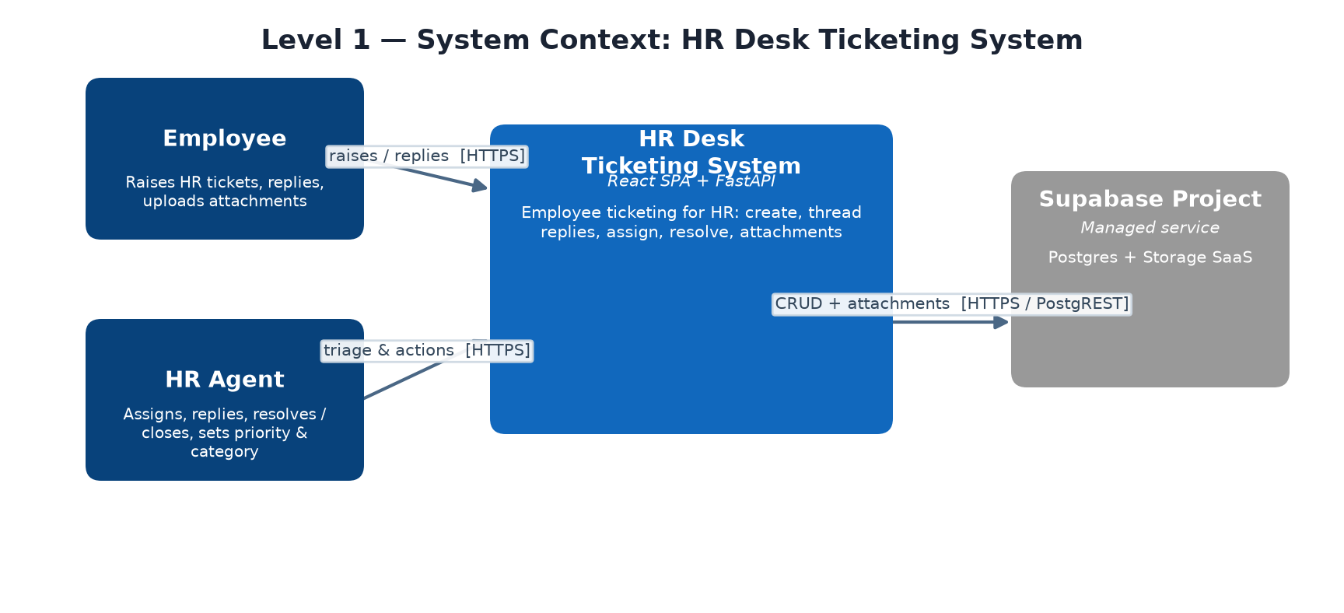
Type | Name | Description
Person | Employee | Raises HR tickets, replies in threads, uploads attachments (max 5 MB)
Person | HR Agent | Triages: assigns to an agent, replies, resolves / closes, sets priority & category
Software System | HR Desk Ticketing System | React SPA + FastAPI backend for HR ticketing; this repository
External System | Supabase Project | Managed Postgres (users/tickets/replies) + Storage (attachment bucket) SaaS

Source | Destination | Relationship | Technology
Employee | HR Desk | Raises / replies to tickets in web UI | HTTPS
HR Agent | HR Desk | Triage, assignment, resolution in web UI | HTTPS
HR Desk | Supabase | CRUD on users/tickets/replies; upload + signed URLs (service_role key, bypasses RLS) | HTTPS / PostgREST

Level 2 — Containers
The repo deploys two containers. The browser runs the SPA and calls the API directly (no SSR/proxy): the base URL comes from VITE_API_URL (default http://localhost:8000/api). Only the FastAPI process talks to Supabase — the SPA never holds credentials. Supabase enforces RLS; the backend uses the service_role key
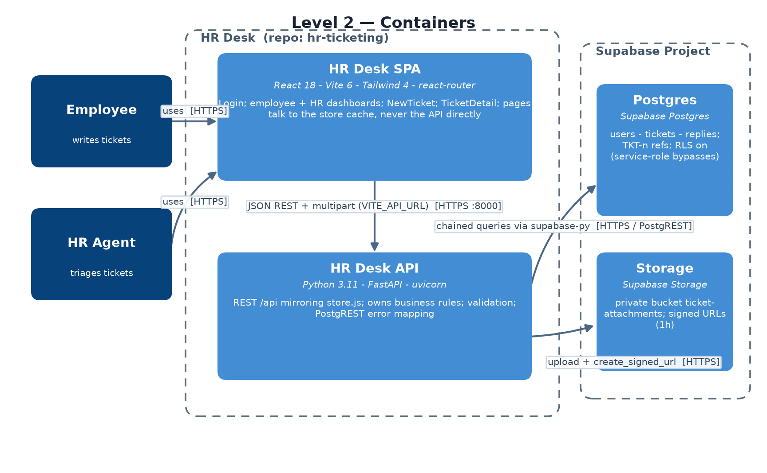
Type | Name | Description
Container | HR Desk SPA | React 18 + Vite 6 + Tailwind 4 + react-router; pages: Login, EmployeeDashboard (/my-tickets), NewTicket, TicketDetail (/tickets/:id), HRInbox (/inbox), HRDashboard (/hr-dashboard); keeps a local cache, pages never call the API directly
Container | HR Desk API | Python 3.11 + FastAPI on uvicorn; REST under /api mirroring src/data/store.js 1:1 (camelCase); owns all business rules; maps PostgREST errors to 4xx/5xx
Data store | Supabase Postgres | users / tickets / replies tables; generated TKT-<n> references (identity starts at 101); updated_at trigger; RLS enabled, only service_role bypasses
Data store | Supabase Storage | Private bucket ticket-attachments; one attachment per ticket at <TKT-n>/<uuid>.<ext>; read back as 1-hour signed URLs

Source | Destination | Relationship | Technology
Employee | HR Desk SPA | Writes & tracks own tickets | HTTPS
HR Agent | HR Desk SPA | Triages and manages tickets | HTTPS
HR Desk SPA | HR Desk API | JSON REST calls + multipart upload (VITE_API_URL) | HTTPS :8000
HR Desk API | Supabase Postgres | Chained queries via supabase-py table builders (eq / is_ / ilike / order / limit) | HTTPS / PostgREST
HR Desk API | Supabase Storage | upload() + create_signed_url() | HTTPS

Level 3 — Frontend components (zoom on the SPA)
Inside the SPA, pages read from a tiny local store with pub/sub and send every mutation to the API through a typed fetch wrapper. AuthContext holds only the acting user (id + role); there is no server auth yet.
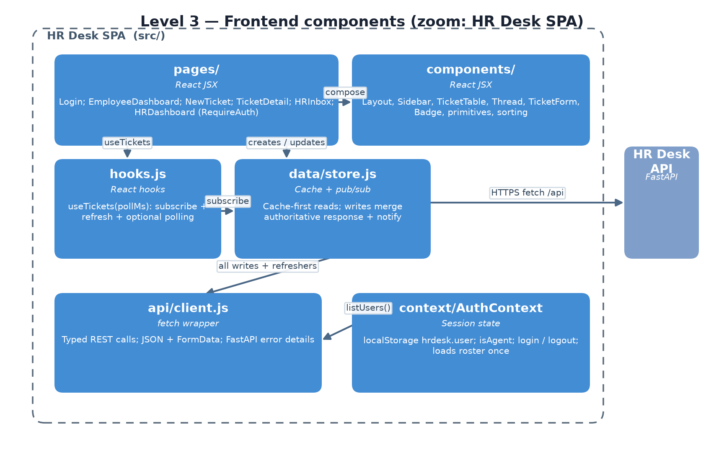
Type | Name | Description
Component | pages/ | Route components: Login; EmployeeDashboard; NewTicket; TicketDetail; HRInbox; HRDashboard — gated by RequireAuth (role-aware redirect)
Component | components/ | Layout, Sidebar, TicketTable, Thread, TicketForm, Badge, primitives, sorting; utils.js
Component | hooks.js | useTickets(pollMs): subscribes to the store, shows cached data immediately, refreshes from API on mount, optional polling
Component | data/store.js | Cache + pub/sub. listTickets()/getTicket() are synchronous cache reads; every write sends to the API, merges the authoritative returned ticket (server stamps statuses) then notifies subscribers
Component | api/client.js | fetch wrapper for every endpoint; JSON bodies camelCase + multipart FormData; converts FastAPI {detail} to readable error strings
Component | context/AuthContext | Loads user roster from GET /api/users at startup; session persisted in localStorage 'hrdesk.user'; exposes user, isAgent, login, logout
Component | data/tickets.js, data/users.js | Legacy mock data from the pre-API demo (kept for reference)

Level 3 — Backend components (zoom on the API)
main.py mounts four routers under /api. Each write endpoint validates input with a Pydantic CamelModel DTO (camelCase aliases = the frontend shape), executes a chained supabase-py query, and returns the full ticket — including its thread — serialized by models.py, so the SPA updates its cache in one round-trip.
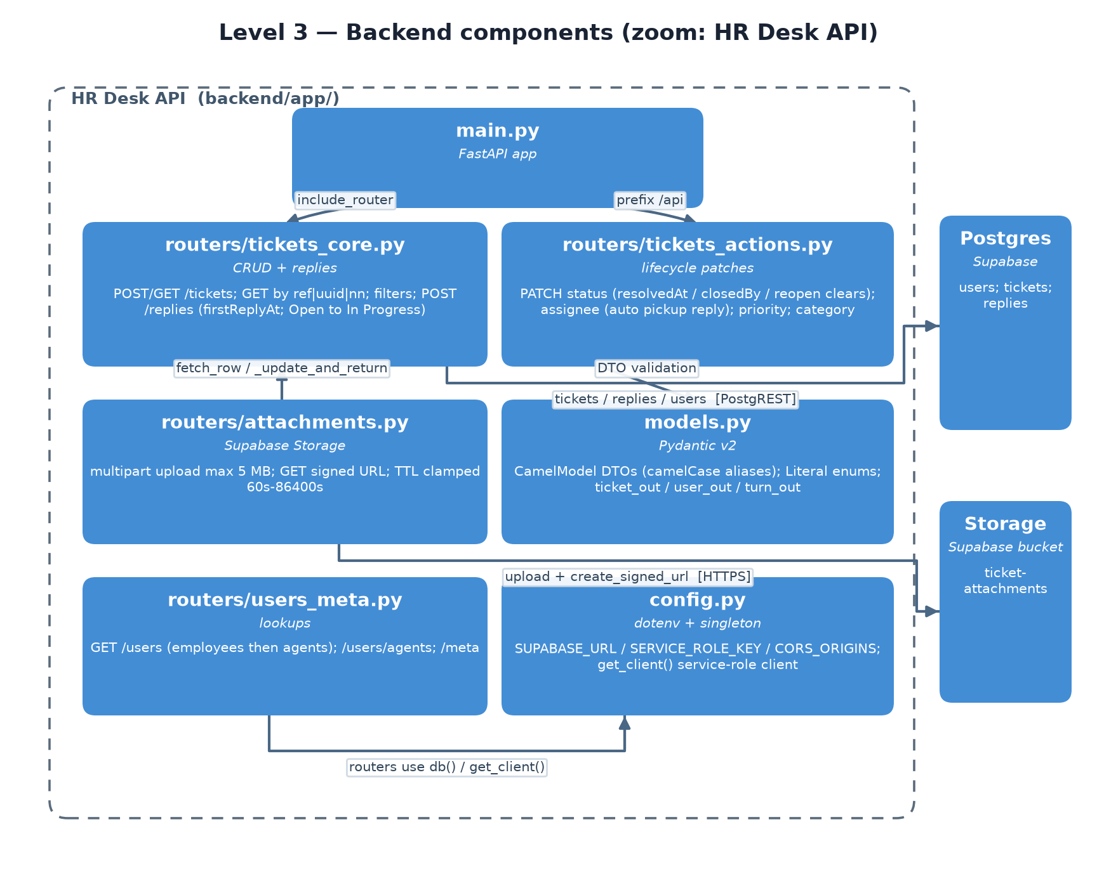
Type | Name | Description
Component | main.py | FastAPI app; CORS from CORS_ORIGINS (default localhost:5173); GET /health; catch-all handler that converts uncaught errors to readable JSON 500
Component | routers/tickets_core.py | POST /tickets (employee-role guard); GET /tickets with filters status/category/priority/employeeId/assigneeId/q/ilike/unassigned/limit; GET /tickets/{TKT-n | uuid | n}; POST /{id}/replies (agent reply stamps first_reply_at once + Open→In Progress; employee reply flips active tickets to Waiting on Employee)
Component | routers/tickets_actions.py | PATCH status (Resolved stamps resolved_at; Closed also records closed_by; reopening clears both); PATCH assignee (assigning an unanswered ticket auto-posts the agent pickup reply); PATCH priority; PATCH category
Component | routers/attachments.py | POST /{id}/attachment (multipart, cap 5 MB → 413, storage failure → 502); GET /{id}/attachment returns a signed URL, TTL clamped 60s–86400s
Component | routers/users_meta.py | GET /users (employees then agents), GET /users/agents, GET /meta (allowed categories / priorities / statuses)
Component | models.py | CamelModel DTOs with alias_generator=to_camel; Literal enums; serializers ticket_out / user_out / turn_out / attachment_out (snake_case rows → camelCase API)
Component | config.py | dotenv settings (SUPABASE_URL, SUPABASE_SERVICE_ROLE_KEY, CORS_ORIGINS, ATTACHMENT_SIGNED_URL_TTL); lazily-created service-role Supabase client singleton

Level 4 — Code (backend module dependency graph)
Dependency direction is strictly downward: routers depend on models and config; never the reverse. Three routers reuse shared helpers from tickets_core (fetch_row, get_user, run, rows_of, _update_and_return) — their PostgREST error mapping is the single place Error → HTTP translation happens (constraint codes 23xxx → 400, everything else → 502).
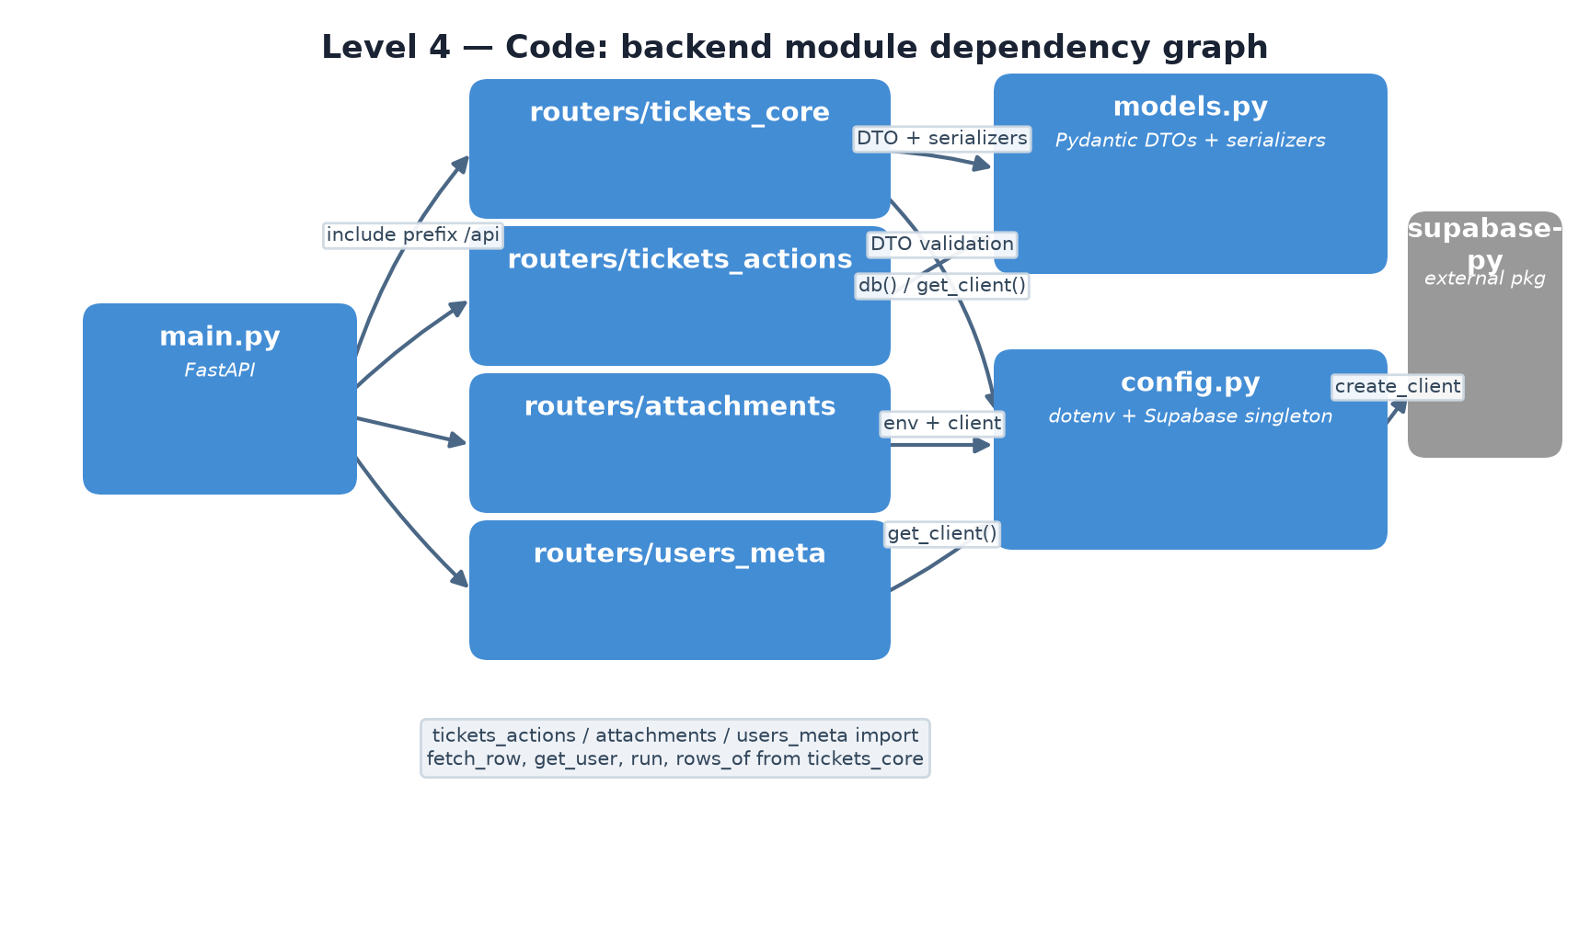
Module | Depends on | Reason
main.py | 4 routers | include_router under /api prefix
tickets_actions | tickets_core | fetch_row / get_user / run / _update_and_return reuse
attachments | tickets_core | fetch_row + _update_and_return
users_meta | tickets_core | rows_of shared execution helper
tickets_core / tickets_actions | models.py | DTO validation + ticket_out serialization
all routers | config.py | db() on the tickets table + get_client() singleton
config.py | supabase-py | create_client(SUPABASE_URL, SERVICE_KEY)

Runtime view — agent replies to a ticket
One round-trip: the caller merges the server response straight into the local cache; every other subscriber re-renders with authoritative data (stamps computed by the API, not duplicated in the UI).
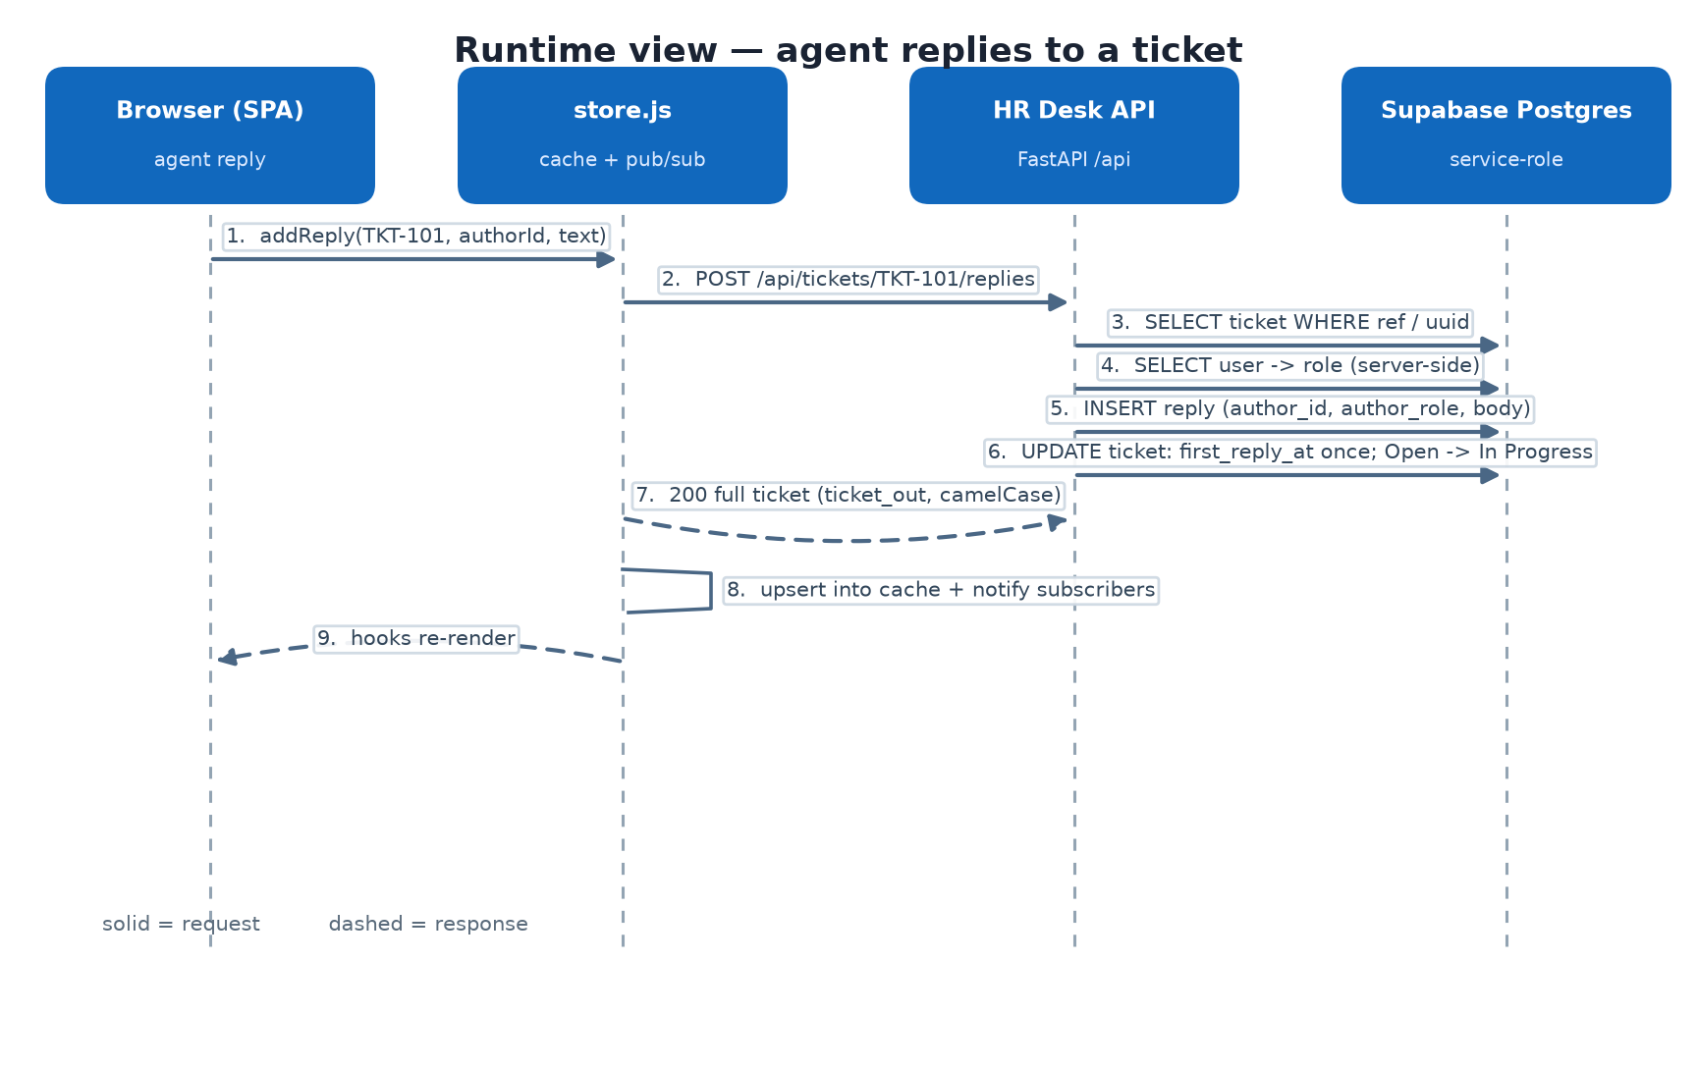
- Agent clicks reply — UI calls store.addReply(TKT-101, {authorId, text})
- store relay → POST /api/tickets/TKT-101/replies
- API resolves the ticket by TKT-<n> reference or Postgres uuid
- API looks the author up and derives their role server-side (never trusts client role)
- API inserts the reply row (author_id, author_role, body)
- API updates the ticket: first_reply_at stamped once; Open → In Progress
- API responds 200 with the full ticket (turns included) in camelCase
- store upserts into the cache (kept sorted by updatedAt) and notifies subscribers
- Subscribed hooks re-render with the merged state

Architecture rules worth remembering
- Contract: endpoint shapes mirror src/data/store.js 1:1 (camelCase) — the SPA layer swap from mock to real API touched no UI code.
- Single writer to the datastore: only the backend talks to Supabase, with the service_role key (RLS bypass by design). Never put that key in frontend code.
- Business rules live in the API: pickup reply on assignment, first_reply_at stamping, Waiting on Employee flips, resolved_at / closed_by semantics, reopen clearing both.
- Identity: the UI address of a ticket is its generated reference TKT-<n> (starts at TKT-101); the Postgres uuid travels alongside for admin/debug.
- All writes return the full ticket incl. thread turns — one round-trip per mutation for cache coherence.
- Attachments: one per ticket, ≤ 5 MB (413 over), replaced on re-upload, private bucket + 1h signed URLs (TTL clamp 60s–86400s).
- Errors: 404 unknown ticket · 413 too large · 422 validation / unknown user · 400 vs 502 mapped from PostgREST codes (23xxx constraint → 400).
- Health: GET /health is liveness only — deliberately does not touch Supabase, safe for probes.

Verification
Sources: docs/c4-architecture.docx (this file) — diagram images from docs/img/*.png, produced by docs/c4_diagrams.py. Interactive HTML version with the same diagrams: docs/c4-architecture.html.

