Assignment – 1
1.
Frontend | Backend | Full Stack
is what users see and interact with on a website — the design, buttons, forms, etc.  Example: The homepage of Amazon — the product images, search bar, and buttons. | is what happens behind the scenes — it handles data, logic, and communication with databases. | means working on both frontend and backend.  Example: A full-stack developer could design the Amazon product page and also write the code that saves your orders to the database.

2.
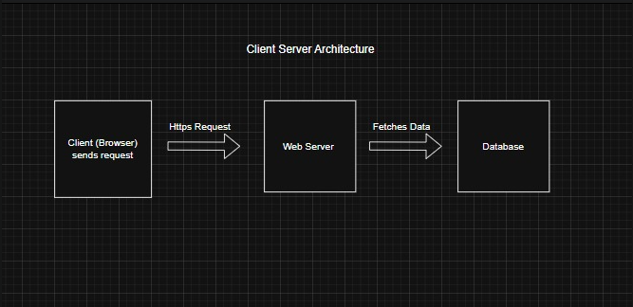
3. You type a web address (like www.google.com).
The browser sends a request to the web server.
The server finds the page and sends back files (HTML, CSS,
JavaScript).
The browser renders those files — showing text, images, and
layout on your screen.

4. VS Code – main text editor to write code.
Web Browser (like Chrome) – to test and view your website.
Node.js (optional) – helps run JavaScript outside a browser for backend work.
Git – keeps track of code changes.
Live Server (VS Code extension) – shows your webpage instantly as you edit.

5. A web server is a computer that stores and delivers web pages to users when they request them.
Examples: Apache, Nginx, Microsoft IIS, and LiteSpeed.

- 6. Frontend Developer: Designs how the website looks and feels.
- Backend Developer: Handles the data and logic behind the website.
- Database Administrator (DBA): Manages the storage, safety, and structure of data in the database.

7. To set up:
- Install VS Code from its website.
- Add extensions for HTML, CSS, JavaScript, and Live Server.
- Open a folder and create .html, .css, and .js files.
- Right-click the HTML file → “Open with Live Server.
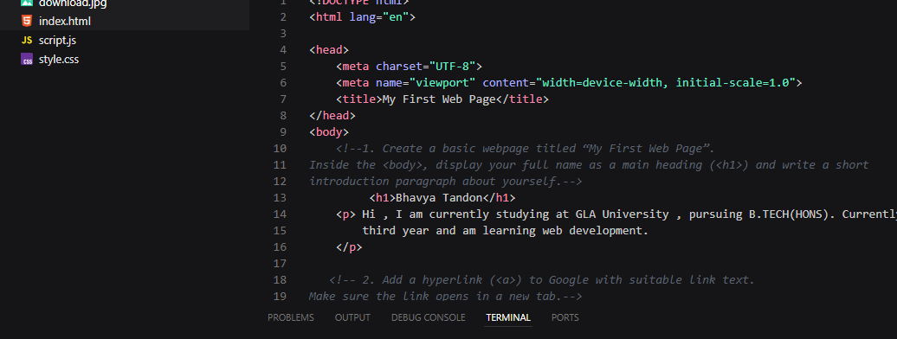

8.
Static Website | Dynamic Website
Same content for everyone; no database connection.  Example: A simple portfolio page. | Content changes based on user input or data.  Example: Facebook — everyone sees different posts.

9.
Browser | Rendering Engine
Google Chrome | Blink
Mozilla Firefox | Gecko
Microsoft Edge | Blink
Apple Safari | WebKit
Opera | Blink

10. 