Selection statements
For three integers, calculate the average of all the non-zero remainders whose quotients are non-zero.
- Without using a loop, input three integers.
- Determine which quotients of the two numbers from the three numbers entered are not zero.
- Include all the non-zero remainders that satisfy the conditions above into the average ($\frac{sum}{count}$).
- If such an average exists, print out the average.
$$\frac{a}{b}=quotient+\frac{remainder}{b}\text{, where }b≠0, quotient≠0,\text{ and }remainder≠0.$$
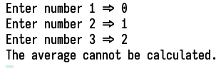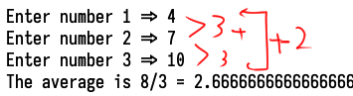

Sentinel Control Loop
For a sequence of non-zero integers, calculate the average of all the non-zero remainders whose quotients are non-zero.
- Using a loop, Input a sequence of integer pairs (a and b) until any integer entered is zero.
- For each pair, determine which quotient of the pairs entered (a and b) is not zero.
- Include all the non-zero remainders into the average ($\frac{sum}{count}$) whenever that condition is true.
- Print out the average if such an average exists.
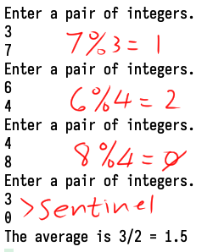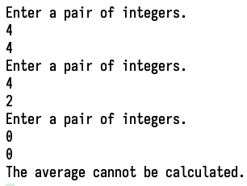

Min, Max, Previous Values
Determine the number of values entered between the maximum number with an increasing last digit and the minimum number with a decreasing last digit in a sequence of non-repeated values entered.
- Enter a sequence of integers until two identical numbers are entered continuously.
- Maximum number with an increasing last digit: find the MAXIMUM of the numbers entered in increasing order when its last digit is in increasing order compared to the previous number.
- Minimum number with a decreasing last digit: find the MINIMUM of the numbers entered when its last digit is in decreasing order compared to the previous number.
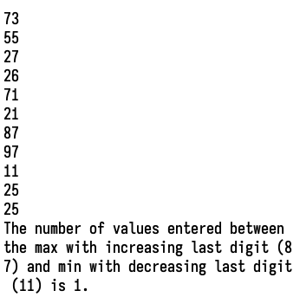
- Print out the number of values (count) entered that lie between these minimum and maximum values if such maximum and minimum points exist in the sequence of numbers entered.
Count | Input | Comment
1 | 73 | First
2 | 55 | Max = 73 (73 is considered here)
3 | 27
4 | 26 | Min = 26
5 | 71
6 | 21 | (same 1 has no effect)
7 | 87 | Max = 87
8 | 97 | (same 7 has no effect here)
9 | 11 | Min = 11
10 | 25
11 | 25 | Sentinel
Count = 1.

