Array 1: Larger Running Averages
Calculate the average of all the numbers greater than their previously running averages.
- Create a function that accepts an integer array.
- The function then calculates and returns the average of all the values that EXCEED the running average of their previous numbers.
  - Previous numbers of a value refer to all the numbers (with a lower index) that occur before that value.
  - Therefore, if a value doesn’t have any previous values, that value will not be considered in the average.
  - The running average of all the previous numbers is calculated by taking the sum divided by the count starting from the first element till the previous element.
- If the function cannot determine any such values, it returns zero.
Input | Output | Explanation
{7, 3, 1, 8, 2, 4, 5, 0, 9}  You should try out other numbers too. | $$\frac{8+5+9}{3}=7.33$$ | Index Item Previous Sum Running Average  0 7 N/A N/A  1 3 7 7.00  2 1 10 5.00  3 8 11 3.67  4 2 19 4.75  5 4 21 4.20  6 5 25 4.17  7 0 30 4.29  8 9 30 3.75
{ 3, 2, 1 } | $$0$$ | There are no values that exceed their previously running averages.
null | $$0$$ | There are no valid values in a null array.
{ } | $$0$$ | There are no valid values in an empty array.
{ 1 } | $$0$$ | 1 has no previously running average.

Array 2: Nested Loop
Create a new array by repeating the values from the original array, excluding one of the smallest numbers each time, while preserving the original order.
- Create a method that accepts an array.
- The method creates and returns a new array newArray that essentially has a length of
$$\frac{array.length×\left(array.length+1\right)}{2}$$
- First, copy all the values from the original array into the newArray.
- Within the nested loop, insert all the previously inserted values, excluding one of their smallest values, into the newArray.
- Iterate through Step 4 until there are no more elements to insert.
- For maximum credit, your time complexity should be $O\left(n^{2}\right)$. The space complexity should be $O\left(n^{2}\right)$ for the result array. Do not create an additional array. Do not sort the array.
Original array | New array | Original array | New array
{ 7, 3, 1, 8, 2, 4, 5, 0, 9 }  Each time, the smallest number is dropped from the sequence. | 7, 3, 1, 8, 2, 4, 5, 0, 9,  7, 3, 1, 8, 2, 4, 5, 9,  7, 3, 8, 2, 4, 5, 9,  7, 3, 8, 4, 5, 9,  7, 8, 4, 5, 9,  7, 8, 5, 9,  7, 8, 9,  8, 9,  9 | 1, 2, 2, 1, 3  Each time, one of the smallest, repeated numbers is dropped from the sequence. | 1, 2, 2, 1, 3,  2, 2, 1, 3,  2, 2, 3,  2, 3,  3
null | null | { 0 } | { 0 }
{ } | { } | { 2, 1 } | { 2, 1, 2 }

Binary Search: Positive Root of a Parabola
Use binary search to approximate the positive root in integer for a given parabola function.
- Create a function named f(x, b, c) that accepts three arguments.
  - Integer x;
  - An integer b;
  - Positive integer c (we will assume positive c, such that $c>0$);
- The function then calculates and returns the integer value from the following equation:
$$f\left(x\right)=x^{2}+bx-c.$$
  - This function produces a parabola.
  - This a concave function because the root of the second derivative of $f\left(x\right)$ is positive, i.e., $f^{''}\left(x\right)=2$.
  - A root refers to the value of x when f(x) = 0.
  - Thus, there are always two calculated roots from the Quadratic formula:
$$\frac{-b±\sqrt{b^{2}+4c}}{2}\text{ when }f\left(x\right)=0.$$
  - Note: This parabola function always has a negative and positive root because the numerator, $-b±\sqrt{b^{2}+4c}$, with $4c>0$ will result in both negative and positive values, thus implying that the root can never be 0.
- Create a second function called “FindRoot” that accepts two positive integers: $b$ and $c$.
- The “FindRoot” function uses the binary search algorithm to find the positive integer root x of the Parabola function by calling the first function $f(x, b, c)≈0$.
- Since we are searching for the positive root, we need to locate the search region between 1 and the high value (since the root has to be positive).
  - To estimate the high value, we’ll iteratively double the search value starting from the value 1 until $f(high)≥0$.
  - This approach ensures that the number of operations remains logarithmic (O(log n)).
- Having determined the high value, use the binary search to locate the integer root that intersects the x-axis.
- Time complexity: $O(log n)$, Space complexity: $O(1)$. Make sure you write some codes to test the cases on the following page.
$$b$$ | $$c$$ | $$f(x)$$ | $$Graph$$ | $$+root$$ | calculated
$$-2$$ | $$3$$ | $$x^{2}-2x-3$$ | 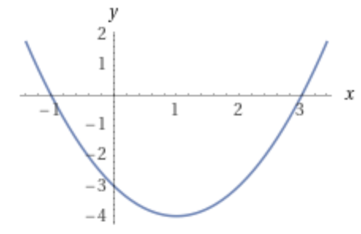 | $$3$$ | $$\frac{2+\sqrt{4+4×3}}{2}=3$$
$$2$$ | $$3$$ | $$x^{2}+2x-3$$ | 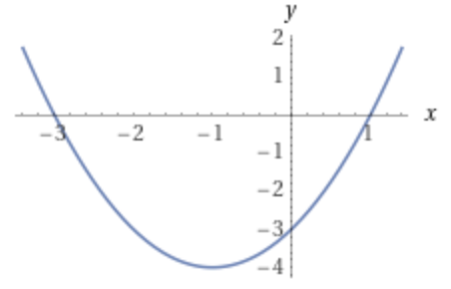 | $$1$$ | $$\frac{-2+\sqrt{4+4×3}}{2}=1$$
$$10$$ | $$75$$ | $$x^{2}+10x-75$$ | 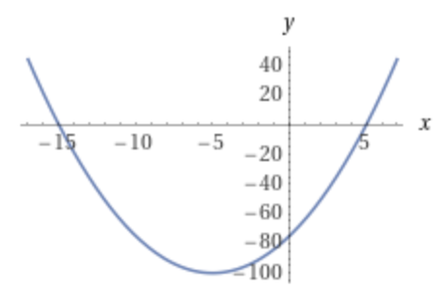 | $$5$$ | $$\frac{-10+\sqrt{400}}{2}=5$$
$$-10$$ | 75 | $$x^{2}-10x-75$$ | 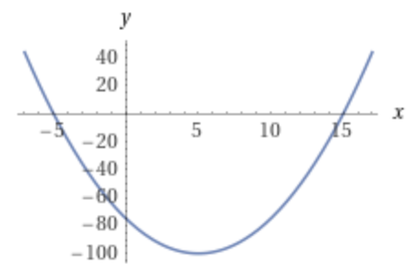 | $$15$$ | $$\frac{10+\sqrt{400}}{2}=15$$
$$-100$$ | $$1000$$ | $$x^{2}-100x-1000$$ | 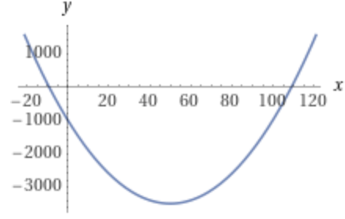 | $$109$$ | $$50+10\sqrt{35}≈109.2$$

