Loop: sum and the largest base-N digit
Determine the sum of all the Base-N digits and the largest Base-N digit in a given integer.
- Create a console application that prompts the user to enter two numbers:
  - Integer (can be positive or negative) and
  - Base-N (must be positive)
- The app should iteratively ensure that the base-N entered is positive, i.e., re-prompt if a negative or zero is entered.
- The app should break down the given integer into base-N digits by repeatedly fetching the remainders as Base-N digits and dividing the integer by N.
- Then, the app then calculates and displays the sum of all these Base-N digits.
- The app also determines the largest Base-N digit and displays it.
Enter an integer  346251  Enter base-N (must be positive)  10  Sum of base-10 digits = 21.  Max base-10 digit = 6. | 6 is the largest digit in 346251 (base-10).  $$3+4+6+2+5+1=21$$
Enter an integer  10  Enter base-N (must be positive)  -3  Enter base-N (must be positive)  3  Sum of base-3 digits = 2.  Max base-3 digit = 1. | The app asks the user to reenter the Base-N because a negative $-3$ is entered.  10 in Base-3 is 101,  so its sum is $1+0+1=2$ and  the maximum digit is 2 here.
Enter an integer  -233573869  Enter base-N (must be positive)  16  Sum of base-16 digits = 79.  Max base-16 digit = 14. | Negative sign in $-233573869$ is dropped, so  $${\left(233573869\right)}_{10}={\left(DEC0DED\right)}_{16}$$  Thus, “E” is the largest hexadecimal digit, which gets translated to 14. And, the sum is  $$D+E+C+0+D+E+D$$  $$13+14+12+0+13+14+13=79$$

Array/Nested Loop: insertion counts
Given an array, build a new array that contains the number of insertions required for each corresponding element in an insertion sort without actually sorting the array.
- Create a method that accepts an array.
- The method returns the count array with the same length as the original array.
- In a nested loop, the method then counts the number of insertions necessary for each element and store them into the count array.
- Please analyze how insertion sort works before implementing it. The solution can be simplified without fully implementing the insertion sort algorithm. You can do it in $O\left(n^{2}\right)$ time.
  - In insertion sort, we compare each element with the ones before it.
  - An “insertion” occurs when we move an element greater than the key element to one position ahead; doing so will create space for the key element.
  - For example, consider the array {1, 10, 23, 5, 2}. To insert the element 5 before the element 10, we need to perform 2 insertions.
    - First, move 23 forward to create space for 5: {1, 10, __, 23, 2}.
    - Second, move 10 forward to create space for 5: {1, __, 10 ,23, 2}.
    - Finally, insert 5 at the correct position: {1, 5, 10, 23, 2}
  - Since we just need to count the number of insertions, we do not need to physically sort these elements.
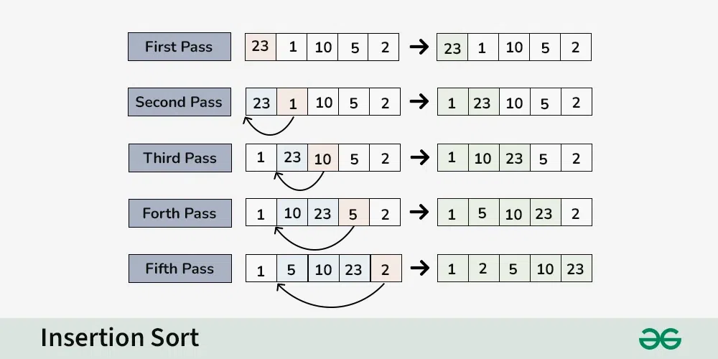
In the example above, for {23, 1, 10, 5, 2} array,
the returned count array will be {0, 1, 1, 2, 3}.

Dictionary: sum of all the largest numbers repeated in every different frequency
Given an array with many repeated values, calculate the sum of all the largest numbers repeated in every different frequency using Dictionaries.
- Create a method that accepts an array as input.
- The method should then count the occurrence of each number in the array and store them into a dictionary.
- Next, the method iterates through the dictionary to identify all the largest numbers for different frequencies.
- Finally, it should sum up all the products of these values with their corresponding frequencies to determine the “sum of all the largest numbers repeated in every different frequency.”
- Return 0 when the input is array is invalid (i.e., null).
- To achieve $O\left(n\right)$ time complexity, we can use two dictionaries: one for counting the occurrences and another for tracking the largest value for different frequencies.
Input Array | Returned Sum
{ 1, 2, 3, 2, 7, 3, 4, 4, 5, 5, 4, 5, 1, 6, 1, 1 }  Occurrence Dictionary  Key Value  1 4  2 2  3 2  7 1  4 3  5 3  6 1 | $4×1$ $+2×3$ $+1×6$ $+3×5$ $=32$  Max Dictionary  Key Value  4 1  2 3  1 6  3 5
null | 0

