1. Create the following tables with the following attributes and constraints on them.
a. Employee (Fname, mname, lname, Ssn, Bdate, address, gender, salary, Super_Ssn,
Dept_num)
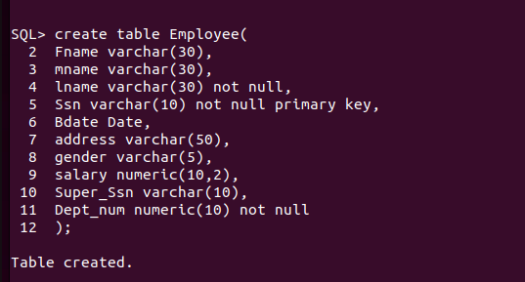

Lname, Ssn, Dept_num should be not null
b. Department (Dept_num, Dept_name, Mgr_Ssn, Mgr_startdate)
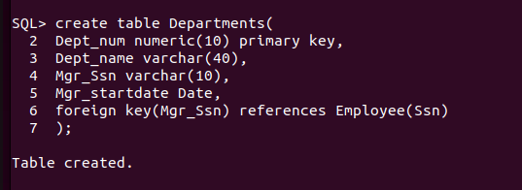
Dept_name should be unique

c. Department_locations (Dept_num, location)
Dept_num and location both are primary key
Dept_num is foreign key
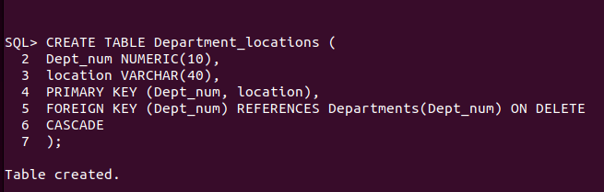

d. Project (Proj_num, Proj_name, Proj_location, Dept_num)
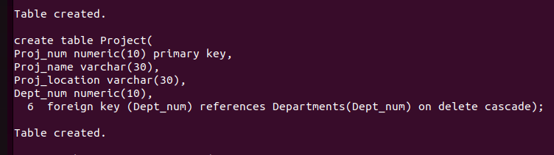

e. Employee_Project (Ssn, Proj_num, Hours)
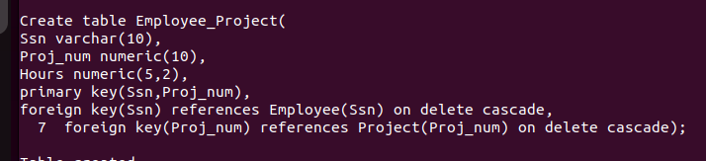

f. Dependent (Ssn, Dept_name, gender, bdate, relationship)
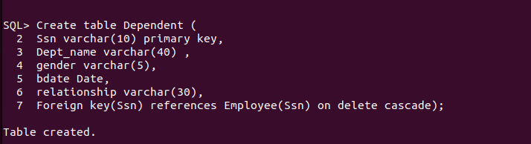

2. Add two column blood group and hobbies to employee table.



3. Increase the size of column blood group to 15 to the employee table.


4. Drop column hobbies from the employee table.



5. Rename Employee Table to Employee_details.


6. Insert atleast five records in each table.
Insertion=
Employee_details;-

Departments insertion-

Department_locations insertion-


Project insetion-



Employee_Project insertion-


7. Give 1000 rupees bonus to each employee.


8. Increase the salary of the employees having salary <5000 by 500 rupees.


9. Give 100 rupees bonus to employees having salary less than 10000 rupees and birth date
before 1990.



10. Give 100 rupees bonus to employees having salary less than 10000 rupees or birth date
before 1990.

11. Give 100 rupees bonus to employees having salary between 1000 to 5000 rupees and birth
date before 1990.

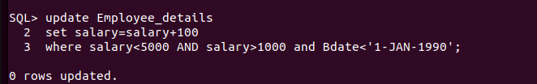

12. Give 100 rupees bonus to employees having salary between 1000, 3000 and 5000 rupees.



13. Update phone number with 0000 where NULL.


14. Give 100 rupees bonus to employees having salary not between 1000 to 5000 rupees and
birth date before 1990.

15. Give 100 rupees bonus to employees having salary between 1000, 3000 and 5000 rupees.

16. Delete from employee the rows having bdate less than 1970.

17. List the name and age of all employees.
18. Display the salaries offered to the employees.
19. List the Bdate and Salary of Employee ‘Smith’.
20. Find the location of Project ‘SUPER’.
21. Find the dependent details of Employee with Ssn number 482928.
22. List the employees having salary > 2000 and bdate before 1/1/1990.
23. List the employees belonging to dept_num 1.
24. List the project details of dept_num 5.
25. List the employee details with their department name.
26. List the employee details with their project names.
27. List the employees belonging to Marketing department.
28. List the project details belonging of Sales department.
29. List the dependent details of employee ‘Smith’.
30. List the various locations of ‘Marketing’ department.
31. List the employees going to ‘Surathkal’ branch.
32. List the employees in the descending order of their salary.
33. List the dependents in the descending order of their names.

