Name: Tarun Dhote
Roll No: 244CA057
Dept: MCA
INSERT
SQL> CREATE TABLE classroom
2 (building varchar(15),
3 room_number varchar(7),
4 capacity numeric(4,0),
5 primary key (building,room_number)
6 );

Table created.

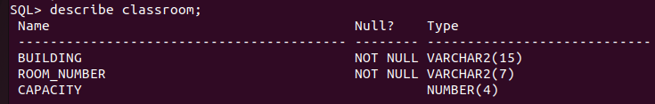
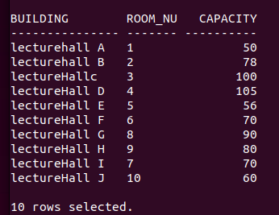
SQL> CREATE TABLE department
2 (dept_name varchar(20),
3 building varchar(15),
4 budget numeric(12,2) check(budget>0),
5 primary key(dept_name)
6 );

Table created.
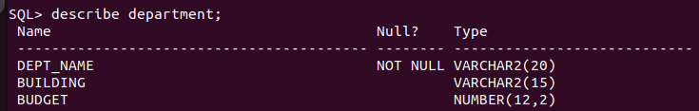
COM
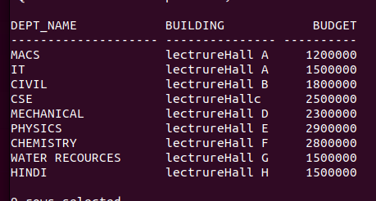
SQL> CREATE TABLE course
2 (course_id varchar(8),
3 title varchar(50),
4 dept_name varchar(20),
5 credits numeric(2,0) check(credits>0),
6 primary key(course_id),
7 foreign key (dept_name) references de_NAMEpartment
8 on delete set null
9 );

Table created.
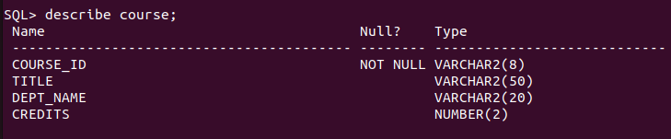
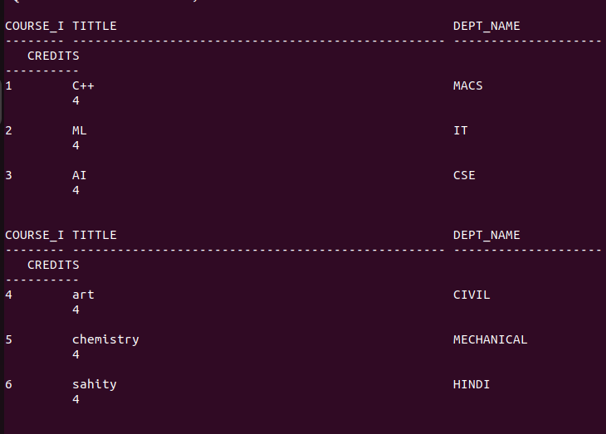
f
SQL> CREATE TABLE instructor
2 (ID varchar(5),
3 name varchar(20) not null,
4 dept_name varchar(20),

5 salary numeric(8,2) check(salary>29000),
6 primary key(ID),
7 foreign key (dept_name) references department
8 on delete set null
9 );

Table created.

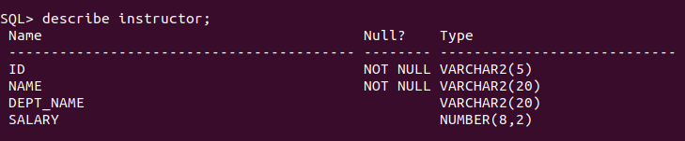
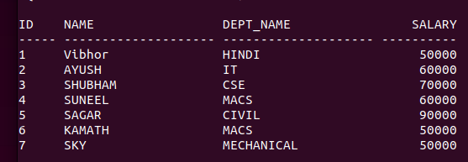
SQL> CREATE TABLE section
2 (course_id varchar(8),
3 sec_id varchar(8),
4 semester varchar(6) check(semester in ('Fall','Winter','Spring','Summer')),
5 year numeric(4,0) check(year>1701 and year<2100),
6 building varchar(15),
7 room_number varchar(7),
8 time_slot_id varchar(4),
9 primary key(course_id,sec_id,semester,year),
10 foreign key (course_id) references course
11 on delete cascade,
12 foreign key (building,room_number) references classroom
13 on delete set null
14 );

Table created.
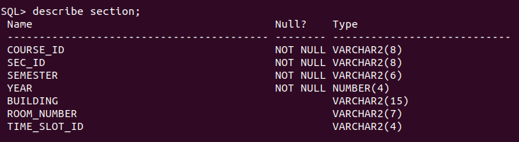

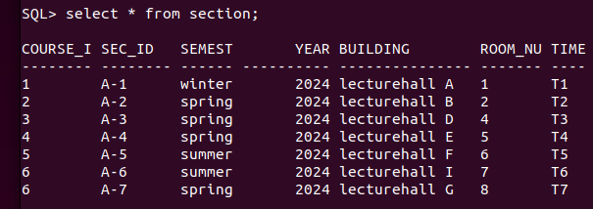
SQL> CREATE TABLE teache

2 (ID varchar(5),
3 course_id varchar(8),
4 sec_id varchar(8),
5 semester varchar(6),
6 year numeric(4,0),
7 primary key(ID,course_id,sec_id,semester,year),
8 foreign key(course_id,sec_id,semester,year) references section
9 on delete cascade
10 )
11 ;

Table created.
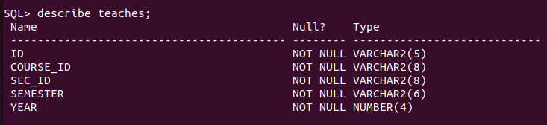
a
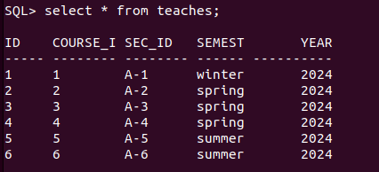
SQL> CREATE TABLE student
2 (ID varchar(5),
3 name varchar(20) not null,
4 dept_name varchar(20),
5 tot_cred numeric(3,0) check(tot_cred>=0),
6 primary key(ID),
7 foreign key (dept_name) references department
8 on delete set null
9 );

Table created.
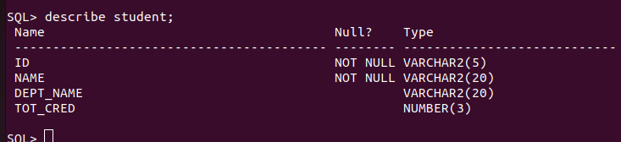
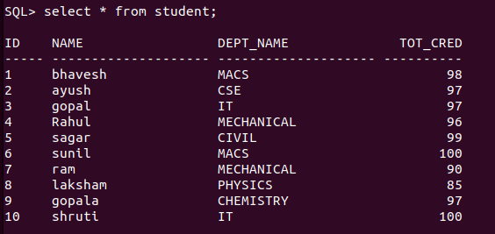
SLE
SQL> CREATE TABLE takes
2 (ID varchar(5),

3 course_id varchar(8),
4 sec_id varchar(8),
5 semester varchar(6),
6 year numeric(4,0),
7 grade varchar(2),
8 primary key (ID,course_id,sec_id,semester,year),
9 foreign key(course_id,sec_id,semester,year) references section
10 on delete cascade,
11 foreign key (ID) references student
12 on delete cascade
13 );

Table created.
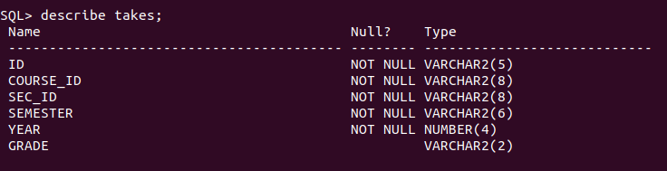
SQL>
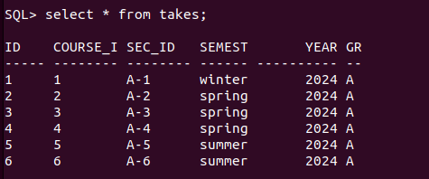

SQL> CREATE TABLE advisor
2 (s_ID varchar(5),
3 i_ID varchar(5),
4 primary key (s_ID),
5 foreign key (i_ID) references instructor(ID)
6 on delete set null,
7 foreign key(s_ID) references student(ID)
8 on delete cascade
9 );

Table created.
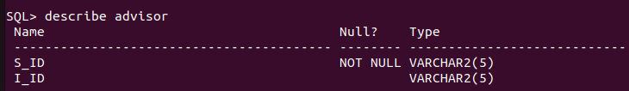
f

SQL> CREATE TABLE time_slot
2 (time_slot_id varchar(4),
3 day varchar(1),
4 start_hr numeric(2) check (start_hr>=0 and start_hr < 24),
5 start_min numeric(2) check (start_min>=0 and start_min<60),
6 end_hr numeric(2) check(end_hr>=0 and end_hr<24),
7 end_min numeric(2) check (end_min>=0 and end_min<60),
8 primary key (time_slot_id,day,start_hr,start_min)
9 );

Table created.
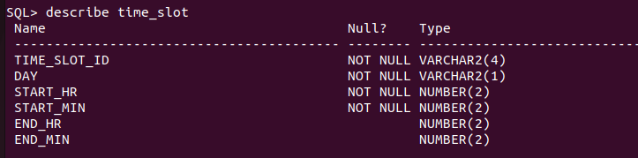
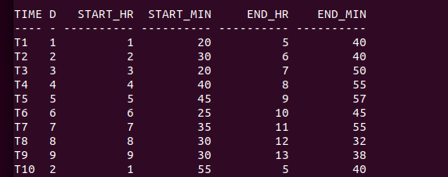
SQL> CREATE TABLE prereq
2 (course_id varchar(8),
3 prereq_id varchar(8),
4 primary key(course_id,prereq_id),
5 foreign key(course_id) references course
6 on delete cascade,
7 foreign key (prereq_id) references course
8 );

Table created.
