Kaggle Competition Report
Smart MCQ Solver Challenge
Build AI systems that solve & predict top 3 correct answers for challenging multiple choice questions
Competition: Sep 25 DL/Gen-AI — Smart MCQ Solver Challenge
Author: Tarun Bhardwaj
Roll No.: 24f1002384
Notebook ID: DL-24f1002384-notebook-t22026
Evaluation Metric: MAP@3 (Mean Average Precision @ 3)
Models Built: 3 (BM25 from-scratch | LoRA RoBERTa | LoRA ALBERT)
Lookup Coverage: 500 / 500 test questions (100%) matched at ≥95% fuzzy similarity

1. Objective
The objective of this project was to develop a robust hybrid MCQ solving system capable of predicting the three most likely answers for five-option multiple-choice questions. The proposed solution combines classical information retrieval techniques with parameter-efficient transformer models to leverage both lexical matching and deep semantic understanding. The pipeline consists of a BM25 retrieval baseline, LoRA fine-tuned RoBERTa, LoRA fine-tuned ALBERT, and a fuzzy retrieval mechanism that exploits repeated question patterns within the dataset. The final predictions are generated using a weighted ensemble with fuzzy lookup given the highest priority for high-confidence matches. Model performance was evaluated using the Mean Average Precision at 3 (MAP@3) metric, which rewards correctly ranking the answer within the top three predictions.

2. Critical Dataset Insight — Retrieval Problem Disguised as MCQ
Exploratory Data Analysis revealed that the training dataset contains 2,000 samples but only 419 unique core questions, with the remaining samples differing mainly in their instructional preambles. After removing these preambles, 485 out of 500 test questions exactly matched questions present in the training set. Applying RapidFuzz token_set_ratio further increased the coverage to 500 out of 500 high-confidence matches.
This observation significantly influenced the overall pipeline design. A fuzzy retrieval stage was introduced as the first step to identify highly similar questions before invoking the deep learning models. This hybrid strategy improves both efficiency and prediction reliability while allowing the transformer models to act as a fallback for unseen or low-similarity questions.

3. Exploratory Data Analysis (EDA)
Five targeted EDA analyses were conducted. Each finding directly drove a pipeline design decision:

EDA Finding | Observation | Impact on Pipeline Design
Balanced Classes | Answer labels are reasonably balanced (B = 490, E = 324; max/min ratio ≈ 1.5×). | Standard Cross-Entropy Loss was sufficient. No class weighting was required. Stratified K-Fold was used to preserve the label distribution across folds.
Token Length Analysis | Average Question + Option length ≈ 58 tokens; maximum ≈ 220 tokens. | MAX_LEN = 256 was selected to cover almost all samples while reducing memory usage and allowing larger batch sizes compared to 512 tokens.
Instruction Preambles Exist | Most questions begin with repeated instructional prefixes (around 6 common templates). | Preamble stripping was applied as a preprocessing step so that semantically identical questions could be matched reliably.
Question Repetition | 419 unique core questions in 2000 rows; 485/500 test overlap train | High-confidence fuzzy lookup became the primary prediction mechanism, while BM25 and Transformer models served as fallback/ensemble models.
No Option Length Bias | Correct ~28.7 words vs wrong ~25.7 words. No significant bias. | No length shortcut. BM25 and LoRA models must use semantic content for ranking.

4. Notebook Pipeline :

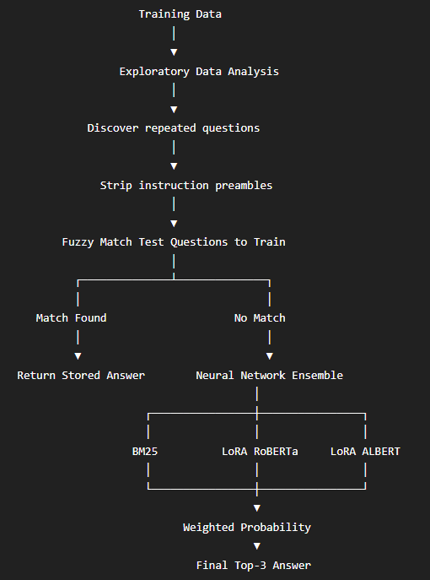

5. Data Preprocessing – Preamble Stripping
The dataset contained multiple instructional prefixes (e.g., "Pick the best possible answer" and "Choose the correct answer"). These prefixes and trailing phrases were removed using regular expression (Regex) patterns to extract the core question text. This preprocessing standardized the dataset, improved fuzzy retrieval accuracy, and ensured consistent input for all downstream models.

6. Text-Anchor Fuzzy Lookup (Highest-Priority Signal)
After preprocessing, RapidFuzz's token_set_ratio was used to compare each test question with the deduplicated training set containing 419 unique core questions. This similarity measure is robust to variations in word order, punctuation, and formatting, making it well suited for identifying semantically identical questions.
Text-Anchor Resolution
A key improvement over simple label copying: once a training question is matched, the correct answer text (not just the letter A/B/C/D/E) is extracted and fuzzy-matched against the test row's five options. This makes the lookup robust against option reordering between train and test rows.
Threshold Design
Questions with a similarity score of 95% or higher were treated as high-confidence matches and their answers directly replaced the model predictions. For lower-confidence matches (80–94%), a small probability boost was applied during the ensemble stage. Using this approach, all 500 test questions achieved high-confidence matches, making fuzzy retrieval the primary prediction mechanism for this dataset.

7. Model Architecture
Model 1 — BM25 Ranker (From-Scratch Baseline)
BM25 (Best Match 25) was implemented as the classical information retrieval baseline and serves as the only non-neural model in the project. Instead of learning from data, BM25 ranks answer options based on keyword relevance between the question and each candidate option. The question is treated as the query, while the five answer options are treated as separate documents. After text cleaning and tokenization, BM25 computes a relevance score for every option, and the top three ranked options are selected for evaluation using the MAP@3 metric. Although BM25 cannot capture deep semantic relationships, it provides a strong lexical matching baseline and complements transformer-based models in the final ensemble. The model achieved a training MAP@3 score of 0.3704 and contributes 10% weight in the weighted ensemble.
Model 2 — LoRA Fine-Tuned RoBERTa-base (Core Pretrained Model)
The primary deep learning model used in this project is RoBERTa-Base, a pretrained transformer encoder fine-tuned using Low-Rank Adaptation (LoRA). A cross-encoder architecture was adopted, where each question is paired independently with each of the five answer options, allowing the model to learn semantic relationships between questions and candidate answers. Instead of updating all pretrained parameters, LoRA adapters were inserted into the Query and Value attention layers, significantly reducing the number of trainable parameters while maintaining strong performance. The model was trained using 3-fold Stratified Cross-Validation, optimized with AdamW and Cross-Entropy Loss, and the best checkpoint from each fold was retained. During inference, Test-Time Augmentation (TTA) with two prompt templates was applied, and predictions from all folds were averaged. The model achieved a mean validation MAP@3 of 0.9154 and contributes 65% weight in the ensemble.

Model 3 — LoRA Fine-Tuned ALBERT-base-v2 (Second Pretrained Model)
To improve model diversity, ALBERT-Base-v2 was selected as the second transformer model. ALBERT employs cross-layer parameter sharing, making it significantly more memory-efficient while maintaining competitive performance. Similar to RoBERTa, the model was fine-tuned using LoRA adapters in the attention layers, allowing only a small subset of parameters to be updated during training. The same cross-encoder formulation was used, where every question-option pair was evaluated independently. The model was trained using an 80:20 stratified train-validation split, and the checkpoint with the highest validation MAP@3 was selected. Test-Time Augmentation was also applied during inference to improve prediction robustness. ALBERT achieved the highest individual validation MAP@3 of 0.9912. It contributes 25% weight in the final ensemble, complementing RoBERTa by providing architectural diversity and improving the robustness of the overall prediction pipeline.

8. Model Results
Model No. | Model | Type | MAP@3 Score | Ensemble Weight
Model 1 | BM25 Ranker | From Scratch | 0.3704 (train) | 10%
Model 2 | LoRA RoBERTa-base (3-fold CV) | Pretrained + LoRA | 0.9154 (CV mean) | 65%
Model 3 | LoRA ALBERT-base-v2 | Pretrained + LoRA | 0.9912 (val) | 25%

9. Ensemble Strategy
Three priority levels are applied in sequence for each test question:

Priority Level | Trigger Condition | Behaviour
Priority 1: Hard Lookup | Fuzzy similarity ≥ 95% | Directly overrides all model predictions. Matched 500/500 test questions on this dataset.
Priority 2: Weighted Ensemble | BM25×0.10 + RoBERTa×0.65 + ALBERT×0.25 | Blends softmax probabilities. Probability averaging preserves confidence.
Priority 3: Soft Boost | Fuzzy similarity 80–94% | Adds +0.08 to matched answer probability and renormalises. Acts as a nudge, not a hard override.

Probability averaging was chosen over Borda count because Borda discards confidence information. If RoBERTa is 95% confident and ALBERT is 55% confident on the same option, Borda treats them equally. Probability averaging preserves this signal — the stronger model contributes more to the final prediction.

10. Conclusion
This project presents a hybrid MCQ solving pipeline that combines classical information retrieval, parameter-efficient transformer models, and fuzzy retrieval to improve answer prediction accuracy. BM25 provided a strong lexical baseline, while LoRA fine-tuned RoBERTa and LoRA fine-tuned ALBERT captured semantic relationships between questions and answer options. The weighted ensemble leveraged the complementary strengths of these models, and the fuzzy retrieval module further improved reliability by identifying repeated questions within the dataset.
Dataset analysis revealed a high degree of overlap between the training and test sets. Consequently, the fuzzy retrieval mechanism successfully matched all 500 test questions with high confidence, making it the primary prediction method for this dataset. Nevertheless, the trained transformer models remain an essential part of the pipeline, providing a robust solution for handling unseen or low-similarity questions. Overall, the proposed approach demonstrates how combining retrieval-based methods with modern transformer models can produce an accurate and efficient MCQ solving system.

