*SLOPE AND SIMPLE MOVING AVERAGE ALGORITHM*

____________________________________

* Algorithm Information:
  + - I used a mixture of slope and SIMPLE moving average as the parameters for making BUY/SELL predictions .
    - How slope is calculated :

slope is first calculated using POLYFIT across 10 consecutive values so as to get the accurate slope value and to capture the exact movement of the curve . This gives the slope (tanx) in terms of radian .

To make this in terms of degree for our algo or for easier understanding , we take the tan inverse of the slope obtained in radians.

Things to work on : Finding some way to normalise these slope values for different stocks as they tend to differ across stocks which make it difficult to use algorithms on across different scrips.

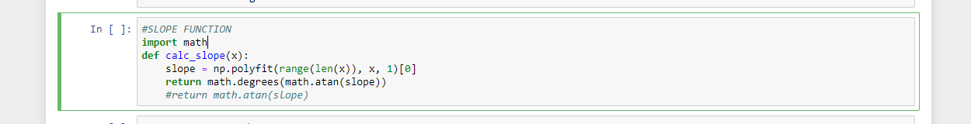

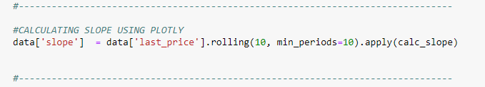

* + - What moving average was used :

A 9 minute moving average was used . 21 minute moving average was tried on the data and observed , however the 21 minute moving average was not used finally as it does not capture the true essence of the live price closely and would be better suited to a longer interval for making decisions ; for example if we were planning to observe data across months.

Hence 9 minute moving average was selected as we were observing data every minute (high frequency trading ) and moreover captured the movement of the stocks better than the 21 minute moving average .

Things we could try : Getting the intersection of a longer moving average and shorter moving average could possibly give more accurate buy/sell predictions.

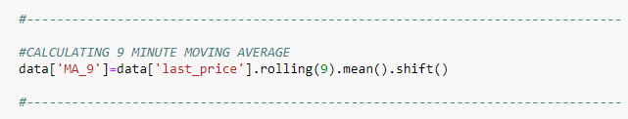

* + - How the condition for BUY/SELL was made :

A combination of thresholds of moving average and slope was given in the following format :

1. CONDITIONS FOR BUY CYCLE

* Both of these conditions have to be satisfied for BUY transaction to occur
  + - * + If the percentage difference of the LAST_PRICE and 9 MINUTE MOVING AVERAGE was greater than or equal to 0.3
* Why this is under BUY cycle is because if the last price is going higher than our moving average line it means that our stocks is doing greater than expected and hence its probably a better option to BUY at this point in time.
  + - * + If the slope at that minute was greater than or equal to 2.
* If the slope is positive in general in means that our stocks are rising with respect to time and hence slope was taking into consideration as it helps in providing a more accurate transaction.
* This was a good threshold that was observed also on applying different other slopes as threshold.

1. CONDITIONS FOR SELL CYCLE

* Both of these conditions have to be satisfied for SELL transaction to occur
  + - * + If the percentage difference of the LAST_PRICE and 9 MINUTE MOVING AVERAGE was lesser than -0.3
* Why this is under SELL cycle is because if the last price is going below the trend of the moving average , our stocks are probably doing worse than predicted or expected and its probably better to SELL at that point .
  + - * + If the slope at that minute was lesser than -2
* If the slope is negative it generally means that the stocks or the line has a downward trend or is in DECLINE , which is not good an hence it is better to SELL
  + - Miscellaneous added details in the algorithm for effective transactions :
* A simple condition was given where if the profit is not obtained from a transaction , that transaction is not allowed to go through
* PREVENTING TRANSACTIONS FROM OCCURING AT THE START OF THE DAY(approx. 15 minute interval )

A condition was given to prevent transactions from 9:15am – 9:32am as when the last price move from one day to another , the price has a difference and hence the moving average is not able to capture this exact change and thinks a huge difference is occurring and predicts buy/sell which is wrong.

* DEALING WITH STOPPING OF CYCLES AT THE END OF THE DAY:

From 2:45pm a loss of 0.5 is allowed

From 3:00pm to 3:05pm a loss of 1 is allowed

From 3:05pm to 3:10pm a loss of 1.5 is allowed

* Above 3 points were implemented so that we do not get huge losses while implementing the hard stop

HARD STOP : If by 3:10pm the cycle is still not closed a condition is given at 3:10pm where a hard stop occurs and the cycle is closed . Here Hard Stop is allowed till 3:13pm in case there is reading/data discrepancies .

EMERGENCY STOP: In case of any data discrepancies or reading errors; an emergency stop is placed so that the the cycles END on that day

___________________________________________________________

* **VARIABLES USED**
* last_action : Basically quantity ; it contains the value of the last transaction made . So every time buy is made quantity+=1 , every time sell is made

quantity-=1

* last_sell : Stores the price of last sell or last buy made and helps in calculating the profit.
* last_pab : Used in calculating the cum_pab values
* count : Used to pass the transaction rows to the algorithm to predict buy/sell only after 20 rows have passed . why 20 ? First 10 is not useful as 9 minute moving average is calculated and 10 null rows appears . Next 10 is not exactly useful as the moving average and slope has not exactly captured the true nature of the last price and hence gave transactions at the start of the day which were not useful. Hence if a count of 20 has passed , transactions are allowed.
* x_bar : stores the cum pab values at the end of the day , used for plotting
* y_bar : stores the dates which is used for plotting
* loss_no : This works in tandem with the allowing of transactions of max loss of -0.5 towards the end of the day and doesn’t allow more than 1 such transaction
* action : stores ‘BUY/SELL’ which is passed in a tuple and added to the transaction table
* quantity: stores the quantity of the transaction and passed in the tuple to the transaction table
* profit : stores the current profit and is passed in the tuple to the transaction table
* brokerage : contains the value of brokerage of the transaction and is passed in the tuple to the transaction table
* pab : contains the profit after brokerage of the transaction and is passed through the tuple to the transaction table
* cum_pab : contains the cumulative profit after brokerage and is passed through the tuple to the transaction table
* slope : contains the value of slope of the transaction and is passed to the general live table on running

____________________________________________________________

* **Results :**
* An example of how the transaction and general data table appear on running it live ( on RELIANCE )

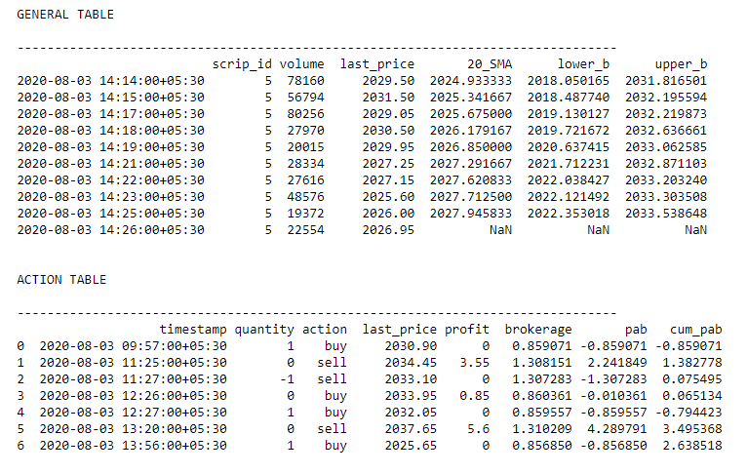

* I ran the data from 2020-08-03  till

2020-08-24 on REC14 scrip

* Note : There is some issue with my laptop where while reading the live data from the updated csv file few rows get missed and hence few key timestamps are missed which resulted in the loss of few graphs for the days , the transactions are made from those days but however the graphs are not available due to certain missed rows. If you run my algo on you’re system it will work perfectly and you will be able to see the graphs for every day!
* This is the last price with buy/sell tickers on few days of the month
* The red tickers indicates SELL
* The green tickers indicates BUY

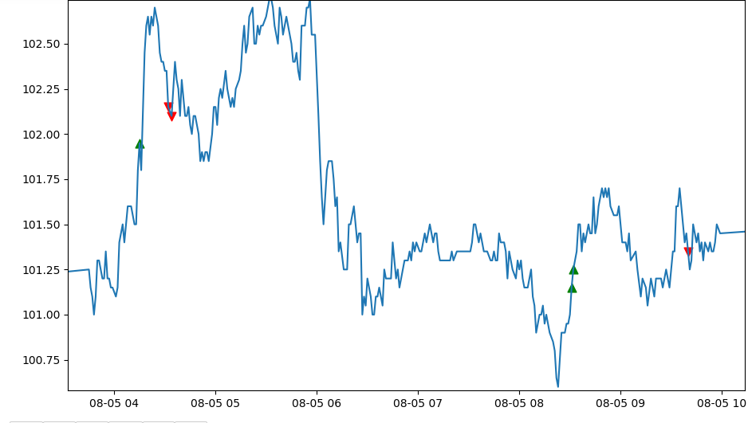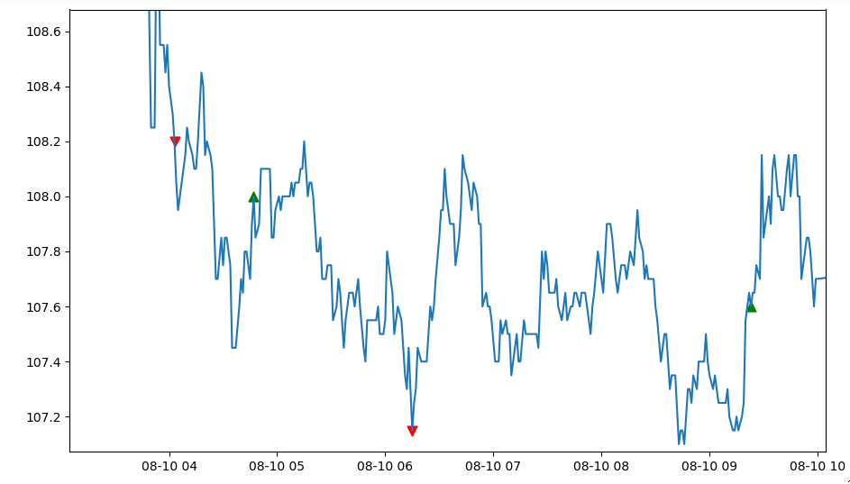

* The graph below is an example of the cum_pab graphs I obtained on running my algorithm on multiple days
* The sum of all cum_pabs for all the days (shown on the graph)gave me a total loss of -2.82

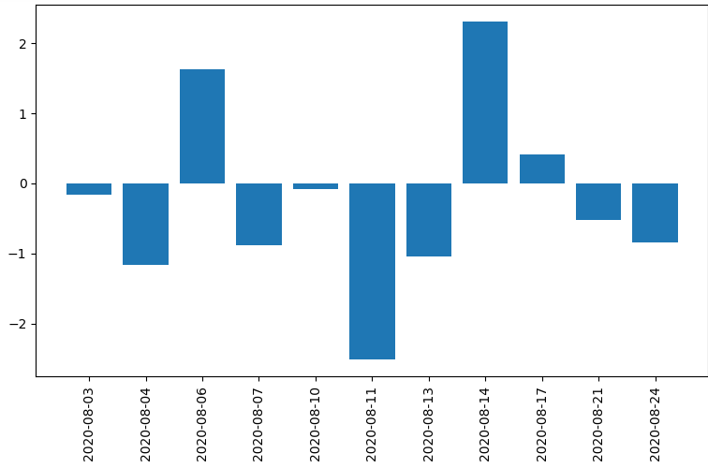

* **Types Of Scrips It works on**
* Works perfect for ***REC14*** however, do not get many transactions as this method doesn’t churn profits , hence we usually complete our transactions at the end of the day when little losses are allowed.
* The percentage difference condition between the 9 minute moving average and last price works across ***ALL SCRIPS***.
* The slope parameter has to be changed based on the scrip as each scrip has its own unique slope value ranges ( should try normalising this somehow )

_____________________________________________

* **REMARKS**
* This is a very basic algorithm used on live data , so its better to think of a more accurate way to predict buy/sell
* Combination of slope and simple moving average has good potential for certain parameters.

____________________________________________________________