1614027_Tarun_Day2_Assignment

A ) GIT

create two separate branches from master

make changes in same function of source code in both branches.

merge branch1 into master

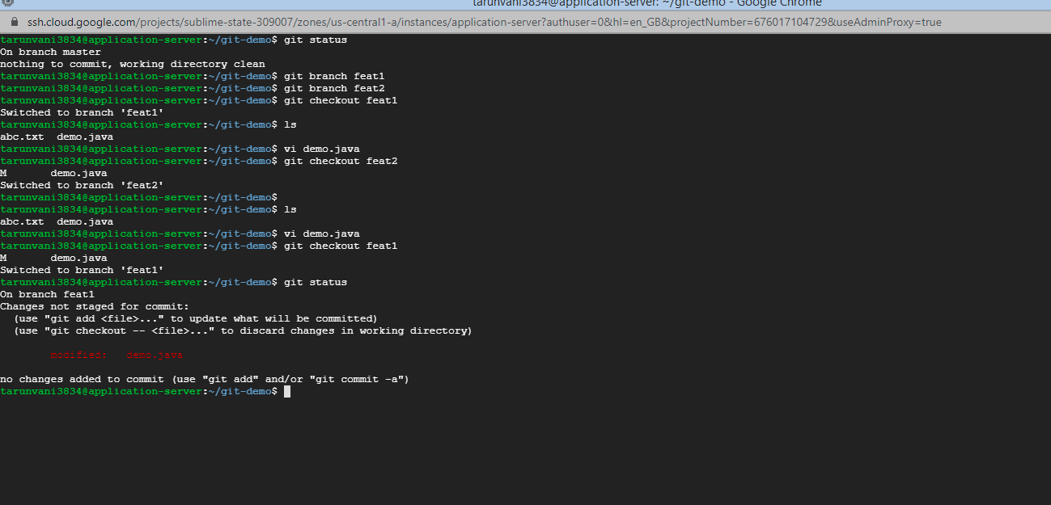

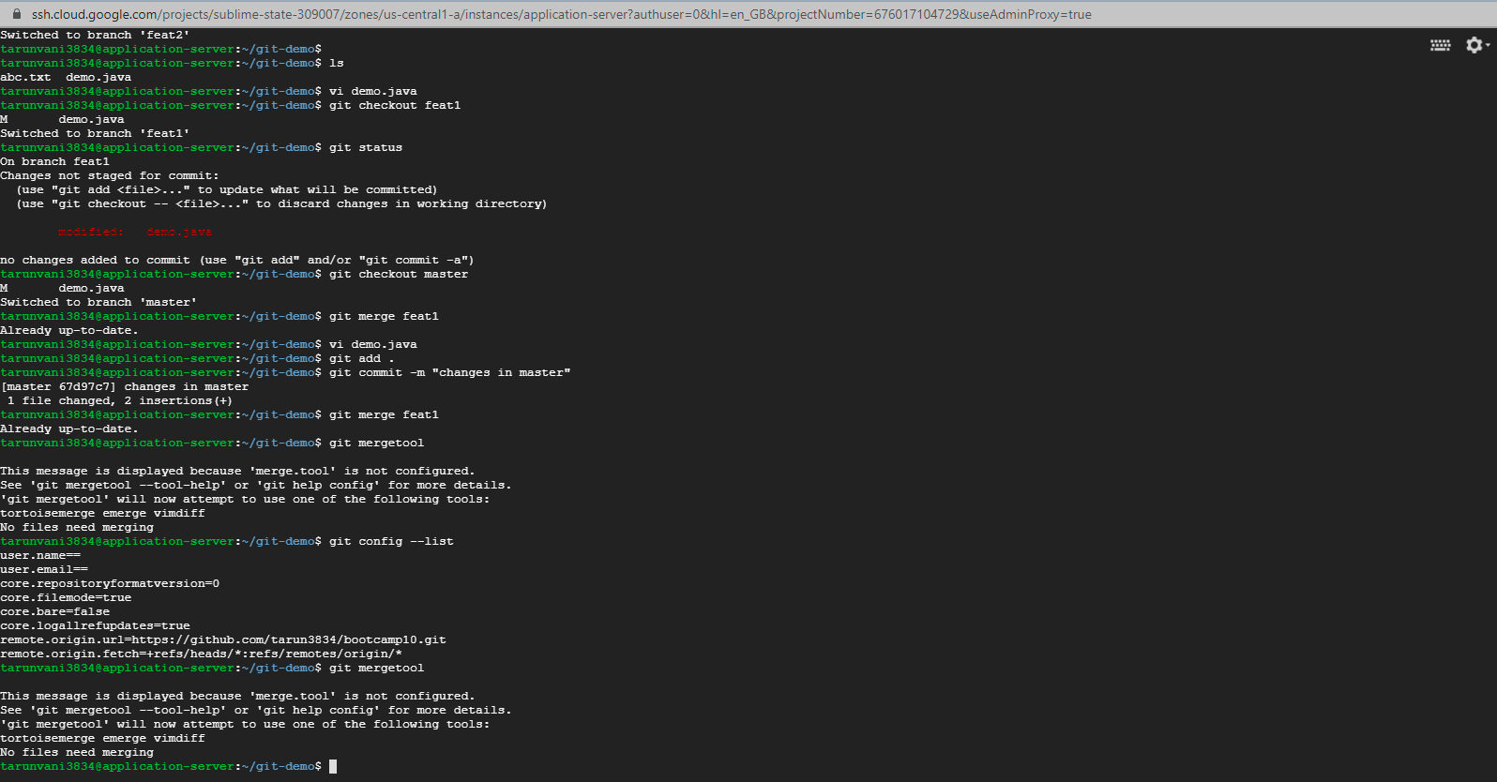

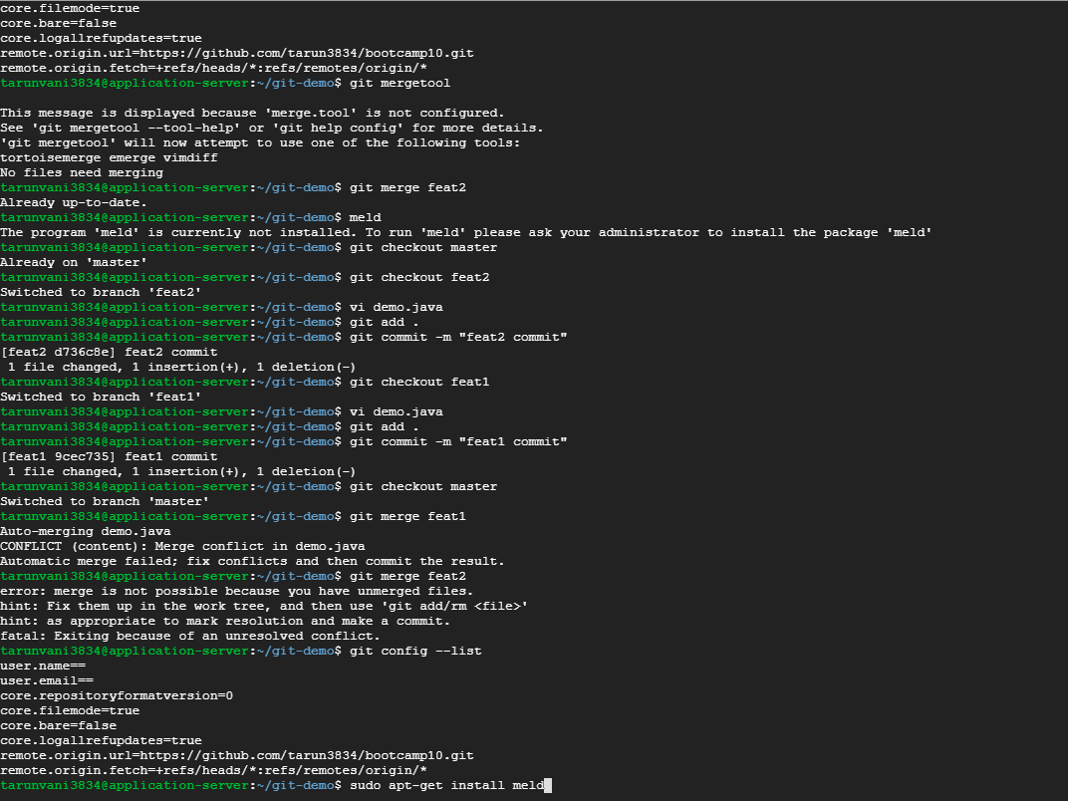

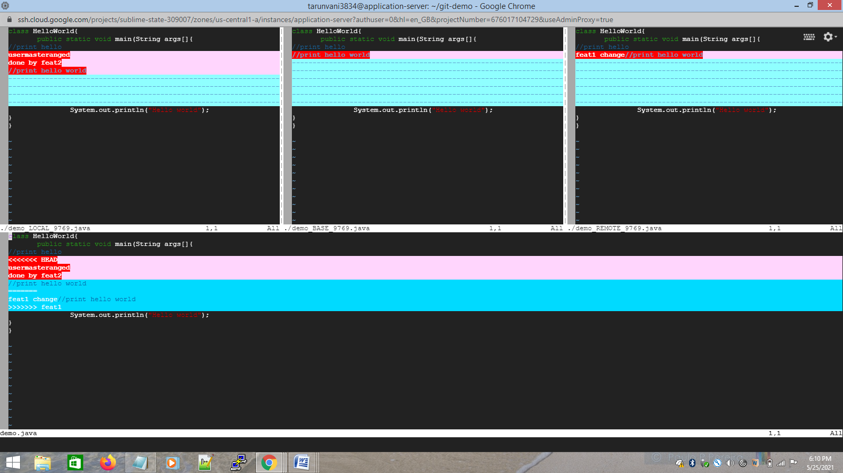

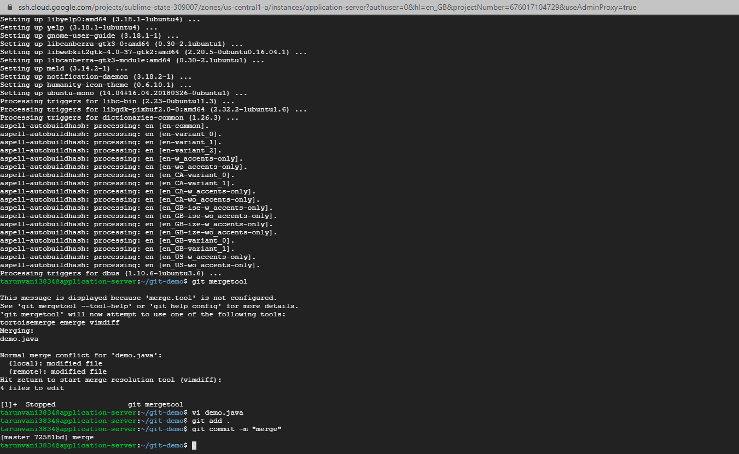

Jenkins

1) Create multiple free style projects in jenkins.

- Checkout

Install jenkins on GCP

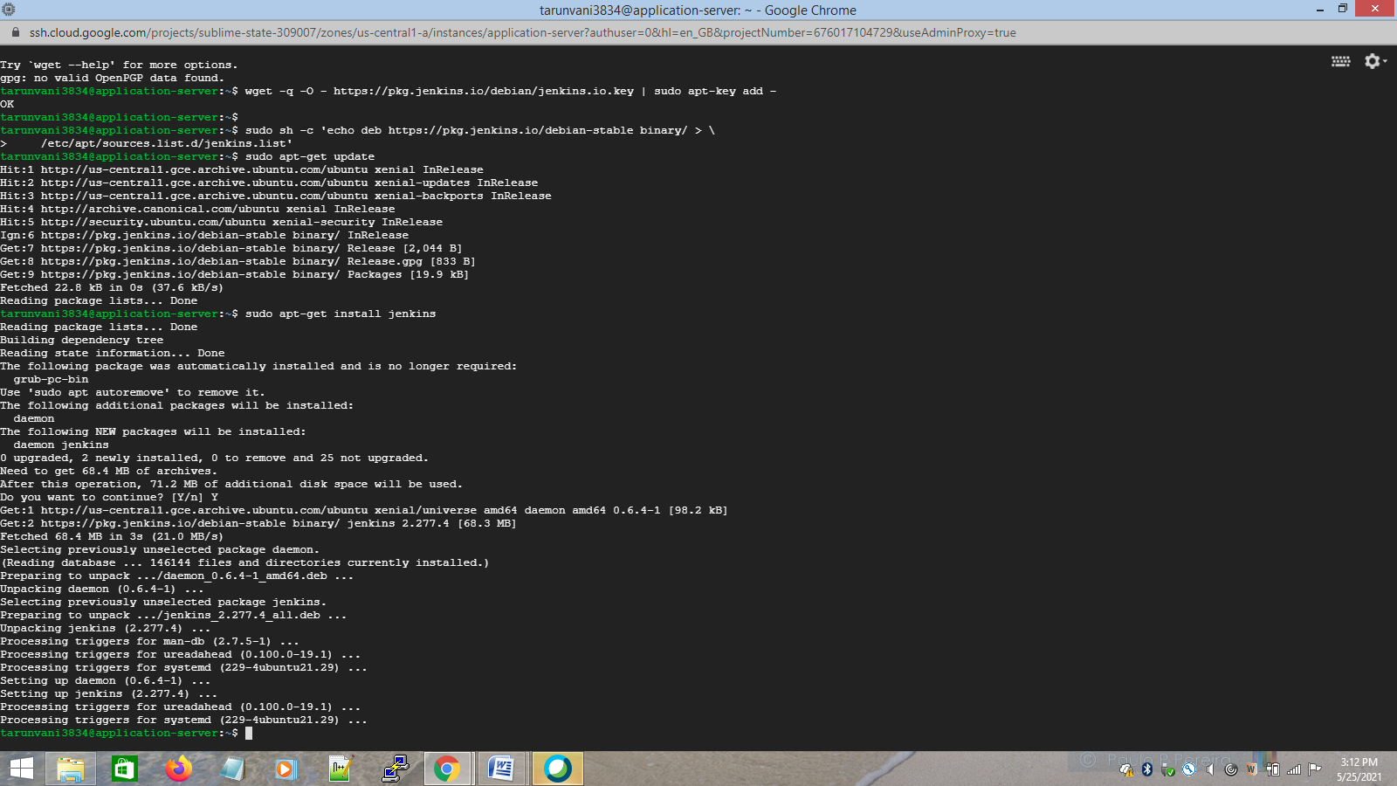

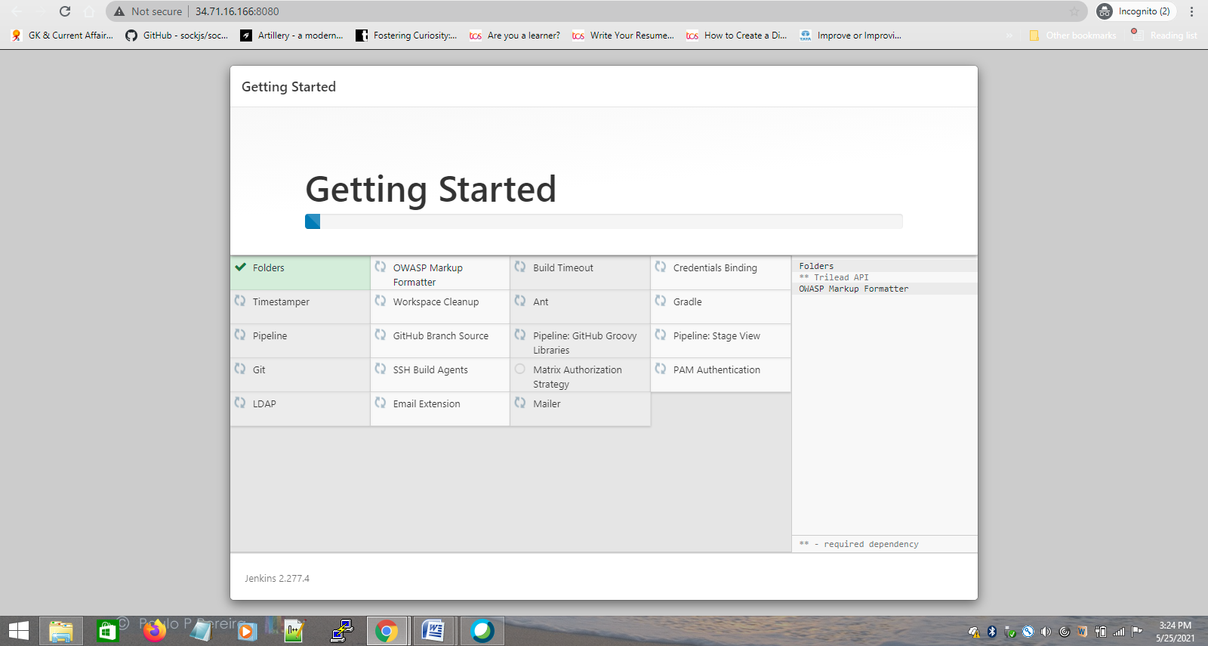

Jenkins URL : http://34.71.16.166:8080/

Install required plugins

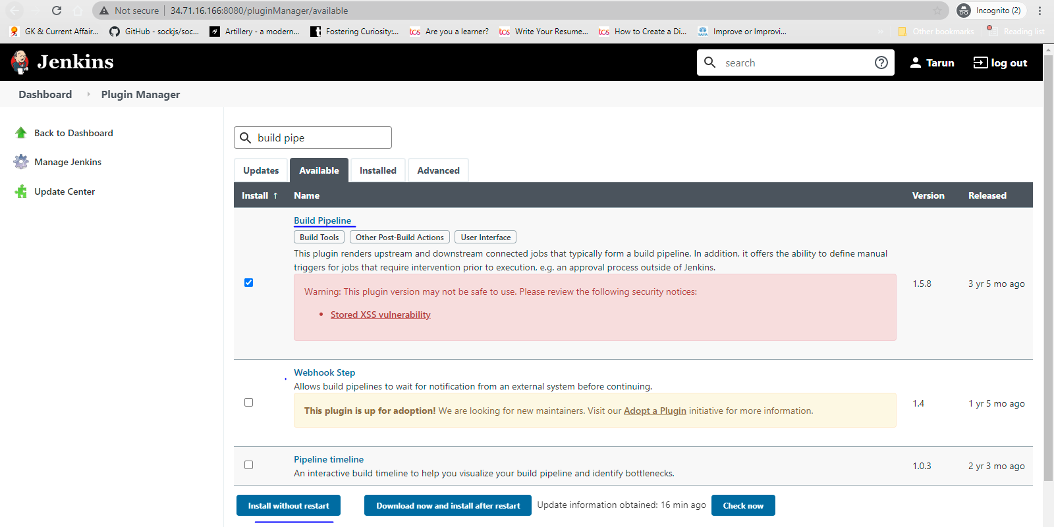

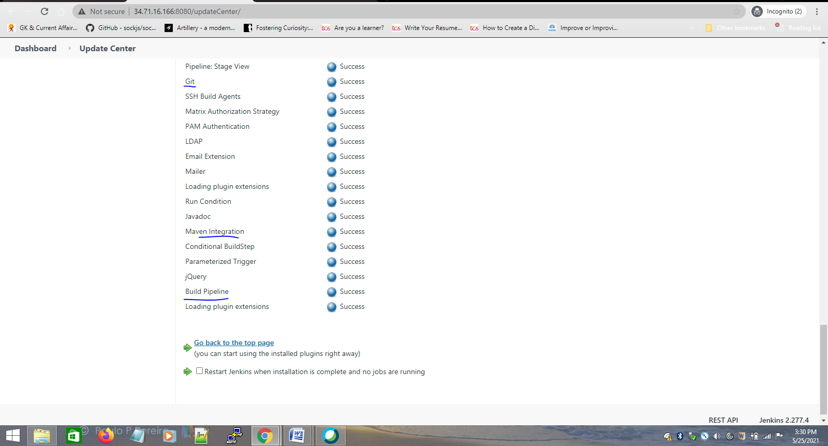

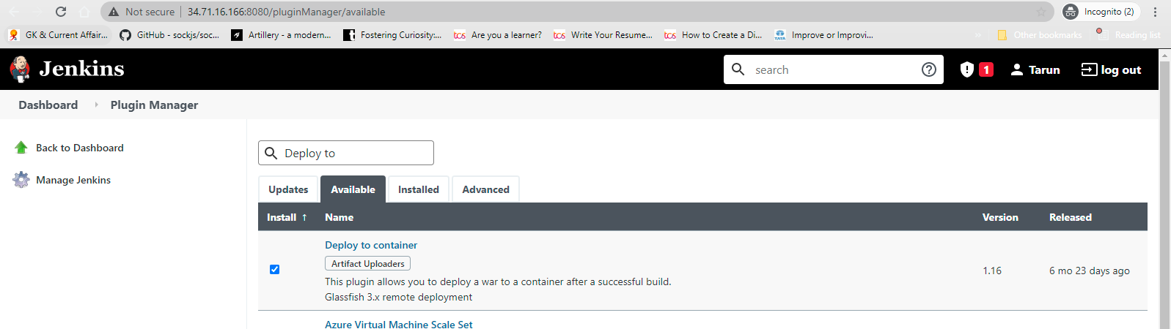

checkout job -freestyle project

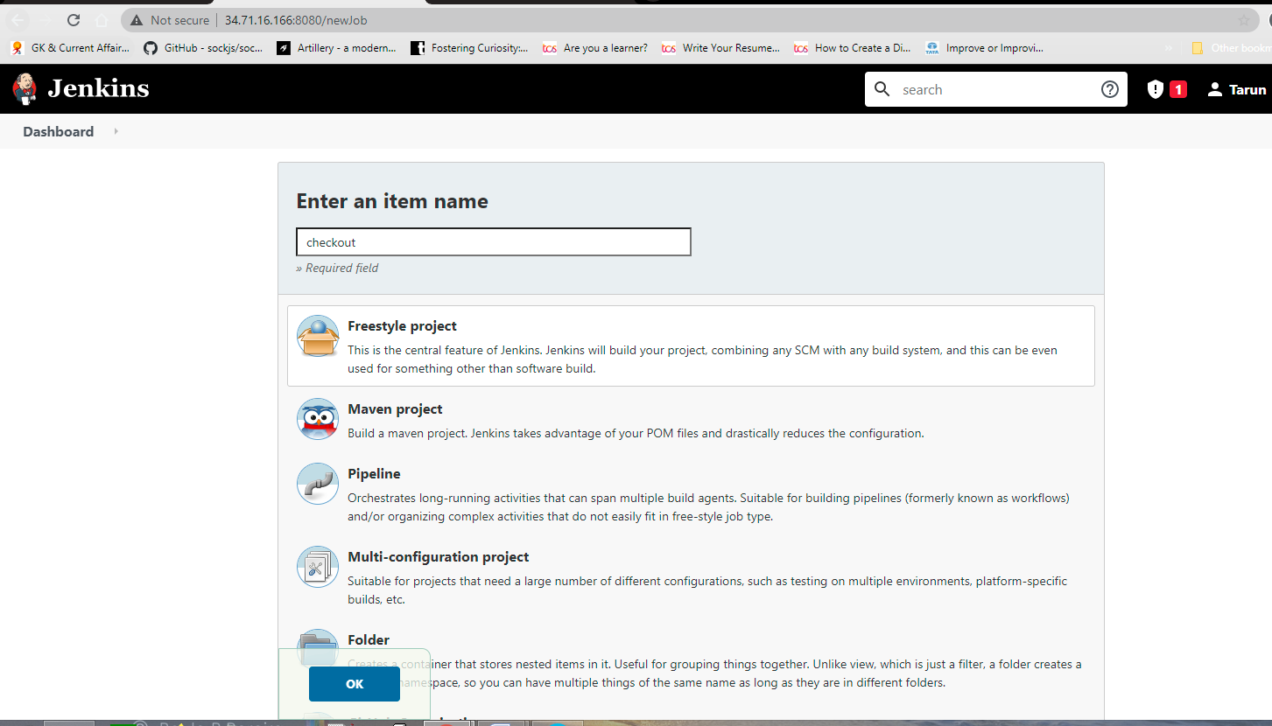

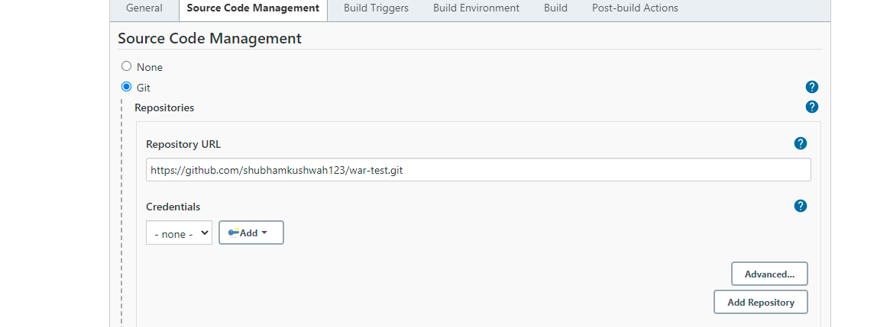

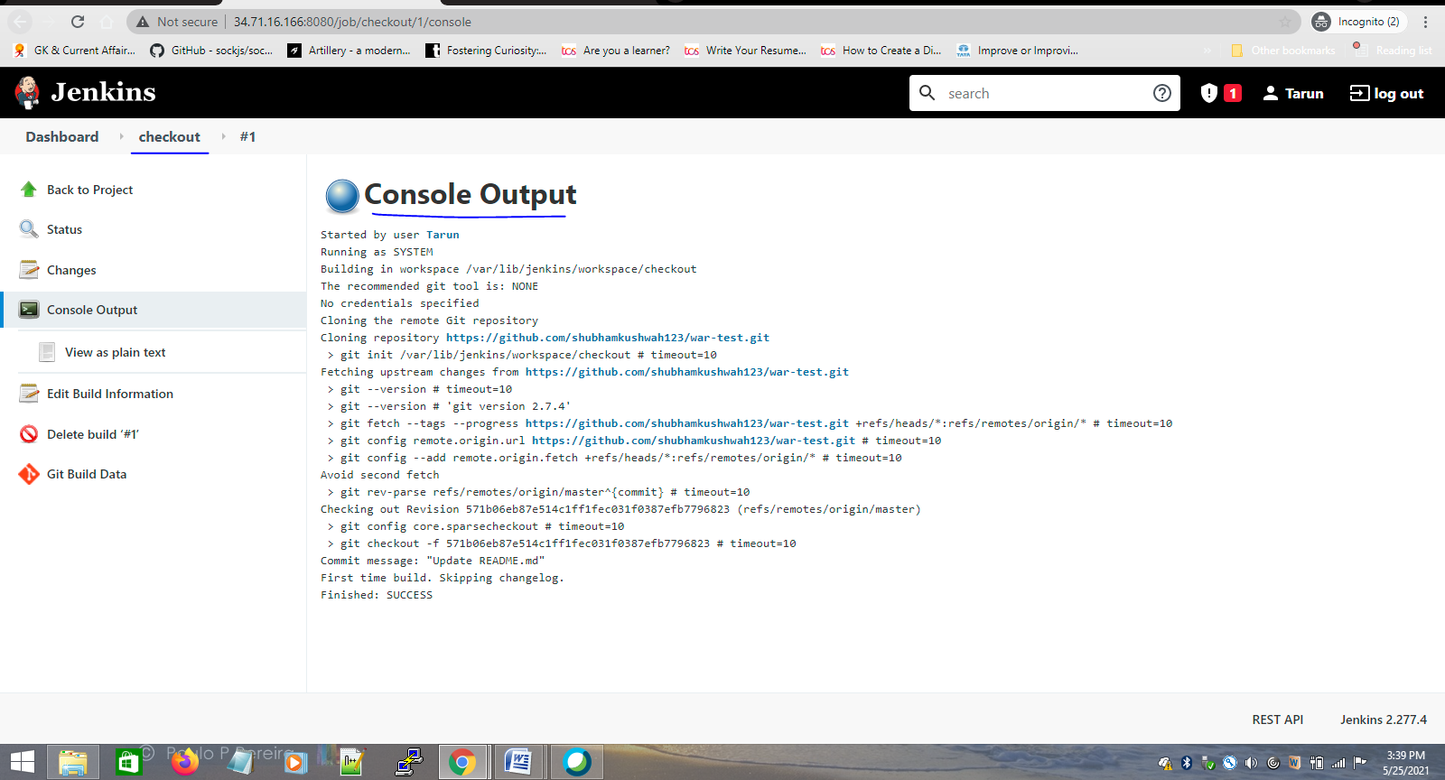

2 ) Create build job (for maven build test and package)

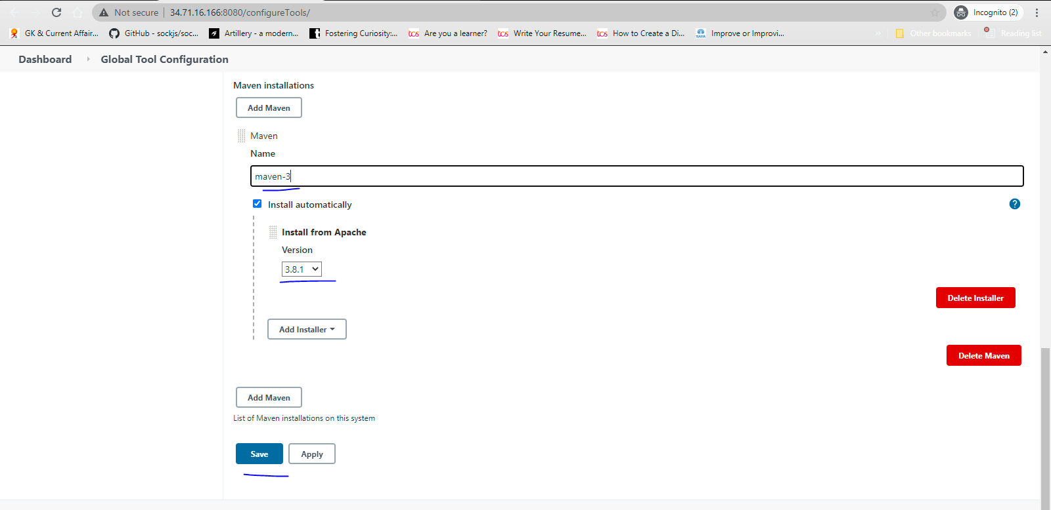

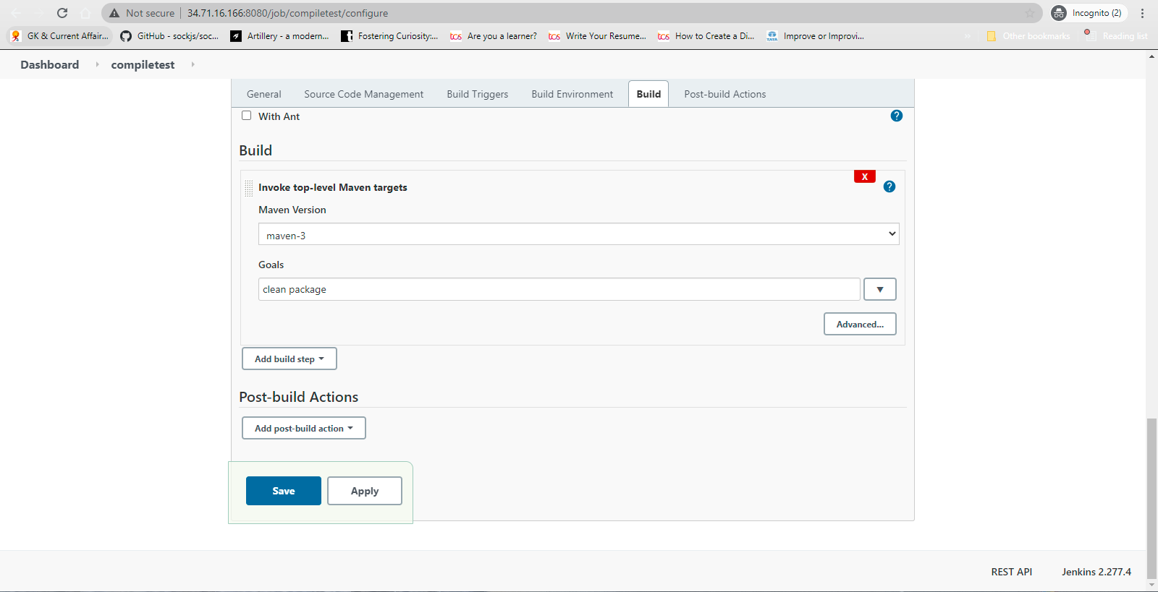

console screen print for second job compile test

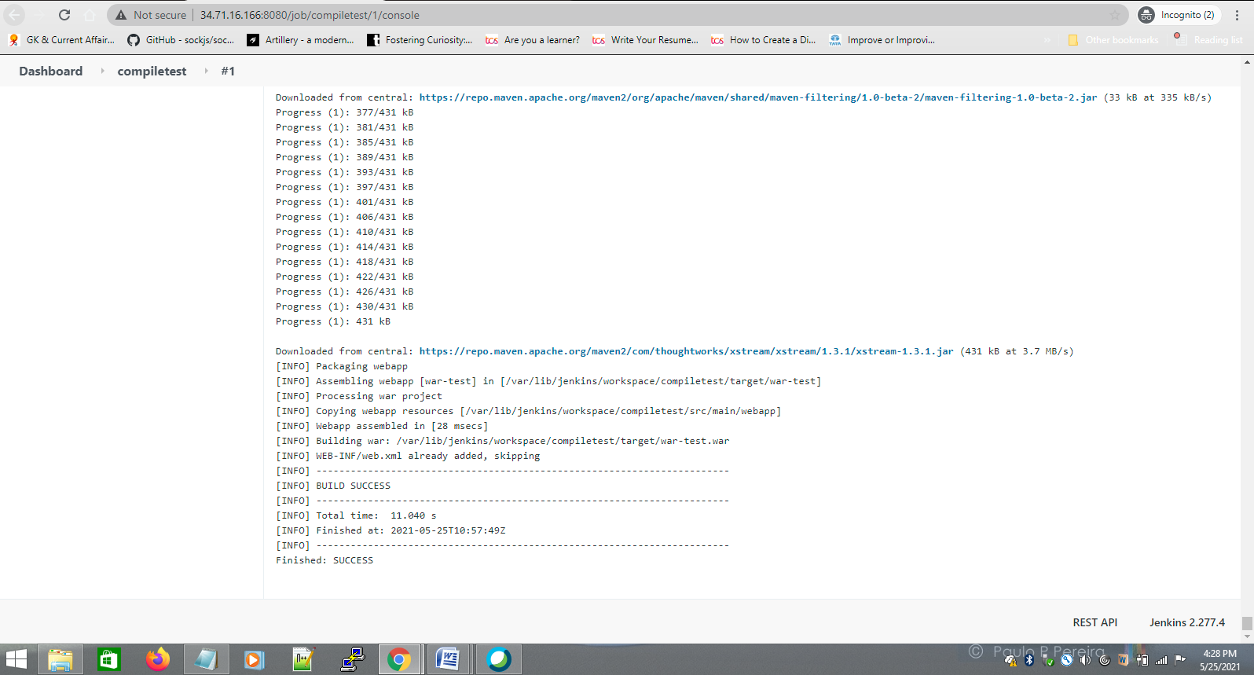

3) Create a deploy freestyle job(project) in jenkins for deploying the web application in a tomcat server.

Tried tomcat 9 installation - but not worked even after setting up everything required.

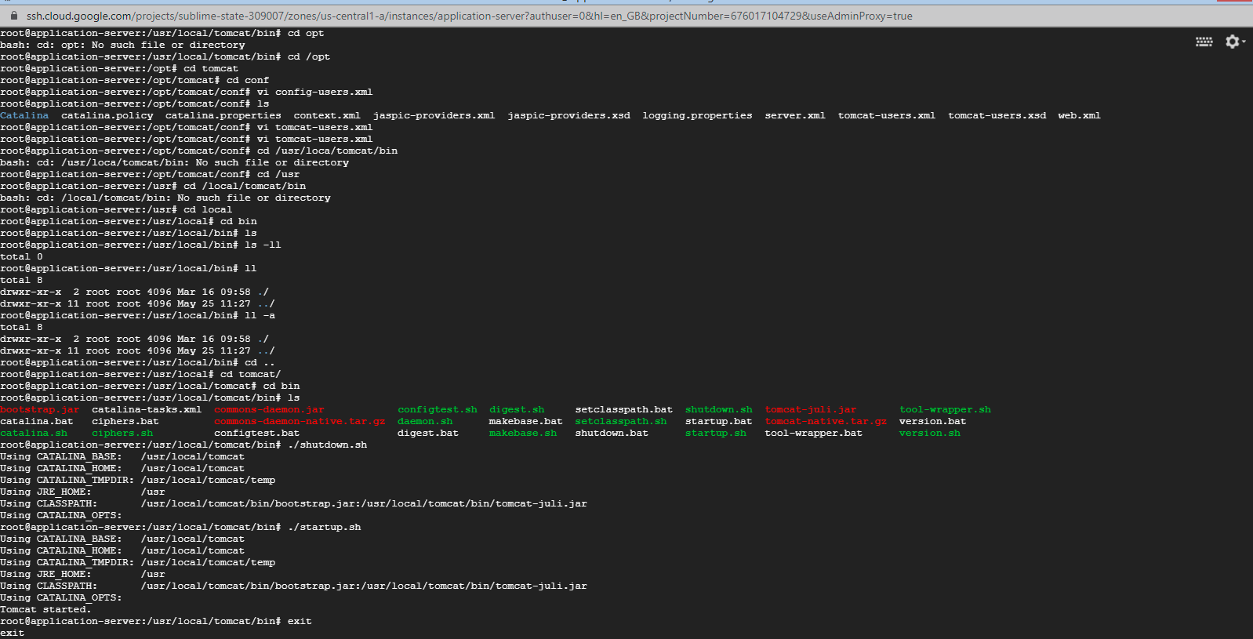

http://34.71.16.166:8888/

also setup firewall rule in GCP. but not working

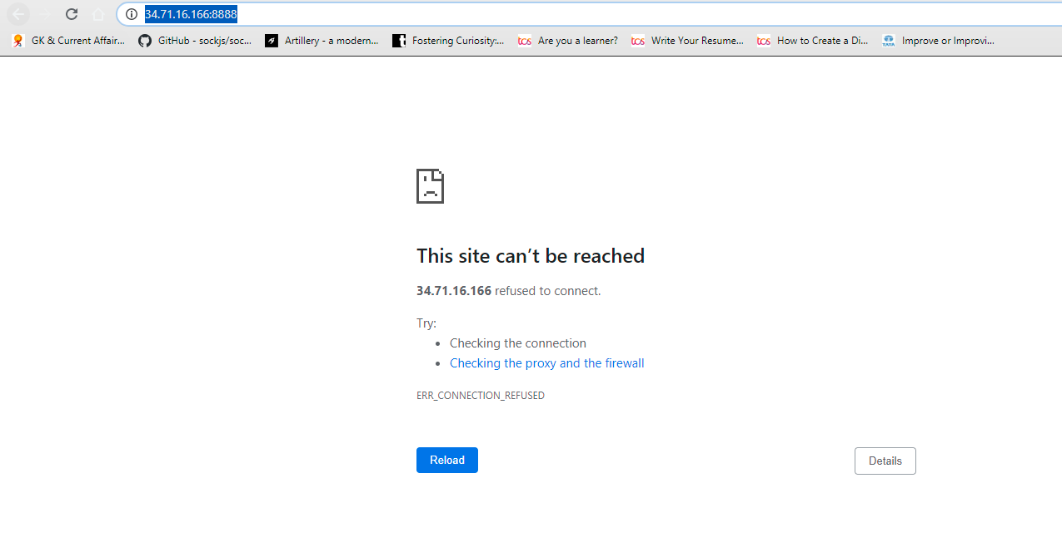

---------------------------------------------------

Establish a build pipeline view with appropriate plug in installation.

Configure maven as a tool in jenkins environment.

Console output screenshots.

Create a pipeline job and write the script to achieve the same tasks.

Pipeline must be triggered with a Github webhook upon every commit.