1614027_Tarun_Day3_Assignment

Install docker

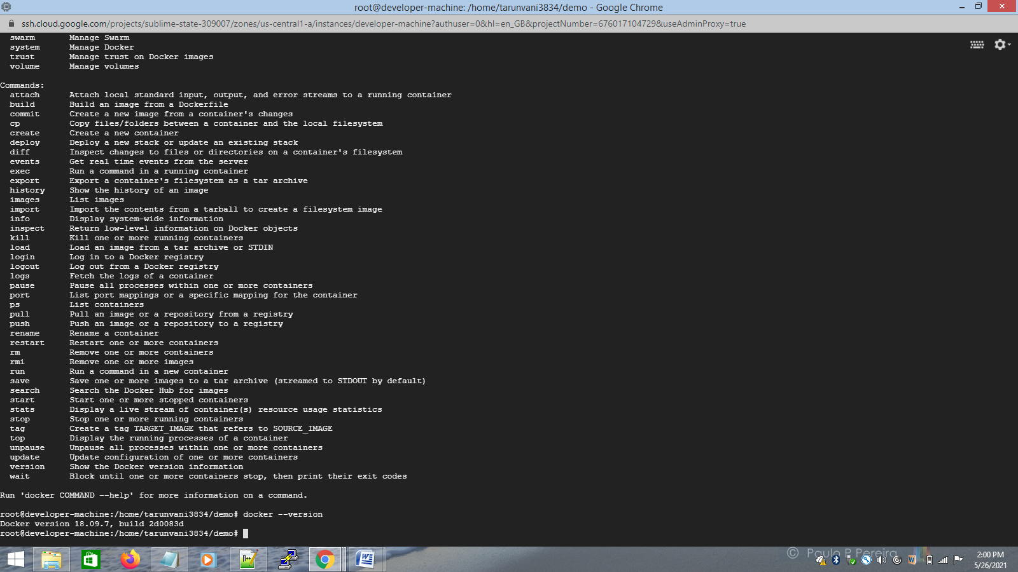

connected to dockerhub

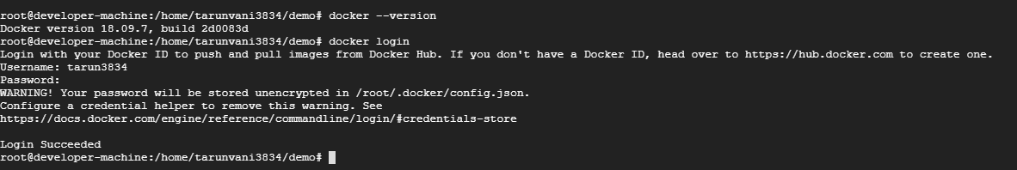

1) Write a docker file to create a docker image for the application using nginx as the base image.

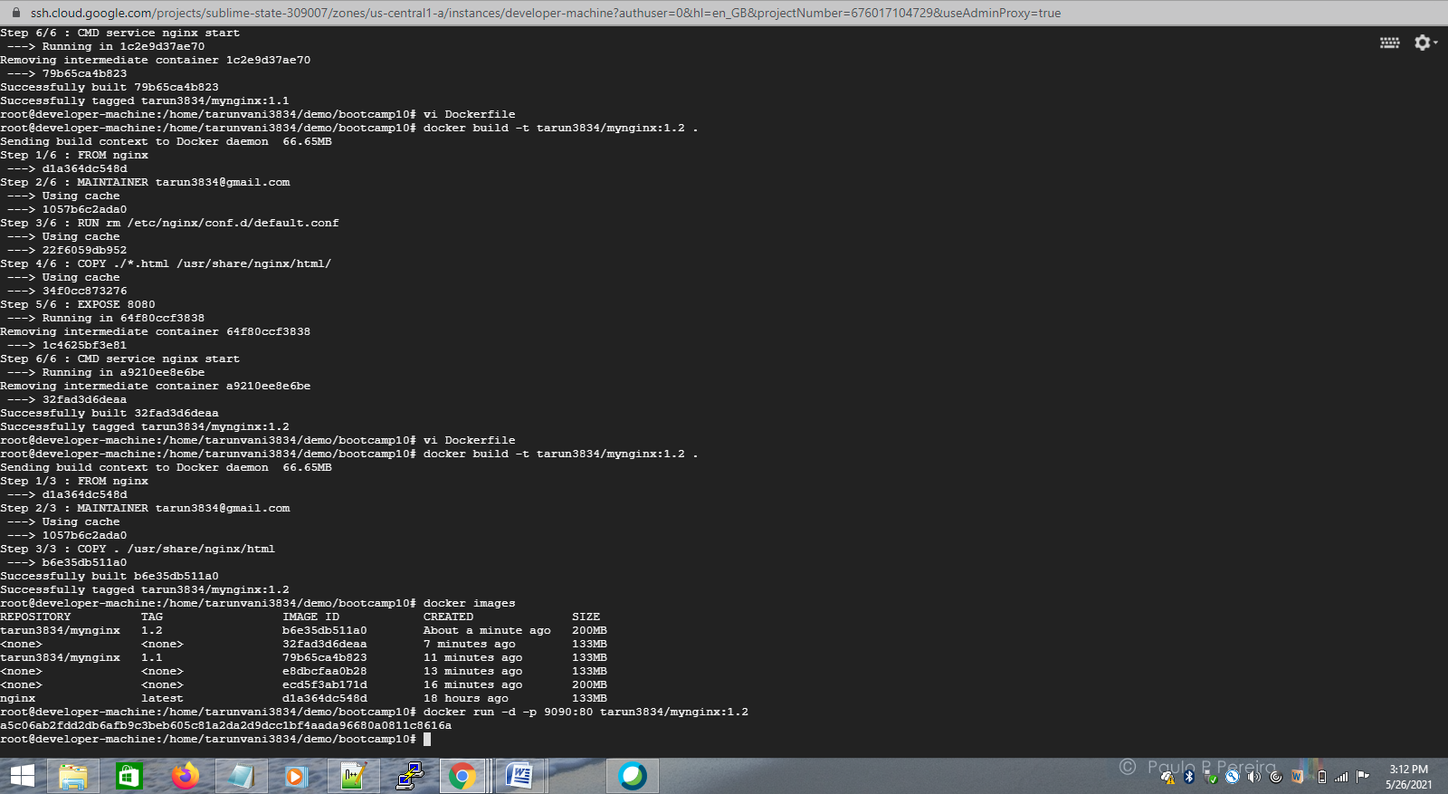

Docker file

FROM nginx

MAINTAINER tarun3834@gmail.com

COPY ./*.html /usr/share/nginx/html/

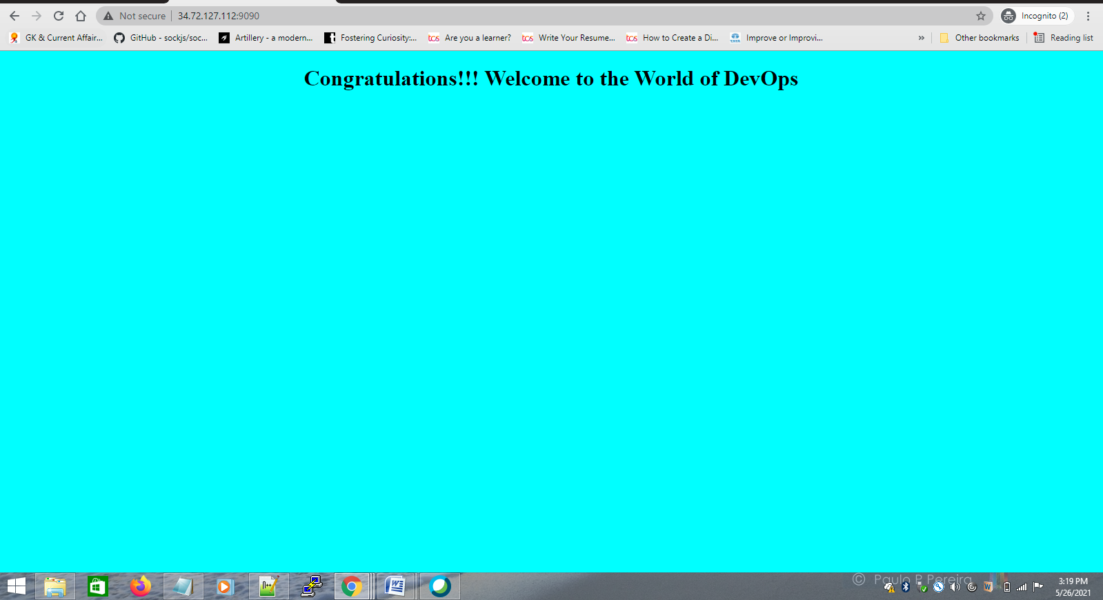

2) Push the docker image to the docker hub.

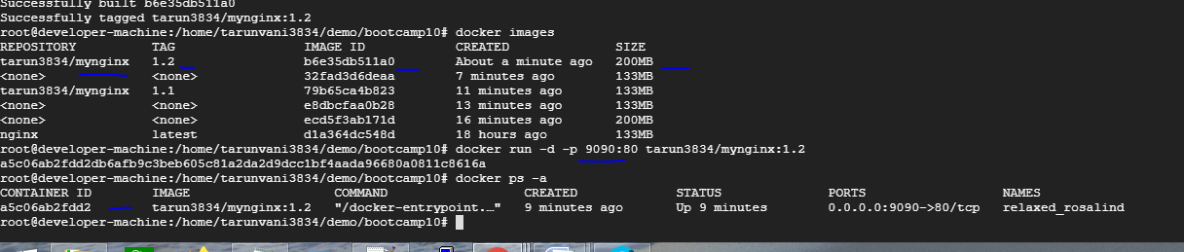

docker push

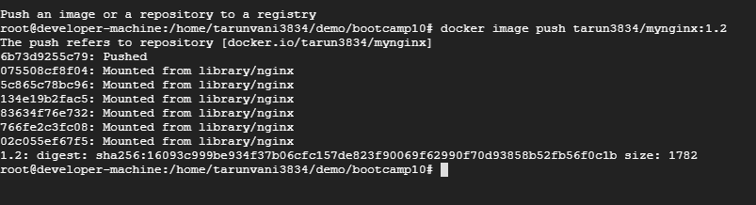

docker hub screen print

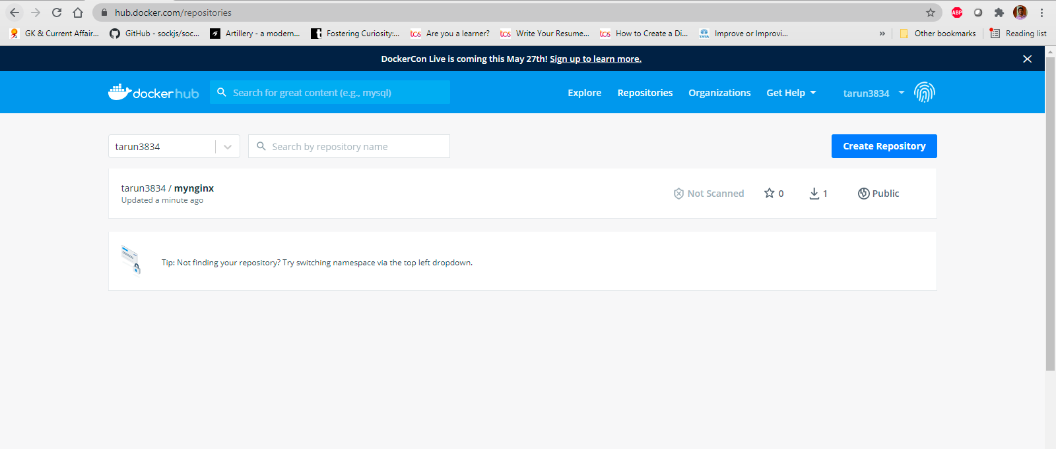

3) Pull and Run the docker containers on any remote instance.

Logged in another instance on GCP and pulled docker image after installing docker and logging in docker

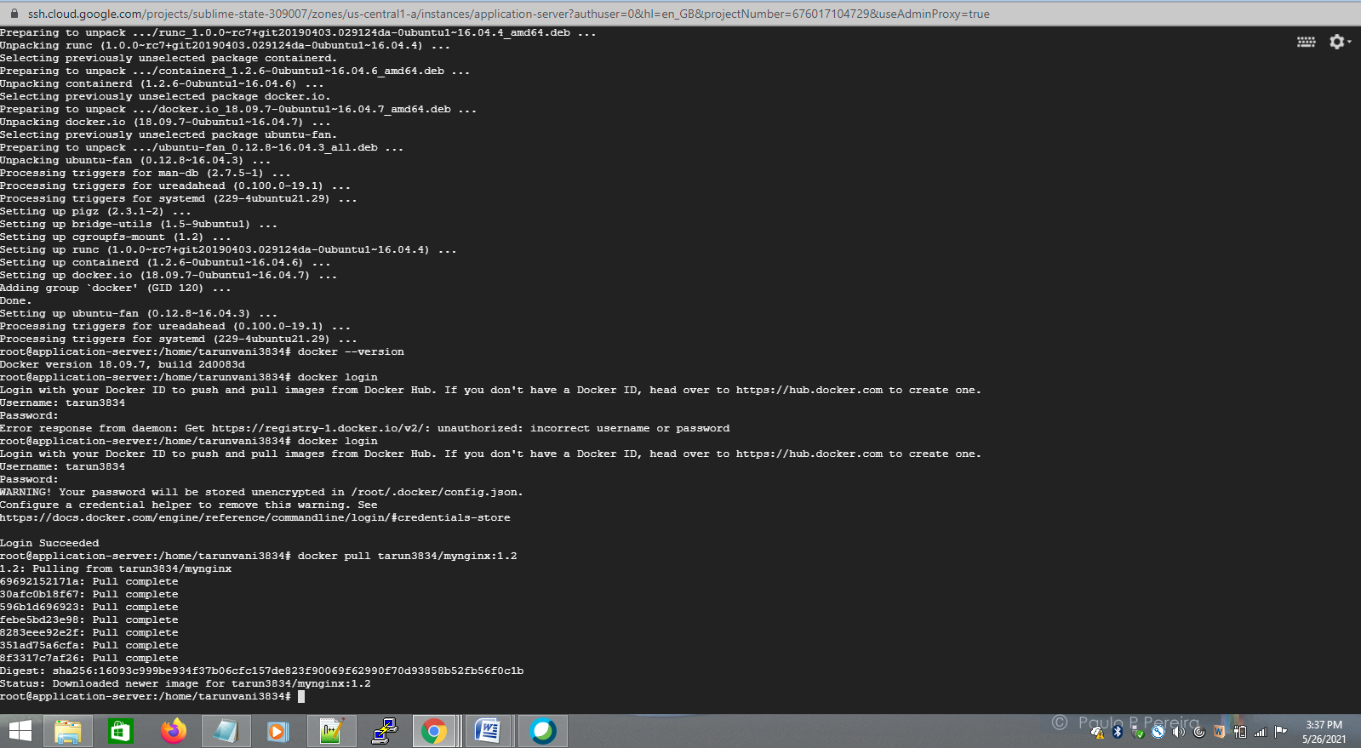

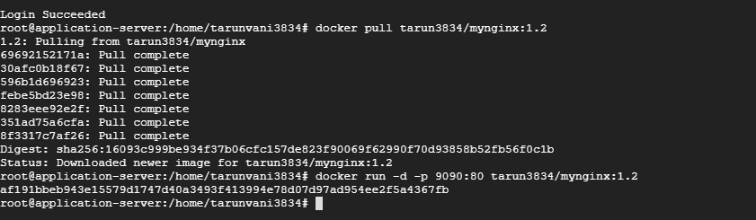

4)Access the application from the browser using appropriate url and port.

Login to 2nd instance IP and port 9090

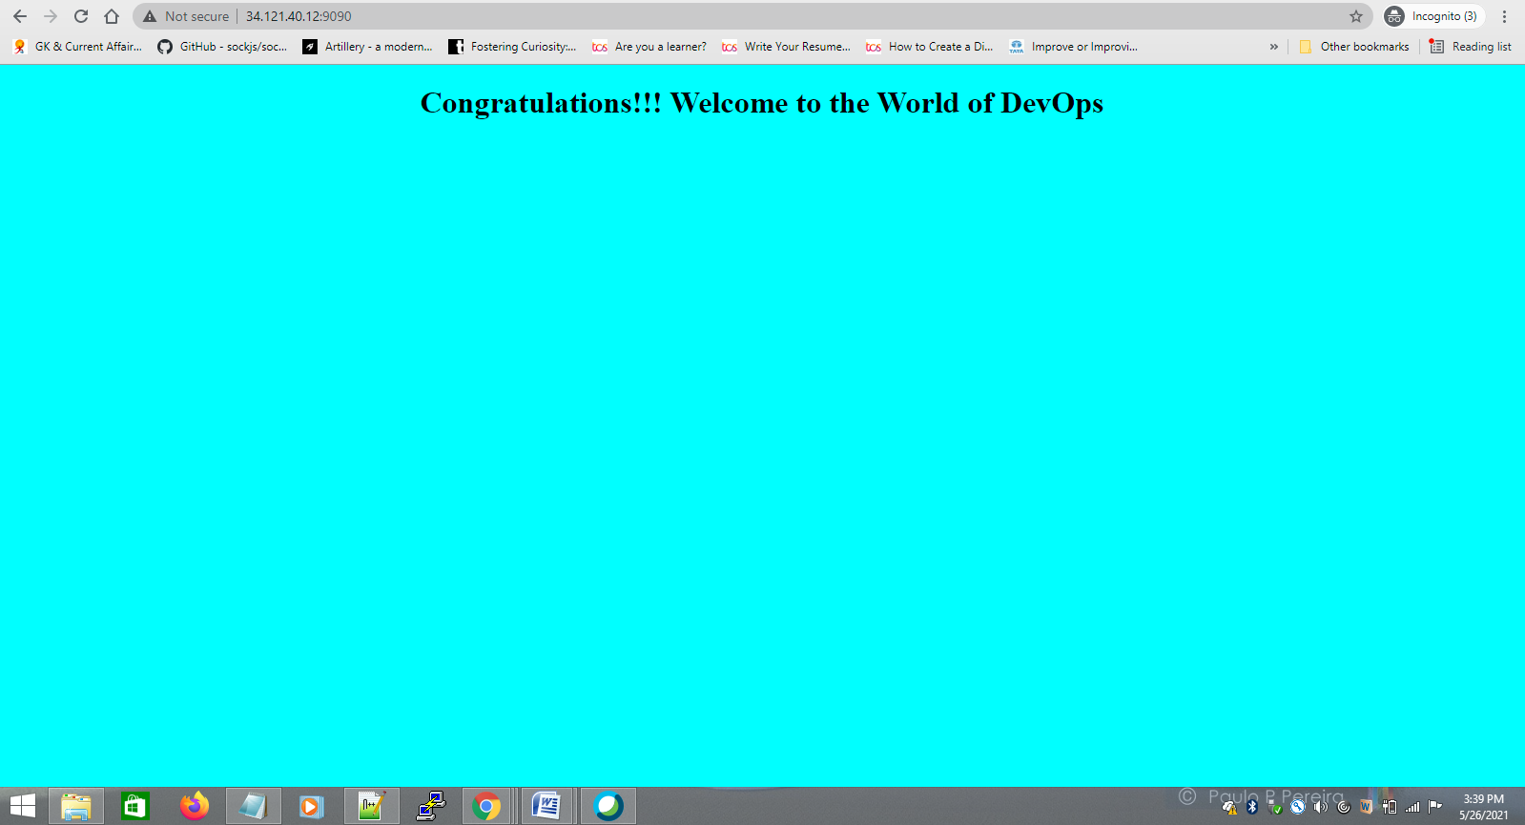

**Docker - compose**

1) Write yml file to run the above application container along with a mysql database container together.

docker-compose.yaml

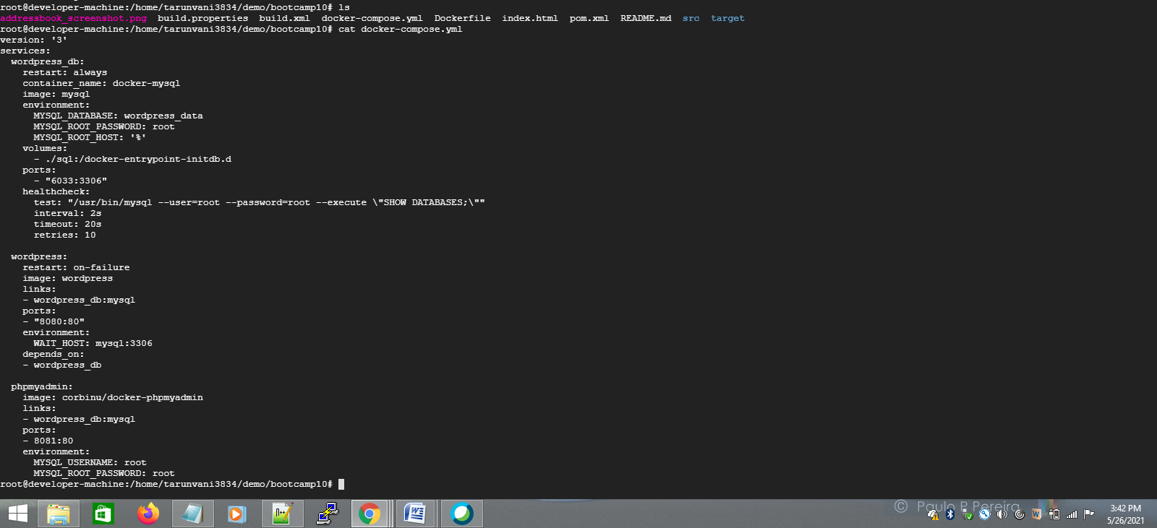

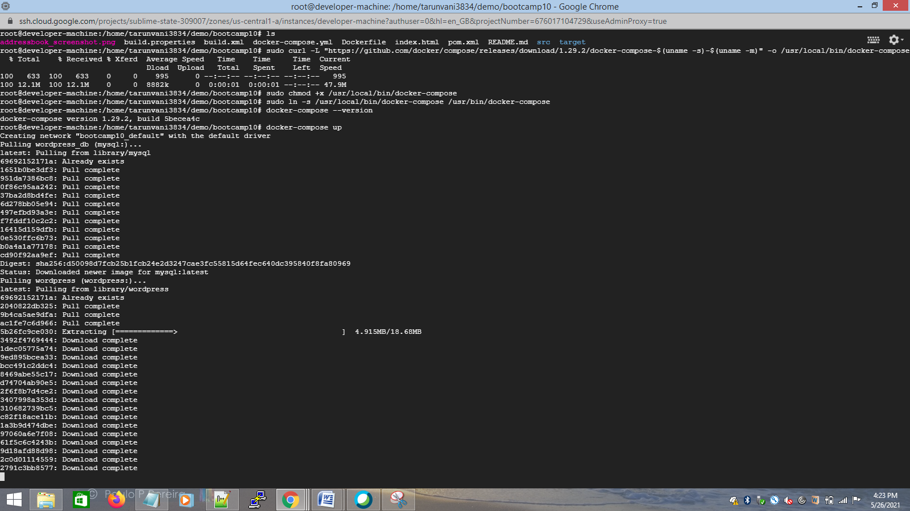

8081 port

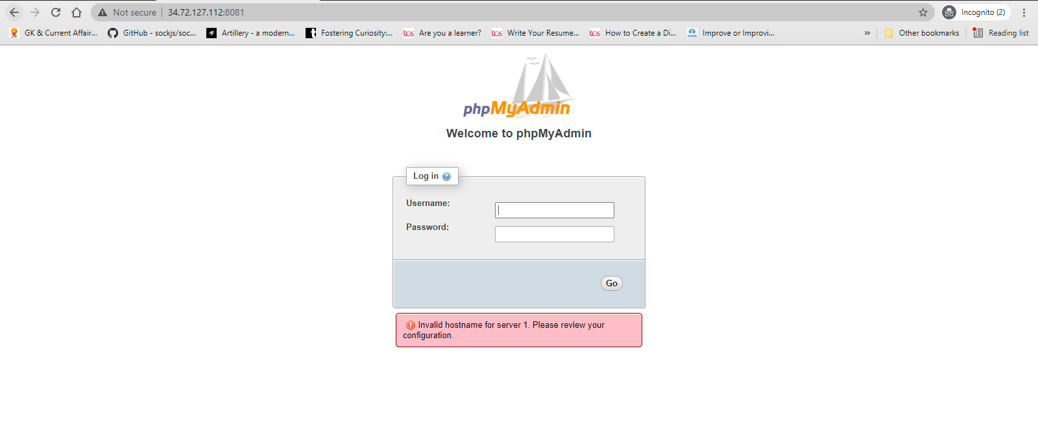

8090 port

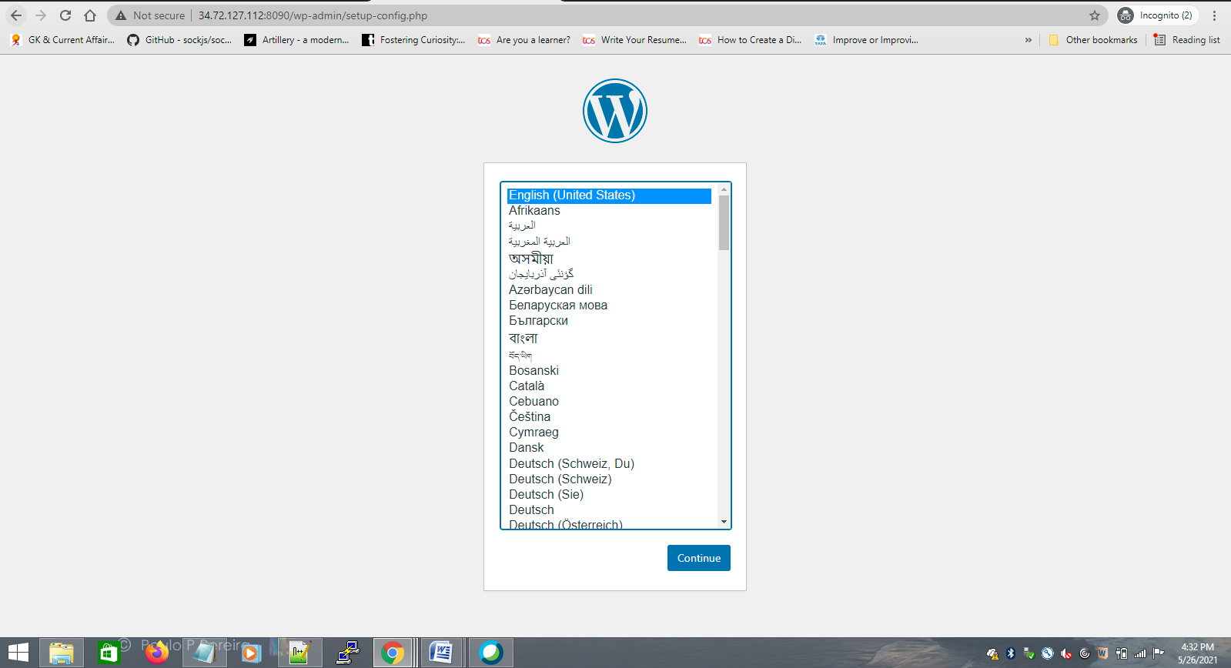

2) Connect to mysql database container in the -it mode and create a table named test having id, name and age as attributes.

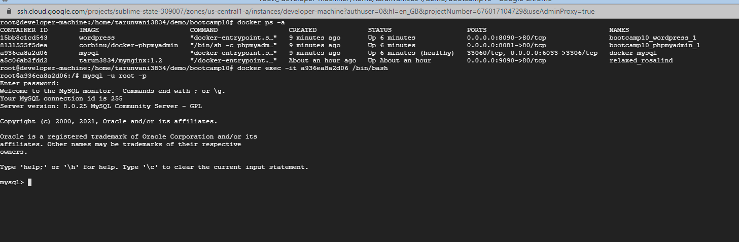

password : root

