Install ansible on GCP instances

1) Create 2 nodes, one is master and another is slave.

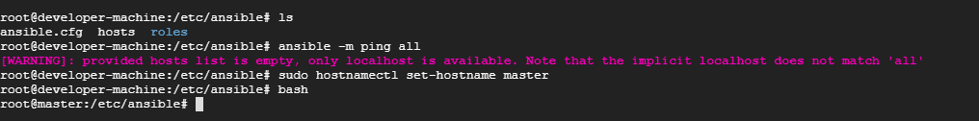

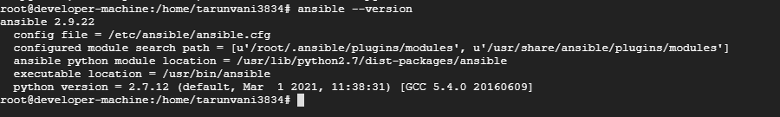

slave node on another instance

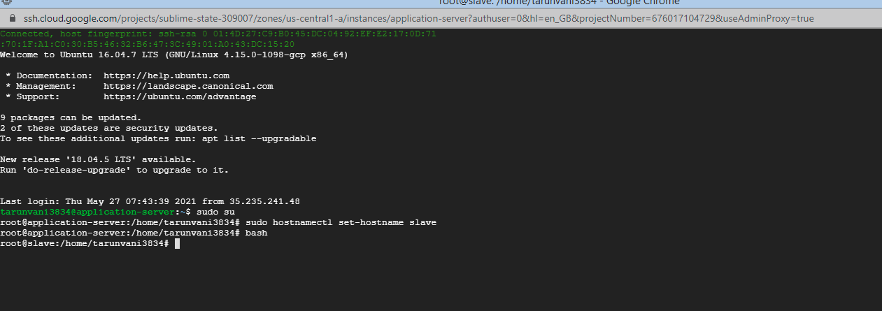

2) Configure the master node to enable password less authentication.

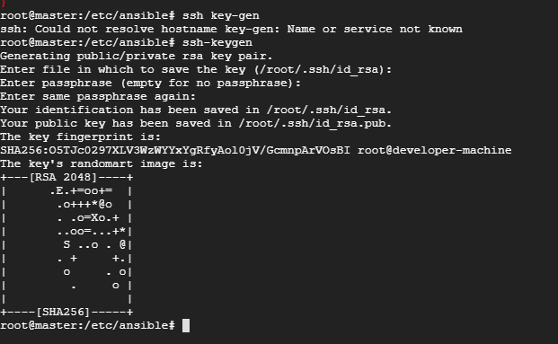

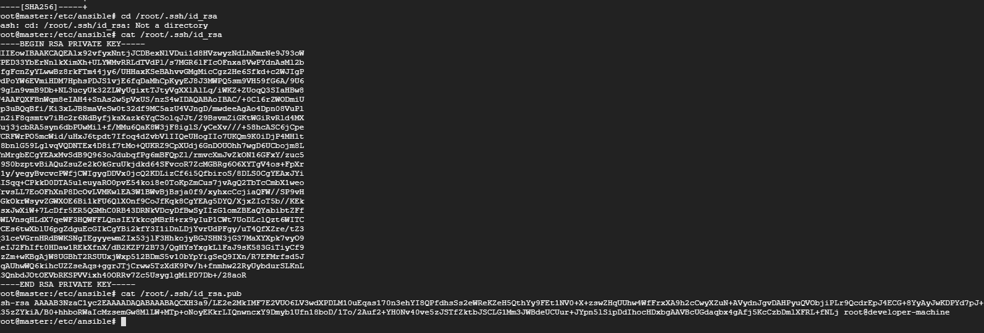

Slave node ssh-copy-id to master

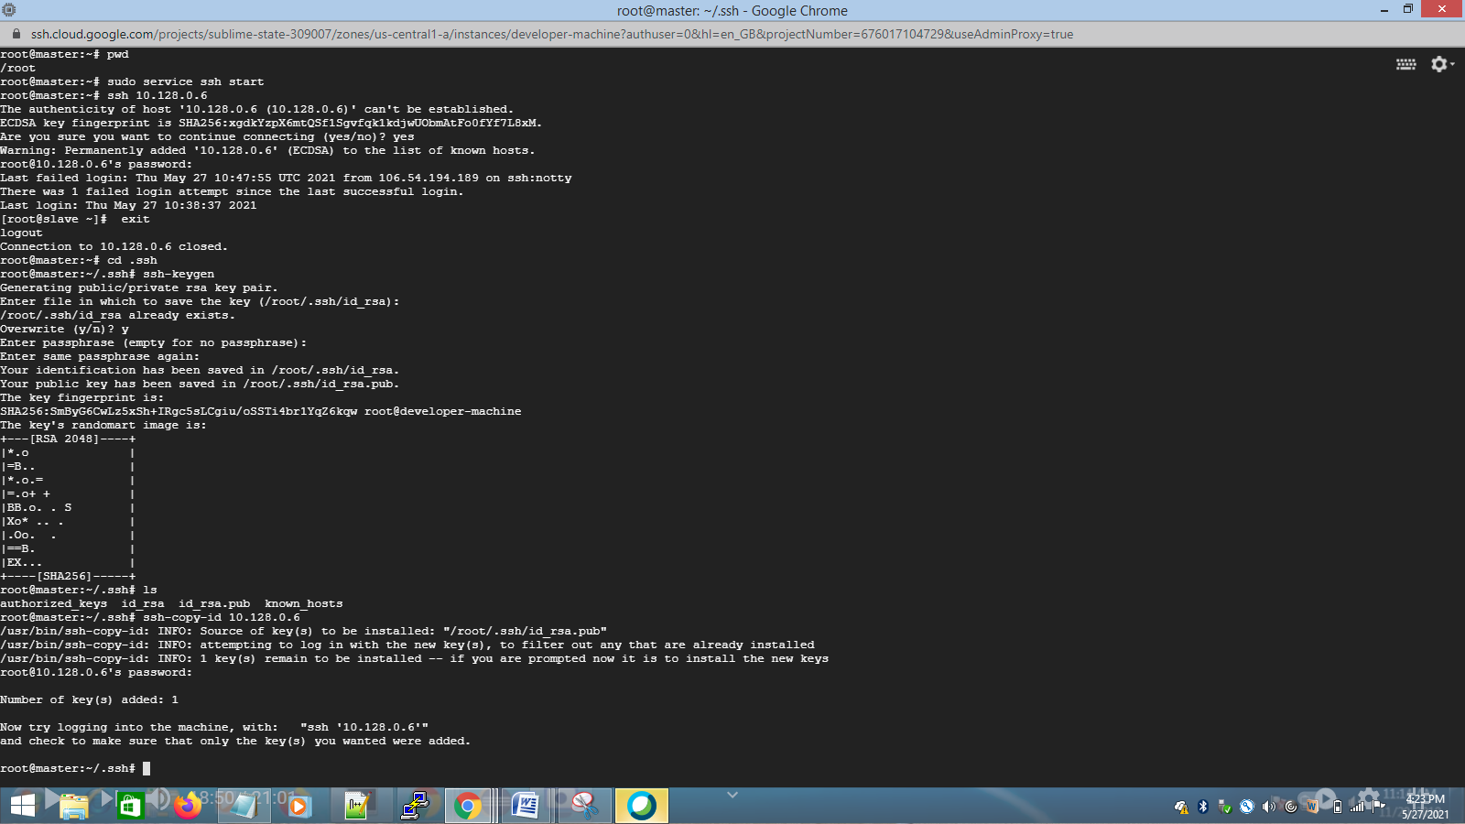

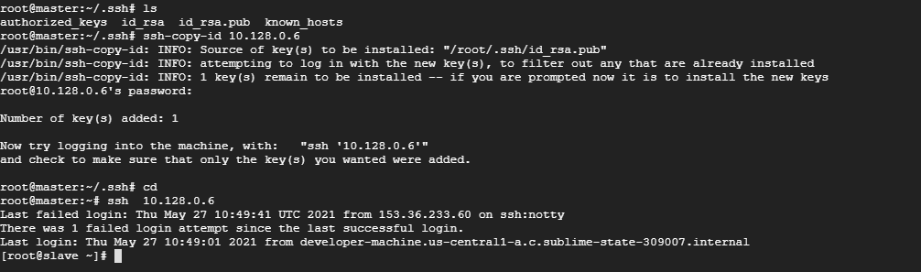

3) Install Ansible on master node.

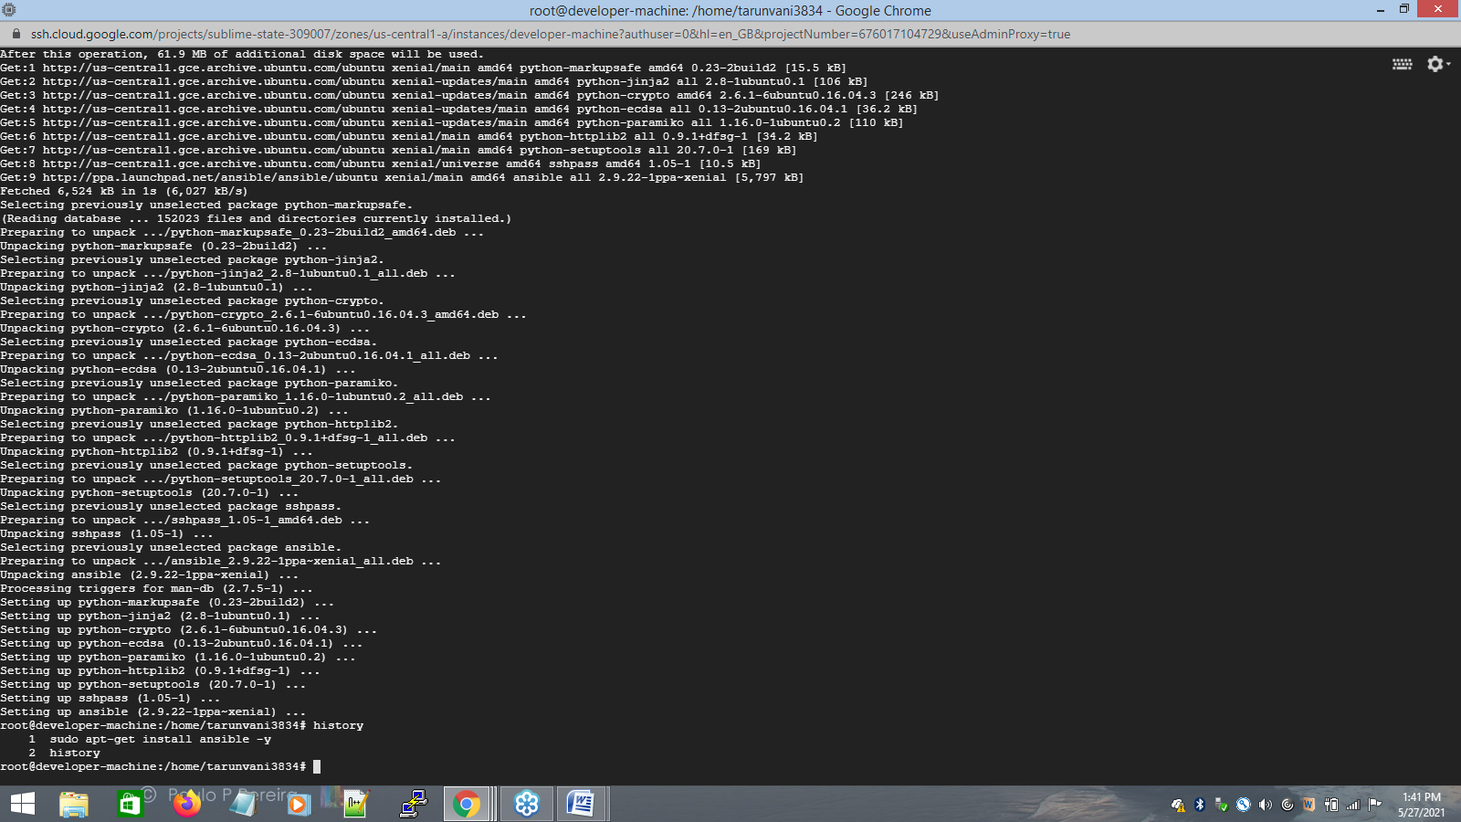

4) Write a playbook to install java,maven,nging,docker in the slave node.

- hosts: all

become: true

tasks:

- name: install java

apt:

pkg: openjdk-8-jdk

state: present

- name: install maven

apt:

pkg: maven

state: present

notify:

- run update

- name: install nginx

apt:

pkg: nginx

state: present

- name: install docker

apt:

pkg: docker.io

state: present

- name: start docker service

service:

name: docker

state: started

enabled: true

handlers:

- name: run update

apt:

update_cache: 'yes'

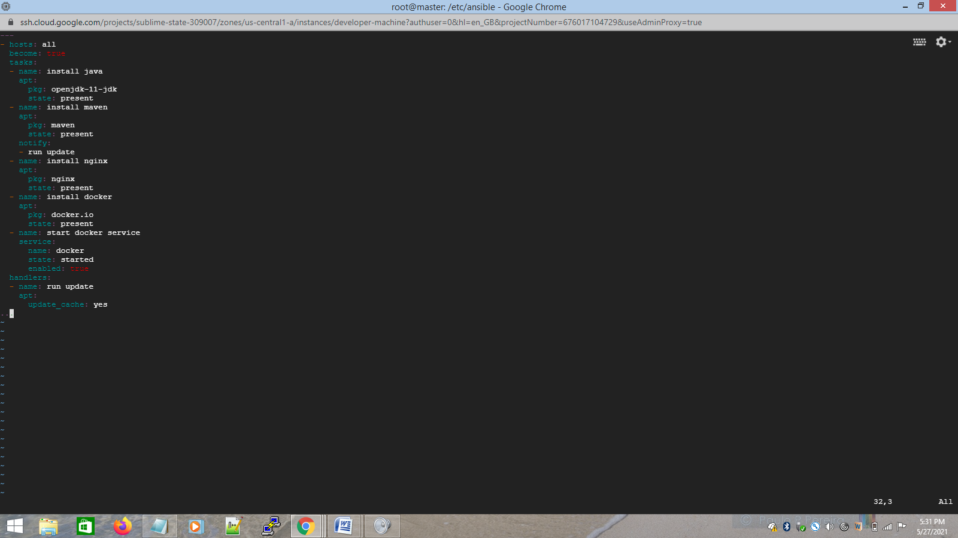

screen print after running the yml

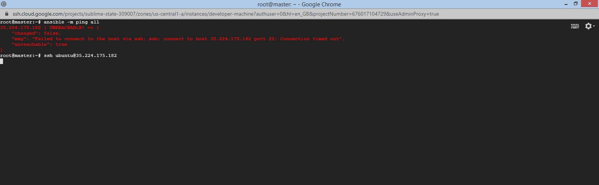

GCP instances getting struck.

Tried creating 2 new GCP instances and connected them again

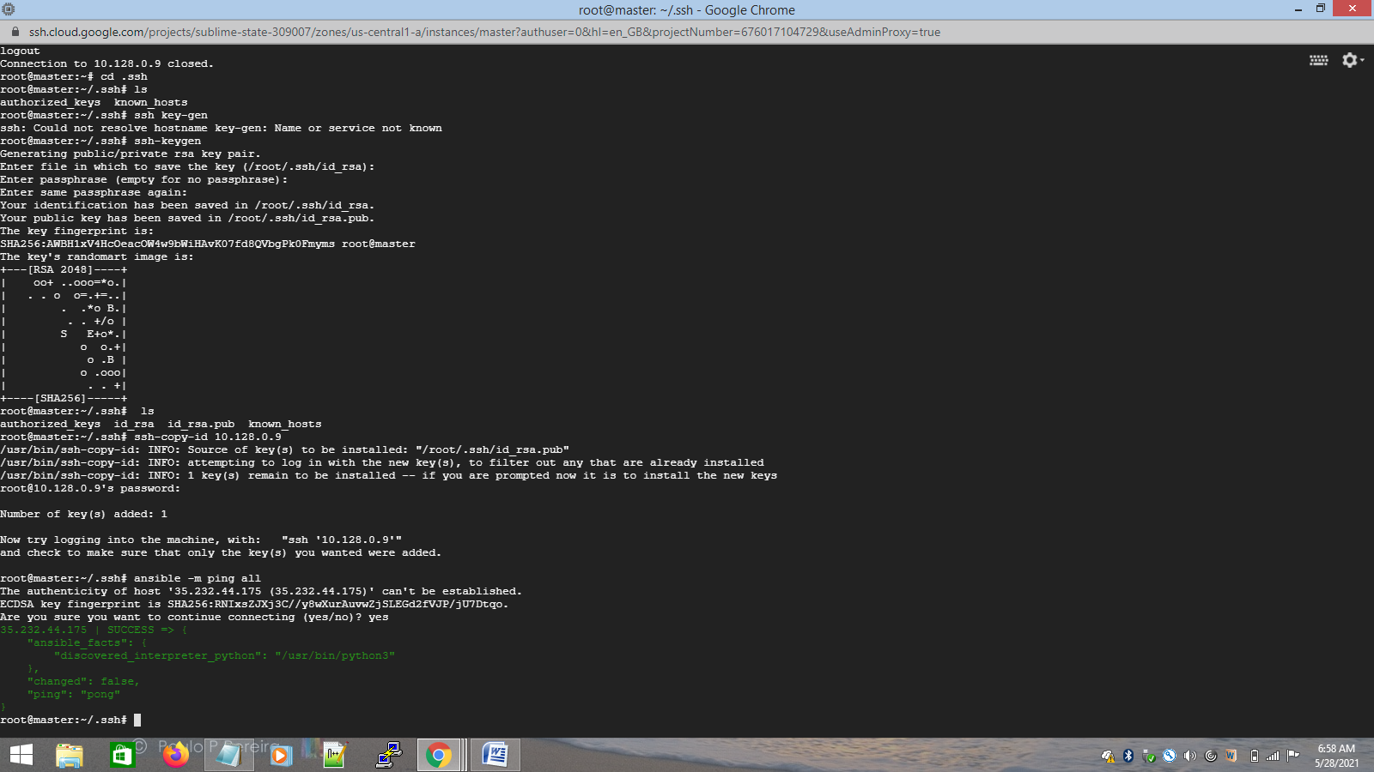

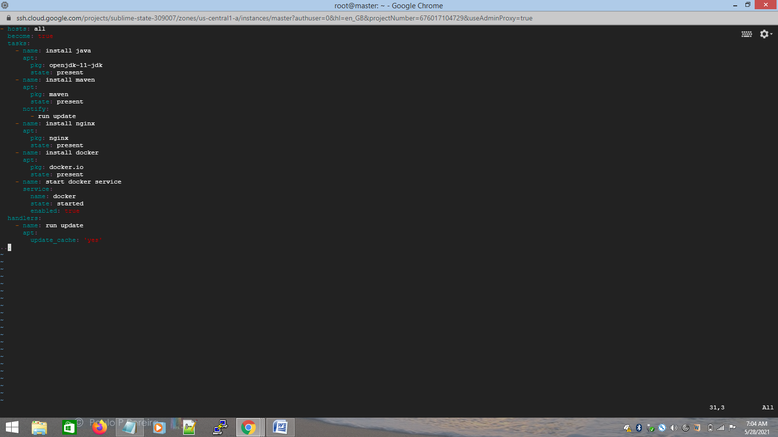

After running playbook,

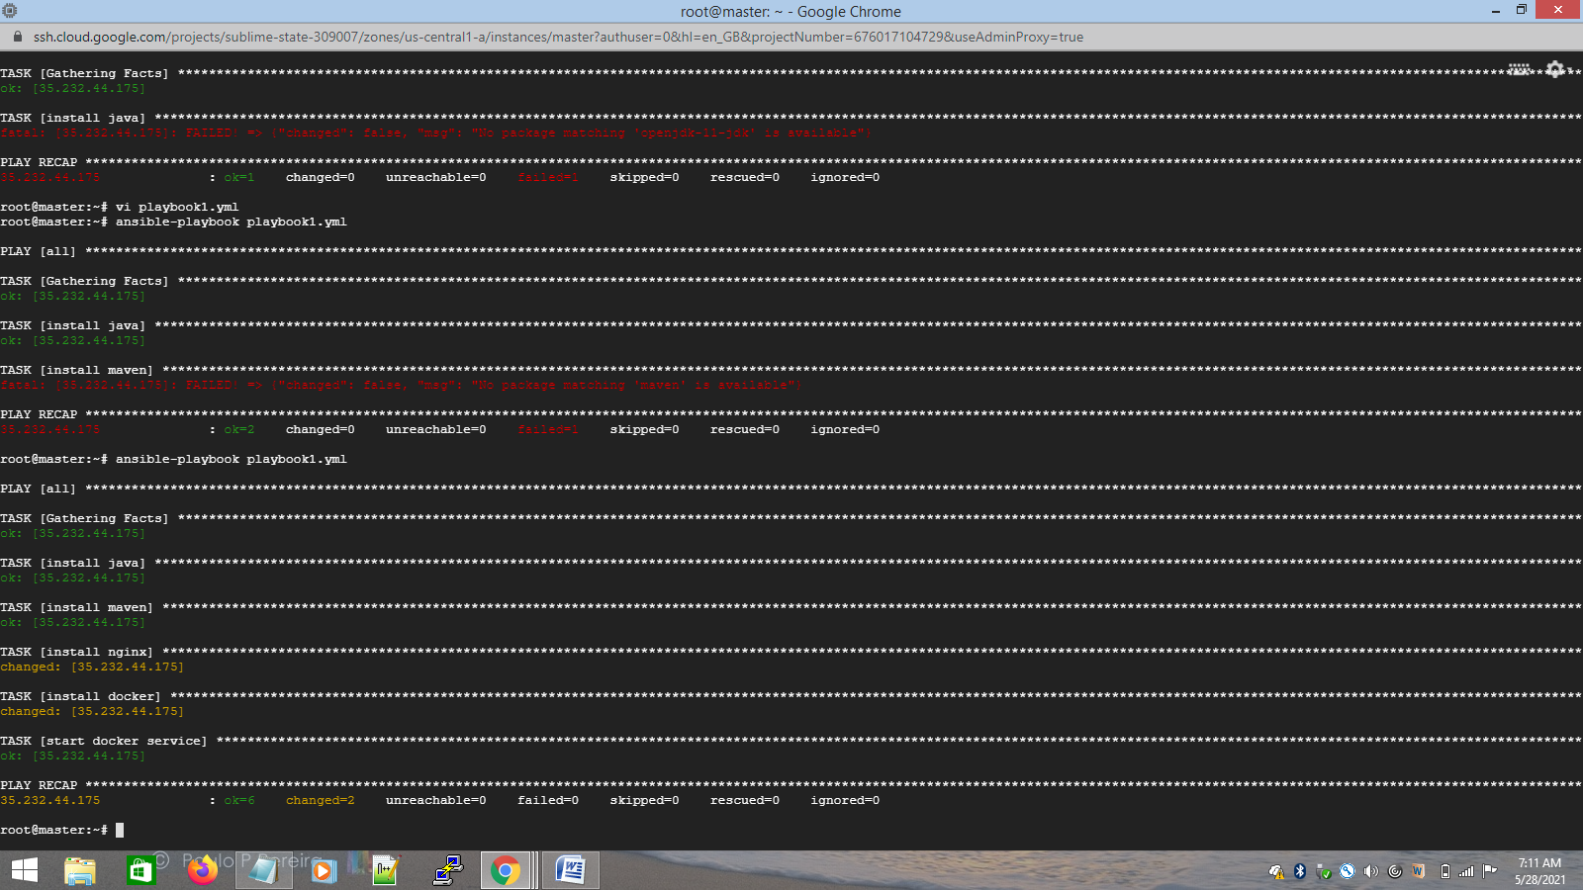

successfully installed all.

5)Configure playbook to deploy the application available in the below repository as docker container in the slave node.

Repo : https://github.com/shubhamkushwah123/war-test.git

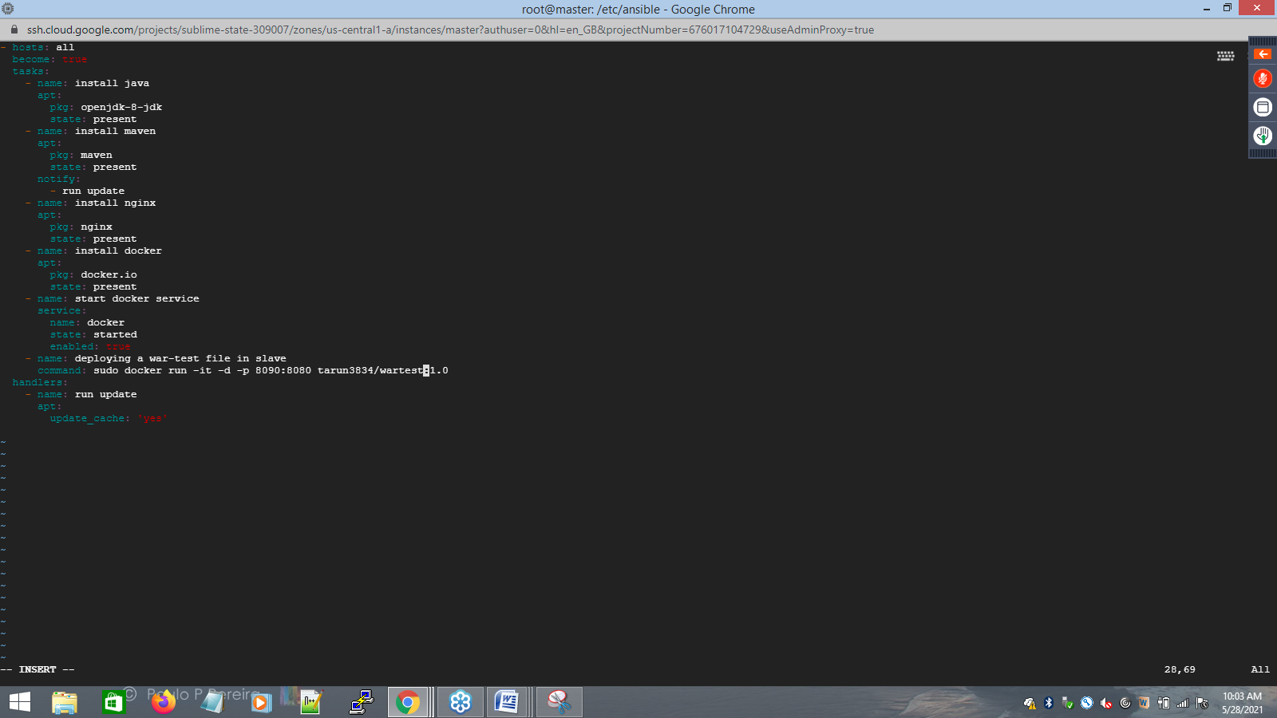

6) Run playbook and attach the screenshots.

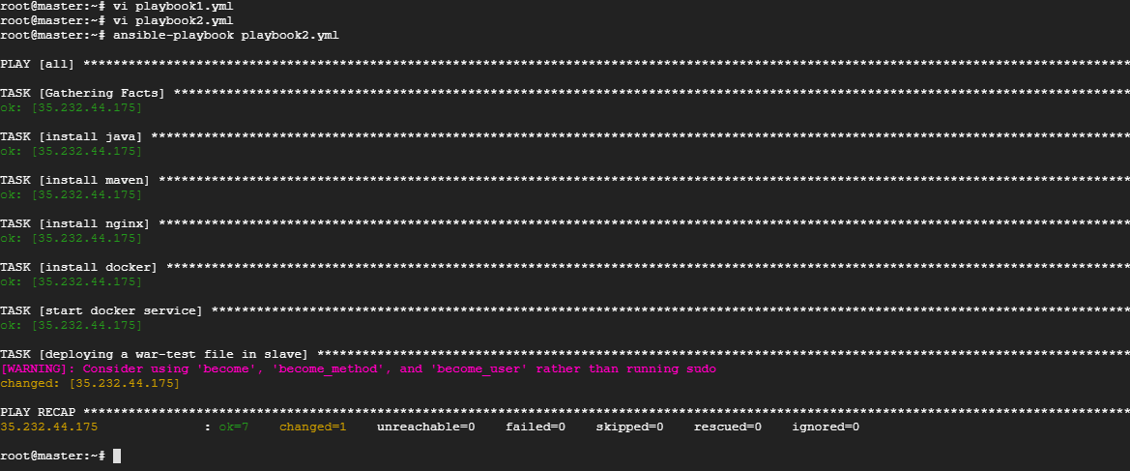

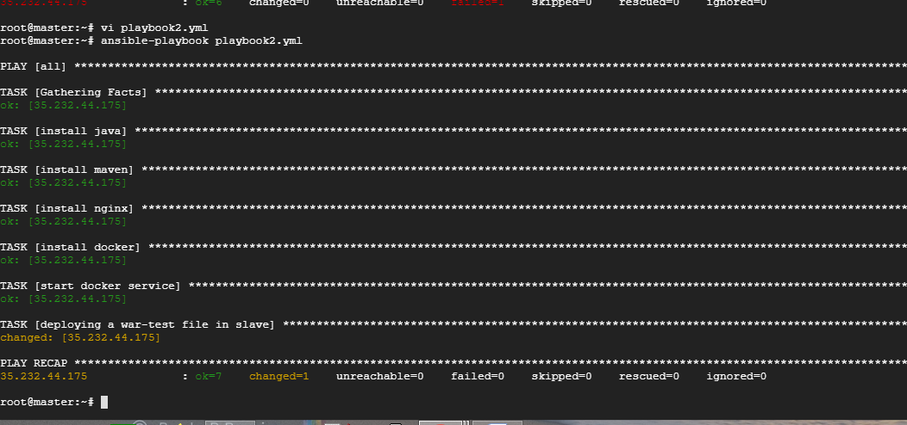

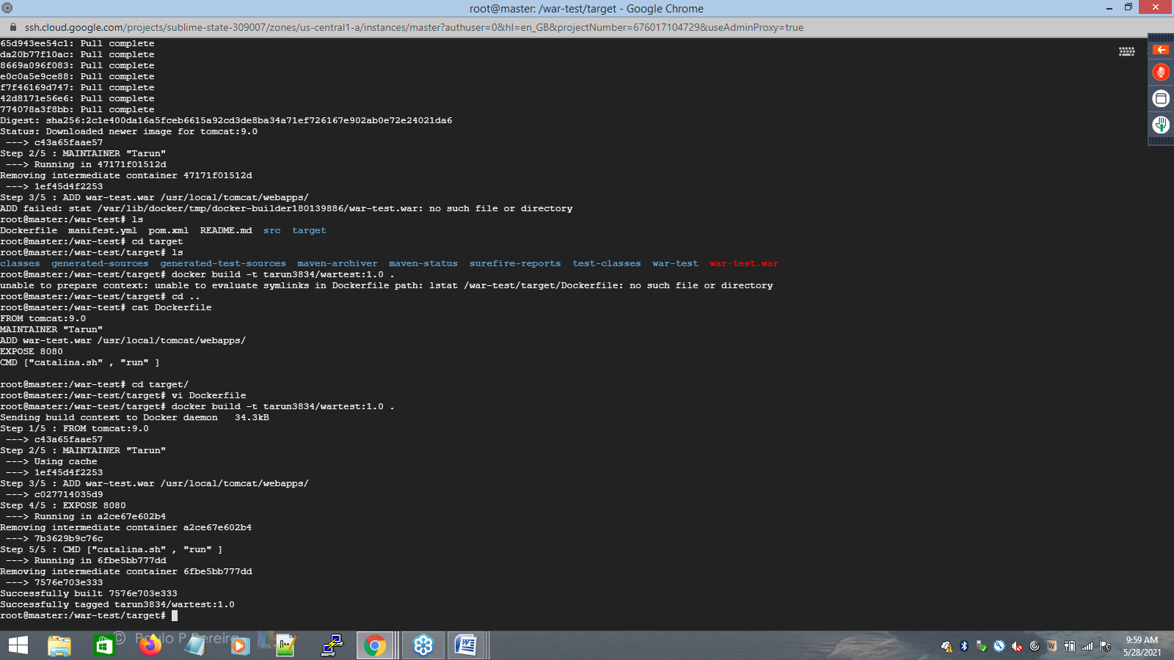

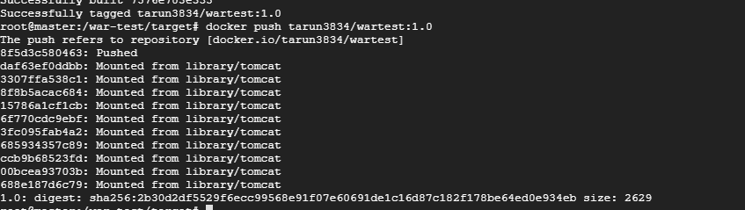

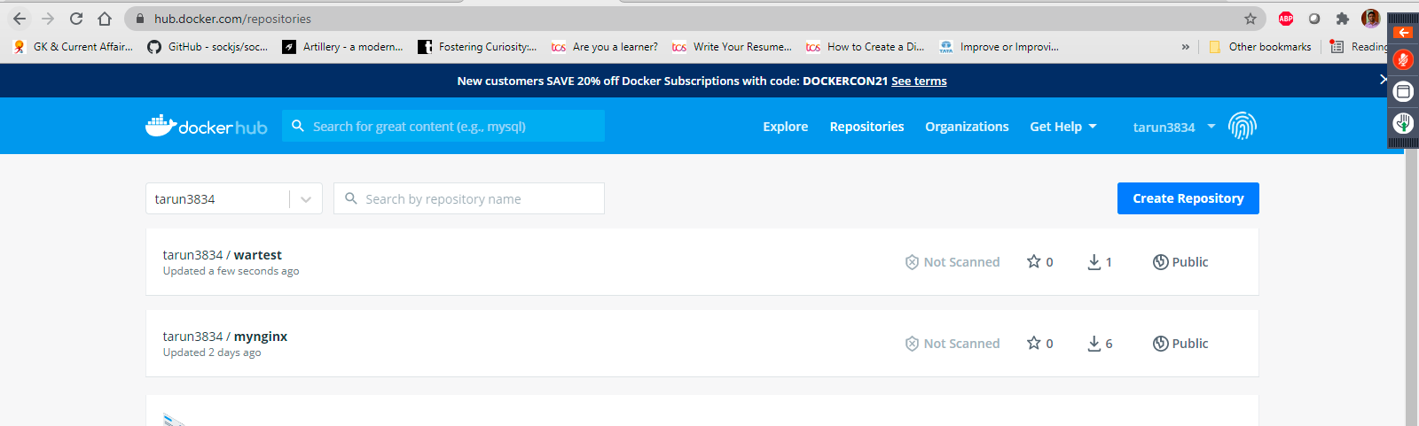

Run the playbook and check slave

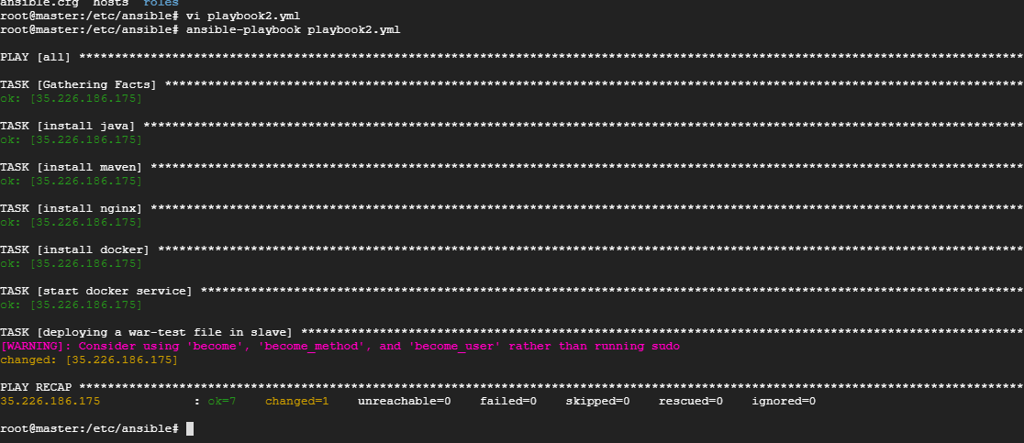

in slave



