Extraction#1:

Extraction#2:

Extraction#3:

Transformation#1

Transformation#2

Loading1:

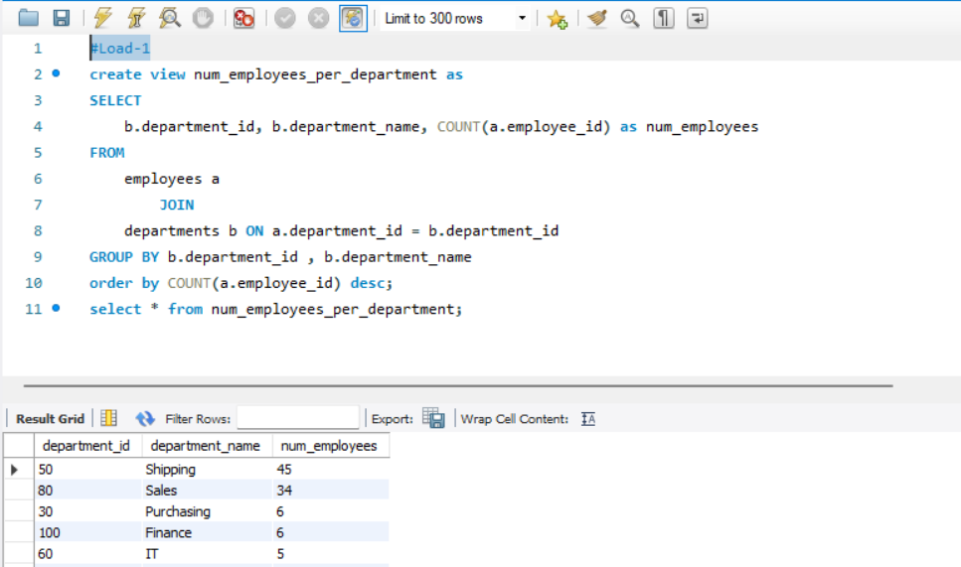

Loading2:

