Assignment:

- Initialization a GitHub Repository:
- Create a new repository- e.g AMAZ_ECOMRC_AUT

Git Setup --- commands
Git config
git - - global user.name - “User1” git config – global user.email user@example.com
Git init project directory
Git Push <Project name>
Git commit <Project name>
Git status – to check status of code
.gitignore for node_modules and other unnecessary files.

- Create the folder structure

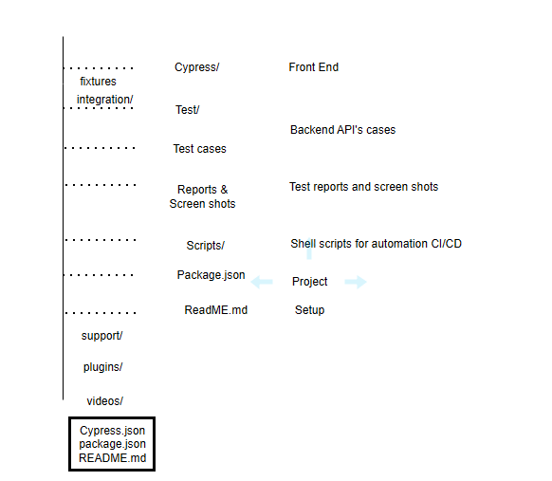
- Project Dependencies :
    - Install necessary packages for cypress,REST Assured,..etc.
Npm init -y
Npm install cypress

- Front End Automation :
Cypress/Playwright for Front end
- Go to your cypress.json file
- Ensure screen shot capture is enabled
{
“screenshotsfolder”:”cypress/screenshots”,
“video”:false
}

Search Product on Amazon.in : Use cypress to automate searching for a product e.g. Titan watch- Titan Smart 3 Premium Smart
Describe ('Amazon product Search,() => {
it('Search for Top',()=> {
Cy.visit('https://www.amzon.in');
Cy.get('#element').type('Titan Watch');
Cy.get('#element1').first().find('a').click();
Cy.wait(1000);
// capture product details
cy.get('element_name').first().within() => {
cy.get('product_name').invoke('text').as('productname');
cy.get('product_price').invoke('text').as('productprice');
cy.get('product_link').invoke('text').as('productlink');
cy.screenshot('amazon-product');
});
//Log product details
cy.get('@ productname'.then(productName =>{
cy.log('productname'+ productname);
});
cy.get('@ productprice'.then(productprice =>{
cy.log('productprice'+ productprice);
});
Cy.get('@ productlink'.then( productlink =>{
cy.log('productlink'+ productlink);
});

// Add to cart
cy.get('addtocart').click();
cy.get('proceedtoBuy').click();
cy.screenshot('amazon-cart');
// verify buy know screen
cy.url().should('include','Buyknow');

// Payment gateway
it('Navigation to the payment Gateway screen',() =>
{
cy.get('place order').click();
cy.url().should('include','payment');
});
});

Flipkart:

Search Product on Flipkart.in : Use cypress to automate searching for a product e.g. Titan watch- Titan Smart 3 Premium Smart

Describe ('Amazon product Search,() => {
it('Search for Top',()=> {
Cy.visit('https://www.flipkar.in');
Cy.get('#element').type('Titan Watch');
Cy.get('#element1').first().find('a').click();
Cy.wait(1000);
// capture product details
cy.get('element_name').first().within() => {
cy.get('product_name').invoke('text').as('fpproductname');
cy.get('product_price').invoke('text').as('fpproductprice');
cy.get('product_link').invoke('text').as('fpproductlink');
});
cy.screenshot('flipkart-product');
//Log product details
cy.get('@ productname'.then(productName =>{
cy.log('productname'+ fpproductname);
});
cy.get('@ productprice'.then(productprice =>{
cy.log('productprice'+ fpproductprice);
});
Cy.get('@ productlink'.then( productlink =>{
cy.log('productlink'+ fpproductlink);
});

// Add to cart
cy.get('addtocart').click();
cy.get('proceedtoBuy').click();
// verify buy know screen
cy.url().should('include','Buyknow');
cy.screenshot('flipkart-product');
// Payment gateway
cy.screenshot('flipkart-gateway');
it('Navigation to the payment Gateway screen',() =>
{
cy.get('place order').click();
cy.url().should('include','payment');
});
});

- Navigation Automation (above) :
  - For navigating from the cart screen to 'Buy Know' Now screen:
    - Identify and click the “Buy Now” button
    - Capture Screen shots at each step

- Backend Automation: API Testing with REST Assured
- Identify API's: User developer tools to find search related API endpoints for product details
- Axios Example:
API Testing
Const axios = require('axios');
const baseurl='https://api.amazon/product/search?q=Top';
axios.get(baseurl)
.then(response => {
console.log(response.data);
const response=await.axios.get( baseurl);
// validate response
expect(response.status).toBe(200);
expect(response.data).toHaveProperty('ProductName');
expect(response.data).toHaveProperty('Productprice')

//validate response structure

})
.catch(error => {
console.error(error);
});

- Data Validation: Compare product details from the front end automation with the API responses to ensure consistency.
- API Values: Use product ID from one API to fetch more details from another API.

- Comparison Automation ( Comparision code)
- Extract the product prices from Amazon/Flipkart using cypress scripts
- Compare prices and log the result, highlighting which platform offers the lowest price
Compare product Prices from Amazon & Flipkart
describe('Compare product price on Amazon & Flipkart',() => {
const product='Titan';
let productprice; // amazon
let fpproductprice; //flipkart

if(productprice < fpproductprice) {
cy.log('Amazon offers the lowest price' productprice);
}
else if(productprice > fpproductprice) {
cy.log('Flipkat offers the lowest price' productprice);
}
else {
cy.log('Both Amazon & Flipkart offer the same price');
}

});

- Reporting:
- Generate test Reports:
  - Use the built-in cypress reporters
  - Customize reports to include screen shots and comparison logs
  - Example (with Cypress)
Report Generation
Npx cypress run –reporter mocha
--reporter-options output=reports/test-report.html
Report Format

- Performance Testing:
- Integrate with Jmeter/Locust
  - Simulate multiple users searching for a product and navigating through the purchase steps.
  - Capture response times and identify bottlenecks
  - Example with Locust
Performance testing
From locust import HttpUser,task

class EcommUser(HttpUser);
@task
def serach product(self);
self.client.get(“/search?=top”)

- Security Testing:
- OWASP or Burp Suite:
  - Integrate with the automated tests to perform security scans on API's and the front end.

- CI/CD Integration:
- Setup Github Actions or Jenkins for Continuous Integrations:
- Example Github Actions workflow (.github/workflows/cypress.yml)
- Git commands :
git log
git rebase -i Head -n ( if necessary squash small changes)
CI/CD
Name: Cypress Tests
on:[push]
jobs:
test:
runs-on: ubuntu-latest
steps:
-name:Checkout code
users:actions/checkout@y2
name:Install dependencies
run: npm install
-name:Run Cypress tests
run:npx cypress run

- Deliverable :
- Push the code to the Github repository and ensure access is granted to the specified accounts.
- Documentation:
  - Create a detailed README.md that includes instructions for setting up,running tests, and understanding the framework structure.
README.md
#Cypress Automation for product price comparison
##** Project setup Instructions**
- ##**Pre-requsite**
Ensure you have the following installed:
[Node.js(version 12 or higher)
Gir
- clone the repository
git clone
- Install dependencies
cd cypress-amazon-flipkart-price-comparison
npm install

#Run Cypress
npx cypress open
npx cypress run – run headless
npx cypress run –reporter mochawesome

- Reports:Save test results, including screen shots, in the reports/ folder and link them in the READ file.

- Execution Time of the Test cases
- Optimization: Cypress is known for running tests quickly in the browser
- Reduce wait time: Use cypress's default automatic waiting mechanism instead of hard cy.wait()
- Parallel testing: Run the tests in parallel across multiple browsers or instances to reduce total execution time
- Headless mode: Run the tests in headless mode

12. Innovation and creative solutions
- Enhance Reporting:
  - Mochawesome is integrated to provide detailed,human readable test reports in HTML format
  - This allwos easy analysis of test results
  - Automatic screen shot capturing: Screenshots are captured at every critical point in the process, such as after searching for the product and after price comparison
  - Handling dynamic elements:
    - Project setup- designing in such a way that automation will not be effected
    - Handling price formats and currency
    - Flexible product search
    - Retry mechanism: Automatic retries for flaky tests: Cypress has bult in support for retries in case certail steps fail due to dynamic loading, product not available, network issue
- Resource optimization : ensures- memory efficient code with minimal overhead
- Innovation includes enhanced reporting,automatic handling of dynamic pop ups and creative solutions for dynamic price comparison

