ACKNOWLEDGEMENT

My sincere thanks to my supervisor Suri Parthasarathy for his guidance and extended support. His valuable feedback helped in enhancing the quality of my work. I would like to thank my organization for the ultimate support they have provided me for these 2 years. Sincere thanks to my manager Saikat Pal for the encouragement and belief.

Special thanks to the Tamil Nadu Pollution Control Board (TNPCB) for allowing me to access the libraries to research for my work and they made sure the required resources are available for this dissertation.

I am grateful to my examiner Vinaya Sathyanarayana for his constant support and guidance. His advice and suggestions have helped me mold this project in the most appropriate way and made me move in the right direction.

Lastly, I am thankful to WILP BITS Pilani, the support from the academic department is inevitable. All the Professors have helped me whenever required and gave me the right suggestions and support throughout.

Abstract

The rapid increase in air pollution levels in Chennai has raised significant concerns about its impact on public health and the environment. This dissertation explores the relationship between air pollution and public health, focusing on the city of Chennai. Using a combination of data analysis and machine learning techniques, the study investigates the patterns and trends of air quality indicators, such as particulate matter (PM10 and PM2.5), sulfur dioxide (SO2), and nitrogen dioxide (NO2).

The analysis reveals a clear association between elevated levels of air pollutants and adverse health outcomes, including respiratory diseases and cardiovascular disorders, among the urban population.

Furthermore, this dissertation explores various technological advancements and public awareness campaigns, in reducing air pollution levels and mitigating its harmful effects on human health.

Overall, the findings underscore the urgent need for coordinated efforts from policymakers, urban planners, healthcare professionals, and the public to address the complex challenges posed by air pollution and safeguard public health and environmental sustainability in urban areas.

**LIST OF SYMBOLS AND ABBREVIATIONS USED**

**LIST OF TABLES**

* 1. National Ambient Air Quality Standard
  2. Emission due to truck movement of demolishing and construction of CMRL

**LIST OF FIGURES**

Fig 2.1.1.Pollutant level with Standard Deviation

Fig 2.2.1. Pollutant level over time period

Fig 2.2.2 Correlation heat map

Fig 2.3.1 Comparison of pollutants

Fig 2.3.2 K-means clustering of pollutants

Fig 4.1 Time series AQI 2020

Fig 4.2 Time series AQI 2021

Fig 4.3 Time series AQI 2022

Fig 4.4 Time series AQI 2023

**TABLE OF CONTENTS**

Chapter 1 Problem statement

Chapter 1.2. Objectives

Chapter 2 Air pollution

Chapter 2.1 Sources of Air pollution

Chapter 2.2 Explorative data analysis

Chapter 2.3 Unsupervised learning

Chapter 2.4 CMRL work

Chapter 3 Recommendations

Chapter 4 Appendices

Chapter 5 Direction of future work

Chapter 6 Bibliography/References

Chapter 7 Checklist

Chapter 1

1.Problem Statement:

Air pollution poses a significant environmental and public health challenge in Chennai, India, with adverse effects on the city's residents and ecosystems. Despite efforts to mitigate pollution levels, the city continues to grapple with deteriorating air quality, posing significant risks to the health and well-being of its residents.

To address this issue effectively, it is imperative to gain a comprehensive understanding of the root causes, major contributors, and consequences of air pollution in Chennai.

* 1. Objective of the project:
* **Identification of Pollution Sources:** A comprehensive analysis is conducted to identify the primary sources of air pollution in Chennai, encompassing industrial emissions, vehicular traffic,construction activities.
* **Assessment of Pollution Contributors:** The study investigates the key sectors, industries, and demographic factors driving air pollution in Chennai, examining the role of industrial establishments, transportation systems, urban development patterns, population density, and socioeconomic factors.
* **Development of Mitigation Strategies:** Evidence-based recommendations and policy interventions are proposed to mitigate air pollution and improve air quality in Chennai. Measures such as emission control regulations, clean energy transitions etc.

Chapter 2: Air Pollution:

AQI: The Air Quality Index (AQI) is a standardized index used to communicate air quality levels to the public. The AQI is calculated based on concentrations of several pollutants, including particulate matter (PM2.5 and PM10), ozone (O3), nitrogen dioxide (NO2), sulfur dioxide (SO2), and carbon monoxide (CO).

AQI Pollutant = pollutant data reading /standard * 100

NAMP: NATIONAL AMBIENT AIR QUALITY MONITORING PROGRAMME

It is a comprehensive program implemented by the Central Pollution Control Board (CPCB) in India for monitoring ambient air quality across the country. NAMP aims to systematically assess and analyze air quality levels in different regions, cities, and industrial areas to understand the extent of air pollution and its impact on public health and the environment.

We are calculating the following - Particulate matter (PM2.5 and PM10), nitrogen dioxide Sulfur dioxide (SO2), and Nitrogen Dioxide (NO2).

In the end we are calculating the Annual Average Value – the annual average value represents the average concentration of a specific air pollutant.

Chapter 2.1 Sources of Air Pollution:

**Studies have shown that there are many investigations that took place with the sources of Air Pollutants in Chennai which includes particulate matter (PM), nitrogen dioxide (NO2), sulfur dioxide (SO2), carbon monoxide (CO).**

**There have been studies that shows that health effects of air pollution exposure on Chennai's population, including respiratory diseases, cardiovascular diseases, cancer, and adverse pregnancy outcomes.**

**Source attribution studies aim to identify the major contributors to air pollution in Chennai, such as vehicular emissions, industrial activities, construction, biomass burning, and dust resuspension.**

**These studies employ chemical analysis, receptor modeling techniques, and dispersion modeling to attribute pollutant sources and prioritize mitigation strategies.**

Chennai's heavy traffic congestion and reliance on motor vehicles contribute significantly to air pollution levels in the city. Studies have investigated the impact of transportation emissions on air quality and public health, highlighting the need for sustainable urban transportation policies and infrastructure improvements.

Policy-oriented research evaluates the effectiveness of existing air quality management policies and proposes evidence-based interventions to mitigate air pollution in Chennai. These studies advocate for stricter emission standards, public awareness campaigns, green infrastructure development, and intersectoral collaboration to address the complex challenges of urban air quality management.

There are multiple roads works undergoing in Chennai such as CMRL Phase 2 and 3 works which are undergoing, due to this Metro Rail work the AQI index has risen significantly, as per CMRL the Carbon Monoxide(CO) and Particulate Matter (PM) level has increased. Under construction areas are restricted for human and vehicle movements. This will result in rerouting, on the project line which passes through busy areas. This may also result in traffic congestion and air pollution from stagnated vehicles. Primary pollutants will be CO,PM.

Chapter 2.2 EXPLORATIVE DATA ANALYSIS:

Here we have taken the monthly average NAMP for North Chennai region this data has pollution levels for every month and we have analyzed the data and provide the average air quality levels and data visualization on it.

Transport activities have various effects on the environment such as air pollution, noise from road traffic. The different factors are engines used, the age of vehicles, poor road conditions and congested traffic in Chennai. The principal vehicular pollutants are carbon monoxide, oxide of nitrogen, hydrocarbons suspended particulate matters, a varying amount of sulphur dioxide, depending on sulphur content of fuel and lead compounds.

­­fig2.2.1 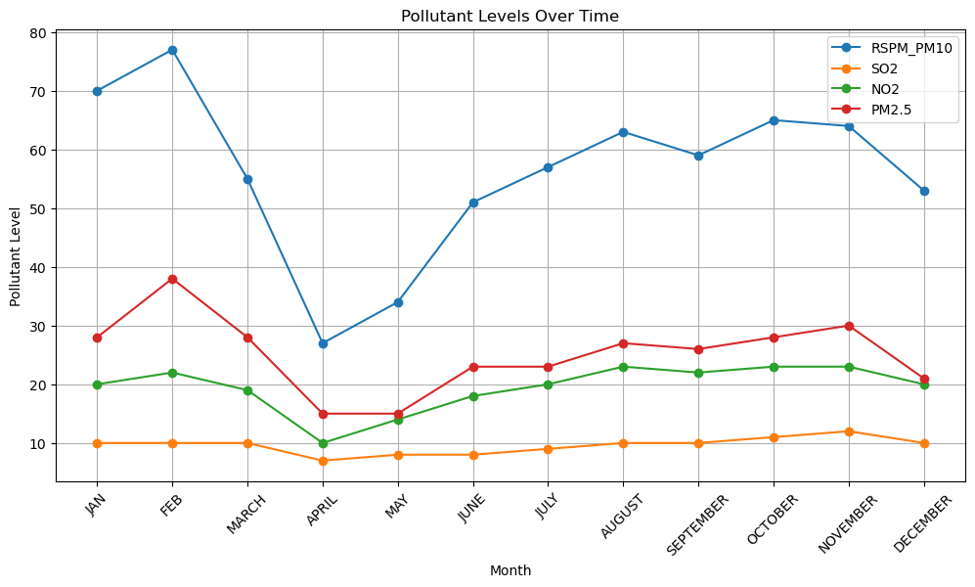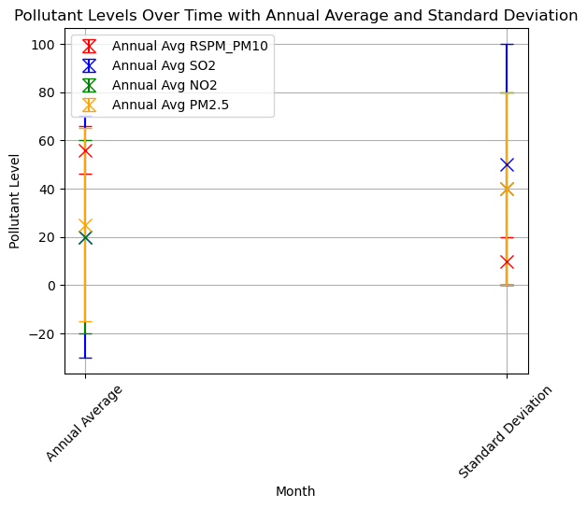fig 2.2.2

Used a correlation heatmap to identify which pollutant is positively or negatively correlated with each other. Here it shows the PM2.5 and PM10 is supposedly to high and provides a negative impact.

Chapter 2.3 Unsupervised learning:

Unsupervised learning involves training the model on unlabeled data to uncover hidden patterns or structures within the data. K-means clustering has been used here which identify the clusters in data corresponds to different pollution levels.

Inclusion of pollutants like RSPM/PM10, SO2, NO2, PM2.5 and comparing them based on their severity levels for the annual year 2022.

Below, we have compared the pollutant as to which is the highest polluting and affecting the environment

Fig 2.3.1

Determining the highest pollutant:

Below, is the comparison of pollutants with K-means clustering

Fig 2.3.2

Chapter 2.4 IMPACT DUE TO CMRL WORK:

* Construction of Chennai metro pollutes due to truck movement on account of transportation of civil construction material and disposal and it is estimated as follows: CO, HC, NOx and PM will be about 78 tons, 2.5 tons, 162 tons and 3 tons respectively. Such transportation is estimated to result in fugitive dust emission of about 19 tons during the period of construction.
* Due to the CMRL work the traffic has been significantly high and the pollution level is also increasing.
* Air pollution from road-based vehicles, especially particulates, are found to cause diseases of brain, heart, lungs and kidneys.
* Higher levels of exposure to ambient PM are associated with worse cognitive .
* Increased risk of fatal CHD associated with each 10 µgm/m3 increase in annual PM(2.5) exposure.
* Significant association between exposure to PM2.5 and risk of incident CKD, eGFR decline, and ESRD.
* The mortality rate advancement attributable to traffic pollution was like that associated with chronic respiratory and pulmonary diseases and diabetes.
* CMRL phase 2 work deadline is 2025 but till now they have almost emitted 132 tonnes of carbon monoxide, 6 tonnes of PM2.5, 274 tonnes of nitrogen oxide and more than 17,000 tonnes of carbon dioxide. All these emissions happen due to the movement of truck on account of transportation of civil construction material and waste disposal during construction.

Chapter 2.5 How does a metro city area like North Chennai estimate the Carbon monoxide concentration?

Assuming the emission spreads in a fixed box model with height (H)=1000m

To find carbon monoxide Concentration C= b+qL/uH

u – upwind wind velocity

Q - Emission rate per unit area 4*10-6 g/s.m2

H – Expected carbon monoxide dispersion height in fixed box model

L – length of the road 10km(1000m) b - **µ g/m3**

C=(5 **µ g/m3)+(4\***10-6 g/m2 * 1000 / 3 m/s * 1000m)

Therefore, the carbon monoxide concentration in a 10KM road in North Chennai = 5+0.000013= 5.000013 **µ g/m3**

**These carbon monoxide are produced majorly by cars and trucks.**

### Table 1.2 Emissions due to truck movement during demolition and construction

|  |  |
| --- | --- |
| **Pollutant** | **Emission (ton)** |
| Carbon Monoxide (CO) | 63.00 |
| PM2.5 | 2.0 |
| Hydro-Carbons (HC) | 2.0 |
| Nitrogen Oxide (NOx) | 131.0 |
| VOC | 20.0 |
| Carbon dioxide (CO2) | 8145 |

Chapter 3

RECOMMENDATIONS:

Promote Sustainable Transportation: Try to choose eco-friendly transportation options such as walking, cycling, or using public transportation whenever possible. Reduce reliance on personal vehicles to decrease vehicle emissions and contribute to cleaner air.

Avoid High-Traffic Areas: Limit time spent in areas with heavy traffic congestion or industrial activity, where pollutant concentrations tend to be higher. Try to opt for less polluted routes or green spaces for outdoor activities like walking or exercising.

Reduce Exposure: Minimize exposure to outdoor air pollution by staying indoors during peak pollution hours, typically during rush hours or when pollutant levels are highest. Use air purifiers with HEPA filters indoors to reduce indoor air pollution.

Monitor Air Quality: Stay informed about local air quality levels by regularly checking air quality index (AQI) reports provided by TNPCB or CPCB. Avoid outdoor activities or take precautions on days when air quality is poor, especially during high-pollution events like festivals or wildfires. Always wear Masks while travelling in these polluted areas.

Plant Trees and Greenery: After each Metro work is complete, start tree-planting initiatives and urban greening projects to enhance green infrastructure and improve air quality. Trees and vegetation help absorb pollutants, provide shade, and create healthier urban environments.

Chapter 4

Appendix 1

Time series analysis from 2019- 2022

We can see that the time series for each month are shown from January 2019 – December 2022. Predominantly, during the month of January, October and November the AQI lies on the higher side.

Fig 4.1

Fig 4.2

Fig 4.3

Fig 4.4

Chapter 5

Future work:

All these results show that when monitored for long term, the outcome such as health impact assessment, public awareness and community engagement will help in conduct comprehensive assessment and studies.

If longitudinal studies are conducted in order to track changes in air quality and health outcomes over time. Long-term data collection can provide valuable insights into trends, patterns, and the effectiveness of interventions in reducing air pollution and associated health risks.

If advanced machine learning models for air quality prediction, pollution source identification, and health impact assessment are developed. Utilizing big data analytics and artificial intelligence techniques to enhance the accuracy and efficiency of air quality management strategies.

Once the metro work is completed and comprehensive health impact assessments are conducted to quantify the burden of air pollution on public health outcomes, including respiratory diseases, cardiovascular disorders, and premature mortality. Evaluating these economic costs of pollution-related health care expenditures and productivity losses.

Chapter 6

References:

TAMILNADU POLLUTION CONTROL BOARD <https://tnpcb.gov.in/>

CENTRAL POLLUTION CONTROL BOARD <https://cpcb.nic.in/>

<https://airquality.cpcb.gov.in/>

CHENNAI METRO RAIL <https://chennaimetrorail.org/>

Chapter 7

Check list of items for the Final report

a) Is the Cover page in proper format? Y

b) Is the Title page in proper format? Y

c) Is the Certificate from the Supervisor in proper format? Has it been signed? Y

d) Is Abstract included in the Report? Is it properly written? Y

e) Does the Table of Contents page include chapter page numbers? Y

f) Does the Report contain a summary of the literature survey? N

i. Are the Pages numbered properly? Y

ii. Are the Figures numbered properly? Y

iii. Are the Tables numbered properly? Y

iv. Are the Captions for the Figures and Tables proper? Y

v. Are the Appendices numbered? Y

g) Does the Report have Conclusion / Recommendations of the work? Y

h) Are References/Bibliography given in the Report? Y

i) Have the References been cited in the Report? Y

j) Is the citation of References / Bibliography in proper format? Y

Student signature

