INSUREHUB
Insurance Policy Management System
Team Project Architecture & Implementation Guide

Assigned Project Topic
Insurance Policy Management API — Create, Renew, and Cancel Insurance Policies.
The goal is to build a complete web application, not only a CRUD application.

Suggested Stack: React + Spring Boot + Spring Security/JWT + JPA/Hibernate + PostgreSQL

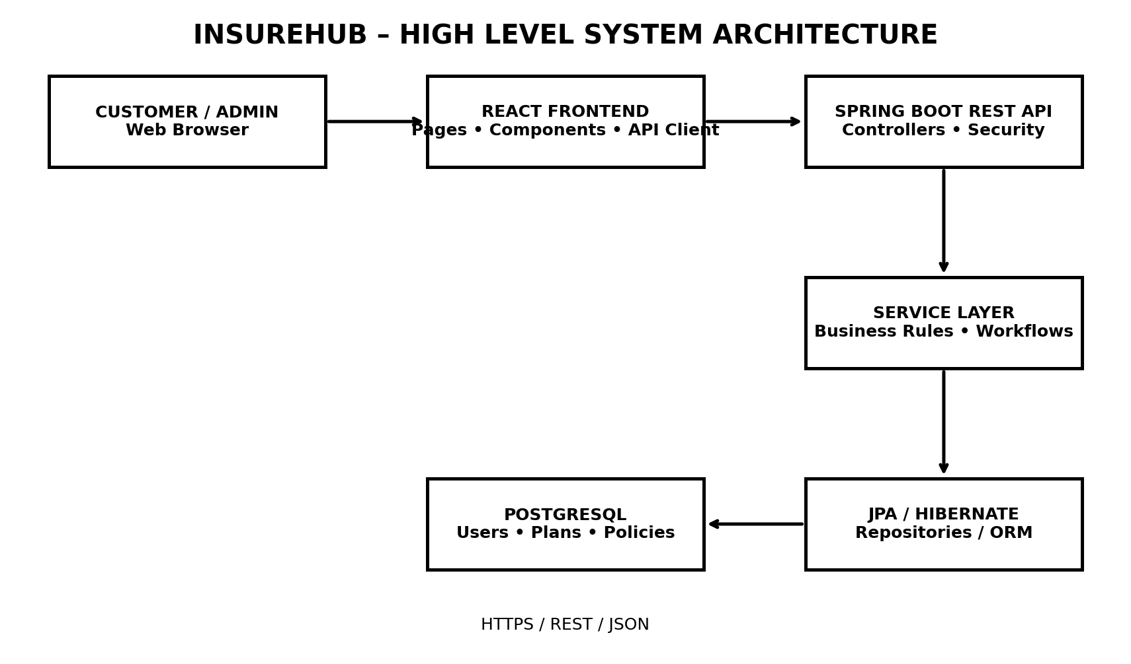
Figure 1 — Complete system at a glance

TEAM GUIDE • BUILD THIS TOGETHER • KEEP THE CODE MODULAR

1. What We Are Building
InsureHub is a role-based insurance policy management website. A customer can register, log in, browse insurance plans, calculate an estimated premium, purchase a policy, view policy details, renew an eligible policy, and request cancellation. An administrator can manage plans, inspect policies, and approve or reject cancellation requests.
The key idea
CRUD is only one part of the project. The main value comes from business workflows: premium calculation, policy state changes, renewal rules, cancellation approval, audit history, authentication, authorization and validation.

Project goals
- Build a real end-to-end web application with separate frontend, backend and database layers.
- Expose a clean REST API that the React frontend consumes.
- Use JWT authentication and role-based authorization.
- Implement meaningful insurance business rules rather than only create/read/update/delete.
- Maintain policy history instead of deleting important records.
- Document and test the API with Swagger/OpenAPI, Postman and automated tests.
- Keep the GitHub repository easy for four members to collaborate on.

What each member should understand
Member | Primary work | Must understand
Member 1 – Backend | Spring Boot, JPA, APIs, security, business logic | Database + API contract + policy lifecycle
Member 2 – Frontend | React pages, components, API integration, UI | API request/response + auth flow
Member 3 – Report | Documentation, diagrams, test evidence, screenshots | Complete feature workflow
Member 4 – PPT/Demo | Presentation, architecture, demo script, results | Why design choices were made

2. System Architecture
The application follows a simple three-tier architecture. Each layer has a clear responsibility.
Figure 2 — High-level architecture

How a normal request travels
- The user clicks a button in the React frontend.
- React sends an HTTP request to the Spring Boot REST API.
- Spring Security checks the JWT and required role.
- The Controller receives and validates the request.
- The Service layer applies business rules.
- The Repository uses JPA/Hibernate to access PostgreSQL.
- The backend returns a JSON response to React.
- React updates the screen.

Example: Renew Policy
React: POST /api/policies/INS-10231/renew
↓
PolicyController
↓
RenewalService
↓
Check policy status + renewal eligibility
↓
Calculate new premium
↓
Update expiry + create history entry
↓
PolicyRepository → PostgreSQL
↓
PolicyResponse JSON → React
Rule of thumb
Controllers should be thin. Put actual insurance rules in services. Repositories should focus on database access.

3. Backend Architecture – Easy Version
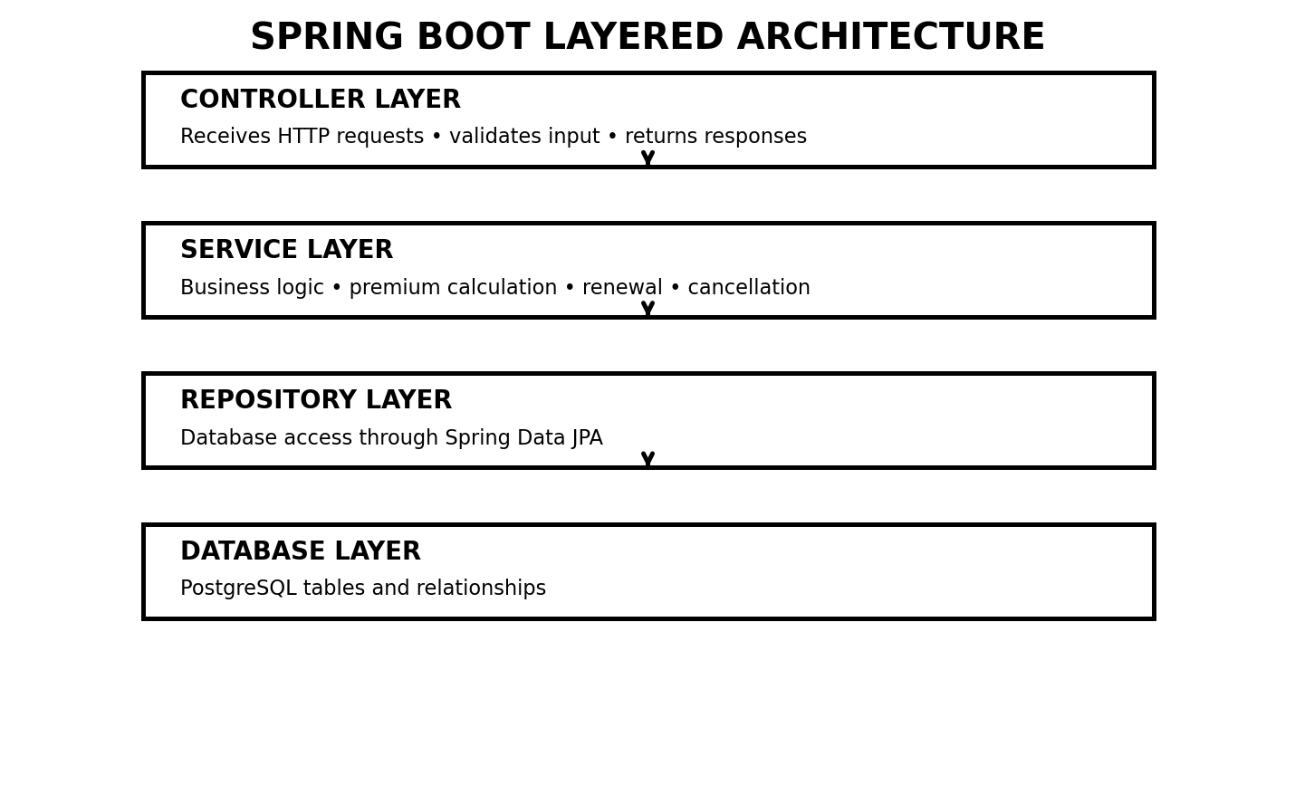
Figure 3 — Spring Boot layered architecture
Layer | What it does | Example classes
Controller | Receives HTTP requests and sends HTTP responses | PolicyController, AuthController
Service | Contains business logic and workflows | PolicyService, RenewalService
Repository | Reads/writes database records | PolicyRepository
Entity | Maps Java objects to database tables | Policy, User, InsurancePlan
DTO | Controls what comes into/out of the API | CreatePolicyRequest, PolicyResponse
Security | Authentication and authorization | JwtFilter, SecurityConfig
Exception | Consistent error responses | GlobalExceptionHandler

Recommended backend package structure
backend/
└── src/main/java/com/insurehub/
├── controller/
├── service/
├── repository/
├── entity/
├── dto/
├── security/
├── exception/
├── config/
└── util/

Why this structure?
If the frontend member changes a screen, the database code should not need to be rewritten. If the premium formula changes, it should mostly affect PremiumService rather than a controller. Separation makes debugging and teamwork easier.

4. Functional Features

Customer features
- Register and log in.
- View available insurance plans.
- Open plan details.
- Calculate an estimated premium.
- Purchase a policy.
- View all own policies.
- Open a policy and see coverage, premium, dates and status.
- Renew an eligible policy.
- Request cancellation.
- View policy history.

Admin features
- Log in as administrator.
- Create/update/deactivate insurance plans.
- View customers and policies.
- View pending cancellation requests.
- Approve/reject cancellation requests.
- View policy history and operational statistics.

Optional features – only after the core is finished
- Payment simulation with a fake transaction record.
- Email-style renewal reminder simulation.
- Claims module.
- Search/filter/sort policies.
- Dashboard charts.
- Export policy data.
Scope control
Do not start with claims, real payment gateways or email integration. Finish authentication → plans → premium → policy → renewal → cancellation → history first.

5. Main Business Workflow – Policy Lifecycle
The policy lifecycle is the feature that turns this project from a basic CRUD system into a workflow-based application.
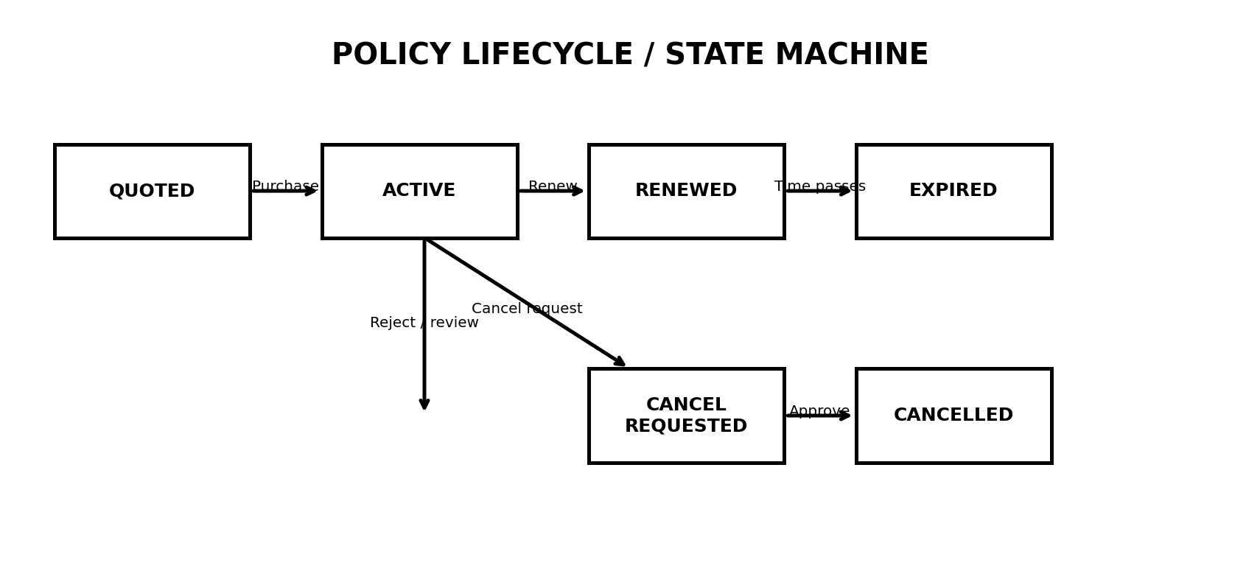
Figure 4 — Policy lifecycle / state machine
Status | Meaning | Typical next action
QUOTED | Premium has been calculated but policy is not active | Purchase
ACTIVE | Policy is currently valid | Renew or request cancellation
RENEWED | Renewal operation has been completed | Continue as active policy
EXPIRED | End date has passed | Renew if business rules allow
CANCEL REQUESTED | Customer asked to cancel; admin review required | Approve / reject
CANCELLED | Policy has been cancelled | View history only

Important business rules
- A cancelled policy must not be renewed.
- A policy should not be physically deleted when cancellation occurs.
- Only the policy owner can operate on their own customer policy.
- Only an authorized admin can approve or reject cancellation requests.
- Renewal must create a history record.
- Cancellation request and decision must create history records.
- Policy number must be unique.
- Dates and coverage must satisfy validation rules.

6. Premium Calculation – Business Logic
The premium calculator is deliberately included so the application performs meaningful computation instead of simply storing form data.
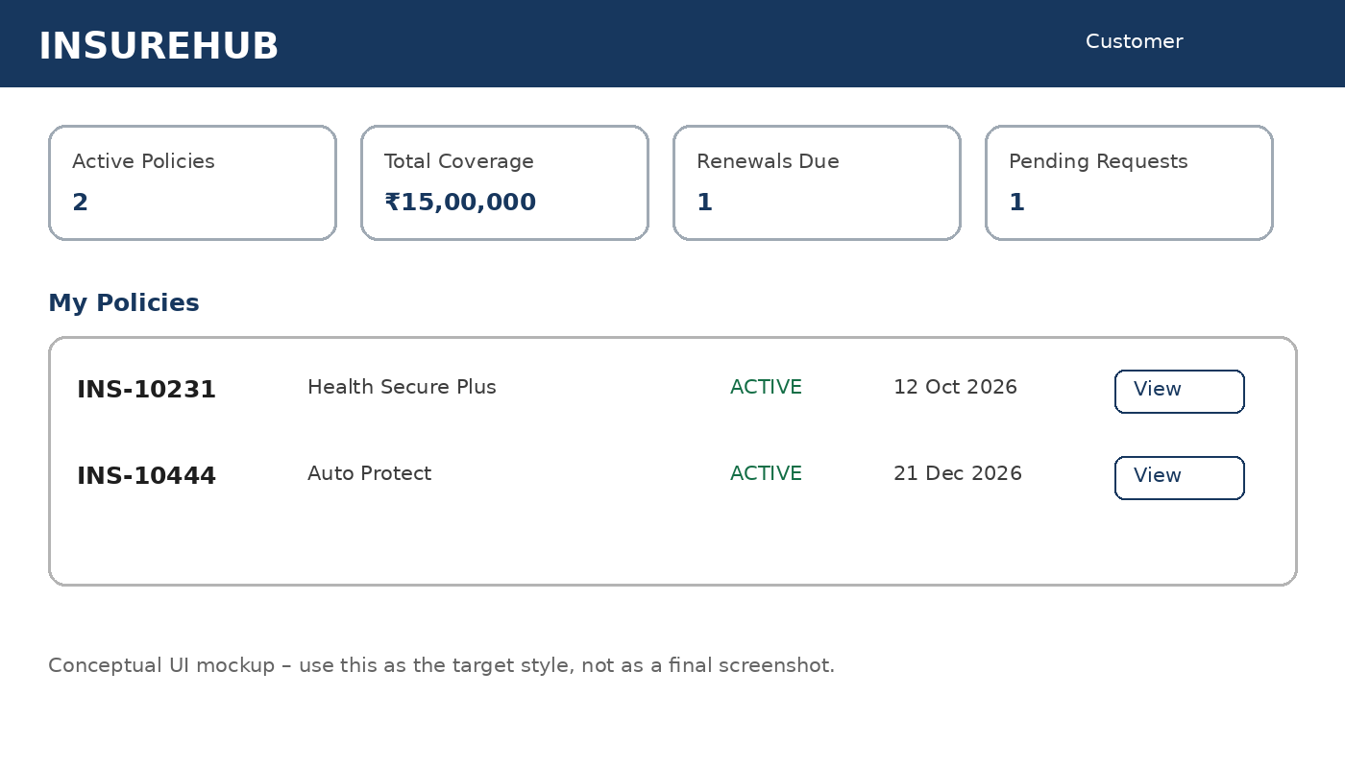
Figure 5 — Conceptual customer dashboard mockup

Suggested formula
finalPremium = basePremium
+ ageFactor
+ coverageFactor
+ riskFactor
- discount
Input | Example | Purpose
Plan | Health Secure Plus | Determines base premium
Age | 25 | Can affect risk/age factor
Coverage | ₹5,00,000 | Higher coverage can increase premium
Duration | 1 year | Changes policy period
Risk category | LOW / MEDIUM / HIGH | Optional simple business rule
Discount | 0–10% | Optional controlled discount

API example
POST /api/quotes/calculate
Request
{
"planId": 2,
"age": 25,
"coverageAmount": 500000,
"durationYears": 1
}
Response
{
"basePremium": 10000,
"ageFactor": 500,
"coverageFactor": 2000,
"riskFactor": 500,
"discount": 0,
"finalPremium": 13000
}
Important
The exact formula is a project-defined simulation, not a real insurer's underwriting formula. State this clearly in the report.

7. Database Design
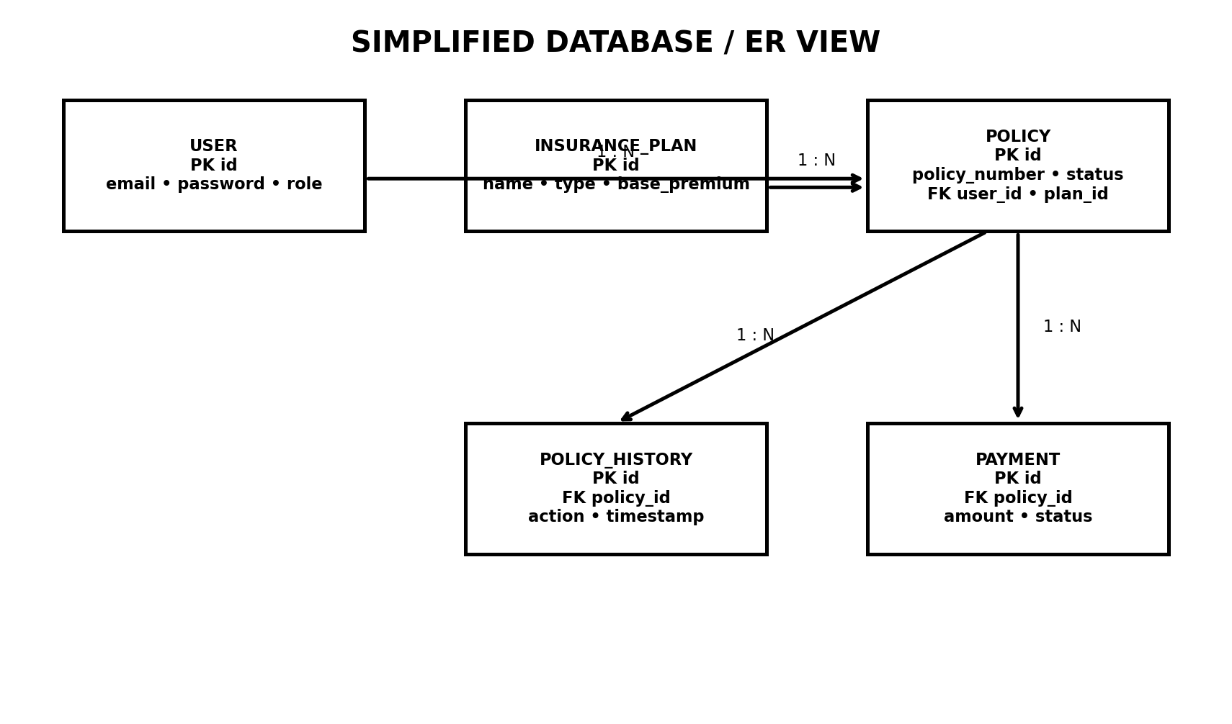
Figure 6 — Simplified ER/database view

Core tables
Table | Important fields | Relationship
USER | id, name, email, password_hash, phone, role, created_at | One user → many policies
INSURANCE_PLAN | id, name, type, description, coverage_amount, base_premium, duration, status | One plan → many policies
POLICY | id, policy_number, user_id, plan_id, premium, dates, status | Belongs to user and plan
POLICY_HISTORY | id, policy_id, action, description, performed_by, timestamp | Many history records → one policy
PAYMENT | id, policy_id, amount, transaction_id, status, payment_date | Many payments → one policy

Relationships
- USER 1 → N POLICY
- INSURANCE_PLAN 1 → N POLICY
- POLICY 1 → N POLICY_HISTORY
- POLICY 1 → N PAYMENT

Do not store passwords as plain text
The User table should contain a password hash produced by a secure password encoder. The frontend should never receive the stored password hash.

8. API Contract – The Bridge Between Frontend and Backend
Before both technical members code heavily, agree on endpoint names, request JSON, response JSON, status codes and authentication requirements. This prevents the frontend and backend from blocking each other.
Method | Endpoint | Purpose | Access
POST | /api/auth/register | Create customer account | Public
POST | /api/auth/login | Authenticate and return JWT | Public
GET | /api/plans | List active insurance plans | Public/Customer
GET | /api/plans/{id} | Get plan details | Public/Customer
POST | /api/plans | Create plan | ADMIN
PUT | /api/plans/{id} | Update plan | ADMIN
POST | /api/quotes/calculate | Calculate premium | Customer
POST | /api/policies | Create/purchase policy | Customer
GET | /api/policies/my | Customer's policies | Customer
GET | /api/policies/{id} | Policy details | Owner/Admin
POST | /api/policies/{id}/renew | Renew policy | Owner
POST | /api/policies/{id}/cancel | Request cancellation | Owner
GET | /api/policies/{id}/history | Policy audit trail | Owner/Admin
GET | /api/admin/cancellation-requests | Pending requests | ADMIN
PUT | /api/admin/cancellation-requests/{id}/approve | Approve cancellation | ADMIN
PUT | /api/admin/cancellation-requests/{id}/reject | Reject cancellation | ADMIN

Example: create policy
POST /api/policies
Authorization: Bearer <JWT>
{
"planId": 2,
"coverageAmount": 500000,
"durationYears": 1
}

Example response
201 Created
{
"policyNumber": "INS-2026-000182",
"planName": "Health Secure Plus",
"premium": 13000,
"startDate": "2026-09-05",
"expiryDate": "2027-09-04",
"status": "ACTIVE"
}

9. Authentication & Authorization
Use Spring Security with JWT-based bearer authentication. The login endpoint returns a token. The frontend stores the token in an appropriate client-side mechanism and sends it in the Authorization header for protected API calls.
Login
POST /api/auth/login
↓
Validate email + password
↓
Create JWT containing user identity/role
↓
React receives token
↓
Authorization: Bearer <token>
↓
Spring Security validates token
↓
Controller is allowed/blocked

Roles
Role | Can do
CUSTOMER | Browse plans, calculate premium, purchase/view/renew/cancel own policies
ADMIN | Manage plans, inspect users/policies, approve/reject cancellation requests
AGENT (optional) | Assist with customer policy operations if the team has time

Security boundary
Never trust a userId sent by the frontend to decide ownership. The backend should derive the authenticated user from the security context/JWT and then check ownership.

Useful HTTP status codes
Code | Meaning
200 | Successful request
201 | Resource created
400 | Invalid request/business rule
401 | Not authenticated / invalid token
403 | Authenticated but not authorized
404 | Resource not found
409 | Conflict, e.g. invalid state or duplicate policy number
500 | Unexpected server error

10. Validation & Exception Handling

Validation examples
- Email must be valid.
- Required fields cannot be empty.
- Coverage amount must be positive and within the selected plan's limits.
- Duration must be within the plan's allowed duration.
- A cancelled policy cannot be renewed.
- Only the owner/admin can view protected policy information.
- Duplicate policy numbers must be rejected.
- Cancellation should only be requested for valid policy states.

Consistent error response
{
"timestamp": "2026-09-05T15:30:00",
"status": 409,
"error": "INVALID_POLICY_STATE",
"message": "Policy INS-10231 cannot be renewed because it is cancelled."
}

Suggested exception classes
- PolicyNotFoundException
- PlanNotFoundException
- UserNotFoundException
- InvalidPolicyStateException
- UnauthorizedPolicyAccessException
- DuplicatePolicyException
Why this matters in viva
Instead of saying 'Spring handles the error', explain that GlobalExceptionHandler converts predictable application failures into clean, consistent HTTP responses for the frontend.

11. Frontend Structure
React is component-based, so keep reusable UI pieces separate from pages and API logic. The frontend should never contain database logic; it calls the backend API.
frontend/
└── src/
├── components/
│ ├── Navbar.jsx
│ ├── PolicyCard.jsx
│ ├── PlanCard.jsx
│ └── ProtectedRoute.jsx
├── pages/
│ ├── Login.jsx
│ ├── Register.jsx
│ ├── Dashboard.jsx
│ ├── Plans.jsx
│ ├── PremiumCalculator.jsx
│ ├── MyPolicies.jsx
│ ├── PolicyDetails.jsx
│ ├── RenewPolicy.jsx
│ ├── CancelPolicy.jsx
│ └── AdminDashboard.jsx
├── services/
│ └── api.js
├── context/
│ └── AuthContext.jsx
├── hooks/
├── utils/
└── App.jsx

Suggested screens
Screen | Purpose
Login/Register | Authentication
Customer Dashboard | Summary of policies and upcoming actions
Plans | Browse insurance plans
Plan Details | Coverage, premium and terms
Premium Calculator | Estimate premium
Purchase Policy | Confirm details and create policy
My Policies | List customer policies
Policy Details | Show full policy + actions
Renew Policy | Show renewal calculation and confirmation
Cancel Policy | Submit cancellation request
Policy History | Show audit trail
Admin Dashboard | Operational summary
Manage Plans | Admin CRUD for insurance plans
Cancellation Requests | Admin approve/reject workflow

12. GitHub Repository & Team Workflow
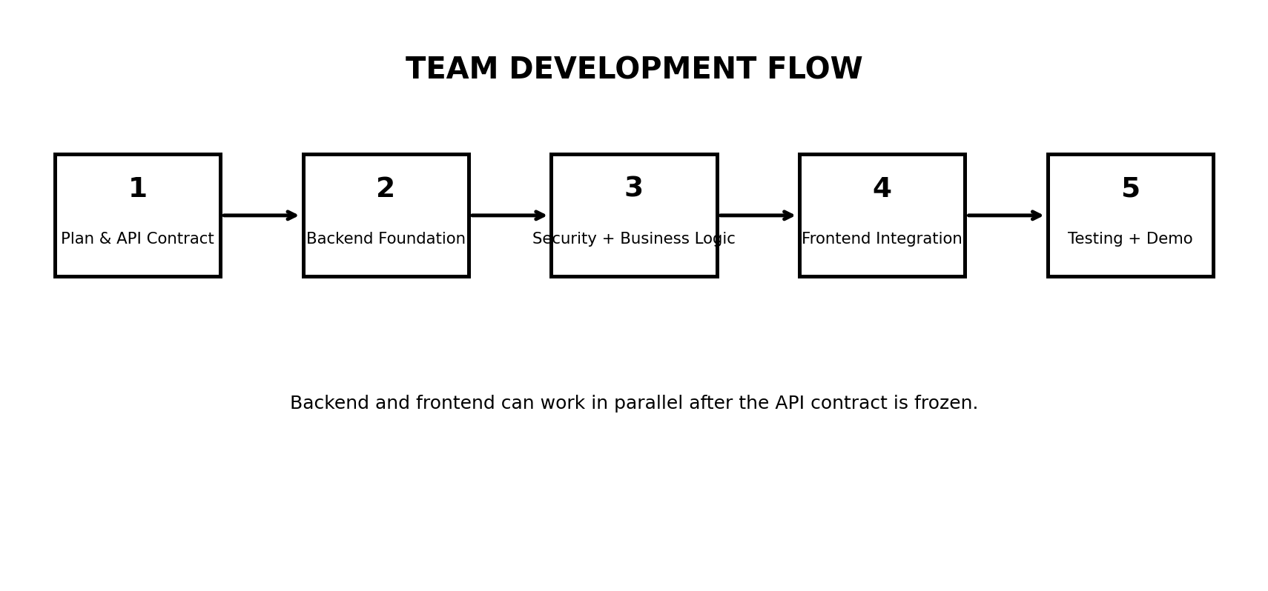
Figure 7 — Recommended development flow
insurance-policy-management/
├── backend/
├── frontend/
├── docs/
│ ├── architecture/
│ ├── database/
│ ├── api/
│ ├── screenshots/
│ └── project-report/
├── README.md
└── .gitignore

Recommended branches
- main – stable integrated version
- backend-dev – backend member
- frontend-dev – frontend member
- docs-dev – report/PPT members (or separate branches if preferred)

Commit examples
feat: add policy creation API
feat: implement JWT login
feat: add renewal workflow
feat: add customer dashboard
docs: add ER diagram
test: add policy renewal tests

The most important collaboration file
Create docs/api/API_CONTRACT.md before major frontend/backend development. It should define every endpoint, request JSON, response JSON, authentication requirement and common errors.

13. Team Task Breakdown
Member | Week/Phase | Tasks | Deliverable
Backend | Phase 1 | Project setup, DB connection, entities | Spring Boot skeleton + schema
Backend | Phase 2 | Repositories, services, controllers | Plan + policy APIs
Backend | Phase 3 | JWT, roles, validation, exceptions | Secure API
Backend | Phase 4 | Renewal, cancellation, history | Complete workflow
Frontend | Phase 1 | Wireframes + routing | Page skeleton
Frontend | Phase 2 | Login, plans, dashboard | Core UI
Frontend | Phase 3 | Policy purchase, renew, cancel | Workflow UI
Frontend | Phase 4 | Admin UI + polish | Integrated frontend
Report | Throughout | Requirements, diagrams, screenshots | Report material
PPT/Demo | Throughout | Architecture, feature slides, demo script | Presentation-ready material

Parallel work rule
Once the API contract is agreed, backend and frontend can work in parallel. The frontend member can use mocked JSON responses while backend endpoints are being developed.
Do not block each other
Frontend should not wait for the backend to be 100% finished. Build screens against the agreed API contract and replace mocks with real Axios calls during integration.

14. Testing Plan

Manual/API test cases
Test | Expected result
Register valid customer | 201 Created
Register duplicate email | 400/409 with clear error
Login valid credentials | JWT returned
Login wrong password | 401
Customer reads own policies | 200
Customer reads another user's policy | 403/404 according to design
Calculate valid premium | 200 + correct calculation
Create policy with invalid plan | 400/404
Renew active policy | 200 + new expiry/history
Renew cancelled policy | 409
Request cancellation | 200/202 + history
Admin approves cancellation | 200 + status CANCELLED
Non-admin approves cancellation | 403
Unknown policy ID | 404

Automated tests
- PremiumServiceTest – verify formula and edge cases.
- PolicyServiceTest – create policy and validation.
- RenewalServiceTest – active/expired/cancelled cases.
- CancellationServiceTest – request and approval rules.
- Controller/API tests – status codes and validation responses.

Testing evidence for report
- Swagger screenshots
- Postman request/response screenshots
- JUnit test results
- Database screenshots showing policy history
- Frontend screenshots of successful workflows

15. Final Demonstration Script
Do not demo the project by randomly clicking pages. Tell a short story and demonstrate one complete business journey.
- Open the application and show the landing/login screen.
- Register a customer or use a prepared demo customer.
- Log in and show the customer dashboard.
- Open insurance plans.
- Select a plan and calculate premium.
- Purchase the policy.
- Open My Policies and show ACTIVE status.
- Open policy history and show the CREATED/ACTIVATED entry.
- Renew the policy and show the changed expiry/history.
- Request cancellation.
- Log out and log in as ADMIN.
- Open cancellation requests and approve the request.
- Open the policy again and show CANCELLED status plus complete history.
- Open Swagger and show the REST API documentation.
- Optionally show a failed request to demonstrate validation/security.
Best viva sentence
“The project uses CRUD for persistent resources, but the core functionality is workflow-based: premium calculation, policy state transitions, renewal, cancellation approval, audit history and role-based authorization.”

16. Viva / Presentation Talking Points
Question | Short answer
Why Spring Boot? | It provides a clean framework for REST APIs, dependency injection, validation and integration with JPA/security.
Why REST API? | It separates frontend from backend and lets different clients consume the same services.
Why JPA/Hibernate? | It maps Java entities to relational database tables and simplifies persistence.
Why JWT? | It provides bearer-token authentication for protected API requests.
Why roles? | Customers and admins must have different permissions.
Why not delete cancelled policies? | Insurance systems need history/auditability; cancellation is a business state, not deletion.
Where is business logic? | Primarily in services such as PremiumService, RenewalService and CancellationService.
How is it more than CRUD? | Premium calculation, state machine, workflows, authorization, audit history and validation.
How does frontend talk to backend? | Through HTTP REST endpoints returning JSON.
How do you test APIs? | Swagger/Postman for API testing plus JUnit/Mockito for automated tests.

17. Complete Project Folder Blueprint
insurance-policy-management/
│
├── backend/
│ ├── src/main/java/com/insurehub/
│ │ ├── controller/
│ │ │ ├── AuthController.java
│ │ │ ├── PlanController.java
│ │ │ ├── PolicyController.java
│ │ │ └── AdminController.java
│ │ ├── service/
│ │ │ ├── AuthService.java
│ │ │ ├── PremiumService.java
│ │ │ ├── PolicyService.java
│ │ │ ├── RenewalService.java
│ │ │ └── CancellationService.java
│ │ ├── repository/
│ │ ├── entity/
│ │ ├── dto/
│ │ ├── security/
│ │ ├── exception/
│ │ └── config/
│ ├── src/test/
│ └── pom.xml
│
├── frontend/
│ ├── src/
│ │ ├── components/
│ │ ├── pages/
│ │ ├── services/
│ │ ├── context/
│ │ ├── hooks/
│ │ └── utils/
│ └── package.json
│
├── docs/
│ ├── architecture/
│ ├── database/
│ ├── api/
│ ├── screenshots/
│ └── project-report/
│
└── README.md

Suggested README sections
- Project overview
- Features
- Architecture
- Technology stack
- Folder structure
- How to run backend
- How to run frontend
- Database setup
- Environment variables
- API/Swagger link
- Demo credentials
- Team members and responsibilities

18. Implementation Roadmap
Figure 8 — Build in this order
Phase | Goal | Definition of done
1. Planning | Freeze requirements and API contract | ERD + endpoints + screen list agreed
2. Backend foundation | DB + entities + repositories | Application connects to PostgreSQL
3. Core APIs | Plans + auth + policies | Basic end-to-end API works
4. Security | JWT + roles | Protected endpoints behave correctly
5. Business workflows | Premium + renew + cancel + history | Complete policy lifecycle works
6. Frontend | Customer + admin UI | All major workflows work through UI
7. Integration | Connect real frontend/backend | No major mock data remains
8. Testing | Unit + API + manual | Test evidence collected
9. Documentation | Report + PPT + screenshots | Submission package complete
10. Final demo | One clean story | Team can explain architecture and code

Recommended stopping point
If time becomes short, stop adding features after the complete customer/admin policy lifecycle. A polished core project is better than five unfinished modules.

19. Technology References
The implementation choices in this guide align with the official documentation for React and Spring technologies. These links are included mainly so the team can learn the framework concepts from primary sources.
React Quick Start — Official React guide covering components, JSX, state, events and lists.
https://react.dev/learn
React Installation / App Setup — Official guidance for starting React projects; Create React App is deprecated.
https://react.dev/learn/installation
Spring REST Guide — Official Spring tutorial for building REST services with Spring Boot.
https://spring.io/guides/tutorials/rest/
Spring Data REST / JPA — Spring guide showing relational JPA data exposed through REST.
https://spring.io/guides/gs/accessing-data-rest/
Spring Security — Spring Boot security reference, including method-level security.
https://docs.spring.io/spring-boot/3.5/reference/web/spring-security.html
Spring Security JWT Resource Server — Official Spring Security reference for bearer tokens including JWT.
https://docs.spring.io/spring-security/reference/servlet/oauth2/resource-server/index.html
springdoc-openapi — OpenAPI/Swagger integration for Spring Boot.
https://github.com/springdoc/springdoc-openapi

Final checklist
- ☐ GitHub repository created with backend/, frontend/, docs/
- ☐ ER diagram finalized
- ☐ API contract finalized
- ☐ Backend connects to PostgreSQL
- ☐ JWT login works
- ☐ Customer/admin roles work
- ☐ Premium calculation works
- ☐ Policy creation works
- ☐ Renewal works
- ☐ Cancellation request + admin approval works
- ☐ Policy history works
- ☐ Frontend integrated
- ☐ Swagger works
- ☐ Tests and screenshots collected
- ☐ Report and PPT completed
- ☐ Final demo rehearsed

