ONLINE COUNSELLING MANAGEMENT SYSTEM

**PROBLEM STATEMENT**

Consider online counselling system. Objective of system is to manage all counselling related processes. the system conducts the seat allotment process for the university in which multiple colleges are affiliated with multiple engineering branches such as cs, it, electrical, etc.

University assign rank to each of student based on academic excellence.

Initially, student fills an online application for counselling for which he provides personal academic and other details.

Student will be allotted seat in college and branch based on joint exam score.

If same joint exam score,then seat allocation is based on school %age.

On completion of counselling, student is provided confirmation letter containing reg no,branch,college,etc

Keep track of no seats at any particular time.

**SUBMISSION DETAILS:**



*The Appropriate Verifier is Business Modeling Tool, as shown in figure below:*

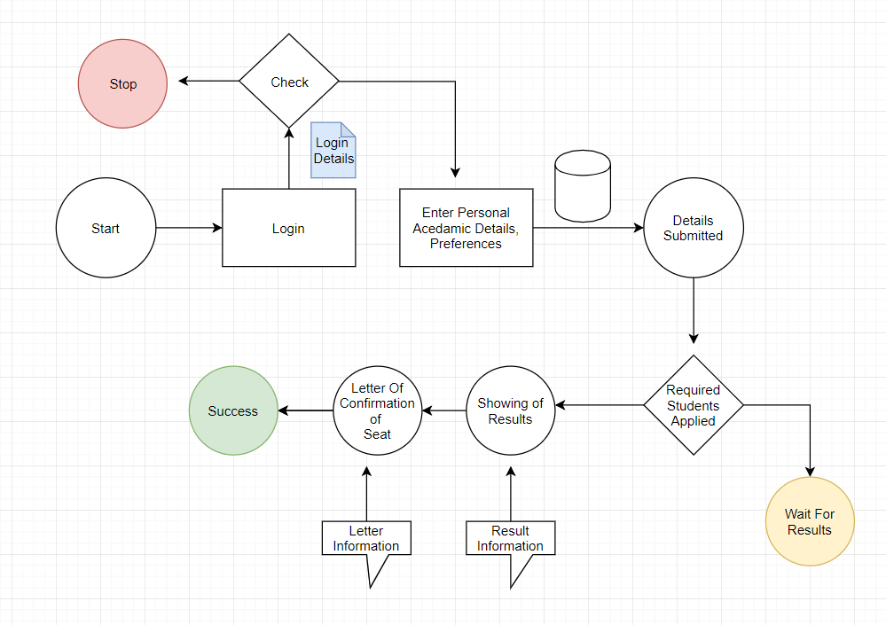

**REQUIREMENT AND DEFINITION PHASE:**

We use USECASE TOOLS to check the various requirements and actions of different users of project.

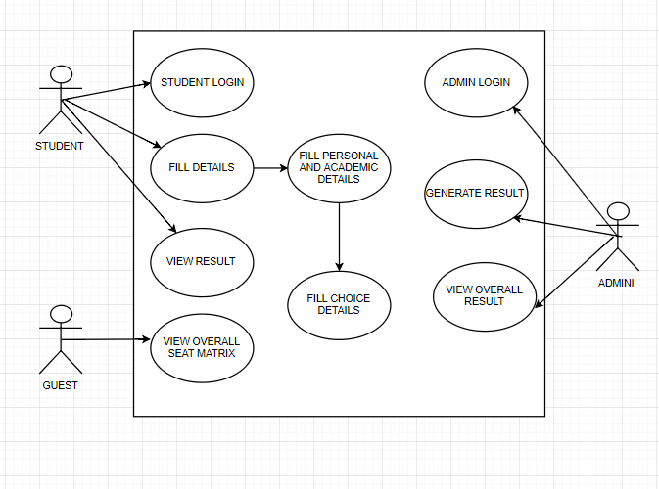



*The Appropriate Verifier is Activity Diagram, as shown in figure below:*

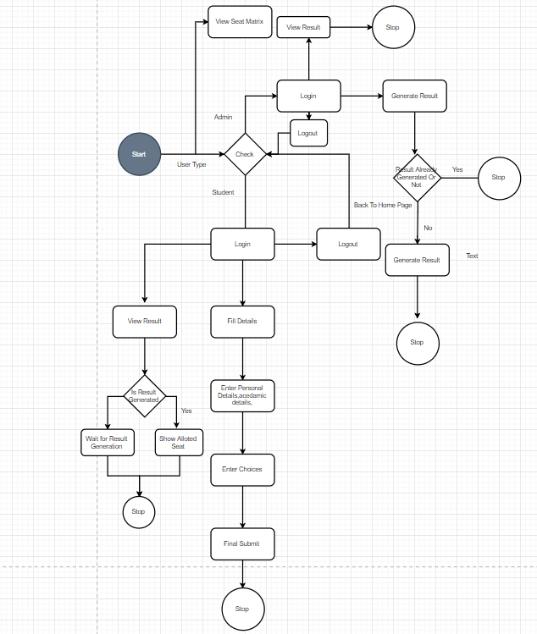



*The Appropriate Verifier that can be used in implementation and coding phase is syntax checker or debugger and we can also have code review .*

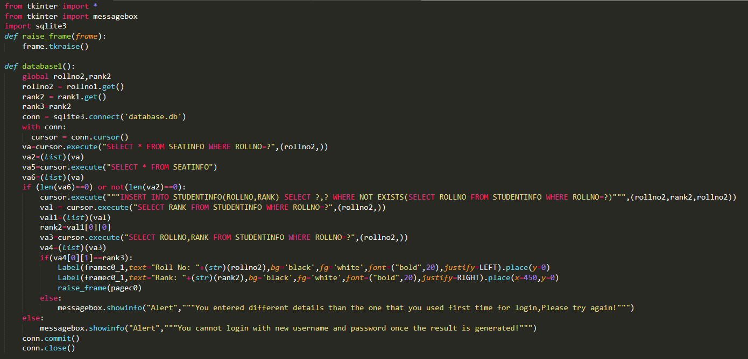

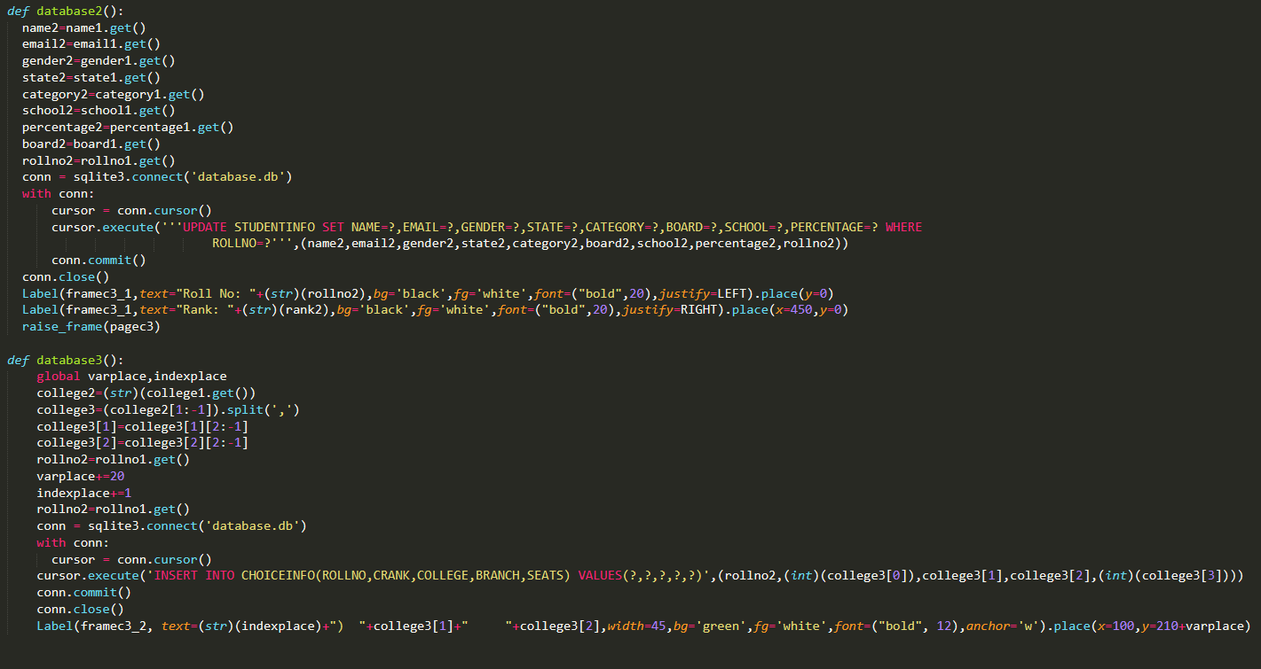

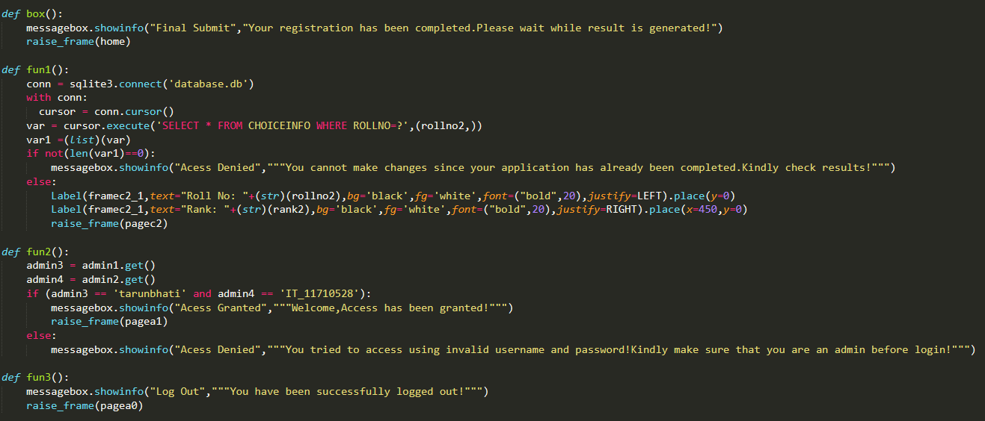

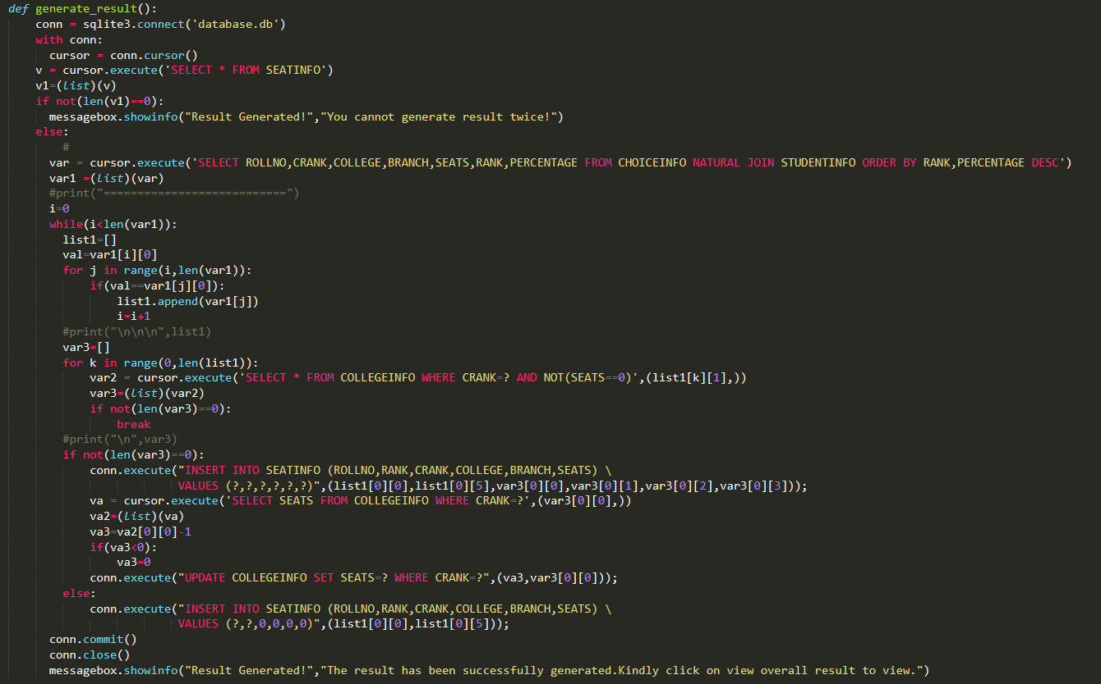

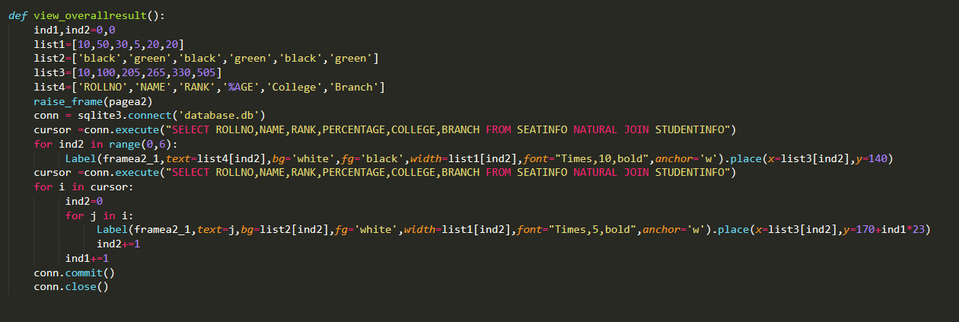

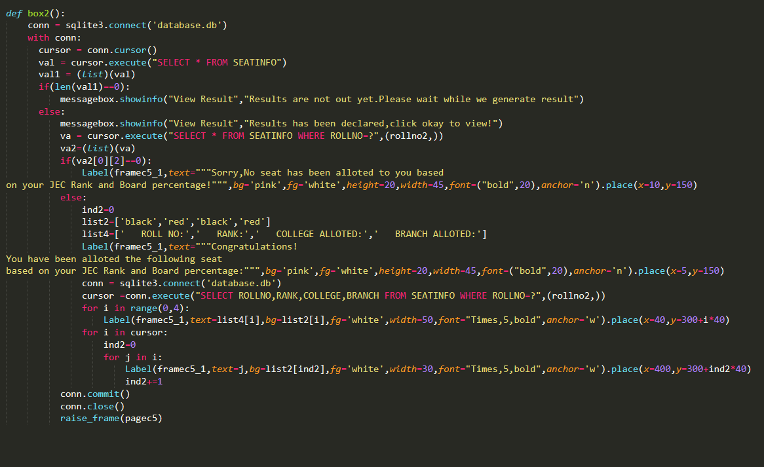

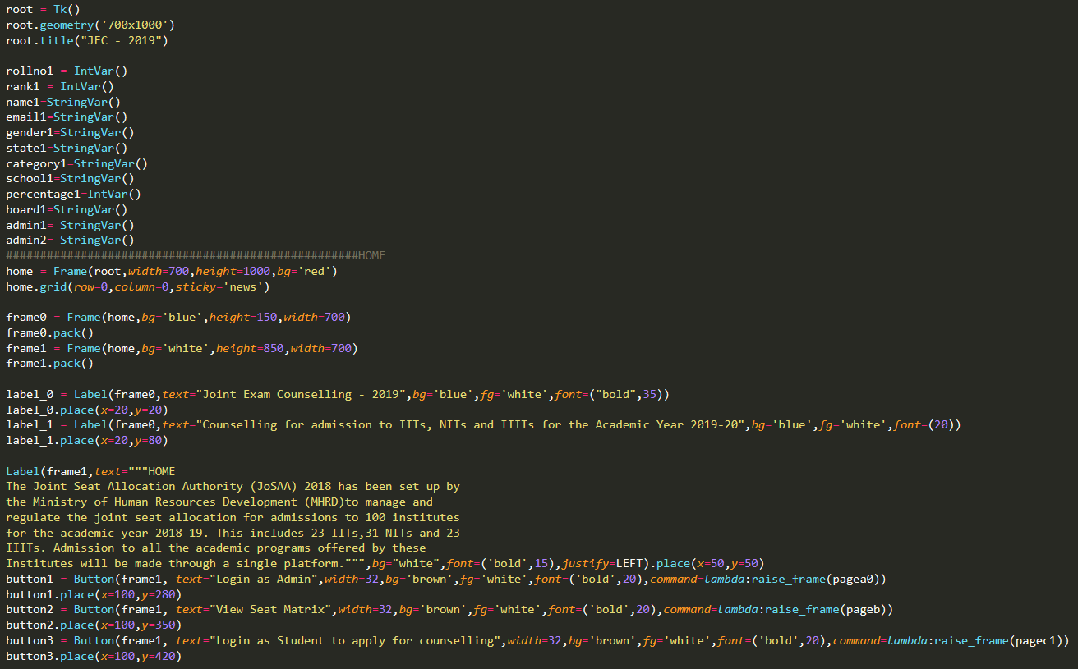

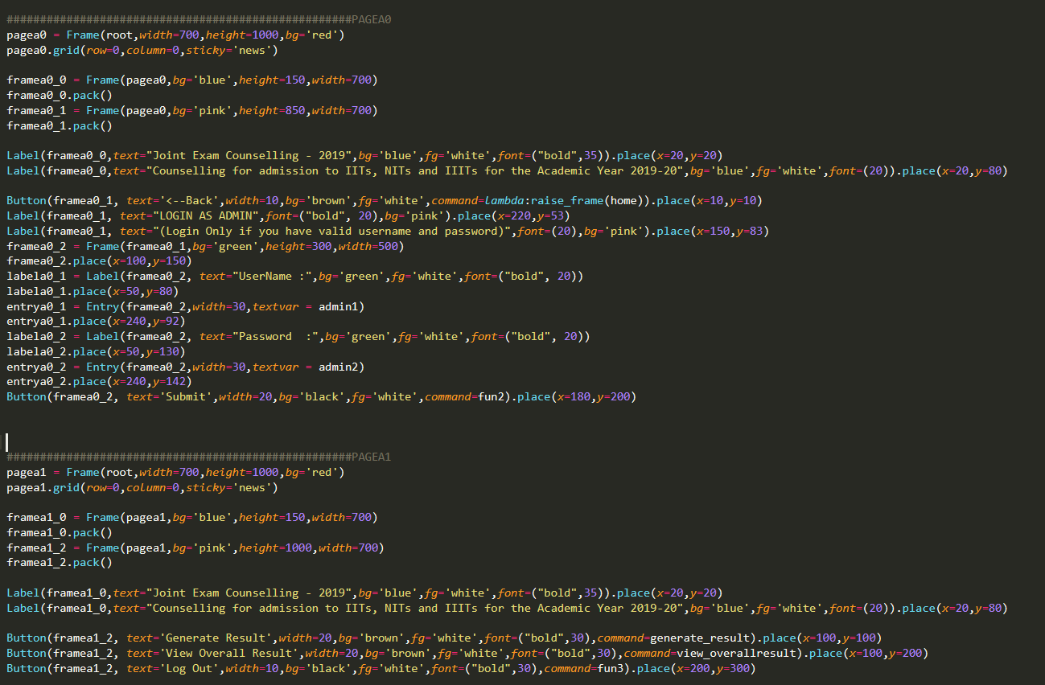

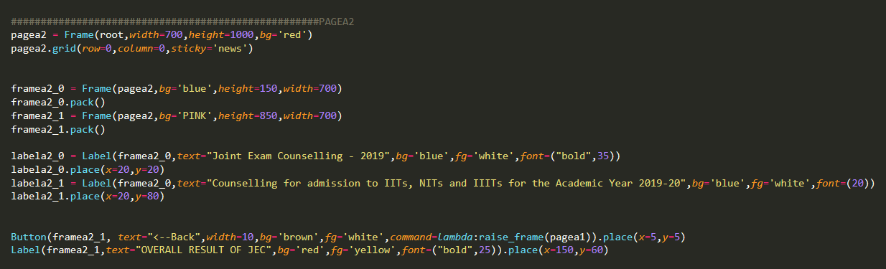

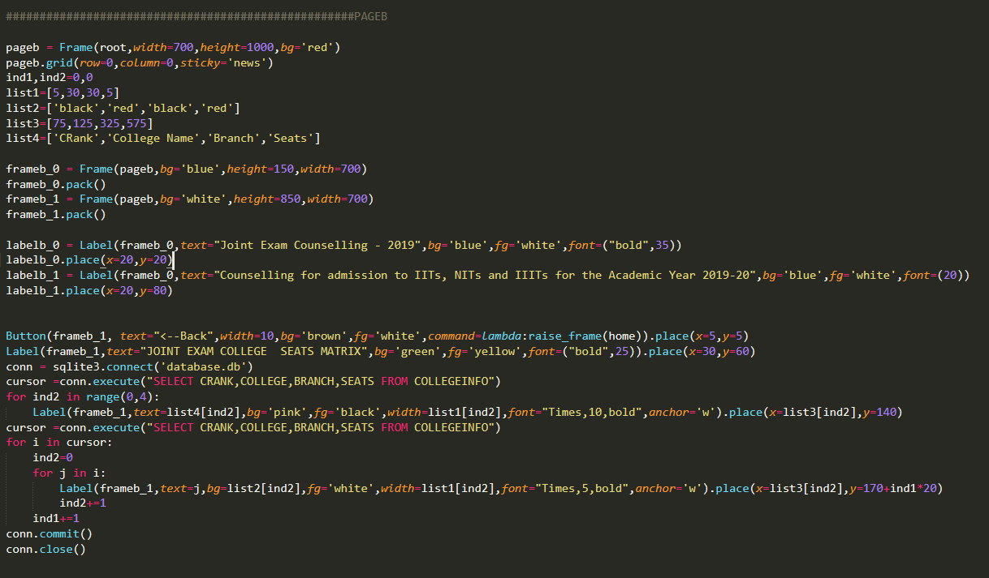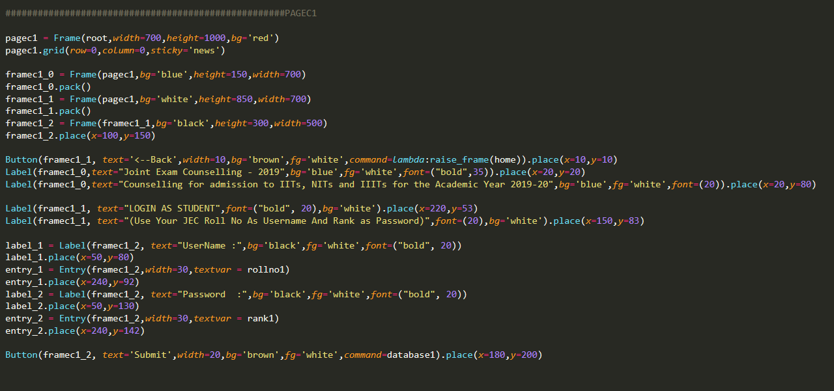 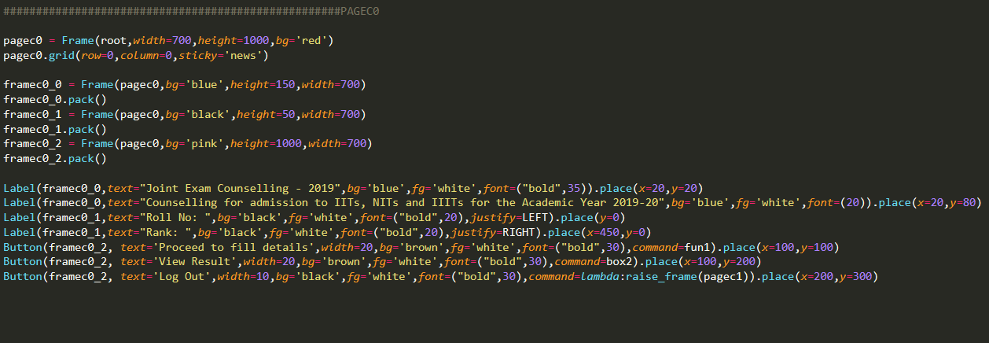 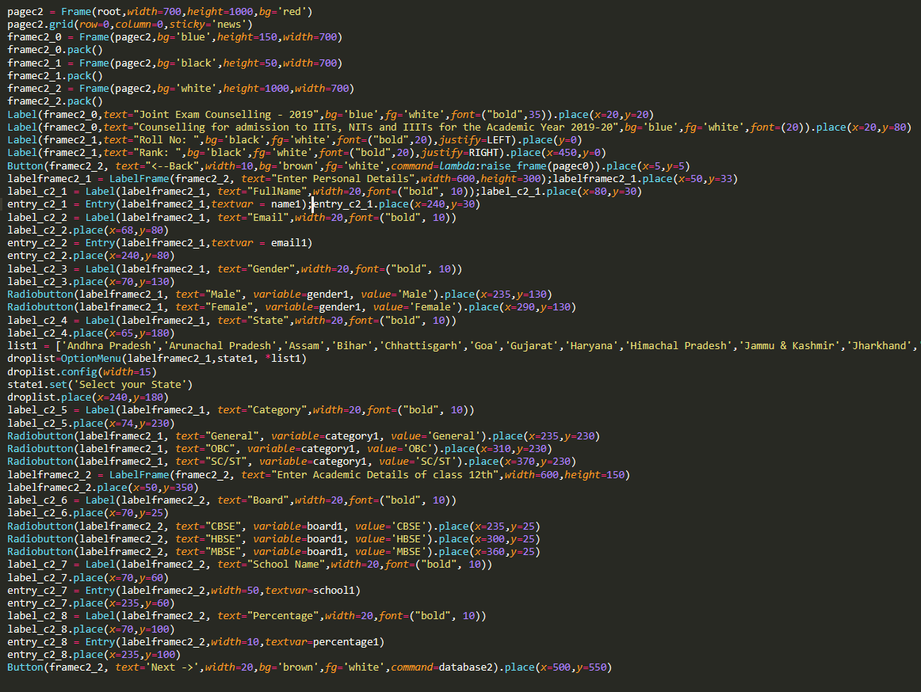

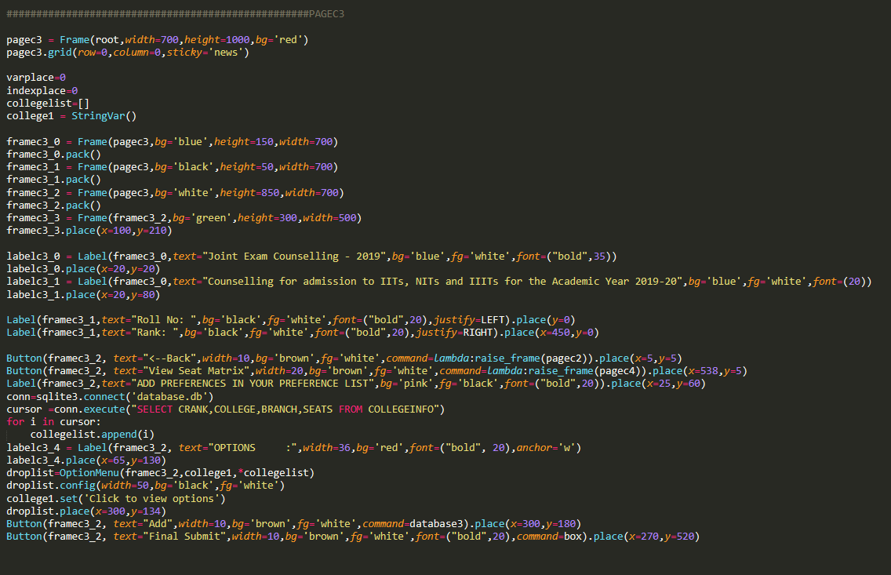

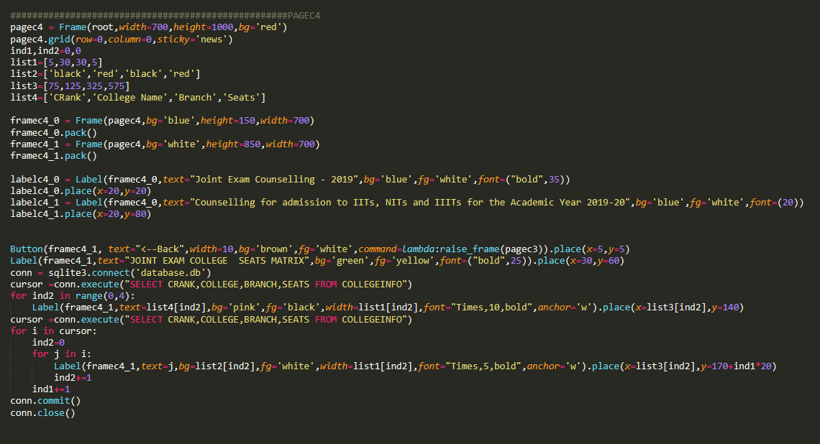

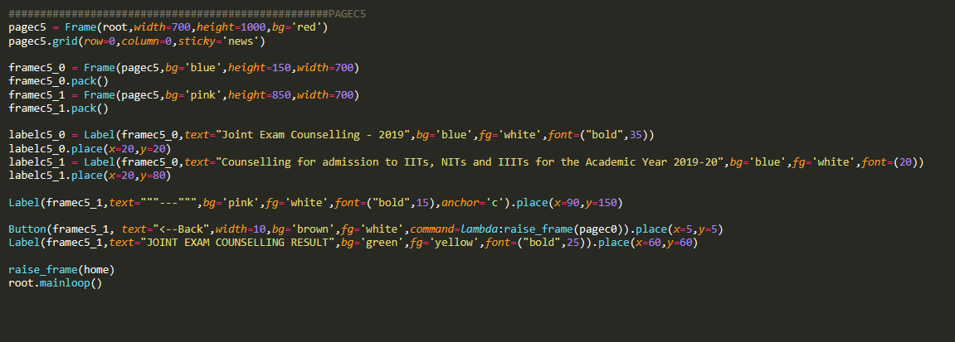



*The Appropriate Verifier that can be used are GUI TESTING TOOLS.*

*Home:*

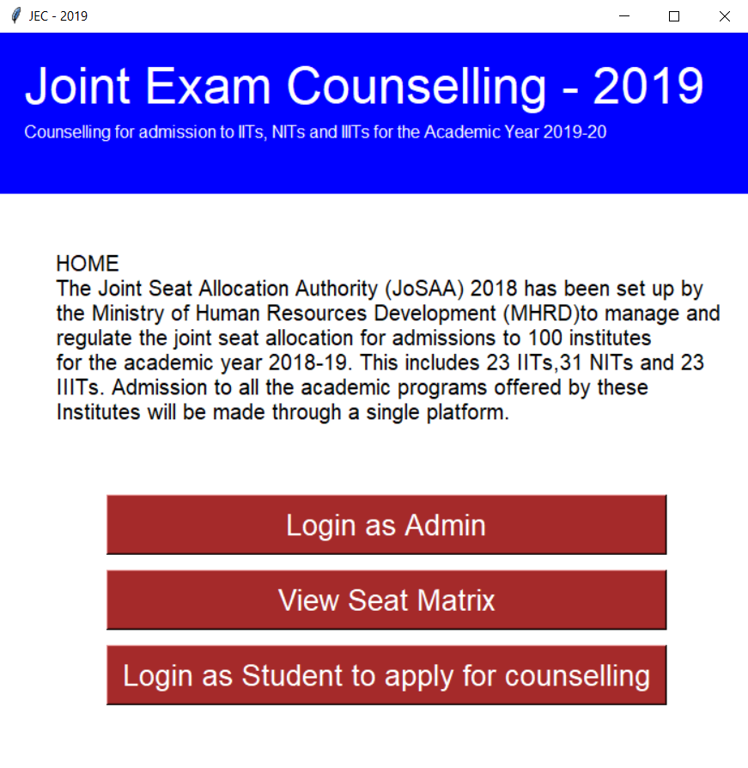

*Login As Admin:*

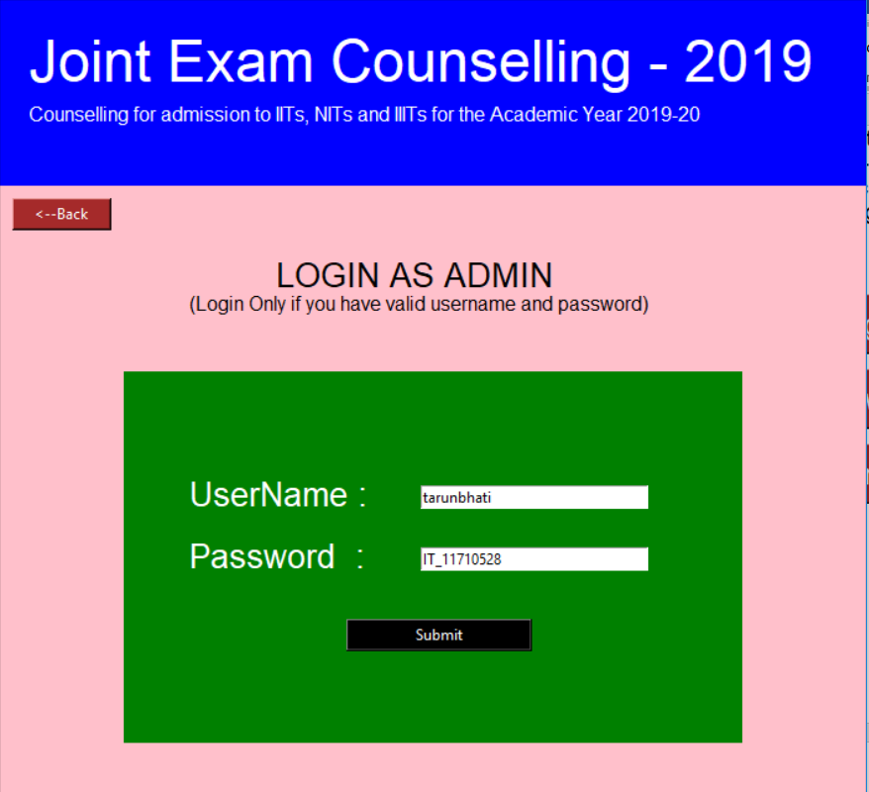

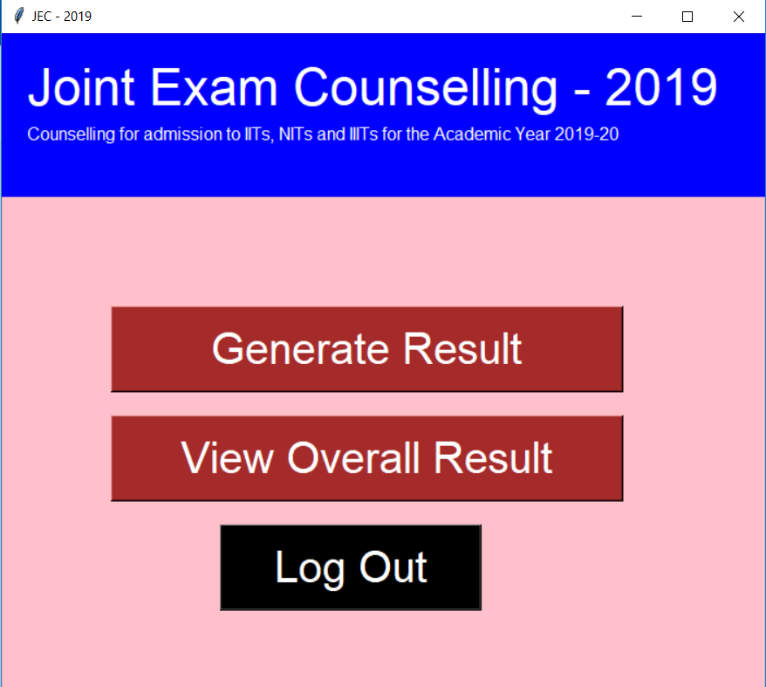

*Login As Student:*

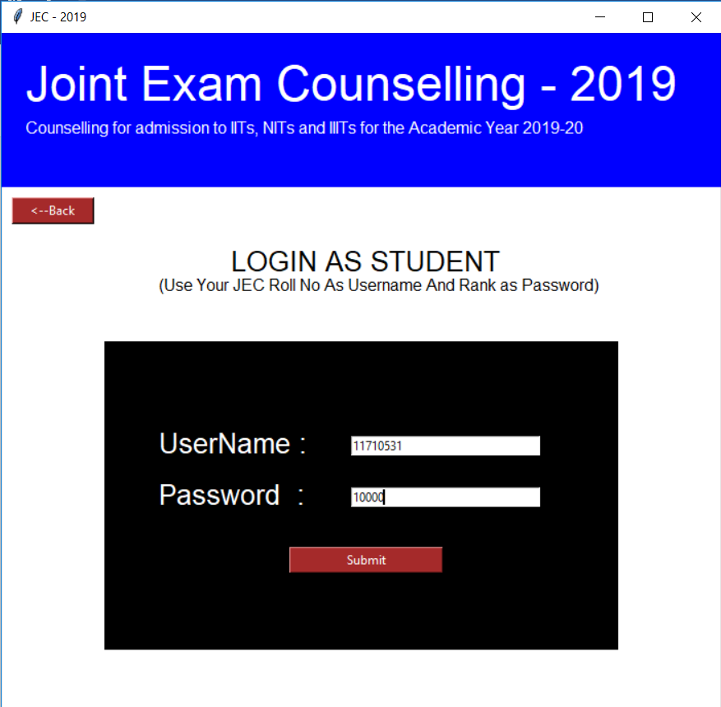

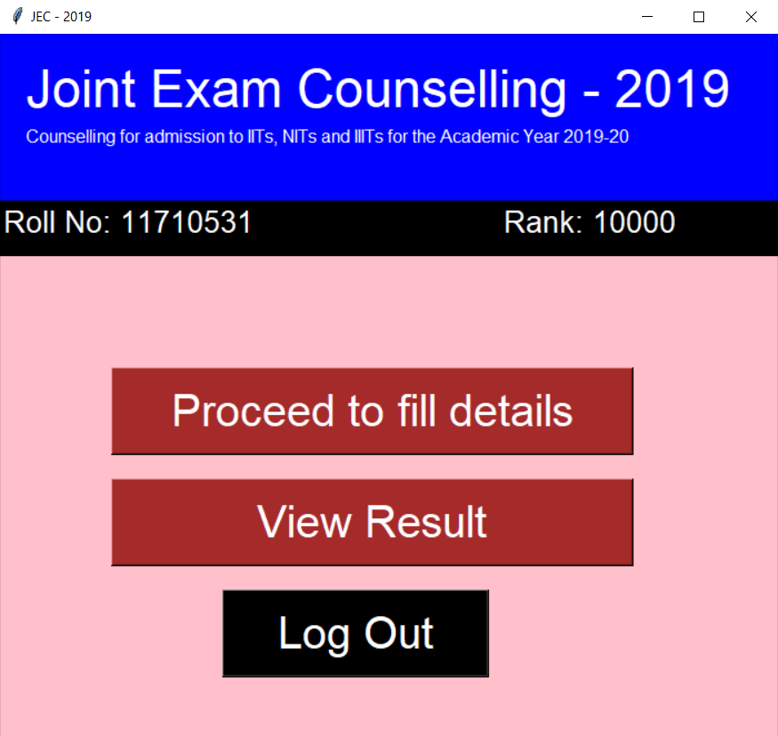

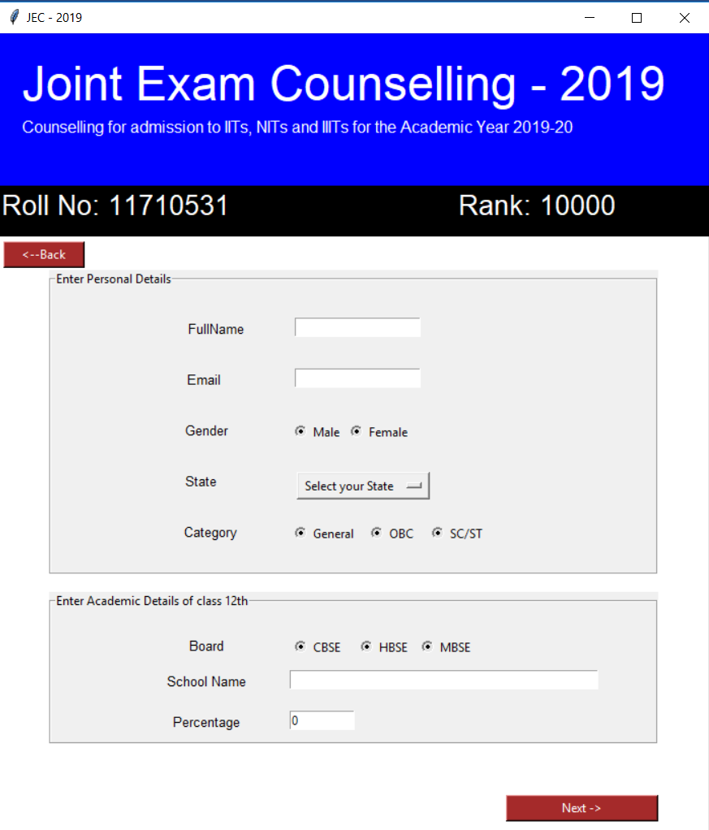

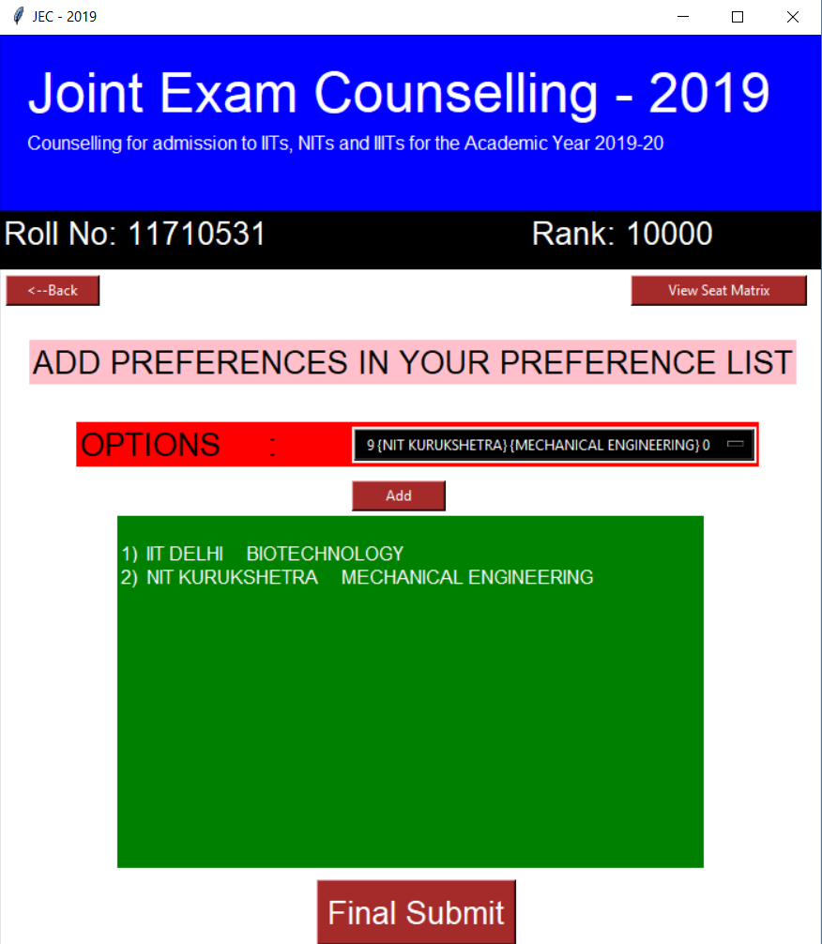

*View Seat matrix:*

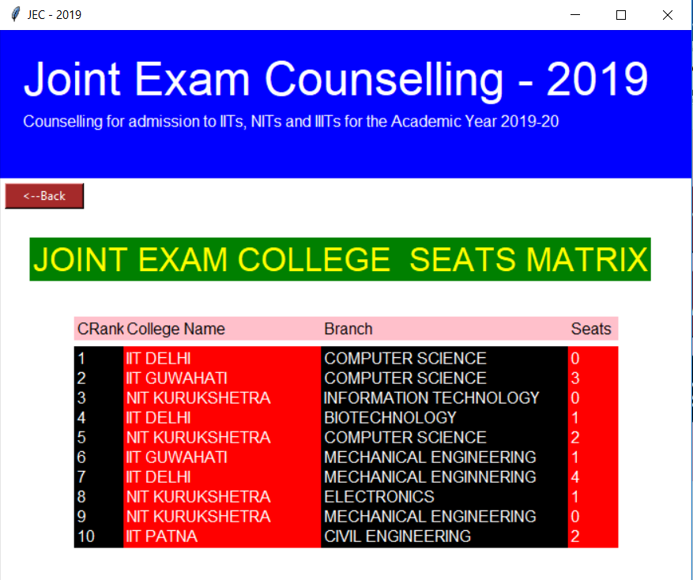

*Validation Checks:*

*Login as Admin:*

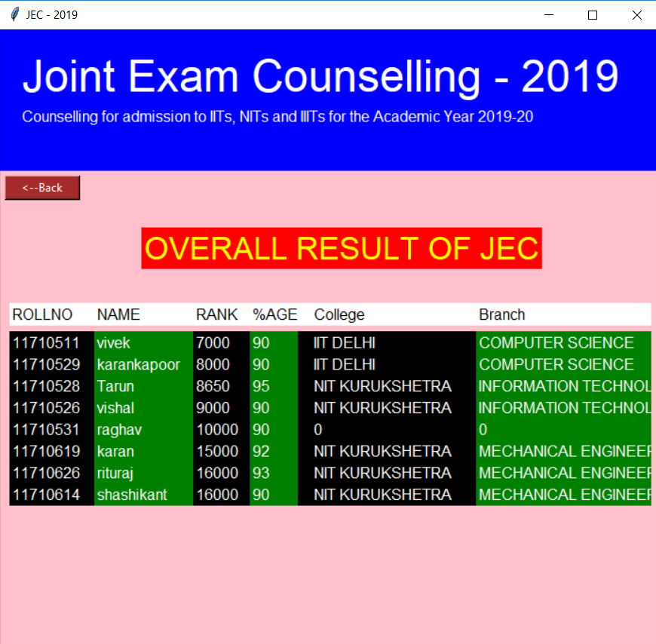

*Login as student:*

