MLA0105-ARTIFICIAL INTELLIGENCE AND EXPERT SYSTEMS

31.
Consider a simple knowledge base describing who loves whom. Define the following relationships in Prolog and write a query to find out who loves someone named "Alice." a) loves(john, mary) b) loves(jane, peter) c) loves(peter, alice) d) loves(john, alice).
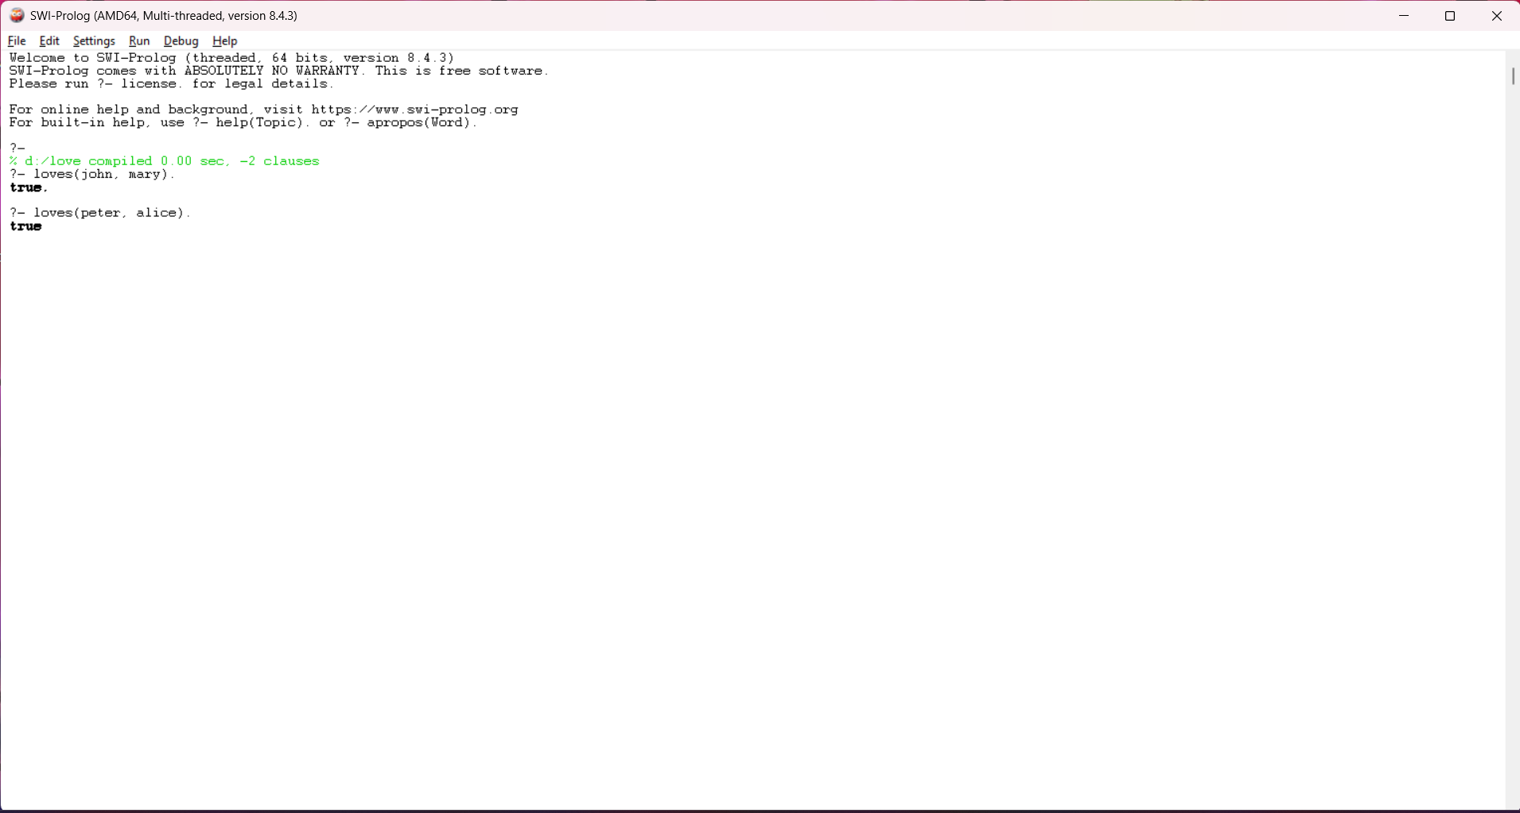
32.
Write a Prolog program containing facts related to following predicates a) Location (city, state) b) Stays (person, city) c) Display: list of persons, state and city d) Given person, find the state in which he is staying.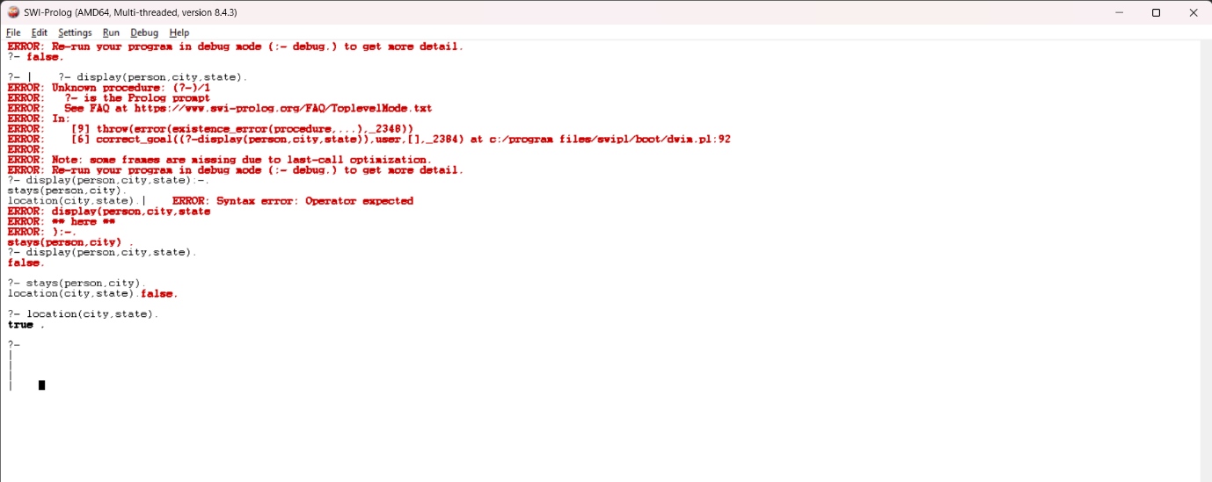

33. Write a Prolog program that answers bout family members and relationships. Include predicates & clauses which defines sister, brother, father, mother, Grandchild, Grandfather and uncle. The program should be able to answer question such as following : a) Father(X, bob) b) Grandson(X,Y) c) Uncle (bill, Sue) d) Mother (marry, X).
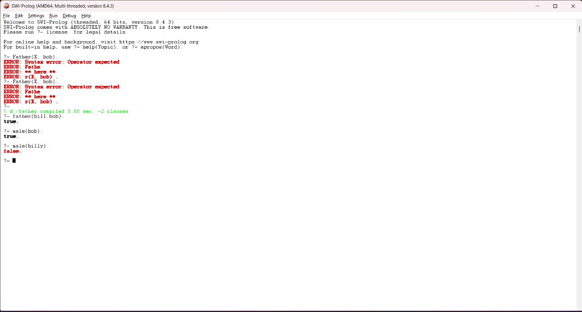

34. Write simple fact for the statements using PROLOG a) Every boy or girl is a child b) Every child gets a doll or a train or a lump of coal c) No boy gets any doll d) no child who is good gets any lump of coal e) Jack is a boy.
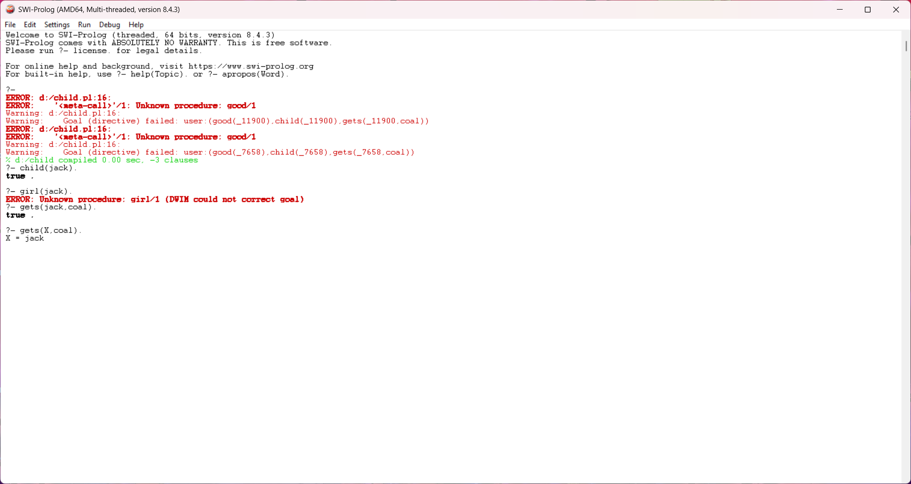

35. . Write predicates, one converts centigrade temperatures to Fahrenheit, the other checks if a temperature is below freezing using PROLOG.
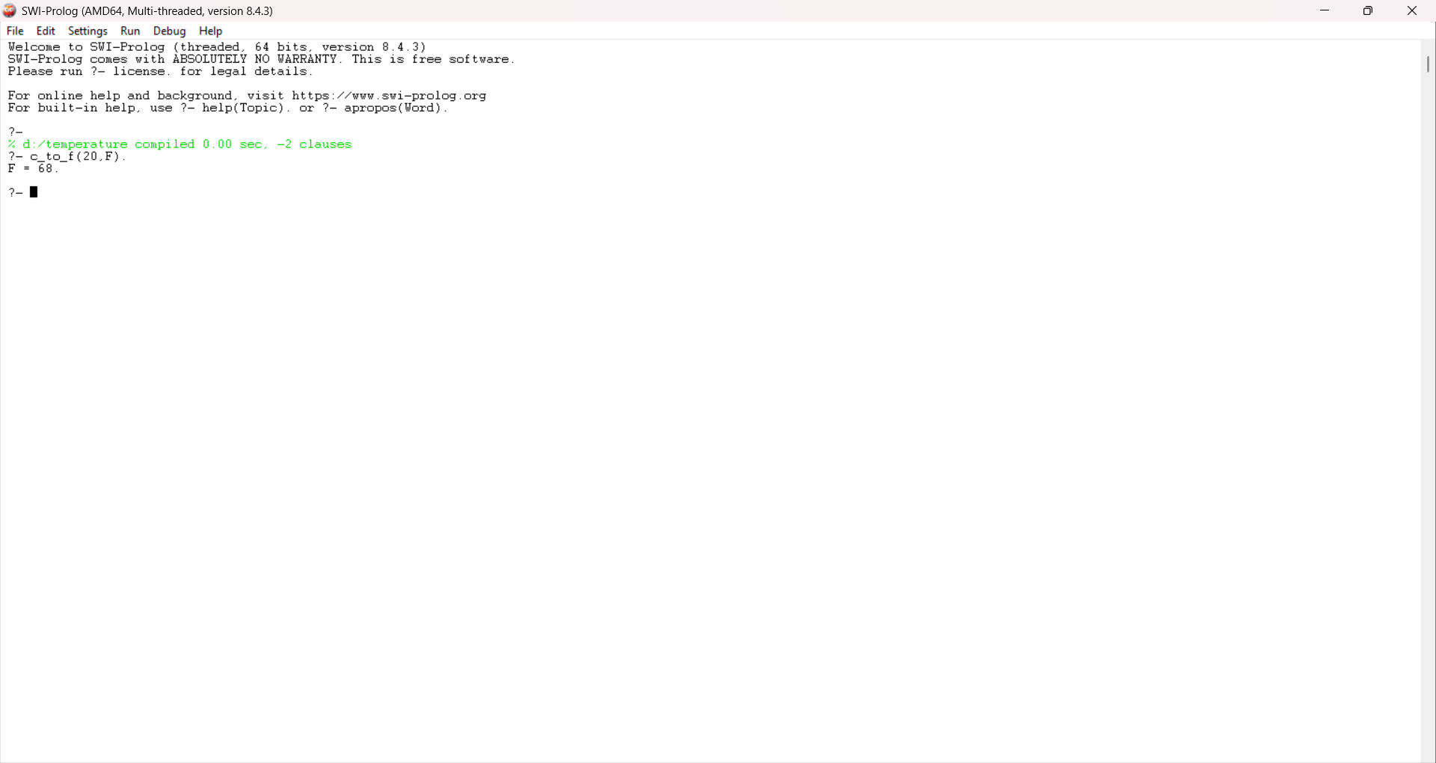
36. Write simple fact for the statements using PROLOG a) Ram likes mango b) Seema is a girl c) Bill likes Cindy d) Rose is red e) John owns gold.
