TARUN CHANDRA

m.tech. (IIT BOmbay): ENERGY SYSTEMS ENGINEERING

**India Energy Transition Dashboard (2000–2025)**

Power BI Dashboard

Table of Contents

1 Project Overview 2

2 Objectives 2

3 Repository Structure 2

4 Data 3

4.1 Data Sources 3

4.2 Assumptions & Limitations 3

4.3 Data Preparation 3

4.4 Standardization: 4

5 Methodology & Calculation: 4

5.1 Emission Factors & Calculations 4

5.2 Efficiency, Utilization and Emission Calculation 4

6 Data Model & Tables 5

6.1 Fact Tables 5

6.2 Dimension Tables 5

7 Key Measures & KPIs 6

8 Dashboard Layout 6

8.1 Page 1 – National Level Energy Summary 6

8.2 Page 2 – State Level Energy Summary (1/2) 6

8.3 Page 3 – State Level Energy Summary (2/2) 7

9 Analytical Use Cases 7

10 Key Insights 7

11 Technical Skills Demonstrated 7

12 Business Value 7

13 Future Scope 8

14 Dashboards Access (How to Use) 8

# Project Overview

This project develops an interactive Power BI dashboard to analyse India’s installed capacity, generation, energy mix, renewable share, and emissions at national and state levels (2000–2025) & to provide insights useful for energy policy, planning, and consulting.

# Objectives

* Understand the progress of India’s energy transition from fossil fuels to renewables by

combining domain expertise in the energy systems with Power BI data analytics skills.

* Visualize capacity addition, generation trends, and RE share at both national & state level.
* Quantify emissions from fossil generation and avoided emissions from renewable energy.
* Build interactive dashboards with filters and drilldowns for decision-making.
* Demonstrate data cleaning, modelling, and visualization skills in Power BI.

# Repository Structure

India_Energy_Transition/

* README.md
* Data/
* raw/ # Original downloaded datasets
* processed/ # Cleaned & structured Excel files
* Docs/
* Data_model_diagram
* DAX_measures
* pbix/
* India_Energy_Transition.pbix
* Output docs/ # Final outputs (Report PDF)

# Data

## Data Sources

|  |  |
| --- | --- |
| **Datasets** | **Source** |
| Electricity Installed Capacity (State/national, by source) | NITI Aayog Energy Data Portal (ICED) https://iced.niti.gov.in |
| Electricity Power Generation (State/national, by source) | NITI Aayog Energy Data Portal (ICED) https://iced.niti.gov.in |
| Emission factors | CEA Baseline CO₂ factors (https://cea.nic.in) |
| India States Locations (Longitude, Latitude) | https://www.kaggle.com/ |

## Assumptions & Limitations

* Year Ranges: Multi-year blocks (e.g., 2002–07) converted to single-year data at range-end.
* Renewable Definition: Solar, Wind, Small-Hydro, Bio Power.
* Capacity Factor: Derived directly from reported generation values.
* Missing Data: year gaps data filled using interpolation.
* Scope: Only national level & Indian states considered (Union Territories excluded).
* India Map: Used ArcGIS (only visible in online mode) because of Power BI desktop version limitation

## Data Preparation

* **Source Data**: Downloaded raw datasets from NITI Aayog Energy data portal & CEA.
* **Restructuring Years:** Where only 5-year cumulative values were given, disaggregated into single years by interpolation. Renamed all “March-end” columns to reflect the corresponding year.
* **Renewable Energy (RE) Consolidation:** Created RES Total (2009–2025). Grouped sub-categories into Solar (all types combined) and Biopower for consistency (2014–2025).
* **Back casting (1997, 2002, 2007):** Derived missing values using multiplying factors based on 2009 shares: Multiplying factor = year 2009 specific row value/ Total RES for year 2009
* **Interpolation:** Estimated annual values between plan-period years (1997, 2002, 2007) by dividing differences equally across intervals.
* **Validation**: Cross-checked reconstructed yearly series with India’s 5-Year Plan periods for consistency.
* **Final Transformation:** Clean dataset structured into columns: Year | State | Source | Capacity (MW) | Generation (GWh) | Emissions (tCO₂ per MWh)
* **Cleaning Tools:** MS Excel (pre-processing), Power BI (pre-processing, modelling & visualization).

## Standardization:

* Units: Capacity (MW), Generation (GWh).
* Source names harmonized: Coal, Oil & Gas, Nuclear, Hydro, Solar, Wind, Small-Hydro, Bio Power
* Added “All India” rows in fact tables for direct national-level KPIs.
* Excluded Union Territories for simplification

# Methodology & Calculation:

* Data Collection & Integration
* Data Cleaning and Transformation
* Data Modelling
* KPI & Metric Calculation
* Dashboard Development
* Validation & Cross-Check

## Emission Factors & Calculations

Emission Factors (CEA Baseline Database, FY 2023–24):

EFCoal = 0.97 tCO₂/MWh

EFOil & Gas = 0.45 tCO₂/MWh

Nuclear, Hydro & Renewables = 0

EFsource = Emission factor of a particular fuel source

EFfossil, avg= weighted average emission factor of fossil fuels (Coal, Oil & gas)

EFfossil, avg=

## Efficiency, Utilization and Emission Calculation

* Total Emissions = $\sum_{all sources}{{(Generation}_{Source}*{EF}_{source})}$
* Avoided Emissions = Total Renewable Generation * EFfossil, avg
* Grid Emission Intensity gCO2 per kWh = $\frac{Total Emission}{Total Generation }$
* Avoided Emission = $Total Renewable Generation* {EF}_{fossil, avg}$
* Capacity Factor = $\frac{Total Generation}{Total Capacity*Yearly Hours}$

# Data Model & Tables

* The model follows a Star Schema design in Power BI for efficient querying and flexible analysis.
* Fact tables store the main quantitative data for capacity, generation & emission factors
* Dimension tables provide descriptive attributes (state, region, source, year) to allow easy filtering/slicing
* Relationship: Many to one between facts and dimensions

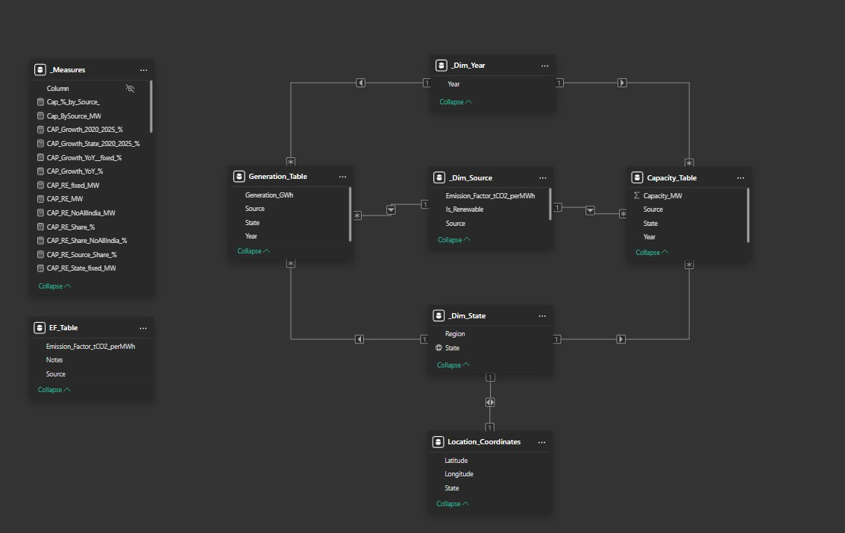

## Fact Tables

* **Generation_table:** Year, State, Source, Generation (GWh)
* **Capacity_table:** Year, State, Source, Capacity (MW)
* **EF_Table:** Source, Emission Factor (tCO2 PER MWh), notes
* **Location_Coordinates:** State, Latitude, Longitude

## Dimension Tables

* **DimYear:** Calendar year (2000–2025)
* **DimState:** State, Region
* **DimSource:** Source, Source group, Is_Renewable (True/False), Emission_Factor_tCO₂/MWh

# Key Measures & KPIs

Core metrics developed in DAX, designed to work at both state and national levels:

_Measures: Logical grouping of all KPIs

* Capacity Share (%)
* Generation Share (%)
* Renewable Energy Share
* Capacity Factor
* Grid Emission Intensity
* Avoided Emission
* Growth metrics (2020-25)
* Top 5 States by different metrics\

# Dashboard Layout

## Page 1 – National Level Energy Summary

* **Cards (2025 baseline):** Renewable capacity, Renewable Generation, Total Capacity, Total Generation, avoided emissions, Total CO2 emissions, Grid emission intensity, capacity factor (%), 2020–25 capacity and generation growth.
* **Graphs:** Total capacity & generation trends, emissions trends, avoided emissions, Capacity and Generation share by source for year 2000-2025
* **Slicers:** Year, source, source Type, Is Renewable.

## Page 2 – State Level Energy Summary (1/2)

* **Cards (2025):** Same KPIs as national but state-specific.
* **Graphs:** Same trends but state-specific for year 2016-2025
* **Slicers:** Year, state, region, source, source type, Is renewable

## Page 3 – State Level Energy Summary (2/2)

* Graphs: Top 5 states by capacity, Renewable capacity, generation, Renewable generation, emissions, avoided emissions.
* Map: State-wise total & Renewable generation.
* Slicers: Year, state, region, source, source type, Is renewable

# Analytical Use Cases

* **National-level insights:** Track India’s RE transition, fossil reliance, and emissions avoidance.
* **State benchmarking:** Compare states by generation, capacity mix, and emission.
* **Top performers:** Identify top 5 states driving the Renewable energy push.
* **Scenario testing:** Use slicers to dynamically see year-wise, source-wise, and region-wise shifts.

# Key Insights

* India’s Renewable share in capacity is significantly higher than in generation shows utilization challenge.
* Coal remains the backbone of power generation (~70%), driving emissions.
* Avoided emissions from Renewable Energy are growing rapidly, reducing around 240 MtCO₂ in 2025.
* State-level variations: Southern & Western states dominate in solar and wind, while Eastern India is still coal-heavy.
* Rajasthan and Gujarat lead in Renewable generation while Chhattisgarh and Uttar Pradesh lead in Emissions.

# Technical Skills Demonstrated

* **Power BI:** Data transformation (Power Query), star schema modelling and dimension design, DAX, measure, Dashboard design principles, interactive map
* **Excel:** Data cleaning & transformation
* **Analytics:** KPI design, Emission modelling, actionable insights
* **Energy Domain:** Knowledge of India’s power sector, emissions accounting, RE integration.

# Business Value

* Helps policymakers assess progress toward renewable targets.
* Provides state-level insights for investment prioritization.
* Quantifies emission reduction benefits of RE adoption.

# Future Scope

* Integrate Real-time data APIs
* Add Financial Metrics – LCOE, tariff data etc.
* Scenario Analysis – Add projections for 2030/2070 net zero
* Automate updates via Power Query
* Benchmarking - Compare India with global Renewable/CO₂ intensity benchmarks

# Dashboards Access (How to Use)

* Download the Power BI file(.pbix) from repository link below  
    
  [Download from GitHub Repository]  
    
  (<https://github.com/tarunchandra007/India_Energy_Transition_Dashboard/raw/refs/heads/main/PBIX/India_Energy_Transition_Dashboard.pbix>)
* Open file in Power BI Desktop.
* Keep Internet ON to view India map
* Use slicers to explore national/state data