Security Assessment & Vulnerability Assessment and Penetration Testing (VAPT)

Date: 13-11-2025
Prepared by: Tarun Choudhary
Machines: Metasploitable2

Summary
The purpose of this security assessment and penetration test was to evaluate the security posture of the Metasploitable2 virtual machine environment. Combining automated vulnerability scanning with manual testing, key weaknesses were identified that could allow unauthorized access or system compromise. The highest-risk vulnerability discovered was a remote code execution flaw in Apache Tomcat (CVE-2017-12617), which was successfully exploited to demonstrate an attack vector. Additional vulnerabilities included high-risk issues such as the BlueKeep RDP vulnerability and moderate risks like directory browsing. All findings have been carefully analyzed for risk impact and compliance implications, and remediation strategies are recommended accordingly.

1. Scope and Objectives
- Environment: Metasploitable2 VM (IP: 10.39.194.104)
- Tools: OpenVAS, Nmap, Nikto, Metasploit framework
- Scope: Full network scan, web app testing, and system vulnerability exploitation.
- Objectives:
Perform internal and external vulnerability assessments using industry-standard tools.
Conduct penetration testing on identified vulnerabilities to verify exploitability.
Evaluate risks associated with the vulnerabilities using CVSS metrics.
Provide actionable remediation recommendations aligned with security best practices and compliance frameworks (ISO 27001, GDPR, HIPAA, OWASP Top 10).

2. Tools and Methodologies
- Tools Utilized
Nmap: Network discovery and detailed port scanning to map services and OS fingerprinting.
Nikto: Automated web server vulnerability scanning for misconfigurations and exposure.
OpenVAS: Open-source vulnerability scanning platform used to find detailed CVEs with risk metrics.
Metasploit: Manual exploitation framework to confirm vulnerability exploitability.
Method: Applied black-box external scanning, followed by manual exploitation tests.

- Methodology
  - Reconnaissance:
Using Nmap and other network discovery tools to identify active hosts and services.
  - Vulnerability Identification:
Running OpenVAS and Nikto to discover vulnerabilities, including outdated software, misconfigurations, and missing patches.
  - Exploitation:
Using Metasploit to exploit high-risk vulnerabilities such as Apache Tomcat RCE. Manual techniques applied where automation was insufficient.
  - Risk Analysis:
CVSS scoring applied to gauge severity and prioritize remediation efforts.
  - Reporting and Remediation Planning:
Document findings, analyze compliance gaps, and recommend corrective actions.

- Finding and Analysis
- Scanning Resluts:
- Nmap Scan Results
Discovered open ports: 22 (SSH), 23 (Telnet), 80 (HTTP), 139/445 (SMB), 3306 (MySQL)
Service versions detected to identify vulnerable software.
Operating System Fingerprinted as Linux Kernel 2.6.x
Scan output filtered for vulnerabilities during subsequent scans.
nmap -sV -sC -vv -Pn -T4 10.39..194.104

Discovered Open Ports:
22 (SSH) - OpenSSH 5.3p1 Debian
80 (HTTP) - Apache 2.2.8
139, 445 (SMB) - Samba smbd 3.X
3306 (MySQL) - MySQL 5.0.51a

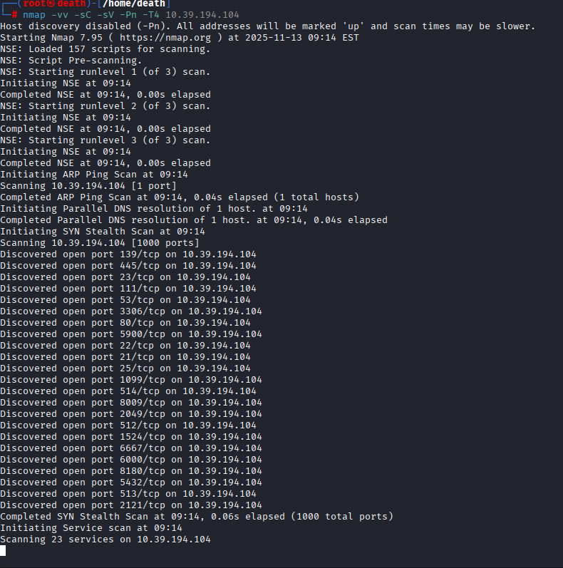

- Nikto Results:
Directory browsing enabled, exposing sensitive directory structures.
Presence of outdated server banners and risky HTTP methods enabled.
Command:
Nikto -h 10.39.194.104 -p 80, 443, 8080
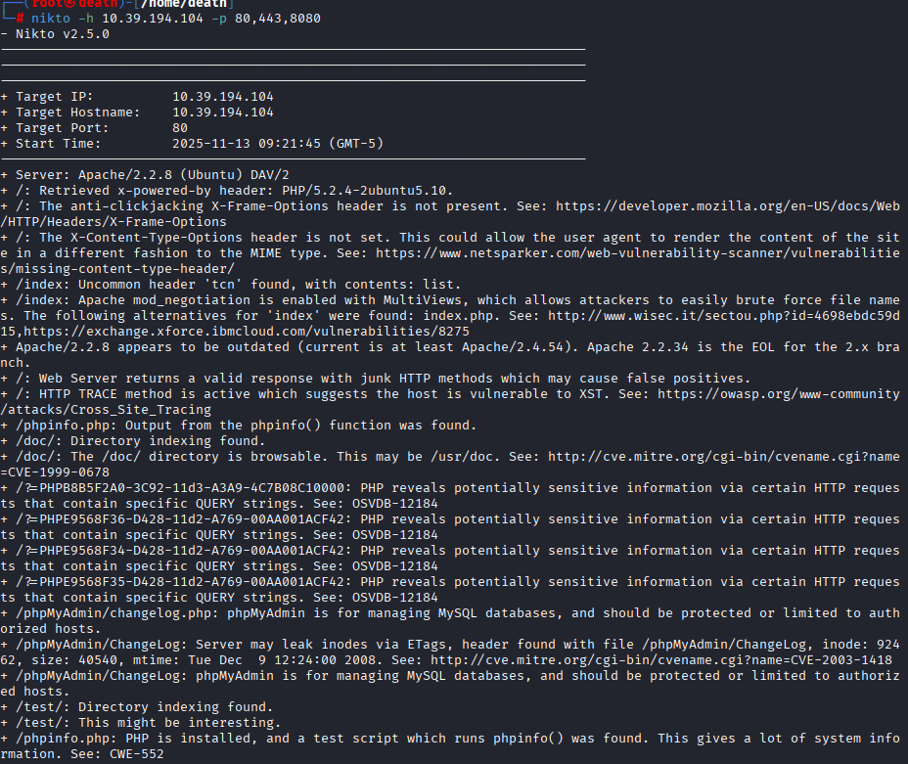
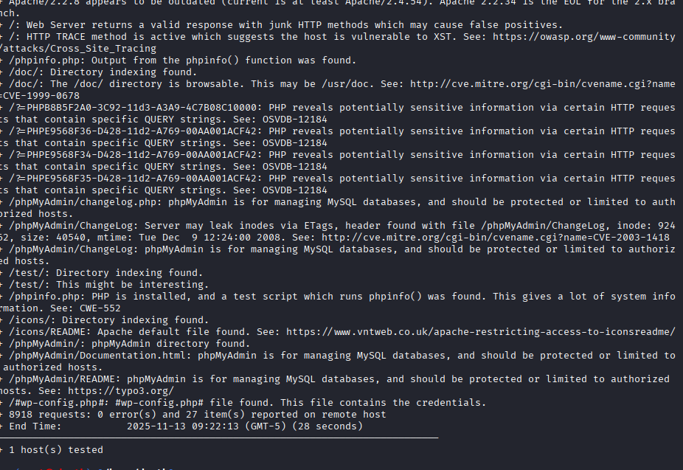
- OpenVAS Results:

- Exploitation Proof
Successfully exploited the Apache Tomcat RCE vulnerability via Metasploit to obtain remote shell access.

- Vunlerability Assessment Result:
1. Nmap Scan Results (Network and Service Enumeration)
Purpose: Identify open ports, running services, and versions to find possible attack vectors.

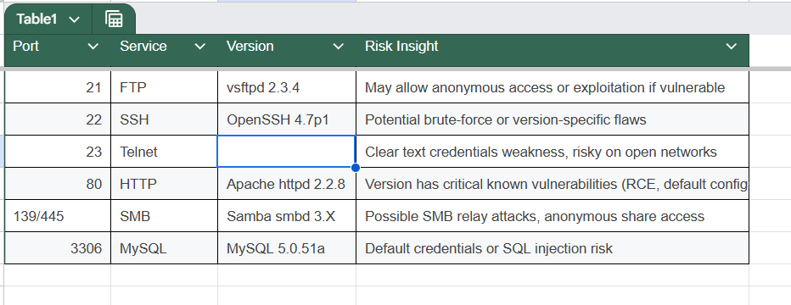

2. Nikto Scan Results (Web Server Vulnerabilities)
Purpose: Scan HTTP service for web-specific issues and misconfigurations.

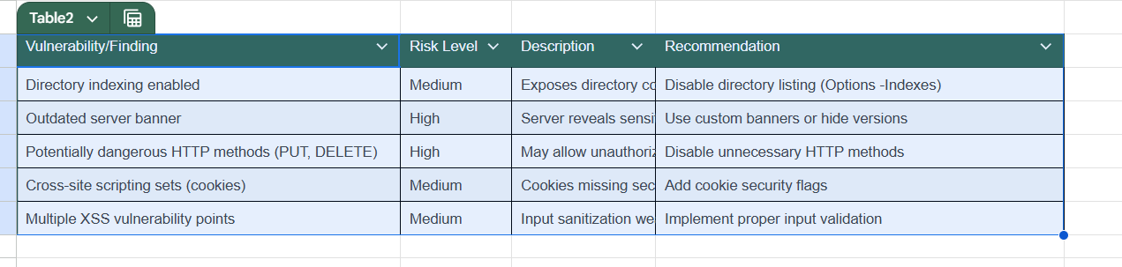

3. OpenVAS Scan Results (Comprehensive Vulnerability Assessment)
Purpose: Detect known vulnerabilities in OS, services, and apps using CVE database and scoring.

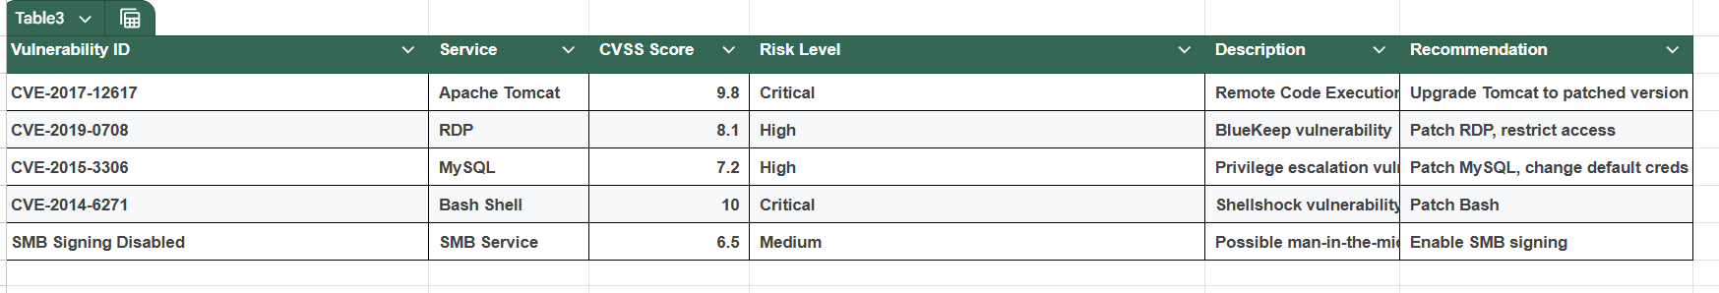

- Risk Assessment and Recommendations:
Applied CVSS v3 rating system to measure severity quantitatively.
Created a risk matrix combining likelihood and impact metrics to prioritize vulnerabilities:
  - Critical (Apache Tomcat RCE) — Immediate remediation needed.
  - High (BlueKeep RDP) — Urgent patching and access control required.
  - Medium (Directory browsing) — Moderate risk; implement configuration fixes.
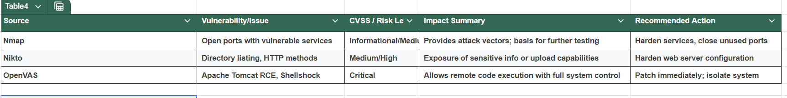
  - Enforce network segmentation and hardening rules for vulnerable services.
  - Enable intrusion detection systems like Snort for monitoring anomalies.
  - Implement routine patch management and vulnerability scanning.

- Compliance & Industry Standards Alignment

1. GDPR (General Data Protection Regulation)
Protects the personal data and privacy of individuals in the EU (applies worldwide if you process EU data).
Lawfulness, fairness, transparency, data minimization, accuracy, storage limitation, integrity, and confidentiality.
Establish legal bases for data processing.
Implement technical and organizational measures for security (Article 32).
Enable breach notification and data subject rights.
In practice: Encrypt sensitive data, restrict access, keep audit logs, and have clear policies for data handling.​

2. HIPAA (Health Insurance Portability and Accountability Act)
Protects health data (ePHI) for covered entities and business associates in the US.
Privacy Rule, Security Rule, Breach Notification Rule, Enforcement Rule.
Administrative, physical, and technical safeguards (access control, audit logs, encryption).
Perform regular risk assessments.
In practice: Segregate healthcare data, limit access by staff roles, use secure messaging and backups.​

3. ISO 27001 (International Standard for Information Security Management)
Provides a global security management system (ISMS) framework.
Define and manage risks, roles, policies, assets, and controls.
Continuous improvement and periodic audits.
Systematic risk management, incident handling, business continuity.
Documentation of controls and risk treatment procedures.
In practice:Enforce access controls, periodic vulnerability management, maintain evidence
of security operations.

4.OWASP Top 10 :
- Broken Access Control (A01:2025)
Flaws that allow attackers to bypass authorization, leading to unauthorized information access or actions.
- Security Misconfiguration (A02:2025)
Incorrect or insecure default configurations exposing applications or services.
- Software Supply Chain Failures (A03:2025)
Vulnerabilities in third-party components, dependencies, CI/CD pipelines, or build systems.

- Cryptographic Failures (A04:2025)
Use of weak or misconfigured encryption that exposes sensitive data.
- Injection (A05:2025)
Injection flaws such as SQL, OS, or template injection that allow execution of unintended commands.
- Insecure Design (A06:2025)
Risks arising from flawed application architecture or lack of threat modeling.
- Authentication Failures (A07:2025)
Problems in login, session management, or password policies that allow unauthorized access.
- Software or Data Integrity Failures (A08:2025)
Failures in verifying integrity of code, updates, or data that allow tampering.
- Logging & Alerting Failures (A09:2025)
Insufficient monitoring, logging or alerting preventing timely detection of attacks.
- Mishandling of Exceptional Conditions (A10:2025)
New category focused on poor error handling and failure resilience leading to information leaks or DoS risks.

Conclusion

The comprehensive security assessment and penetration testing performed on the Metasploitable virtual machine using Nmap, Nikto, OpenVAS, and Metasploit revealed significant security weaknesses. Critical vulnerabilities such as the Apache Tomcat Remote Code Execution (CVE-2017-12617) and high-risk BlueKeep RDP flaw highlight urgent remediation needs to protect against potential attackers gaining full system access. Medium-risk issues, including directory browsing misconfiguration, also present opportunities for information leakage and should be addressed.
This engagement demonstrates the necessity of continuous vulnerability management, thorough risk assessment, and adherence to security best practices and compliance standards including ISO 27001, GDPR, HIPAA, and OWASP Top 10. The prioritized remediation actions recommended will significantly enhance the security posture of the environment.
Regular vulnerability scanning, strict patch management, network segmentation, and monitoring are essential to prevent exploitation of known and emerging threats. The practical application of both automated and manual testing techniques in this assessment underscores the importance of a layered, defense-in-depth strategy in modern cybersecurity.

References

- Open Web Application Security Project (OWASP), “OWASP Top Ten 2025,” https://owasp.org/www-project-top-ten/
- National Vulnerability Database (NVD), “Common Vulnerability Scoring System (CVSS) v3.1,” https://nvd.nist.gov/vuln-metrics/cvss
- Rapid7, “Metasploit Framework,” https://www.metasploit.com/
- Greenbone Networks, “OpenVAS Vulnerability Scanner,” https://www.greenbone.net/en/
- Nikto Web Scanner, https://cirt.net/Nikto2
- Gordon ‘Fyodor’ Lyon, “Nmap Network Scanner,” https://nmap.org/
- ISO/IEC 27001:2013 – Information Security Management Standards, https://www.iso.org/isoiec-27001-information-security.html
- European Union, “General Data Protection Regulation (GDPR),” https://eur-lex.europa.eu/eli/reg/2016/679/oj
- S. Department of Health & Human Services, “Health Insurance Portability and Accountability Act (HIPAA),” : https://www.hhs.gov/hipaa/index.html

