Edge-intelligence_MACSE604
Lab-1
Error Debugging and Solutions
NAME: TARUNKUMAR R
ROLLNO:25MML0057
1)Error in the code import CV2
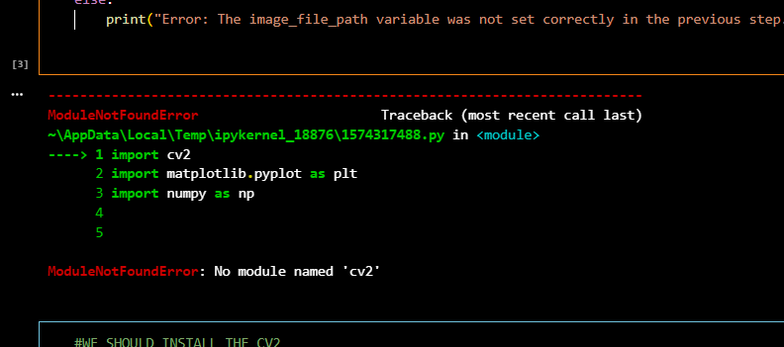

Solution:
We should install the opencv-python which was installed in lab desktop
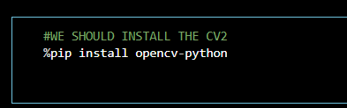

2)Error matplotlib was not installed in lab desktop
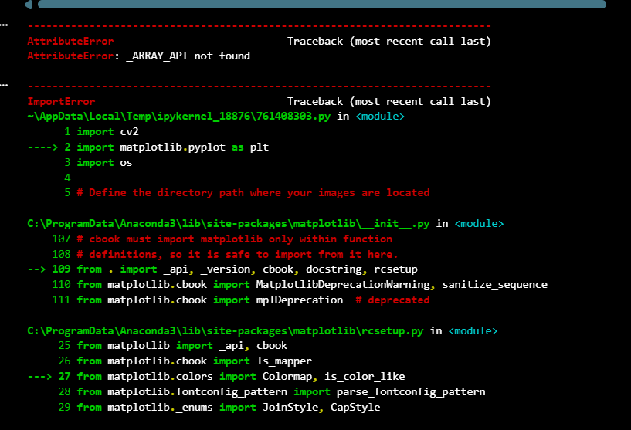
Solution: to install the modules using the pip


3)_ARRAY_API NOT FOUND ERROR
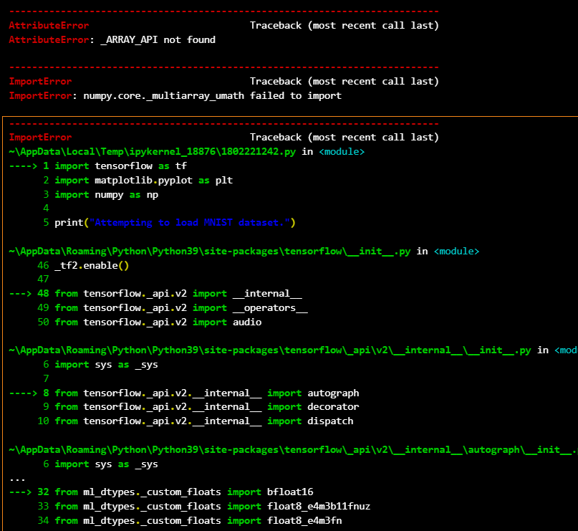

Explanation:
Root Cause: Broken/Incompatible NumPy Installation
The error _ARRAY_API not found and numpy.core._multiarray_umath failed to import indicates:
1. Mismatched C-Extensions
- NumPy has core components written in C for speed
- These are compiled as shared libraries (.pyd files on Windows, .so on Linux/Mac)
- When you update Python, change Python versions, or mix pip/conda installations, these compiled extensions become incompatible with your current Python interpreter
2. Common Triggers:
- Python version change (from Python 3.8 to 3.9 without reinstalling NumPy)
- Mixed package managers (installing some packages with pip, others with conda)
- Partial/Corrupted installation (installation interrupted, disk errors, permission issues)
- Version conflicts (newer NumPy versions may drop support for older Python versions)
3. Technical Explanation:
When you import NumPy, it tries to load _multiarray_umath.pyd (Windows) which contains:
- Core array operations
- Mathematical functions
- Memory management routines

