**Project Synopsis**

**On**

**ParkMeRight**

**Submitted By**

**Monika Sharma**

**Tarun Dhiraj**

**Under the guidance of**

**Prof. DiptiTheng**

**Department of CSE**

**Department of Computer Science & Engineering**



**Department of Computer Science & Engineering**

**G.H.RaisoniCollege of Engineering**

**Digdoh Hills, Nagpur**

**Session 2013-2014**

**INDEX**

* ABSTRACT
* INTRODUCTION
* LITERATURE SURVEY
* WORKING
* CONCLUSION
* REFERENCES

**ABSTRACT**

The ever increasing population gives rise to the number of vehicles on road. As the count of multiplexes and malls is rising and making the cities crowded, the traffic problems faced by the people are countless, mostly encountered one of them being the parking space availability. Since there is a surge in the number of vehicles, people often face difficulties related to parking. There is never a certainty of getting a place to park the vehicles by owners when they get to the destination.

One of the solution to this problem is Multistorey[4] car park buildings near big landmarks, like malls, multiplexes etc, where there is always a rush in order to take the load off the roads. But the glitch here is that not many people are aware of and have faith in this facility which is recently introduced in India.

To make parking comfortable and bring these car parks to the fore, the project team has come up with ParkMeRight. A project that is meant for user friendly management of these car park systems along with letting the vehicle owners be in touch with these systems 24×7. Hence, the users would be able to park their cars comfortably without being worried.

The synopsis covers all the details about ParkMeRight as to what it is and its working. It also includes the how about of survey done by the project team for reaching to a solution, the future scope of this project and the references.

**INTRODUCTION**

ParkMeRight is a project meant for advance booking of parking spaces by vehicle owners so as to reduce the uncertainty of getting an available space for parking when required. This project is being made keeping in mind the Multistorey car park buildings that are recently introduced in India and that too in few metro cities like Mumbai, Chennai and Pune. It will be used for reserving spaces in these buildings. The present daily requirements by people are being considered in this project.

The user, while enquiring, has to provide information related to the car like the name or the model so that they can be told whether there is any space left for the parking for their vehicle(depending on its size) in the building or not. If available, they can book it and tell the time duration for which it would be required (The process is similar to the booking of tickets for movies). The payment can be made well in advance or at the time of leaving. All the details of booking and payment will be communicated to the user time to time.

This project will not only help the user to secure a parking space for their vehicle and make the roads less crowded but will also lead to an increase in the use of the multistorey park buildings by spreading awareness among people since it is user friendly.

**LITERATURE SURVEY**

First of all to understand, what is Multi-Storey Car Park?A multi-storey car-park (also called as a parking garage, parking structure, parking ramp, parkade, parking building or parking deck) is a building designed for car parking and where there are a number of floors or levels on which parking takes place. It is essentially a stacked car park.

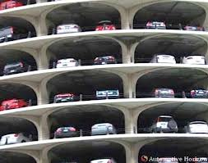 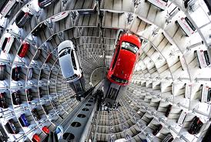

Figure 1: Exterior Figure 2: Interior

As we can see, Figure 1 shows how a Multistorey car park looks from outside and Figure 2 shows an interior view of these kind of buildings. There are multiple levels called storey meant for parking of vehicles (cars) of various shapes and sizes. The cars are kept in a way that resembles a stack.

Movement of vehicles between floors can be effected by:

* interior ramps - the most common type
* exterior ramps - which may take the form of a circular ramp (colloquially known as a 'whirley-gig' in America)
* vehicle lifts - the least common
* automated robot systems - combination of ramp and elevator

In India, the most common way of loading the vehicles is ‘Vehicle lifts’as seen in figure 3. In this kind, the cars are taken to the desired level or floor by a lift meant for cars. The functioning is same as that of the lifts meant for carrying persons.

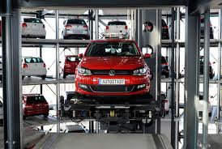

Figure 3: Vehicle Lifts

The project team came across a research paper related to E-Parking System [1] while doing the survey. The study helped to find a proper solution to the mentioned traffic problems.

**E-Parking System:**It provides an alternative for patrons to enquire the availability and/or reserve a parking space at their desired parking facility to ensure the availability of vacant car park space when they arrive at the parking facility.System can be accessed via internet on WAP enabled Android smart phone.

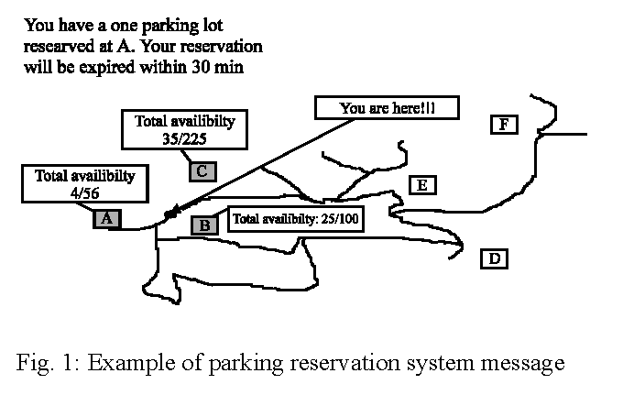

Figure 4: Example of parking system reservation message[1]

The above figure, Figure 4, is an example of parking system reservation message which shows the number of available spaces out of the total spaces at different car parks. The message related to booked space is displayed to the user on their phones along with the current position and the nearest car park location.

But there are some limitations of implementing this system in India. The most important of them being, lesser multi-storey car park systems in India. So, smart parking systems can’t be implemented. Manual operation by an operator is required.

**WORKING**

The project is divided into two parts. One is the development of a web application while another being an android application. The working of both these parts is different but the goal of both is same: a user friendly management of multistorey car parks.

**A Web Application:** One web application would be made that will be used by the person in charge of that car park so that the updates can be made regularly without fail regarding free space availability, advance booking, entry and exit of cars etc. The person involved will look after the correct and precise allotment of space without any inconvenience to the users.

**An Android Application:** An android app would be there for the users (Car owners) who will be receiving the information they want through this app. This app will be in sync with the web application created above. The user can ask for allotment of space for parking if available for their car in advance by stating the size of car and time for which it is required.

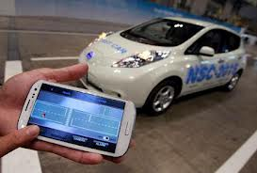

Figure 5: Working Example

Figure 5 shows how the user is able to see on their phone the location of their car in the car park once the user enters the park. The example shown in this figure uses the sensors system.

The user would always be able to find out where their car exactly is without going inside the car park via android app on their phone along with other information.

Some mock-ups are as follows:

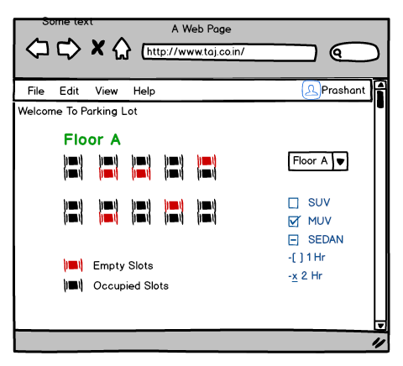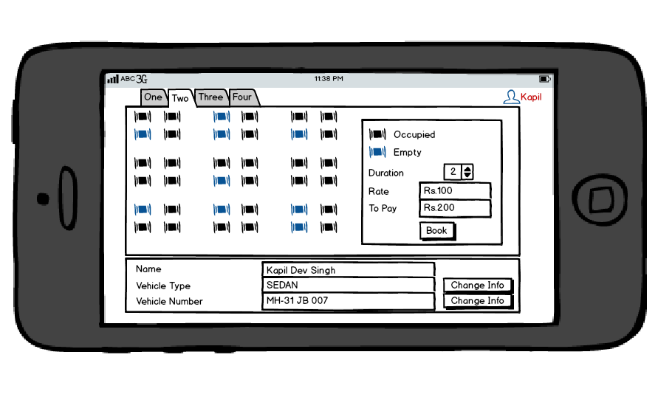

WEB APPLICATION

ANDROID APPLICATION

**CONCLUSION**

Presently, India doesn’t have the Smart Parking system with wireless sensor networks for full automation. Due to ever increasing influx of vehicles, there is a dire need of smart parking system management tools to manage the heavy ingress of vehicles. There are various other smart parking system alternatives like RFID enabled parking system, E-parking system, fuzzy logic implementation in parking system etc. which are, due to some technical backwardness, not feasible in India presently.

ParkMeRight will be an effective parking system keeping in mind the present scenario of India, where the parking systems are not so smart i.e. they are not based on wireless sensor networks and are not fully automatic. Currently few smart parking systems have come up but they are limited to metro living crowd. This project will remove all backdrops and will work towards solving the problems faced by vehicle owners.

**REFERENCES**

**[1] M.Y.I Idris, “***Car**Park System: A review of Smart parking System and Its technology****”*, Information Technology Journal 8(2),101-113,2009**

**[2] [Online] http://www.upark.in**

**[3] Bong, D.B.L. , K.C. Ting and K.C. Lai, “***Integrated approach in the design of car-park occupancy information system***” . IAENG Int. J. Comput. Sci., 35:1-8, 2008.**

**[4]** Daniele Luttazzi, “*Lepidezze postribolari”* (2007, Feltrinelli, p.275)

**[5] Hinze, D., 2000. “***Italians drive for smart card parking in major cities***”. Card Technol. Today, 2: 6-7**

**[6] Idna, M.Y. and E.M. Tamil, 2007. “***Parking Information System Using GPS and Shortest Path Algorithm***”. Proceeding s of the SCOREED 2007, MAY 14-15, University Tenaga Nasional, Malaysia, pp: 1-7**

**[7] Inaba, K. ,M. Shibui, T. Naganawa, M.Ogiwara and N.Yoshikai, 2001. “***Intelligent Parking Reservation service on the internet***”. SAINT W, Symposium on applications and the internet workshops(SAINT 2001 Workshops), Jan 8-12, San diego, CA USA,pp: 159-164**