|  |
| --- |
| **11 i) write a PHP script to find out the sum of individual digits of a given number upto single digit.**  **AIM: Php script to find the sum of individual digits of a given number upto single digit.**  **DESCRIPTION:** PHP (Php Hypertext Preprocessor) is a server scripting language, and a powerful tool for making dynamic and interactive web pages. PHP is a widely-used, free, and efficient. PHP scripts are executed on the server. A PHP script can be placed anywhere in the document using starting tag as ‘<?php’, ends with ‘?>’ and saved with .php extension. Every statement in the code ends with a semicolon(;).  **Syntax:**  <?php  //PHP code goes here ;  ?>  **PROGRAM:**  <center>  <form method="post">  <label>Enter a Positive number:</label>  <input type="textbox" name="n" required/><br/><br/>  <input type="submit" name="submit"/>  </form>  <?php if(isset($_POST['submit']))  {  $n=$_POST['n']; function digSum($n)  {  $sum=0;  while($n>0 || $sum>9)  {  if($n == 0)  {  $n=$sum;  $sum=0;  }  $sum+=$n%10;  $n=(int)$n/10;  }  return $sum;  }  echo "Number:$n <br/>The sum of digits upto 1 is :"; echo digSum($n);  }  ?>  </center> |



**11**

**i**

**i)**

**write**

**a PHP script to check whether the given number is Palindrome or not**

**.**

**AIM:**

**Php script to**

**check whether the given number is Palindrome or not.**

**DESCRIPTION:**

Palindrome is a word, number, phrase or other sequence of characters which

reads the same bac

kward as forward, such as ‘madam’ or ‘19591’.

•

s

trrev() :

-

This method is used for just reverse the input data as it as.

•

method=”post” :

-

POST method is used for sending any sensitive information because the

information sent using the POST method is not

visible to anyone.

•

isset() :

-

The isset function is used to determine whether a variable is set or not.

•

echo() :

-

Its is a Printing statement. We can use with or without ‘()’, it does not return any

values. It is faster than print statement and we can pass

multiple stings separated by a

comma(,) in echo.

**PROGRAM:**

<

center

>

<

form method="post"

>

<

label>Enter a number:</label

>

<

input type="textbox" name="n" required/><br/><br/

>

<

input type="submit" name="submit"/

>

<

/form

>

<

?php

if(isset($_POST['submit'

]))

{

$n=$_POST['n'];

$rev=strrev($n);

if($n==$rev)

echo "$n is Palindrome";

else

echo "$n is not Palindrome";

}

?>

<

/center

>

|  |
| --- |
| **11 iii) write a PHP script to work with indexed and associative arrays.**  **AIM: Php script to work with indexed and associative arrays.**  **DESCRIPTION:**  • An **Array** is a special variable, which can hold multiple values in one single variable. It stores only homogenous type of data , you can access the values by referring to an index number.  Syntax:array(); // to create an array  i. **Indexed arrays:-** Array with a numeric index. The index can be assigned automatically always starts with 0  Syntax: array(“value1”, “value2”, “value3”,..); ii. **Associative array**:- Array with named keys that you assign to them.  Syntax: $arrayname=array(“key1”=>”value1”, “key2”=> “value2”, “key3”=> “value3”,..);  (or)  $arrayname[‘key1’]=”value1”;  $arrayname[‘key2’]=”value2”;  iii.    **PROGRAM:**  **Multidimensional array**  :  -    Array containing one or more arrays.    $sub = array("pavan","satish","karim");    <?php  //Indexed array  print_r($sub); echo "<br/><br/>";  //Associative array  $pavan=array("DWHDM" => 22,"Web technologies" => 21,"RPA" => 21); print_r($pavan); echo "<br/>";  $satish=array("DWHDM" => 21,"Web technologies" => 24,"RPA" => 22); print_r($satish); echo "<br/>";  $karim=array("DWHDM" => 18,"Web technologies" => 20,"RPA" => 17); print_r($karim); echo "<br/>";  ?> |

|  |
| --- |
| **11 iv) write a PHP script to fetch data from HTML form.**  **AIM: Php script to fetch data from HTML form.**  **DESCRIPTION:**   * $_POST :- It is super global variable which is used to collect form data after submitting an HTML form with method=”post”. $_POST is widely used to pass sensitive data. The POST does not show this information as it’s encoded in the request. Syntax: $_POST[‘element_name’]; * $_GET :- It is also same as POST but GET displays the submitted data as part of the url. GET allows only ASCII data. Normally GET is used to retrieve data.   Syntax: $_GET[‘element_name’];  **PROGRAM:** PHP code  <?php  $name1=$_POST['name1'];  $name2=$_POST['name2'];  $phn=$_POST['phn']; $email=$_POST['email']; echo "Your Details<br/><br/>"; echo "Name:$name1 $name2<br/>"; echo "Mobile:$phn<br/>"; echo "Email:$email<br/>"; echo "College Name:";  $option = isset($_POST['clg']) ? $_POST['clg'] : false; switch($option)  {  case 1:  echo "Aditya Engineering College";  break;  case 2:  echo "Aditya College of Engineering & Technology";  break;  default:  echo "Aditya College of Engineering";  break;  }  ?> |

|  |
| --- |
| HTML code  <!DOCTYPE html>  <html>  <head>  <title>Fetching data</title>  </head>  <body ><center>  <form action="11-4.php" method="post">  <table cellspacing="8">  <tr><td><label>Enter first name:</label></td>  <td><input type="text" name="name1"/></td></tr> <tr><td><label>Enter second name:</label></td>  <td><input type="text" name="name2"/></td></tr>  <tr><td><label>Enter mobile number:</label></td>  <td><input type="text" name="phn"/></td></tr>  <tr><td><label>Enter your E-mail:</label></td>  <td><input type="text" name="email"/></td></tr>  <tr><td><label>Enter college Name:</label></td>  <td><select name="clg">  <option value="1">Aditya Engineering College</option>  <option value="2">Aditya College of Engineering &  Technology</option>  <option value="3">Aditya College Of Engineering</option>  </select></td></tr>  <tr><td colspan="2" align="center"><input type="submit" value="Show Details" name="show"></td></tr>  </table>  </form></center>  </body>  </html> |



**OUTPUT:**

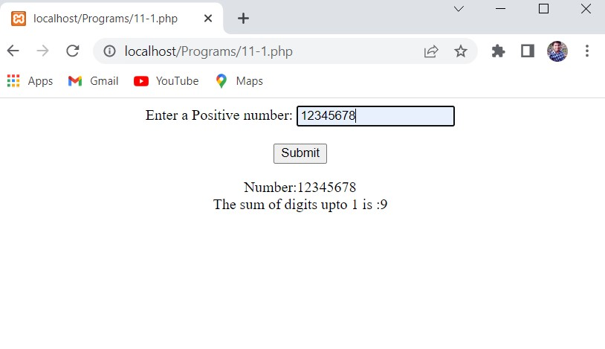

**OUTPUT:**

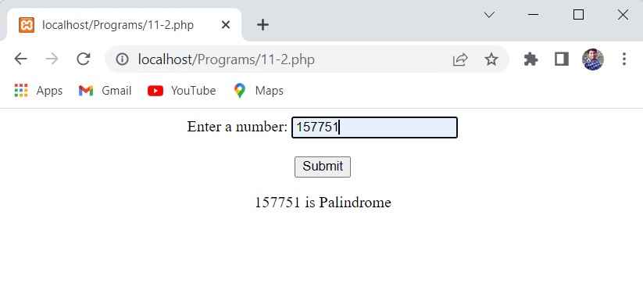

**OUTPUT:**

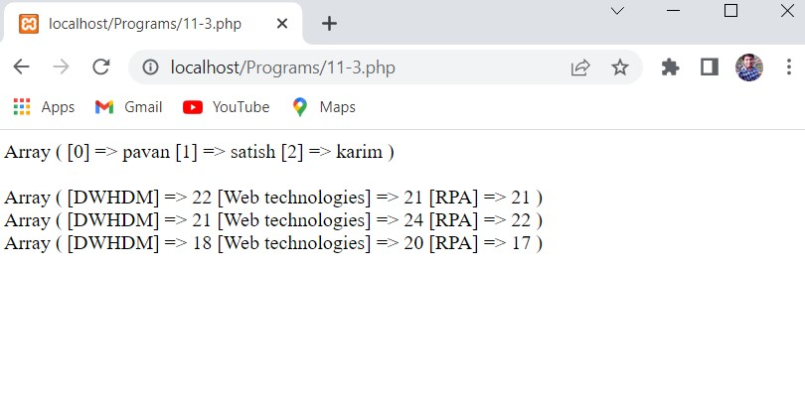

**OUTPUT:**

