**Society App**

**Create Relations NearBy and Help Others**

**Make Good where you live**

**Homepage**

1. Login As Society Member
2. Login As Society President
3. Login As Labour

**Signup**

**sp = society president**

**sm = society member**

**For Society President**

1. **Signup (only for sp) :**

**Signup Form**:

Society Name*: Vasundhra Enclave

President Number*: xxxxxxxxxxxx

Street Address*: Near Rajiv Metro Station

Society Location*: **City, State, zip**

Password*: xyz

Confirm Password*: xyz

**Signup Button**

1. **Will open admin panel for society**

Side bar for admin panel black color. It will collapsible

**3. One link in sidebar will All Members**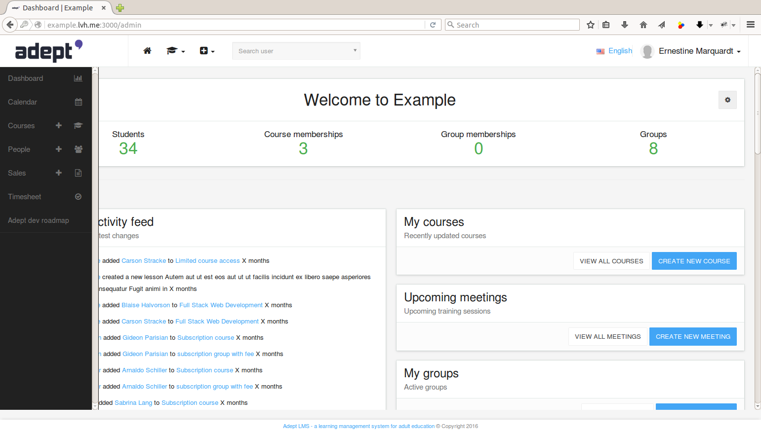

**All Member**: List all members, edit, update, delete

Name

Number

Flat No.

Email

Blood Group

Members Count:

Since: 2012- current

**3.1. Create New Member**

Create Form

Role: Member, President, Labour, POE(Power of attorney)

**If role == Member || President**

Name:

Photo:

Flat No.(uniq)

Tower No.(uniq)

Mob. Number:(uniq)

Email(uniq):

Alt No.:

Blood Group:

Occupation:

Members Count: Adult: Kids:

Bio:

Password:

Confirm Password:

**If role == Labour**

Name:

Time Availability: Time Bar include weekend or weekdays

Night Charges:

Occupation/Work:

Contact No.(uniq):

Password:

Confirm Password:

**3.2. Left Members** Under all members

**3.2.1 Listing**

Name

Number

Flat No.

Email

Blood Group

Members Count:

Since: 2012- current

**4. Complaints**

Watch only to Labour and President

**4.1.1 Listing**

Complaint No.

Flat No.

Mobile No.

Complaint About:

Status || Mark Resolve (Button):

**4.1.2 Show Complaint**

Complaint No.

Flat No.

Mobile No.

Complaint About:

Complaint Desc:

Status: Resolved(Text) || Mark Resolve (Button):

**4.2 Feedbacks (Not Show to Labour)**

Feedback No.:

Flat No. (Not Compulsory):

Mobile No (Not Compulsory):

Feedback Desc:

Status: Approved on date(Text) || Approved By datepicker (Button):

Include Ratings for society

Open to society or not: If opened, add signature system

**Registration on announceMents for members ------ Listing**

**5. Announcements:** Will notify to all members of society

**5.1** **Listing** Last announcements

Title:

Desc:

Date:

Name: President Name

**5.2 Create**

Title:

Desc:

Date:

Name: President Name : DropDown

**5.3** **Show**

Title:

Desc:

Date:

Name: President Name

**Registration on announceMents for members ------ Listing**

**6**. **Policies:** upload Policies (jpeg and pdf)

**6.1 Listing**

Name:

Upload Date:

Link To download Policy:

Action:

**6.2 Create Policy**

Policy Name:

Write Policy:  
Date:

Upload File:

**6.3 Show Policy**

Policy Name:

Write Policy:  
Date:

Upload File:

**7.** **Banners**:

Add Dynamic Banners:

**7.1 Banner List**

Position: DropDown for different Positions

Banner Size: Automatically Select

Upload Banner: Link

**7.2 Create Banner**

Position: DropDown for different Positions

Banner Size: Automatically Select

Upload Banner: Link

**8. Memberships**

Free Tier Monthly Yearly

**10 members 0-200 members 0-200 members**

**2500rs 20,000 rs**

**Above 200 members we will charge 100rs per member**

**9. DashBoard**

Activity List - latest announcements

New Members - Who just joined

Complaints - Latest complaints

Feedback - Feedbacks

**10. Society Funds**

Available Funds

Maintenance charges

Other Funds

Total Funds, need to pay

List Members : Who payed and who not paid funds

Balance Sheet

**Tab for: Got Funds** from: flat sale, In house Business and others

**11. Emergency Details**

**Create Form also available**

Name | contact no. | availability | Expert in

**Prototype 2**

**12. Fun Videos**

**13. Video Conferencing**

**14. Scan Adhar card or scan licence**

**15. Check for member previous details**

**16. Add Inhouse business (Selling and purchasing things, somebody has papad business etc)**

**17. Interlink Societies (Link societies and help others)**

**18. Competition b/w Societies**

**19. School/park/hospitals etc information**

**20. Club booking approval**

**Society Member**

* **Dashboard**

AnnounceMents

Feedback (Need Signature)

Maintenance pending this month

* Search for member and connect
* Connected members can chat
* Advertise flat for sale
* Contact Society president for problems and issues
* Public Feed / Personal Feed of connected members
* Feedback and complaints
* Sale 2nd hand things
* Invite local and connected members on occasions
* Carpool
* Buy or sell flat
* Rent your belongings (car parking space, shop, flat as of now)
* Job Portal
* Rate Your society
* Very Very Emergency Help (Hot)
* Add Inhouse business (Selling and purchasing things, somebody has papad business etc).
* Register for Competition b/w Societies
* School/park/hospitals etc information Request
* Club booking Request
* Matrimony Option

**Labour**

* Complaints
* Contact Society president
* Some Urgent Notification