HLD and LLD
Yara Custom Application

Created By: Tarun Garg
Email: tarun.garg@nagarro.com

Table of Contents
HLD Diagram 3
Description 4
Data Migration 5
LLD Diagram 6
1.1 Claim Management System (CMS) Diagram 6
1.1 Description 7
1.2 Leave Management System (LMS) Diagram 8
1.2 Description 9
1.2.2 Leave Management System (LMS) TimeSheet Diagram 10
1.3 Helpdesk Diagram 11
1.3 Description 12
1.4 Travel Management System (TMS) Diagram 13
1.4 Description 14
1.5 Employee Management System (EMS) 13
1.5 Description 14
1.9 Asset/Inventory Management System 13
1.9 Description 14
1.7 Minutes of Meeting 15
1.7 Description 16
1.8 All Idea Matters 17
1.8 Description 18
1.6 Master Data Management 19
1.6 Description 19
1.10 PO, PR Approval System 19
1.10 Description 19
Deployment Architecture 20
Description 21

HLD Diagram

Used AWS as deployment server

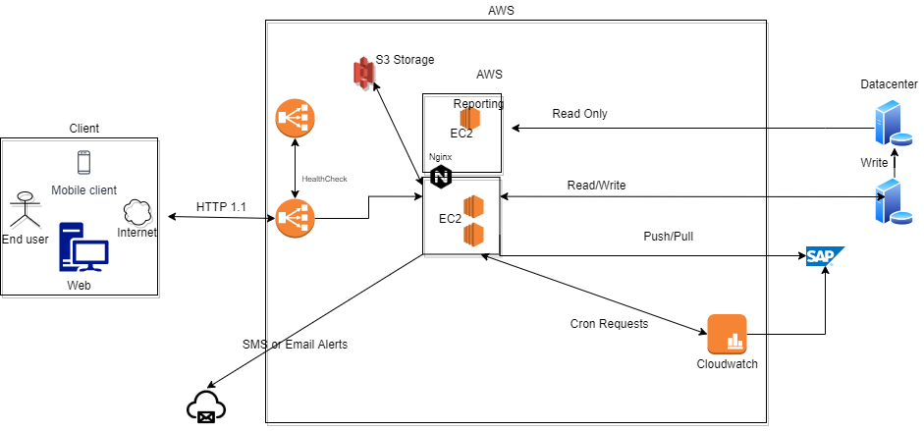

Description
- There are two UI of application Mobile and Web.
- Client request will go to AWS Load Balancer.
- We have one another Load Balancer for health check to Primary Load Balancer.
- If Load Balancer stops responding, then other Load Balancer will take over the requests.
- We have configured Load Balancer to divert the Report related APIs to Reporting server. As reports are heavy operations and, in our requirement, we have reporting in every module. For performance reason we kept it separate.
- Our .net application is deployed on all EC2 instances
- Instances are attached with DB for read/write data.
- Instances are also attached with SAP to process SAP related dependencies.
- We have a backup DB, which only stores data. It is a master slave architecture. Right now, we are using slave as reporting purposes.
- Instances are connected with any third party Email/SMS server for handling alerts.
- In case the load increased, we can directly save data to master DB from Lambda functions and call these functions directly from UI.
- We have batch/cron jobs, so we used AWS Cloudwatch for handling this.
- The EC2 instances will use to handle the other client requests.
- Upon EC2, we have nginx as intermediator for caching and proxy purposes.
- We are using S3 storage for storing the attachments.
- We have a SAP system that is taking requests from servers.

Data Migration
The scope of data to be migrated may include configurations or open requests in Lotus Notes at the time of project launch
1. Do we have access to Legacy DB or schema
2. We have to access the Legacy data through APIs

- Do we have access to Legacy DB or schema
Approach 1: If we have access to legacy DB and DB relations are easy to understand then we can keep the new DB schema almost same to reduce efforts of migrations and by Understanding the relations between tables, we can integrate our new system.

Approach 2: If we have access to legacy DB and it is complex to understand then we can create similar tables with legacy as prefix. If old user login then we can use that legacy prefixed tables. For new user, we can use our new table structures.

- We have to access the Legacy data through APIs
Approach 1: We can hit open APIs and map the fields as per our system.
Data migration will be done only once under single iteration
Assumptions:
Client no longer wants to keep the dependency on legacy system.
Approach:
1. We have take a db backup at our side by overriding some fields of data like email, other confidential information
2. We can play around legacy system DB and able to achieve DB migration in single iteration.

Low Level Diagram
  - Claim Management System (CMS)
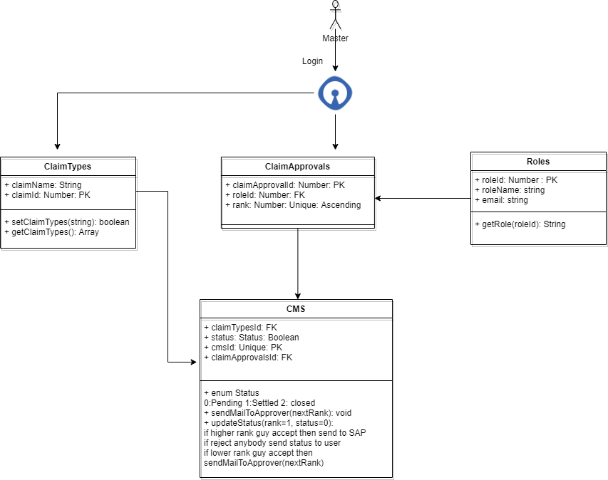

1.1 Model Description

- Master will update Claim Approvals table through CRM
- He will update the rank wise role for approval the request
- Now End user will update request through website in CMS table.
- updateStatus() method will firstly check the status and rank parameter. So on employee request no parameter will send so we pick default one.
- if rank not exist then it will call sendMailToApprover() and update claimApprovalsId in DB and mail will send to the approver.
- Upon the action on mail, update status will again check for the status and rank.
- If status is rejected, it will set status Closed and send notification to employee.
- If status is accepted, it will check for next rank from previously set value claimApprovalsId and send email to next person
- If updateStatus() method get accept from the last higher rank guy then the request will go to SAP system
- SAP system in return will send the response to our system and updateStatus() will update the status to settled and notify the employee
- Reporting system can use same CMS table and relationships for generating the response.

1.2 Leave Management System (LMS)
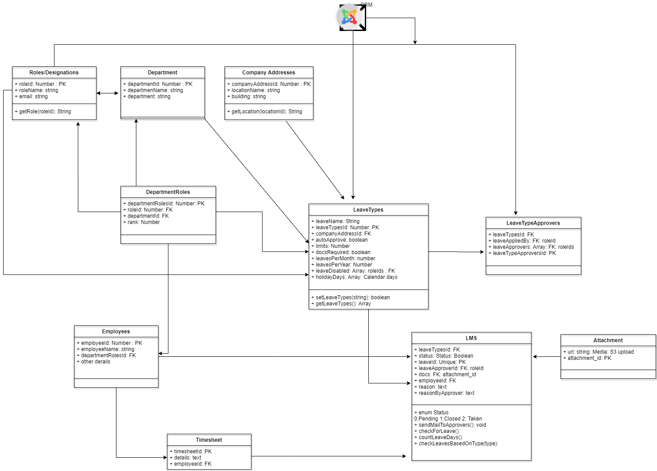

1.2 Description

- Master will create the leave types from CRM and details will store in table LeaveTypes
- A dropdown will give to Master to select Department (Department Table)
- After selecting the department, related Roles will show up (DepartmentRoles table).
- After updating the fields, the information will store in LeaveTypes and LeaveTypesApprover tables.
- Now we can hide or show section of leaves based on LeaveTypes Table from leaveDiabled field which includes are roles for which leaves should enable and disable
- When employee will apply a leave, the information will store in LMS table.
- We can check Leave Type and rules from LeaveType table
- Check if docs required from docsRequired table, if yes then check for limit like 2 days. If applied leaves count is greater than 2, we can validate docs. Which covers sick leave
- We can check for autoApprove field, for auto approving the leaves
- Also, we have limitperMonth field, for limiting autoApprove
- We have limitsPerYear field, with which we can handle maternity leave.
- We can check holidayDays in LeaveTypes table to check if any leave occur in holidays or not
- For reporting we can use LMS table

1.2.2 Leave Management System (LMS): Timesheet

Added timesheet, if not updated add Entry in LMS.
1.3 Helpdesk

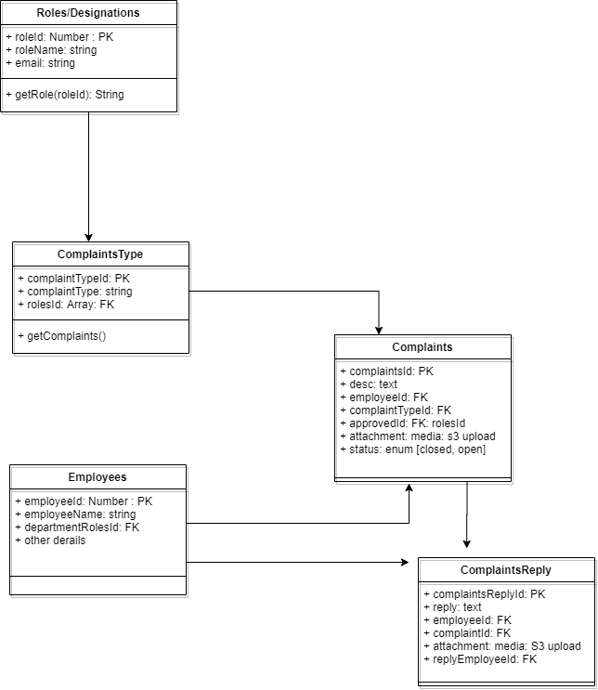

1.3 Description

- Master will create the complaint types from CRM and details will store in table ComplaintsType table
- A dropdown will give to Master to select Department (Department Table)
- Information will store in complaintType
- An employee can raise request and request will store in Complaints table with status pending
- An email will to the requested department people
- Department reply will store in ComplaintsReply table.
- If employee is satisfied, we can close the complaint and status will set to Complete in Complaints table

1.4 Travel Management System (TMS)
1.5 Employee Management System (EMS)
1.9 Asset/Inventory Management System (AMS)
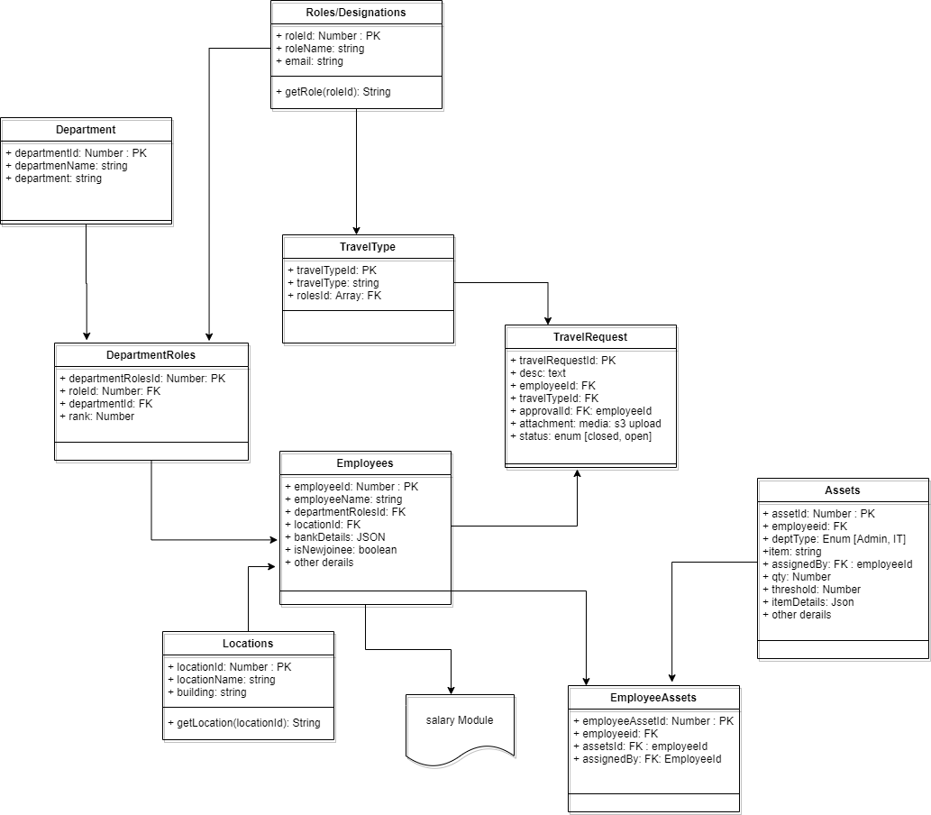

Description
- For TMS, we gave an option on CMS to configure Travel Types and store it in TravelType table.
- Employee will raise a request and request will store in TravelRequest table.
- Approve request will go store status in table and email will send to employee
- For EMS system, we have locations, assets, role defined in Employees table.
- Employee table further linked with salary Module.
- We have Assets tables which store assets related information which company has
- We have departmentType option in Assets table to segregate b/w the different departments
- We can store other Assets related details itemDetails. Which accepts json
- There is employee assets table, which keeps the record of assets given to employee
- There is a threshold value in Assets table. When threshold reaches on assigning the asset, we can send an email to assignedBy person of Assets table.
- If employee resigns, we can check the record of assets by employee and create a checklist. Even update the status of assets on EmployeeAssets table.

1.7 Minutes of Meeting

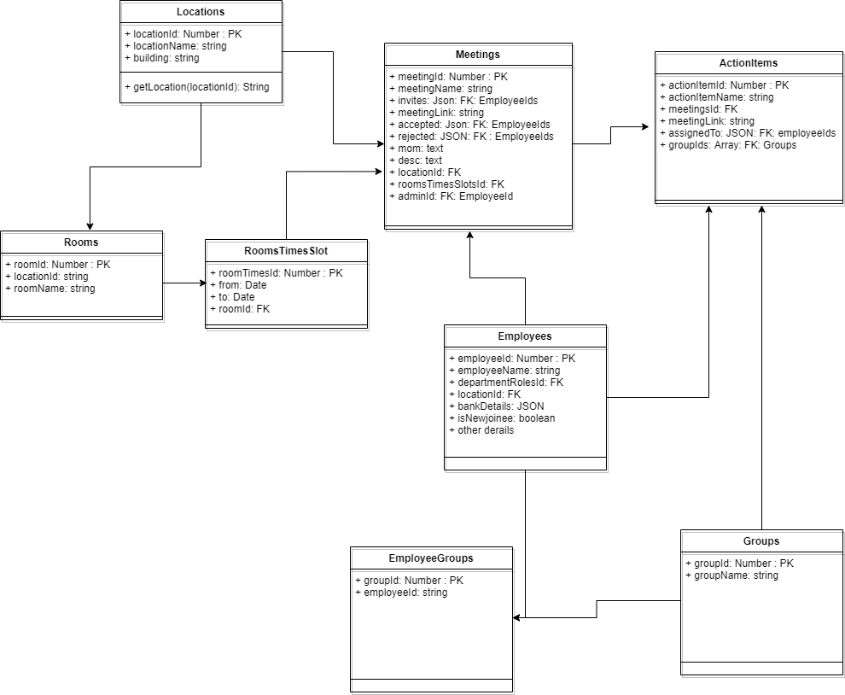

Description
- We have meetings table to store the meeting related information.
- We have roomTimeSlotTable that will store information datetime information from and to. We can check if any time is conflicting for particular room.
- We have roomId in roomTimeSlotTable that store meeting room related information
- We have invitees in Meetings table including information of all invitees who will attend the meeting.
- Minutes of meetings can be stored in mom field in Meetings table.
- Agenda can be save desc field in Meetings table
- Accepted, rejected information is also stored in table.
- There is adminId, who has scheduled the meeting.
- There is Actionitems a separate table, which includes information about groups and assignees list.
- We have status for action Items.
- We have linked system information also like jira and ids for linked system
- There is meetingLink to in Meetings table for online links to save

1.8 All Idea Matters

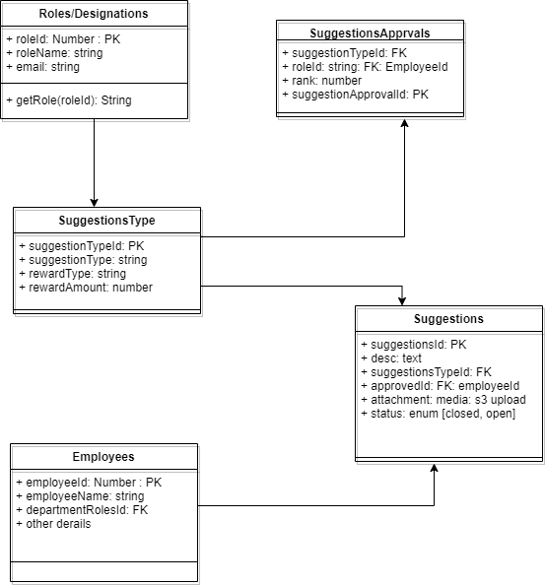

Description
- Master can create multiple Suggestion Types and store in SuggestionTypes table.
- Master can also add approvals list in SuggestionApprovals with rank information.
- Same rank person will get the mail at single time
- So on acceptance if request the mail will float as per the rank.
- The employee/enduser can add suggestions and suggestions can be add Suggestions table.
- User can also add attachment and write description.
- We have approvedId field to tell who approved the request.
- There is reward information in SuggestionsType table has information on reward
- We have rewardType and rewardAmount field. rewardType can be a voucher or rupee or anything
- rewardAmount is a amount to be given to user on acceptance.

1.6 Master Data Management

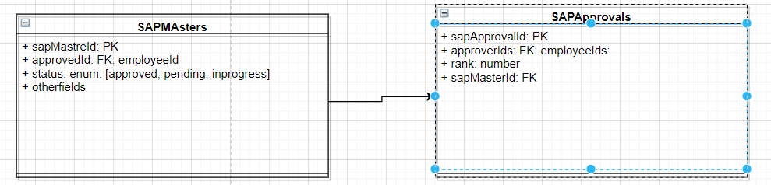

Description:
- SAP master requests will be in SAP Masters table. We will update the approvedId, who will accept and reject the approvals.
- SAP approvals are approvals list based on rank id

1.10 PO, PR Approval System
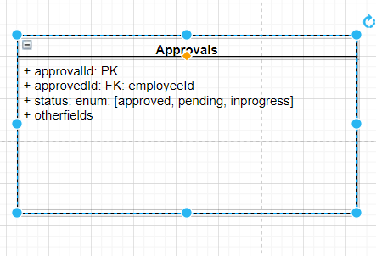

Description:
- Approvals include all data from the SAP systems
- We will update the approvedId, who will accept and reject the approvals.
- Response will also share to SAP
- Mail and resporting will occure based on the data we have in DB

Deployment Architecture
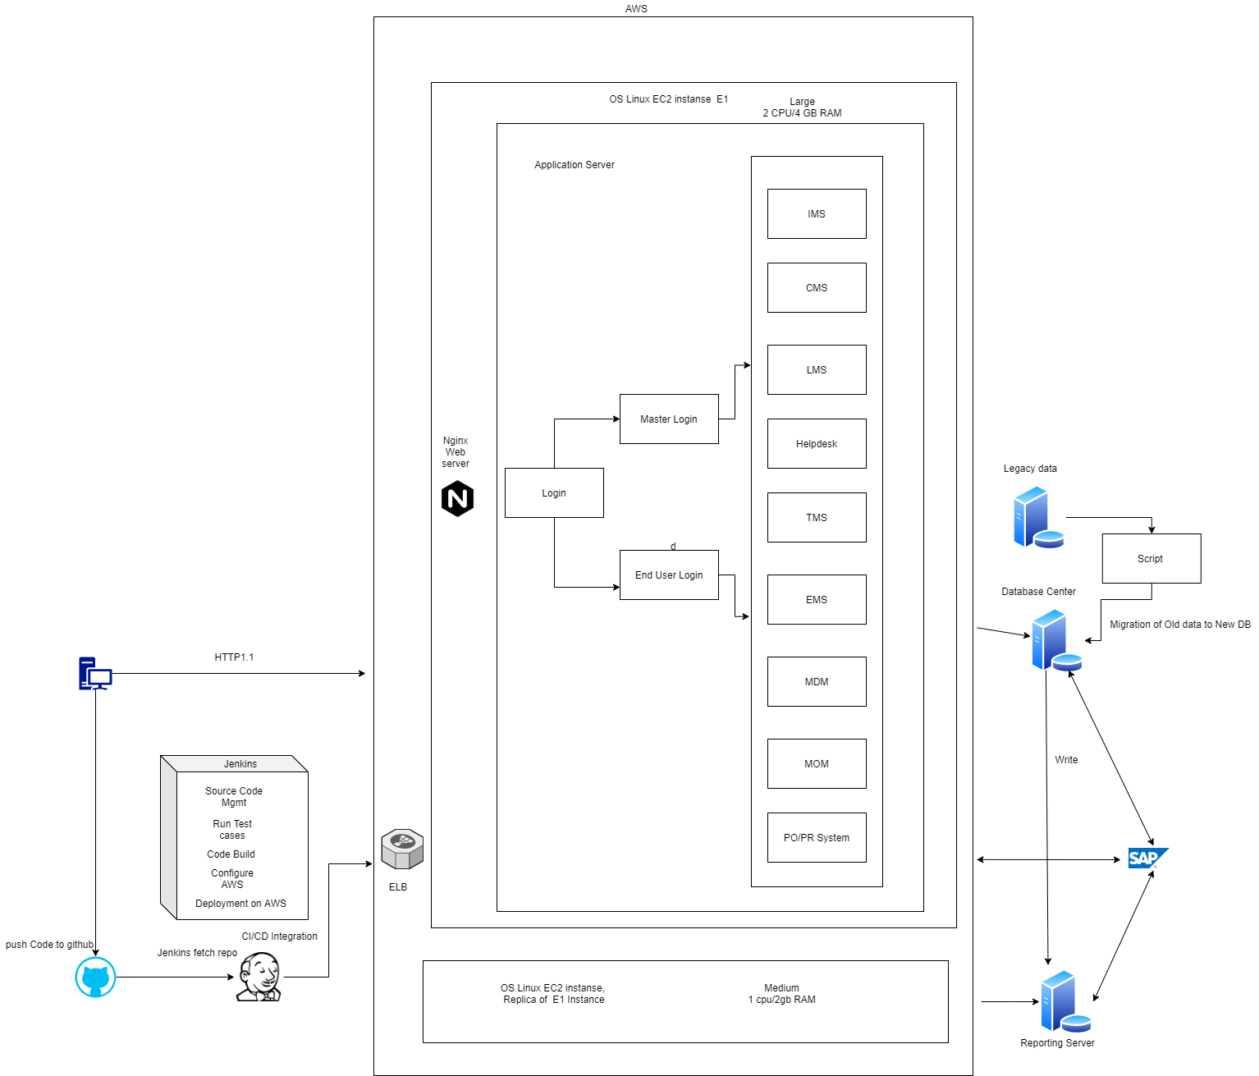
Description
- Team can push the code to Github
- Using Jenkins for CI/CD purposes.
- As code will push to Github, Jenkins will start run tests.
- Code check and code deployment on AWS.
- ELB will divide the requests based on reporting and normal urls.
- We have different DB for reporting to handle load and keep as a backup.
- At application level, We have configured multiple DB config Master and slave.
- Instances and ELB are stateless. Session is stored in DB.
- We have written a script for migration of Legacy data for the first time after prod deployment.

