

Experiment 5
UML Class Diagram (StarUML) — Organ Transplant Coordination System (OTCS)
Modeled in StarUML, maintained in the same OTCS project used for Experiments 1–4. Diagram exported as an image; the StarUML project file (.mdj) is not attached, per submission guidelines.
Submitted by
TARUN GARG
24BCE5084
NIGAM ANAND NAYAK
24BCE5202
SHIVAM KUMAR
24BCE1001
Under the guidance of
Dr. Ilakiyaselvan N.
SOFTWARE ENGINEERING
VELLORE INSTITUTE OF TECHNOLOGY, CHENNAI
2026-27

1. Objective
To design a UML Class Diagram for the Organ Transplant Coordination System (OTCS) in StarUML, using the same project/domain established in the earlier experiments (SRS, use case diagrams, and use case specifications). The class diagram identifies the core domain classes, their attributes and operations, and expresses every major UML relationship type — generalization (inheritance), association, aggregation, composition, dependency, and realization — with role names and multiplicity clearly labeled on each end.

2. Design Summary
The domain model below realizes the same actors and workflows already specified for UC1–UC4 (Register Organ Donor, Register Transplant Candidate, Perform Donor-Recipient Matching & Confirm Allocation, and Track Organ Transport). It defines 9 classes/interfaces in total — 5 core domain classes plus a base class, an interface, and 2 child classes derived from the base class through generalization — satisfying the minimum of 5 classes with at least 2 child classes.
Class | Type | Role in OTCS
Person | Abstract base class | Common identity/contact attributes shared by every human actor in the domain.
Donor | Child class (extends Person) | An organ donor; adds blood type, HLA typing, consent, and donor status (realizes UC1).
Recipient | Child class (extends Person) | A transplant candidate; adds required organ, urgency status, waitlist position (realizes UC2).
Hospital | Concrete class | Institution that registers donors and recipients.
TransplantCoordinator | Concrete class | Reviews and confirms matches (realizes UC3).
MatchAllocation | Concrete class | A donor–recipient match/allocation decision (realizes UC3).
OrganTransport | Concrete class | Tracks an organ in transit after a confirmed match (realizes UC4).
ComplianceReport | Concrete class | Regulatory report summarizing match/allocation outcomes (FR11).
INotificationService | Interface | Contract for real-time notification to affected parties (FR6).

3. Relationships Used
Relationship Type | Notation | Example in this Diagram
Generalization (inheritance) | Hollow triangle, solid line | Donor --|> Person, Recipient --|> Person
Association | Plain solid line, role names + multiplicity at both ends | Hospital "1" -- "0..*" Recipient : registers; Donor "1" -- "0..*" MatchAllocation : is matched as (+matchedDonor); Recipient "1" -- "0..*" MatchAllocation : is matched as (+matchedRecipient); TransplantCoordinator "1" (+coordinator) -- "0..*" MatchAllocation : reviews; TransplantCoordinator "1" -- INotificationService : uses
Aggregation | Hollow diamond at the whole end | Hospital "1" o-- "0..*" Donor : maintains (a Donor record can outlive its originating Hospital reference in the aggregate sense)
Composition | Filled diamond at the whole end | MatchAllocation "1" *-- "0..1" OrganTransport : initiates (a transport job cannot exist without its owning match)
Dependency | Dashed line, open arrowhead | ComplianceReport ..> MatchAllocation : <<summarizes>>
Realization | Dashed line, hollow triangle | MatchAllocation ..|> INotificationService

4. Class Diagram
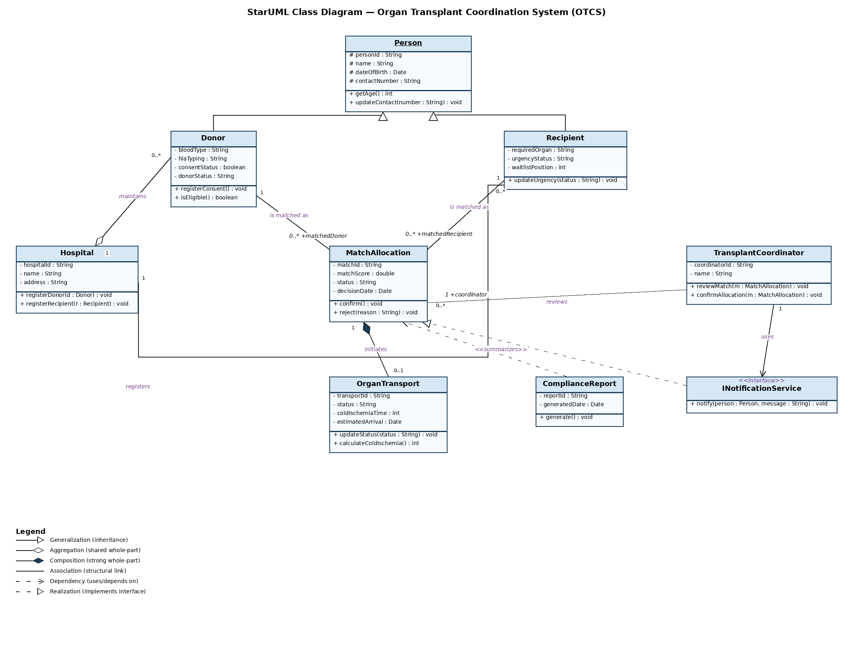
Figure 5-1. OTCS Class Diagram — modeled in StarUML, exported as image (project maintained under the same OTCS StarUML project as prior experiments).

5. Traceability to Earlier Experiments
This class diagram is derived from, and consistent with, the actors, use cases, and functional requirements established in the earlier experiments for the same OTCS project:
Class Diagram Element | Traces to
Donor, Hospital classes and the Hospital–Donor / Hospital–Recipient associations | UC1 (Register Organ Donor), UC2 (Register Transplant Candidate), FR1, FR2
MatchAllocation class, Donor/Recipient associations, TransplantCoordinator–MatchAllocation association | UC3 (Perform Donor-Recipient Matching & Confirm Allocation), FR3–FR5, NFR1, STRQ1
MatchAllocation *-- OrganTransport composition | UC4 (Track Organ Transport), FR6, FR7
MatchAllocation ..|> INotificationService, TransplantCoordinator -- INotificationService | FR6 (real-time notification on match confirmation)
ComplianceReport ..> MatchAllocation dependency | FR11 (Generate Compliance Report)

6. Conclusion
The OTCS class diagram consolidates the domain into 9 classes/interfaces — 5+ concrete/abstract classes plus 2 child classes (Donor and Recipient) generalized from the abstract Person class — connected through all six major UML relationship categories (generalization, association, aggregation, composition, dependency, realization), each carrying explicit role names and multiplicity. The model was authored in StarUML within the same OTCS project used for the SRS and use case diagrams in Experiments 1–4, and is submitted here as an exported diagram image rather than the StarUML .mdj project file.

