ASSIGNMENT 2

Video Link: <https://drive.google.com/file/d/1ogiHM-rtIY07KCFNESOAdsD-x_a2ugb8/view>

Question 1:

Use a python code to display the following star pattern using the for loop.

*

* *

* * *

* * * *

* * * * *

* * * *

* * *

* *

*

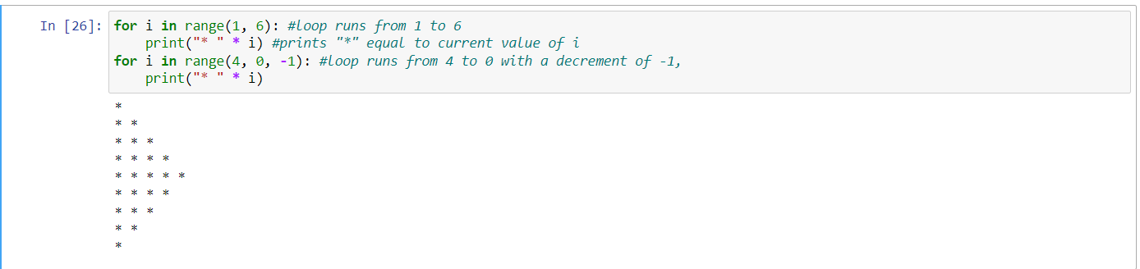

Description:

The code defines two nested for loops in Python. The first for loop iterates over the range 1 to 6 (not including 6), and the second loop iterates over the range 4 to 0 (not including 0), counting down by -1. In each iteration of the first loop, the inner print statement multiplies a string "* " by the loop variable i and outputs the result. The effect of this is to print a sequence of lines with increasing numbers of asterisks, with each line consisting of i asterisks and i spaces. In each iteration of the second loop, the inner print statement multiplies the string "* " by the loop variable i and outputs the result, just like in the first loop. The effect of this is to print a sequence of lines with decreasing numbers of asterisks, with each line consisting of i asterisks and i spaces.

Question 2:

Use looping to output the elements from a provided list present at odd indexes. my_list = [10, 20, 30, 40, 50, 60, 70, 80, 90, 100]

Description:

Create a list called my_list with the values provided by the user. Then it performs a list slicing operation on "my_list" and prints the result. The slicing operation in list, expression my_list [ 1 : len(my_list) : 2 ] returns the portion of the list from index start position 1 to index end, of the list I.e., the last element in list which will be known by using len() function which will return the length of string with a step size of 2 in this code.

Question 3:

Write a code that appends the type of elements from a given list.

Input

x = [23, ‘Python’, 23.98]

Expected output

[23, 'Python', 23.98]

[<class 'list'>, <class 'list'>, <class 'list'>]

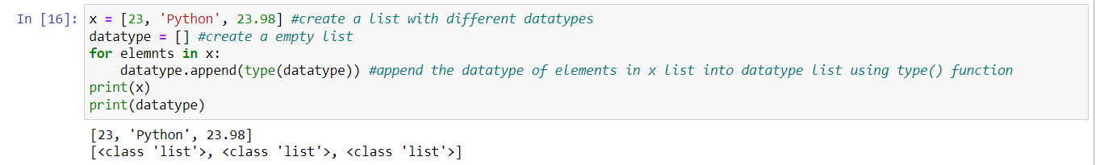Description:

There are different data types in python. These datatypes are used to define the type of data stored in a variable namely Numeric data types: int, float, complex, String data types: str, Sequence types: list, tuple, range, Mapping data type: dict, Boolean type: bool, set data types: set. This code defines a list x with three elements of different data types (integer, string, and float). Then, it creates an empty list datatype and uses a for loop to iterate through each element in x. For each iteration, it appends the result of calling type on that element to the datatype list. Finally, it prints both x and datatype. The output of x will be the original list, and the output of datatype will be a list of class types of each element in x.

Question 4:

Write a function that takes a list and returns a new list with unique items of the first list.

Sample List: [1,2,3,3,3,3,4,5]

Unique List: [1, 2, 3, 4, 5]

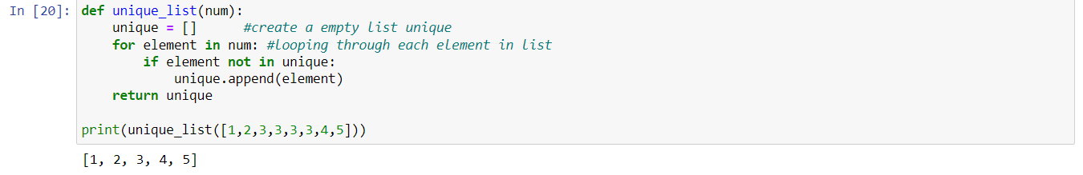

Description:

This code defines a function named unique_list which takes a list of numbers as an argument num. The function first creates an empty list unique. Then, it loops over each element in the input list num using a for loop. For each iteration, the code checks if the current element is already in the unique list. Not in is a Boolean operator it returns true if the value is not present in each collection of values. Otherwise, it returns false. If the element is not found in the unique list, it is added to the list using the append method. Finally, the function returns the unique list, which contains only the unique elements from the input list num. When the code is run with [1,2,3,3,3,3,4,5] as input, the output will be [1, 2, 3, 4, 5], a list that contains only the unique elements from the input list, with duplicates removed.

Question 5:

Write a function that accepts a string and calculate the number of upper-case letters and lower-case letters.

Input String: 'The quick Brow Fox'

Expected Output:

No. of Upper-case characters: 3

No. of Lower-case Characters: 12

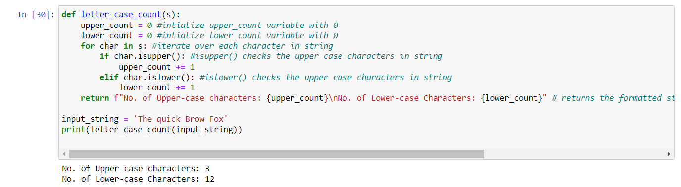

Description:

The code defines a function "letter_case_count" that takes a string as input and returns the number of upper case and lower case characters in the string. The function initializes two variables "upper_count" and "lower_count" to keep track of the number of upper case and lower case characters, respectively. The function then iterates over each character in the input string using a for loop, and for each character, it checks if it is an upper case character using the "isupper()" method or a lower case character using the "islower()" method. i[supper()](https://www.geeksforgeeks.org/python-string-isupper-method/) is a built-in method used for string handling. This method returns True if all characters in the string are uppercase, otherwise, returns “False.” i[slower()](https://www.geeksforgeeks.org/python-string-isupper-method/) is a built-in method used for string handling. This method returns True if all characters in the string are lowercase, otherwise, returns “False” If the character is upper case, the "upper_count" variable is incremented by 1, and if it is lower case, the "lower_count" variable is incremented by 1. Finally, the function returns a formatted string indicating the number of upper case and lower case characters in the input string. The input string is defined as "The quick Brow Fox" and is passed to the function as an argument, and the result is printed to the console.

Name: Garimella Venkata Tarun Chowdary

CRN: 23921

Student id: 700746945