DAY 4 JENKINS

Assignment1:
  - Install Nginx
# sudo apt-get install nginx
# sudo systemctl status nginx
  - Install below listed plugins
    - SSH plugin
    - Git plugin
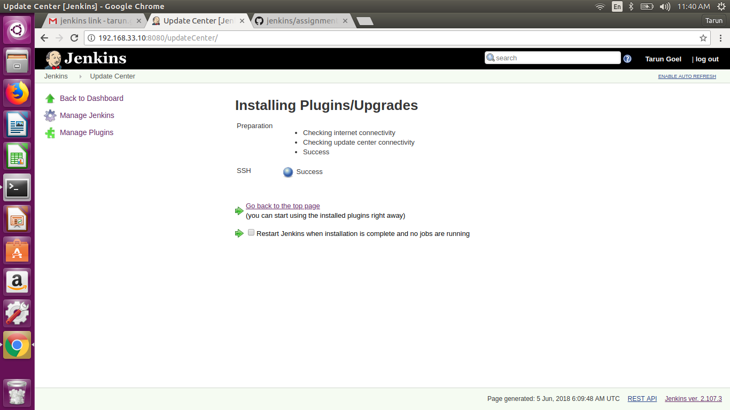

Assignment2:
1.Enable password less login between jenkins & root user
# sudo su jenkins
# cd /var/lib/.ssh
# ssh-keygen -t rsa
# cat id_rsa.pub
( copy the public key and paste it to root .ssh directory)
# sudo su root
# cd /root/.ssh
# sudo vim authorised_keys
# sudo vim /etc/ssh/ssh_config
( Uncomment Strictly host checking and add no )

#sysemtctl restart ssh
# exit
# sudo su jenkins
# ssh root@ipaddress
# Now you should be able to login in root user without any password
2.Check Global configuration and provide SSH remote host(root) details
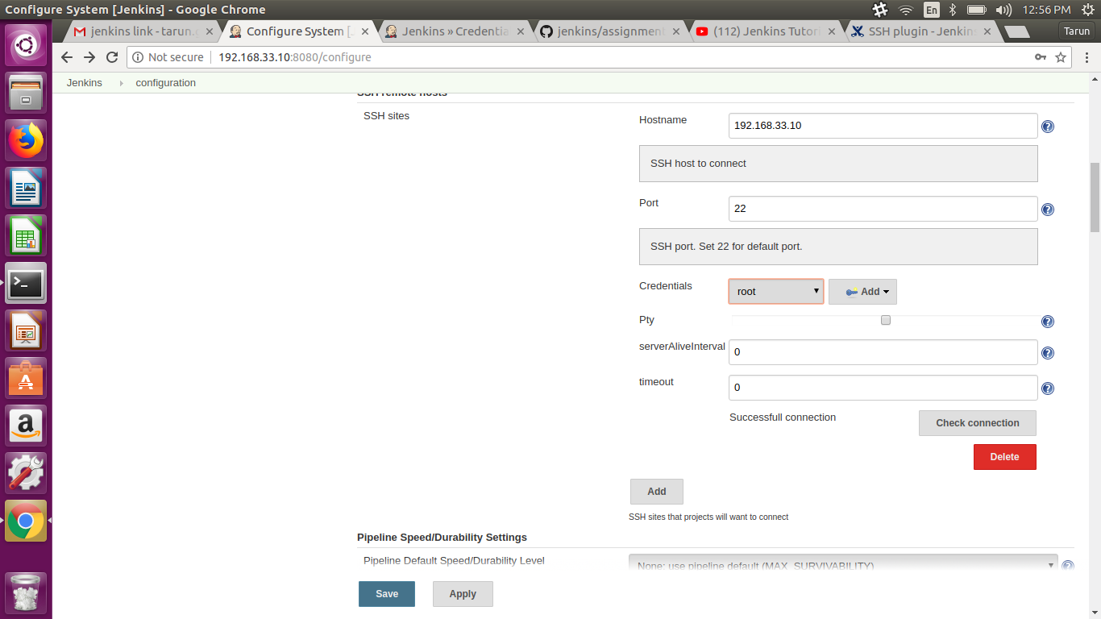
- Assignment3:
  - Create a tag creator Jenkins Job
  - Job will create tag on your forked repo.
  - Job should accept 2 parameters
    - SRC_BRANCH
    - TAG_NAME
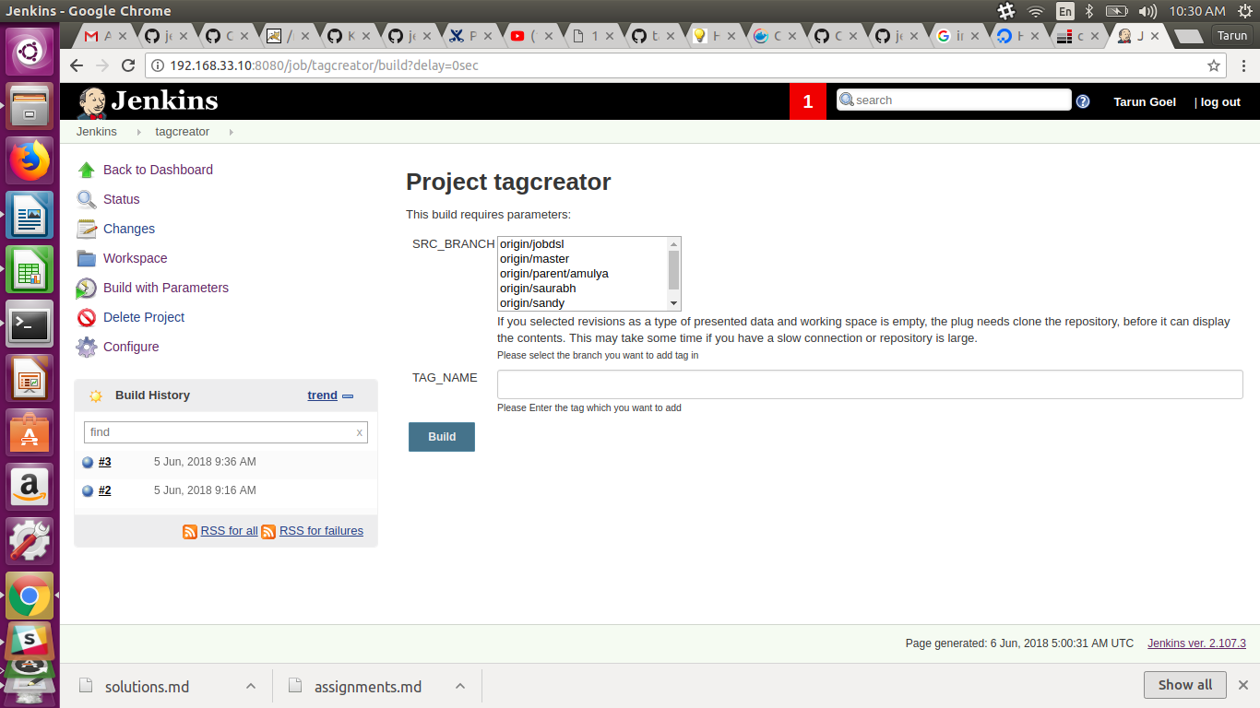
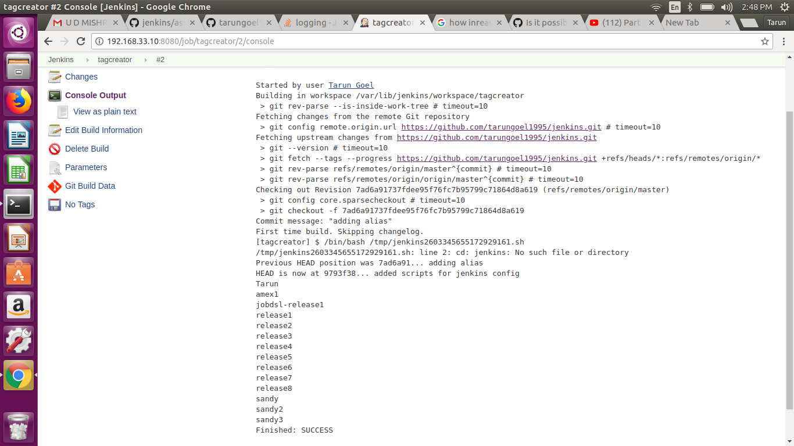
Assignment4:
  - Sync your forked jenkins repo with https://github.com/ot-training/jenkins.git (using multiple remote).
# cd /var/lib/jenkins/workspace/
#ls
#cd tagcreator/
#ls
#ls -al
#sudo git remote add upstream https://github.com/ot-training/jenkins.git
#sudo git fetch upstream

  - Create a Deployer Jenkins Job(static-code-deployment).
It will checkout code from https://github.com//jenkins.git (your forked repo).
Job will require a parameter TAG_NAME
It will use SSH Publish plugin to publish files from jenkins server to target server
Deploy index.html (existed inside attendees/assignments/day7) into nginx doc root.
Update index.html (with your name) and create a new tag.
Deploy with new tag.
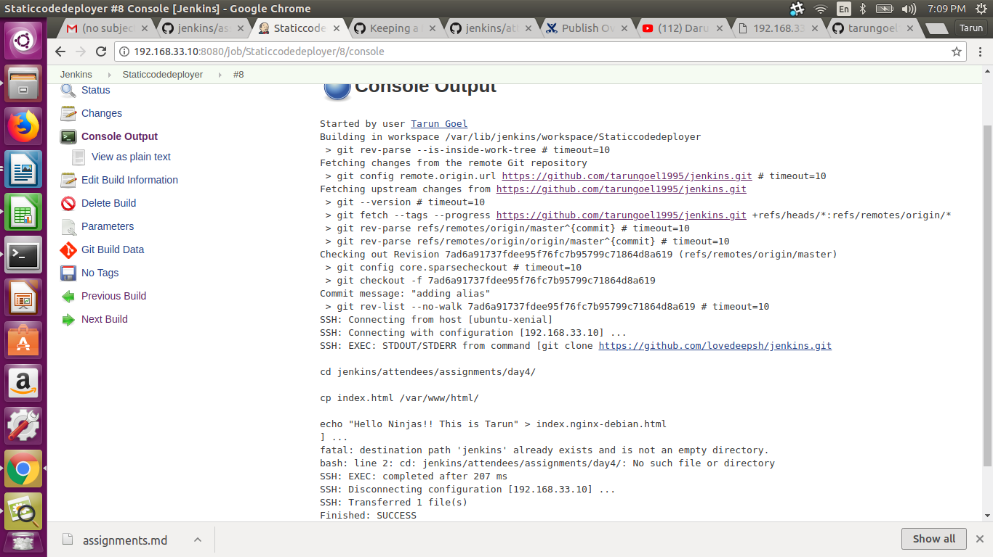
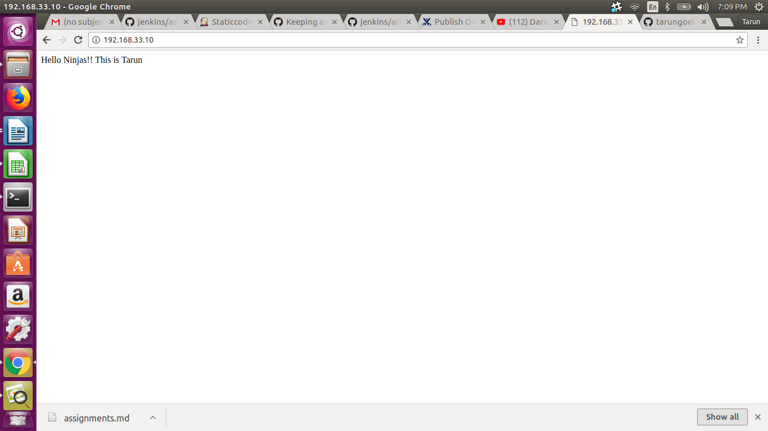

Assignment5:
  - Install tomcat7
  - Install mysql
  - Fork ContinuousIntegration from opstree account.
  - Create a job Spring3HibernateApp-deployment
    - This job will be copy of static-code-deployment
    - Update deploymnet target to tomcat webapps directory
    - This job and code-stability (job from 6th day assignmnet) will have common workspace.
  - Deploy Spring3HibernateApp.war into tomcat7 (pick from workspace, copy into webapp of tomcat)
  - Verify you can acecess http://:8080/Spring3HibernateApp/
# Installed Tomcat8
# installed mysql-server
#forked above mentioned repo
#created a jenkins job which deploy Spring3HibernateApp.war to tomcat/webapps. Console output of which is shown below.
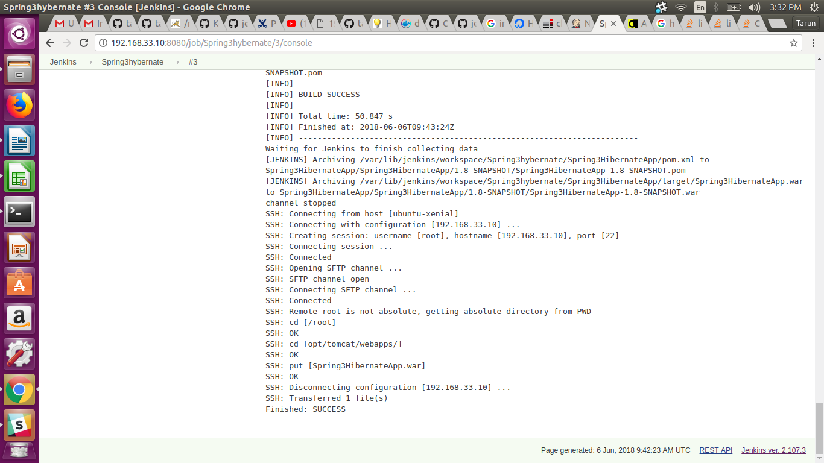
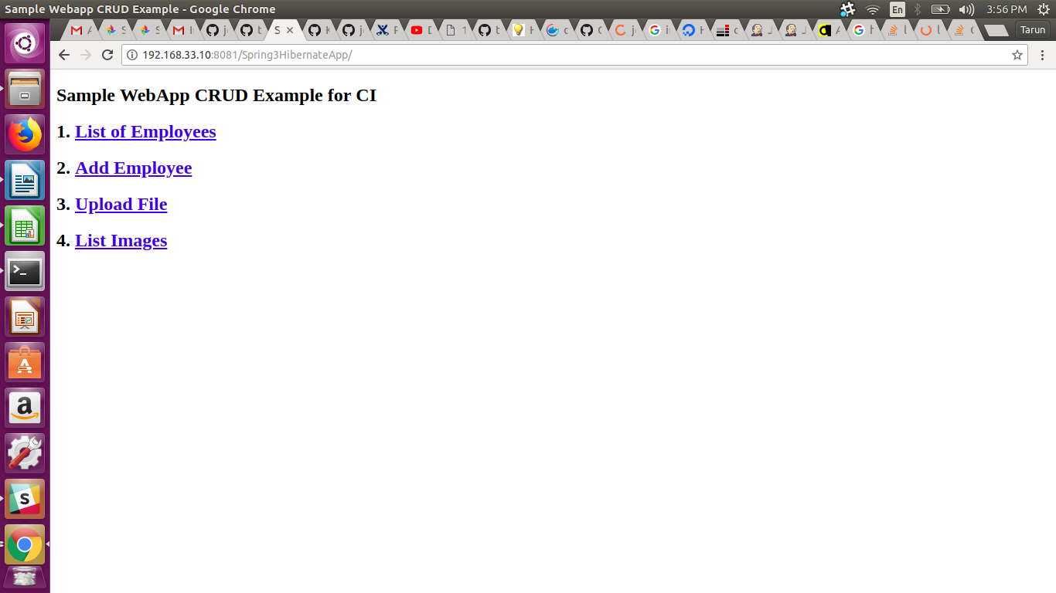
- Assignment6:
  - Configure nginx in a way so that it can serve
    - static file (index.html) at http://
    - java application (Spring3HibernateApp) at http:///Spring3HibernateApp/
Hint: Add another location (Spring3HibernateApp/) and proxy_pass details in your nginx configireation.
(Pending, still working on the solution)

Assignment7:
- Deploy a demo node application
  - Fork node-js-sample repo into your account
  - Create a jenkins job to build node code and create a tar file(artifact)
  - Stop already application, Deploy tar file on a target server and start application again. Hint: Use pm2 to start and stop node process (process management
(Pending, still working on the solution)

