Assignment 7 Jenkins

- Assignment1:
1. Create 2 slave and connect them to jenkins master.
Steps:
- Create ssh connection between master and slave machines.
- Add the ssh credentials in confiuration and check ssh connection.
- Go to Manage Jenkins.
- Click on Manage nodes.
- Create new nodes.
- Provide Node Name and select Permanent agent.
- Then provide name, description, no. of executors, labels, remote root directory.
- Select Launch method via ssh.
- Provide host name and credentials & click save.
- Go to the nodes and click launch node.
- Now the nodes are being started.
(Similarly we can multiple nodes which act as slave for master server)

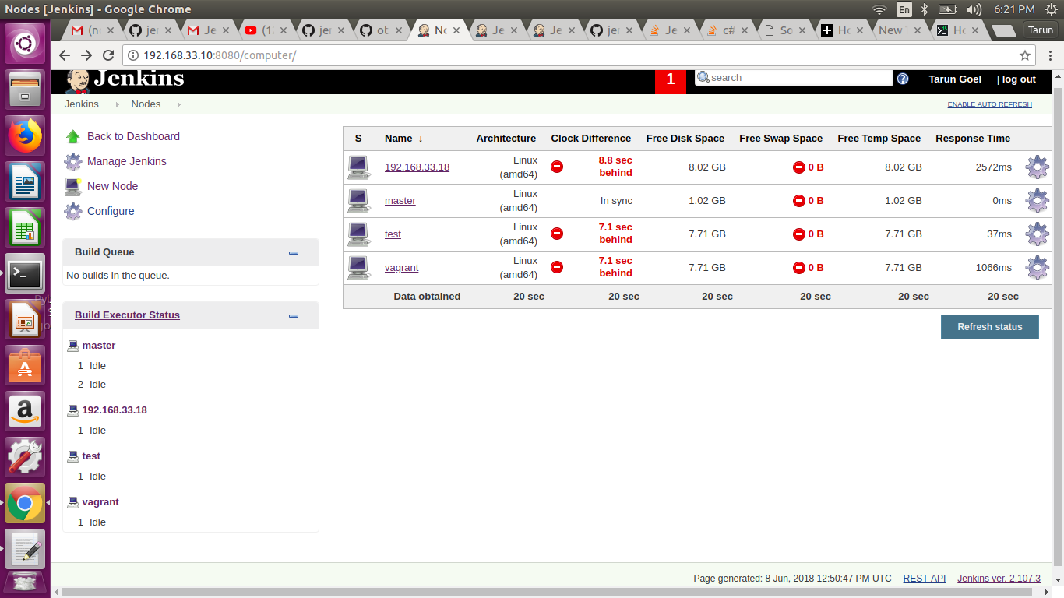

2. Restrict jobs for a specific jenkins slave.
Steps:
- Click on any particular job which you want to restrict for a specific jenkins slave and go in configure job section.
- Click on the checkbox for “Restrict where this project can be run” in General section.
- Give the name of slave in the box of Label expression.
- Click on save and build now
- In Console Output you can see that your job is being built on Specfic slave which you selected.
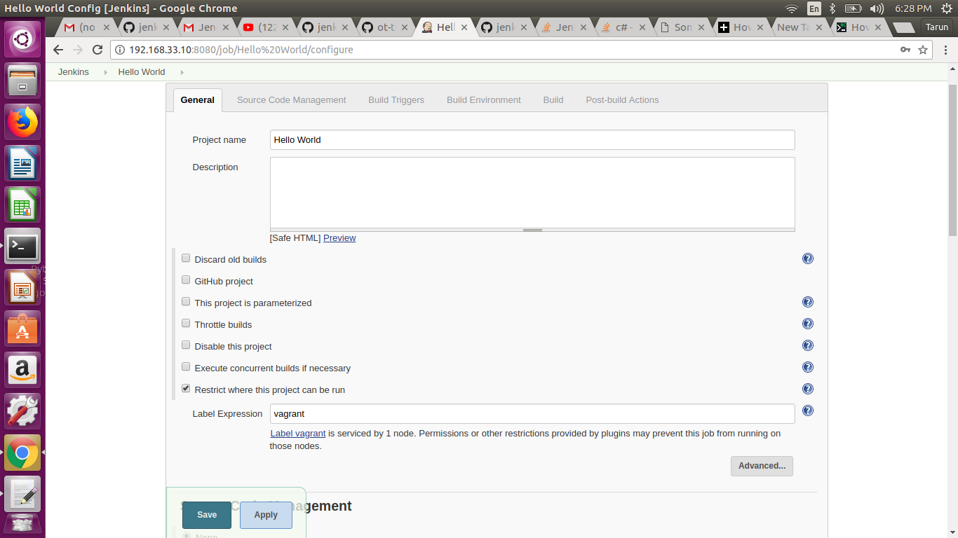
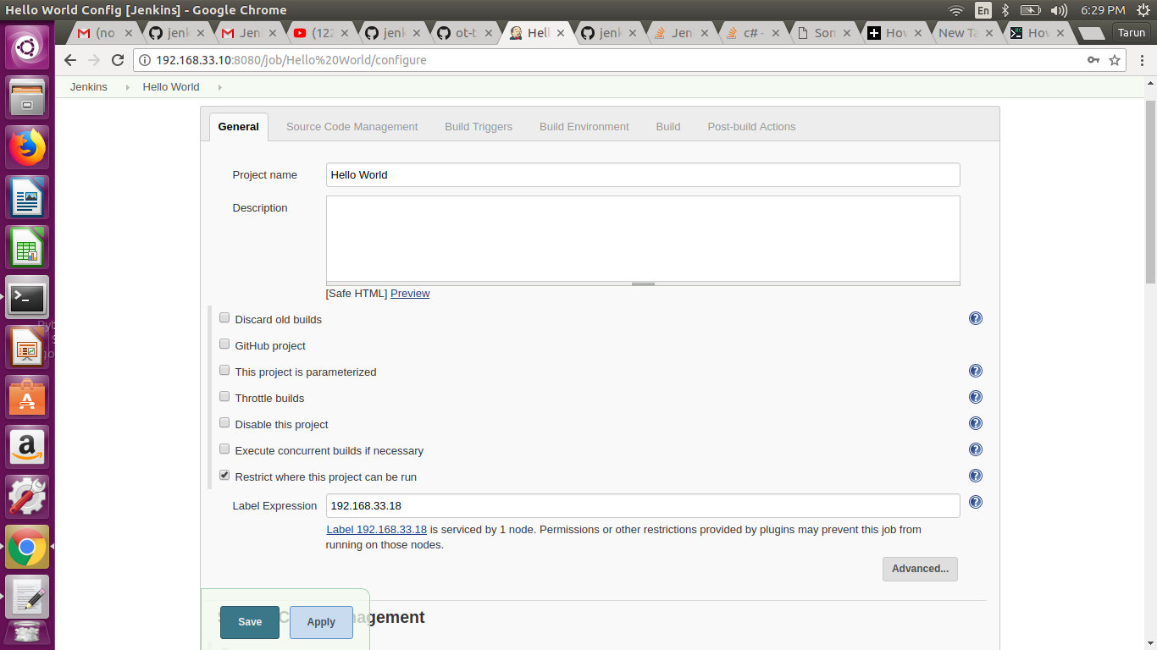

3. Create a job that can run on either salve(any of the two).
- Go to manage jenins and manage nodes.
- Click on nodes and configure them
- In Labels section enter ‘Multiple’ for both nodes and save them.
- Now select any job and in configuration, general section, Click on the checkbox for “Restrict where this project can be run” in General section.
- Give ‘Multiple’ in the box of Label Expression.
- Save and build the job.
(Job will run on either of slaves )

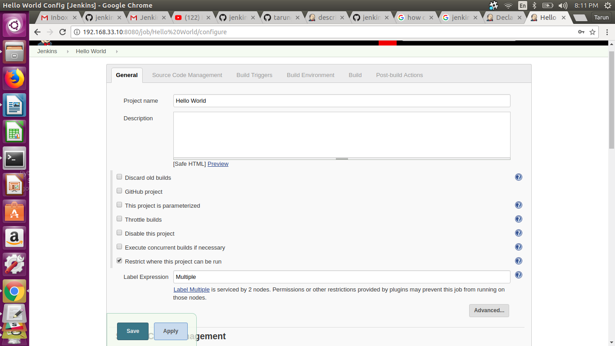

- Assignmnet2: Use jenkins rest api to
1. Get the list of all jobs
Command:
#curl -u tarungoel1995:11d5e1c07cb82e34b45bf909e21f0403 http://192.168.33.10:8080/api/json?pretty=true

Output:-
{
"_class" : "hudson.model.Hudson",
"assignedLabels" : [
{
"name" : "idle"
},
{
"name" : "master"
}
],
"mode" : "NORMAL",
"nodeDescription" : "the master Jenkins node",
"nodeName" : "",
"numExecutors" : 2,
"description" : null,
"jobs" : [
{
"_class" : "hudson.maven.MavenModuleSet",
"name" : "CICD",
"url" : "http://192.168.33.10:8080/job/CICD/",
"color" : "blue"
},
{
"_class" : "hudson.model.FreeStyleProject",
"name" : "clonejenkins",
"url" : "http://192.168.33.10:8080/job/clonejenkins/",
"color" : "blue"
},
{
"_class" : "hudson.maven.MavenModuleSet",
"name" : "codeanalysis",
"url" : "http://192.168.33.10:8080/job/codeanalysis/",
"color" : "blue"
},
{
"_class" : "hudson.maven.MavenModuleSet",
"name" : "codecoverage",
"url" : "http://192.168.33.10:8080/job/codecoverage/",
"color" : "blue"
},
{
"_class" : "hudson.model.FreeStyleProject",
"name" : "codestability",
"url" : "http://192.168.33.10:8080/job/codestability/",
"color" : "aborted"
},
{
"_class" : "hudson.maven.MavenModuleSet",
"name" : "codestabilityday3",
"url" : "http://192.168.33.10:8080/job/codestabilityday3/",
"color" : "blue"
},
{
"_class" : "hudson.maven.MavenModuleSet",
"name" : "codestabilty2",
"url" : "http://192.168.33.10:8080/job/codestabilty2/",
"color" : "blue"
},
{
"_class" : "org.jenkinsci.plugins.workflow.job.WorkflowJob",
"name" : "descriptive",
"url" : "http://192.168.33.10:8080/job/descriptive/",
"color" : "blue"
},
{
"_class" : "hudson.model.FreeStyleProject",
"name" : "devproject",
"url" : "http://192.168.33.10:8080/job/devproject/",
"color" : "blue"
},
{
"_class" : "hudson.model.FreeStyleProject",
"name" : "directorytask",
"url" : "http://192.168.33.10:8080/job/directorytask/",
"color" : "blue"
},
{
"_class" : "hudson.model.FreeStyleProject",
"name" : "DOWNSTREAM",
"url" : "http://192.168.33.10:8080/job/DOWNSTREAM/",
"color" : "blue"
},
{
"_class" : "hudson.model.FreeStyleProject",
"name" : "GIT CLONE",
"url" : "http://192.168.33.10:8080/job/GIT%20CLONE/",
"color" : "blue"
},
{
"_class" : "hudson.model.FreeStyleProject",
"name" : "Hello Person",
"url" : "http://192.168.33.10:8080/job/Hello%20Person/",
"color" : "blue"
},
{
"_class" : "hudson.model.FreeStyleProject",
"name" : "Hello World",
"url" : "http://192.168.33.10:8080/job/Hello%20World/",
"color" : "blue"
},
{
"_class" : "hudson.model.FreeStyleProject",
"name" : "helloworld",
"url" : "http://192.168.33.10:8080/job/helloworld/",
"color" : "blue"
},
{
"_class" : "hudson.model.FreeStyleProject",
"name" : "Nested View",
"url" : "http://192.168.33.10:8080/job/Nested%20View/",
"color" : "blue"
},
{
"_class" : "hudson.model.FreeStyleProject",
"name" : "PERIODICAL",
"url" : "http://192.168.33.10:8080/job/PERIODICAL/",
"color" : "blue"
},
{
"_class" : "hudson.model.FreeStyleProject",
"name" : "POLLSCM",
"url" : "http://192.168.33.10:8080/job/POLLSCM/",
"color" : "blue"
},
{
"_class" : "hudson.model.FreeStyleProject",
"name" : "seedjob1",
"url" : "http://192.168.33.10:8080/job/seedjob1/",
"color" : "blue"
},
{
"_class" : "hudson.maven.MavenModuleSet",
"name" : "Spring3hybernate",
"url" : "http://192.168.33.10:8080/job/Spring3hybernate/",
"color" : "blue"
},
{
"_class" : "hudson.model.FreeStyleProject",
"name" : "Staticcodedeployer",
"url" : "http://192.168.33.10:8080/job/Staticcodedeployer/",
"color" : "blue"
},
{
"_class" : "hudson.model.FreeStyleProject",
"name" : "tagcreator",
"url" : "http://192.168.33.10:8080/job/tagcreator/",
"color" : "blue"
},
{
"_class" : "hudson.model.FreeStyleProject",
"name" : "test",
"url" : "http://192.168.33.10:8080/job/test/",
"color" : "blue"
},
{
"_class" : "hudson.model.FreeStyleProject",
"name" : "UPSTREAMJOB",
"url" : "http://192.168.33.10:8080/job/UPSTREAMJOB/",
"color" : "blue"
}
],
"overallLoad" : {

},
"primaryView" : {
"_class" : "hudson.model.AllView",
"name" : "all",
"url" : "http://192.168.33.10:8080/"
},
"quietingDown" : false,
"slaveAgentPort" : -1,
"unlabeledLoad" : {
"_class" : "jenkins.model.UnlabeledLoadStatistics"
},
"useCrumbs" : true,
"useSecurity" : true,
"views" : [
{
"_class" : "hudson.model.AllView",
"name" : "all",
"url" : "http://192.168.33.10:8080/"
},
{
"_class" : "hudson.plugins.nested_view.NestedView",
"name" : "complex-jobs",
"url" : "http://192.168.33.10:8080/view/complex-jobs/"
},
{
"_class" : "hudson.plugins.nested_view.NestedView",
"name" : "simple-jobs",
"url" : "http://192.168.33.10:8080/view/simple-jobs/"
}
]
}

2. Get the last build status
Command:
# curl -u tarungoel1995:11d5e1c07cb82e34b45bf909e21f0403 http://192.168.33.10:8080/job/Hello%20World/lastSuccessfulBuild/api/json

Output:
{"_class":"hudson.model.FreeStyleBuild","actions":[{"_class":"hudson.model.CauseAction","causes":[{"_class":"hudson.model.Cause$UpstreamCause","shortDescription":"Started by upstream project \"descriptive\" build number 2","upstreamBuild":2,"upstreamProject":"descriptive","upstreamUrl":"job/descriptive/"}]},{},{},{}],"artifacts":[],"building":false,"description":null,"displayName":"#3","duration":53,"estimatedDuration":51,"executor":null,"fullDisplayName":"Hello World #3","id":"3","keepLog":false,"number":3,"queueId":92,"result":"SUCCESS","timestamp":1528383688682,"url":"http://192.168.33.10:8080/job/Hello%20World/3/","builtOn":"","changeSet":{"_class":"hudson.scm.EmptyChangeLogSet","items":[],"kind":null},"culprits":[]}

3. Get the console o/p of a job build.
Command:
# curl -s -S -u tarungoel1995:11d5e1c07cb82e34b45bf909e21f0403 http://192.168.33.10:8080/job/Hello%20World/3/logText/progressiveText?start=0

Output:
Started by upstream project "descriptive" build number 2
originally caused by:
Started by user Tarun Goel
Building in workspace /var/lib/jenkins/workspace/Hello World
[Hello World] $ /bin/sh -xe /tmp/jenkins4804077634826307492.sh
+ echo Hello World
Hello World
Triggering a new build of UPSTREAMJOB
Finished: SUCCESS

4. Trigger a jenkins job build
Command:
# curl -u tarungoel1995:11d5e1c07cb82e34b45bf909e21f0403 -X POST http://192.168.33.10:8080/job/Hello%20World/build

Output:
#you will see that a build is triggered in that job.

