Jenkins Assignment 6

Assignment1:
  - Create a scripted pipeline that will containe different stages of a CI/CD pipeline. Include all CI and CD jobs.
  - Insert manual approval before deployment job.
  - Restrict manual approval for a specific user
(Pending, Still working on this problem.)
- Assignment2:
  - Create a declarative CI pipeline
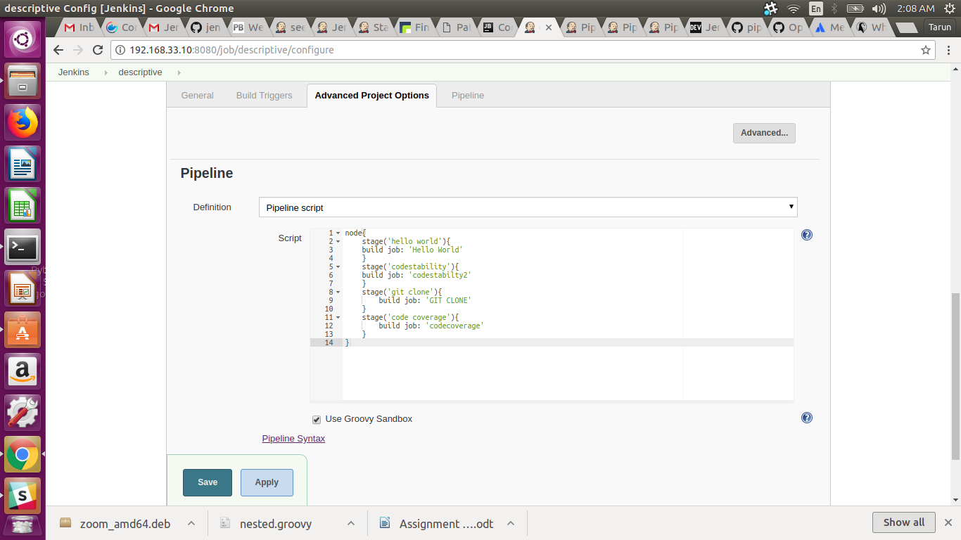
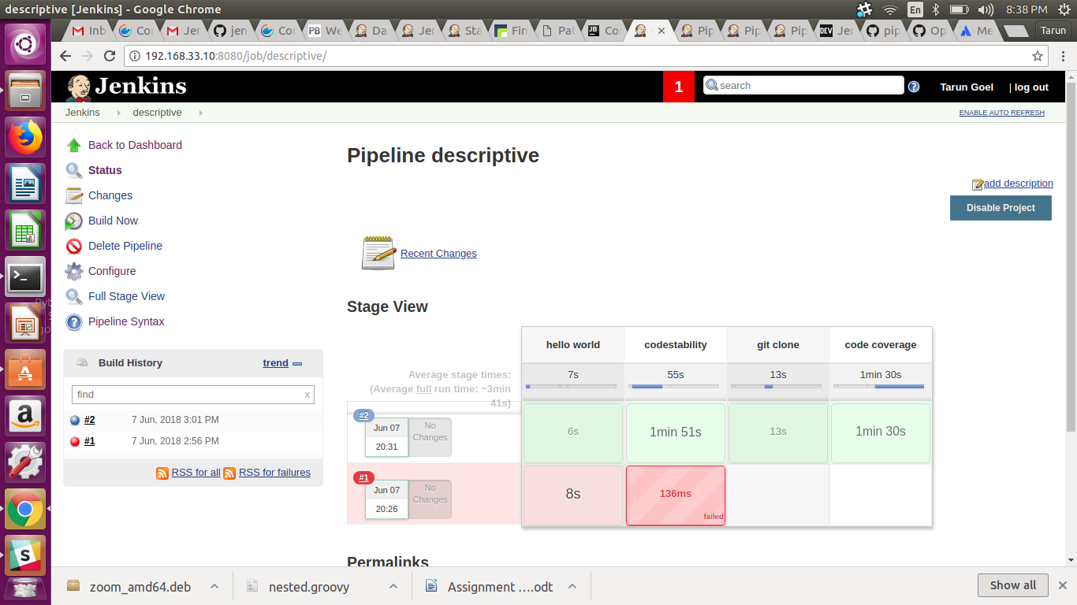

- Assignment3:
  - Write a Jenkinsfile for CI of java project.

