DAY 3 JENKINS

Assignment1:
- Pre requisite
  - Install below plugins
    - Maven integration plugin
    - Checkstyle Plug-in
    - FindBugs Plug-in
    - Static Analysis Collector Plug-in
    - Cobertura Plugin
#go to manage jenkins
# go to manage plugins
# select available and search for above plugins and install them.

  - Install below softwares under Global tool configuration
    - Maven | Maven 3.5.2
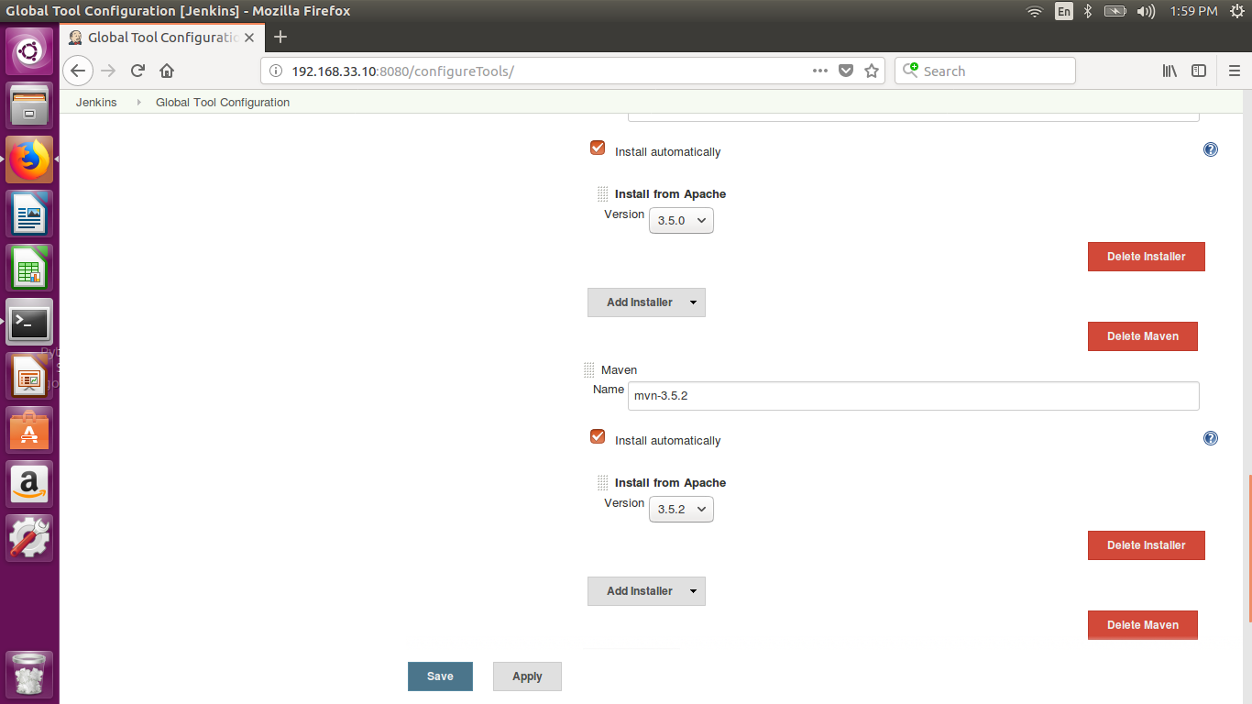

    - Java | You need Oracle account for same | JDK 8u162
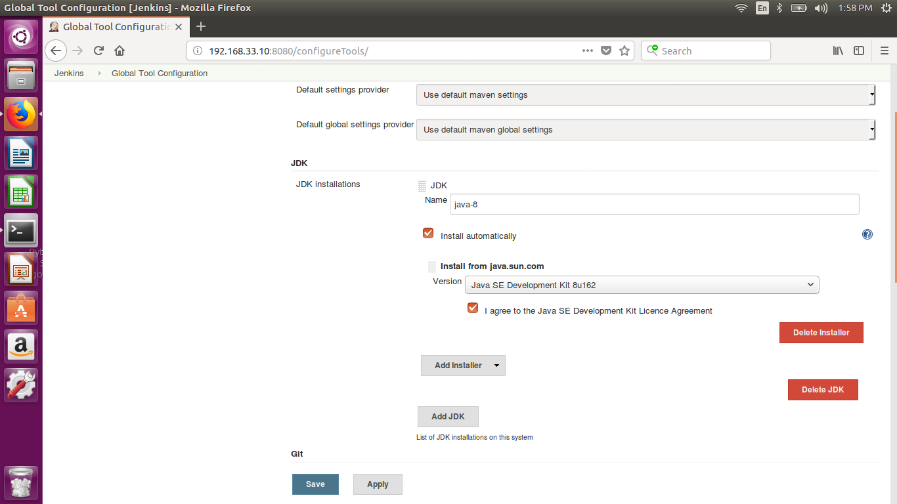
    - Git | You need to manually install git first
apt-get -y install git
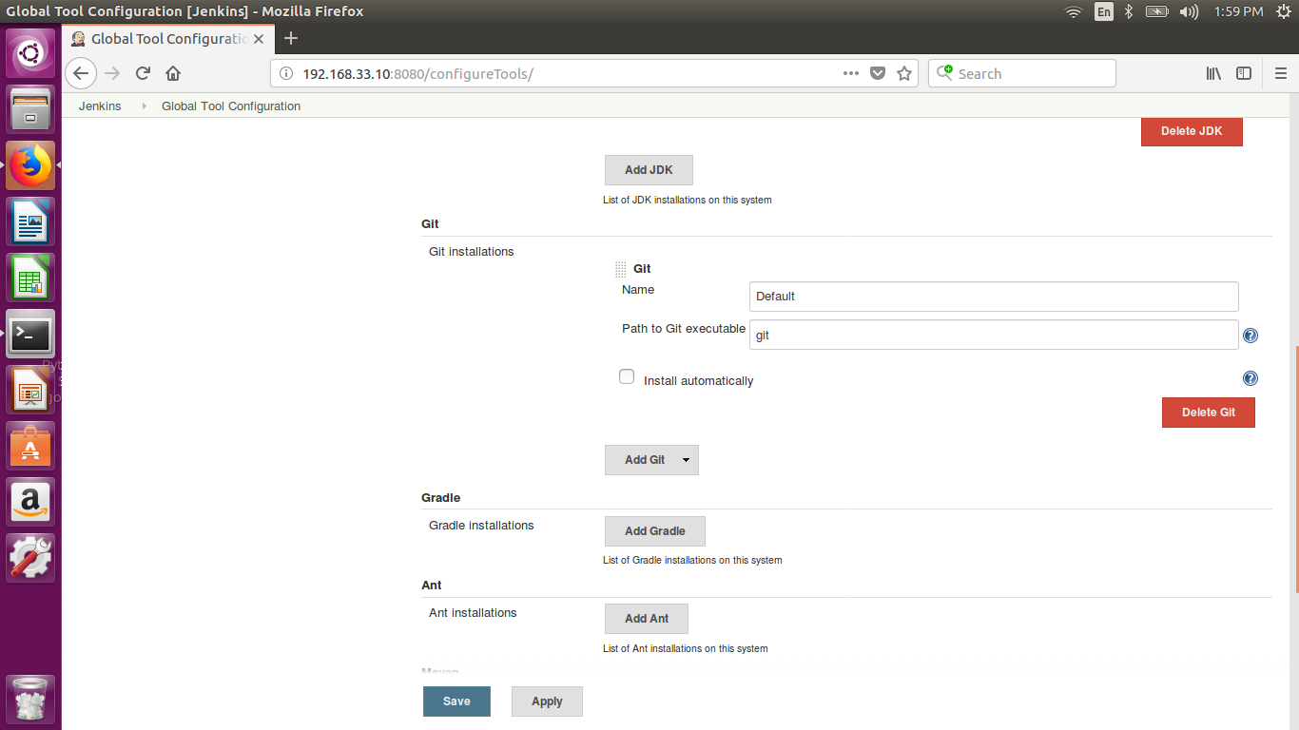
- Setup CodeStability Job
  - Choose Job type as MavenProject
  - Provide git repository https://github.com/OpsTree/ContinuousIntegration
  - Use clean compile as target
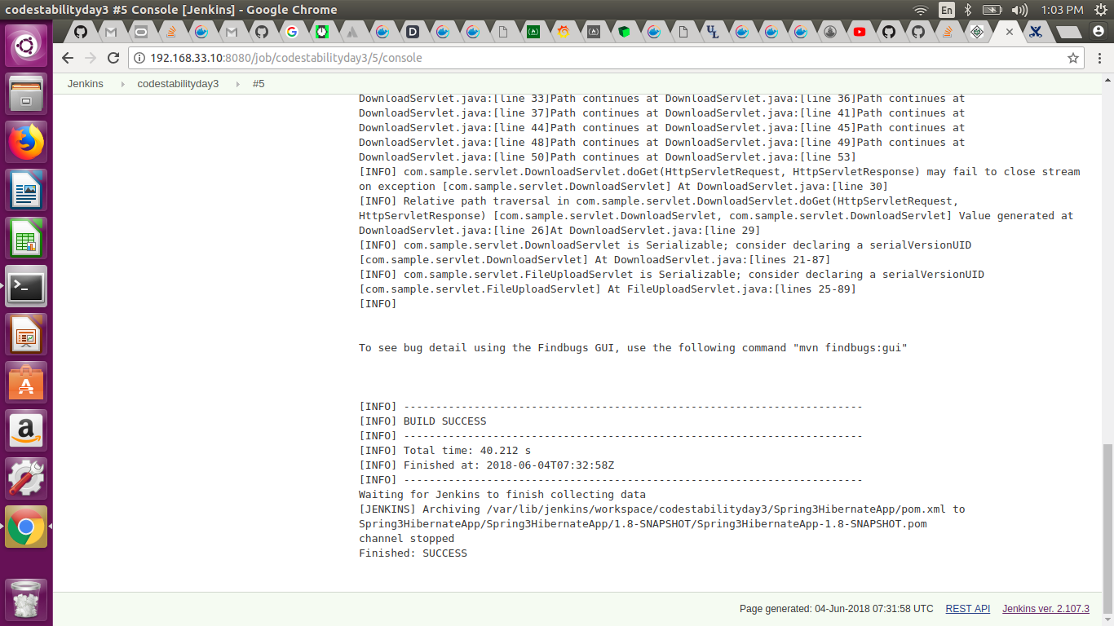
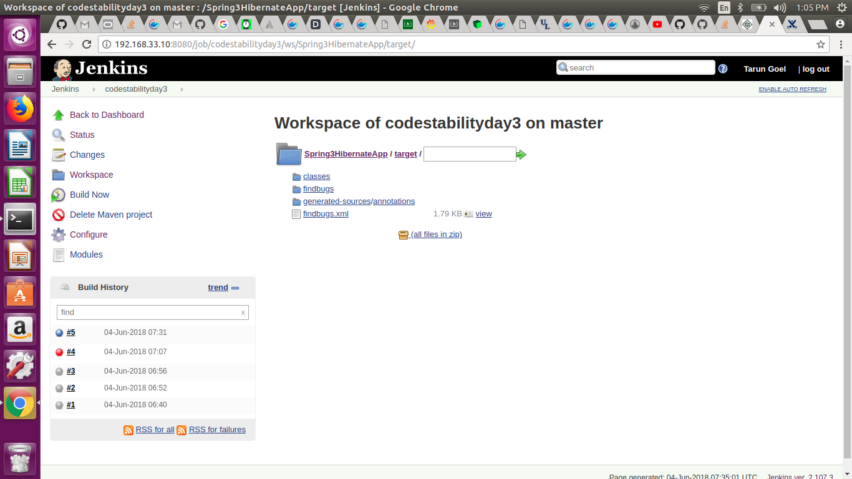
- Setup static code analysis Job
  - Choose Job type as MavenProject
  - Provide git repository https://github.com/OpsTree/ContinuousIntegration
  - Use clean compile findbugs:findbugs checkstyle:checkstyle as target
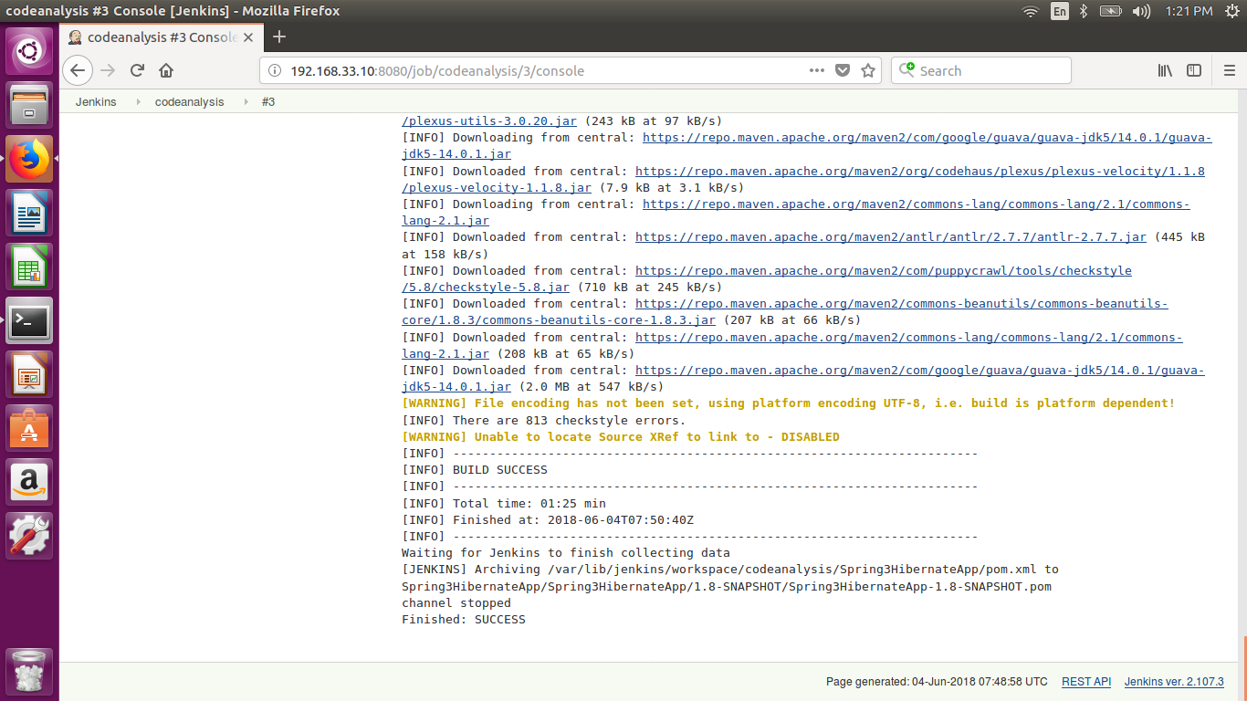
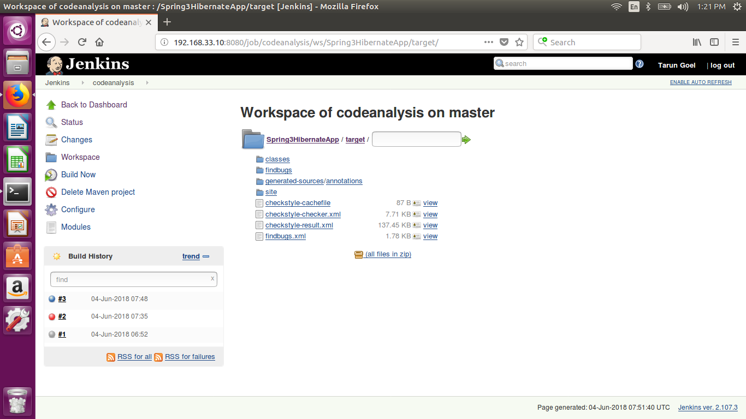
- Setup code coverage Job
  - Choose Job type as MavenProject
  - Provide git repository https://github.com/OpsTree/ContinuousIntegration
  - Use clean compile cobertura:cobertura as target
