Absolutely, Sai — let’s break this down in a clean, interview-ready, visually structured way.
You’ll get (1) a clear CI flow explanation, (2) how SonarQube fits in, (3) default SonarQube dashboard & port, and (4) a generated sample Sonar dashboard image (already created above).

🚀 CI Flow Explained (Trigger → Validate → Build → Store Artifacts)
1️⃣ Triggering the CI Pipeline
This is the moment your pipeline starts. Common triggers:
- Developer pushes code to GitHub/Azure Repos
- Pull Request created
- Scheduled build (nightly)
- Manual trigger from Jenkins/GitHub Actions/Azure DevOps
Tools:
- GitHub Actions
- Jenkins
- Azure DevOps Pipelines
What happens:
The CI engine pulls the latest code from the repository and starts the pipeline.

2️⃣ Code Validation (SonarQube Stage)
This is where your code is checked for:
- Bugs
- Vulnerabilities
- Code smells
- Duplications
- Test coverage
Tools:
- SonarQube (most common)
- SonarCloud (cloud version)
How it works:
- Pipeline downloads the code
- Sonar scanner analyzes the code
- Results are pushed to the SonarQube dashboard
- Pipeline can fail if quality gate fails (very common interview question)

3️⃣ Build Stage
This is where your code is compiled into deployable artifacts.
Tools by language:
- Java → Maven / Gradle
- .NET → MSBuild
- Python → pip / setuptools
- Node.js → npm / yarn
Output examples:
- .jar, .war (Java)
- .dll, .zip (DotNet)
- .whl (Python)
- .tgz (Node)

4️⃣ Artifact Management (JFrog / Nexus)
After building, artifacts must be stored in a central repository.
Why?
- Versioning
- Rollbacks
- Immutable storage
- Deployment pipelines pull from here
Tools:
- JFrog Artifactory
- Sonatype Nexus
Stored items:
- Build artifacts
- Docker images
- Helm charts
- Terraform modules

🎯 SonarQube Default Dashboard & Port
🔌 Default SonarQube Port
http://localhost:9000
🖥️ Default Login (first time)
username: admin
password: admin
📊 What You See on the Dashboard
The main SonarQube dashboard shows:
- Bugs
- Vulnerabilities
- Security Hotspots
- Code Smells
- Coverage %
- Duplications %
- Quality Gate status (Pass/Fail)
You already have a sample SonarQube dashboard image generated above — it visually represents exactly what you’d see on port 9000.

🔍 What You Can Do Next
If you want, I can also generate:
- A full CI/CD pipeline diagram
- A JFrog Artifactory dashboard sample
- A Nexus repository layout diagram
- A GitHub Actions YAML showing all these stages
Just tell me what you want to explore next. 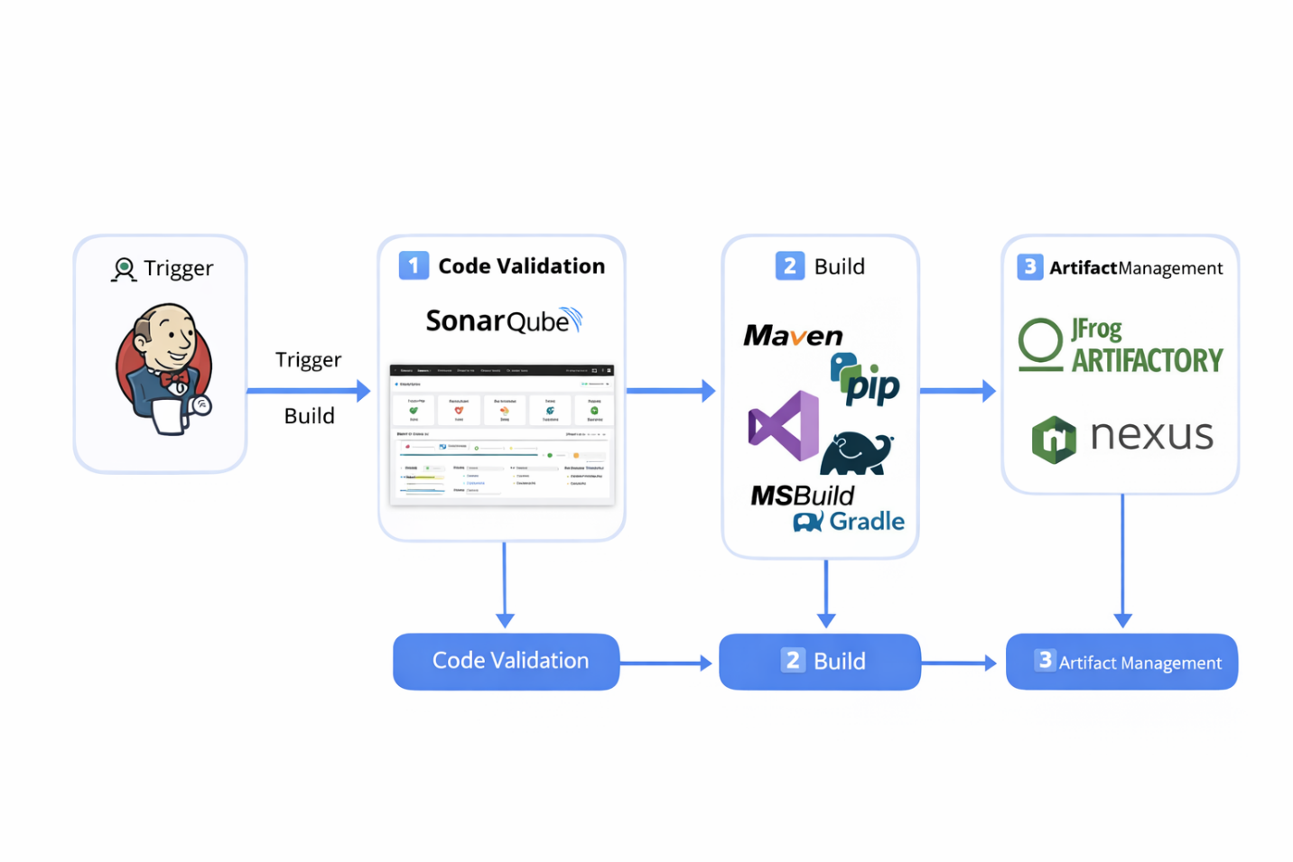
Here are several real SonarQube dashboard GUI examples so you can visualize what code quality analysis looks like in practice:

🧭 How to Read the SonarQube Dashboard
Each project dashboard typically includes:
- Summary tiles for Bugs, Vulnerabilities, Code Smells, Coverage, and Duplications
- A Quality Gate indicator (✅ Pass / ❌ Fail)
- Trend graphs showing how issues evolve over time
- Navigation tabs: Projects, Issues, Rules, Quality Profiles, Quality Gates, Administration

⚙️ Default Access
- URL: http://localhost:9000
- Default credentials:
- username: admin
- password: admin
Once logged in, you’ll see a dashboard similar to the first image above — a clean summary of your project’s health with color-coded metrics and drill-down links to specific files or rules.
Would you like me to generate a custom sample dashboard layout (with mock metrics and graphs) that you can use for interview presentations or documentation?

Here’s the clean, structured, interview-ready explanation of AWS, Azure, OCI, and OpenStack infrastructure components — exactly the way a DevOps/Cloud Engineer is expected to understand them in real-world projects.
I’ll break it down cloud-by-cloud, service-by-service, and also show how they relate to each other so you can build a strong mental model.

🌩️ 1. AWS Infrastructure Components (Core DevOps Focus)
EC2 (Elastic Compute Cloud)
What it is: Virtual machines in AWS.
Use cases: Application servers, bastion hosts, Jenkins runners, databases (self-managed), etc.
Key concepts: AMIs, instance types, security groups, key pairs, EBS volumes, autoscaling.

S3 (Simple Storage Service)
What it is: Object storage (images, logs, backups, artifacts).
Use cases:
- Store Terraform state
- Store CI/CD artifacts
- Host static websites
- Backup and archival
Key features: Versioning, lifecycle rules, encryption, bucket policies.

RDS (Relational Database Service)
What it is: Managed SQL databases (MySQL, PostgreSQL, SQL Server, Oracle).
Why DevOps cares:
- Automated backups
- Multi-AZ failover
- No OS patching
- Parameter groups for tuning

Lambda
What it is: Serverless compute (event-driven).
Use cases:
- Triggered by S3 uploads
- API backend
- Automation scripts
- CloudWatch event handlers

CloudWatch
What it is: Monitoring + logging + alerting.
Key components:
- Metrics
- Logs
- Alarms
- Dashboards
- Events (EventBridge)

EKS (Elastic Kubernetes Service)
What it is: Managed Kubernetes cluster.
Why DevOps uses it:
- Deploy microservices
- Use Helm, Ingress, autoscaling
- Integrate with IAM, VPC, ALB

KMS (Key Management Service)
What it is: Encryption key management.
Use cases:
- Encrypt S3, EBS, RDS
- Encrypt secrets in Terraform
- Encrypt environment variables in Lambda

CloudFormation
What it is: AWS-native Infrastructure as Code.
Why DevOps uses it:
- Automate VPC, EC2, RDS, IAM
- Reproducible infra
- Stack updates and rollback

☁️ 2. Azure Infrastructure Components
AKS (Azure Kubernetes Service)
Azure’s managed Kubernetes.
Features:
- Node pools
- Azure CNI networking
- Azure Monitor integration
- ACR integration

ACR (Azure Container Registry)
Private container registry.
Use cases:
- Store Docker images
- Integrate with AKS
- Build images using Azure DevOps

Azure DevOps
CI/CD + Repo + Boards + Artifacts.
DevOps pipelines:
- Build pipelines (CI)
- Release pipelines (CD)
- YAML pipelines

Azure Functions
Serverless compute.
Use cases:
- Event-driven automation
- API endpoints
- Data processing

Azure Monitor
Central monitoring + logging.
Components:
- Metrics
- Logs (Log Analytics Workspace)
- Alerts
- Application Insights

Azure AD (Entra ID)
Identity and access management.
Use cases:
- RBAC for Azure resources
- SSO for apps
- Service principals for CI/CD
- Managed identities

🟧 3. Oracle Cloud Infrastructure (OCI)
OCI is becoming popular in enterprises due to cost advantages.
Compute
Virtual machines similar to EC2.
Features:
- Bare metal
- VM shapes
- Autoscaling

VCN (Virtual Cloud Network)
Equivalent to AWS VPC.
Components:
- Subnets
- Route tables
- Security lists
- NSGs

Object Storage
Equivalent to AWS S3.
Use cases:
- Backups
- Terraform state
- Artifacts

Load Balancer
Equivalent to AWS ALB/ELB.
Supports:
- HTTP/HTTPS
- SSL termination
- Health checks

IAM
Identity and access management.
Key concepts:
- Users
- Groups
- Policies
- Dynamic groups

OKE (Oracle Kubernetes Engine)
Managed Kubernetes service.
Features:
- Node pools
- VCN integration
- OCI registry

Block Volumes
Equivalent to AWS EBS.
Use cases:
- Attach to compute instances
- High IOPS workloads

DevOps Service
OCI’s CI/CD platform.
Capabilities:
- Build pipelines
- Deployment pipelines
- Artifact management

🟦 4. OpenStack (Private Cloud)
OpenStack is used by enterprises to build their own cloud.
Key Components
OpenStack Service | Purpose | AWS Equivalent
Nova | Compute (VMs) | EC2
Neutron | Networking | VPC
Cinder | Block storage | EBS
Swift | Object storage | S3
Keystone | Identity | IAM
Glance | VM images | AMI
Heat | IaC templates | CloudFormation
Why companies use OpenStack:
- Full control
- On-prem cloud
- No vendor lock-in

🔥 5. Cross-Cloud Comparison (Quick Reference)
Concept | AWS | Azure | OCI | OpenStack
Compute | EC2 | VM | Compute | Nova
Object Storage | S3 | Blob Storage | Object Storage | Swift
Kubernetes | EKS | AKS | OKE | Magnum
IAM | IAM | Azure AD | IAM | Keystone
IaC | CloudFormation | ARM/Bicep | Resource Manager | Heat
Serverless | Lambda | Functions | Functions | —
Monitoring | CloudWatch | Monitor | Observability | Ceilometer

🎯 6. How to Use This for Interviews
Interviewers expect you to explain:
- What each service does
- When to use it
- How it compares across clouds
- Real-time scenarios (e.g., scaling, networking, CI/CD, security)
You now have a complete, structured understanding.

