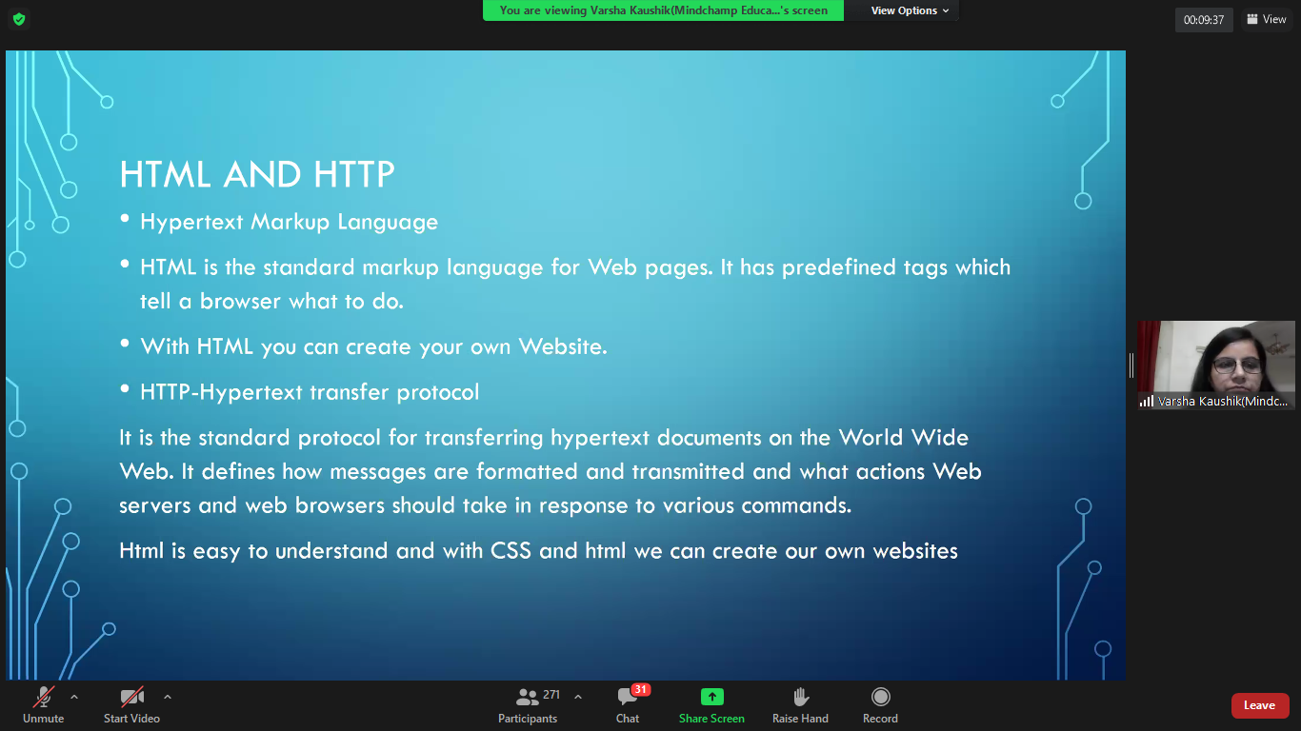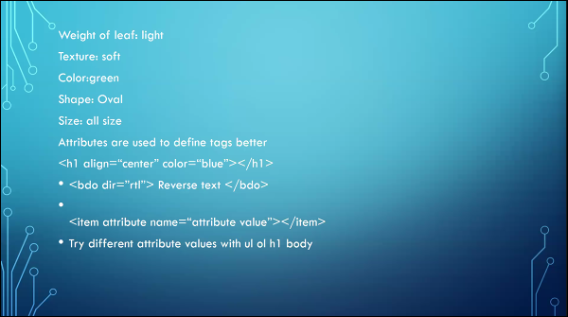

<mark>--highlighter

<small>--align in line

<ins>--insert

<del>--strikeout

<!--\*\*\*--> --comment

<q>--quotes(“xx”)

style="color:colorname"—color change using CSS

<Body background=" "style="background-repeat:no-repeat;background-size:100%">--background without repeat

behavior="scroll"—attribute of marquee

direction="right/left/up/down"—attribute of marquee (scroll direction)

hspace="\*\*px"—attribute of marquee (horizontal space)

vspace=”\*\*px”—attribute of marquee(vertical space)

<fieldset> — box like table

<fieldset style=”background-color:pink;”> — background in CSS

<ul style="list-style-type:square;"><!--lower-alpha,display:none;-->

<https://htmlcolorcodes.com/> color codes html