**Acknowledgement**

A project work is a product of experience and it goes a long way in shaping a person in one aspect. With great gratitude I would like to acknowledge the immense help of all those who contributed with their valuable suggestions and timely assistance to complete this work. All that I have done is only due to such supervision and assistance and I would not forget to thank them.

I thank Dr. D. Evangelin Geetha for providing me an opportunity to do the project giving all support and guidance which made me complete the project duly. I am extremely thankful to her for providing such a nice support and guidance, taking keen interest in my project work and guiding me all along, till the completion of my project work by providing all the necessary information for developing a good system

**Abstract**

Online examinations are an important method of evaluating the success potential of students a user can register for the exam in the website and he can only take the exam in a particular period of time as specified by the admin, Admin can add multiple quiz topics and questions under it, and start only the quiz topics which exam should be conducted. And Student who has registered can take the exam and view the scores after the exam. Admin can view all the details of students and their marks and rank according to their marks.

**Table of Contents**

1. Introduction ------------- 4
   * + Overview
     + Proposed system

2. Hardware and software requirements ------------- 5

3. Software Requirements Specification ------------- 6-7

4. Implementation ------------- 8-32

5. Reports ------------- 33-37

1. Conclusion ------------- 38
2. Future Scope And Enhancement ------------- 39
3. Bibliography ------------- 39

**Introduction**

The project RENT ANYTHING system is proposed for renting resources through the website

People with resource can add there things for renting. Perspective of this project is to provide a platform for rent items online.

**Overview:-**

The purpose is to understand the functionality of ‘RENT ANYTHING’ system it

Includes models and features*.* user can also insert items for rent on to the website, also details about the products like size, colour, model can also be uploaded when items are added into the database

**Proposed System:-**

The features provided by this software are people can add there items for renting and can also search for things they want to rent.

**Hardware And Software Requirements**

**Hardware Requirements:-**

* RAM : 250MB or above.
* Hard Disk : 50GB or above.

**Software Requirements:-**

* Operating system : Windows / Mac / Linux.
* Web-Technology : PHP.
* Front End : HTML, CSS, JavaScript.
* Back End : MySQL.
* Web Server : Apache Server

**Software Requirements Specification**

# Introduction

## Purpose

The purpose is to understand the functionality of ‘RENT ANYTHING’ system it. Includes models and features. user can also insert items for rent on to the website,also details about the products like size,color,model can also be uploaded wen items are added into the database

# Overall Description

## Product Perspective

The project RENT ANYTHING system is proposed for renting resources through the website

People with resource can add there things for renting

Perspective of this project is to provide a platform for rent items online. So it can be easy to procure items for rent and also it provides a platform for earning a income from there existing objects

## Product Functions

**Registration:-** customers who need to rent must first register there accounts.with valid proofs and ids.

**Admin Verification :-** Admin has to verify the details which are uploaded by the user and only after verification user will be able to rent resources.

**Adding items for rent :-** other users or business can also add there items on the webstite for renting.

**Check Status:-** can check the status of the rented item, date, time, place.

## User Classes and Characteristics

This project mainly deals with two types of users , customer and Admin.

customer:-can rent any items on the website

Admin:- can remove item from the website can also verify users

## Operating Environment

OS : any operating system which supports browser.

XAMPP/WAMPP: to run server.

RAM: 1 GB and above

Hard Disk. 2GB and above.

Browser: Any web Browser.

# System Features

The features provided by this software are people can add there items for renting and can also search for things they want to rent.

## Verify users

Admin has to verify the user account and check all the signup details given are correct and then he must allow the user to rent any product,the admin must keep track of the item rented

## Check Status

Admin can check the state of the order.the rent period, sum of amount payable,admin can keep track of all these .

## Adding items

Admin can insert items into the inventory for rent,and user can also insert items for rent on to the website,also details about the products like size,color,model can also be uploaded wen items aare added into the database

## user Login

User can login into the system and can either rent from the website or he can also add his item for rent,user login can also add or rent items it will a platform for the user to show his items.

**Implementation**

<!DOCTYPE html>

<html>

<head>

<meta charset="utf-8">

<meta name="viewport" content="width=device-width, initial-scale=1">

<link rel="stylesheet" href="https://maxcdn.bootstrapcdn.com/bootstrap/3.3.7/css/bootstrap.min.css">

<script src="https://ajax.googleapis.com/ajax/libs/jquery/3.2.1/jquery.min.js"></script>

<script src="https://maxcdn.bootstrapcdn.com/bootstrap/3.3.7/js/bootstrap.min.js"></script>

<style>

.navbar {

margin-bottom: 50px;

border-radius: 0;

}

/* Remove the jumbotron's default bottom margin */

/* Add a gray background color and some padding to the footer */

.sizee

{

width: 100%;

height: 600px;

}

.w

{

height:250px;

width: 1150px;

border-color: black;

border-size:3px;

background-color:grey;

}

.ta

{

border-color: black;

height: 200px;

width:900;

border-width: 4px;

background-color: white;

margin-bottom: 23px;

}

.img

{

margin-bottom: 29px;

margin-left :25px;

}

.space

{

height: 100px;

}

body

{

background-image: url("bikescover.jpg");

}

.r{

border-radius: 25px;

padding: 20px;

}

.o

{

background: rgba(255,255,255,0.5);

filter: alpha(opacity=50);

}

.affix {

top: 0;

width: 100%;

z-index: 9999 !important;

}

</style>

</head>

<body>

<div><div class="container">

<div class="container text-center">

<h1 class="a">RENT ANY</h1>

</div>

</div>

<nav class="navbar navbar-inverse " data-spy="affix" >

<div class="container-fluid">

<div class="navbar-header">

<button type="button" class="navbar-toggle" data-toggle="collapse" data-target="#myNavbar">

<span class="icon-bar"></span>

<span class="icon-bar"></span>

<span class="icon-bar"></span>

</button>

<a class="navbar-brand" href="index.html">REnt</a>

</div>

<div class="collapse navbar-collapse" id="myNavbar">

<ul class="nav navbar-nav">

<li class="active a"><a href="index.html">HOME</a></li>

<li class="hover"><a href="index.html">PRODUCTS</a></li>

<li><a href="about.html">ABOUT US</a></li>

<li><a href="contact.html">CONTACT</a></li>

</ul>

<ul class="nav navbar-nav navbar-right">

<li><a href="login1.html"><span class="glyphicon glyphicon-user"></span>LOGIN</a></li>

</ul>

</div>

</div>

</nav></div>

<div class="container-fluid w r o">

<div class="container-fluid ta r o ">

<div class="row">

<div class="col-sm-6 ">

<img class="img" src="bi1.jpg">

</div>

<div class="col-sm-6 ">KTM RC 200 is the most affordable track based 200cc motorcycle in India, KTM RC 200 comes with all of the premium equipment like USD forks, projectors headlights, aerodynamic design and all-new Black-White-Orange theme. It lacks ABS while shares the Orange frame with its elder sibling, RC390. KTM RC200 competes against Bajaj Pulsar RS200 and Honda CBR250R in India.</div>

</div>

</div>

</div>

<br class="space">

<div class="container-fluid w r o">

<div class="container-fluid ta r o">

<div class="row">

<div class="col-sm-6">

<img class="img" src="bi2.jpg">

</div>

<div class="col-sm-6">KTM RC 200 is the major lead into KTM’s race bikes. The bike is definitely a sight to behold for its amazing style and striking details. The outstanding looks and performance of the bike has made it instantly desirable among the youth. 2017 KTM RC 200 has been launched recently and comes with black , white and orange theme with very little color reversa</div>

</div>

</div>

</div>

<br>

<br>

<div class="container-fluid w r o">

<div class="container-fluid ta r o">

<div class="row">

<div class="col-sm-6">

<img class="img " src="bi3.jpg">

</div>

<div class="col-sm-6">TM RC 200 is a more viable bike, with better engine configuration, and more usable power. The bike is more refined in terms of engine sound resulting into secluding engine noise to a larger extent. For those with the courage and vision to follow their sense of adventure, KTM is the perfect match. True adventurers, permanently challenging themselves, looking to new horizons for the next goal, destin</div>

</div>

</div>

</div>

<br>

<br>

<div class="container-fluid w r o">

<div class="container-fluid ta r o">

<div class="row">

<div class="col-sm-6">

<img class="img " src="bi4.jpg">

</div>

<div class="col-sm-6">The dual headlights of KTM RC 200 allow you to get a clear view of roads at night and confirms you safe driving. However, KTM should have equipped the RC 200 with ABS (Anti-lock Braking System). it is quite surprising to see that a bike priced at INR 1.75 lakhs is not equipped with a must-have safety feature. Even Bajaj is offering ABS in Pulsar RS200 for an additional amount of INR 12,000.

Suspension</div>

</div>

</div>

</div>

<br>

<br>

<div class="container-fluid w r o">

<div class="container-fluid ta r o">

<div class="row">

<div class="col-sm-6">

<img class="img " src="bi5.jpg">

</div>

<div class="col-sm-6">KTM RC 200 is the major lead into KTM’s race bikes. The bike is definitely a sight to behold for its amazing style and striking details. The outstanding looks and performance of the bike has made it instantly desirable among the youth. 2017 KTM RC 200 has been launched recently and comes with black , white and orange theme with very little color reversa</div>

</div>

</div>

</div>

<br>

<br>

<div class="container-fluid w r o">

<div class="container-fluid ta r o">

<div class="row">

<div class="col-sm-6">

<img class="img " src="bi6.jpg">

</div>

<div class="col-sm-6">Front Brake 300 mm Disc brake with four-pot brake caliper

Rear Brake 230 mm brake with one-pot brake caliper, floating brake discs

Anti-lock Braking System (ABS)

Front Suspension WP Suspension 4357 (Upside Down Forks)

Rear Suspension WP Suspension 4618 EM (Monoshock)

Front Wheel Travel 125 mm

Rear Wheel Travel 150 mm</div>

</div>

</div>

</div>

<br>

<br>

<div class="container-fluid w r o">

<div class="container-fluid ta r o">

<div class="row">

<div class="col-sm-6">

<img class="img " src="bi7.jpg">

</div>

<div class="col-sm-6"> Wet sump

Bore 72 mm

Stroke 49 mm

Fuel Type Petrol

Bharat Stage IV (BS4)

Clutch Clutch in oil bath, mechanically operated

Primary Gear Ratio 22:72

Secondary Gear Ratio 14:42

Gear Pattern 1-down, 5-up

BRAKES & SUSPENSION

WHEELS & TYRES</div>

</div>

</div>

</div>

<br>

<br>

<div class="container-fluid w r o">

<div class="container-fluid ta r o">

<div class="row">

<div class="col-sm-6">

<img class="img " src="bi10.jpg">

</div>

<div class="col-sm-6">KTM RC 200 is the most affordable track based 200cc motorcycle in India, KTM RC 200 comes with all of the premium equipment like USD forks, projectors headlights, aerodynamic design and all-new Black-White-Orange theme. It lacks ABS while shares the Orange frame with its elder sibling, RC390. KTM RC200 competes against Bajaj Pulsar RS200 and Honda CBR250R in India.</div>

</div>

</div>

</div>

<br>

<br>

</body>

</html>

<!DOCTYPE html>

<html>

<head>

<meta charset="utf-8">

<meta name="viewport" content="width=device-width, initial-scale=1">

<link rel="stylesheet" href="https://maxcdn.bootstrapcdn.com/bootstrap/3.3.7/css/bootstrap.min.css">

<script src="https://ajax.googleapis.com/ajax/libs/jquery/3.2.1/jquery.min.js"></script>

<script src="https://maxcdn.bootstrapcdn.com/bootstrap/3.3.7/js/bootstrap.min.js"></script>

<style>

.navbar {

margin-bottom: 50px;

border-radius: 0;

}

/* Remove the jumbotron's default bottom margin */

/* Add a gray background color and some padding to the footer */

.sizee

{

width: 100%;

height: 600px;

}

.w

{

height:250px;

width: 1150px;

border-color: black;

border-size:3px;

background-color:grey;

}

.ta

{

border-color: black;

height: 200px;

width:900;

border-width: 4px;

background-color: white;

margin-bottom: 23px;

}

.img

{

margin-bottom: 29px;

margin-left :25px;

}

.space

{

height: 100px;

}

body

{

background-image: url("cameracover.jpg");

}

.r{

border-radius: 25px;

padding: 20px;

}

.o

{

background: rgba(255,255,255,0.5);

filter: alpha(opacity=50);

}

.affix {

top: 0;

width: 100%;

z-index: 9999 !important;

}

</style>

</head>

<body>

<div><div class="container">

<div class="container text-center">

<h1 class="a">RENT ANY</h1>

</div>

</div>

<nav class="navbar navbar-inverse " data-spy="affix" >

<div class="container-fluid">

<div class="navbar-header">

<button type="button" class="navbar-toggle" data-toggle="collapse" data-target="#myNavbar">

<span class="icon-bar"></span>

<span class="icon-bar"></span>

<span class="icon-bar"></span>

</button>

<a class="navbar-brand" href="index.html">REnt</a>

</div>

<div class="collapse navbar-collapse" id="myNavbar">

<ul class="nav navbar-nav">

<li class="active a"><a href="index.html">HOME</a></li>

<li class="hover"><a href="index.html">PRODUCTS</a></li>

<li><a href="about.html">ABOUT US</a></li>

<li><a href="contact.html">CONTACT</a></li>

</ul>

<ul class="nav navbar-nav navbar-right">

<li><a href="login1.html"><span class="glyphicon glyphicon-user"></span>LOGIN</a></li>

</ul>

</div>

</div>

</nav></div>

<div class="container-fluid w r o">

<div class="container-fluid ta r o ">

<div class="row">

<div class="col-sm-6 ">

<img class="img" src="cam1.jpg">

</div>

<div class="col-sm-6 "> 18MP APS-C CMOS sensor and DIGIC 4+

9-point AF with 1 center cross-type AF point

Standard ISO: 100 to 6400, expandable to 12800

Wi-Fi and NFC supported

Lens Mount: Canon EF mounide-area, 9-point with cross-type central AF point Wide-area, 9-point AF with 1 centre cross-type sensor Wide area, 9-point all cross-type sensors 19-point cross-type AF system including 3 AF area tracking modes 19-point cross-type AF system including 3 AF area tracking modes t </div>

</div>

</div>

</div>

<br class="space">

<div class="container-fluid w r o">

<div class="container-fluid ta r o">

<div class="row">

<div class="col-sm-6">

<img class="img" src="cam2.jpg">

</div>

<div class="col-sm-6">Canon

Model EOS 1300D

Item Weight 485 g

Product Dimensions 7.8 x 12.9 x 10.1 cm

Batteries: 1 Lithium ion batteries required.

Item model number EOS 1300D

Resolution 18

Included Components Camera, 18-55 Lens, 55-250mm Lens, 16GB Memory Card, Carry Case

Screen Size 3 Inches

Optical Zoom 18 Megapixels

Optical Sensor Resolution 18 Megapixels

Min Shutter Speed 1/4000

Voltage 7.4 Volts

Batteries Included No

Batteries Required Yes

Battery Cell Composition Lithium Ion</div>

</div>

</div>

</div>

<br>

<br>

<div class="container-fluid w r o">

<div class="container-fluid ta r o">

<div class="row">

<div class="col-sm-6">

<img class="img " src="came3.jpg">

</div>

<div class="col-sm-6">3 fps 4 fps 5 fps 5 fps 5 fps

Coverage, Magnification, Eyepoint and Construction Bright viewfinder with 95 per cent coverage, 0.80x, 21 mm. Pentamirror Bright viewfinder with 95 per cent coverage, 0.87x, 19 mm. Pentamirror Bright viewfinder with 95 per cent coverage, 0.85x, 19 mm. Pentamirror Intelligent viewfinder with 95 per cent coverage, 0.82x, 19 mm. Pentamirror Intelligent viewfinder with 95 per cent coverage, 0.82x, 19 mm. Pentamirror </div>

</div>

</div>

</div>

<br>

<br>

<div class="container-fluid w r o">

<div class="container-fluid ta r o">

<div class="row">

<div class="col-sm-6">

<img class="img " src="cam4.jpg">

</div>

<div class="col-sm-6"> 1080p, 720p and 640 x 480 manual control with selectable frame rates, sound level control 1080p, 720p and 640 x 480 manual control with selectable frame rates, sound level control 1080p, 720p and 640 x 480 manual control with selectable frame rates, sound level control and Video Snapshot with in-camera editing 1080p, 720p and 640 x 480 manual control with selectable frame rates, sound level control 1080p, 720p and 640 x 480 manual control with selectable frame rates, sound level control, Movie Digital Zoom </div>

</div>

</div>

</div>

<br>

<br>

<div class="container-fluid w r o">

<div class="container-fluid ta r o">

<div class="row">

<div class="col-sm-6">

<img class="img " src="cam5.jpg">

</div>

<div class="col-sm-6">Bright 7.5 cm (3.0 inch) LCD 920 k dots Touch screen 7.7 cm (3.0 inch) 3:2 Clear View LCD II, approximately 1040 k dots Touch screen Vari Angle 7.7 cm (3.0 inch) 3:2 Clear View II TFT, approximately 1040 k dots Touch screen Vari Angle 7.7 cm (3.0 inch) 3:2 Clear View II TFT, approximately 1040 k dots Touch screen Vari Angle 7.7 cm (3.0 inch) 3:2 Clear View II TFT, approximately 1040 k dots </div>

</div>

</div>

</div>

<br>

<br>

<div class="container-fluid w r o">

<div class="container-fluid ta r o">

<div class="row">

<div class="col-sm-6">

<img class="img " src="cam6.jpg">

</div>

<div class="col-sm-6">hide-area, 9-point with cross-type central AF point Wide-area, 9-point AF with 1 centre cross-type sensor Wide area, 9-point all cross-type sensors 19-point cross-type AF system including 3 AF area tracking modes 19-point cross-type AF system including 3 AF area tracking modes ii</div>

</div>

</div>

</div>

<br>

<br>

<div class="container-fluid w r o">

<div class="container-fluid ta r o">

<div class="row">

<div class="col-sm-6">

<img class="img " src="cam7.jpg">

</div>

<div class="col-sm-6"> 1080p, 720p and 640 x 480 manual control with selectable frame rates, sound level control 1080p, 720p and 640 x 480 manual control with selectable frame rates, sound level control 1080p, 720p and 640 x 480 manual control with selectable frame rates, sound level control and Video Snapshot with in-camera editing 1080p, 720p and 640 x 480 manual control with selectable frame rates, sound level control 1080p, 720p and 640 x 480 manual control with selectable frame rates, sound level control, Movie Digital Zoom </div>

</div>

</div>

</div>

<br>

<br>

<div class="container-fluid w r o">

<div class="container-fluid ta r o">

<div class="row">

<div class="col-sm-6">

<img class="img " src="cam8.jpg">

</div>

<div class="col-sm-6">ide-area, 9-point with cross-type central AF point Wide-area, 9-point AF with 1 centre cross-type sensor Wide area, 9-point all cross-type sensors 19-point cross-type AF system including 3 AF area tracking modes 19-point cross-type AF system including 3 AF area tracking modes </div>

</div>

</div>

</div>

<br>

<br>

</body>

</html>

<!DOCTYPE html>

<html>

<head>

<meta charset="utf-8">

<meta name="viewport" content="width=device-width, initial-scale=1">

<link rel="stylesheet" href="https://maxcdn.bootstrapcdn.com/bootstrap/3.3.7/css/bootstrap.min.css">

<script src="https://ajax.googleapis.com/ajax/libs/jquery/3.2.1/jquery.min.js"></script>

<script src="https://maxcdn.bootstrapcdn.com/bootstrap/3.3.7/js/bootstrap.min.js"></script>

<style>

.navbar {

margin-bottom: 50px;

border-radius: 0;

}

/* Remove the jumbotron's default bottom margin */

/* Add a gray background color and some padding to the footer */

.sizee

{

width: 100%;

height: 600px;

}

.w

{

height:250px;

width: 1150px;

border-color: black;

border-size:3px;

background-color:grey;

}

.ta

{

border-color: black;

height: 200px;

width:900;

border-width: 4px;

background-color: white;

margin-bottom: 23px;

}

.img

{

margin-bottom: 29px;

margin-left :25px;

}

.space

{

height: 100px;

}

body

{

background-image: url("carcover.jpg");

}

.r{

border-radius: 25px;

padding: 20px;

}

.o

{

background: rgba(255,255,255,0.5);

filter: alpha(opacity=50);

}

.affix {

top: 0;

width: 100%;

z-index: 9999 !important;

}

</style>

</head>

<body>

<div><div class="container">

<div class="container text-center">

<h1 class="a">RENT ANY</h1>

</div>

</div>

<nav class="navbar navbar-inverse " data-spy="affix" >

<div class="container-fluid">

<div class="navbar-header">

<button type="button" class="navbar-toggle" data-toggle="collapse" data-target="#myNavbar">

<span class="icon-bar"></span>

<span class="icon-bar"></span>

<span class="icon-bar"></span>

</button>

<a class="navbar-brand" href="index.html">REnt</a>

</div>

<div class="collapse navbar-collapse" id="myNavbar">

<ul class="nav navbar-nav">

<li class="active a"><a href="index.html">HOME</a></li>

<li class="hover"><a href="index.html">PRODUCTS</a></li>

<li><a href="about.html">ABOUT US</a></li>

<li><a href="contact.html">CONTACT</a></li>

</ul>

<ul class="nav navbar-nav navbar-right">

<li><a href="login1.html"><span class="glyphicon glyphicon-user"></span>LOGIN</a></li>

</ul>

</div>

</div>

</nav></div>

<br class="space">

<div class="container-fluid w r o">

<div class="container-fluid ta r o">

<div class="row">

<div class="col-sm-6">

<img class="img" src="car2.jpg">

</div>

<div class="col-sm-6">

Find fully detailed specs information on all the latest cars, plus 1000s of older models too. Whether you're looking for fuel consumption, insurance group, dimensions, power, performance or speed figures, road tax costs or boot size, we've got all the car specification facts and figures you'll ever need</div>

</div>

</div>

</div>

<br>

<br>

<div class="container-fluid w r o">

<div class="container-fluid ta r o">

<div class="row">

<div class="col-sm-6">

<img class="img " src="car3.jpg">

</div>Even if you are an expert, it would take more time to solve a classic Rubik’s cube than to think of which company excels in making budget cars in India with an obvious reply being Maruti Suzuki. Selling cars to multiple generations, they have been flexible to incorporate the latest in every form and also make it easily accessible.

The Alto, which has been selling amazingly since its debut in 2000, is offered in two versions namely the Alto 8</div>

</div>

</div>

</div>

<br>

<br>

<div class="container-fluid w r o">

<div class="container-fluid ta r o">

<div class="row">

<div class="col-sm-6">

<img class="img " src="car4.jpg">

</div>

<div class="col-sm-6">odern Entry level cars have moved on from the notion of looking basic providing only the bare essentials to justify its price tag. The new age Maruti Suzuki cars endorse the same with a modern approach. While the previous generation Alto K10 looked dated, the new version looks trendy with characteristic des</div>

</div>

</div>

</div>

<br>

<br>

<div class="container-fluid w r o">

<div class="container-fluid ta r o">

<div class="row">

<div class="col-sm-6">

<img class="img " src="car5.jpg">

</div>

<div class="col-sm-6"> possibly mistake it for the younger 800 at one glance as both these cars share the same height and width except the K10 is longer by 150mm. The characteristic shoulder line flows from the front wheel arch to the tail lamp giving a strong profile. The B-Pillars have been masked with the help of blackened tape to showcase a larger glass area. It is again the premium variant which gets body colours exterior mirrors whil</div>

</div>

</div>

</div>

<br>

<br>

<div class="container-fluid w r o">

<div class="container-fluid ta r o">

<div class="row">

<div class="col-sm-6">

<img class="img " src="car6.jpg">

</div>

<div class="col-sm-6">Asking for premium feeling interiors in a car which is priced between Rs 3.5 lakhs to Rs 4.5 lakhs will surely get you wrong looks but seriously if you step inside this revised Alto K10, you would feel impressed for sure as Maruti Suzuki has pushed the envelope further. They have made the interiors feel more engaghii</div>

</div>

</div>

</div>

<br>

<br>

<div class="container-fluid w r o">

<div class="container-fluid ta r o">

<div class="row">

<div class="col-sm-6">

<img class="img " src="car7.jpg">

</div>

<div class="col-sm-6">Even if you are an expert, it would take more time to solve a classic Rubik’s cube than to think of which company excels in making budget cars in India with an obvious reply being Maruti Suzuki. Selling cars to multiple generations, they have been flexible to incorporate the latest in every form and also make it easily accessible.

The Alto, which has been selling amazingly since its debut in 2000, is offered in two versions namely the Alto 8</div>

</div>

</div>

</div>

<br>

<br>

<div class="container-fluid w r o">

<div class="container-fluid ta r o">

<div class="row">

<div class="col-sm-6">

<img class="img " src="car8.jpg">

</div>

<div class="col-sm-6">Body Type Hatchback

Segment A

Engine K10B

Displacement (cc) 998

Fuel Type Petrol

Transmission Manual

No of Gears 5

Performance

Peak Power(BHP@ Max RPM) 67/6000

Peak Torque(Nm@ Max RPM) 90/3500

Mileage (City/Highway in KMPL) 22/24Check Fuel Card Offers Ad

Dimensions

Length (mm) 3545</div>

</div>

</div>

</div>

<br>

<br>

</body>

</html>

<!DOCTYPE html>

<html lang="en">

<head>

<title>RENT ANYTHING</title>

<meta charset="utf-8">

<meta name="viewport" content="width=device-width, initial-scale=1">

<link rel="stylesheet" href="https://maxcdn.bootstrapcdn.com/bootstrap/3.3.7/css/bootstrap.min.css">

<script src="https://ajax.googleapis.com/ajax/libs/jquery/3.2.1/jquery.min.js"></script>

<script src="https://maxcdn.bootstrapcdn.com/bootstrap/3.3.7/js/bootstrap.min.js"></script>

<style>

</style>

</head>

<body>

<div class="container">

<div class="container text-center">

<h1 class="a">RENT ANY</h1>

</div>

</div>

<nav class="navbar navbar-inverse " data-spy="affix" data-offset-top="250">

<div class="container-fluid">

<div class="navbar-header">

<button type="button" class="navbar-toggle" data-toggle="collapse" data-target="#myNavbar">

<span class="icon-bar"></span>

<span class="icon-bar"></span>

<span class="icon-bar"></span>

</button>

<a class="navbar-brand" href="index.html">REnt</a>

</div>

<div class="collapse navbar-collapse" id="myNavbar">

<ul class="nav navbar-nav">

<li class="active a"><a href="index.html">HOME</a></li>

<li class="hover"><a href="#products">PRODUCTS</a></li>

<li class="hover"><a href="about.html">ABOUT US</a></li>

<li><a href="contact.html">CONTACT</a></li>

</ul>

<ul class="nav navbar-nav navbar-right">

<li><a href="login1.html"><span class="glyphicon glyphicon-user"></span>LOGIN</a></li>

</ul>

</div>

</div>

</nav>

<section id="contact">

<div class="container">

<div class="well well-sm">

<h3><strong>Contact Us</strong></h3>

</div>

<div class="row">

<div class="col-md-7">

<iframe src="https://www.google.com/maps/embed?pb=!1m10!1m8!1m3!1d3736489.7218514383!2d90.21589792292741!3d23.857125486636733!3m2!1i1024!2i768!4f13.1!5e0!3m2!1sen!2sbd!4v1506502314230" width="100%" height="315" frameborder="0" style="border:0" allowfullscreen></iframe>

</div>

<div class="col-md-5">

<h4><strong>Get in Touch</strong></h4>

<form>

<div class="form-group">

<input type="text" class="form-control" name="" value="" placeholder="Name">

</div>

<div class="form-group">

<input type="email" class="form-control" name="" value="" placeholder="E-mail">

</div>

<div class="form-group">

<input type="tel" class="form-control" name="" value="" placeholder="Phone">

</div>

<div class="form-group">

<textarea class="form-control" name="" rows="3" placeholder="Message"></textarea>

</div>

<button class="btn btn-default" type="submit" name="button">

<i class="fa fa-paper-plane-o" aria-hidden="true"></i> Submit

</button>

</form>

</div>

</div>

</div>

</section>

</body>

</html>

<<!DOCTYPE html>

<html>

<head>

<meta charset="utf-8">

<meta name="viewport" content="width=device-width, initial-scale=1">

<link rel="stylesheet" href="https://maxcdn.bootstrapcdn.com/bootstrap/3.3.7/css/bootstrap.min.css">

<script src="https://ajax.googleapis.com/ajax/libs/jquery/3.2.1/jquery.min.js"></script>

<script src="https://maxcdn.bootstrapcdn.com/bootstrap/3.3.7/js/bootstrap.min.js"></script>

<style>

.navbar {

margin-bottom: 50px;

border-radius: 0;

}

/* Remove the jumbotron's default bottom margin */

/* Add a gray background color and some padding to the footer */

.sizee

{

width: 100%;

height: 600px;

}

.w

{

height:250px;

width: 1150px;

border-color: black;

border-size:3px;

background-color:grey;

}

.ta

{

border-color: black;

height: 200px;

width:900;

border-width: 4px;

background-color: white;

margin-bottom: 23px;

}

.img

{

margin-bottom: 29px;

margin-left :25px;

}

.space

{

height: 100px;

}

body

{

background-image: url("cyclecover.jpg");

}

.r{

border-radius: 25px;

padding: 20px;

}

.o

{

background: rgba(255,255,255,0.5);

filter: alpha(opacity=50);

}

.affix {

top: 0;

width: 100%;

z-index: 9999 !important;

}

</style>

</head>

<body>

<div><div class="container">

<div class="container text-center">

<h1 class="a">RENT ANY</h1>

</div>

</div>

<nav class="navbar navbar-inverse " data-spy="affix" data-offset-top="250">

<div class="container-fluid">

<div class="navbar-header">

<button type="button" class="navbar-toggle" data-toggle="collapse" data-target="#myNavbar">

<span class="icon-bar"></span>

<span class="icon-bar"></span>

<span class="icon-bar"></span>

</button>

<a class="navbar-brand" href="index.html">REnt</a>

</div>

<div class="collapse navbar-collapse" id="myNavbar">

<ul class="nav navbar-nav">

<li class="active a"><a href="index.html">HOME</a></li>

<li class="hover"><a href="index.html">PRODUCTS</a></li>

<li><a href="about.html">ABOUT US</a></li>

<li><a href="contact.html">CONTACT</a></li>

</ul>

<ul class="nav navbar-nav navbar-right">

<li><a href="login1.html"><span class="glyphicon glyphicon-user"></span>LOGIN</a></li>

</ul>

</div>

</div>

</nav></div>

<br class="space">

<div class="container-fluid w r o">

<div class="container-fluid ta r o">

<div class="row">

<div class="col-sm-6">

<img class="img" src="cy1.jpg">

</div>

<div class="col-sm-6">

Frame/Fork: 4130-Chromoly Steel

Tires: 26c x 4 inch

Rims: 100mm Drilled Fat Rims

Brake: Avid BB5 Disc Brakes

Rear Cassette: Easily convert to geared riding

Headset: 1-1/8’’ threadless

Stem: 3D forged alloy

Spoke: Carbon Steel

Handlebars: Alloy 8 x 700mm

Bottle Opener: Mounted to Seat Tube

</div>

</div>

</div>

</div>

<br>

<br class="space">

<div class="container-fluid w r o">

<div class="container-fluid ta r o">

<div class="row">

<div class="col-sm-6">

<img class="img" src="cy2.jpg">

</div>

<div class="col-sm-6">

SRAM X: 8 Speed Trigger Shifter

SRAM X4: Rear Derailleur (Large Cage)

SRAM PG-820: 8 Speed Cassette - 11-32

SRAM PC 850: 8 Speed Chain</div>

</div>

</div>

</div>

<br>

<br>

<div class="container-fluid w r o">

<div class="container-fluid ta r o">

<div class="row">

<div class="col-sm-6">

<img class="img " src="cy3.jpg">

</div>

<div class="col-sm-6"> Frame/Fork: 4130-Chromoly Steel

Tires: 26c x 4 inch

Rims: 100mm Drilled Fat Rims

Brake: Avid BB5 Disc Brakes

Headset: 1-1/8’’ threadless

Stem: 3D forged alloy

Spoke: Carbon Steel

Handlebars: Alloy 8 x 700mm

Bottle Opener: Mounted to Seat Tube

Geared Components:

Race Face Narrow-</div>

</div>

</div>

</div>

<br>

<br>

<div class="container-fluid w r o">

<div class="container-fluid ta r o">

<div class="row">

<div class="col-sm-6">

<img class="img " src="cy4.jpg">

</div>

<div class="col-sm-6">

Frame/Fork: 4130-Chromoly Steel

Tires: 26c x 4 inch

Rims: 100mm Drilled Fat Rims

Brake: Avid BB5 Disc Brakes

Rear Cassette: Easily convert to geared riding

Headset: 1-1/8’’ threadless

Stem: 3D forged alloy

Spoke: Carbon Steel

Handlebars: Alloy 8 x 700mm

Bottle Opener: Mounted to Seat Tube

</div>

</div>

</div>

</div>

<br>

<br>

<div class="container-fluid w r o">

<div class="container-fluid ta r o">

<div class="row">

<div class="col-sm-6">

<img class="img " src="cy5.jpg">

</div>

<div class="col-sm-6">

Frame/Fork: 4130 Chromoly Steel

Brake: Cantilever

Handlebars: Zoom Drop Bar

Seatpost: Zoom Alloy

Wheelset: 30MM Deep Rim

Tires: Kenda Small Block 8

</div>

</div>

</div>

</div>

<br>

<br>

<div class="container-fluid w r o">

<div class="container-fluid ta r o">

<div class="row">

<div class="col-sm-6">

<img class="img " src="cy6.jpg">

</div>

<div class="col-sm-6">

Frame/Fork: 4130-Chromoly Steel

Tires: 26c x 4 inch

Rims: 100mm Drilled Fat Rims

Brake: Avid BB5 Disc Brakes

Rear Cassette: Easily convert to geared riding

Headset: 1-1/8’’ threadless

Stem: 3D forged alloy

Spoke: Carbon Steel

Handlebars: Alloy 8 x 700mm

Bottle Opener: Mounted to Seat Tube

</div>

</div>

</div>

</div>

<br>

<br>

<div class="container-fluid w r o">

<div class="container-fluid ta r o">

<div class="row">

<div class="col-sm-6">

<img class="img " src="cy7.jpg">

</div>

<div class="col-sm-6"> Frame: 4130 Chromoly Steel w/ "Pulsar" graphics by DKLEIN

Fork: Rockshox Recon Silver TK - Solo Air

Wheels: WTB SX 19 29'' Rims - 32H Disc Hubs

Tires: WTB Vigilante 29'' x 2.3''

Crank: 2015 SRAM GX 1000 1x MTB Crank w/ 32t Chainring (GXP Bottom Bracket)

Brakes: Avid BB7 Brake System

Saddle: WTB Rocket

Available Size</div>

</div>

</div>

</div>

<br>

<br>

<div class="container-fluid w r o">

<div class="container-fluid ta r o">

<div class="row">

<div class="col-sm-6">

<img class="img " src="cy8.jpg">

</div>

<div class="col-sm-6">ou’ve perfected your routes, threaded gridlocked road and conquered your streets. You’ve explored your city. Now, you’re ready to Explore Your State. Say hello to the newest and most tenacious members of the State Bicycle Co. family: The Off-Road Division. This premiere line of resilient Mountain Bikes, strapping Gravel / CX Bicycles, and brawny Fat Bikes were consciously built to take you as far and wide as your spirit of adventure can go. We believe that riding offroad bikes should be as affordable</div>

</div>

</div>

</div>

<br>

<br>

<div class="container-fluid w r o">

<div class="container-fluid ta r o">

<div class="row">

<div class="col-sm-6">

<img class="img " src="cy10.jpg">

</div>

<div class="col-sm-6">

SRAM X: 8 Speed Trigger Shifter

SRAM X4: Rear Derailleur (perfected your routes, threaded gridlocked road and conquered your streets. You’ve explored your city. Now, you’re ready to Explore Your State. Say hello to the newest and most tenacious members of the State Bicycle Co. family: The Off-Road Division. This premiere line of resilient Mountain Bikette - 11-32

SRAM PC 850: 8 Speed Chain</div>

</div>

</div>

</div>

<br>

</body>

</html>

**Reports**

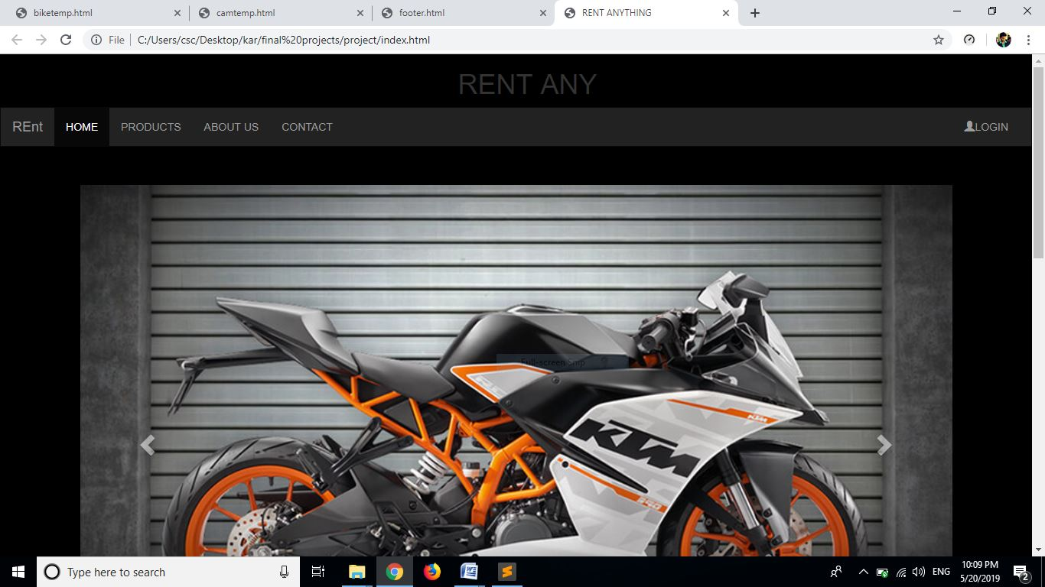

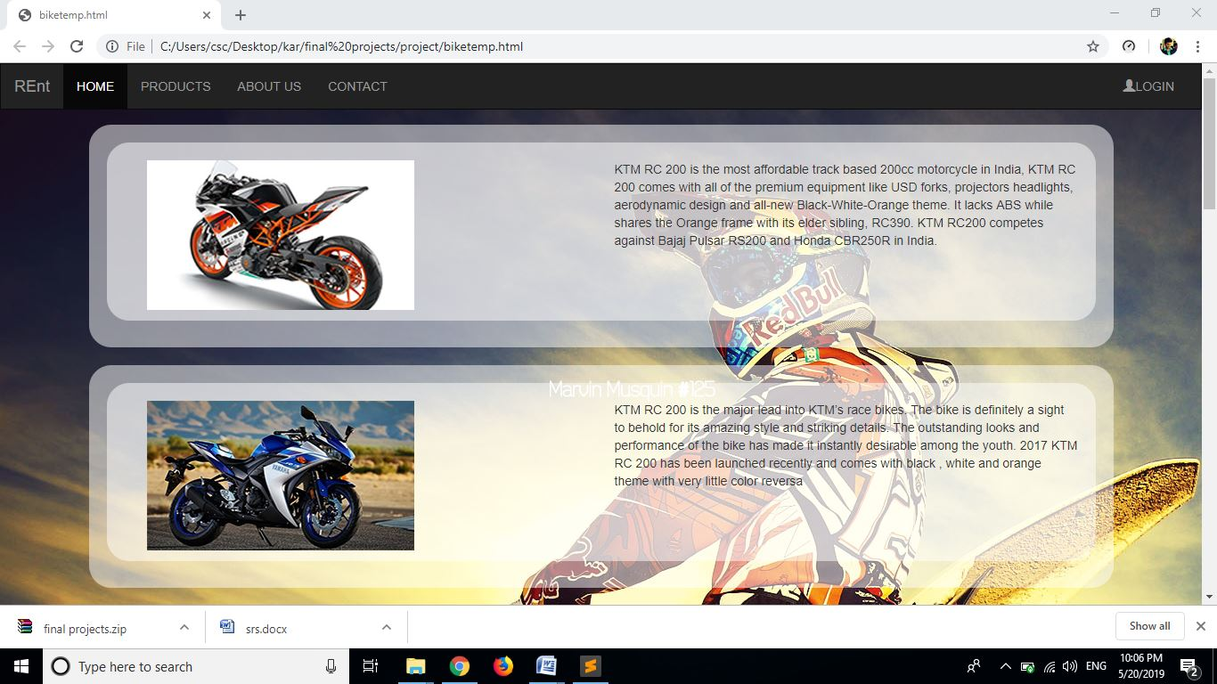

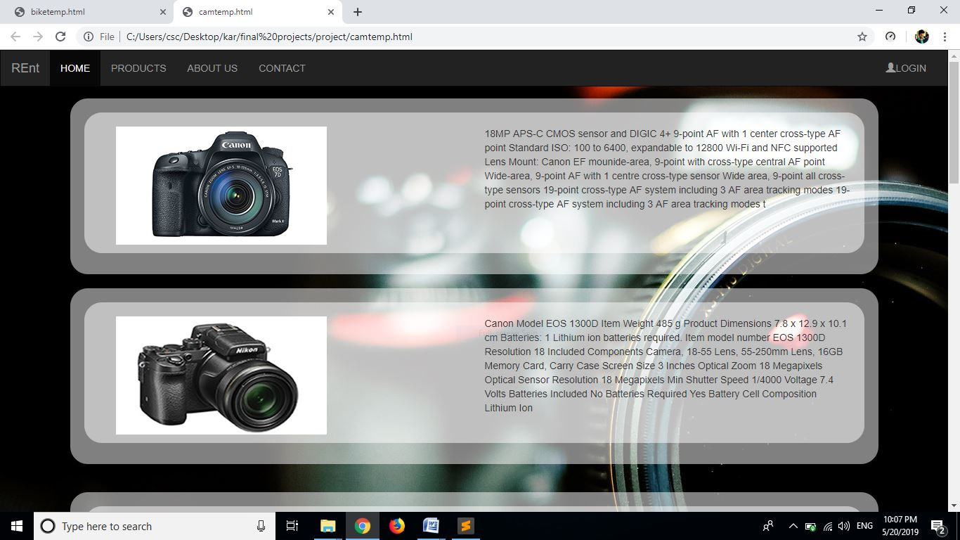

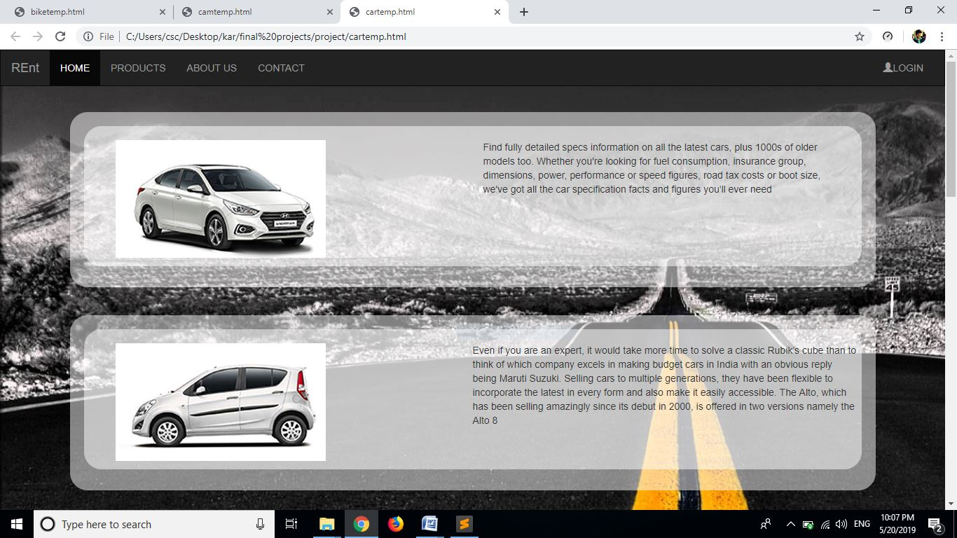

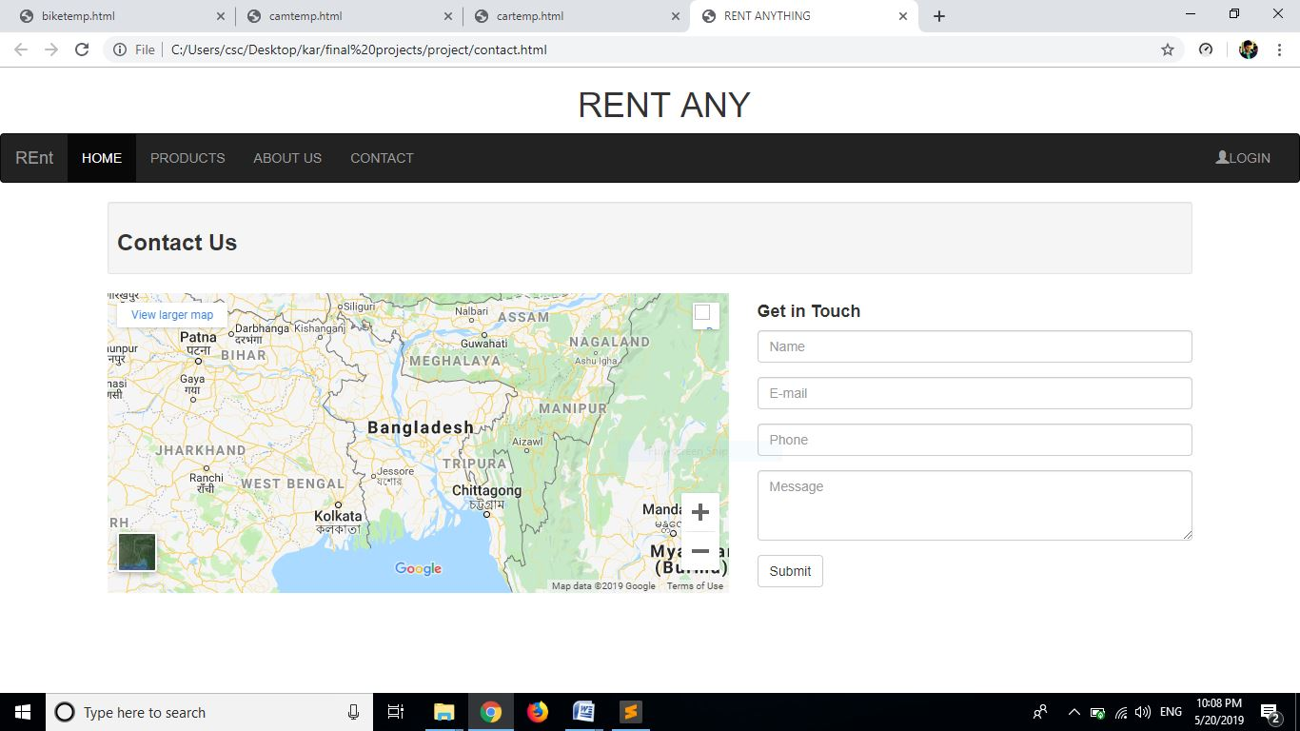

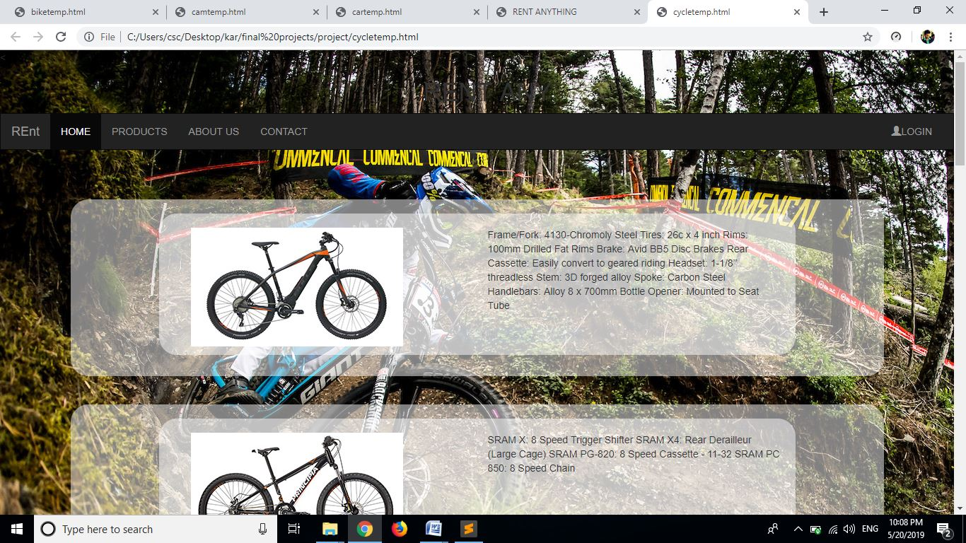

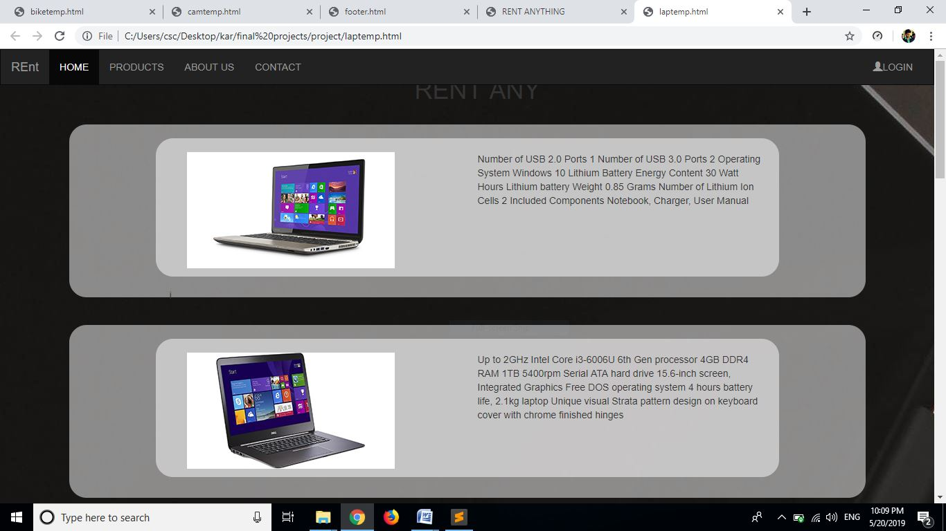

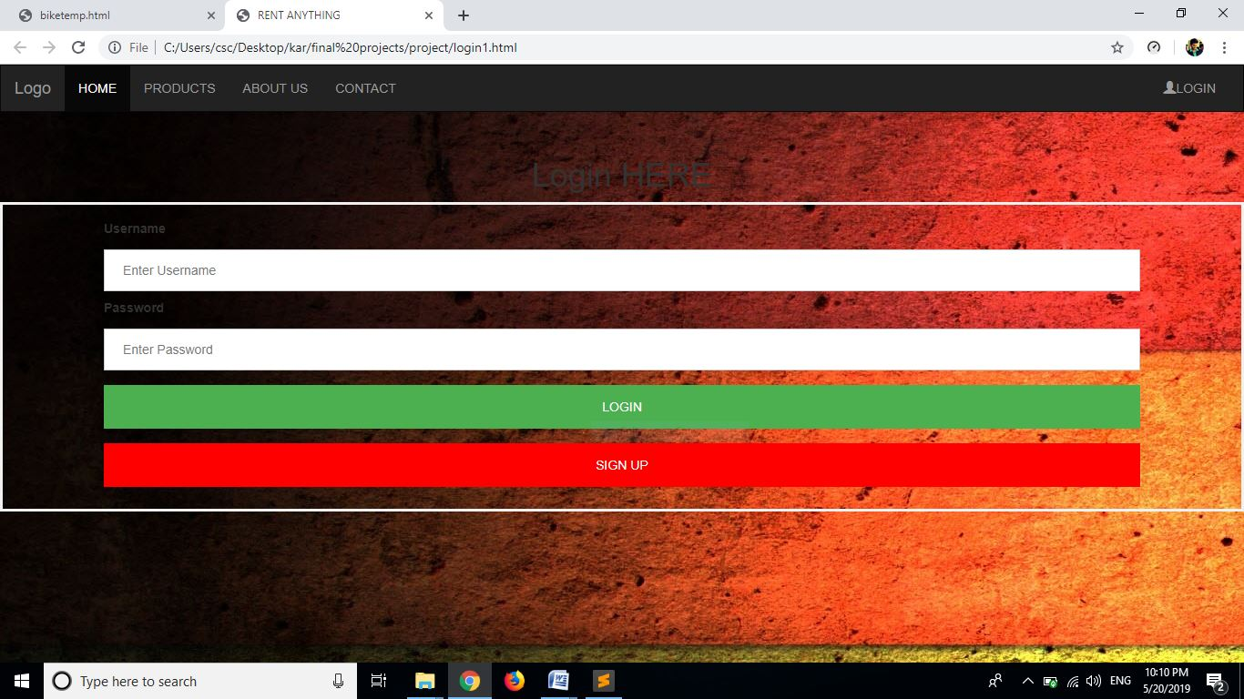

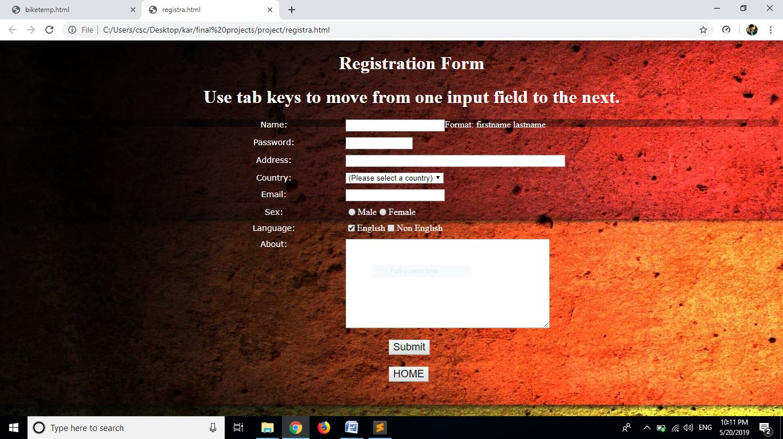

**Conclusion**

If this website is implemented people can rent anything they have by posting it on the website when not used so they will get the money and also user can rent anything from the website and pay the money so he can avoid buying things which he requires for short period of time.

**Future Scope And Enhancement**

This project does not take complete information from the user, and also does not verify the user so, it is difficult to track people who take the products and does not return it in time.

**Bibliography**

<https://www.w3schools.com/php/>

<https://www.guru99.com/php-tutorials.html>

<https://www.youtube.com/watch?v=qVU3V0A05k8&list=PL0eyrZgxdwhwBToawjm9faF1ixePexft->