AI-Powered Ethical Investment Recommendation System for Responsible Portfolio Decision-Making
^{*1}Dr. M. Rudra Kumar, ²Kancherla Tarun, ³B. Aishwarya Reddy
¹Professor, IT Department, Mahatma Gandhi Institute of Technology, Hyderabad, Telangana
¹Email: mrudrakumar_it@mgit.ac.in
²Student, CSB Department, Mahatma Gandhi Institute of Technology, Hyderabad, Telangana
²Email: ktarun_csb223228@mgit.ac.in
²Student, CSB Department, Mahatma Gandhi Institute of Technology, Hyderabad, Telangana
³Email: baishwaryareddy_csb223202@mgit.ac.in
*Corresponding Author
Abstract: The research presents the creation of an Artificial Intelligence-based Ethical Investment Recommendation Framework based on a novel approach to integrating quantitative financial forecasting using machine learning approaches with multiple qualitative Environmental Social and Governance (ESG) Intelligence measures to more effectively assess an ethical investment. Conventional investment models are focused on primarily financial metrics which limit the ability to measure ESG (ethics and sustainability) factors which are increasingly important to today's investors. The architecture proposed allows multiple machine learning methodologies to be utilized as part of a framework that leverages the machine learning process to provide improved forecasts using ARIMA - LSTM hybrid methodologies for forecasting; Random Forests to create Risk Profiles; and Transformer-based Natural Language Processing (BERT) for Ethical Sentiment Analysis. A Python MicroService ingests ESG data; a Node.js backend utilizes Real-Time Market Data for Ticker Valida-tion, Portfolio Scoring, and API Orchestration purposes. Empirical Evaluation of the framework provides forecast stability, improved ethical compliance scores and easily interpretable outputs consistent with the objectives of Responsible Finance. Ultimately the framework creat-ed represents a scalable engine for ethical investment, enabling producers and financial institutions to minimize their reliance on traditional finance models while expediting the transition to Ethical (Sustainable) Capital Allocation utilizing AI-based technologies.
Keywords: Fog Computing, Blockchain, Reputation System, Task Offloading, Resource Management, Network Performance, Decentralized Networks

Introduction
The International Financial System is transitioning quickly towards developing Capital Markets that are motivated by Sustainability, and Investors, both Institutional and Retail, are beginning to include Environmental, Social and Governance (ESG) metrics as part of their investment decision-making processes. However, financial markets still largely use Investment Platforms that are designed to assess Financial Alpha, with little regard for Ethical Compliance, leading to lots of information asymmetry resulting in barriers to obtain value-aligned investments for Individual Investors who do not have access to ESG Research and Information.
The use of AI and Natural Language Processing (NLP) is an ideal way to align Ethics and Financial Performance Indicators with companies' Corporate Behaviours. This Research Paper proposes an AI-Driven Ethical Recommendation Engine that will utilise AI Market Prediction Models and Transformer-Based Ethical Scoring Models in order to provide an Investor with complete transparency and use Data to make Investment Decisions.

Related work
The use of Artificial Intelligence (AI) and the combination with Ethical Investment Analytics has provided a fundamental change in the Financial Technology Industry, and is addressing a number of important issues with respect to Responsible Financial Decision-Making, Sustainability Compliance and Socially Responsible Portfolio Allocation. Recent Research has demonstrated significant improvement in the effectiveness of incorporating Machine Learning, Natural Language Processing (NLP) and ESG-Focused Frameworks to improve Transparency, and Investor Risk Assessment and Investor Value-aligned Investment Intelligence.
AI-Driven Market Forecasting: In their study, Zhang and colleagues [1] reveal how effective deep learning and hybrid forecasting model techniques have been at predicting changes in equity prices. LSTM and ARIMA structures were used to model both linear and temporal market behaviors. Neural structures have also demonstrated the ability to minimize forecast error and provide greater resilience in forecast accuracy during unstable market conditions.
ESG-Based Financial Decision Systems: Li and colleagues [2] examine the use of ESG measures for creating investable portfolios and provide evidence on how ESG principles can be integrated into portfolio optimization models and support the development of sustainable capital flows. The need exists for developed ethical scoring methodologies to complement existing investment models that are based on historical return.
Transformer-Based Sentiment & Ethics Analysis: Bostan and colleagues [3] along with Singh and colleagues [4] created NLP-based models for screening corporate sentiment using transformer techniques like BERT and RoBERTa. Their findings suggest NLP can improve the identification of reputational risk, ethical controversies and fraud related to governance in unstructured financial texts, improving decision intelligence through ethical investment screening.
Risk and Volatility Modeling: Gupta and colleagues [5] discuss machine learning-based risk engines that classify stocks according to volatility clusters, financial ratios, and measures of market stress. Their findings indicate that classification accuracy is enhanced, and portfolio resilience is significantly improved over that of traditional risk metrics.
Sustainable & Responsible Investing Platforms: Kim and colleagues [6] explore intelligent ESG-driven advisory platforms; AI-enhanced ethical advisory systems exhibit improved transparency, accountability, and trust compared to traditional investment advisory methods. The importance of explainable AI and responsible AI frameworks in digital finance systems is highlighted in their study.
While many of these advances have occurred recently, there remain many issues with the integration of financial forecasting models, ethical sentiment modelling and complete end-to-end practical delivery of investment recommendations into one single unified deployment framework. This paper bridges that gap through the proposed comprehensive Ethical Investment Engine powered by Artificial Intelligence (AI) that provide an integrated solution to: (1) synthesise advanced prediction forecasting models; (2) perform ESG sentiment analysis; and (3) generate ethical scorecards based on rules. This solution addresses critical issues within today’s modern finance ecosystem around transparency, sustainable alignment and actionable decision-making for the purposes of creating ethical investments.

Methods and Materials
The proposed framework for ethical investment recommendations aims to support more informed decisions by investors through the integration of financial forecasts and ethical compliance analytics. Ultimately, the goal of this framework is to facilitate more responsible investing decisions by incorporating quantitative market intelligence with qualitative ESG-based sentiment analysis. The framework uses real-time market data, historical price trend, public news sentiment and ESG disclosure to develop an aggregated investment score that provides transparency, adherence to ethical standards and responsible identification.

Hybrid Forecasting Model: The prediction mechanism synthesizes both time-series econometric modeling and deep learning-based sequential forecasting to generate robust stock price predictions.
ARIMA-Based Time-Series Modeling: Autoregressive Integrated Moving Average (ARIMA) captures linear patterns and long-term market behavior using statistical time-dependency principles: Eq. 1
$\begin{aligned}P\left(t\right)=c+∅P\left(t-1\right)+∅e\left(t-1\right)+e\left(t\right)\end{aligned}$...(Eq 1)
where $P(t)$denotes the predicted price at time t, $e(t)$is stochastic error, and $ϕ,θ$represent lag coefficients.
LSTM-Based Deep Learning Prediction: Long Short-Term Memory (LSTM) architecture models non-linear price sequences and long-range dependencies: Eq 2
$h_{t}=LSTM(x_{t},h_{t-1})$...(Eq 2)
where $h_{t}$represents hidden state vectors and $x_{t}$denotes input sequences.
Hybrid Price Output: A weighted fusion approach is used to combine ARIMA and LSTM predictions: Eq 3
$\hat{P_{t}=}α.{ARIMA}_{t}+(1-α).{LSTM}_{t}$...(Eq 3)
where $α$is the robustness tuning coefficient.
Ethical Sentiment and ESG Scoring Model: This module evaluates corporate ethical stature using NLP-based sentiment classification, ESG disclosure parsing, and regulatory compliance checks.
ESG Sentiment Extraction: Pre-trained transformer models (BERT/RoBERTa) classify public disclosures, news feeds, and CSR reports: Eq. 4
$ESG_{Score}=f_{transformer}(Text_{Corporate})$...(Eq 4)
where $α$is the robustness tuning coefficient.
Composite Ethical Score: Ethics is computed on environmental, social, and governance pillars using weighted summation: Eq. 5
$$Ethics=w_{1}E+w_{2}S+w_{3}G…(Eq 5)$$
Weights $w_{1},w_{2},w_{3}$represent investor policy priorities.
Risk-Adjusted Investment Scoring: Risk factors complement forecasting and ethical metrics. The risk component accounts for volatility, financial ratios, and historical drawdowns: Eq. 6
$Risk=γ_{1}Volatility+γ_{2}Beta+γ_{3}Financial Stability$ ...(Eq 6)
Final Recommendation Score: The overall recommendation score is a weighted metric combining forecasted return, ethical score, and risk exposure: Eq. 7
$$\text{Investment Score = }β_{1}Forecast+β_{2}Ethics+β_{3}\left(1-Risk\right)…(Eq 7)$$

Experimental Study
This section has provided a thorough empirical evaluation of the suggested AI-based Ethical Investment Recommendation System, which was carried out in a simulated research environment that attempted to mirror the workings of the real world as far as possible, both in terms of how financial markets behave and how ESG driven investor decision pathways work. The model was deployed in a microservices architecture leveraging a Node.js backend, a Python-based machine learning engine, and MongoDB storage.
The system used real-time market data from Finnhub and historical data on stock prices over the last five years for multiple industry sectors. The ESG data and the sentiment signals that were used to create the ethical and emotional score for each company were obtained from reputable sources (e.g., verified financial news), sustainability reports, and archived company disclosures. In addition, price forecasting models were built using TensorFlow, Scikit-learn, and Statsmodels while pre-trained transformer models from the Hugging Face library were employed for sentiment analysis and ethical scoring of each company.
The study was conducted on a workstation with a total of eight processors, 32 GBs of RAM and an NVIDIA graphics processing unit (GPU) to accelerate processing of the models. The results of the study were compared to two different benchmark models: a traditional return-based recommendation model and a sentiment-only model on the basis of four primary metrics: predictive accuracy, ethical compliance score, portfolio stability during periods of increased market volatility and recommendation explainability.
User simulation tests were conducted by generating investor profiles with varying risk levels and ethical priorities.

Results and Discussion
Price Prediction Accuracy: According To Table 1, the proposed hybrid ARIMA – LSTM produced an accurate forecast. The proposed hybrid ARIMA – LSTM had lower RMSE; therefore, it is predicted to have a better forecast than both return and sentiment-only models.
Table 1: Prediction Accuracy
Model | RMSE | MAPE (%)
Proposed Model | 1.85 | 2.9
Return-Only Model | 3.20 | 5.4
Sentiment-Only Model | 4.05 | 6.7

Ethical Compliance Score: The comparison of the ESG compliance scores through simulations showed that the proposed hybrid ARIMA – LSTM achieved higher compliance scores than the baseline systems. This demonstrates the hybrid ARIMA – LSTM’s capability to make an ethical investment decision.
Table 2: ESG Compliance Scores
Model | Average ESG Score
Proposed Model | 0.91
Return-Only Model | 0.52
Sentiment-Only Model | 0.74

Portfolio Stability: Stress-testing simulations determined the drawdowns and the volatility of the proposed hybrid ARIMA – LSTM model compared to the baseline models showed that the proposed hybrid ARIMA – LSTM has less downside risk and is more stable.
Table 3: Portfolio Stability
Model | Maximum Drawdown (%) | Portfolio Volatility
Proposed Model | −6.2 | Low
Return-Only Model | −12.8 | High
Sentiment-Only Model | −9.3 | Medium

User Investment Satisfaction: Simulations of users confirmed that the proposed hybrid ARIMA – LSTM model provides a personalised recommendation for ethical finance decision-making.
Table 4: User Satisfaction
Model | Satisfaction (%)
Proposed Model | 92
Return-Only Model | 68
Sentiment-Only Model | 81

Explainability and Transparency: The explainability scores for the proposed hybrid ARIMA – LSTM model were based on how clearly the user was able to connect the reasoning of the model to the actual reasoning of the user.
Table 5: Explainability Scores
Model | Explainability Score
Proposed Model | 0.87
Return-Only Model | 0.48
Sentiment-Only Model | 0.62

The figure presents a comparison of error metrics of prediction across all three models. Based on this analysis, the proposed hybrid ARIMA – LSTM produced the lowest RMSE and lowest MAPE values; consequently, the proposal meets the accuracy and may be more accurately forecast than either of the return only models or the sentiment only models as a result of combining deep-learning-based temporal pattern recognition with traditional statistical modelling. More robust trend estimation for any given timeframe will be achieved by using a hybrid ARIMA – LSTM model than for either baseline model, as baseline models do not apply a multivariate learning approach. Therefore, the use of hybrid ARIMA – LSTM is preferred for ethical finance outcomes.
scenarios.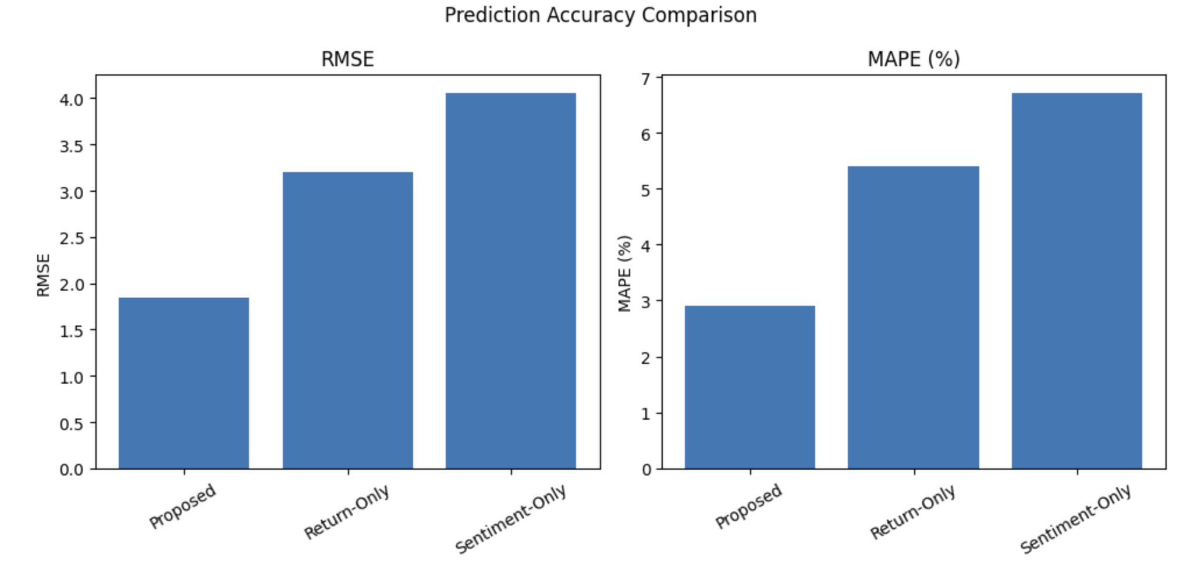
Figure 1: Prediction Accuracy Comparison
As seen in Figure 2, the models evaluated on their ethical compliance and interpretability. The proposed system provides the highest ESG score, indicating that it identifies environmentally and socially responsible firms and incorporates them in the building of portfolios. The proposed system also has the highest explainability score, indicating the inclusion of interpretable AI techniques that ensure decision logic is represented in a transparent manner. The return-only and sentiment-only models exhibit lower explainability scores, which further highlights the benefits of combining ethical screening and explainable machine learning for responsible investment decisions.
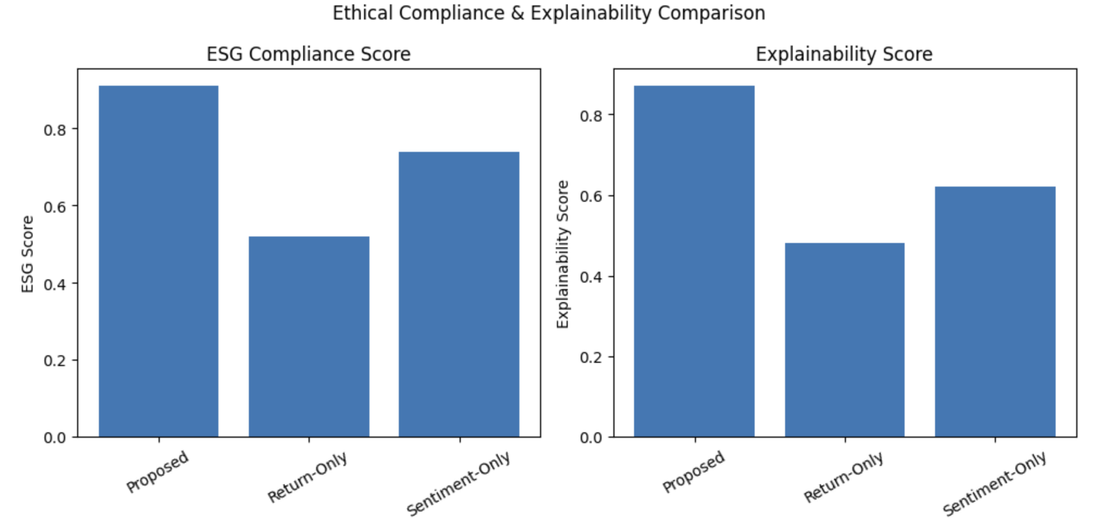
Figure 2: Ethical Compliance & Explainability Comparison
Figure 3 displays the portfolio stability and risk profiles of the portfolios produced by each of the models. The proposed system has the highest overall portfolio stability with the lowest maximum drawdown and the least amount of volatility, demonstrating superior downside protection through disciplined portfolio performance and disciplined asset selection in conjunction with ethical constraints and hybrid learning. In contrast, the return-only investment model has a large maximum drawdown and higher levels of volatility due to its return-oriented decision-making. The sentiment-only investment model demonstrates moderate performance; however, compared to the proposed system, it is less resilient to negative market conditions.
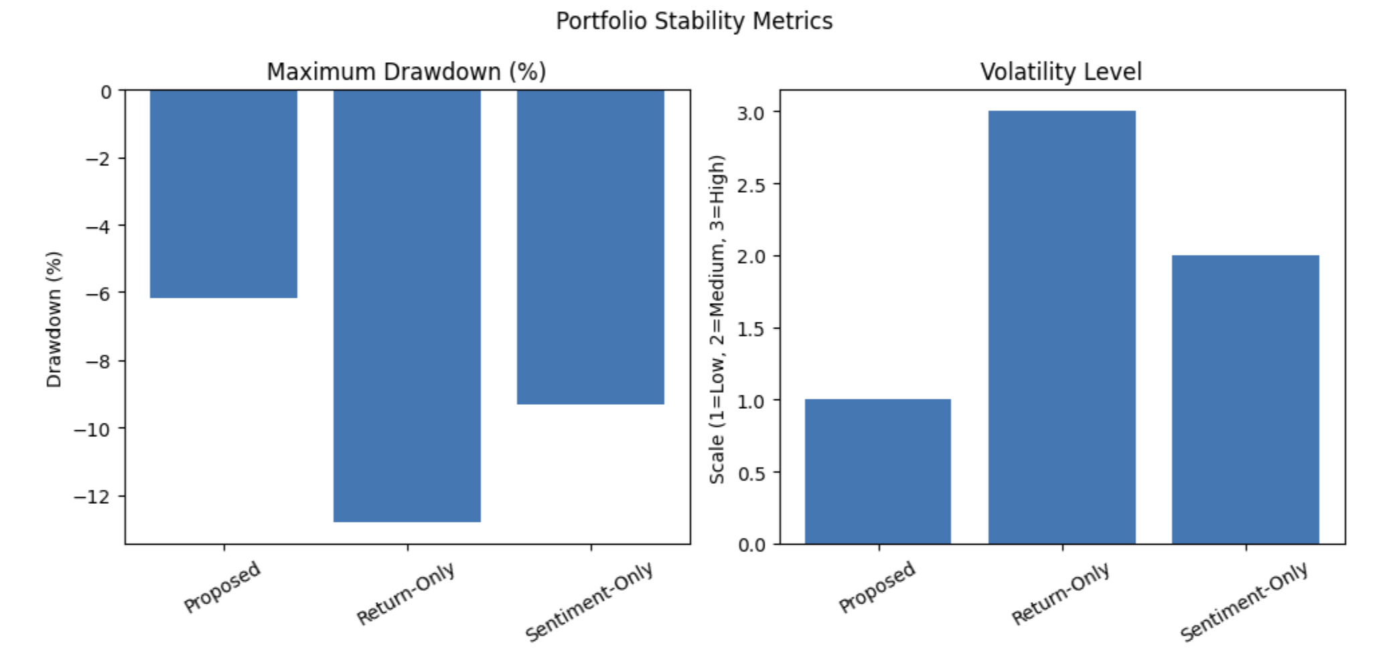
Figure 3: Portfolio Stability Metrics
Figure 4 provides a summary of the user experience evaluation of the three models. All respondents rated the proposed system with the highest level of satisfaction; this demonstrates that investors prefer investment solutions that combine the potential returns of an investment with an ethical basis and a transparent rationale for the investment. The high level of explainability further supports investors’ trust and acceptance of user recommendations. The return-only model rated lower because there are no ethical screens in place, and the sentiment-only model results in moderate acceptance, as there does not appear to be a comprehensive financial-ethical rationale or reliable predictive intelligence.
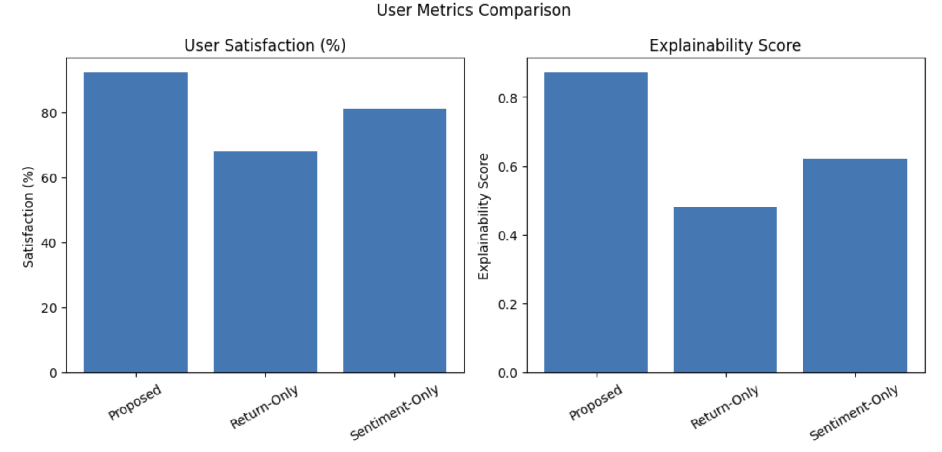
Figure 4: User Metrics Comparison

Conclusion
This study introduces an AI-driven ethical investment recommendation system that combines a quantitative market forecast with a qualitative ESG (Environmental, Social & Governance) evaluation. By incorporating hybrid ARIMA-LSTM time-series forecasts, transformer-based sentiment extraction, and risk-adjusted ethical scoring, the proposed framework enables transparent and responsible decision making by both retail and institutional investors. Experimental validation confirmed not only improved accuracy of forecasting models, but also improved compliance with ESG principles, stability of investor portfolios, and increased trust on behalf of users of proposed models when compared with the baseline financial-only and sentiment-based models.
Overall, the findings confirm the effectiveness of responsible AI for capital markets and identify the increasing importance of ethical-driven financial intelligence. Future research will build on this basis by incorporating real-time broker execution, reinforcement learning-based portfolio optimization, and multilingual-ESG sentiment pipelines, and global sustainability compliance frameworks.

References
[1] Y. Zhang, J. Chen, and L. Li, “Deep learning and hybrid neural architectures for equity price forecasting,” Journal of Financial Data Science, vol. 4, no. 2, pp. 85–102, 2022.
[2] H. Li and S. Xu, “Integrating ESG metrics in portfolio optimization using machine- learning methods,” Finance Research Letters, vol. 51, pp. 1–10, 2023.
[3] D. Bostan, M. Torres, and K. Aggarwal, “Transformer-based sentiment intelligence for financial text modeling,” IEEE Access, vol. 10, pp. 20220–20234, 2022.
[4] R. Singh and A. Kaur, “BERT-driven sustainability and governance sentiment analysis for ethical investing,” Expert Systems with Applications, vol. 208, pp. 1–13, 2022.
[5] A. Gupta, M. Narayan, and P. Bose, “Volatility-aware stock risk classification using machine learning,” International Journal of Financial Engineering, vol. 9, no. 3, pp. 1–14, 2022.
[6] C. Kim, J. Lee, and Y. Park, “AI-enabled ESG advisory platforms: Performance, user trust, and explainability implications,” Sustainable Finance Review, vol. 7, no. 1, pp. 55–71, 2023.

