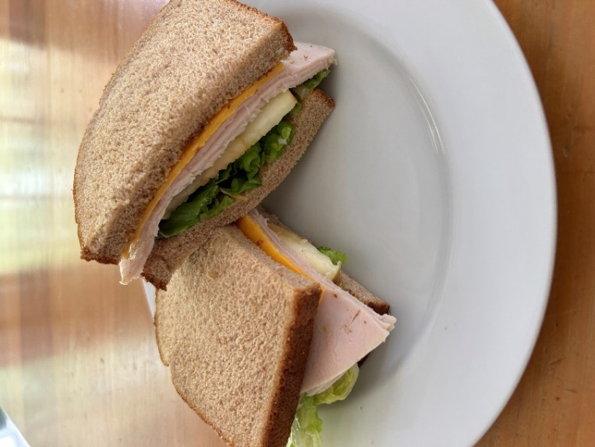
TURKEY APPLE CHEDDAR SANDWICH

2 Slices Whole Wheat Bread
3 oz (or 3-4 slices) Oven Roasted turkey Breast, pre-sliced
1 slice Cheddar Cheese
6 each Apple Slices, pre-sliced, pre-washed
1/4 cup Romaine Lettuce Hearts, pre-cut, pre-washed
2 Tbsp Honey Mustard, purchased or use recipe below

HONEY MUSTARD RECIPE:
1 Tbsp Honey
1 Tbsp Mustard, Dijon or Grainy
TO MAKE HONEY MUSTARD:
- Place honey and mustard in a small bowl.
- Using a wire whisk, mix well.

TO MAKE SANDWICH:
- Using a spoon, spread 1 Tbsp Honey Mustard on 1 side of each slice of bread.
- On 1 slice of bread place cheddar cheese.
- Over cheese place turkey.
- Over turkey place apple slices.
- Over apple place lettuce.
- Cover the lettuce with the other slice of bread to put the two sides of the sandwich together.
- Cut sandwich in half.

